Task 1
  - Section 1 – Introduction
In recent years, various health benefits have been associated with regular physical activity [1]. As a result, long-distance endurance sports such as marathons, ultra-marathons, and triathlons have increased in popularity [2] – [4]. Esteve-Lanao et al. [2] state that participation in marathon events by recreational runners has become immensely popular worldwide. Additionally, wearable tracking devices have become a common necessity [5][6] as they provide real-time sport-related data (e.g., pace, heart rate). This, in turn, helps individuals achieve a target performance, either during training or a race.
Predicting marathon race time (MRT) is highly important and provides various entities with valuable insights, but some researchers [2][5][7] have considered it a difficult task. Among others, the underlying reasons point toward the complexity of the sport itself, including the event landscape, unpredictable environmental conditions, different runner biometrics [7], and different tracking devices [5]. This led to the introduction of machine learning (ML) to improve accuracy, including tree-based algorithms (supervised), clustering (unsupervised), and time-series algorithms.
The purpose of this experimental study [8] is to investigate the use of tree-based ML models to predict an athlete's MRT and subsequently evaluate the comparative predictive performance of Random Forest (RF) and Extreme Gradient Boosting (XGBoost) regressors across diverse historical data. The dependent variable of this study is the predictive performance of the ML algorithms in estimating the continuous MRT value, whilst the independent variables will be the dataset and the model type (RF against XGBoost). Specifically, historical training data will be aggregated into blocks starting from 16 weeks, iteratively reduced by 2-week intervals, until reaching a minimum of 6 weeks. Moreover, the control variables will be the dataset features, including activity metrics and demographic information, and the repeated k-fold cross-validation technique, so that each ML regressor can make decisions on the same data. This research does not take into consideration the landscape or weather conditions, nor any anthropometric or physiological factors that might alter the result.
To achieve this, the study aims to explore the effectiveness of tree-based ML regressor models in predicting an athlete’s MRT and to identify the optimal model based on predictive performance. Furthermore, this study seeks to determine whether the number of weeks of historical data yields a quantifiable increase in the models’ predictive performance. Specifically, the hypothesis of this research states that an XGBoost ML regressor will achieve higher predictive performance than an RF regressor. Additionally, it is expected that XGBoost will be most accurate when trained on larger volumes of historical activity data (16-week training block), as this will supply the model with more comprehensive data about an individual's marathon buildup.
In view of the previously mentioned factors and as illustrated in Fig. 1, a positivist philosophy will be adopted as this study is highly focused on gathering quantifiable outcomes (predictive performance). A deductive approach will be implemented because a hypothesis has been established, and the study is designed to prove or disprove it. In addition, an experimental strategy will be conducted, given that the research has a dependent variable (accuracy), two independent variables (model type and timeframe of historical data), and various control variables to ensure an unbiased investigation. Thus, a mono-method quantitative research choice will be adhered to, as no surveys, interviews, or questionnaires will be held. It will depend exclusively on an open-source dataset as input and values obtained from different experiments as output. Consequently, although the dataset encompasses a period of time, a cross-sectional time horizon will be utilized. This is because the experiments will leverage a snapshot of aggregated data, rather than monitoring athletes during a specific training block.
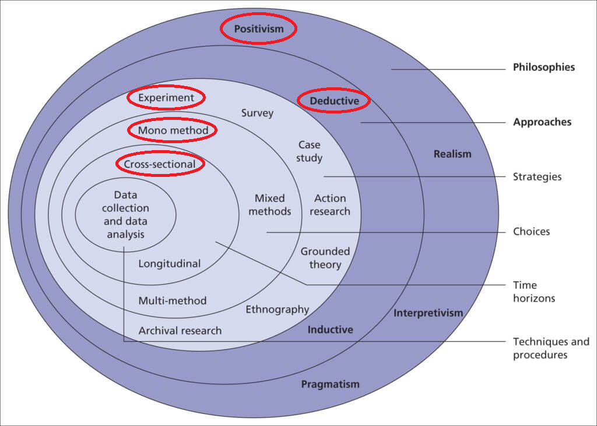
Figure 1 The Research Onion - Adopted from [9]
  - Section 2 – Literature Review
The running community has grown immensely over the past few years, driving the demand for wearable tracking devices that capture real-time, sport-related data. Due to the complexity of forecasting marathon race times, predictive machine learning (ML) algorithms have become a prevalent and necessary resource for individuals in training and attaining target performances. As this technological integration has transformed how athletes strategize for major marathon races, various researchers have acknowledged and sought to improve these predictive models.
This section evaluates research methodologies adopted from a chosen set of studies and analyses the different approaches and frameworks employed by the researchers. Fig. 2 illustrates the selected set of academic studies, presenting a more comprehensive understanding of the contributions and interconnections to the predictive side of this domain. To deliver a systematic and comparative analysis, this section is based on the research onion model proposed in [9] and the research design framework proposed in [8]. Common methodological patterns will be highlighted, along with their advantages and disadvantages.
A. Instance-Based, Regression, and Deep Learning Models for Performance Prediction
With very similar objectives in mind, all six studies [10 – 14] adopted a positivist standpoint, considering an individual’s performance in a marathon event a continuous, measurable, and objective outcome that can be precisely calculated by machine learning (ML) techniques. Hence, they were all distinctly deductive in nature as they validated existing hypotheses using experimental designs and historical data. Almost all studies utilized longitudinal data gathered over multiple years, except for [11]. Additionally, they entirely depend on quantitative, numerical data, distinguishing them as mono-method quantitative methodological studies. No qualitative information was gathered about an athlete’s emotional state or training experience.
Both Feely et al. [10] and Lerebourg et al. [11] employed the same instance-based learning approach as a regressor to predict athlete marathon race times (MRT). The difference was that the former study coupled the k-Nearest Neighbour (KNN) model with a case-based reasoning (CBR) system, which helped bypass the necessity of complex physiological domain models and mitigated the likelihood of unrepresentative training recommendations. The latter study compared a KNN model against an Artificial Neural Network (ANN), on the same objective. A clear difference is observed in the time horizon when choosing longitudinal [10] and cross-sectional [11] historical datasets.
Feely et al. [10] gathered thousands of activity records from 19,930 individuals between 2014 and 2017, and notably, due to forecasting difficulties, the runners were eligible based on their marathon performance. It included finish times between three and five hours for females and less than five hours for males, and although this resulted in better accuracy (even through visual illustrations), including sub-three-hour female athletes should have been considered, as it provides variance. On the other hand, Lerebourg et al. [11] investigated solely using four static inputs from 820 runners, including at least one 10-kilometer race result. These were appropriately normalized before being fed to the ANN model, aligning with the sigmoid transfer function, and to eliminate scale variations between the input variables for the KNN model, for accurate Euclidean distance calculations.
Regarding this study [10], the large-scale dataset was essential and proved highly beneficial when performing 3 separate experiments on feature variations. Although the Root Mean Square Error (RMSE) showed the models' improved performance over time, one must consider that it was not put through real-world trials. Furthermore, the dataset by Lerebourg et al. [11] was effective in addressing overfitting and showed that KNN outperformed the ANN model; however, incorporating a half-marathon race result from the same year could improve the model's predictive performance. This study [10] also stated that the k value was set to 15 after showing a point of error stabilization, whilst Lerebourg et al. [11], although having an acceptable Mean Absolute Error (MAE), set the k value to 3 without any explicit reasons. This could mean that other values could have led to better results. A common shortcoming of both studies is gender imbalance, with a 24% [10] and 17% [11] female sample population, which could result in inaccurate training recommendations and MRT prediction for this gender.
In another study by Ruiz-Mayo et al. [12], two regressors were evaluated and compared with a baseline ZeroR model: Linear Regression (LR) and Bagging, to assess the validity of more complex regressors for forecasting the MRT. Starting with the time horizon, the 6-week longitudinal dataset selection contradicts the researchers. It was explicitly mentioned that several months of preparation are required to compete. Without any explanation for this period selection, it might depict uninformed decisions, as this hides the majority of the training period, which could have resulted in better model performance. Adequate filtering was held, and relevant features were engineered based on weekly, bi-weekly, and the full training window. These supply the models with significant information, which contributed towards low MAE values, showing the importance of rigorous pre-processing.
The issue with the employed dataset was the population size, which contained only 1,000 suitable athletes from the original 3,386, coming from two major marathon events in the first half of the year, whilst there are a total of six. Therefore, generalizability could be difficult when applied to others. Moreover, using the Weka and Knime software and the standard 10-fold cross-validation, the researchers [12] developed a Bagging model of 100 combined regression trees that attained the lowest MAE of all the models. Thus, testing the algorithm with slightly more regression trees at a time could reveal better results. Nonetheless, the study still meticulously held the three separate experiments, starting with the original, filtered, and then the injury-free dataset.
Furthermore, both Dash et al. [13] and El-Kassabi et al. [14] leverage DL models for their investigations, as the former employed a regression and time-series Long Short-Term Memory (LSTM) model, while the latter compared the predictive performance among a Recurrent Neural Network (RNN), LSTM, and Gated Recurrent Unit (GRU). Although DL models were used, the objective differed. El-Kassabi et al. [14] focused on predicting the MRT, and Dash et al. [13] developed a model that forecasted an athlete's performance across a wide range of distances, elevations, and performance categories. Both studies based their experiments on longitudinal and sequential historical training logs, with an average of 6.6 years [13] and 5 months [14]. The sequential aspect is of great importance and was rightly considered due to the nature of DL models. Also, the time horizon aspect provided the algorithms with valuable information, which was reflected in the results.
Regarding the participants, Dash et al. [13] had one issue, as only 15 recreational runners were included in the study. Additionally, one model was developed and modified for each individual. Thus, future work would suggest gathering and testing the superior model on a larger sample population and developing a generalized LSTM predictive model, as this is not contextually feasible. This would result in more training patterns, enhancing model training, increasing scalability, and highlighting certain flaws and possible improvements. However, it must be noted that the specialised filtering process exhibited lower Mean Absolute Percentage Error (MAPE) values, showing its significance again, as in [12]. Even the hyperparameter optimization framework (Optuna) was selected strategically, likely due to its efficiency. Overfitting was also addressed by having two regularization methods, dropout and early stopping.
Analysing the dataset in this study [14], the preparation period was more than accounted for, as mentioned in [12], and the experiments were systematically designed and executed, starting with 25 and then 50 hidden states for each model. To further enhance the dataset, the statistical three-sigma rule was adopted to eliminate outliers, yielding a highly concentrated dataset. This ensured an unbiased comparison and clear evaluation of the superior GRU model, primarily through the MAPE metric, as in [13]. A possible issue would be generalising the model, similar to the issue in [12], since it was only applied to the Boston marathon. Thus, this should be tested on other major marathons to validate its applicability. The experimental findings also showed that more hidden states contributed to slightly more precise predictions; therefore, future research should assess how MRT predictions change with gradual increments in hidden states.

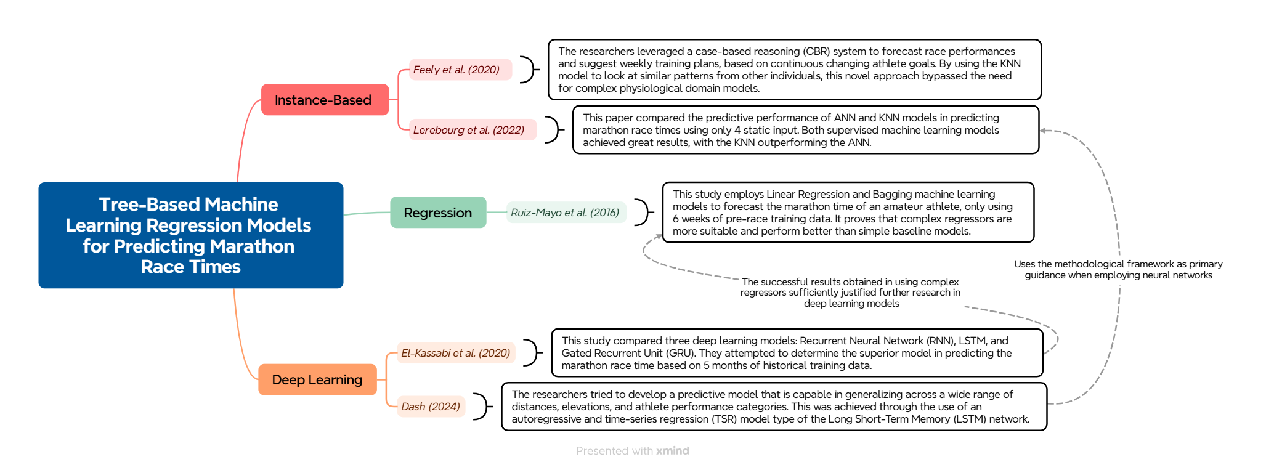
Figure 2 Literature Map

  - Section 3 – Research Methodology
After analyzing the methodologies outlined in Section II, it was noted that researchers in numerous studies ([10], [11], [12], [13], [14]) employed a comparative approach, which evaluated machine learning (ML) models from the same or different paradigms. These investigations were conducted to determine whether more complex algorithms are necessary to achieve a common objective, concerning prediction accuracy in long-distance running events. In keeping with these methodological approaches, our study endorsed a similar strategy, performing progressive and comparative experiments aimed at addressing the following research questions:
- RQ1: Which tree-based machine learning regressor obtains the highest predictive performance when forecasting an athlete’s marathon race time?
- RQ2: To what extent does the amount of weekly historical data affect the predictive accuracy?
All six individual experiments are conducted to collectively address RQ1 and RQ2, in which two ML regressors are evaluated based on their predictive performance on progressively reducing data, coupled with a repeated k-fold cross-validation technique for each experiment. In this manner, a superior model is established. This will help analyse the effects of different weekly historical data from different evaluation metrics and determine whether a model remains consistently better. To address the research questions, this paper presents the following objectives, which are also outlined within the research pipeline (Fig. 2):
- Obtain a dataset containing daily activity records from individuals and filter to the dominant demographic (gender and age group).
- Check for major marathon events that have at least 16 weeks of daily training data.
- Aggregate the training block data of each athlete into a single record whilst engineering new features.
- Conduct benchmark testing using the reference solution [15] and its utilised dataset.
- Test and evaluate the predictive performance of both ML regressors on progressively reducing data to identify which model adjusts best to different data availability.
A. Methodology Approach
This approach supports the positivist philosophy and deductive approach conveyed in Section I, which highlights a systematic and rigorous analysis of ML regressors for predicting an individual's marathon race time (MRT), while gathering measurable outcomes through their predictive performance. During each experimental course, a cross-sectional dataset will be supplied to each model, independent of the historical timeframe being assessed. Therefore, a mono-method quantitative research choice will be followed. Consequently, our experiments align with the Research Onion model illustrated in Fig. 1, maintaining consistency in our research methodology.
B. Research Pipeline and Methods – Experiment Design
The research pipeline in Fig. 3 outlines the main phases required to achieve the stated objectives and answers the research questions posed in this paper. The foundational work necessary for the experiments (Phases 01 and 02) was conducted in a similar study that aimed to predict the MRT using sequential deep learning (DL) models, and a reference solution was also provided [15]. In turn, the desired dataset was provided with the target value. This was also highly specific to the dominant demographic group within the dataset (males aged 35 to 54 years). Additionally, from the six available marathon majors, the training block concerning the Tokyo 2019 marathon was removed as it contained only 8.5 weeks of data.
In Phase 03, this data source was utilised, and additional features were engineered from two native input features: distance (kilometres) and duration (minutes). The individual training blocks were then combined into a single record per athlete, and a repeated k-fold cross-validation technique was applied to the data files for model training and testing within Phase 04. Therefore, the last phase focused on obtaining quantitative results by employing and comparing two ML regressors: Random Forest (RF) and XGBoost, starting with the data-rich train-test files and progressively utilising those that had less weekly training data.
RQ1: Which tree-based machine learning regressor obtains the highest predictive performance when forecasting an athlete’s marathon race time? And RQ2: To what extent does the amount of weekly historical data affect the predictive accuracy?
This subsection addresses both research questions concurrently; the progressive data-reduction experiments designed for RQ2 ultimately generate the performance metrics required to identify the superior tree-based model for RQ1. This also provides further analysis on how both models adjust and perform when provided with fewer weeks of training data.
Primarily, benchmark testing was held using the exact reference solution code and aggregated data [15] on Linear and Random Forest (RF) regressors. Since XGBoost is also investigated in this research, this model was implemented within the same reference code [15] to maintain consistency. Thus, three benchmark models were developed to enable a fair comparison of results. Due to the unpredictable and irregular nature of physical exertion by an athlete, the Linear regressor was not considered for this research.
The following experiments were conducted using two ML regressors, RF and XGBoost, based on three criteria: (a) similar underlying algorithmic structures, (b) common data input ratios, and (c) no feature scaling required. Therefore, this contributed to a better comparative study, specifically analysing the effectiveness of tree-based ensemble regression models. A sequentially ordered activity dataset, consisting of 16-week training blocks per athlete from the dominant demographic, was progressively reduced in 2-week intervals until reaching 6 weeks and hence aggregated. Another study [12] also used tree-based ensemble regression models, but only with 6 weeks of data; thus, this led to such a methodological approach. Some inessential features were removed, such as rolling metrics and weekly metrics, and new ones were formulated from the original distance and duration column values. This ensured that the models were supplied with essential information to aid performance predictions, as previously done by [10]. Notably, the original dataset [16] was open-source and obtained from Kaggle.
During training, model architectures were kept the same as those developed within the benchmark models to maintain coherence. The models were evaluated using standard 10-fold cross-validation, meaning the data was iteratively split into a 90:10 train-test ratio. This methodological step ensured a strong evaluation and mimics the approach taken in previous work [12]. Reliability was also established by repeating the experiment three times, thereby reducing the likelihood of random errors, an approach similarly adopted by [13]. Moreover, shared hyperparameters between the ML models were kept constant (such as the number of estimators) to ensure a fair structural comparison. The effectiveness of their predictive performance was assessed using the universal Mean Absolute Error (MAE), Root Mean Square Error (RMSE), and the R-squared value (R²) metrics, as proposed by [10] [11] [12] [14], and these are defined as follows:
$$\begin{aligned}MAE= \sum_{t=1}^{n}{\frac{|y_{pt}- y_{t }|}{n}} \#\left(1\right)\end{aligned}$$
$$\begin{aligned}RMSE= \sqrt{\frac{\sum_{t=1}^{n}{{(y_{pt}- y_{t })}^{2}}}{n}} \#\left(2\right)\end{aligned}$$
$$\begin{aligned}R^{2}=1- \frac{\sum_{i=1}^{n}{{\left(y_{i} - {\hat{y}}_{i}\right)}^{2}}}{\sum_{i=1}^{n}{{\left(y_{i} - \overline{y}\right)}^{2}}} \#\left(3\right)\end{aligned}$$
To answer both research questions, the MAE and R² values were key to deducing which model accomplished the closest prediction to the actual target MRT value, with the RMSE highlighting any limitations of the individual models. Each metric was accompanied by a standard deviation, given that 3 experiments were held on each dataset and model. These metrics were calculated using their respective imports from sklearn.metrics library.
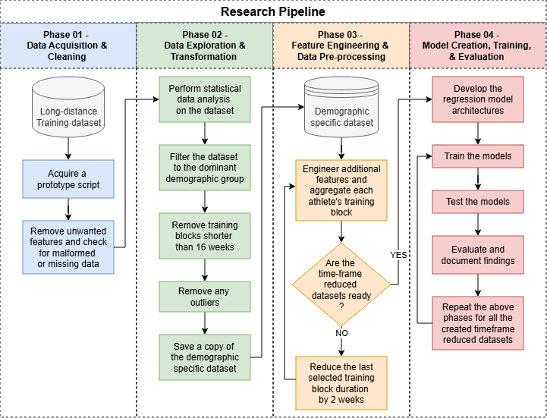
Figure 3 Research Pipeline
C. Validity, Reliability, and Generalizability
Validity: Numerous steps were taken to ensure the validity of each experiment, including the domain-standard 10-fold cross-validation technique for all datasets, even after reducing some historical data, which inherently uses a 90:10 split ratio. Consequently, the same train and test data files were supplied to each ML regressor to ensure valid comparisons. The models were also chosen with intent, as they fall within the same ML category types and require no feature scaling. Construct validity was adhered to when developing new features, as they represented valid athlete physical exertions during the training block. Additionally, the evaluation metrics (MAE, RMSE, R²) were valid as they were used in similar studies [10] [11] [12] [14], and they provided complementary strengths to ensure a robust and valid evaluation.
Reliability: Having the model architectures and common hyperparameter values as control variables ensured experimental reliability. Using the domain-standard 10-fold cross-validation technique ensured stable and consistent results during training and testing. Moreover, both models underwent a repeated 10-fold cross-validation process (three times) for each data iteration to mitigate any random errors caused by data splitting, and the same technologies and environments were used. Notably, a common script was utilised when calculating and developing new features for all datasets.
Generalizability: Regarding this aspect, the results are partially limited because the study focused on a specific demographic, applying only to male runners aged 35 to 54. Therefore, employing the developed models on athletes from different demographic groups would yield inaccurate results. Also, only two ML regressors were used with a specific, consistent structure throughout. On the other hand, when the models were provided with unseen test data, they adjusted and performed predictions accordingly, and training data was gathered before five of the six major marathons. Consequently, making them applicable for most marathon majors for this specific demographic group. While the research provides valuable insight into MRT predictions, attention should be given when applied to broader contexts.
D. Technologies and Environment Used
The experiments were executed on a local machine with a 13th Gen Intel® Core™ i7-1355U CPU, 16 GB of RAM, and an integrated Intel® UHD Graphics GPU, drawing from 7.8 GB of the system RAM. Since the ML regression models did not require high computational power for training and testing, this setup was more than enough. All the prototypes were developed and executed in a dedicated Python 3.11.14 environment using a Jupyter Notebook with multiple sections, as it provides a lot of flexibility and compatibility. Additionally, key dependencies and libraries included NumPy, Pandas, Matplotlib, Seaborn, Scikit-learn, Statsmodels, TensorFlow, and Dill, managed via the conda-forge channel.
E. Ethical Considerations
While conducting this study, an open-source dataset was used, consisting of running activity gathered from public athlete Strava pages. As a data source, it was used in numerous studies. It is licensed under the Creative Commons Attribution 4.0 (CC BY 4.0, Deed – Attribution 4.0 International – Creative Commons) licence, and the data collection process was in accordance with the Brazilian Ethics Research Committee standards.
The individuals were anonymised, and no personal information was kept or shared to safeguard any sensitive information and the runners’ identities. Only essential training session data was used, such as training distance and duration, gender, age group, country, and a list of previously run marathon majors. No harm was inflicted on the runners themselves as they were not instructed or forced to run for the benefit of this study; rather, they were primarily randomly chosen from Strava based on their participation in marathon majors in 2019 and 2020.
In mentioning Strava, a popular training application worldwide, the tracking devices used during the training sessions, their software, and those linked to them were not recorded as they did not form part of this study. Our study is purely aimed at predicting an athlete's running performances within different marathons while leveraging separate training efforts.
F. Generative Artificial Intelligence (AI) Considerations
Artificial Intelligence tools, specifically Gemini 3.1 Pro and Grammarly, were utilised to support the development of this paper, mainly for reconstructing the text for academic soundness, suggesting phrases and synonyms, and code snippets for the creation of the prototype. The methodological approach and decisions taken during the study were made entirely by the author, who fully takes authorship of the presented content.

  - Section 4 – Results, Analysis, and Discussion

  - Section 5 – Conclusion

References:
[1] S. Wiecha, P. S. Kasiak, I. Cieśliński, M. Maciejczyk, A. Mamcarz, and D. Śliż, “Modeling Physiological Predictors of Running Velocity for Endurance Athletes,” JCM, vol. 11, no. 22, p. 6688, Nov. 2022, doi: 10.3390/jcm11226688.
[2] J. Esteve-Lanao, S. Del Rosso, E. Larumbe-Zabala, C. Cardona, A. Alcocer-Gamboa, and D. A. Boullosa, “Predicting Recreational Runners’ Marathon Performance Time During Their Training Preparation,” Journal of Strength & Conditioning Research, vol. 35, no. 11, pp. 3218–3224, Nov. 2021, doi: 10.1519/JSC.0000000000003199.
[3] M. Thuany et al., “An analysis of the 6-h ultra-marathon race using a machine learning approach,” Front. Sports Act. Living, vol. 7, p. 1577470, Sep. 2025, doi: 10.3389/fspor.2025.1577470.
[4] J. Martínez-Gramage, J. P. Albiach, I. N. Moltó, J. J. Amer-Cuenca, V. Huesa Moreno, and E. Segura-Ortí, “A Random Forest Machine Learning Framework to Reduce Running Injuries in Young Triathletes,” Sensors, vol. 20, no. 21, p. 6388, Nov. 2020, doi: 10.3390/s20216388.
[5] A. Karahanoğlu, R. Gouveia, J. Reenalda, and G. Ludden, “How Are Sports-Trackers Used by Runners? Running-Related Data, Personal Goals, and Self-Tracking in Running,” Sensors, vol. 21, no. 11, p. 3687, May 2021, doi: 10.3390/s21113687.
[6] M. Pobiruchin, J. Suleder, R. Zowalla, and M. Wiesner, “Accuracy and Adoption of Wearable Technology Used by Active Citizens: A Marathon Event Field Study,” JMIR Mhealth Uhealth, vol. 5, no. 2, p. e24, Feb. 2017, doi: 10.2196/mhealth.6395.
[7] M. S. Sainin, “Regression-based Finish Time Prediction of 100km Trail Running using Structured Athlete Performance,” in 2025 International Conference on Advances in Machine Intelligence, and Cybersecurity Technologies (AMICT), Kota Kinabalu, Sabah, Malaysia: IEEE, Nov. 2025, pp. 290–295. doi: 10.1109/AMICT65811.2025.11402768.
[8] J. W. Creswell and J. D. Creswell, Research design: qualitative, quantitative, and mixed methods approaches, Sixth edition. Los Angeles: SAGE, 2023.
[9] M. N. K. Saunders, P. Lewis, and A. Thornhill, Research methods for business students, Ninth edition. Harlow, England ; New York: Pearson, 2023.
[10] C. Feely, B. Caulfield, A. Lawlor, and B. Smyth, “Providing Explainable Race-Time Predictions and Training Plan Recommendations to Marathon Runners,” in Fourteenth ACM Conference on Recommender Systems, Virtual Event Brazil: ACM, Sep. 2020, pp. 539–544. doi: 10.1145/3383313.3412220.
[11] L. Lerebourg, D. Saboul, M. Clémençon, and J. B. Coquart, “Prediction of Marathon Performance using Artificial Intelligence,” Int J Sports Med, vol. 44, no. 05, pp. 352–360, May 2023, doi: 10.1055/a-1993-2371.
[12] D. Ruiz-Mayo, E. Pulido, and G. Martınez-Munoz, “Marathon Performance Prediction of Amateur Runners based on Training Session Data”.
[13] S. Dash, “Win Your Race Goal: A Generalized Approach to Prediction of Running Performance,” Sports Med Int Open, vol. 08, no. CP, p. a-2401-6234, Oct. 2024, doi: 10.1055/a-2401-6234.
[14] H. T. El-Kassabi, K. Khalil, and M. A. Serhani, “Deep Learning Approach for Forecasting Athletes’ Performance in Sports Tournaments,” in Proceedings of the 13th International Conference on Intelligent Systems: Theories and Applications, Rabat Morocco: ACM, Sep. 2020, pp. 1–6. doi: 10.1145/3419604.3419786.
[15] zuskakluska, "Intelligent marathon race predictions," Kaggle, 2025. [Online]. Available: https://www.kaggle.com/code/zuskakluska/intelligent-marathon-race-predictions. [Accessed: Apr. 11, 2026].
[16] L. A. Afonseca, R. N. Watanabe, and M. Duarte, “A worldwide comparison of long-distance running training in 2019 and 2020: associated effects of the COVID-19 pandemic,” PeerJ, vol. 10, p. e13192, Mar. 2022, doi: 10.7717/peerj.13192.

