Planning Search

by Miguel Ángel Martínez Fernández

[www.github.com/miguelangel](http://www.github.com/miguelangel)

The project

This project will cover a group of problems in classical PDDL (Planning Domain Definition Language) for the air cargo domain discussed in the lectures.

Different tasks will be performed in this project:

* set up the problems for search,
* experiment with various automatically generated heuristics to solve the problems
* provide an analysis of the results

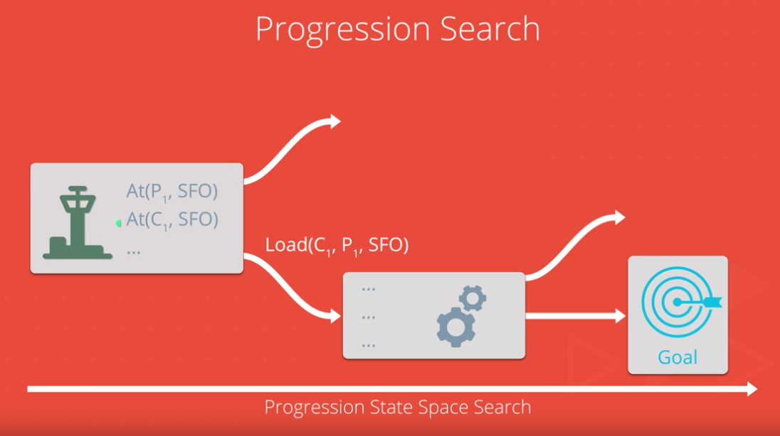

The challenge

A set of problems will be encoded and resolved by the student partial implementation (some code is reuse of companion code from the Stuart Russel/Norvig AIMA  book).

**Air Cargo Action Schema**

Action(Load(c, p, a),

PRECOND: At(c, a) ∧ At(p, a) ∧ Cargo(c) ∧ Plane(p) ∧ Airport(a)

EFFECT: ¬ At(c, a) ∧ In(c, p))

Action(Unload(c, p, a),

PRECOND: In(c, p) ∧ At(p, a) ∧ Cargo(c) ∧ Plane(p) ∧ Airport(a)

EFFECT: At(c, a) ∧ ¬ In(c, p))

Action(Fly(p, from, to),

PRECOND: At(p, from) ∧ Plane(p) ∧ Airport(from) ∧ Airport(to)

EFFECT: ¬ At(p, from) ∧ At(p, to))

**Air Cargo Problem #1:**

Init(At(C1, SFO) ∧ At(C2, JFK)

∧ At(P1, SFO) ∧ At(P2, JFK)

∧ Cargo(C1) ∧ Cargo(C2)

∧ Plane(P1) ∧ Plane(P2)

∧ Airport(JFK) ∧ Airport(SFO))

Goal(At(C1, JFK) ∧ At(C2, SFO))

**Air Cargo Problem #2:**

Init(At(C1, SFO) ∧ At(C2, JFK) ∧ At(C3, ATL)

∧ At(P1, SFO) ∧ At(P2, JFK) ∧ At(P3, ATL)

∧ Cargo(C1) ∧ Cargo(C2) ∧ Cargo(C3)

∧ Plane(P1) ∧ Plane(P2) ∧ Plane(P3)

∧ Airport(JFK) ∧ Airport(SFO) ∧ Airport(ATL))

Goal(At(C1, JFK) ∧ At(C2, SFO) ∧ At(C3, SFO))

**Air Cargo Problem #3:**

Init(At(C1, SFO) ∧ At(C2, JFK) ∧ At(C3, ATL) ∧ At(C4, ORD)

∧ At(P1, SFO) ∧ At(P2, JFK)

∧ Cargo(C1) ∧ Cargo(C2) ∧ Cargo(C3) ∧ Cargo(C4)

∧ Plane(P1) ∧ Plane(P2)

∧ Airport(JFK) ∧ Airport(SFO) ∧ Airport(ATL) ∧ Airport(ORD))

Goal(At(C1, JFK) ∧ At(C3, JFK) ∧ At(C2, SFO) ∧ At(C4, SFO))

The Results

A few hundreds of hours later, the moment of truth is upon us. The solution is coded and it is time to test it.

Three problems have been tested against different algorithms, aborting the execution if no result is found after 25 minutes.

A few executions later...

Air Cargo Problem #1 Results

|  |  |  |  |  |  |
| --- | --- | --- | --- | --- | --- |
|  | **Air Cargo Problem #1** | | | | |
|  | Expansions | Goal  Tests | New  Nodes | Time elapsed (sec) | Plan length |
| 1. Breadth first search | 43 | 56 | 180 | 0.063270470 | 6 |
| 1. Breadth first tree search | 1458 | 1459 | 5960 | 0.761046078 | 6 |
| 1. Depth first graph search | 21 | 22 | 84 | 0.032917761 | 20 |
| 1. Depth limited search | 101 | 271 | 414 | 0.148747783 | 50 |
| 1. Uniform cost search | 55 | 57 | 224 | 0.067270886 | 6 |
| 1. Recursive best first search with h 1 | 4229 | 230 | 17023 | 1.902893294 | 6 |
| 1. Greedy best first graph search with h 1 | 7 | 9 | 28 | 0.014840714 | 6 |
| 1. A* search with h 1 | 55 | 57 | 224 | 0.070309599 | 6 |
| 1. A* search with h ignore preconditions | 41 | 43 | 170 | 0.086801050 | 6 |
| 1. A* search with h pg levelsum | 11 | 13 | 50 | 0.541952483 | 6 |

**Optimal plan:**

Load(C1, P1, SFO)

Load(C2, P2, JFK)

Fly(P2, JFK, SFO)

Unload(C2, P2, SFO)

Fly(P1, SFO, JFK)

Unload(C1, P1, JFK)

Air Cargo Problem #2 Results

|  |  |  |  |  |  |
| --- | --- | --- | --- | --- | --- |
|  | **Air Cargo Problem #2** | | | | |
|  | Expansions | Goal  Tests | New  Nodes | Time elapsed (sec) | Plan length |
| 1. Breadth first search | 3343 | 4609 | 30509 | 3.112878162 | 9 |
| 1. Breadth first tree search | Execution interrupted after 25 min. | | | | |
| 1. Depth first graph search | 624 | 625 | 5602 | 0.627360680 | 619 |
| 1. Depth limited search | 222719 | 2053741 | 2054119 | 639.611617878 | 50 |
| 1. Uniform cost search | 4852 | 4854 | 44030 | 3.693827908 | 9 |
| 1. Recursive best first search with h 1 | Execution interrupted after 25 min. | | | | |
| 1. Greedy best first graph search with h 1 | 990 | 992 | 8910 | 0.923688966 | 15 |
| 1. A* search with h 1 | 4852 | 4854 | 44030 | 3.617807142 | 9 |
| 1. A* search with h ignore preconditions | 1450 | 1452 | 13303 | 2.359241932 | 9 |
| 1. A* search with h pg levelsum | 86 | 88 | 841 | 7.715594813 | 9 |

**Optimal plan:**

Load(C1, P1, SFO)

Load(C2, P2, JFK)

Load(C3, P3, ATL)

Fly(P2, JFK, SFO)

Unload(C2, P2, SFO)

Fly(P1, SFO, JFK)

Unload(C1, P1, JFK)

Fly(P3, ATL, SFO)

Unload(C3, P3, SFO)

Air Cargo Problem #3 Results

|  |  |  |  |  |  |
| --- | --- | --- | --- | --- | --- |
|  | **Air Cargo Problem #2** | | | | |
|  | Expansions | Goal  Tests | New  Nodes | Time elapsed (sec) | Plan length |
| 1. Breadth first search | 14663 | 18098 | 129631 | 14.801872248 | 12 |
| 1. Breadth first tree search | Execution interrupted after 25 min. | | | | |
| 1. Depth first graph search | 408 | 409 | 3364 | 0.427939078 | 392 |
| 1. Depth limited search | Execution interrupted after 25 min. | | | | |
| 1. Uniform cost search | 18235 | 18237 | 159716 | 12.945869346 | 12 |
| 1. Recursive best first search with h 1 | Execution interrupted after 25 min. | | | | |
| 1. Greedy best first graph search with h 1 | 5614 | 5616 | 49429 | 4.814608156 | 22 |
| 1. A* search with h 1 | 18235 | 18237 | 159716 | 13.271433661 | 12 |
| 1. A* search with h ignore preconditions | 5040 | 5042 | 44944 | 7.346515556 | 12 |
| 1. A* search with h pg levelsum | 315 | 317 | 2902 | 34.059256274 | 12 |

**Optimal plan:**

Load(C1, P1, SFO)

Load(C2, P2, JFK)

Fly(P2, JFK, ORD)

Load(C4, P2, ORD)

Fly(P1, SFO, ATL)

Load(C3, P1, ATL)

Fly(P1, ATL, JFK)

Unload(C1, P1, JFK)

Unload(C3, P1, JFK)

Fly(P2, ORD, SFO)

Unload(C2, P2, SFO)

Unload(C4, P2, SFO)

The Conclusion

Testing indicates that the following algorithms reach the optimal solution:

* Breadth first search
* Uniform cost search
* A* search with h 1
* A* search with h ignore preconditions
* A* search with h pg levelsum

Before discussing the algorithms performance, let’s groups the algorithms in **uniform search strategies** (1-7) and **heuristic search strategies** (8-10).

**Uniform search strategies:**

Uniform search methods have access only to the problem definition. That behaviour differs from heuristic search strategies, which uses a heuristic function to estimate the cost of the solution.

* *Depth first graph search* is the fastest and less memory consuming algorithm **but** it does not reach to an optimal path length.
* *Breadth first search* would be the winner if finding the optimal path length is mandatory. BFS is complete and optimal algorithm.

AIMA (section 3.4.7, Figure 3.21) contains a table comparing different uniform search strategies with different criteria (completeness, time, space, optimality). Our results performs as described in that table.

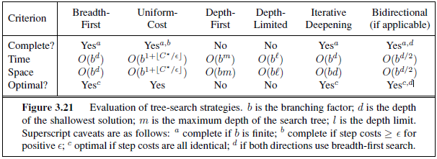

**Heuristic search strategies**

Heuristic search strategies uses specific-domain knowledge to improve its performance by estimating the cost of the solution. AIMA book explains how *the performance of heuristic search algorithms depends on the quality of the heuristic function*.

Based on the results, it can be concluded that:

* *A* search with h ignore preconditions* is the fastest algorithm if memory is not a restriction.
* *A* search with h pg levelsum* is the less memory consuming algorithm if time is not a restriction.

Both solutions are complete.

I sincerely hope you enjoyed this reading as much as I did writing it for you.

Miguel Ángel