Required Capstone Checkpoint 2.1: Retrieval Strategy Design and Baseline Implementation

Directions

You will continue working with the same dataset and scenario you selected for your capstone checkpoint in Module 1. In this activity, you will design and implement a baseline retrieval system that supports the types of queries required for your scenario.

Download this worksheet and save a copy to your device before you begin working. Type your responses directly into the document, save your completed work, and upload the finished file when you are ready to submit.

Use this worksheet to:
- Document your retrieval approach
- Capture representative retrieval queries and results
- Provide evidence that your retrieval system is functioning
- Observe how retrieval performance changes across different query types
- Reflect on where the retrieval approach performs well and where it struggles

1. Selected Scenario and Retrieval Approach
- Identify your chosen capstone scenario.
- Describe the retrieval approach you implemented (keyword-based, semantic, or hybrid).
- Briefly explain why this retrieval approach is appropriate for your dataset and query types.
- Describe any trade-offs you considered when selecting this approach
Scenario
☐ Research Paper Navigator
☒ Wikipedia Retrieval Engine

Retrieval approach used, brief explanation, and description of trade-offs considered
Response:
I chose a hybrid retrieval strategy that combines BM25 keyword search with semantic vector search over the corpus of approximately 2,400 Wikipedia articles because hybrid retrieval leverages the complementary strengths of both methods: BM25 excels at lexical precision for entity-centric questions, while embeddings capture semantic relationships and paraphrased queries that keyword matching alone would miss. This dual approach provides robustness across diverse query types and reduces the risk of missing relevant documents due to vocabulary mismatch. My approach pulls a candidate pool of 10 results from each retriever method independently, normalizes their scores to a common [0, 1] scale, and fuses them using equal weights (0.5 each) before returning the top 3 documents to the LLM. The BM25 component provides lexical precision for exact term matches (useful when queries contain specific entity names or keywords), while the vector search via OpenAI embeddings captures semantic similarity, enabling retrieval even when query wording differs substantially from source documents.
Key tradeoffs: The equal weighting assumes both methods contribute equally, but this may not hold across all query types—entity-focused queries might benefit from higher BM25 weight, while paraphrased or conceptual questions might favor embeddings. My candidate pool size of 10 balances computational cost against recall; smaller pools risk missing relevant documents, while larger pools increase latency and context window usage. Additionally, I return only 3 final documents to prioritize conciseness and API cost control, but this may lose nuance when questions span multiple articles. Finally, my approach relies entirely on persisted Chroma embeddings (OpenAI's text-embedding-3-small model), so embedding quality, staleness, and API costs are critical dependencies.

2. Baseline Retrieval System Evidence
- Provide evidence that your retrieval system was implemented and tested.
- Evidence may include screenshots, logs, outputs, notebook examples, code snippets, or brief descriptions showing that retrieval queries were executed successfully.
Evidence of retrieval system implementation and testing
Response:
VS Code Terminal Outputs.
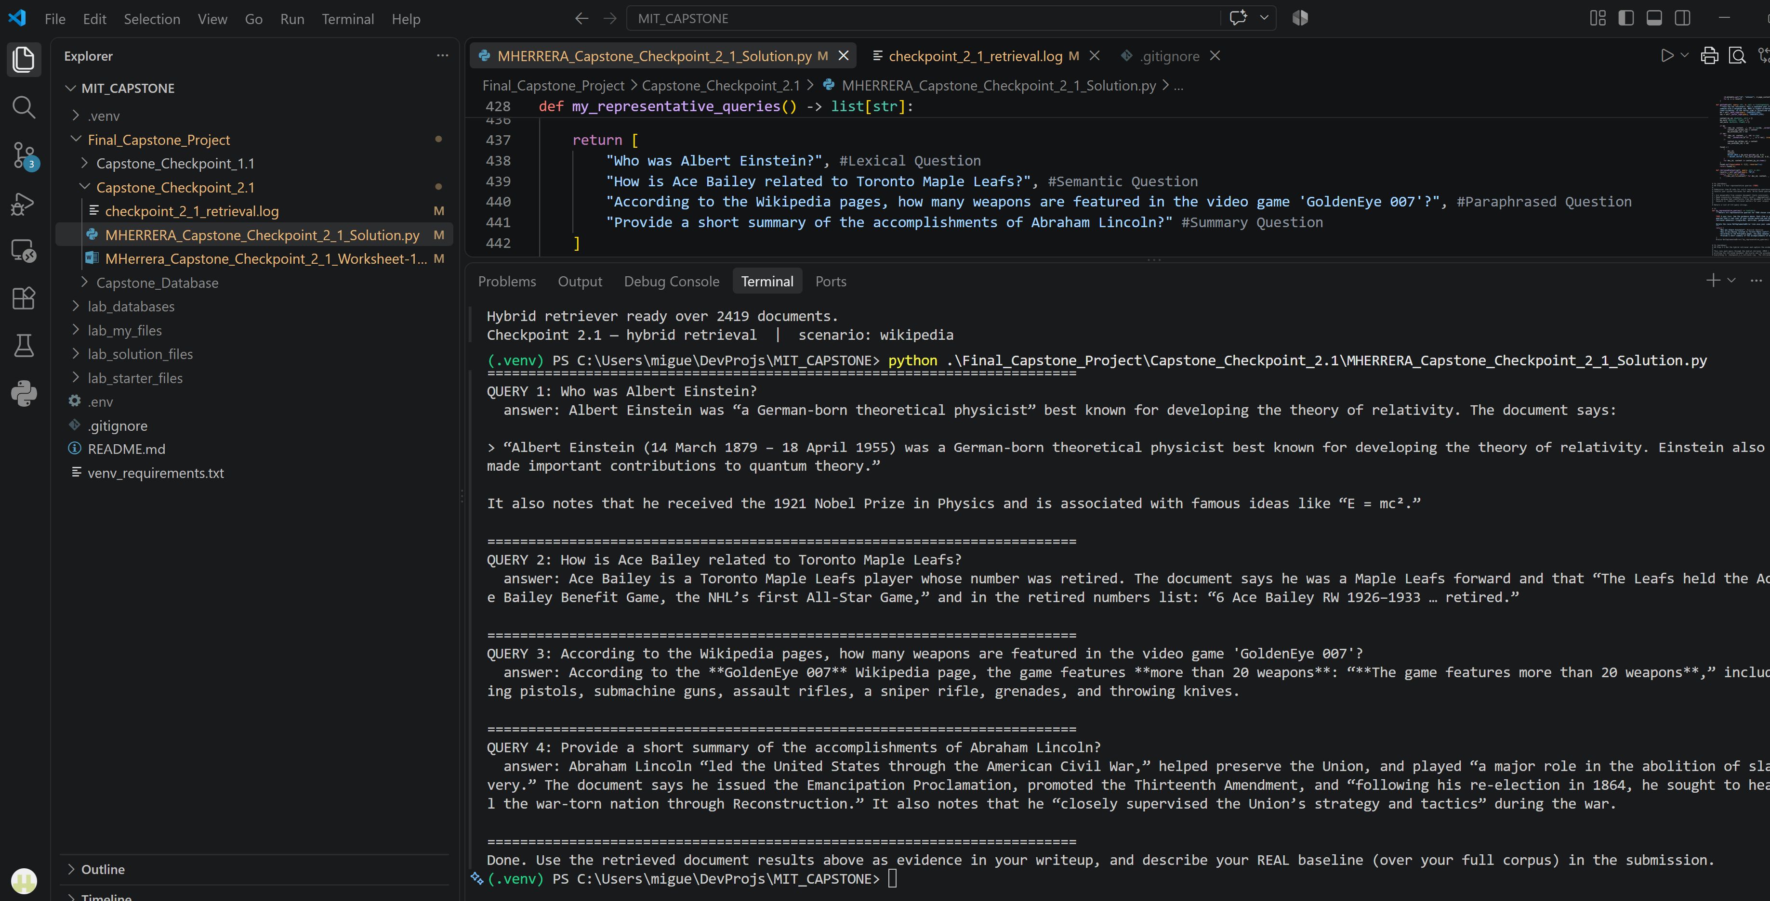

3. Representative Queries and Retrieved Results
- Provide three to five representative queries relevant to your scenario.
- Include the retrieved results for each query.
- Focus on showing how the retrieval system behaves across different types of information needs. Where possible, include a mix of precise, conceptual, or broader exploratory queries.
Query 1 – Lexical Question
Query: Who was Albert Einstein?"
Retrieved results:
Albert Einstein was “a German-born theoretical physicist” best known for developing the theory of relativity. The document says:
“Albert Einstein (14 March 1879 – 18 April 1955) was a German-born theoretical physicist best known for developing the theory of relativity. Einstein also made important contributions to quantum theory.”
It also notes that he received the 1921 Nobel Prize in Physics and is associated with famous ideas like “E = mc².”
Observations:
What worked well? What limitations, challenges, or unexpected retrieval behaviors did you observe?
Query 1 worked well: The solution returned quotes directly from the Wikipedia page. This was a Lexical question, so I was expecting the BM25 ranking to have influenced the output more than the Semantic search. However, my code has a 50/50 weight between the two search strategies. Therefore, I believe both influence the output equally.

Query 2 – Semantic Question
Query: How is Ace Bailey related to Toronto Maple Leafs?
Retrieved results:
Ace Bailey is a Toronto Maple Leafs player whose number was retired. The document says he was a Maple Leafs forward and that “The Leafs held the Ace Bailey Benefit Game, the NHL’s first All-Star Game,” and in the retired numbers list: “6 Ace Bailey RW 1926–1933 … retired.”
Observations:
What worked well? What limitations, challenges, or unexpected retrieval behaviors did you observe?
Query 2 also worked well: The solution returned quotes directly from the Wikipedia page. This was a semantic question, so I was expecting the Chroma DB embedding indexing to have influenced the output more than the BM25 search. However, my code has a 50/50 weight between the two search strategies. Therefore, I believe both influence the output equally.

Query 3 – Paraphrased Question
Query: According to the Wikipedia pages, how many weapons are featured in the video game 'GoldenEye 007'
Retrieved results:
According to the **GoldenEye 007** Wikipedia page, the game features **more than 20 weapons**: “**The game features more than 20 weapons**,” including pistols, submachine guns, assault rifles, a sniper rifle, grenades, and throwing knives.
Observations:
What worked well? What limitations, challenges, or unexpected retrieval behaviors did you observe?
Query 3 also worked well: Same results as with Query 1 and Query 2. The solution returned the correct quotes and directly from the Wikipedia page This was a paraphrased question, so I was expecting the Chroma DB embedding indexing to have influenced the output more than the BM25 search.

Query 4 – Summary Question
Query: Provide a short summary of the accomplishments of Abraham Lincoln?
Retrieved results:
Abraham Lincoln “led the United States through the American Civil War,” helped preserve the Union, and played “a major role in the abolition of slavery.” The document says he issued the Emancipation Proclamation, promoted the Thirteenth Amendment, and “following his re-election in 1864, he sought to heal the war-torn nation through Reconstruction.” It also notes that he “closely supervised the Union’s strategy and tactics” during the war.
Observations:
What worked well? What limitations, challenges, or unexpected retrieval behaviors did you observe?
Query 4 also worked well: Same results as with the other queries. The solution returned quotes with the summary matching the information stored in the Wikipedia page.

4. Retrieval Performance Reflection
- Reflect on where your retrieval approach performs well and where it struggles.
- Consider how different query types affect retrieval quality, relevance, flexibility, or precision.
Retrieval strengths
Which types of queries did your retrieval strategy handle most effectively? What aspects of the approach contributed to these results?

Retrieval limitations or challenges
Which queries were more difficult for the retrieval system? What limitations or trade-offs became apparent?

Patterns observed across different query types
What patterns did you observe when comparing retrieval performance across different query types? How did these observations influence your understanding of the strengths and limitations of your chosen retrieval strategy?

5. Retrieval Strategy Reflection
If you were continuing to improve this system, would you keep the same retrieval approach or make changes? Explain your reasoning.
Reflection
Response:

Supporting Materials
Additional Evidence (Optional):
If needed, include any additional screenshots, output excerpts, or code snippets that support your responses above. No additional files or repository link are required for this checkpoint.

End of Required Capstone Checkpoint 2.1
Return to the assignment page in the learning platform to upload and submit your completed capstone checkpoint and complete any remaining items in this module.

