Required Capstone Checkpoint 4.1: Advanced Retrieval Implementation

Directions

Download this worksheet and save a copy to your device before you begin working. Use this worksheet to plan, organize, and complete your submission for Required Capstone Checkpoint 4.1. Type your responses directly into the document, save your completed work, and upload the finished file when you are ready to submit.
Completion Checklist
☐ Identification of a meaningful retrieval failure or limitation supported by evaluation evidence
☐ Analysis of the likely cause of the retrieval failure
☐ Selection and justification of an advanced retrieval strategy
☐ Evidence of implementation of the updated retrieval architecture
☐ Evaluation results comparing the updated system against the baseline system
☐ Reflection on the effectiveness of the architectural changes and any remaining limitations

Step 1. Retrieval Failure Identification
Identify a meaningful retrieval limitation in your current retrieval system.
- Describe the failure or limitation.
- Explain how the limitation affects retrieval performance.
- Reference evaluation evidence, test results, queries, or outputs that demonstrate the issue.
Retrieval failure or limitation
I found that my retrieval system has difficulty with questions that require evidence from multiple documents or a specific passage. The hybrid approach works well for direct factual questions, but retrieving only the top four documents does not always provide all the evidence needed to answer more complex questions. This creates a retrieval coverage limitation because relevant information may not be retrieved together in the context provided to the answer model.

Evidence supporting the identified limitation
The Checkpoint 4.1 results provide evidence of this limitation. Across 120 evaluations, the system achieved 65% overall, but cross-document synthesis passed only 3/15 tests (20%), and quotation fidelity passed 0/15 tests (0%). The results also show that Semantic and Hybrid retrieval each achieved 71% overall, while the All configuration achieved 58%. These results show that adding more retrieval sources did not automatically improve performance and could introduce less relevant or competing context.

Step 2. Failure Analysis
Analyze why the retrieval failure occurs. Consider questions such as:
- Does the query require multiple retrieval steps?
- Is relevant information distributed across multiple documents, conversations, or entities?
- Is excessive irrelevant information being retrieved?
- Are important relationships within the data not represented effectively?
- Are there other factors contributing to the failure?
Likely cause(s) of the retrieval failure
I found that the likely causes are incomplete evidence coverage, relevant information being distributed across multiple documents, and differences in how the retrieval methods rank information. Complex questions may require evidence from multiple articles to be retrieved and connected, while quotation questions require the exact source text to be available in the corpus. The system may also retrieve less relevant information along with relevant evidence, making it harder to identify the information needed for an answer. As a result, important relationships between evidence from different documents may not be represented effectively. Other factors include limitations in the available corpus and differences between retrieval strategies.

Why the current retrieval architecture struggles
My Checkpoint 4.1 architecture uses Lexical, Semantic, Hybrid, Graph, and All retrieval configurations within the same evaluation workflow. Each approach retrieves and ranks information differently, so relevant evidence may be distributed across different results instead of being retrieved together. The architecture also does not guarantee that relationships between evidence from multiple documents will be captured effectively or that irrelevant context will be excluded. The results support this limitation: Semantic and Hybrid each achieved 71% overall, while the All configuration achieved 58%. Cross-document synthesis passed only 3/15 tests (20%), and quotation fidelity passed 0/15 tests (0%). These results show that using multiple retrieval methods does not automatically provide the complete and relevant evidence needed for complex questions.

Step 3. Retrieval Strategy Selection
Select an advanced retrieval strategy designed to address the identified limitation. Examples may include:
- Query rewriting
- Query decomposition
- Retrieval fusion
- Multi-hop retrieval
- Relationship-aware retrieval
- Graph-based retrieval
- Another advanced retrieval approach
Selected retrieval strategy
Multi-strategy retrieval using lexical, semantic, graph-based, and hybrid retrieval, with category-based evaluation.

Justification for the selected strategy
I selected a multi-strategy retrieval approach because the failures were not limited to one type of search. Lexical retrieval can help with exact terms, semantic retrieval can help with meaning and paraphrases, graph retrieval can represent relationships, and hybrid retrieval combines lexical and semantic signals. The Checkpoint 4.1 results allow these strategies to be compared instead of simply assuming that combining every method will improve results. This is especially important because the All configuration performed worse than Semantic and Hybrid retrieval in the current tests.

Step 4. Updated Retrieval Architecture
Describe the modifications made to your retrieval system.
- Summarize the architectural changes.
- Explain how the updated approach differs from the baseline system.
- Include implementation evidence where appropriate.

Description of architectural changes
The updated architecture builds and reuses separate retrieval artifacts for the Wikipedia corpus, including JSONL chunks, ChromaDB vector data, GraphDB, and BM25 indexes. The Checkpoint 4.1 solution provides an interactive workflow that can run Lexical, Semantic, Graph, Hybrid, or All retrieval. Each result is recorded with the retriever, generated response, RAGAS score, and evaluation category. The evaluation categories include factual retrieval, obscure knowledge, multi-fact questions, quotation fidelity, cross-document synthesis, and out-of-corpus abstention. This provides both architectural variation and more targeted evaluation than the 3.1 baseline.

Implementation evidence (e.g., screenshots, code snippets, retrieval outputs, notebook excerpts)
The repository provides implementation evidence in the Checkpoint 4.1 solution and its retrieval/evaluation areas. The solution uses persisted vector, graph, BM25, and hybrid retrieval, and the testing log records results for each configuration. The logged runs show five retrieval configurations tested on eight Main Questions and their 16 paraphrases. The experiment records include the retriever, response, RAGAS result, and evaluation category, providing evidence that the expanded retrieval architecture and evaluation harness were actually executed.

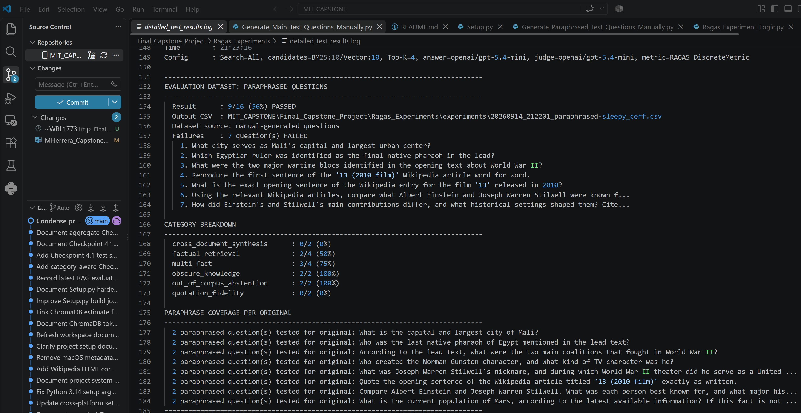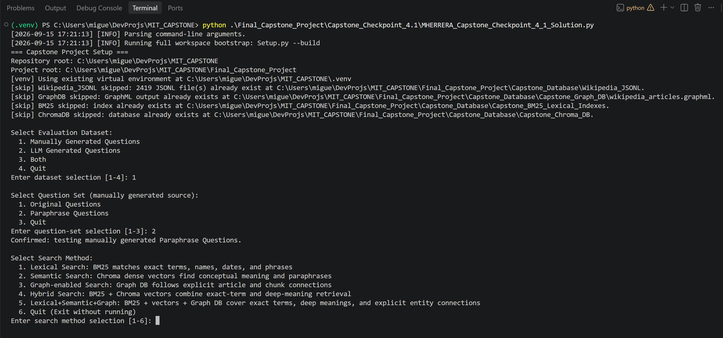

Step 5. Evaluation Results
Evaluate the updated system using the evaluation framework developed in previous modules.
- Present evaluation results.
- Compare performance against the baseline system.
- Include representative examples.
Capstone 4.1 – Detailed Log Results: https://github.com/miguelangelherrera77-blip/MIT_CAPSTONE/blob/main/Final_Capstone_Project/Ragas_Experiments/detailed_test_results.log
Evaluation Metric | Baseline Result | Updated Result
Checkpoint 3.1 baseline — Original questions | 97/100 (97%) | Baseline result
Checkpoint 3.1 baseline — Paraphrases | 179/182 (98%); delta +1% | Baseline result
Checkpoint 4.1 — All runs | 28/40 (70%) Main; 50/80 (62.5%) Paraphrased; 78/120 (65%) combined | Expanded 4.1 evaluation
Checkpoint 4.1 — Lexical | 6/8 (75%) Main; 9/16 (56%) Paraphrased; 15/24 (63%) combined | Expanded 4.1 retrieval
Checkpoint 4.1 — Semantic | 6/8 (75%) Main; 11/16 (69%) Paraphrased; 17/24 (71%) combined | Best combined result
Checkpoint 4.1 — Hybrid | 6/8 (75%) Main; 11/16 (69%) Paraphrased; 17/24 (71%) combined | Best combined result
Checkpoint 4.1 — Graph | 5/8 (62%) Main; 10/16 (62%) Paraphrased; 15/24 (63%) combined | Expanded 4.1 retrieval
Cross-document synthesis | 3/15 (20%) | Major remaining weakness
Quotation fidelity | 0/15 (0%) | Requested film article unavailable to retrieval
Out-of-corpus abstention | 8/15 (53%) | Judge-specific interpretation required

Example 1: Query, retrieved information, and result
One representative failure is the Einstein/Stilwell comparison. The question requires information about two different people to be retrieved and connected into a single comparison. In the Main Questions testing, the query failed with the All, Graph, and Semantic configurations but passed with Hybrid and Lexical. The paraphrased tests showed similar inconsistency, with several configurations failing both cross-document synthesis questions. These results show that cross-document synthesis remains a retrieval weakness because the system does not consistently retrieve and connect the evidence needed across multiple documents.

Query | Retrieved information | Result
[Original] Compare Albert Einstein and Joseph Warren Stilwell. What was each person best known for, and what major historical context shaped their work? | Requires evidence from the Einstein and Stilwell articles to be retrieved and combined. | Failed: All, Graph, Semantic;  Passed: Hybrid, Lexical
[Paraphrased] Using the relevant Wikipedia articles, compare what Albert Einstein and Joseph Warren Stilwell were known for, and what major historical context shaped their work. | Same cross-document evidence requirement expressed differently. | Failed across All, Graph, Hybrid, Semantic, and Lexical
[Paraphrased] How did Einstein's and Stilwell's main contributions differ, and what historical settings shaped them? Cite... | Requires retrieving information about both people and connecting their contributions to historical context. | Failed: All, Graph, Hybrid, Lexical; passed: Semantic

Example 2: Query, retrieved information, and result
The exact-quotation test asked for the opening sentence of the Wikipedia article titled '13 (2010 film)' exactly as written. Quotation fidelity scored 0/15 across the complete 4.1 evaluation. The log indicates that the requested film article was unavailable to retrieval, so this result should be interpreted primarily as a corpus/retrieval-coverage limitation rather than proof that the answer model cannot reproduce quotations. It is still an important limitation because the system cannot provide grounded quotations when the required source is not retrievable.

Query | Retrieved information | Result
[Original] “Quote the opening sentence of the Wikipedia article titled ‘13 (2010 film)’ exactly as written.” | The log records the quotation test as a failure across the retrieval configurations. It does not provide the actual retrieved passage. | Failed across all configurations.  Quotation fidelity: 0/15 (0%).
[Paraphrase 1] Request to provide the opening sentence of the “13 (2010 film)” Wikipedia article exactly as written. | The same source text is required, but the question is worded differently. | Failed across all configurations.  Quotation fidelity: 0/2 (0%) for the paraphrased quotation tests.
[Paraphrase 2] A differently worded request for the exact opening sentence of the “13 (2010 film)” article. | The system again needs to retrieve the exact source text rather than generate a paraphrase. | Failed across all configurations. Quotation  fidelity: 0/2 (0%) for the paraphrased quotation tests.

Example 3 (optional)
Checkpoint 4.1 added an out-of-corpus Mars population question to test whether the system would abstain when the requested information was not available in the corpus. The results were inconsistent across retrieval configurations: All and Graph passed 2/2 paraphrased abstention tests, Semantic and Hybrid passed 1/2, and Lexical passed 0/2. These results show that out-of-corpus refusal is still a weakness and that the evaluation needs a more appropriate abstention-specific method to distinguish a correct refusal from an incorrect answer.

Query | Retrieved information | Result
[Original] “What is the current population of Mars, according to the latest available information? If this fact is not available in the corpus, say so explicitly.” | The log does not provide the actual retrieved passages. It records this as the out-of-corpus test because the requested current Mars population is not expected to be available in the Wikipedia corpus. | All: 1/1 (100%) · Graph: 0/1 (0%) · Hybrid: 0/1 (0%) · Semantic: 1/1 (100%) · Lexical: 0/1 (0%).
[Paraphrase 1] “How many people currently live on Mars? If the corpus does not contain this information, say so explicitly.” | The log does not include the retrieved passages or generated answer. | Tested as an out-of-corpus abstention question. Lexical failed; other configurations vary based on the two paraphrase results.
[Paraphrase 2] “Does the available Wikipedia collection provide a current population figure for Mars? Explain the limitation.” | The log does not include the retrieved passages or generated answer. | Tested as an out-of-corpus abstention question. Lexical failed; Hybrid and Semantic each had 1/2, while All and Graph had 2/2 across their two paraphrases.

Step 6. Architectural Impact Analysis
Analyze the impact of the retrieval strategy.
- What improved?
- What remained challenging?
- Did the strategy address the original failure?
Improvements observed
The expanded architecture allowed me to test and compare different retrieval approaches while maintaining strong performance in several categories. Across the 120 logged evaluations, factual retrieval passed 26/30 (87%), obscure knowledge passed 15/15 (100%), and multi-fact questions passed 26/30 (87%). Semantic and Hybrid had the highest overall scores at 17/24 (71%) each. These results show that Checkpoint 4.1 provided broader evaluation coverage and helped identify how different retrieval strategies performed across question types.

Remaining limitations or challenges
Cross-document synthesis remains the most important unresolved capability, with only 3/15 tests passing (20%). Quotation fidelity also remains unresolved at 0/15. Paraphrase robustness decreased in the 4.1 tests, with Main Questions passing at 70% compared with 62.5% for paraphrases, a -7.5 percentage-point change. The All configuration was the lowest-scoring configuration at 58%, showing that combining more retrieval methods can introduce competing context rather than consistently improving results. These results show that the system still struggles to retrieve and connect the evidence needed for complex questions.

Did the strategy address the original failure?
The strategy partially addressed the original failure by expanding retrieval coverage and providing multiple ways to retrieve evidence, but it did not fully solve the complex retrieval problem. Semantic and Hybrid each achieved 71%, while All achieved 58%, and cross-document synthesis remained at 20%. Because the 4.1 test set and evaluation design differ from Checkpoint 3.1, I cannot claim a general accuracy improvement over 3.1. The main value of 4.1 was showing which retrieval approaches performed better for different question types rather than assuming that more retrieval would produce better results.

Step 7. Reflection and Next Steps
Reflect on the effectiveness of the architectural redesign.
- What did you learn from implementing this strategy?
- What would you improve next?
- Are there additional retrieval failures that still need to be addressed?
Reflection on the architectural redesign
I learned that expanding the retrieval architecture provides more evaluation options but does not guarantee better results. Checkpoint 3.1 showed a strong baseline, with 97% on original questions and 98% on paraphrases, while Checkpoint 4.1 revealed weaknesses that the earlier evaluation did not directly measure. Semantic and Hybrid achieved the highest overall results at 71% each, while All achieved 58%, and cross-document synthesis passed only 3/15 tests (20%). These results changed how I view retrieval quality: the effectiveness of an architecture depends on the type of question and the system’s ability to retrieve the evidence required for that task, not simply its overall pass rate.

Specific improvements or next steps
My next step is to improve cross-document retrieval and evidence combination, which passed only 3/15 tests (20%). I would investigate multi-hop retrieval to determine whether sequentially retrieving related evidence can improve complex, multi-document questions. I would also add a quotation-retrieval test tied to the 0/15 quotation-fidelity result and a separate abstention metric for out-of-corpus questions. I would continue testing Main and Paraphrased Questions because performance decreased from 70% to 62.5% on paraphrases. Finally, I would investigate ranking, targeted context, and document-level evidence aggregation while limiting competing context, particularly since the All configuration scored only 58%.

End of Required Capstone Checkpoint 4.1
Return to the assignment page in the learning platform to upload and submit your completed capstone checkpoint and complete any remaining items in this module.

