**Solid Inclusion Calculator: Instruction Manual**

Table of Contents

Installing the MATLAB program 2

Running the program as a standalone application. 2

Running the program with MATLAB. 2

Performing your first calculation 6

Generating an isomeke graph 8

Modifying thermodynamic and physical properties 11

References 14

**Figures**

Figure 1: Example file organization needed to run the application. 3

Figure 2: Interactive application window that performs the calculations. 4

Figure 3: Accessing scripts to modify code within MATLAB. 5

Figure 4: Entering compositions of solid solutions, feldspar-in-garnet example. 6

Figure 5: Calculation results output window. 7

Figure 6: Setting the isomekes intervals.. 8

Figure 7: View of application with all isomekes variables set and ready to run. 9

Figure 8: Completed isomeke graph for the feldspar-in-garnet example. 9

Figure 9: Load data into the window using the “Output Data” tab. 10

**Tables**

Table 1: Name of thermodynamic and physical properties in MATLAB program. 11

Table 2: Equations of State. 11

Table 3: Thermal models. 12

Table 4: Thermal model parameters (required if used). 12

Table 5: Bulk modulus variation with temperature. 12

Table 6: Phase transition models. 13

Table 7: Landau theory phase transition parameters (required if used). * 13

Table 8: Bragg-Williams phase transition parameters (required if used). * 13

# Installing the MATLAB program

Download the files from one of the following websites:

* + Baylorvvgp.com/downloads
  + G3 Supplemental files

The program can be run as a standalone application or in MATLAB. Using the standalone app does not require installation of MATLAB, but does require downloading and installing **MATLAB runtime**.

The installation of **MATLAB runtime** will automatically start if it is not installed on your computer.

## Running the program as a standalone application.

*Pros:* Easiest to use. Does not require MATLAB.

*Cons:* Thermodynamic and physical properties of minerals cannot be modified, EoS’ cannot be changed, and the underlying code cannot be modified. The program is less stable on Macintosh operating systems. Calculations are slower.

1. Open the folder “Standalone Application”.
2. Double-click “solid_inclusion_calculator_installer”.
3. Choose an installation folder. Installation may take a few minutes or longer if **MATLAB runtime** is needed.
4. Access the folder where the application was installed (or your desktop if a shortcut was installed). Enter the folder “Application”.
5. Double click “solid_inclusion_calculator”. The program will now open.
6. Follow the instructions under “Performing you first calculation” in this instruction manual.

## Running the program with MATLAB.

*Pros:* All thermodynamic and physical properties of minerals can be modified, EoS’ can be changed, and the underlying code can be modified. Stable on any operating system. Calculations are faster. Code can easily be modified to perform elastic modeling calculations for many analyses.

*Cons:* More difficult to use.

1. Move all of the files within the folder “MATLAB Application” into a folder that can be accessed by MATLAB. We recommend putting it in a subfolder within the MATLAB root folder (see Figure 1 below).

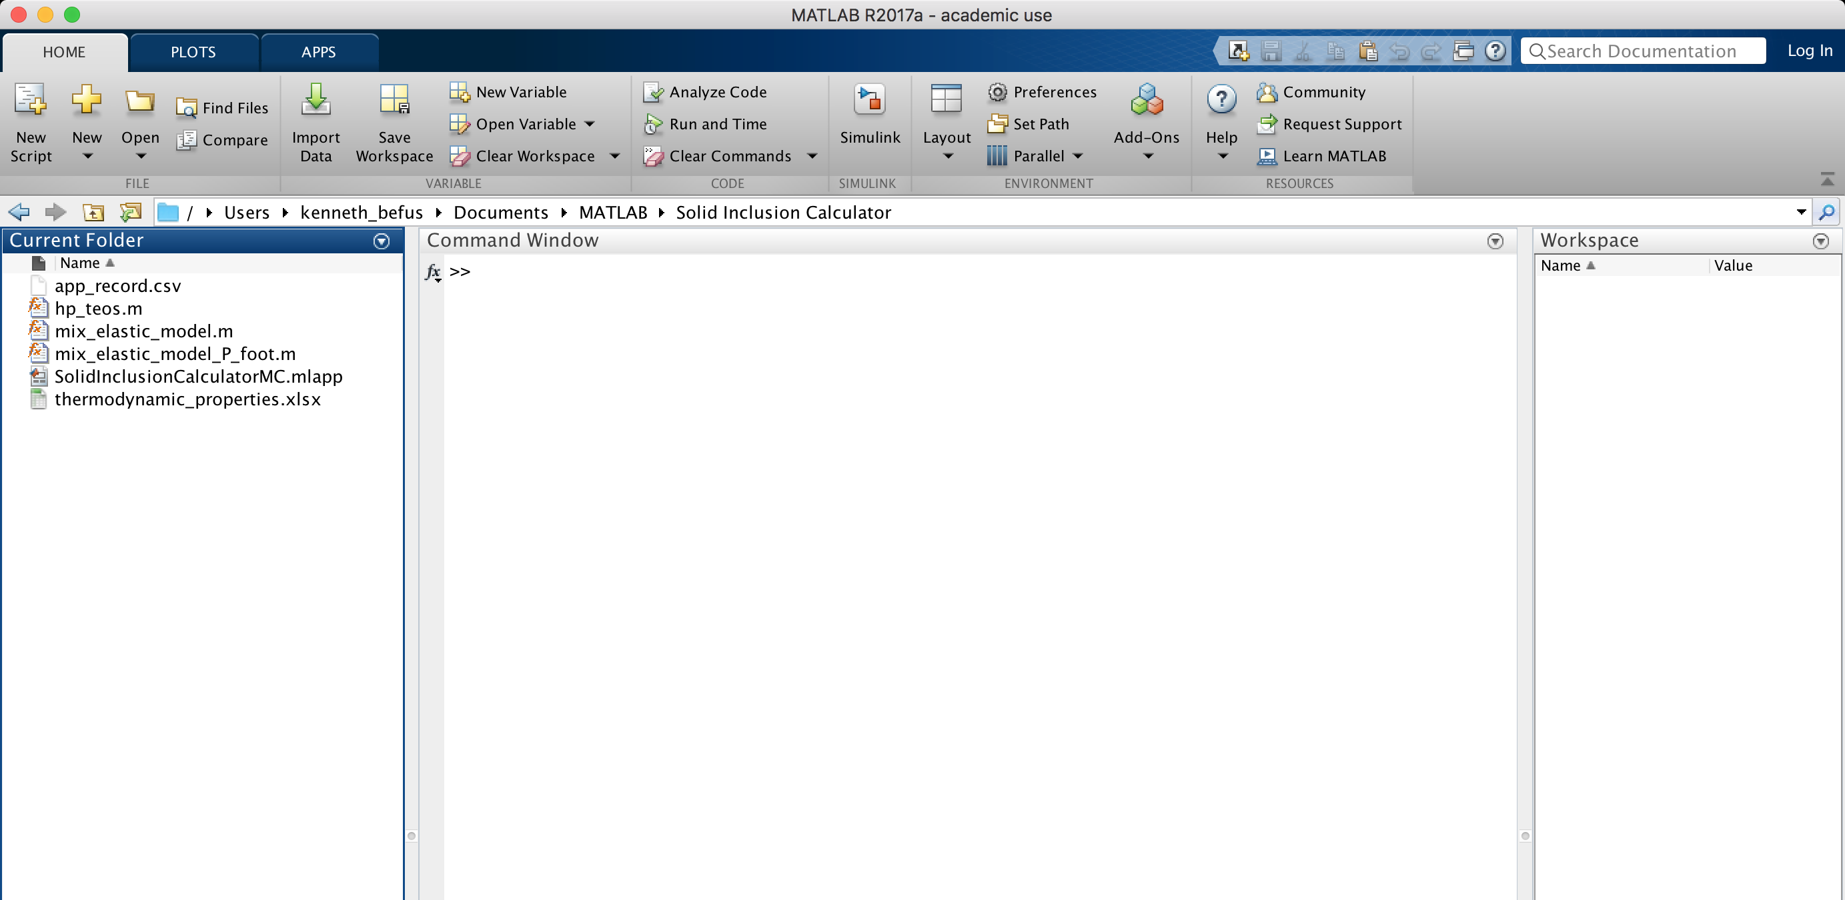

Figure 1: Example file organization needed to run the application.

1. To run the program type “solid_inclusion_calculator. into the command window.
   * You can also open the application by double clicking on solid_inclusion_calculator.mlapp in the Current Folder.
   * The application will now open in a new window (Figure 2)

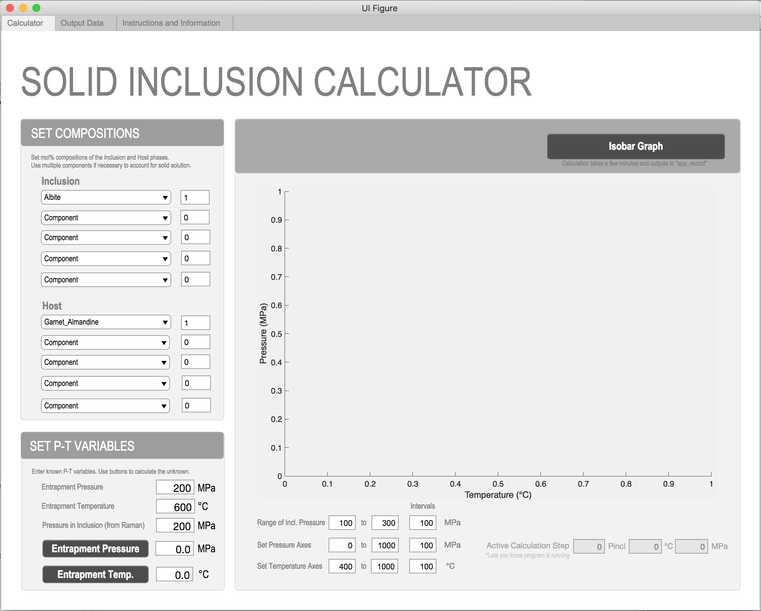

Figure 2: Interactive application window that performs the calculations.

1. The Solid Inclusion Calculator application accesses the following 3 scripts to perform calculations:

* elastic_model.m
* elastic_model_P_foot.m
* eos.m

These files do not need to be opened for the application to run. You may open the scripts to look at the code. These files can be modified by the user to modify the code (Figure 3).

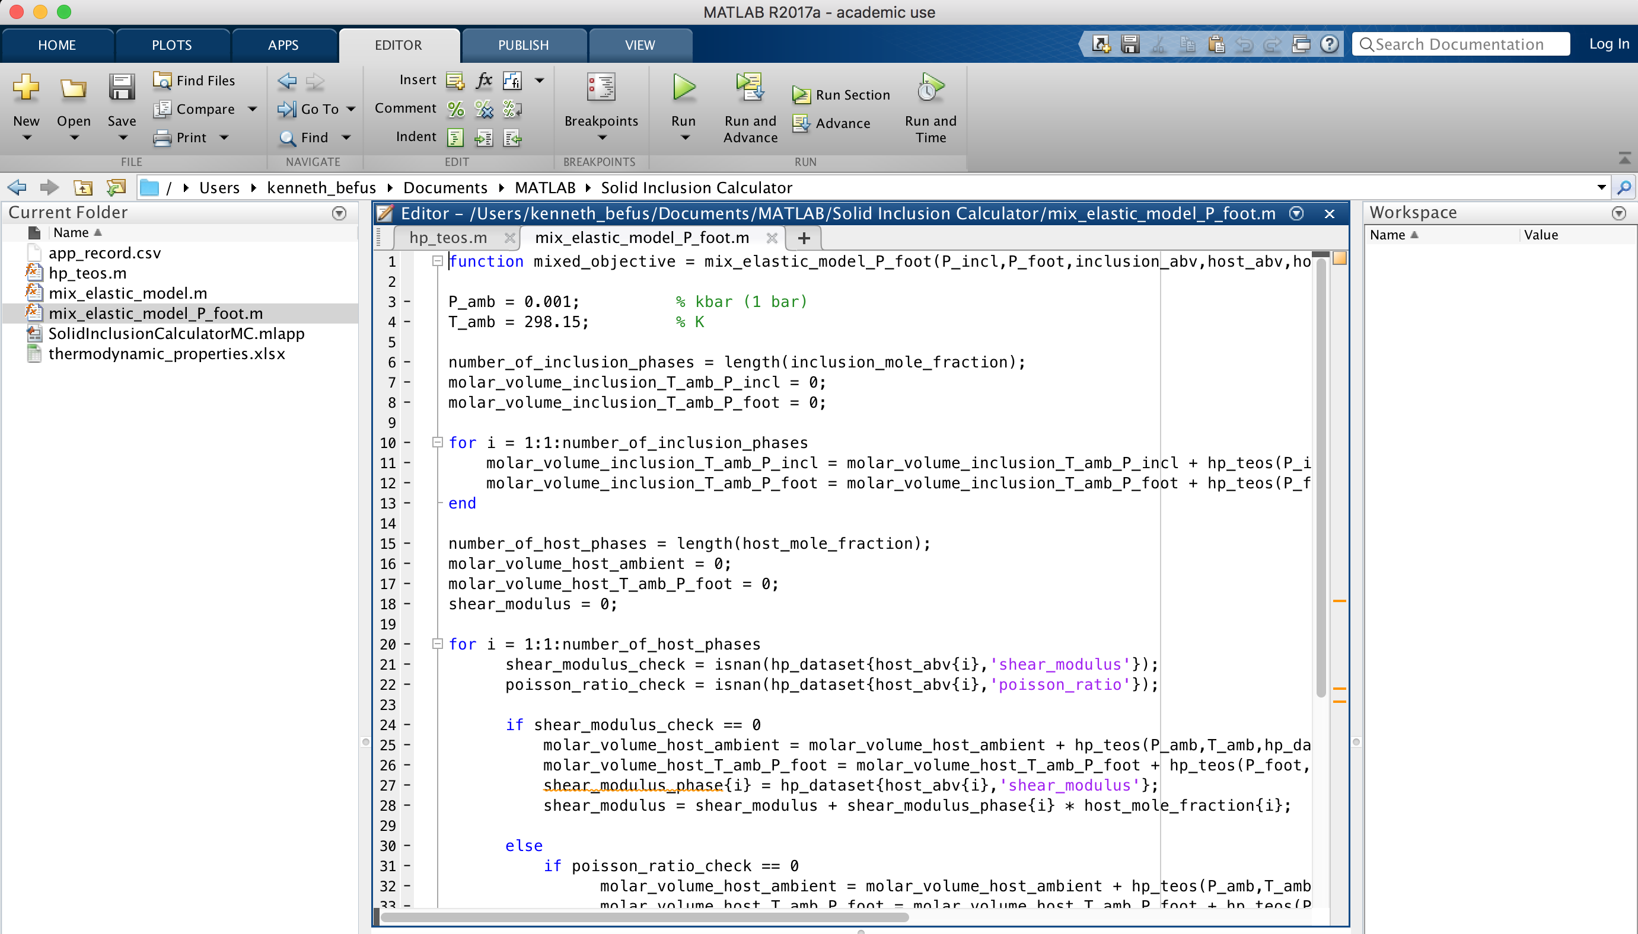

Figure 3: Accessing scripts to modify code within MATLAB.

# Performing your first calculation

Here, we walk you through a demonstration of the Solid Inclusion Calculator application. The application has many different input fields that can be used to make calculations. Brief instructions can also be found in the “Instructions and Information” tab in the program.

1. Determine or estimate the composition of the inclusion and host. Use the drop-down lists to select the mineral component(s). Enter the mole fraction in the box to the right.
   1. Solid solutions with up to 5 components can be accommodated.
   2. Be sure that the components sum to 1.

*Example: Feldspar-in-Garnet*  
The feldspar will be an Andesine (Ab60An40) hosted within an Almandine garnet with lesser Mn and Mg components (Alm80Spess10Py10). Set the solid solution compositions in the drop-down windows (Figure 4).   
  
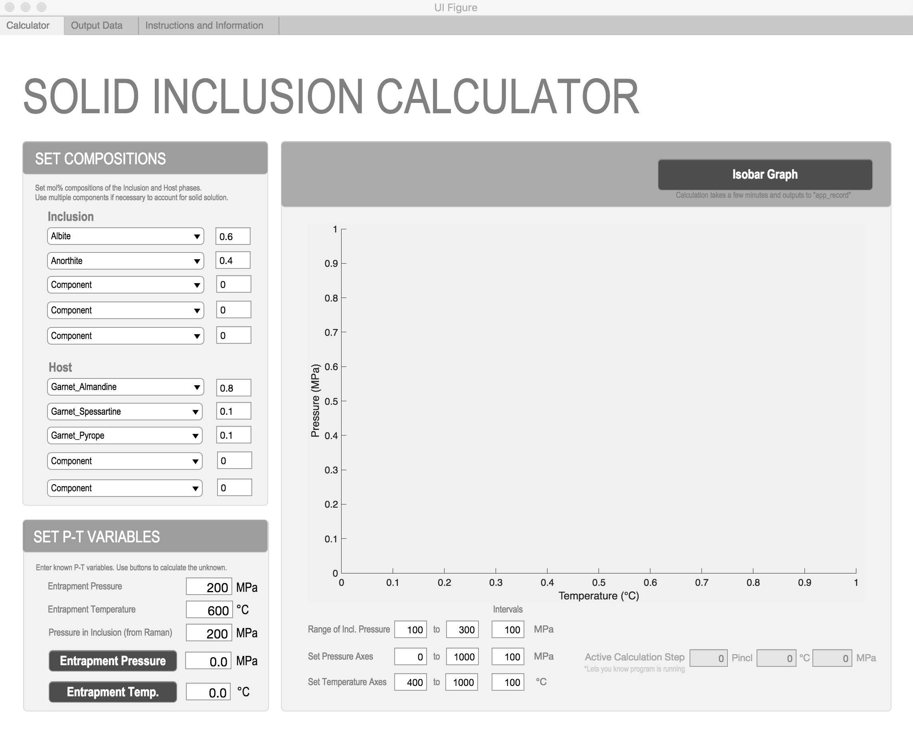

Figure 4: Entering compositions of solid solutions, feldspar-in-garnet example.

1. The “Set P-T Variables” is the area of the application used to calculate the unknown P or T of entrapment.
2. Enter the known variables, which will be inclusion pressure and an estimated P or T of entrapment.
3. Click the button to solve for the unknown variable (e.g., if entrapment pressure is unknown then click “Entrapment Pressure.”)
   1. Don’t worry about the third variable. Whatever number is left in that cell will be ignored by the calculation.
   2. The calculation will take a few seconds to find a solution. The time will vary depending on computer power, the minerals, and the number of minerals (componenents) used.
4. We recommend using single calculations with this part of the application for initial reconnaissance of an inclusion-host pair. The calculations are performed relatively quickly and are helpful for identifying relevant P-T conditions. This is important to establish prior to producing the isomeke graph, which takes longer to calculate.

*Example: Feldspar-in-Garnet (continued)*  
We have found that a feldspar preserves a residual inclusion pressure of 400 MPa. We use an independent temperature estimate of 515 **°**C. Click “Entrapment Pressure” and the script ran for ~15 seconds before the value was found. The inclusion was entrapped at 807 MPa.

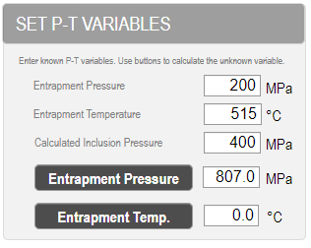

Figure 5: Calculation results output window. The feldspar-in-garnet in our example is calculated to have been entrapped at 807 MPa.

# Generating an isomeke graph

Isomeke graphs are powerful for evaluating the usefulness of an inclusion-host pair to serve as a barometer or thermometer, and to evaluate the sensitivity of an inclusion-host pair (isomeke spacing).

1. Set the compositions of the inclusion and host.
2. Use the “Set P-T Variables” window to make some preliminary calculations for relevant conditions. This will help set the most efficient intervals and ranges for pressure axes, temperature axes, and inclusion pressures.
3. The intervals define how many calculations the script will run to make the isomekes. More intervals provide more constraints, but will also take much longer to calculate.
   1. We recommend 100 MPa intervals for Inclusion Pressure
   2. We recommend limiting the P-T space to only geologically relevant conditions.
4. Click the “Isomeke Graph” button in the upper right to run the model.
   1. The graph will populate when all the calculations have finished.
   2. The model may take a few minutes
   3. In the lower right we provide some gray boxes that show the active calculation step. This is how you know the model is running.
   4. The values of inclusion pressure for the isomekes are not labeled on the graph. To quickly identify the isomekes run single calculations using the “Set P-T Variables.”

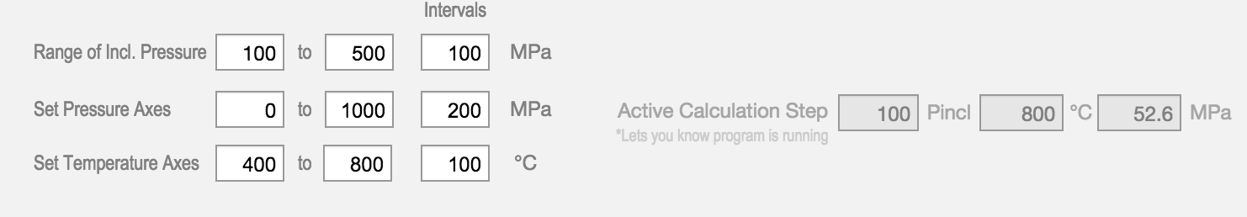

Figure 6: Setting the isomekes intervals. Minimize the ranges as much as possible to reduce calculation time. When the script is running, the most recent calculation will be shown in the gray “Active Calculation Step” fields and a status bar also notifies you of the calculation progress.

*Example: Feldspar-in-Garnet (continued)*  
We are interested in amphibolite to granulite facies metamorphism so we set the “Pressure Axes” to 0 to 1000 MPa with 200 MPa intervals. We set the “Temperature Axes” to 400 to 800 **°**C with 100 **°**C intervals. We want the full range of isomekes over that area so we ran the following single calculations to help us define the interval area for inclusion pressure:

800**°**C, Pincl of 0 MPa = Entrapment pressure of -91 MPa (outside of P-T domain)  
800**°**C, Pincl of 400 MPa = Entrapment pressure of 742 MPa

800**°**C, Pincl of 600 MPa = Entrapment pressure of 1188 MPa (outside of P-T domain)

400**°**C, Pincl of 0 MPa = Entrapment pressure of -56 MPa (outside of P-T domain)  
400**°**C, Pincl of 600 MPa = Entrapment pressure of 1331 MPa (outside of P-T domain)

We conclude that inclusion pressures ranging from 100 to 500 MPa will fill the P-T space. We also learn that the slopes are very shallow indicating the pair makes a good barometer. The lowest pressure isomeke is that of Pincl =100 MPa.

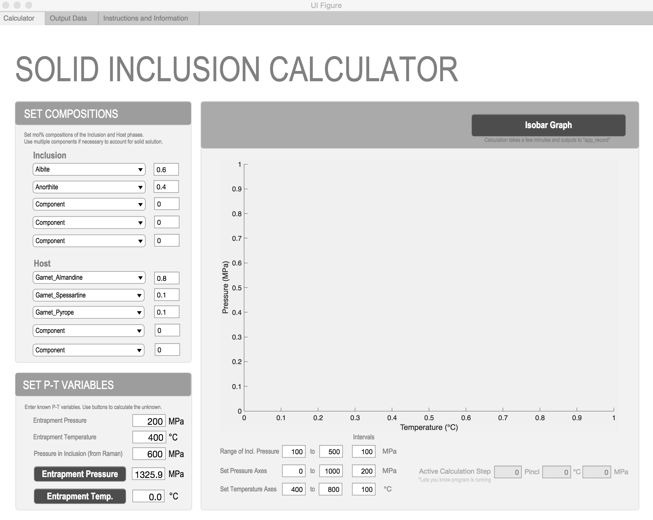

Figure 7: View of application with all isomekes variables set and ready to run.

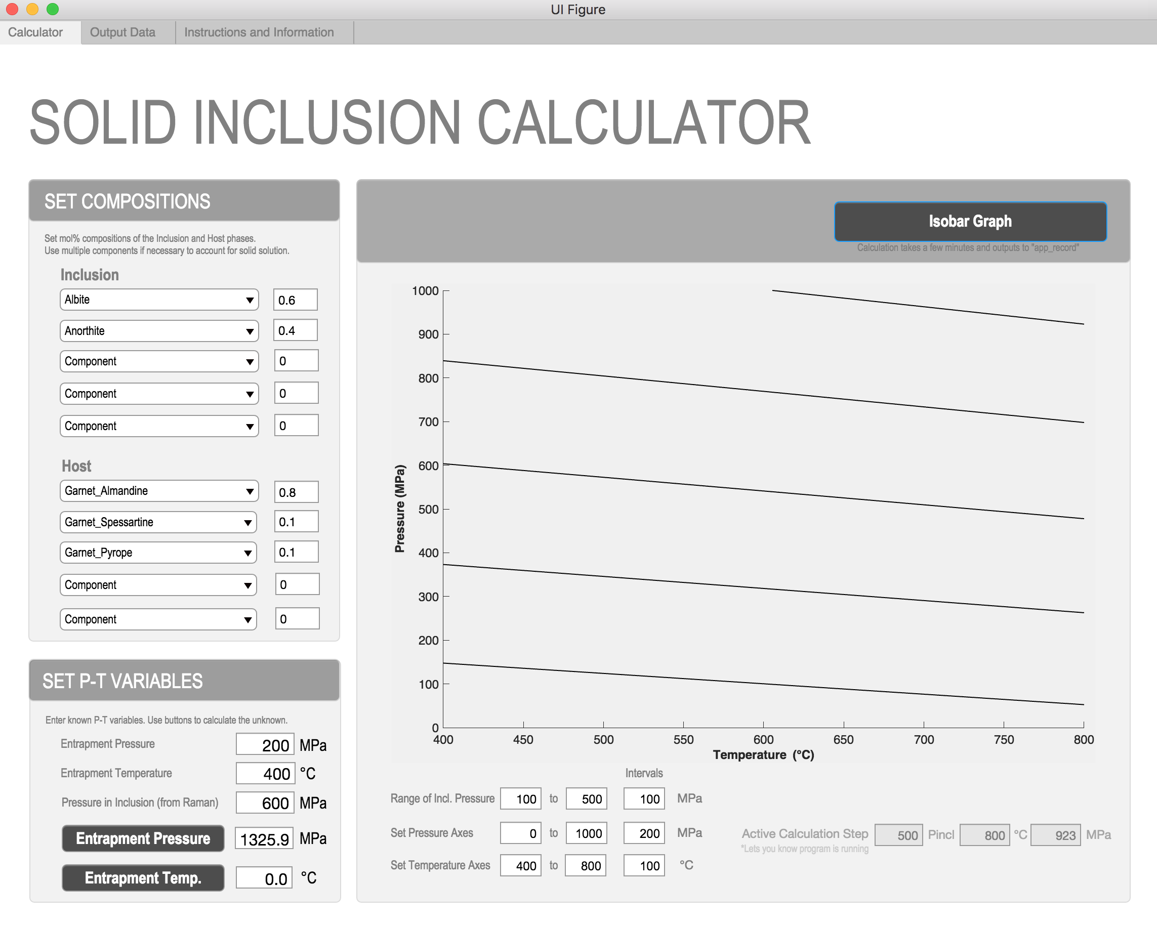

Figure 8: Completed isomeke graph for the feldspar-in-garnet example.

Accessing the data

The program produces a static plot that will not be sufficient for some users. There are 2 recommended ways to fully access the isomeke data.

Method 1

1. Select the “Output Data” tab on the top of the application.
2. Click the “Load Data” button. The data will populate and it can be copy-pasted and moved to other software.

Method 2

1. Extract the data from Matlab.
2. The data is saved to “isomekes_record.xls”.
3. To open the data you may double click “isomekes_record” in your working folder or type “isomekes _record” in the Command Window. If you are using the standalone application, the “isomekes_record.xls” will appear on your desktop.

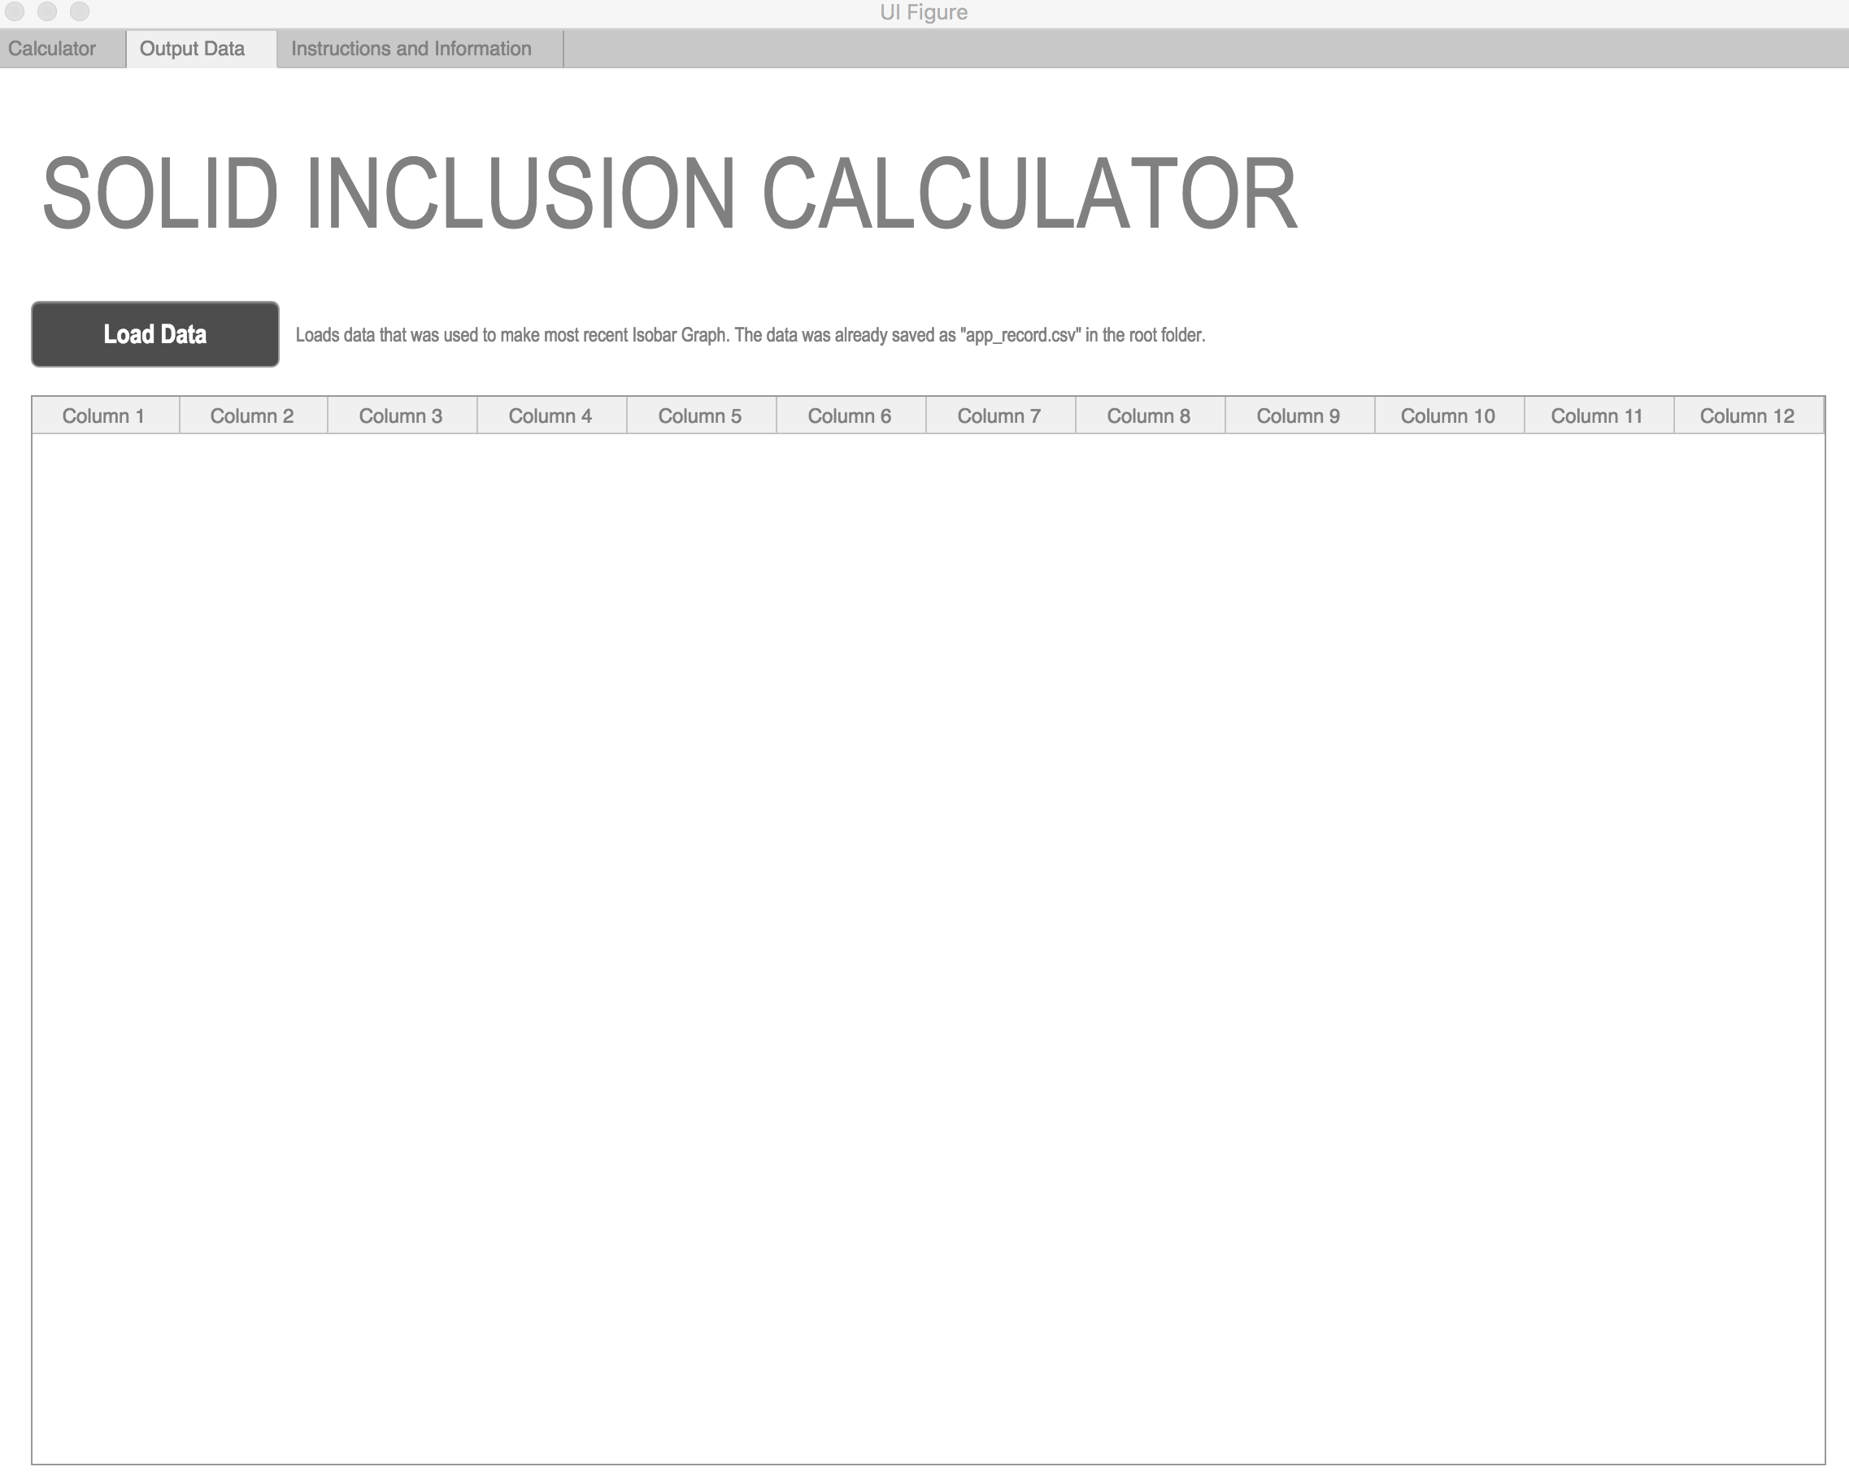

Figure 9: Load data into the window using the “Output Data” tab. Copy-paste the data and move it to other software.

# Modifying thermodynamic and physical properties

Thermodynamic and physical properties of minerals, Equations of State (EoS’), thermal terms, phase transition models and input variables, and bulk moduli temperature variations can be modified in the spreadsheet “thermodynamic_properties.xls”. Thermodynamic properties have the same units as in the Holland and Powell (2011) database.

The units and references of all thermodynamic and physical properties are given in the file “thermodynamic_properties_references_matlab.xls”. The units are also listed in the tables below. The thermodynamic properties that are input into “thermodynamic_properties.xls” must be converted to these units to output correct values.

Table 1: Name of thermodynamic and physical properties in MATLAB program.

|  |  |  |
| --- | --- | --- |
| **Variable** | **Variable Name in Spreadsheet** | **Units** |
| Entropy (S0) | s0 |  |
| Molar Volume (V0) | v0 |  |
| Thermal Expansivity (α0) | alpha0 |  |
| Bulk Modulus (*K*0) | k0 | kbar |
| Bulk Modulus – 1st derivative (*K0’)* | k0­_1 |  |
| Bulk Modulus – 2nd derivative (*K0’’)* | k0­_2 | kbar |
| Shear Modulus (G0)* | *shear_modulus* | kbar |
| Poisson’s Ratio (ν)* | *poisson_ratio* |  |

*If no shear modulus is assigned, the code utilizes the Poisson’s ratio of the host to estimate the shear modulus by using the equation:

Table 2: Equations of State.

|  |  |  |
| --- | --- | --- |
| **Equation of State (EoS)** | **Variable Name in Spreadsheet** | **Variable Assignment** |
| Tait EoS* | EoS_type | 1 |
| Birch-Murnaghan | EoS_type | 2 |

Table 3: Thermal models.

|  |  |  |
| --- | --- | --- |
| **Equation of State (EoS)** | **Variable Name in Spreadsheet** | **Variable Assignment** |
| Tait thermal pressure1 | thermal_type | 1 |
| Berman thermal model2 | thermal_type | 2 |
| Kroll thermal model3 | thermal_type | 3 |

Table 4: Thermal model parameters (required if used).

|  |  |  |
| --- | --- | --- |
| **Variable** | **Variable Name in Spreadsheet** | **Units** |
| Einstein temperature (ϴi) 1,3 | einstein_T* | K |
| Temperature variation of thermal expansivity2 | alpha1‡ | K |

*If no value is input for “einstein_T”, the Einstein T is calculated by using the equation: 10636/(S0 * 1000/ni + 6.44), where ni is the number of atoms (apfu sum).

‡Assign “0” to “alpha1” if you are using the Berman thermal model, but no temperature variation to thermal expansivity.

Table 5: Bulk modulus variation with temperature.

|  |  |  |
| --- | --- | --- |
| **Variable** | **Variable Name in Spreadsheet** | **Variable Assignment** |
| No bulk modulus temperature varitaiton | K_type | “empty = no temperature variation” |
| Linear Bulk modulus temperature variation | K_type | 1 |
| Hellfrich-Connolly approximation to bulk modulus temperature variation | K_type | 2 |
|  |  |  |
| **Variable** | **Variable Name in Spreadsheet** | **Units** |
| Bulk modulus variation with T (if K_type = 1) | dK_dT*‡ | K |
| Hellfrich-Connolly approximation, δ substitution for *K0’* (if K_type = 2) | delta_T† |  |
| Hellfrich-Connolly approximation, δ’  (if K_type = 2) | delta_T_Pr |  |

*By default, a value of 0 is assigned to “dK_dT” if no bulk modulus variation with temperature is needed.

‡If the Hellfrich-Connolly approximation is used, the variable “K_type” must be assigned a value of 2

Table 6: Phase transition models.

|  |  |  |
| --- | --- | --- |
| **Transition Model** | **Variable Name in Spreadsheet** | **Number** |
| None | lambda | “empty = no phase transition” |
| Launda theory | lambda | 1 |
| Bragg-Williams theory | lambda | 2 |

Table 7: Landau theory phase transition parameters (required if used). *

|  |  |  |
| --- | --- | --- |
| **Variable** | **Variable Name in Spreadsheet** | **Units** |
| Critical temperature (Tc) | *crit_temp* | K |
| Entropy of disordering at Tc­ (Smax) | *max_s* |  |
| Volume of disordering at Tc (Vmax) | *max_v* |  |

*see Holland & Powell (1998, 2011) for further details.

Table 8: Bragg-Williams phase transition parameters (required if used). *

|  |  |  |
| --- | --- | --- |
| **Variable** | **Variable Name in Spreadsheet** | **Units** |
| Total enthalpy (ΔH) | *delta_h* |  |
| Total volume of disordering (ΔH) | *delta_v* |  |
| Interaction energy term (W) in W = WH  + PWv | *w* |  |
| Interaction energy term (Wv) in W = WH  + PWv | *wv* |  |
| Number of Si disordering with each Al | *n* |  |
| Scaling factor on the energy of disordering (fac) | *sf* |  |

*see Holland & Powell (1996b, 1996a, 2011)

# References

Holland, T., & Powell, R. (1996a). Thermodynamics of order-disorder in minerals; I, Symmetric formalism applied to minerals of fixed composition. *American Mineralogist*, *81*(11–12), 1413–1424. https://doi.org/10.2138/am-1996-11-1214

Holland, T., & Powell, R. (1996b). Thermodynamics of order-disorder in minerals; II, Symmetric formalism applied to solid solutions. *American Mineralogist*, *81*(11–12), 1425–1437. https://doi.org/10.2138/am-1996-11-1215

Holland, T., & Powell, R. (1998). An internally consistent thermodynamic data set for phases of petrological interest. *Journal of Metamorphic Geology*, *16*(3), 309–343. https://doi.org/10.1111/j.1525-1314.1998.00140.x

Holland, T., & Powell, R. (2011). An improved and extended internally consistent thermodynamic dataset for phases of petrological interest, involving a new equation of state for solids. *Journal of Metamorphic Geology*, *29*(3), 333–383. https://doi.org/10.1111/j.1525-1314.2010.00923.x