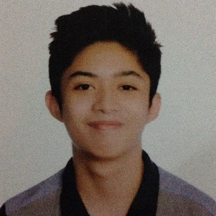Christian Miguel A. Fernandez

15 A. Padre Burgos street, San Isidro 1 village, Concepcion Uno, Marikina City 1811

Contact no: 0917-510-5655

Email: [miguelfernandez2898@gmail.com](mailto:miguelfernandez2898@gmail.com)

|  |
| --- |
| **Career Objective**  Seeking for a challenging workplace and a progressive environment that provide opportunities to different areas of learning where I can capitalize on my skills on web development. |
|  |

**Areas of Expertise**

* Web Skills: HTML/HTML5, CSS/CSS3, CMS (Wordpress), JavaScript
* Front End framework: Bootstrap
* UI and UX tools: Photoshop
* Content Management System: Wordpress

**Personal Skills**

* Excellent written and verbal communication skills
* Highly organized and efficient
* Ability to work on my own
* Very hard working and eager to learn
* A team player

**Online Portfolio: http://miguelfernandez.ga/**

**Education**

Primary: Our Lady of Perpetual Succor College (OLOPSC) (2005-2011)

30 General Ordoñez Ave, Marikina, 1810 Metro Manila

Secondary: Our Lady of Perpetual Succor College (OLOPSC) (2011-2015)

30 General Ordoñez Ave, Marikina, 1810 Metro Manila

Tertiary: Our Lady of Perpetual Succor College (OLOPSC) (2016-2020)

Bachelor of Science in Computer Science

30 General Ordoñez Ave, Marikina, 1810 Metro Manila

|  |  |
| --- | --- |
|  |  |