Bs

Generate Numbers
1. Generate sample data from the vector
R
Copy code
# Create vector
x <- c(23,45,21,34,5,6,7,8,86,45,3)

# Random sample
sample(x, 5)

2. Generate sample data using replacement
R
Copy code
# Create vector
x <- c(23,45,21,34,5,6,7,8,86,45,3)

# Sampling with replacement
sample(x, 5, replace = TRUE)

3. Generate sample data with uneven probabilities
R
Copy code
# Create vector
x <- c(23,45,21,34,5)

# Uneven probabilities
sample(x, 3, prob = c(0.1,0.2,0.3,0.2,0.2))
Probabilities

Suppose the mean checkout time of a supermarket cashier is three minutes. Find the

probability of a customer checkout being completed by the cashier in less than two

minutes.

pnorm(2, mean = 3, sd = 1)

*****************
Q.) Marks of large number of students are distribution normally with mean 50 and

standard Deviation 12. If a student is selected at random what is the probability that his

marks will be Between (1) 38 and 62 (2) 26 and 74 (Given area between z = 0 and z = 1

is 0.34135 & z = 0 and z = 2 is 0.47725

pnorm(62,50,12) - pnorm(38,50,12)

pnorm(74,50,12) - pnorm(26,50,12)
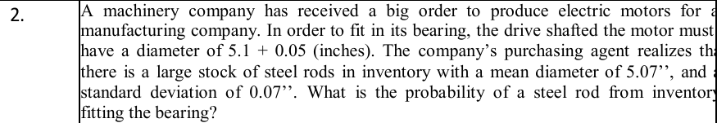

pnorm(5.15,5.07,0.07) - pnorm(5.05,5.07,0.07)
------------------------------------------------------------------
Correlation,Coefficient,Co Variance,Regression,Predict

x <- c(2,3,5,1,8)
y <- c(25,25,20,30,16)

# correlation
cor(x,y)

# covariance
cov(x,y)

# scatter plot
plot(x,y)

# regression
model <- lm(y~x)

# predict Y when X=4
predict(model,data.frame(x=4))

# predict X when Y=23
model2 <- lm(x~y)
predict(model2,data.frame(y=23))

*******************

salary <- c(110,130,140,160,170,90,100,130,150)
bonus <- c(12,15,14,15,20,12,10,12,18)

data <- data.frame(salary,bonus)

write.csv(data,"data.csv")

cor(salary,bonus)

cov(salary,bonus)

plot(salary,bonus)

model <- lm(bonus~salary)

predict(model,data.frame(salary=105))

model2 <- lm(salary~bonus)

predict(model2,data.frame(bonus=14))

Chart
1. Horizontal and Vertical Bar Chart
R
Copy code
X <- c("A","B","C","D")
Y <- c(2,4,6,8)

# Vertical Bar Chart
barplot(Y,names.arg=X)

# Horizontal Bar Chart
barplot(Y,names.arg=X,horiz=TRUE)

***************************

2. Histogram
R
x <- c(19,23,11,5,16,21,32,14,19,27,39)

hist(x)

************

3. Line Chart and Scatter Chart
R
X <- c(1,2,3,4,5)
Y <- c(3,7,8,9,12)

# Line Chart
plot(X,Y,type="l")

# Scatter Chart
plot(X,Y)

***************************************************
Formulas
✅ Margin of Error (ME)
$$ME=Z\sqrt{\frac{\hat{p}(1-\hat{p})}{n}}$$

✅ Confidence Interval (CI)
$$\hat{p}±ME$$

✅ Margin of Error (ME)
$$ME=Z\frac{σ}{\sqrt{n}}$$

✅ Confidence Interval
$$CI=\overset{ˉ}{x}±ME$$

Common values:
- 90% → Z = 1.645
- 95% → Z = 1.96
- 99% → Z = 2.576

# Given values
n <- 611
x <- 281
p_hat <- x / n
z <- 1.645 # 90% confidence

# Margin of Error
ME <- z * sqrt((p_hat * (1 - p_hat)) / n)
ME

# Confidence Interval
lower <- p_hat - ME
upper <- p_hat + ME

Question:- For a random sample of 36 items and a sample mean of 211, compute a 95%

confidence interval of mean if the population standard deviation is 23.

# Given values
n <- 36
mean <- 211
sigma <- 23
z <- 1.96 # 95% confidence

# Margin of Error
ME <- z * (sigma / sqrt(n))
ME

# Confidence Interval
lower <- mean - ME
upper <- mean + ME

Q.) Write a program in R to generate population of 100 random numbers. Take 80

samples out of population and calculate 95% confidence interval.

# Generate population of 100 random numbers
population <- rnorm(100, mean = 50, sd = 10)

# Take 80 samples from population
sample_data <- sample(population, 80)

# Sample mean and standard deviation
x_bar <- mean(sample_data)
s <- sd(sample_data)
n <- length(sample_data)

# 95% confidence level
z <- 1.96

# Margin of Error
ME <- z * (s / sqrt(n))

# Confidence Interval
lower <- x_bar - ME
upper <- x_bar + ME

# Output
lower
upper

Q.) Write a program in R to generate 36 random samples and calculate 90%, 95% and and 99% confidence interval.

# Generate 36 random samples
data <- rnorm(36, mean = 100, sd = 15)

# Sample statistics
x_bar <- mean(data)
s <- sd(data)
n <- length(data)

# Z values
z90 <- 1.645
z95 <- 1.96
z99 <- 2.576

# Margin of Error
ME90 <- z90 * (s / sqrt(n))
ME95 <- z95 * (s / sqrt(n))
ME99 <- z99 * (s / sqrt(n))

# Confidence Intervals
CI90 <- c(x_bar - ME90, x_bar + ME90)
CI95 <- c(x_bar - ME95, x_bar + ME95)
CI99 <- c(x_bar - ME99, x_bar + ME99)

$$Z=\frac{\overset{ˉ}{X}-μ}{\frac{σ}{\sqrt{n}}}$$

**********************************************
Q.) Write a program in R to test null hypothesis using Z test where populations mean=3, σ = 2 and sample given is (3, 7, 11, 0, 7, 0, 4, 5, 6, 2). If null hypothesis is H0 : sample mean=3, what is your conclusion.

# Step 1: Enter Data
x <- c(3,7,11,0,7,0,4,5,6,2)

# Step 2: Calculate values
mean_x <- mean(x)
sigma <- 2
n <- length(x)

# Step 3: Z-test
z <- (mean_x - 3) / (sigma / sqrt(n))
z

# Step 4: Decision (5% level, two-tailed)
if(abs(z) > 1.96){
print("Reject H0")
} else {
print("Fail to Reject H0")
}

Q.) Write a program in R to test the hypothesis that the mean systolic blood pressure in a certain population equals 140 mmHg. The standard deviation has a known value of 20 and a data set of 55 patients is available as (use scan to insert data) (120,115,94,118,111,102,102,131,104,107,115,139,115,113,114,105,115,134,109,1 09,93,118,109,106,125,150,142,119,127,141,149,144,142,149,161,143,140,148,149, 141,146,159,152,135,134,161,130,125, 141,148,153,145,137,147,169)

# Step 1: Mean
mean_bp <- mean(bp)

# Step 2: Z-test
mu <- 140
sigma <- 20
n <- length(bp)

z <- (mean_bp - mu) / (sigma / sqrt(n))
z

# Step 3 : Decision
if(abs(z) > 1.96){
print("Reject H0")
} else {
print("Fail to Reject H0")
}

Q.) Suppose the IQ in a certain population is normally distributed with a mean of μ = 100 and standard deviation of σ = 15. A scientist wants to know if a new medication affects IQ levels, so she recruits 20 patients to use it for one month and records their IQ levels at the end of the month. Data are (88, 92, 94, 94, 96, 97, 97, 97, 99, 99, 105, 109, 109, 109, 110, 112, 112, 113, 114, 115) Write a program in R to shows how to perform a one sample z-test using 99% confidence interval to determine if the new medication causes a significant difference in IQ levels.

# Data
iq <- c(88,92,94,94,96,97,97,97,99,99,
105,109,109,109,110,112,112,113,114,115)

# Given
mu <- 100
sigma <- 15
n <- length(iq)

# Z-test
z <- (mean(iq) - mu) / (sigma / sqrt(n))
z

# Decision (99% level)
if(abs(z) > 2.576) "Reject H0" else "Fail to Reject H0"

***************************************************
Q.) The following data shows sales made by salespeople from two different cities. City A: 59,68,44,71,63,46,69,54,48 City B : 50,36,62,52,70,41 Assuming the populations sampled to be approximately normal having the same variance, test whether there is any significant difference between the means of these samples.

Step 1: Enter Data
cityA <- c(59,68,44,71,63,46,69,54,48)
cityB <- c(50,36,62,52,70,41)

Step 2: Perform t-test (Equal Variance)

t.test(cityA, cityB, var.equal = TRUE)
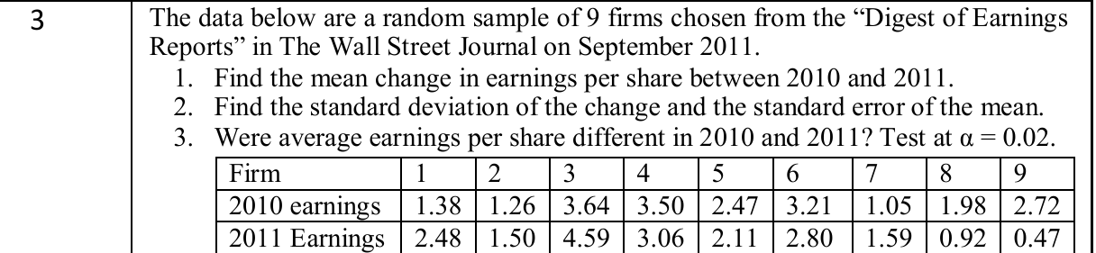

# Data
earn2010 <- c(1.38,1.26,3.64,3.50,2.47,3.21,1.05,1.98,2.72)
earn2011 <- c(2.48,1.50,4.59,3.06,2.11,2.80,1.59,0.92,0.47)

# Paired t-test
t.test(earn2011, earn2010, paired = TRUE, conf.level = 0.98)

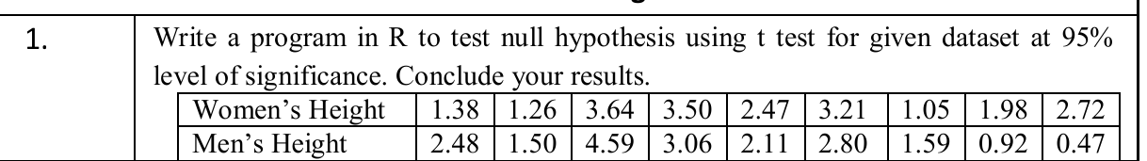

# Data
women <- c(1.38, 1.26, 3.64, 3.50, 2.47, 3.21, 1.05, 1.98, 2.72)
men <- c(2.48, 1.50, 4.59, 3.06, 2.11, 2.80, 1.59, 0.92, 0.47)
# Paired t-test
t.test(men, women, paired = TRUE, conf.level = 0.95)

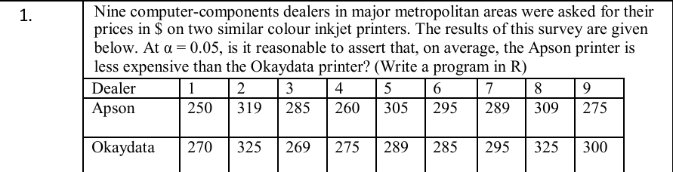
# Prices
apson <- c(250, 319, 285, 260, 305, 295, 289, 309, 275)
okaydata <- c(270, 325, 269, 275, 289, 285, 295, 325, 300)

# Paired t-test
t.test(apson, okaydata,
paired = TRUE,
alternative = "less")

*********************************************
Q.) In a hospital 480 female and 520 male babies were born in a week. Do these figures confirm the hypothesis that males and females are born in equal numbers?

x <- 520
n <- 1000

prop.test(x, n, p = 0.5, alternative = "two.sided")

Q.) Write a program in R to apply Z test for a population of mice containing half male and have female (p = 0.5 = 50%). Some of these mice (n = 160) have developed a spontaneous cancer, including 95 male and 65 female.

x <- 95
n <- 160

prop.test(x, n, p = 0.5, alternative = "two.sided", correct = FALSE)

Q.) We have two groups of individuals Group A with lung cancer x=490: n = 500 and Group B, healthy individuals x=400: n = 500. Write a program in R to test whether the proportions of smokers are the same in the two groups of individuals?

x <- c(490, 400) # smokers
n <- c(500, 500) # total individuals

prop.test(x, n, alternative = "two.sided", correct = FALSE)
**************************************
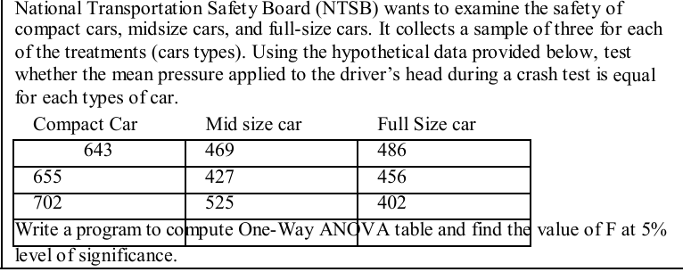

# Data
compact <- c(643, 655, 702)
midsize <- c(469, 427, 525)
fullsize <- c(486, 456, 402)

# Combine data
pressure <- c(compact, midsize, fullsize)

# Create group labels
type <- factor(c(rep("Compact",3),
rep("Midsize",3),
rep("Fullsize",3)))

# ANOVA test
model <- aov(pressure ~ type)

# ANOVA table
summary(model)

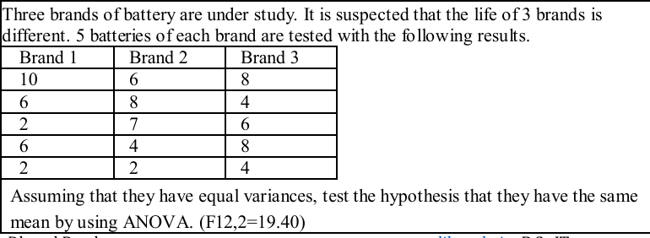

# Data
brand1 <- c(10, 6, 2, 6, 2)
brand2 <- c(6, 8, 7, 4, 2)
brand3 <- c(8, 4, 6, 8, 4)

# Combine data
life <- c(brand1, brand2, brand3)

# Group labels
brand <- factor(c(rep("Brand1",5),
rep("Brand2",5),
rep("Brand3",5)))

# ANOVA test
model <- aov(life ~ brand)

# ANOVA table
summary(model)

**************************************************
Q.) Write a program in R to create a vector (1,21,17,20,7,0,8,16,29,3,8,12,11,9,21,25,15,16) and calculate 88% interval estimate using t distribution.

# Data
x <- c(1,21,17,20,7,0,8,16,29,3,8,12,11,9,21,25,15,16)

# 88% Confidence Interval
t.test(x, conf.level = 0.88)

Q.) Write a program in R to read any 10 integer number from user using scan() and calculate 95% interval estimate using t distribution.

# Input from user
x <- scan(n = 10)

# 95% Confidence Interval
t.test(x, conf.level = 0.95)

Q.) Write a program in R to read data.csv file and calculate 90% and 99% interval estimate using t distribution.

# Read CSV file
data <- read.csv("data.csv")

# Assuming column name is x
x <- data$x

# 90% CI
t.test(x, conf.level = 0.90)

# 99% CI
t.test(x, conf.level = 0.99)

