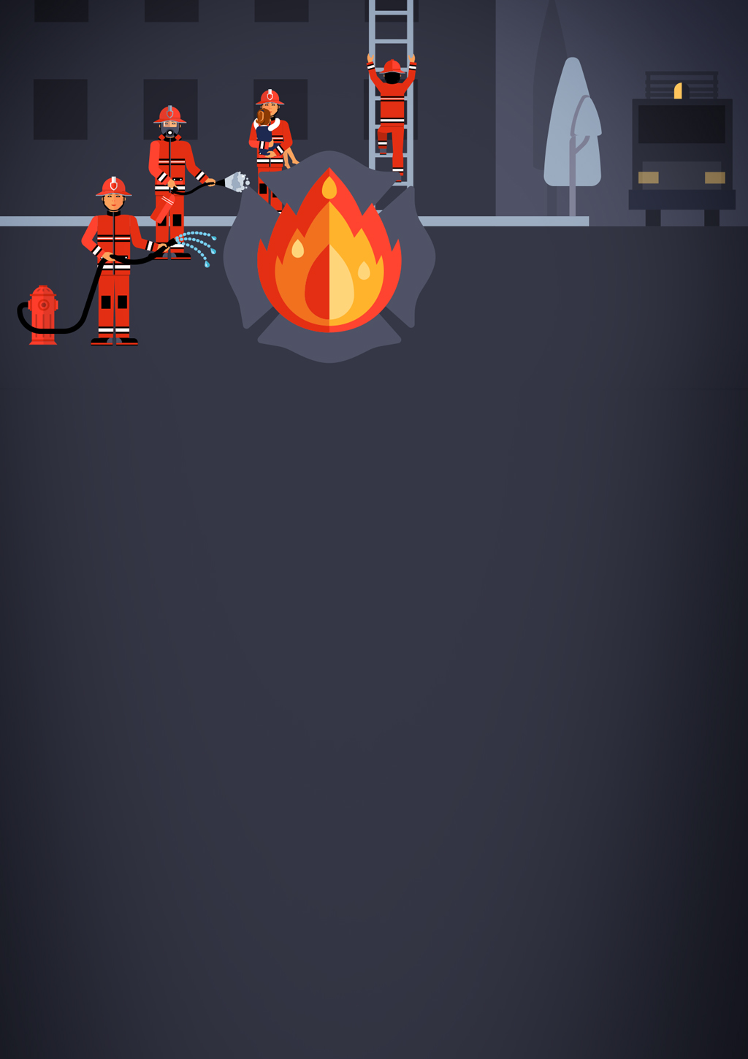

Polimi on fire!

Figure 1

Game Design Document







Index

Figure 2

1. **Introduction**
   1. **Game Concept**
   2. **Principal Characteristiscs**
   3. **Game Gender**
   4. **Public of the game**
   5. **Visual Style**
   6. **Game Scope**
2. **Game mechanics**
   1. **Gameplay**
   2. **Story**
   3. **Map Generation**
   4. **Characters**
   5. **Enemies**
   6. **Movement and physics**
   7. **Controls**
3. **Interface**
   1. **Videogame FlowChart**
   2. **Menu**
   3. **Credits**
   4. **Profile selection**
   5. **Character selection**
   6. **Difficulty selection**
   7. **Punctuation**
   8. **Level end**
4. **Art**
   1. **Art 2D**
   2. **Art 3D**
   3. **Audio**
5. **Introduction**
   1. **Game Concept**
   2. **Principal Characteristiscs**



* 1. **Game Gender**
  2. **Public of the game**
  3. **Visual Style**
  4. **Game Scope**



1. **Game mechanics**
   1. **Gameplay**
   2. **Story**
   3. **Map Generation**
   4. **Characters**
   5. **Enemies**
   6. **Movement and physics**
   7. **Controls**
2. **Interface**
   1. **Videogame FlowChart**



* 1. **Menu**
  2. **Credits**
  3. **Profile selection**
  4. **Character selection**
  5. **Difficulty selection**
  6. **Punctuation**
  7. **Level end**

1. **Art**
   1. **Art 2D**
   2. **Art 3D**
   3. **Audio**