**Team Count:**

**MIGUEL N. GUTIERREZ**

**PROBLEM:**

1. Due to the highly fragmented industry of logistics and supply chain, coupled with the complex way of doing logistics at an archipelago- businesses (especially SME’s), still find it difficult to ship, transport and store their goods at an efficient cost.
2. Suppliers also find it difficult to maximize their load, and find legitimate customers. Small suppliers (truckers, warehouse owners, and shippers), also find it difficult to compete with bigger ones who are able to drive down rates and have more marketing capital to do so.

**Solution:**

1. Create a site which can serve as a “market place for truckers, warehouse owners, and shippers) so that business can move their products from origin to destination
2. Suppliers to subscribe their assets by completing requirements, then be given access wherein when customers book near their vicinity they can accept booking

**Project title:**

XDOCK (Project Crossdock)

**Project Objectives:**

**XDOCK looks to help businesses satisfy their clients requirements through logistics and warehousing.**

**Suppliers will have avenues to maximize their load through the XDOCK site.**

**Target Users/Audience:**

**B2B, truckers, ship owners, warehouse owners**

**Introduction:**

In the logistics industry, Philippines is known to be the most complicated country to do logistics in. Not only because of its numerous islands, but also because of its laws, and traffic. Coincidently, it is also known that doing business in this Country, is very difficult.

Business owners, especially the small ones find it difficult to store and transport their goods to make their business thrive. Some fall to fly by night suppliers which leads to more harm than good, or pay more because they lack access or base load with the bigger players.

At the other spectrum suppliers, find it difficult to compete with bigger suppliers. Their loads are not optimal and they end up losing money, or customers due to longer lead time or poor service.

With XDOCK, we look to bring the two parties together. Customers can book for space, and transport their goods door to door through a click of a finger. While Suppliers can get customers just by subscribing to our site. With this we bring together the highly fragmented industry of supply chain and make the odds of a successful business, higher.

**SITE MAP**

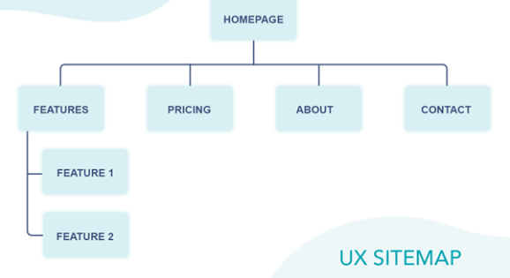

Lorem ipsum dolor sit amet, consectetur adipiscing elit. Mauris enim urna, tincidunt ac tempus eu, viverra eu ex. Aenean pharetra neque sed volutpat facilisis. Ut eu bibendum nisl. Ut posuere elit purus, a rutrum neque sagittis at. Quisque vehicula molestie magna. Praesent enim dolor, rhoncus sed eros et, viverra ullamcorper diam.

**Features:**

* Supplier enrollment
* Customer Booking
  + Warehouse Space
  + Shipping to Vismin
  + Trucking

**NOTE:**

**CREATE A FOLDER IN THE Gdrive link. Filename should be your Firstname, lastname.**