# Deterministic Models

### Support Vector Machines

Support Vector Machines (SVM) is a widely used supervised learning algorithm and even though you can also use it to regression it is mainly used for binary classification problems.

The objective of SVM is to find an optimal hyperplane in N-dimensional space, being N the total number of features in our data, that distinctly classifies each data point. This optimal hyperplane is the one that maximizes the margin, i.e maximizes the distance between the data points of each class of our target variable.

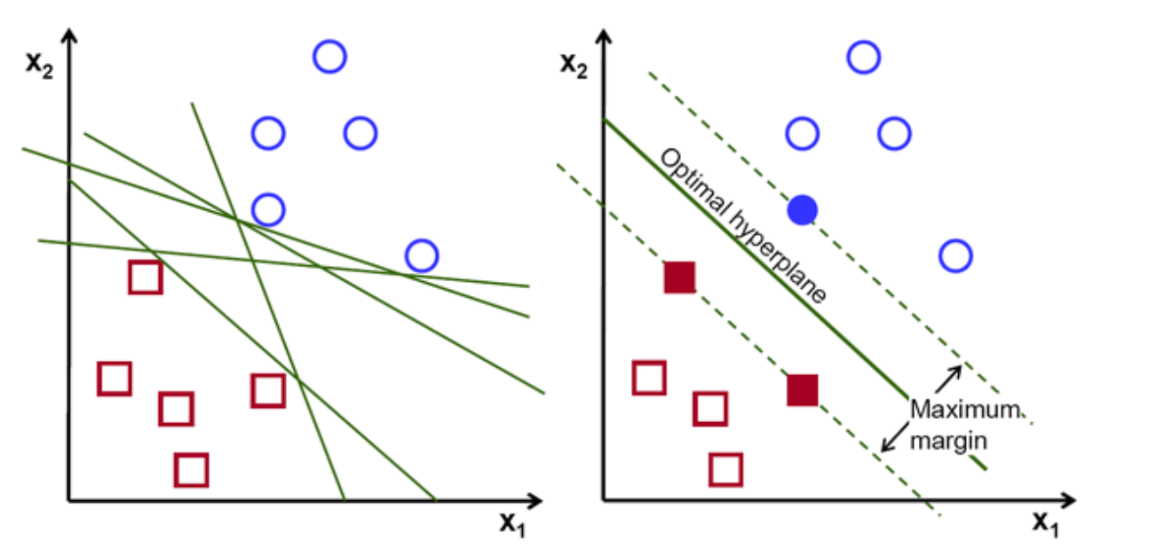

Intuitively SVM is an algorithm that behaves well when we are working with a linear separable data. In this report we also generalize the usage of SVM - SVC (Support Vector Classifier) to be more concrete - to the case of non-linearly separated data by applying a Kernelized SVM that creates a new transformed feature space by computing internally the similarity between pairs of points to make it linear separable.

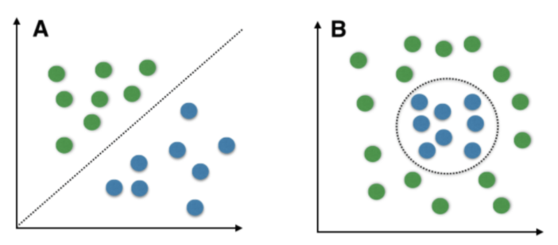

the classification of new data points will be made taking into to consideration on which side of the hyperplane these new data points fall.

Links:

<https://towardsdatascience.com/support-vector-machine-introduction-to-machine-learning-algorithms-934a444fca47>

<https://www.geeksforgeeks.org/classifying-data-using-support-vector-machinessvms-in-python/>

<https://www.geeksforgeeks.org/introduction-to-support-vector-machines-svm/>

<https://www.geeksforgeeks.org/support-vector-machine-in-machine-learning/?ref=rp>