Mesh Painter

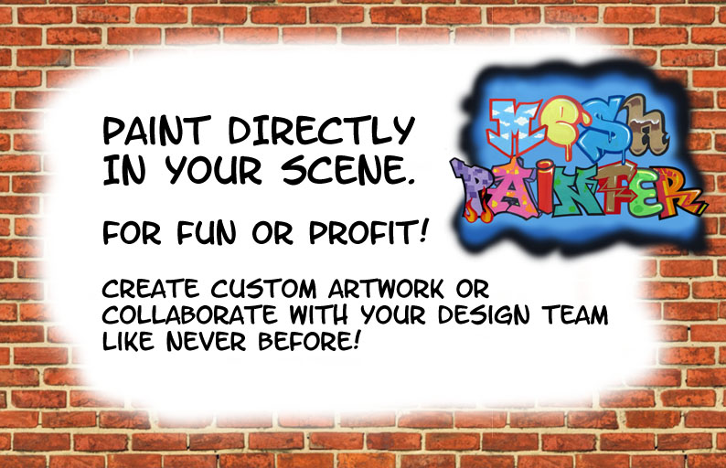

Create custom artwork painting directly on your game objects or collaborate like never before by leaving directions, color choices and other design notes to the team. Now you can literally Sketch out your scene before you build!

Starting MeshPainter
To start using MeshPainter click on the Window menu item, scroll down to the MeshPainter item and then click on Open Window.

Painting With MeshPainter
First select a game object and ensure it has a collider of type Mesh Collider. Then hold down the hotkey (Left Control key by default) while right clicking on the object to begin painting on it. At the top of the MeshPainter window you can select the paint color to use or change the brush size and hardness by dragging the sliders. To switch over to using the eraser just tick the box marked Eraser and then adjust its size and hardness using the sliders as with the brush. You can also paint using a texture by ticking the box marked Texture. It will use the size and hardness of the regular brush.

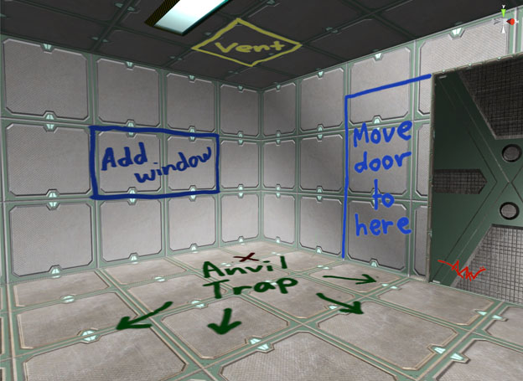

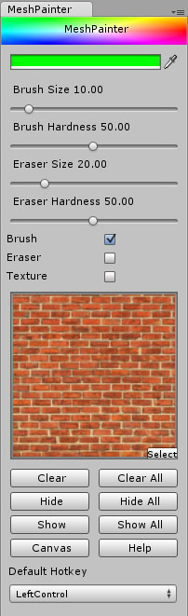

Setting Texture Properties

In order to use a texture for painting you must first change some of its properties. Do this by first selecting the texture in the Project window and change the texture type to Advanced in the inspector window. Next tick the box marked Read/Write enabled, set the Max Size to 512 and set the Format to RGBA 32 bit. You can then select the texture to use by clicking on the button marked Select in the texture preview window.

Removing Paintings

To remove a painting from an object simply click on the Clear button below the texture preview. You will then be asked to confirm whether to clear the paintings from the current object. To remove the paintings from all objects click on the Clear All button instead. Always remove paintings from an object before deleting the object otherwise you will end up creating a lot of orphaned meshes which will be located in the MeshPainter/Meshes folder. You will be able to spot them as they have a random 20 character string for a name.

Hiding and Showing Paintings

Because of the way MeshPainter creates surfaces to paint on you will notice that the number of draw calls increases the more you paint on objects. This is normal but if most of your paintings are directions to other artists or were not intended to be included in the final build then you can hide them by selecting an object and clicking on the Hide or Hide All buttons. To show the paintings again select the object and click on the Show or Show All buttons.

Hiding and Showing the Canvas Objects

If you have a nice piece of art that you would like to duplicate or move to another location in your scene then you can reveal the canvas object in the hierarchy. To do this start by selecting the object with a painting on it and then click on the Canvas button. This toggles the visibility of the hidden child object in the hierarchy called 'mpCanvas' which will be attached to the currently selected object as a child object. You may need to click within the hierarchy window to update this view.

Hotkey Selection

You can change the default hotkey used by the program by selecting a new key to use from the drop down menu at the bottom of the window.

Notes
There is no undo function yet but that will be the next addition to the program.

Lighting calculations are not always quite right depending on the object being painted or the shader being used on that object. This will also be fixed in a future update.

FAQ

If the program is not painting on an object make sure the object has a Mesh Collider attached and that you are in Brush or Texture mode.

If you are getting a lot of leaked objects then perhaps you have deleted objects with paintings attached. To avoid this always use Clear or Clear All on an object before deleting it as this will safely destroy the meshes and textures used in the painting process.

To learn more about Mesh Painter and to view the tutorial videos you can visit MeshMaker.com

