ZZ-PAT client (SERVER side) install instructions

You can place in any directory (with write permissions) the files
ZZ-PatV02.exe
UNZIP.EXE
zip.exe

(you can use zip.exe and unzip.exe provided in th opentm2 program in c:\OTM\win)

STRONGLY RECOMMENED:

ZZ-Pat can be installed in a shared environment and used by reveral users at the same time, so we need to call ZZ-Pat with a user name (just to keep parameters for each person) to store parameters. I will asume the user name is "project_manager". So, create a bat file and place it in the same directory as these programas and use it to start ZZ-PaT by user.

- Create for instance ZZ-Pat_project_manager.bat
- open this file adn add a line with the user name you wish with "start ZZ-PatV02.exe project_manager"

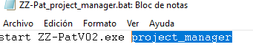

1 Setup de parameters file

-Double click ZZ-Pat_project_manager.bat. This will open the program and create a parameter file named ZZ-PatV02_PAR_project_manager.XML. Select Parameters:

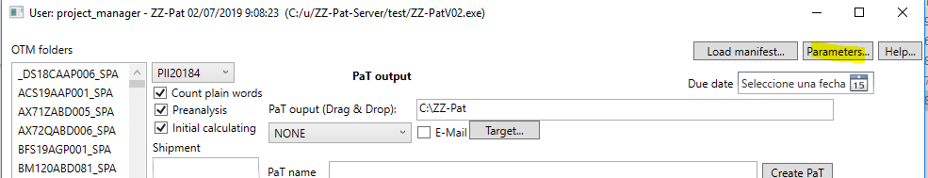

The "ZZ-Pat parameters" will come up.

The first thing we have to deal is a security mechanism to store sensible information.

We need a key to cypher sensible information, and several approachs are usually followed.

I have choosen the path to generate by code a password using a clear text (in this case a number) that is known by the project manager (or its company) and the translator. This number should be kept between these two parties.

The info is encrypted with the Rfc2898DeriveBytes, with the today still valid PBKFD2 mechanism still considered safe. The easiest way to crack these sensible information is find out this numer, and inspect the code. Crack the files without these (the code and the number) is not known by normal means.

The most valuable info that we store are the mail for sending/receiving emails and the ftp paswords accounts in the server side, so I think reasonable protection is given to then.

If you are a security paranoid, you can change the salt in the source code and change the number generation mechanism also in the code, and unless you provide the code or unless the code itself disclosed, it would make really hard to break the encrypted info.

So, we should choose a random number default lower than

999999999999999

so let say

123451234556783

This number should be the same for all users in the Z-PAT ecosystem.

Once choosen you cannot change it without reentering all sensible information. Press Save

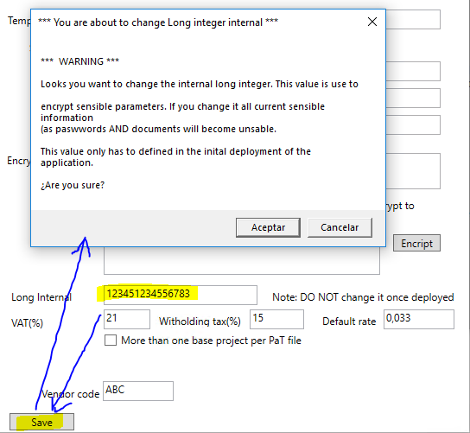

Once saved, we can go on and return to the parameters window.

PM email -> It should be the user (project_manager) email. For instance -> project_manager@dom.com

Out PaT dir -> The default directory where the PaT files will be created. You can leave the default.

Temporary dir -> The place for temporary files. You can leave it. %TEMP%\ZZ-Pat\PB\ will be corrected resolved to your temporary directory by Windows.

We have to setup an email account for sending email.

Note: This account is used in the server machine AND in the translator machine. Be aware tha many providers (Google is just an example) willl easily block any use of an email account from let say a remote machine they are not aware (in this case the translator machine). Other providers will allow you with with very easy setup (GMX).

Enter the SSL mechanism, Port, Host and User.

You need to encript the email password. Let say my password is "LisbonIsGreat!" and your long internal is 123451234556783 as stated before:

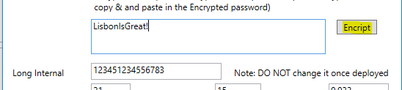

you should press "Encrypt" to find the encrypted value. Then paste the result value to the "Encrypted password".

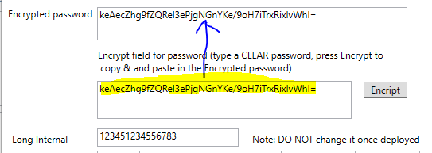

Vat (%) -> VAT value in financial info.

Withholding tax (%) -> Base deduction (usally for IRS taxation in freenlaces at least here)

Default rate -> default price per word (later can be changed)

More than one base project per PaT file -> Will allow you to send folders from diferent base projects.

Vendor code -> The vendor code you can define, i.e. ABC.

Press Save

2 Set up an address

We will set a translator addres using an ftp server. You need an ftp user.

In the main dialog select "Target..".

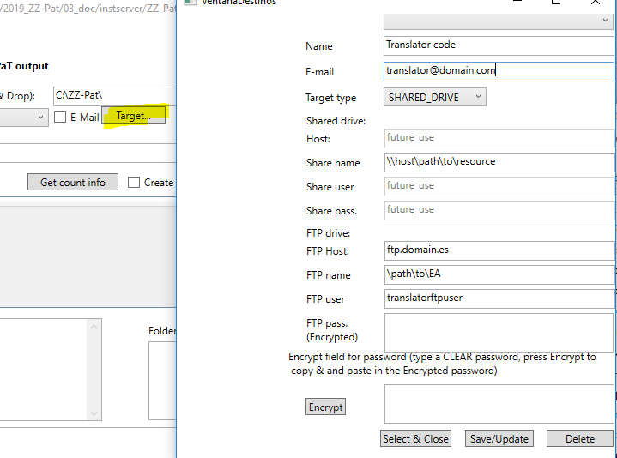

Name -> Do not use blancks. i.e. translator_name
Email -> The translator email, i.e. translator@domain.com
Target type -> FTP
(Selecting FTP you can ignore Host, share name, user and password).
FTP Host -> your host address (i.e. 1.2.3.4 or ftp.domain.com)
FTP -> The path you will place and receive the PaT files. This directory should exist. FTP user (next field) should have write/read access. For example (/files/Pat_NoBorrar)
FTP User -> fptuser ZZ-PaT will use to login and transfer files to the FTP name directory
FTP Pass (Encrypted) -> First you have to type the password in clear text, then press "Encrypt". The password will be encrypted. Copy the encrypted password and paste it in the FTP pass (Encrypted). The value not only depends of the password itself but also of the number you choose in the parameter configuration.

Press Save

3 Verify

In the main window, we have selected a

Folder -> _DS18CAAP006
Translator -> translator_name (notice the hostname and the ftp directory).
E-Mail -> Sent an email to the translator.

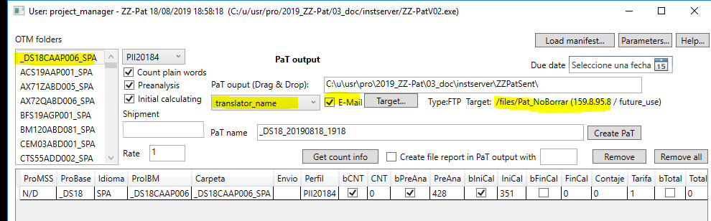

Selecting "Create PaT" the folder is sent. Notice the bottom log area

.
.
PaT file created succesfully in: C:\u\usr\pro\2019_ZZ-Pat\03_doc\instserver\ZZPatSent\_DS18_20190818_1918.PaT.zip
Translator name: translator_name -> FTP
Transfered... 5 % (8192) bytes
.
.
.
Transfered... 95 % (155648) bytes
Transfered... 100 % (163840) bytes
Upload File Complete, status 226 Transfer complete.
Sending note to xxxxxxxxxxx@gmail.com
... Done!
Some clean up...
Done
************************ END ************************

