This docs shows the ZZ-PaT flow, with 2 different roles, the PROJECT MANAGER (miquel.canals.ext@strakertranslations.com) and the TRANSLATOR (miguelknals@gmail.com).
The PROJECT MANAGER steps are run the the project manager computer (ZZ-PAT server program + OpenTM2
The TRANSLATOR steps are run in the translator computer (ZZ-PAT client program + OpenTM2)
These steps cover an scenario were 3 folders (DSM21ABD001, 2 and 3) are sent to a translator thru an FTP exchange area.

PROJECT MANAGER -> Open ZZ-PAT
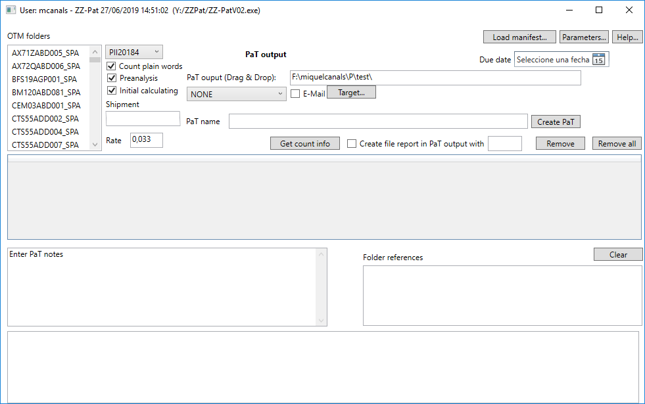

PROJECT MANAGER -> Optional: Fill Shipment info, select profile, Due Date, Notes and any reference info and your working directory

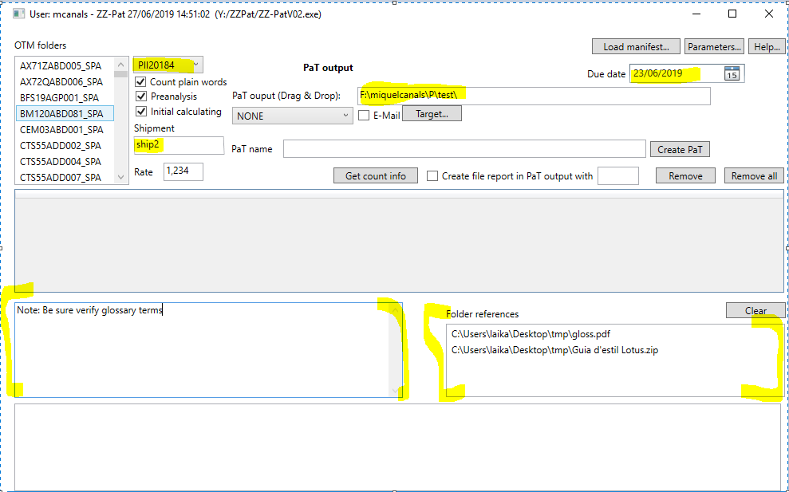

PROJECT MANAGER -> Then we select the folders to be sent with double click
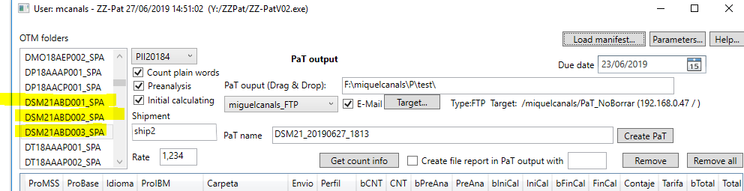

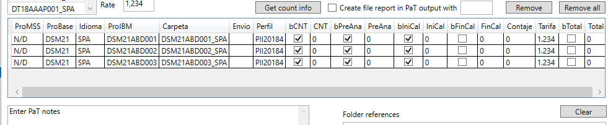
Optional: Press "Get count info" to verify CNT, preanalysis and/or initial calculating
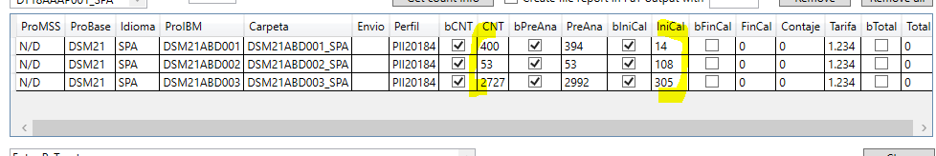

PROJECT MANAGER -> Select a translator to send the folders and optional sent an email

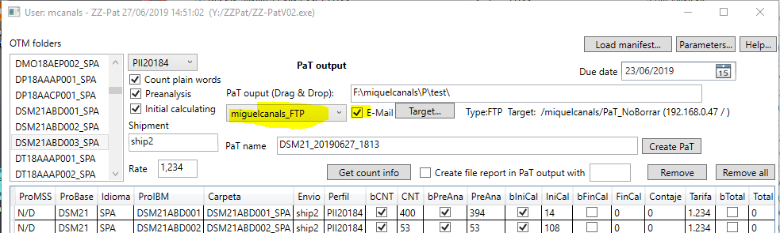

PROJECT MANAGER -> The working directory before:

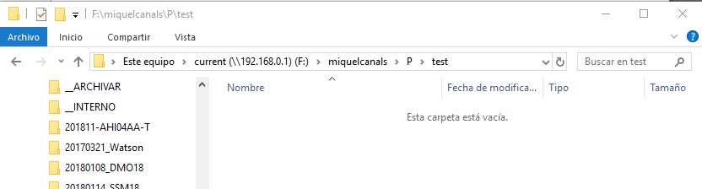

PROJECT MANAGER -> Press "Create Pat", PAT file is created in the working directory and sent to translator:
a) Pat file in the working directory
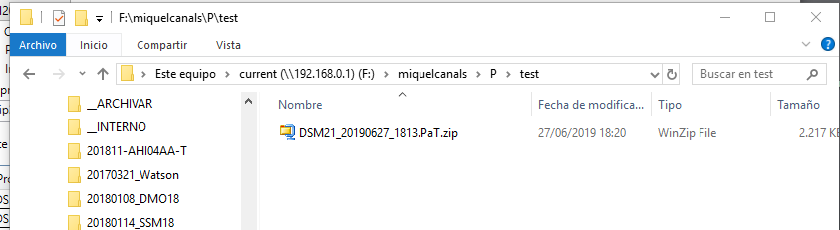

b) Content of a PAT FILE (Folders, reference files and PAT manifest files)
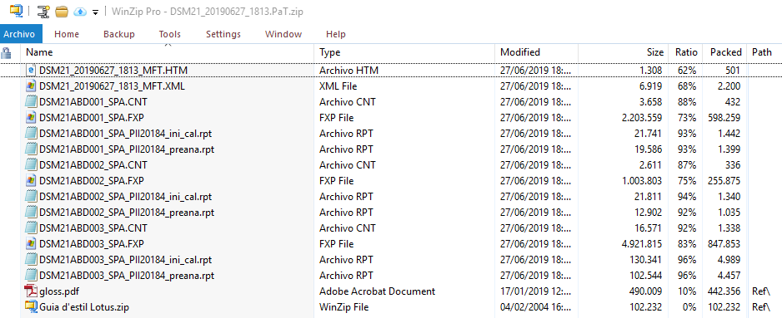
c) Pat is sent to translator and email sent (the ZZ-Pat displays the process)
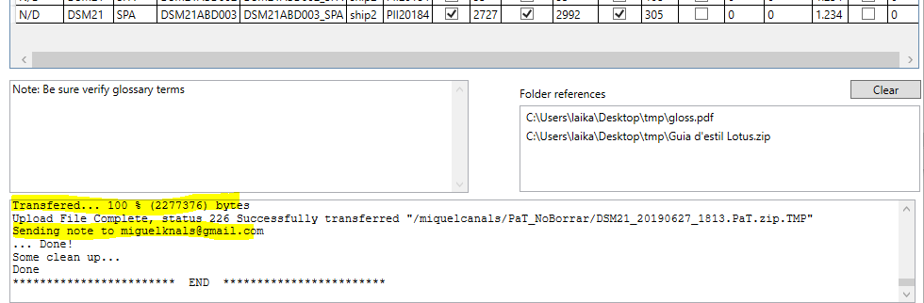

TRANSLATOR -> Receives an email
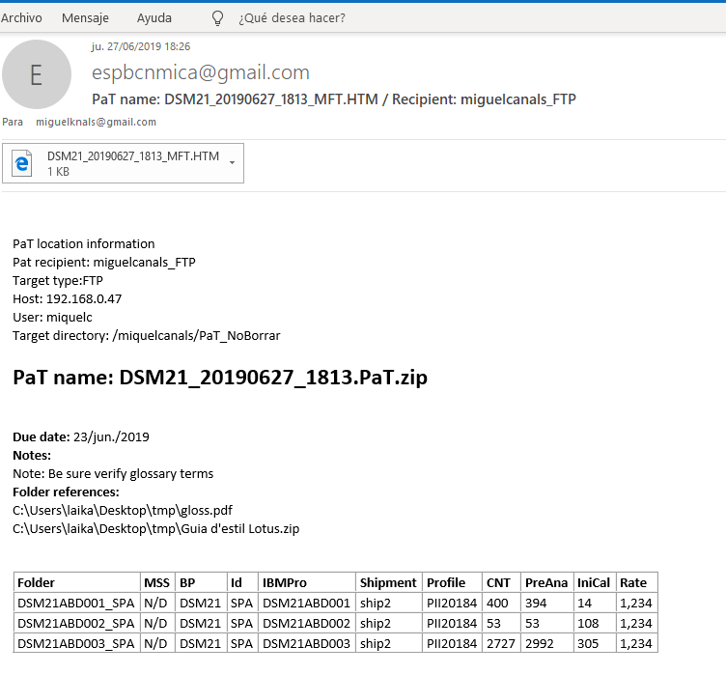

TRANSLATOR -> Opens the ZZ-PatClient
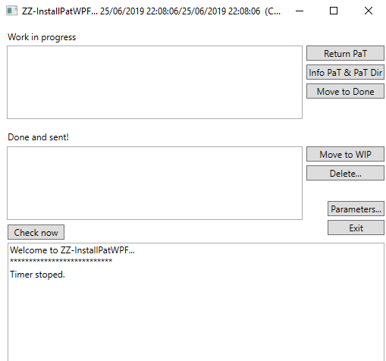

TRANSLATOR -> Press "Check now". The new Pat if available, will be detected. The PaT file is downloaded, and translator is advised about the new PaT to be loaded in OpenTM2

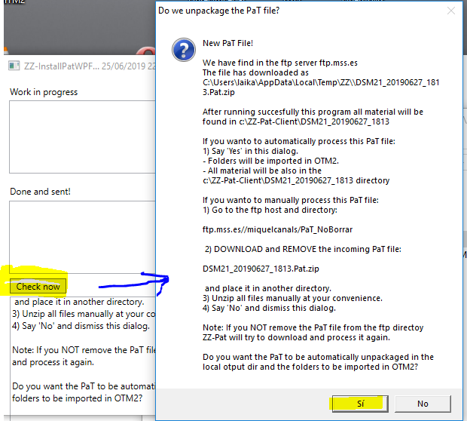

TRANSLATOR -> Says "YES"
a) PaT unpacks the pat file and loads de folders. Pat is now "Work in progress" and package info is displayed
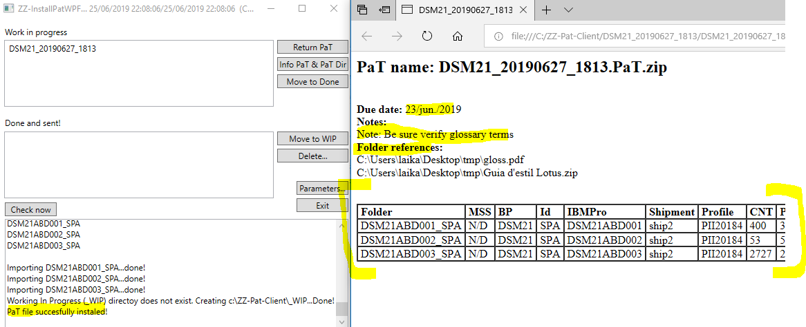

b) Pressing "Info PaT & PaT Dir" will show the PaT conents with Ref files and wordcounts (and also the original FXP files as backup)
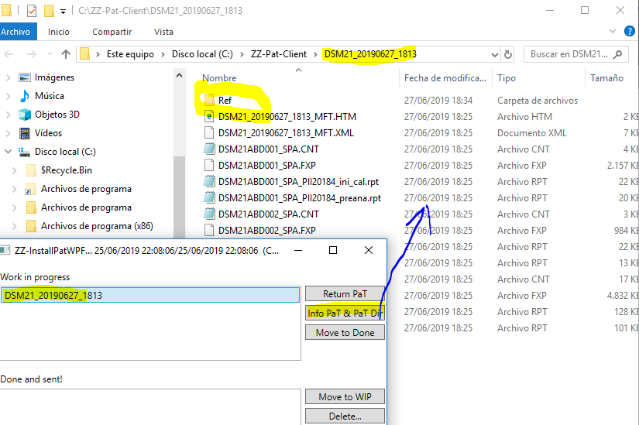

d) Open TM2 translator has the folders to be translated.
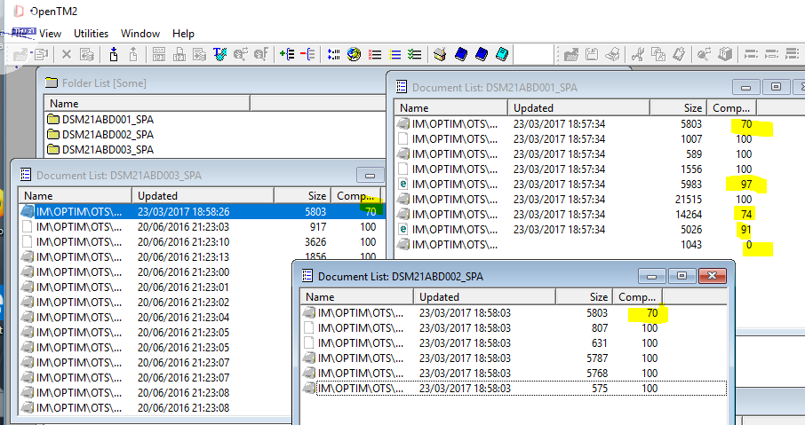

TRANSLATOR -> Translator translates
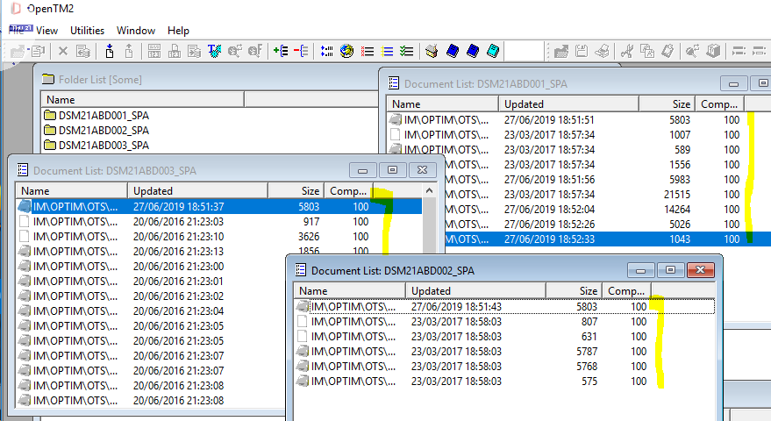

TRANSLATOR -> Is ready to return the folders pressing "Return PaT" and press "Yes"
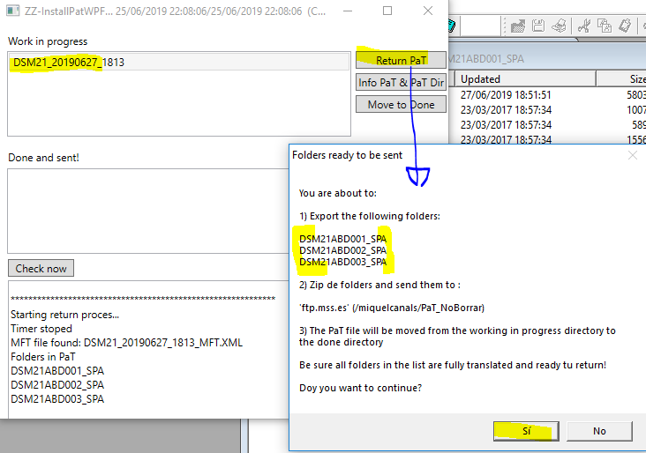

TRANSLATOR -> Folders are exported and sent back to the FTP server. Package are not longer in the "Work in progress" but in the "Done and sent!" area. An email is sent to the PROJECT MANAGER. PaT can be move back to Work in progress if needed (i.e. resent the folders)

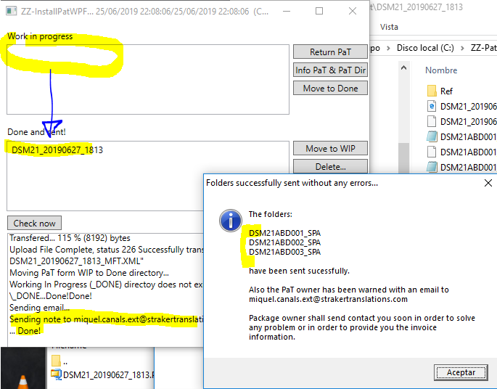

PROJECT MANAGER -> Receives an email that states a PaT folders are now in the FTP server.
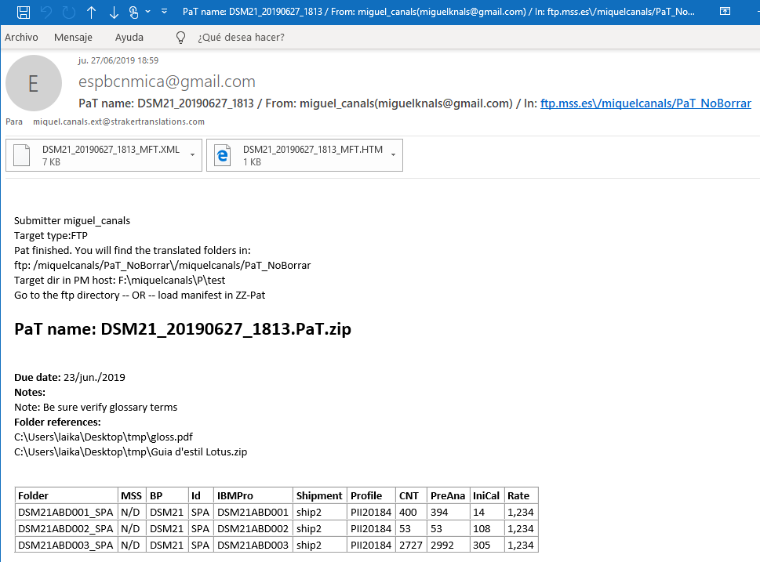

PROJECT MANAGER -> Unpacks the PAT manifest file (from the (a) email or (b) PaT file itself). The manifest file (MFT) is the file that contains all wordcount info. This file is signed to avoid any tampering.
a) First option, download the MFT.XML from the email
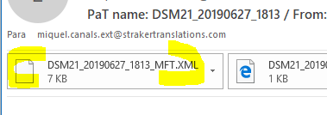
b) Second option, extract the MFT.XML from the original PaT file.
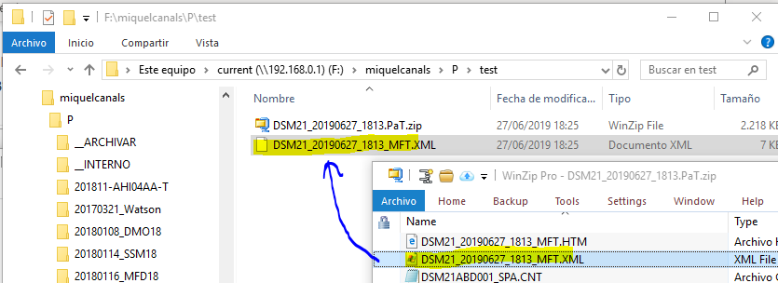

PROJECT MANAGER -> Opens ZZ-PAT and selects "Load manifest..."
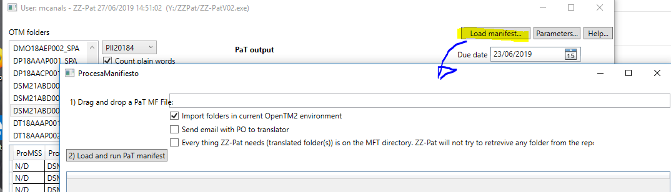

PROJECT MANAGER -> Drags and drops the manifest file and selects "Load and run PaT manifest" and optionally can select to send the result wct info to the translator:
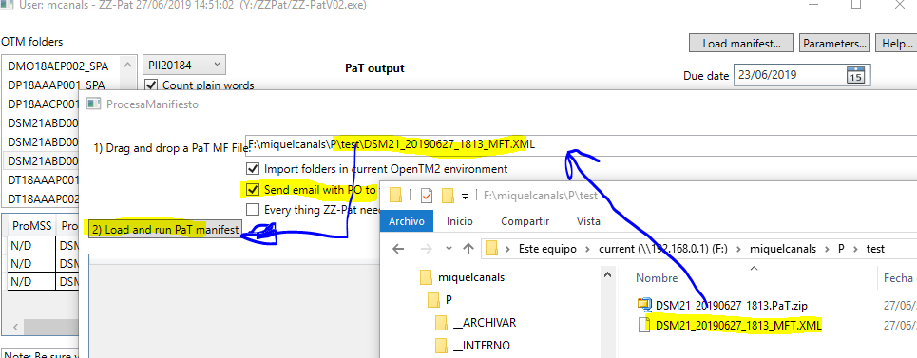

PROJECT MANAGER -> After pressing "Load and run PaT manifest", using the manifest info, translator folders are downloaded from the FTP server, wordcount info is created and info is (optionally) sent to the translator
 | Initial calculating | Final calculating | Payable Words
DSM21ABD001_SPA | 14 | 110 | 96
DSM21ABD002_SPA | 108 | 126 | 18
DSM21ABD003_SPA | 305 | 322 | 17

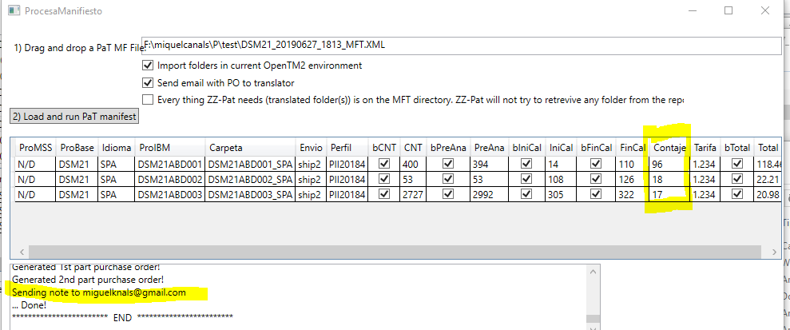
PROJECT MANAGER -> Folders, and calculating info is in the working directory:
a) TRANSLATOR folders are in OpenTM2 and also in the working directory
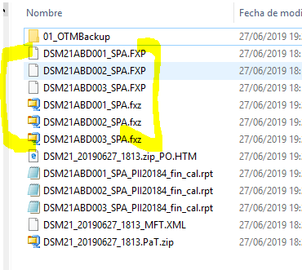
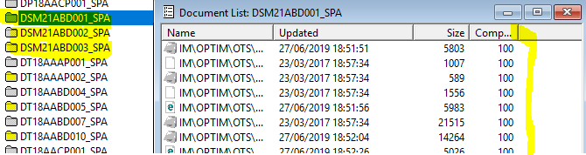

b) Final calculating ready to be used for accounting purposes.

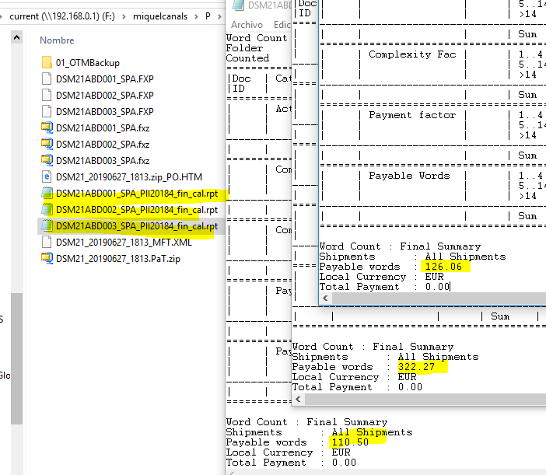

c) HTML with readable information
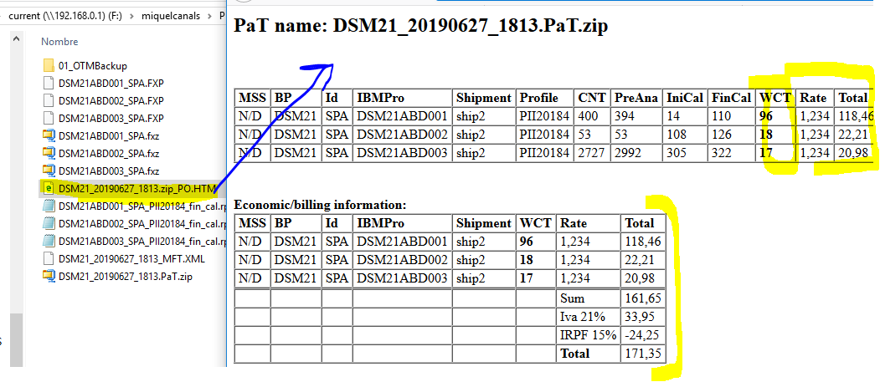

TRANSLATOR -> Receives and optional email with the html info
