ZZ-PAT client (TRANSLATOR side) install instructions

We assume you are outside the customer network so FTP exchange area will be used.

You should receive a zip file like ZZ-InstallPaTWPF_2090615.zip at least with:
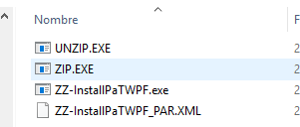

You should extract this files in any directory, recommended a directory with no blanks, for instance c:\ZZ-Pat_Prog

ZZ-InstallPaTWPF_PAR.XML is the configuration file we need to setup.

Open the client and select Parameters...

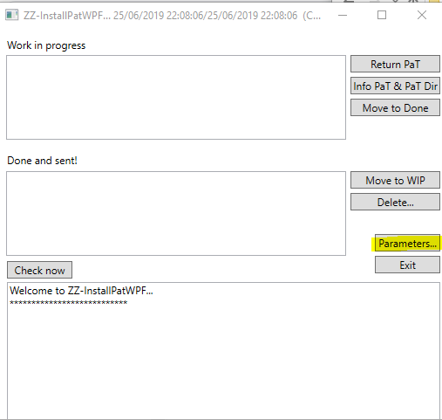

Several fields should be provided by your admin or he/she will let you know if are ok by default.

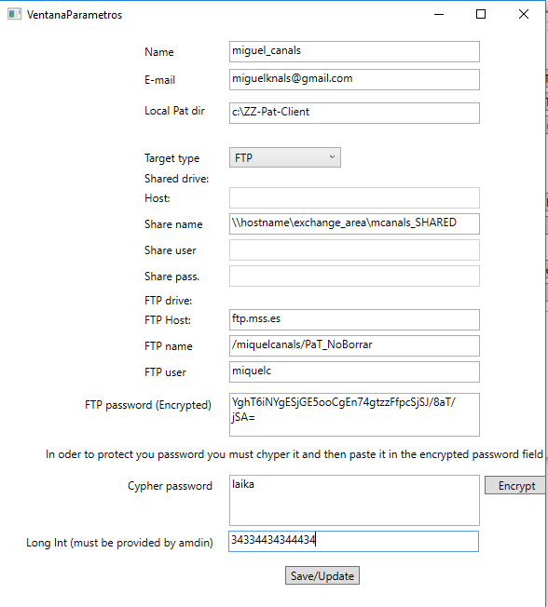

- Special value "Long int" (Admin parameter)

The Long Int parameter is used to encrypt sensible ZZ-Pat info (for instance password or email info).

If you are requested is recomended be the first thing to change. Type the Long int if your are instructed to do so.
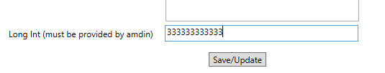
Then also recommended press "Save/Update" and come back to the parameters dialog.

After this is correctly set DO NOT CHANGE THIS VALUE otheriwse you will not be able to receive/sent any PAT file. If this value is change for any reason, you ALSO HAVE TO ENCRYPT again your FTP password.

- Name -> name_last_name. Do not use blanks. By user

-E-mai -> Your email. By user

-Local Pat dir -> Your local directory where the pat files will be download in your computer. The directory MUST exist and strongly recommend to do NOT use any blank. Recommended valure C:\ZZ-Pat_Data

-Target type -> FTP if you are outside your customer environment. By admin.

- Host/Share name/Share user/Share password -> Not usee if FTP target type.

- FTP host -> ftp host. Usualy user should now or ask your admin.

- FTP name -> By admin. Usually "/Pat_NoBorrar" This a FTP directory that must exist on the server workspace where all the pat info is transferred. For instance if for any reason a Pat is not download you would be able to download it manually. Be sure to enter correctly this fpt directory (using the starting and intermediate backslash / )

- FTP user -> your ftp user. By user or admin.

-Special instuction to set up an encrypted password.

Your password will be stored in the parameter file. Because of that we will encrypt it.

1) Type your password in clear text in the Cypher password and press Encrypt

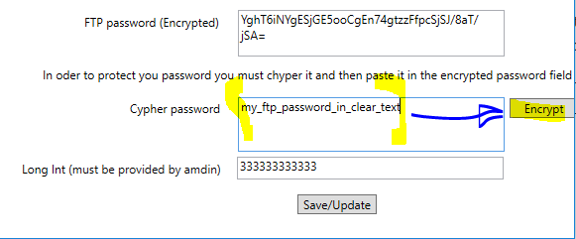

2) After you press encrypt the password will be Encrypted

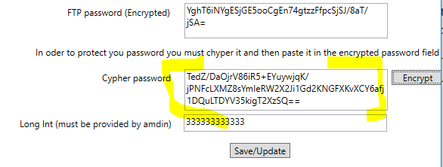

3) Copy and paste the Cyphered password in the "FTP password (Encypted)

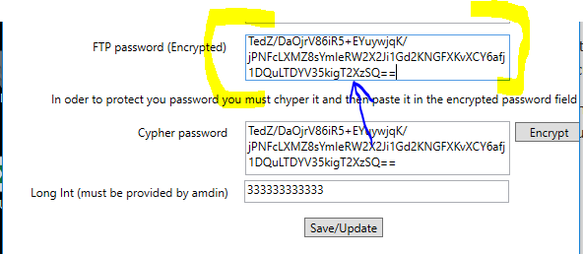

Press "Save/Update"

You are done

Now, pressing "Check now" should detect any package is there is one available.

You can verify if your FTP connection is ok pressing "Check now".

WRONG!

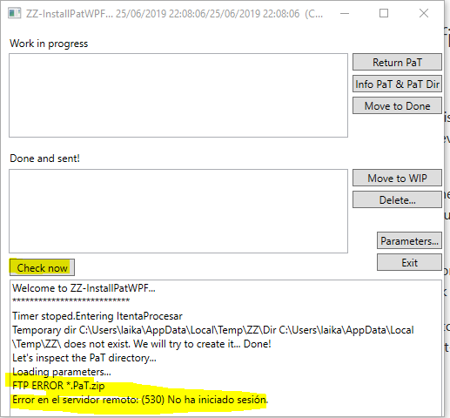

CORRECT!

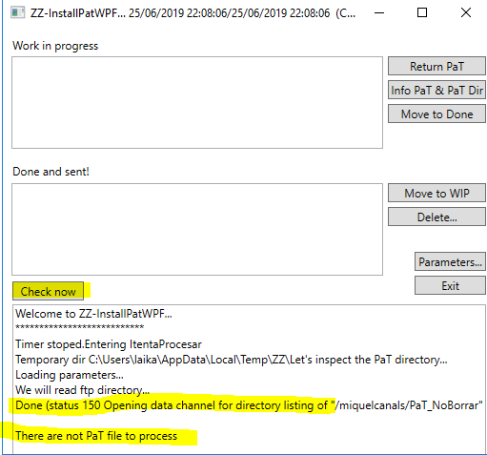

If a Pat is available it will be downloaded and you will be warned. i.e.

ZZ-Pat allow some control of the ftp pats. For an FTP server,

- ZZPAT will read all Pat.zip files and display them
- There will be the "CURRENT Pat" where you will be able to:

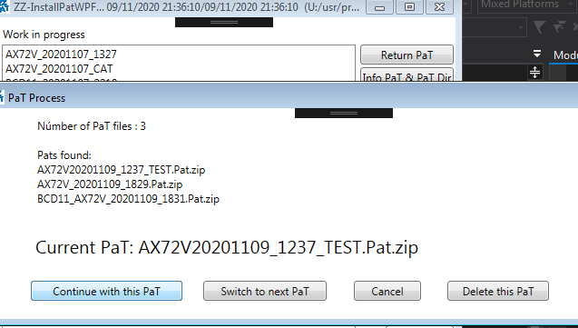

"Continue with this PaT" -> Procedure will continue with the CURRENT PaT
"Switch to next Pat" -> Will switch to the net Pat.zip from the list starting from the CURRENT PaT
"Cancel" -> Cancel and exits to previous one
"Delete" -> Will delete the PaT from the FTP SERVER (If you delete it, by mistake, Project Manager will have to resent it again).

The "Continue with this PaT" will download the pat and start the PaT installation.

