Problem 1

P&H
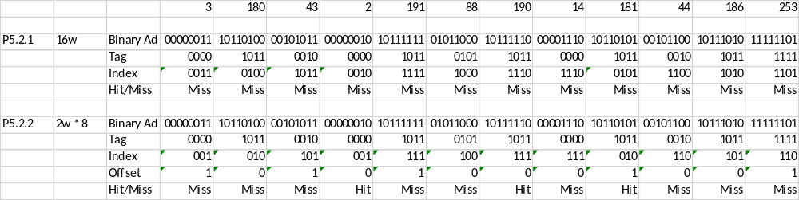

Tag Index Offset
31-10 9-5 4-0

5.3.1 The block size is 2^#OffsetBits otherwise 2^5 = 32B or 8 Words

5.3.2 The cache has 2^#IndexBits entries. 2^5 = 32 Lines

Problem 2

Fill in the following table:

Address Bits | Cache Size | Block Size | Associativity | Tag Bits | Index Bits | Offset Bits | Bits Per Row
16 | 4KB | 4B | 1 | 4 | 10 | 2 | 37
16 | 16KB | 8B | 2 | 3 | 10 | 3 | 132
16 | 32KB | 8B | 4 | 3 | 10 | 3 | 260
16 | 2KB | 4B | 2 | 6 | 8 | 2 | 71
32 | 8KB | 8B | 1024 | XXX | XXX | 3 | XXX
32 | 32KB | 16B | 2 | 18 | 10 | 4 | 275
32 | 64KB | 16B | 1 | 16 | 12 | 4 | 146
32 | 512KB | 128B | 4 | 15 | 10 | 7 | 4112
64 | 512KB | 256B | 2 | 46 | 10 | 8 | 4143
64 | 256GB | 256B | 1 | 26 | 30 | 8 | 2075
64 | 2MB | 64B | 2 | 44 | 14 | 6 | 1069
64 | 2MB | 128B | 1 | 43 | 14 | 7 | 1068
64 | 4MB | 32B | 2 | 43 | 16 | 5 | 556

