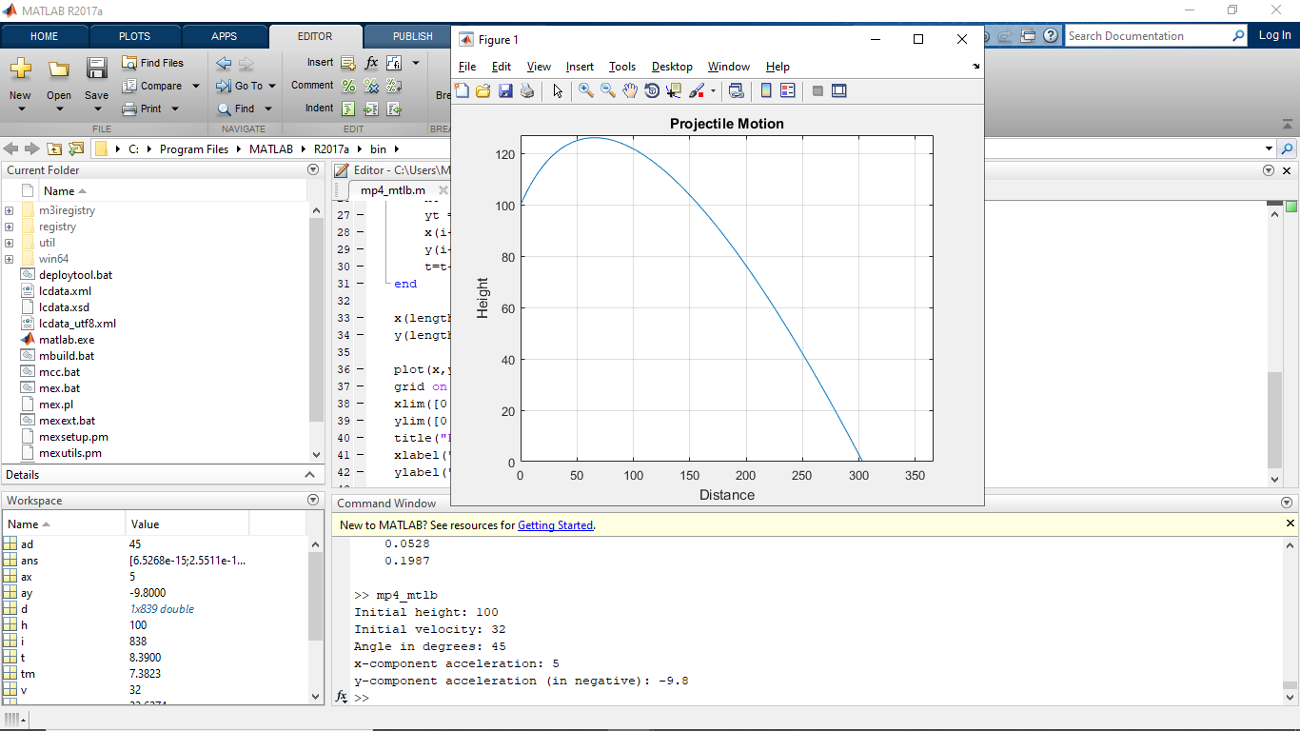Lim, Francis  
Monoso, Jose Miguel  
2ECE – C

Problem 4: Matlab