**RMI US Program Technical Assessment**

Analysis Team Associate/Senior Associate (Summer 2022)

Submission by: Miguel Moravec

# Answered Questions

1. Using the national data provided, develop a downscaled (i.e. Arizona’s) estimate of the following (your result should be a time series that runs through 2030):
   1. LDV stock
      1. 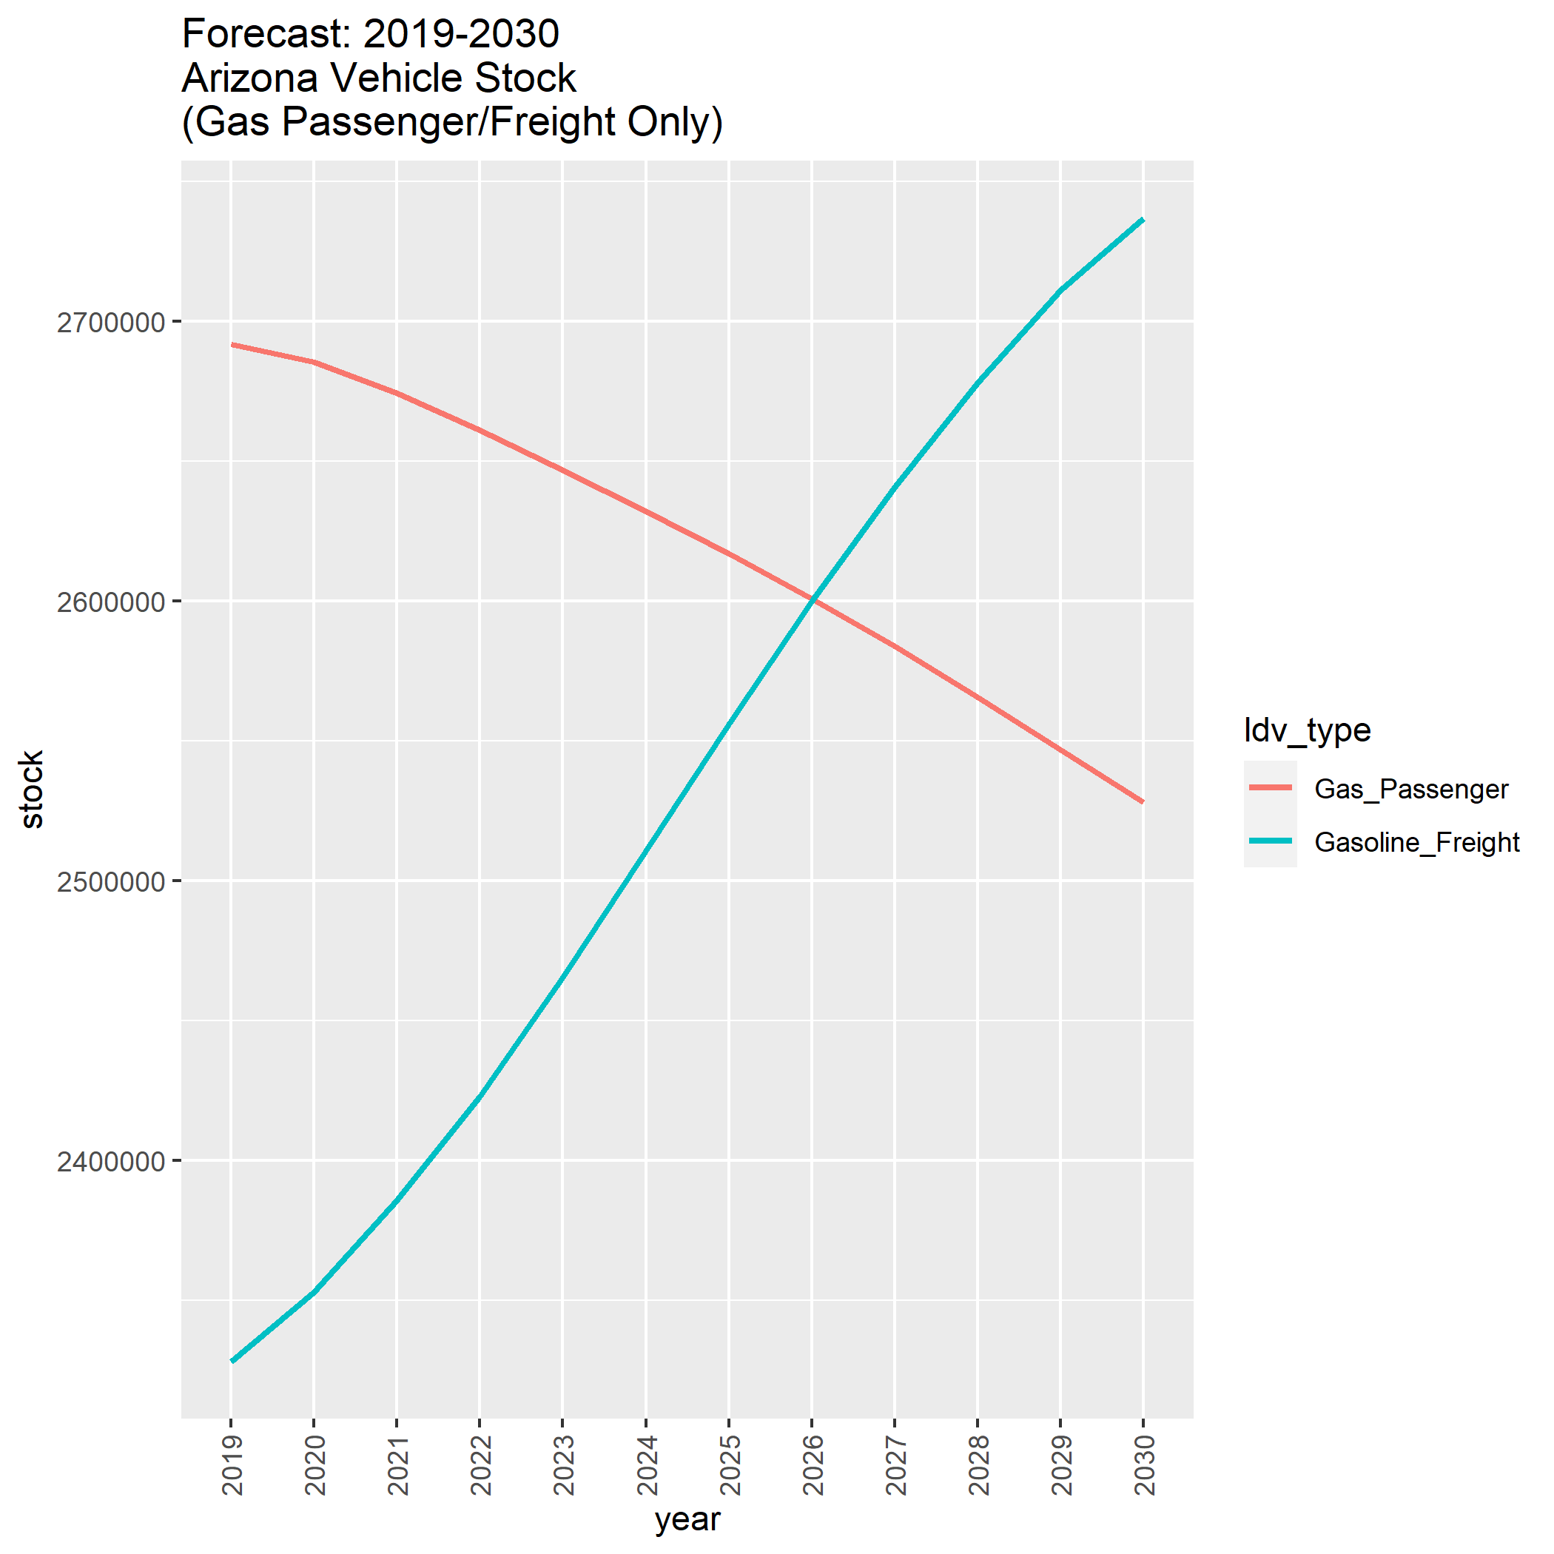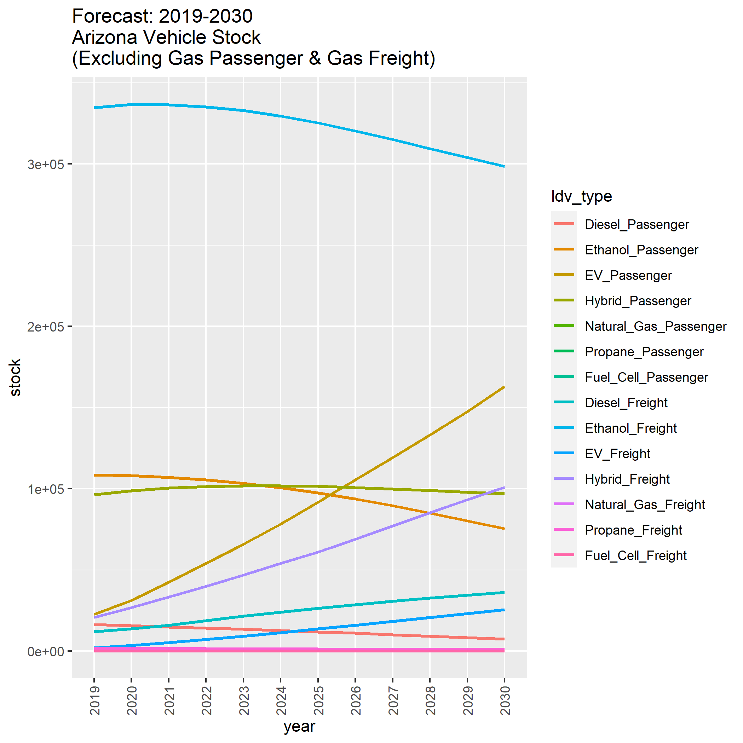Complete, time series available in Appendix A and R Notebook ‘50-RMI-Answers’
   2. Fuel consumption in BTU
      1. Complete, time series available in Appendix A and R Notebook ‘50-RMI-Answers’

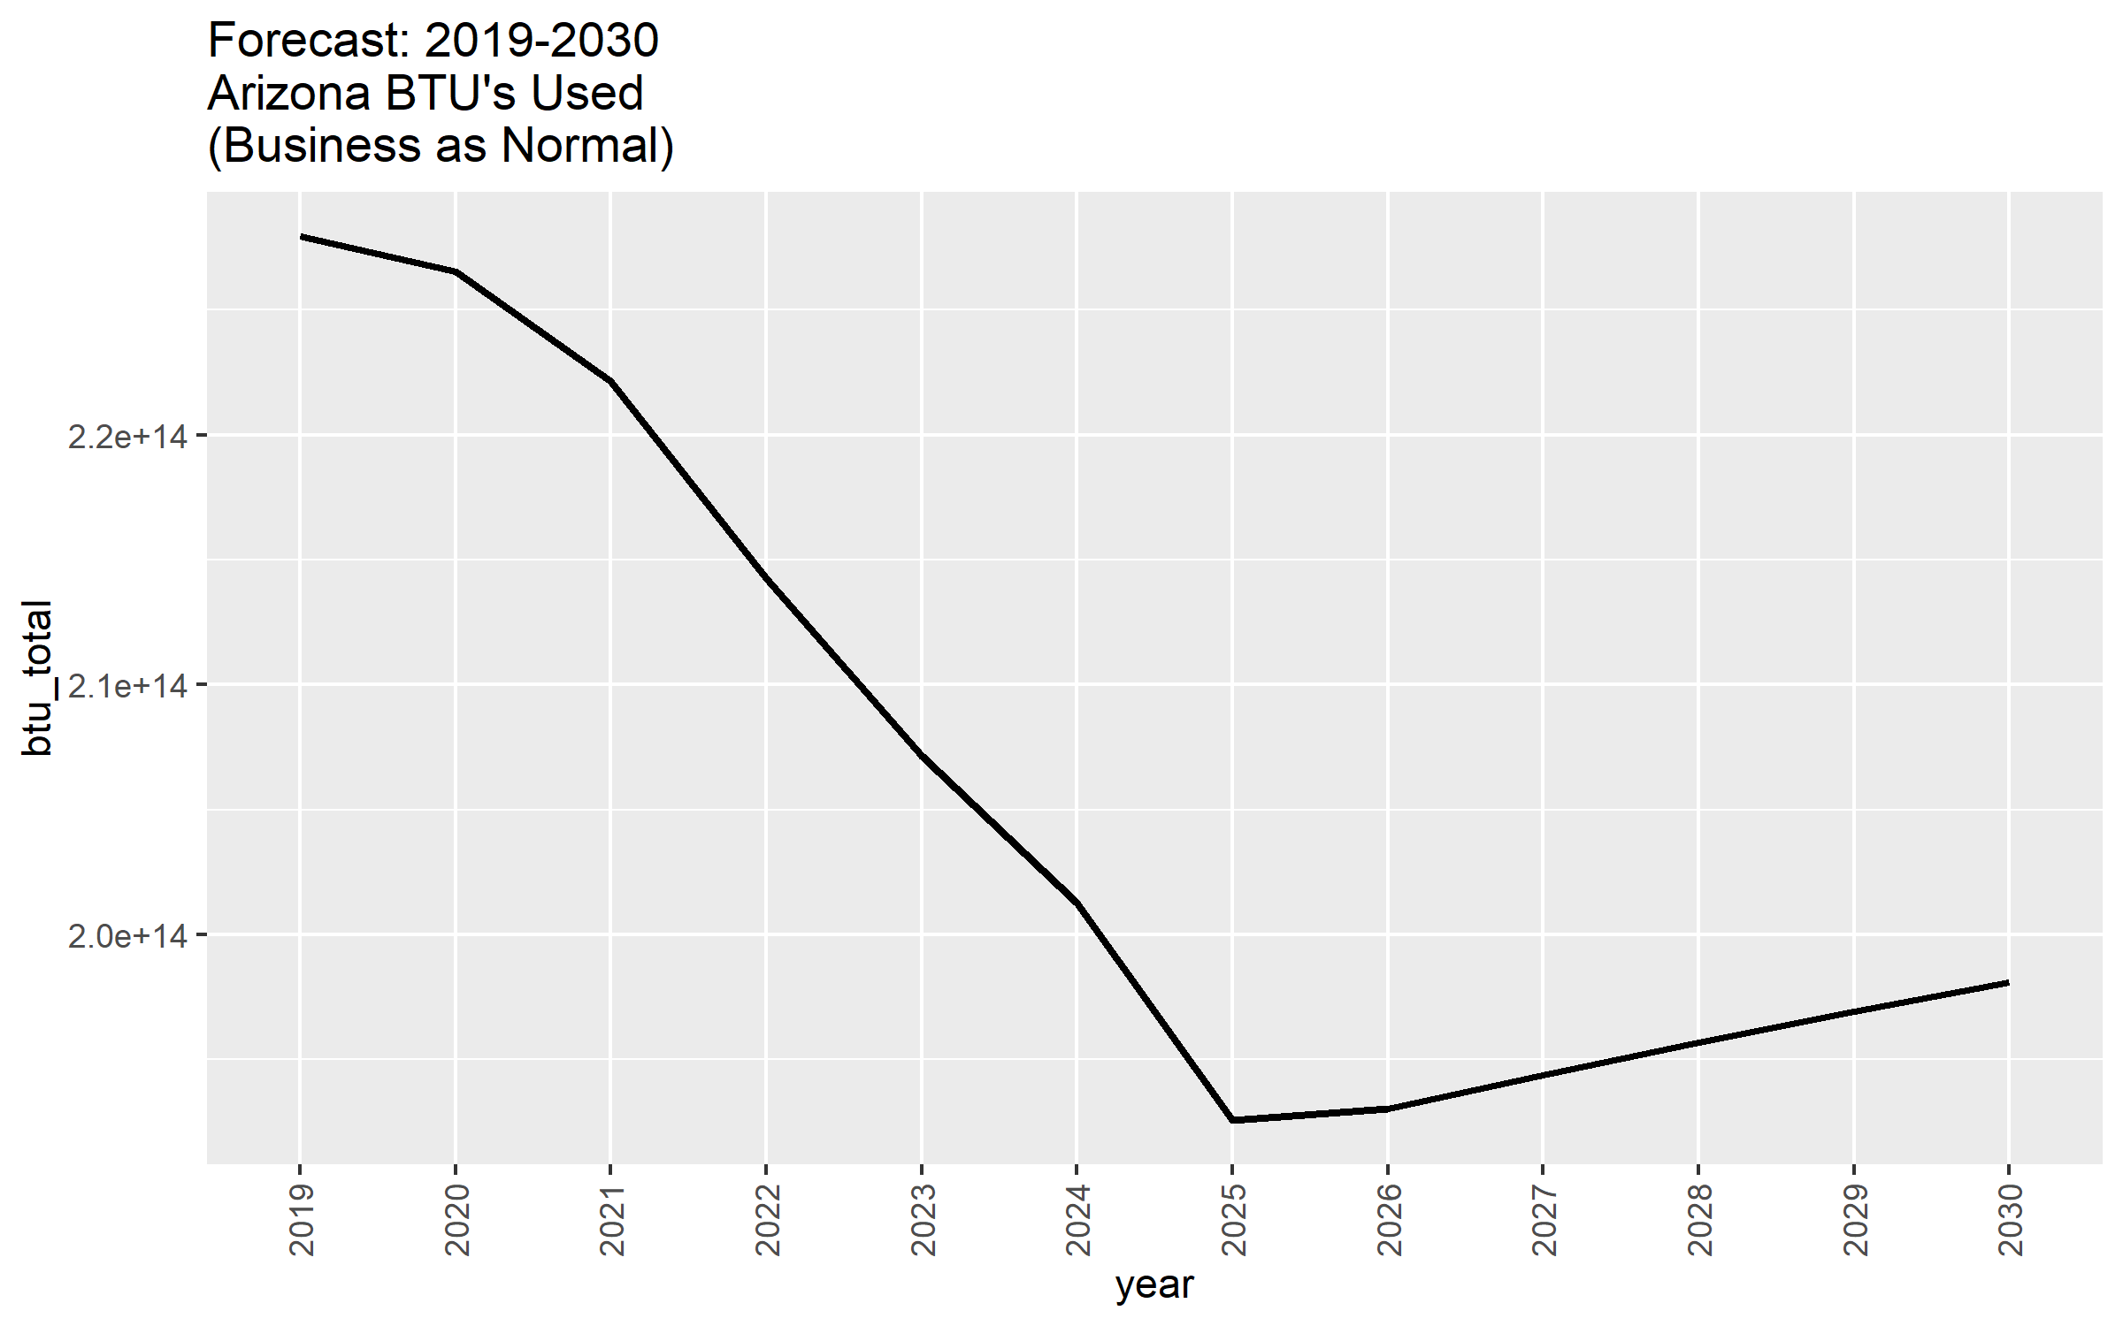

* 1. Tailpipe GHG Emissions (i.e. ignore power sector emissions)
     1. Complete, time series available in Appendix A and notebooks

1. How did you choose to downscale the data to Arizona? Why did you choose this methodology?
   1. I started with the simple assumption that AZ represented a 1/50th (0.20) proportion of the US in regards to
      1. Stock
         1. 0.20 of US fleet
      2. Fuel Consumption
         1. 0.20 of US fuel use
      3. Tailpipe Emissions
         1. 0.20 of US tailpipe
   2. I challenged this assumption by finding public agency data that revealed in 2019, Arizona in fact had these proportions:
      1. State Stock
         1. AZ had 0.22 of US fleet
      2. State EV Stock
         1. AZ had 0.28 of US EV fleet
      3. State VMT
         1. AZ had 0.23 of US VMT
   3. Foundation: Using this updated information, I established data driven, foundational values for AZ for the year 2019:
      1. State Stock
         1. AZ had ~5,637,901 LDV vehicles
            1. 0.22 of RMI provided US LDV fleet
            2. Following national proportions for LDV type

Except for EVs

* + 1. State EV Fleet
       1. AZ had ~24639 EV’s
          1. 0.28 of RMI provided US LDV EV types
          2. Since AZ has more EV’s than average, I subtracted a proportionate number of equivalent ICE vehicles from the stock count such that AZ still represented 0.22 of US LDV fleet
    2. State VMT
       1. AZ had ~6.5758 x 10^10 miles of VMT
          1. 0.23 of RMI provided US VMT
  1. Forecast: For subsequent years, I simply assumed that each of these proportions remained the same and updated values iteratively to reflect the national, annual increases in each category observed in the provided RMI datasets
     1. Strengths of the technique:
        1. Simple but founded in reality from foundation
        2. Don’t expect large deviations from national proportions in short 11 year time frame
           1. Leading states will continue leading while laggards lag
        3. Can calculate Fuel Consumption and Emissions from State VMT and Stock
           1. Assume each LDV vehicle travels equal portion of state’s annual VMT
           2. Convert miles travelled to Consumption, Emissions based on RMI provided LDV type information
        4. Use of federal data allows this model to be applied to all 50 states
           1. Can verify efficacy of model with known data from other states
           2. Can transfer to RMI clients in other states
           3. The code as its written now allows user to select any of the 50 states

Results work best in states similar to AZ for now

1. Given the downscaling method you chose, what are the potential weaknesses of this estimate? Where might your approach overestimate or underestimate the real numbers?
   1. My approach generates reasonable values for state stock and VMT per LDV as compared to present day
      1. These values are conservative as time goes on, would be underestimates in the event that EV stock/other forecasts increased more quickly than RMI provided resources expected
   2. My approach slightly underestimates its ‘foundational’ emissions values for 2019, only accounting for 60% of estimates of AZ 2019 observed transportation emissions
      1. This is even after accounting for the fact the LDV emissions account for approximately [~58%](https://www.c2es.org/content/regulating-transportation-sector-carbon-emissions/) of reported state transportation sector emissions
      2. I suspect my simplification of the VMT to fuel use/emissions conversion is not capturing situations where vehicles do no perform as they are rated, such as during traffic or weather conditions that consume more fuel
      3. If this underestimate is consistently observed at ~40% across a diverse range of states that I apply the model too, I could resolve the underestimate by applying a 1.4x factor to emissions values forecasted for 2019 and all subsequent years
2. Arizona has decided to set a goal that by 2030, 45% of light-duty vehicle stock will be zero-emission vehicles. Estimate the following outcomes for 2030:
   1. Stock of zero-emission vehicles on the road
      1. Total Zero Emissions Vehicles
         1. 2,732,706
      2. By category:
         1. Cars_100_mile_ev
            1. 64,055
         2. Cars_200_mile_ev
            1. 508,695
         3. Cars_300_mile_ev
            1. 1,789,275
         4. light_trucks_100_mile_ev
            1. 4,558
         5. light_trucks_200_mile_ev
            1. 346,597
         6. light_trucks_300_mile_ev
            1. 19,527
      3. Full stock time series available in Appendix B and R notebook

* 1. Tailpipe GHG emissions
     1. 8,370,656,535 kg CO2
     2. 8.37 Million Metric Tons
     3. Available by LDV type in Appendix B and R notebook

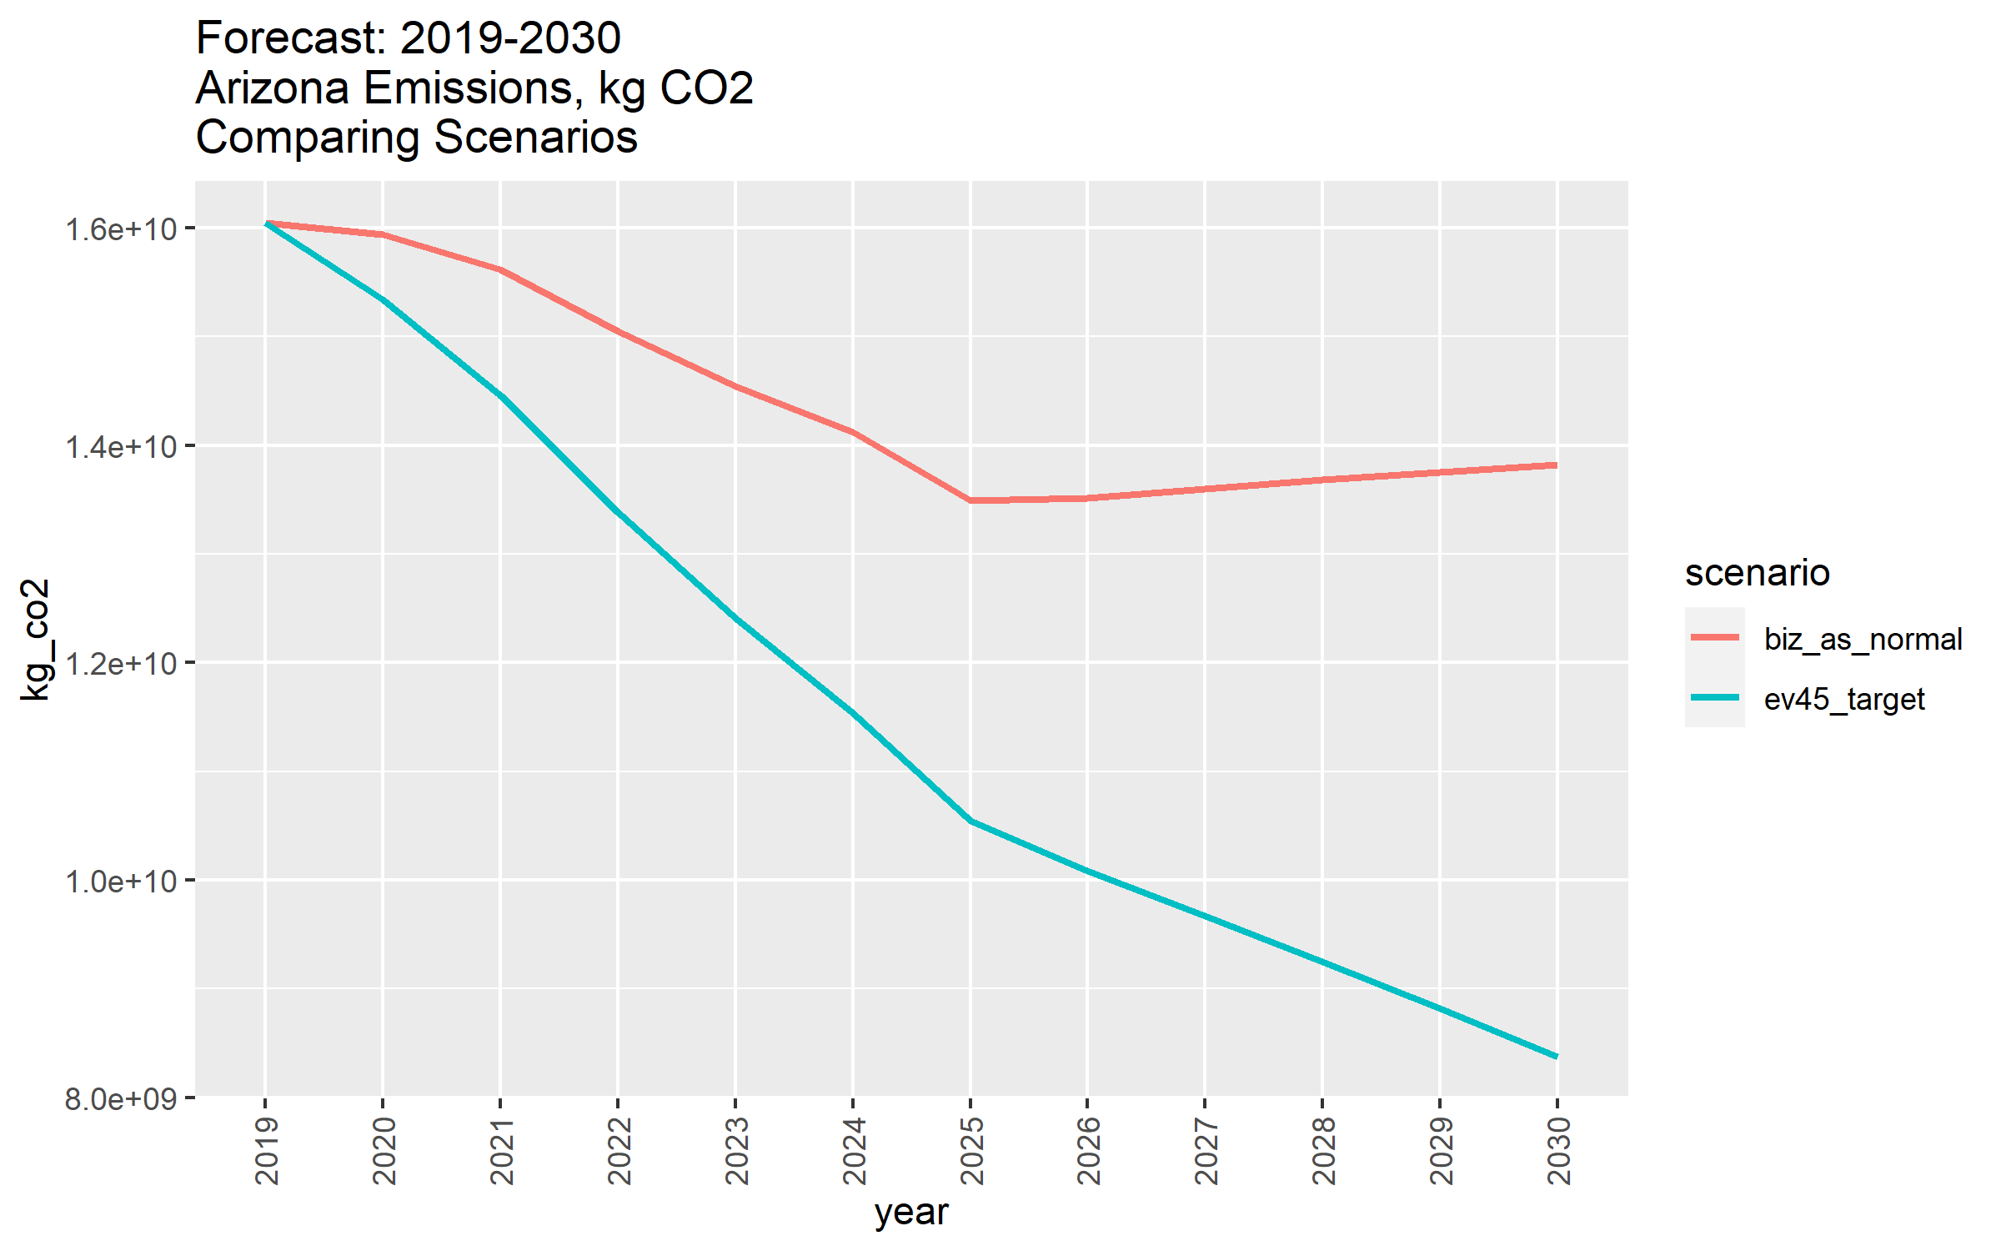

1. What other policies would you consider important for Arizona to consider in their efforts to decarbonize the transportation sector? Why?
   1. ‘Aggressiveness’ of 2030 Target Implementation
      1. Emissions could vary greatly depending on how the 2030 target is implemented.
      2. Policymakers should consider how front-loaded, incremental, and back-loaded EV fleet changes will affect emissions generated before 2030
      3. This point could be impactfully communicated with a dynamic data dashboard, similar to EPS
   2. Infrastructure
      1. Arizona already [leads](https://afdc.energy.gov/data/10366) most states in Electric Vehicle Supply Equipment (EVSE) Ports. AZ should renew its investments in ESVE to handle 2030’s expected EV capacity.
      2. AZ is set to receive [$76.5 million](https://azdot.gov/planning/transportation-studies/arizona-electric-vehicle-program) in federal dollars to do this through the National Electric Vehicle Infrastructure (NEVI) program and is submitting an initial EVSE plan by August 2022
      3. We should reward our AZ partners for leveraging this opportunity
   3. Laws and Incentives
      1. Arizona again leads most states in terms of EV incentives, featuring [25 on the book polices](https://afdc.energy.gov/laws/state_summary?state=az). AZ should expand its lead, especially as federal funds become available, with additional policies in areas such as:
         1. Exemptions
         2. Fuel Discounts
         3. Grants
         4. HOV Access
         5. Loans
         6. Rebates
         7. Tax Incentives
         8. Technical Assistance
      2. A data dashboard such as EPS that visually depicts how the above incentives might improve EV stock/generate long term revenue would be a compelling way to engage AZ state partners

# APPENDIX A: Business as Normal Forecasts

## LDV stock (Vehicle Units)

conventional_cars_gasoline

2019-01-01 2691882

2020-01-01 2685629

2021-01-01 2674494

2022-01-01 2661137

2023-01-01 2646907

2024-01-01 2632135

2025-01-01 2617052

2026-01-01 2600770

2027-01-01 2584006

2028-01-01 2565795

2029-01-01 2546823

2030-01-01 2528160

conventional_cars_tdi_diesel

2019-01-01 16433.605

2020-01-01 15691.924

2021-01-01 14936.924

2022-01-01 14185.721

2023-01-01 13429.405

2024-01-01 12658.961

2025-01-01 11859.884

2026-01-01 11020.021

2027-01-01 10134.040

2028-01-01 9236.365

2029-01-01 8350.275

2030-01-01 7518.003

alternative_fuel_cars_ethanol_flex_fuel_ice

2019-01-01 108456.79

2020-01-01 108028.00

2021-01-01 107017.55

2022-01-01 105466.74

2023-01-01 103336.37

2024-01-01 100689.18

2025-01-01 97505.05

2026-01-01 93792.93

2027-01-01 89536.46

2028-01-01 84946.64

2029-01-01 80133.07

2030-01-01 75416.87

alternative_fuel_cars_100_mile_electric_vehicle

2019-01-01 5447.546

2020-01-01 5555.964

2021-01-01 5594.606

2022-01-01 5602.453

2023-01-01 5581.085

2024-01-01 5529.516

2025-01-01 5447.744

2026-01-01 5327.754

2027-01-01 5162.432

2028-01-01 4955.843

2029-01-01 4709.709

2030-01-01 4418.893

alternative_fuel_cars_200_mile_electric_vehicle

2019-01-01 6275.228

2020-01-01 6409.331

2021-01-01 6594.016

2022-01-01 6951.729

2023-01-01 7777.717

2024-01-01 9627.814

2025-01-01 13348.274

2026-01-01 17406.660

2027-01-01 21578.742

2028-01-01 25866.411

2029-01-01 30356.265

2030-01-01 35092.761

alternative_fuel_cars_300_mile_electric_vehicle

2019-01-01 10989.62

2020-01-01 19293.31

2021-01-01 30389.71

2022-01-01 41429.86

2023-01-01 52373.98

2024-01-01 63023.00

2025-01-01 72992.41

2026-01-01 82666.48

2027-01-01 92337.23

2028-01-01 102252.14

2029-01-01 112527.83

2030-01-01 123434.75

alternative_fuel_cars_plug_in_10_gasoline_hybrid

2019-01-01 6146.029

2020-01-01 6177.030

2021-01-01 6192.959

2022-01-01 6189.229

2023-01-01 6165.709

2024-01-01 6124.572

2025-01-01 6064.456

2026-01-01 5982.444

2027-01-01 5869.015

2028-01-01 5717.365

2029-01-01 5517.580

2030-01-01 5278.280

alternative_fuel_cars_plug_in_40_gasoline_hybrid

2019-01-01 6557.009

2020-01-01 7912.133

2021-01-01 9032.916

2022-01-01 9947.791

2023-01-01 10716.130

2024-01-01 11394.975

2025-01-01 11916.643

2026-01-01 12409.305

2027-01-01 12901.397

2028-01-01 13408.387

2029-01-01 13941.375

2030-01-01 14565.085

alternative_fuel_cars_electric_diesel_hybrid

2019-01-01 0.00000

2020-01-01 0.00000

2021-01-01 0.00000

2022-01-01 0.00000

2023-01-01 0.00000

2024-01-01 0.00000

2025-01-01 0.00000

2026-01-01 0.00000

2027-01-01 0.00000

2028-01-01 0.00000

2029-01-01 0.00000

2030-01-01 36.66173

alternative_fuel_cars_electric_gasoline_hybrid

2019-01-01 83626.84

2020-01-01 84628.73

2021-01-01 85131.44

2022-01-01 85155.29

2023-01-01 84852.58

2024-01-01 84327.97

2025-01-01 83457.48

2026-01-01 82375.03

2027-01-01 81111.33

2028-01-01 79735.63

2029-01-01 78349.92

2030-01-01 77142.98

alternative_fuel_cars_natural_gas_ice

2019-01-01 419.5147

2020-01-01 380.5712

2021-01-01 359.5746

2022-01-01 340.9695

2023-01-01 324.3828

2024-01-01 309.0687

2025-01-01 294.7858

2026-01-01 282.4116

2027-01-01 271.0686

2028-01-01 261.1518

2029-01-01 252.6610

2030-01-01 245.7938

alternative_fuel_cars_natural_gas_bi_fuel

2019-01-01 1001.2098

2020-01-01 969.2651

2021-01-01 940.5895

2022-01-01 913.4498

2023-01-01 887.0560

2024-01-01 858.8850

2025-01-01 828.3445

2026-01-01 797.4750

2027-01-01 767.0442

2028-01-01 739.1146

2029-01-01 715.1780

2030-01-01 695.5637

alternative_fuel_cars_propane_ice

2019-01-01 102.3720

2020-01-01 105.5753

2021-01-01 108.8004

2022-01-01 111.5429

2023-01-01 114.2635

2024-01-01 116.8085

2025-01-01 119.1342

2026-01-01 121.4818

2027-01-01 123.8732

2028-01-01 126.2866

2029-01-01 128.7878

2030-01-01 131.2889

alternative_fuel_cars_propane_bi_fuel

2019-01-01 185.2833

2020-01-01 184.2740

2021-01-01 184.2082

2022-01-01 183.8791

2023-01-01 183.6158

2024-01-01 183.2648

2025-01-01 182.8260

2026-01-01 182.4091

2027-01-01 182.1239

2028-01-01 181.9264

2029-01-01 181.9923

2030-01-01 182.2775

alternative_fuel_cars_fuel_cell_methanol

2019-01-01 0

2020-01-01 0

2021-01-01 0

2022-01-01 0

2023-01-01 0

2024-01-01 0

2025-01-01 0

2026-01-01 0

2027-01-01 0

2028-01-01 0

2029-01-01 0

2030-01-01 0

alternative_fuel_cars_fuel_cell_hydrogen

2019-01-01 141.4252

2020-01-01 158.4068

2021-01-01 167.0950

2022-01-01 173.1724

2023-01-01 178.6135

2024-01-01 183.7913

2025-01-01 189.5396

2026-01-01 195.9461

2027-01-01 203.1863

2028-01-01 211.2602

2029-01-01 220.1240

2030-01-01 229.7556

conventional_light_trucks_gasoline

2019-01-01 2328070

2020-01-01 2352849

2021-01-01 2385680

2022-01-01 2422680

2023-01-01 2465525

2024-01-01 2511031

2025-01-01 2556268

2026-01-01 2600207

2027-01-01 2640959

2028-01-01 2678160

2029-01-01 2711169

2030-01-01 2736959

conventional_light_trucks_tdi_diesel

2019-01-01 11932.26

2020-01-01 13682.11

2021-01-01 15963.54

2022-01-01 18775.74

2023-01-01 21494.00

2024-01-01 23946.19

2025-01-01 26303.86

2026-01-01 28549.95

2027-01-01 30667.86

2028-01-01 32640.42

2029-01-01 34466.64

2030-01-01 36193.40

alternative_fuel_light_trucks_ethanol_flex_fuel_ice

2019-01-01 334670.9

2020-01-01 336670.8

2021-01-01 336415.8

2022-01-01 335054.4

2023-01-01 332850.5

2024-01-01 329509.9

2025-01-01 325223.9

2026-01-01 320332.9

2027-01-01 314956.0

2028-01-01 309402.3

2029-01-01 303950.6

2030-01-01 298460.3

alternative_fuel_light_trucks_100_mile_electric_vehicle

2019-01-01 4.967839

2020-01-01 11.488129

2021-01-01 20.238300

2022-01-01 31.669976

2023-01-01 46.629947

2024-01-01 65.852099

2025-01-01 90.211448

2026-01-01 120.526558

2027-01-01 157.474864

2028-01-01 201.903155

2029-01-01 254.460638

2030-01-01 314.441654

alternative_fuel_light_trucks_200_mile_electric_vehicle

2019-01-01 1538.958

2020-01-01 3062.137

2021-01-01 4781.856

2022-01-01 6671.441

2023-01-01 8672.803

2024-01-01 10797.571

2025-01-01 12985.932

2026-01-01 15144.797

2027-01-01 17287.658

2028-01-01 19442.402

2029-01-01 21641.461

2030-01-01 23910.296

alternative_fuel_light_trucks_300_mile_electric_vehicle

2019-01-01 382.9188

2020-01-01 403.7781

2021-01-01 432.5690

2022-01-01 470.3641

2023-01-01 518.8287

2024-01-01 579.9670

2025-01-01 656.0935

2026-01-01 750.7365

2027-01-01 865.7871

2028-01-01 1002.7414

2029-01-01 1163.5470

2030-01-01 1347.0748

alternative_fuel_light_trucks_plug_in_10_gasoline_hybrid

2019-01-01 639.4850

2020-01-01 721.2335

2021-01-01 800.2833

2022-01-01 877.1171

2023-01-01 954.6531

2024-01-01 1033.9442

2025-01-01 1112.0945

2026-01-01 1188.9722

2027-01-01 1269.4701

2028-01-01 1356.4841

2029-01-01 1450.9138

2030-01-01 1549.7316

alternative_fuel_light_trucks_plug_in_40_gasoline_hybrid

2019-01-01 730.536

2020-01-01 1187.612

2021-01-01 1655.724

2022-01-01 2090.179

2023-01-01 2490.606

2024-01-01 2858.365

2025-01-01 3324.326

2026-01-01 4416.631

2027-01-01 5711.529

2028-01-01 6998.529

2029-01-01 8258.324

2030-01-01 9500.150

alternative_fuel_light_trucks_electric_diesel_hybrid

2019-01-01 0.0000000

2020-01-01 0.0000000

2021-01-01 0.0000000

2022-01-01 0.0000000

2023-01-01 0.0000000

2024-01-01 0.0000000

2025-01-01 0.0000000

2026-01-01 0.3510399

2027-01-01 0.8117798

2028-01-01 1.3822197

2029-01-01 2.1281796

2030-01-01 3.0935394

alternative_fuel_light_trucks_electric_gasoline_hybrid

2019-01-01 19333.13

2020-01-01 24956.15

2021-01-01 30852.86

2022-01-01 36975.45

2023-01-01 43412.21

2024-01-01 50170.45

2025-01-01 56638.43

2026-01-01 63357.57

2027-01-01 70162.50

2028-01-01 76898.50

2029-01-01 83519.31

2030-01-01 89855.19

alternative_fuel_light_trucks_natural_gas_ice

2019-01-01 337.1958

2020-01-01 306.1068

2021-01-01 292.4382

2022-01-01 280.0640

2023-01-01 269.4012

2024-01-01 260.2083

2025-01-01 251.6079

2026-01-01 244.5871

2027-01-01 238.7072

2028-01-01 233.8365

2029-01-01 228.3954

2030-01-01 224.5997

alternative_fuel_light_trucks_natural_gas_bi_fuel

2019-01-01 843.4392

2020-01-01 851.5570

2021-01-01 858.9947

2022-01-01 862.8781

2023-01-01 866.3007

2024-01-01 868.4070

2025-01-01 868.2095

2026-01-01 867.9462

2027-01-01 866.6737

2028-01-01 865.1379

2029-01-01 862.2857

2030-01-01 857.9196

alternative_fuel_light_trucks_propane_ice

2019-01-01 314.9925

2020-01-01 304.1542

2021-01-01 295.5098

2022-01-01 287.7650

2023-01-01 281.4901

2024-01-01 276.3342

2025-01-01 271.9901

2026-01-01 268.7430

2027-01-01 266.1980

2028-01-01 264.3331

2029-01-01 262.8850

2030-01-01 261.5686

alternative_fuel_light_trucks_propane_bi_fuel

2019-01-01 1438.8907

2020-01-01 1343.7589

2021-01-01 1255.8892

2022-01-01 1170.7182

2023-01-01 1091.8439

2024-01-01 1018.3449

2025-01-01 949.2558

2026-01-01 886.2442

2027-01-01 828.6517

2028-01-01 777.0269

2029-01-01 730.0753

2030-01-01 686.3050

alternative_fuel_light_trucks_fuel_cell_methanol

2019-01-01 0

2020-01-01 0

2021-01-01 0

2022-01-01 0

2023-01-01 0

2024-01-01 0

2025-01-01 0

2026-01-01 0

2027-01-01 0

2028-01-01 0

2029-01-01 0

2030-01-01 0

alternative_fuel_light_trucks_fuel_cell_hydrogen

2019-01-01 0.0000000

2020-01-01 0.1316400

2021-01-01 0.3071599

2022-01-01 0.5704399

2023-01-01 0.8995398

2024-01-01 1.3602797

2025-01-01 1.9965396

2026-01-01 2.8302594

2027-01-01 3.8394992

2028-01-01 5.0900789

2029-01-01 6.6039386

2030-01-01 8.3591383

## Fuel Consumption (Gallons)

conventional_cars_gasoline

2019-01-01 9.418263e+13

2020-01-01 9.340700e+13

2021-01-01 9.096106e+13

2022-01-01 8.666539e+13

2023-01-01 8.261288e+13

2024-01-01 7.980892e+13

2025-01-01 7.554484e+13

2026-01-01 7.498174e+13

2027-01-01 7.464035e+13

2028-01-01 7.431338e+13

2029-01-01 7.399651e+13

2030-01-01 7.375886e+13

conventional_cars_tdi_diesel

2019-01-01 457983133200

2020-01-01 438706348754

2021-01-01 413818821682

2022-01-01 383556392715

2023-01-01 353340996934

2024-01-01 325564031279

2025-01-01 290678107962

2026-01-01 270245825732

2027-01-01 248863155038

2028-01-01 227394226522

2029-01-01 206152147353

2030-01-01 186247483735

alternative_fuel_cars_ethanol_flex_fuel_ice

2019-01-01 3.731028e+12

2020-01-01 3.690492e+12

2021-01-01 3.571093e+12

2022-01-01 3.366579e+12

2023-01-01 3.161986e+12

2024-01-01 2.994704e+12

2025-01-01 2.749804e+12

2026-01-01 2.641940e+12

2027-01-01 2.526267e+12

2028-01-01 2.402921e+12

2029-01-01 2.273510e+12

2030-01-01 2.147726e+12

alternative_fuel_cars_100_mile_electric_vehicle

2019-01-01 68688058711

2020-01-01 70313863015

2021-01-01 69968753638

2022-01-01 68851143119

2023-01-01 66720555151

2024-01-01 64842464988

2025-01-01 62127689880

2026-01-01 60685610157

2027-01-01 58814295065

2028-01-01 56532072151

2029-01-01 53818283212

2030-01-01 50658239668

alternative_fuel_cars_200_mile_electric_vehicle

2019-01-01 72486528162

2020-01-01 74217652183

2021-01-01 75921574751

2022-01-01 78965443655

2023-01-01 86473638974

2024-01-01 105441220774

2025-01-01 142627128977

2026-01-01 185551088836

2027-01-01 230158944340

2028-01-01 276429787059

2029-01-01 325100456590

2030-01-01 377020995811

alternative_fuel_cars_300_mile_electric_vehicle

2019-01-01 1.278852e+11

2020-01-01 2.262782e+11

2021-01-01 3.553508e+11

2022-01-01 4.775307e+11

2023-01-01 5.917586e+11

2024-01-01 7.026867e+11

2025-01-01 7.884701e+11

2026-01-01 8.927304e+11

2027-01-01 9.981987e+11

2028-01-01 1.107509e+12

2029-01-01 1.221645e+12

2030-01-01 1.345294e+12

alternative_fuel_cars_plug_in_10_gasoline_hybrid

2019-01-01 141553768422

2020-01-01 143598041819

2021-01-01 143351667532

2022-01-01 139982154334

2023-01-01 129914407865

2024-01-01 126014198431

2025-01-01 117991141208

2026-01-01 113457179779

2027-01-01 111440292800

2028-01-01 108938648441

2029-01-01 105402159977

2030-01-01 101133406457

alternative_fuel_cars_plug_in_40_gasoline_hybrid

2019-01-01 123630544501

2020-01-01 151199462981

2021-01-01 172690377958

2022-01-01 186607727004

2023-01-01 190961593793

2024-01-01 198544434485

2025-01-01 198948166408

2026-01-01 203463215292

2027-01-01 211473618180

2028-01-01 220137653252

2029-01-01 229345152995

2030-01-01 240362151574

alternative_fuel_cars_electric_diesel_hybrid

2019-01-01 0

2020-01-01 0

2021-01-01 0

2022-01-01 0

2023-01-01 0

2024-01-01 0

2025-01-01 0

2026-01-01 0

2027-01-01 0

2028-01-01 0

2029-01-01 0

2030-01-01 620600000

alternative_fuel_cars_electric_gasoline_hybrid

2019-01-01 2.035714e+12

2020-01-01 2.066467e+12

2021-01-01 2.029023e+12

2022-01-01 1.933649e+12

2023-01-01 1.844558e+12

2024-01-01 1.788780e+12

2025-01-01 1.625340e+12

2026-01-01 1.602618e+12

2027-01-01 1.582031e+12

2028-01-01 1.560491e+12

2029-01-01 1.539491e+12

2030-01-01 1.524632e+12

alternative_fuel_cars_natural_gas_ice

2019-01-01 13782247953

2020-01-01 12394741502

2021-01-01 11399717155

2022-01-01 10349523752

2023-01-01 9410325760

2024-01-01 8716323578

2025-01-01 7797064490

2026-01-01 7465790155

2027-01-01 7174904573

2028-01-01 6928443563

2029-01-01 6719816852

2030-01-01 6557425293

alternative_fuel_cars_natural_gas_bi_fuel

2019-01-01 35101643506

2020-01-01 33636355205

2021-01-01 31792154480

2022-01-01 29533353399

2023-01-01 27467252444

2024-01-01 25856917719

2025-01-01 23595805607

2026-01-01 22698339598

2027-01-01 21858141728

2028-01-01 21110960631

2029-01-01 20479949565

2030-01-01 19979231159

alternative_fuel_cars_propane_ice

2019-01-01 3487483908

2020-01-01 3560471769

2021-01-01 3569440915

2022-01-01 3497005310

2023-01-01 3427231814

2024-01-01 3405035310

2025-01-01 3273197648

2026-01-01 3334824200

2027-01-01 3404953510

2028-01-01 3479673061

2029-01-01 3558092957

2030-01-01 3639031670

alternative_fuel_cars_propane_bi_fuel

2019-01-01 6432612514

2020-01-01 6336731770

2021-01-01 6177972166

2022-01-01 5891887750

2023-01-01 5645067453

2024-01-01 5480325639

2025-01-01 5181397490

2026-01-01 5164048751

2027-01-01 5163066799

2028-01-01 5169991188

2029-01-01 5185820501

2030-01-01 5210660034

alternative_fuel_cars_fuel_cell_methanol

2019-01-01 0

2020-01-01 0

2021-01-01 0

2022-01-01 0

2023-01-01 0

2024-01-01 0

2025-01-01 0

2026-01-01 0

2027-01-01 0

2028-01-01 0

2029-01-01 0

2030-01-01 0

alternative_fuel_cars_fuel_cell_hydrogen

2019-01-01 3648343647

2020-01-01 4133649808

2021-01-01 4377486717

2022-01-01 4495784614

2023-01-01 4544090665

2024-01-01 4603079477

2025-01-01 4634592062

2026-01-01 4782540373

2027-01-01 4956593715

2028-01-01 5155563068

2029-01-01 5376349656

2030-01-01 5626046731

conventional_light_trucks_gasoline

2019-01-01 1.099291e+14

2020-01-01 1.091174e+14

2021-01-01 1.074077e+14

2022-01-01 1.044440e+14

2023-01-01 1.020325e+14

2024-01-01 9.959006e+13

2025-01-01 9.624529e+13

2026-01-01 9.727198e+13

2027-01-01 9.887232e+13

2028-01-01 1.004085e+14

2029-01-01 1.018354e+14

2030-01-01 1.031191e+14

conventional_light_trucks_tdi_diesel

2019-01-01 4.526436e+11

2020-01-01 5.174633e+11

2021-01-01 5.947837e+11

2022-01-01 6.820548e+11

2023-01-01 7.619959e+11

2024-01-01 8.133335e+11

2025-01-01 8.545378e+11

2026-01-01 9.286566e+11

2027-01-01 9.996284e+11

2028-01-01 1.066794e+12

2029-01-01 1.130017e+12

2030-01-01 1.191574e+12

alternative_fuel_light_trucks_ethanol_flex_fuel_ice

2019-01-01 1.570485e+13

2020-01-01 1.553019e+13

2021-01-01 1.507341e+13

2022-01-01 1.435725e+13

2023-01-01 1.367255e+13

2024-01-01 1.295711e+13

2025-01-01 1.211167e+13

2026-01-01 1.185639e+13

2027-01-01 1.166519e+13

2028-01-01 1.147604e+13

2029-01-01 1.129472e+13

2030-01-01 1.112341e+13

alternative_fuel_light_trucks_100_mile_electric_vehicle

2019-01-01 0

2020-01-01 0

2021-01-01 299080389

2022-01-01 546039535

2023-01-01 784550967

2024-01-01 1076517589

2025-01-01 1447513297

2026-01-01 1938714141

2027-01-01 2533258332

2028-01-01 3250370882

2029-01-01 4101030532

2030-01-01 5081493115

alternative_fuel_light_trucks_200_mile_electric_vehicle

2019-01-01 20877819949

2020-01-01 41536891976

2021-01-01 64516690870

2022-01-01 88618102294

2023-01-01 113192782702

2024-01-01 137989975848

2025-01-01 161534998700

2026-01-01 188608818886

2027-01-01 215806667567

2028-01-01 243394332755

2029-01-01 271855711908

2030-01-01 301912692296

alternative_fuel_light_trucks_300_mile_electric_vehicle

2019-01-01 5950833366

2020-01-01 6343612713

2021-01-01 6739046133

2022-01-01 7201348622

2023-01-01 7757787326

2024-01-01 8444499774

2025-01-01 9358195613

2026-01-01 10717188397

2027-01-01 12361732781

2028-01-01 14332529568

2029-01-01 16654845294

2030-01-01 19337240565

alternative_fuel_light_trucks_plug_in_10_gasoline_hybrid

2019-01-01 19423085546

2020-01-01 21933434679

2021-01-01 24177869340

2022-01-01 26197572654

2023-01-01 27420433796

2024-01-01 28732892154

2025-01-01 28339333326

2026-01-01 30102807777

2027-01-01 32069701753

2028-01-01 34325477101

2029-01-01 36765744937

2030-01-01 39330573978

alternative_fuel_light_trucks_plug_in_40_gasoline_hybrid

2019-01-01 18961762583

2020-01-01 30847475955

2021-01-01 42665595664

2022-01-01 51917639960

2023-01-01 59163428932

2024-01-01 65076498162

2025-01-01 64773259339

2026-01-01 80421063114

2027-01-01 103506389947

2028-01-01 127181928601

2029-01-01 150652242411

2030-01-01 174052992954

alternative_fuel_light_trucks_electric_diesel_hybrid

2019-01-01 0

2020-01-01 0

2021-01-01 0

2022-01-01 0

2023-01-01 0

2024-01-01 0

2025-01-01 0

2026-01-01 8530748

2027-01-01 19748639

2028-01-01 33700316

2029-01-01 52033470

2030-01-01 75860871

alternative_fuel_light_trucks_electric_gasoline_hybrid

2019-01-01 6.284415e+11

2020-01-01 8.073502e+11

2021-01-01 9.689679e+11

2022-01-01 1.112794e+12

2023-01-01 1.260469e+12

2024-01-01 1.404834e+12

2025-01-01 1.432252e+12

2026-01-01 1.584614e+12

2027-01-01 1.756108e+12

2028-01-01 1.930817e+12

2029-01-01 2.104719e+12

2030-01-01 2.274889e+12

alternative_fuel_light_trucks_natural_gas_ice

2019-01-01 15364416569

2020-01-01 13749158600

2021-01-01 12786464004

2022-01-01 11790054506

2023-01-01 10894788837

2024-01-01 10061598791

2025-01-01 9103513486

2026-01-01 8800192935

2027-01-01 8591361407

2028-01-01 8426648025

2029-01-01 8243250069

2030-01-01 8130425037

alternative_fuel_light_trucks_natural_gas_bi_fuel

2019-01-01 41464601774

2020-01-01 41117222742

2021-01-01 40307466975

2022-01-01 38828451305

2023-01-01 37357996189

2024-01-01 35826217268

2025-01-01 34088010331

2026-01-01 33859705992

2027-01-01 33817838119

2028-01-01 33797160897

2029-01-01 33737124369

2030-01-01 33649238018

alternative_fuel_light_trucks_propane_ice

2019-01-01 15000502146

2020-01-01 14231861870

2021-01-01 13439728750

2022-01-01 12523705988

2023-01-01 11703170666

2024-01-01 10955247388

2025-01-01 10155439369

2026-01-01 9987820410

2027-01-01 9898309132

2028-01-01 9843898709

2029-01-01 9808932159

2030-01-01 9794129506

alternative_fuel_light_trucks_propane_bi_fuel

2019-01-01 70849767345

2020-01-01 64986600127

2021-01-01 59012085012

2022-01-01 52765523728

2023-01-01 47163135336

2024-01-01 42090644510

2025-01-01 37352321789

2026-01-01 34639615483

2027-01-01 32394570140

2028-01-01 30408625606

2029-01-01 28611751309

2030-01-01 26961956881

alternative_fuel_light_trucks_fuel_cell_methanol

2019-01-01 0

2020-01-01 0

2021-01-01 0

2022-01-01 0

2023-01-01 0

2024-01-01 0

2025-01-01 0

2026-01-01 0

2027-01-01 0

2028-01-01 0

2029-01-01 0

2030-01-01 0

alternative_fuel_light_trucks_fuel_cell_hydrogen

2019-01-01 0

2020-01-01 4661083

2021-01-01 10493616

2022-01-01 19054713

2023-01-01 29171345

2024-01-01 43023675

2025-01-01 61946968

2026-01-01 88299751

2027-01-01 119892480

2028-01-01 159161602

2029-01-01 206811519

2030-01-01 262379592

## Emissions (kg CO2)

conventional_cars_gasoline

2019-01-01 6654944367

2020-01-01 6600138312

2021-01-01 6427308193

2022-01-01 6123776540

2023-01-01 5837425840

2024-01-01 5639298066

2025-01-01 5337998501

2026-01-01 5298209841

2027-01-01 5274087266

2028-01-01 5250983487

2029-01-01 5228593138

2030-01-01 5211801111

conventional_cars_tdi_diesel

2019-01-01 33945710

2020-01-01 32516915

2021-01-01 30672251

2022-01-01 28429200

2023-01-01 26189635

2024-01-01 24130806

2025-01-01 21545061

2026-01-01 20030621

2027-01-01 18445737

2028-01-01 16854460

2029-01-01 15279997

2030-01-01 13804663

alternative_fuel_cars_ethanol_flex_fuel_ice

2019-01-01 255351525

2020-01-01 252577290

2021-01-01 244405586

2022-01-01 230408692

2023-01-01 216406320

2024-01-01 204957546

2025-01-01 188196575

2026-01-01 180814383

2027-01-01 172897693

2028-01-01 164455941

2029-01-01 155599008

2030-01-01 146990339

alternative_fuel_cars_100_mile_electric_vehicle

2019-01-01 0

2020-01-01 0

2021-01-01 0

2022-01-01 0

2023-01-01 0

2024-01-01 0

2025-01-01 0

2026-01-01 0

2027-01-01 0

2028-01-01 0

2029-01-01 0

2030-01-01 0

alternative_fuel_cars_200_mile_electric_vehicle

2019-01-01 0

2020-01-01 0

2021-01-01 0

2022-01-01 0

2023-01-01 0

2024-01-01 0

2025-01-01 0

2026-01-01 0

2027-01-01 0

2028-01-01 0

2029-01-01 0

2030-01-01 0

alternative_fuel_cars_300_mile_electric_vehicle

2019-01-01 0

2020-01-01 0

2021-01-01 0

2022-01-01 0

2023-01-01 0

2024-01-01 0

2025-01-01 0

2026-01-01 0

2027-01-01 0

2028-01-01 0

2029-01-01 0

2030-01-01 0

alternative_fuel_cars_plug_in_10_gasoline_hybrid

2019-01-01 10002189

2020-01-01 10146638

2021-01-01 10129229

2022-01-01 9891139

2023-01-01 9179752

2024-01-01 8904163

2025-01-01 8337254

2026-01-01 8016884

2027-01-01 7874371

2028-01-01 7697605

2029-01-01 7447717

2030-01-01 7146087

alternative_fuel_cars_plug_in_40_gasoline_hybrid

2019-01-01 8735734

2020-01-01 10683754

2021-01-01 12202302

2022-01-01 13185702

2023-01-01 13493346

2024-01-01 14029150

2025-01-01 14057677

2026-01-01 14376711

2027-01-01 14942726

2028-01-01 15554927

2029-01-01 16205529

2030-01-01 16983990

alternative_fuel_cars_electric_diesel_hybrid

2019-01-01 0.00

2020-01-01 0.00

2021-01-01 0.00

2022-01-01 0.00

2023-01-01 0.00

2024-01-01 0.00

2025-01-01 0.00

2026-01-01 0.00

2027-01-01 0.00

2028-01-01 0.00

2029-01-01 0.00

2030-01-01 45998.87

alternative_fuel_cars_electric_gasoline_hybrid

2019-01-01 143843556

2020-01-01 146016562

2021-01-01 143370775

2022-01-01 136631604

2023-01-01 130336502

2024-01-01 126395162

2025-01-01 114846508

2026-01-01 113240968

2027-01-01 111786341

2028-01-01 110264306

2029-01-01 108780401

2030-01-01 107730516

alternative_fuel_cars_natural_gas_ice

2019-01-01 729218.7

2020-01-01 655805.8

2021-01-01 603159.0

2022-01-01 547593.3

2023-01-01 497900.3

2024-01-01 461180.7

2025-01-01 412542.7

2026-01-01 395015.0

2027-01-01 379624.2

2028-01-01 366583.9

2029-01-01 355545.5

2030-01-01 346953.4

alternative_fuel_cars_natural_gas_bi_fuel

2019-01-01 1857228

2020-01-01 1779700

2021-01-01 1682123

2022-01-01 1562610

2023-01-01 1453292

2024-01-01 1368090

2025-01-01 1248454

2026-01-01 1200969

2027-01-01 1156514

2028-01-01 1116981

2029-01-01 1083594

2030-01-01 1057101

alternative_fuel_cars_propane_ice

2019-01-01 219293.0

2020-01-01 223882.5

2021-01-01 224446.4

2022-01-01 219891.7

2023-01-01 215504.3

2024-01-01 214108.6

2025-01-01 205818.7

2026-01-01 209693.7

2027-01-01 214103.5

2028-01-01 218801.8

2029-01-01 223732.9

2030-01-01 228822.3

alternative_fuel_cars_propane_bi_fuel

2019-01-01 404482.7

2020-01-01 398453.7

2021-01-01 388470.9

2022-01-01 370481.9

2023-01-01 354961.8

2024-01-01 344602.9

2025-01-01 325806.3

2026-01-01 324715.4

2027-01-01 324653.6

2028-01-01 325089.0

2029-01-01 326084.4

2030-01-01 327646.3

alternative_fuel_cars_fuel_cell_methanol

2019-01-01 0

2020-01-01 0

2021-01-01 0

2022-01-01 0

2023-01-01 0

2024-01-01 0

2025-01-01 0

2026-01-01 0

2027-01-01 0

2028-01-01 0

2029-01-01 0

2030-01-01 0

alternative_fuel_cars_fuel_cell_hydrogen

2019-01-01 0

2020-01-01 0

2021-01-01 0

2022-01-01 0

2023-01-01 0

2024-01-01 0

2025-01-01 0

2026-01-01 0

2027-01-01 0

2028-01-01 0

2029-01-01 0

2030-01-01 0

conventional_light_trucks_gasoline

2019-01-01 7767593024

2020-01-01 7710236152

2021-01-01 7589427413

2022-01-01 7380014871

2023-01-01 7209616088

2024-01-01 7037033383

2025-01-01 6800691862

2026-01-01 6873238382

2027-01-01 6986318330

2028-01-01 7094867892

2029-01-01 7195686272

2030-01-01 7286396965

conventional_light_trucks_tdi_diesel

2019-01-01 33549947

2020-01-01 38354382

2021-01-01 44085367

2022-01-01 50553905

2023-01-01 56479135

2024-01-01 60284280

2025-01-01 63338341

2026-01-01 68832024

2027-01-01 74092459

2028-01-01 79070753

2029-01-01 83756836

2030-01-01 88319429

alternative_fuel_light_trucks_ethanol_flex_fuel_ice

2019-01-01 1074839764

2020-01-01 1062886391

2021-01-01 1031624255

2022-01-01 982610050

2023-01-01 935749399

2024-01-01 886784489

2025-01-01 828922663

2026-01-01 811451251

2027-01-01 798365523

2028-01-01 785419855

2029-01-01 773010781

2030-01-01 761286231

alternative_fuel_light_trucks_100_mile_electric_vehicle

2019-01-01 0

2020-01-01 0

2021-01-01 0

2022-01-01 0

2023-01-01 0

2024-01-01 0

2025-01-01 0

2026-01-01 0

2027-01-01 0

2028-01-01 0

2029-01-01 0

2030-01-01 0

alternative_fuel_light_trucks_200_mile_electric_vehicle

2019-01-01 0

2020-01-01 0

2021-01-01 0

2022-01-01 0

2023-01-01 0

2024-01-01 0

2025-01-01 0

2026-01-01 0

2027-01-01 0

2028-01-01 0

2029-01-01 0

2030-01-01 0

alternative_fuel_light_trucks_300_mile_electric_vehicle

2019-01-01 0

2020-01-01 0

2021-01-01 0

2022-01-01 0

2023-01-01 0

2024-01-01 0

2025-01-01 0

2026-01-01 0

2027-01-01 0

2028-01-01 0

2029-01-01 0

2030-01-01 0

alternative_fuel_light_trucks_plug_in_10_gasoline_hybrid

2019-01-01 1372435

2020-01-01 1549816

2021-01-01 1708408

2022-01-01 1851120

2023-01-01 1937528

2024-01-01 2030266

2025-01-01 2002457

2026-01-01 2127064

2027-01-01 2266045

2028-01-01 2425438

2029-01-01 2597868

2030-01-01 2779098

alternative_fuel_light_trucks_plug_in_40_gasoline_hybrid

2019-01-01 1339838

2020-01-01 2179683

2021-01-01 3014751

2022-01-01 3668500

2023-01-01 4180488

2024-01-01 4598305

2025-01-01 4576879

2026-01-01 5682552

2027-01-01 7313762

2028-01-01 8986675

2029-01-01 10645087

2030-01-01 12298584

alternative_fuel_light_trucks_electric_diesel_hybrid

2019-01-01 0.000

2020-01-01 0.000

2021-01-01 0.000

2022-01-01 0.000

2023-01-01 0.000

2024-01-01 0.000

2025-01-01 0.000

2026-01-01 632.299

2027-01-01 1463.769

2028-01-01 2497.867

2029-01-01 3856.721

2030-01-01 5622.808

alternative_fuel_light_trucks_electric_gasoline_hybrid

2019-01-01 44405679

2020-01-01 57047366

2021-01-01 68467270

2022-01-01 78630026

2023-01-01 89064771

2024-01-01 99265547

2025-01-01 101202894

2026-01-01 111968830

2027-01-01 124086564

2028-01-01 136431533

2029-01-01 148719433

2030-01-01 160743665

alternative_fuel_light_trucks_natural_gas_ice

2019-01-01 812931.3

2020-01-01 727468.0

2021-01-01 676531.8

2022-01-01 623811.8

2023-01-01 576443.3

2024-01-01 532359.2

2025-01-01 481666.9

2026-01-01 465618.2

2027-01-01 454568.9

2028-01-01 445853.9

2029-01-01 436150.4

2030-01-01 430180.8

alternative_fuel_light_trucks_natural_gas_bi_fuel

2019-01-01 2193892

2020-01-01 2175512

2021-01-01 2132668

2022-01-01 2054413

2023-01-01 1976612

2024-01-01 1895565

2025-01-01 1803597

2026-01-01 1791517

2027-01-01 1789302

2028-01-01 1788208

2029-01-01 1785031

2030-01-01 1780381

alternative_fuel_light_trucks_propane_ice

2019-01-01 943231.6

2020-01-01 894899.5

2021-01-01 845090.1

2022-01-01 787490.6

2023-01-01 735895.4

2024-01-01 688866.0

2025-01-01 638574.0

2026-01-01 628034.1

2027-01-01 622405.7

2028-01-01 618984.4

2029-01-01 616785.7

2030-01-01 615854.9

alternative_fuel_light_trucks_propane_bi_fuel

2019-01-01 4455033

2020-01-01 4086357

2021-01-01 3710680

2022-01-01 3317896

2023-01-01 2965618

2024-01-01 2646660

2025-01-01 2348714

2026-01-01 2178139

2027-01-01 2036971

2028-01-01 1912094

2029-01-01 1799107

2030-01-01 1695368

alternative_fuel_light_trucks_fuel_cell_methanol

2019-01-01 0

2020-01-01 0

2021-01-01 0

2022-01-01 0

2023-01-01 0

2024-01-01 0

2025-01-01 0

2026-01-01 0

2027-01-01 0

2028-01-01 0

2029-01-01 0

2030-01-01 0

alternative_fuel_light_trucks_fuel_cell_hydrogen

2019-01-01 0

2020-01-01 0

2021-01-01 0

2022-01-01 0

2023-01-01 0

2024-01-01 0

2025-01-01 0

2026-01-01 0

2027-01-01 0

2028-01-01 0

2029-01-01 0

2030-01-01 0

# Appendix B: 45% EV 2030 Target

## LDV Stock (Vehicle Units)

conventional_cars_gasoline

2019-01-01 2691881.5

2020-01-01 2485712.7

2021-01-01 2274662.0

2022-01-01 2061388.8

2023-01-01 1847241.9

2024-01-01 1632554.4

2025-01-01 1417554.7

2026-01-01 1201357.0

2027-01-01 984676.3

2028-01-01 766549.3

2029-01-01 547661.4

2030-01-01 329082.2

conventional_cars_tdi_diesel

2019-01-01 16433.605

2020-01-01 15691.924

2021-01-01 14936.924

2022-01-01 14185.721

2023-01-01 13429.405

2024-01-01 12658.961

2025-01-01 11859.884

2026-01-01 11020.021

2027-01-01 10134.040

2028-01-01 9236.365

2029-01-01 8350.275

2030-01-01 7518.003

alternative_fuel_cars_ethanol_flex_fuel_ice

2019-01-01 108456.79

2020-01-01 108028.00

2021-01-01 107017.55

2022-01-01 105466.74

2023-01-01 103336.37

2024-01-01 100689.18

2025-01-01 97505.05

2026-01-01 93792.93

2027-01-01 89536.46

2028-01-01 84946.64

2029-01-01 80133.07

2030-01-01 75416.87

alternative_fuel_cars_100_mile_electric_vehicle

2019-01-01 5447.546

2020-01-01 10977.429

2021-01-01 16437.536

2022-01-01 21866.848

2023-01-01 27266.946

2024-01-01 32636.841

2025-01-01 37976.535

2026-01-01 43278.010

2027-01-01 48534.153

2028-01-01 53749.029

2029-01-01 58924.361

2030-01-01 64055.010

alternative_fuel_cars_200_mile_electric_vehicle

2019-01-01 6275.228

2020-01-01 49464.045

2021-01-01 92703.444

2022-01-01 136115.871

2023-01-01 179996.573

2024-01-01 224901.384

2025-01-01 271676.558

2026-01-01 318789.658

2027-01-01 366016.453

2028-01-01 413358.836

2029-01-01 460903.404

2030-01-01 508694.614

alternative_fuel_cars_300_mile_electric_vehicle

2019-01-01 10989.62

2020-01-01 170733.31

2021-01-01 333269.72

2022-01-01 495749.86

2023-01-01 658133.99

2024-01-01 820223.00

2025-01-01 981632.41

2026-01-01 1142746.49

2027-01-01 1303857.24

2028-01-01 1465212.15

2029-01-01 1626927.84

2030-01-01 1789274.76

alternative_fuel_cars_plug_in_10_gasoline_hybrid

2019-01-01 6146.029

2020-01-01 6177.030

2021-01-01 6192.959

2022-01-01 6189.229

2023-01-01 6165.709

2024-01-01 6124.572

2025-01-01 6064.456

2026-01-01 5982.444

2027-01-01 5869.015

2028-01-01 5717.365

2029-01-01 5517.580

2030-01-01 5278.280

alternative_fuel_cars_plug_in_40_gasoline_hybrid

2019-01-01 6557.009

2020-01-01 7912.133

2021-01-01 9032.916

2022-01-01 9947.791

2023-01-01 10716.130

2024-01-01 11394.975

2025-01-01 11916.643

2026-01-01 12409.305

2027-01-01 12901.397

2028-01-01 13408.387

2029-01-01 13941.375

2030-01-01 14565.085

alternative_fuel_cars_electric_diesel_hybrid

2019-01-01 0.00000

2020-01-01 0.00000

2021-01-01 0.00000

2022-01-01 0.00000

2023-01-01 0.00000

2024-01-01 0.00000

2025-01-01 0.00000

2026-01-01 0.00000

2027-01-01 0.00000

2028-01-01 0.00000

2029-01-01 0.00000

2030-01-01 36.66173

alternative_fuel_cars_electric_gasoline_hybrid

2019-01-01 83626.84

2020-01-01 84628.73

2021-01-01 85131.44

2022-01-01 85155.29

2023-01-01 84852.58

2024-01-01 84327.97

2025-01-01 83457.48

2026-01-01 82375.03

2027-01-01 81111.33

2028-01-01 79735.63

2029-01-01 78349.92

2030-01-01 77142.98

alternative_fuel_cars_natural_gas_ice

2019-01-01 419.5147

2020-01-01 380.5712

2021-01-01 359.5746

2022-01-01 340.9695

2023-01-01 324.3828

2024-01-01 309.0687

2025-01-01 294.7858

2026-01-01 282.4116

2027-01-01 271.0686

2028-01-01 261.1518

2029-01-01 252.6610

2030-01-01 245.7938

alternative_fuel_cars_natural_gas_bi_fuel

2019-01-01 1001.2098

2020-01-01 969.2651

2021-01-01 940.5895

2022-01-01 913.4498

2023-01-01 887.0560

2024-01-01 858.8850

2025-01-01 828.3445

2026-01-01 797.4750

2027-01-01 767.0442

2028-01-01 739.1146

2029-01-01 715.1780

2030-01-01 695.5637

alternative_fuel_cars_propane_ice

2019-01-01 102.3720

2020-01-01 105.5753

2021-01-01 108.8004

2022-01-01 111.5429

2023-01-01 114.2635

2024-01-01 116.8085

2025-01-01 119.1342

2026-01-01 121.4818

2027-01-01 123.8732

2028-01-01 126.2866

2029-01-01 128.7878

2030-01-01 131.2889

alternative_fuel_cars_propane_bi_fuel

2019-01-01 185.2833

2020-01-01 184.2740

2021-01-01 184.2082

2022-01-01 183.8791

2023-01-01 183.6158

2024-01-01 183.2648

2025-01-01 182.8260

2026-01-01 182.4091

2027-01-01 182.1239

2028-01-01 181.9264

2029-01-01 181.9923

2030-01-01 182.2775

alternative_fuel_cars_fuel_cell_methanol

2019-01-01 0

2020-01-01 0

2021-01-01 0

2022-01-01 0

2023-01-01 0

2024-01-01 0

2025-01-01 0

2026-01-01 0

2027-01-01 0

2028-01-01 0

2029-01-01 0

2030-01-01 0

alternative_fuel_cars_fuel_cell_hydrogen

2019-01-01 141.4252

2020-01-01 158.4068

2021-01-01 167.0950

2022-01-01 173.1724

2023-01-01 178.6135

2024-01-01 183.7913

2025-01-01 189.5396

2026-01-01 195.9461

2027-01-01 203.1863

2028-01-01 211.2602

2029-01-01 220.1240

2030-01-01 229.7556

conventional_light_trucks_gasoline

2019-01-01 2328070

2020-01-01 2321476

2021-01-01 2322933

2022-01-01 2328559

2023-01-01 2340031

2024-01-01 2354163

2025-01-01 2368027

2026-01-01 2380592

2027-01-01 2389970

2028-01-01 2395797

2029-01-01 2397433

2030-01-01 2391849

conventional_light_trucks_tdi_diesel

2019-01-01 11932.26

2020-01-01 13682.11

2021-01-01 15963.54

2022-01-01 18775.74

2023-01-01 21494.00

2024-01-01 23946.19

2025-01-01 26303.86

2026-01-01 28549.95

2027-01-01 30667.86

2028-01-01 32640.42

2029-01-01 34466.64

2030-01-01 36193.40

alternative_fuel_light_trucks_ethanol_flex_fuel_ice

2019-01-01 334670.9

2020-01-01 336670.8

2021-01-01 336415.8

2022-01-01 335054.4

2023-01-01 332850.5

2024-01-01 329509.9

2025-01-01 325223.9

2026-01-01 320332.9

2027-01-01 314956.0

2028-01-01 309402.3

2029-01-01 303950.6

2030-01-01 298460.3

alternative_fuel_light_trucks_100_mile_electric_vehicle

2019-01-01 4.967839

2020-01-01 397.271264

2021-01-01 791.804572

2022-01-01 1189.019384

2023-01-01 1589.762491

2024-01-01 1994.767778

2025-01-01 2404.910263

2026-01-01 2821.008509

2027-01-01 3243.739951

2028-01-01 3673.951378

2029-01-01 4112.291997

2030-01-01 4558.056148

alternative_fuel_light_trucks_200_mile_electric_vehicle

2019-01-01 1538.958

2020-01-01 32397.273

2021-01-01 63452.129

2022-01-01 94676.851

2023-01-01 126013.350

2024-01-01 157473.254

2025-01-01 188996.752

2026-01-01 220490.754

2027-01-01 251968.751

2028-01-01 283458.632

2029-01-01 314992.827

2030-01-01 346596.799

alternative_fuel_light_trucks_300_mile_electric_vehicle

2019-01-01 382.9188

2020-01-01 2056.4813

2021-01-01 3737.9755

2022-01-01 5428.4739

2023-01-01 7129.6418

2024-01-01 8843.4834

2025-01-01 10572.3131

2026-01-01 12319.6594

2027-01-01 14087.4133

2028-01-01 15877.0708

2029-01-01 17690.5797

2030-01-01 19526.8107

alternative_fuel_light_trucks_plug_in_10_gasoline_hybrid

2019-01-01 639.4850

2020-01-01 721.2335

2021-01-01 800.2833

2022-01-01 877.1171

2023-01-01 954.6531

2024-01-01 1033.9442

2025-01-01 1112.0945

2026-01-01 1188.9722

2027-01-01 1269.4701

2028-01-01 1356.4841

2029-01-01 1450.9138

2030-01-01 1549.7316

alternative_fuel_light_trucks_plug_in_40_gasoline_hybrid

2019-01-01 730.536

2020-01-01 1187.612

2021-01-01 1655.724

2022-01-01 2090.179

2023-01-01 2490.606

2024-01-01 2858.365

2025-01-01 3324.326

2026-01-01 4416.631

2027-01-01 5711.529

2028-01-01 6998.529

2029-01-01 8258.324

2030-01-01 9500.150

alternative_fuel_light_trucks_electric_diesel_hybrid

2019-01-01 0.0000000

2020-01-01 0.0000000

2021-01-01 0.0000000

2022-01-01 0.0000000

2023-01-01 0.0000000

2024-01-01 0.0000000

2025-01-01 0.0000000

2026-01-01 0.3510399

2027-01-01 0.8117798

2028-01-01 1.3822197

2029-01-01 2.1281796

2030-01-01 3.0935394

alternative_fuel_light_trucks_electric_gasoline_hybrid

2019-01-01 19333.13

2020-01-01 24956.15

2021-01-01 30852.86

2022-01-01 36975.45

2023-01-01 43412.21

2024-01-01 50170.45

2025-01-01 56638.43

2026-01-01 63357.57

2027-01-01 70162.50

2028-01-01 76898.50

2029-01-01 83519.31

2030-01-01 89855.19

alternative_fuel_light_trucks_natural_gas_ice

2019-01-01 337.1958

2020-01-01 306.1068

2021-01-01 292.4382

2022-01-01 280.0640

2023-01-01 269.4012

2024-01-01 260.2083

2025-01-01 251.6079

2026-01-01 244.5871

2027-01-01 238.7072

2028-01-01 233.8365

2029-01-01 228.3954

2030-01-01 224.5997

alternative_fuel_light_trucks_natural_gas_bi_fuel

2019-01-01 843.4392

2020-01-01 851.5570

2021-01-01 858.9947

2022-01-01 862.8781

2023-01-01 866.3007

2024-01-01 868.4070

2025-01-01 868.2095

2026-01-01 867.9462

2027-01-01 866.6737

2028-01-01 865.1379

2029-01-01 862.2857

2030-01-01 857.9196

alternative_fuel_light_trucks_propane_ice

2019-01-01 314.9925

2020-01-01 304.1542

2021-01-01 295.5098

2022-01-01 287.7650

2023-01-01 281.4901

2024-01-01 276.3342

2025-01-01 271.9901

2026-01-01 268.7430

2027-01-01 266.1980

2028-01-01 264.3331

2029-01-01 262.8850

2030-01-01 261.5686

alternative_fuel_light_trucks_propane_bi_fuel

2019-01-01 1438.8907

2020-01-01 1343.7589

2021-01-01 1255.8892

2022-01-01 1170.7182

2023-01-01 1091.8439

2024-01-01 1018.3449

2025-01-01 949.2558

2026-01-01 886.2442

2027-01-01 828.6517

2028-01-01 777.0269

2029-01-01 730.0753

2030-01-01 686.3050

alternative_fuel_light_trucks_fuel_cell_methanol

2019-01-01 0

2020-01-01 0

2021-01-01 0

2022-01-01 0

2023-01-01 0

2024-01-01 0

2025-01-01 0

2026-01-01 0

2027-01-01 0

2028-01-01 0

2029-01-01 0

2030-01-01 0

alternative_fuel_light_trucks_fuel_cell_hydrogen

2019-01-01 0.0000000

2020-01-01 0.1316400

2021-01-01 0.3071599

2022-01-01 0.5704399

2023-01-01 0.8995398

2024-01-01 1.3602797

2025-01-01 1.9965396

2026-01-01 2.8302594

2027-01-01 3.8394992

2028-01-01 5.0900789

2029-01-01 6.6039386

2030-01-01 8.3591383

## Emissions (kg CO2)

conventional_cars_gasoline

2019-01-01 6654944367

2020-01-01 6108829019

2021-01-01 5466436549

2022-01-01 4743642572

2023-01-01 4073864015

2024-01-01 3497715664

2025-01-01 2891385230

2026-01-01 2447367838

2027-01-01 2009774478

2028-01-01 1568768234

2029-01-01 1124341286

2030-01-01 678402787

conventional_cars_tdi_diesel

2019-01-01 33945710

2020-01-01 32516915

2021-01-01 30672251

2022-01-01 28429200

2023-01-01 26189635

2024-01-01 24130806

2025-01-01 21545061

2026-01-01 20030621

2027-01-01 18445737

2028-01-01 16854460

2029-01-01 15279997

2030-01-01 13804663

alternative_fuel_cars_ethanol_flex_fuel_ice

2019-01-01 255351525

2020-01-01 252577290

2021-01-01 244405586

2022-01-01 230408692

2023-01-01 216406320

2024-01-01 204957546

2025-01-01 188196575

2026-01-01 180814383

2027-01-01 172897693

2028-01-01 164455941

2029-01-01 155599008

2030-01-01 146990339

alternative_fuel_cars_100_mile_electric_vehicle

2019-01-01 0

2020-01-01 0

2021-01-01 0

2022-01-01 0

2023-01-01 0

2024-01-01 0

2025-01-01 0

2026-01-01 0

2027-01-01 0

2028-01-01 0

2029-01-01 0

2030-01-01 0

alternative_fuel_cars_200_mile_electric_vehicle

2019-01-01 0

2020-01-01 0

2021-01-01 0

2022-01-01 0

2023-01-01 0

2024-01-01 0

2025-01-01 0

2026-01-01 0

2027-01-01 0

2028-01-01 0

2029-01-01 0

2030-01-01 0

alternative_fuel_cars_300_mile_electric_vehicle

2019-01-01 0

2020-01-01 0

2021-01-01 0

2022-01-01 0

2023-01-01 0

2024-01-01 0

2025-01-01 0

2026-01-01 0

2027-01-01 0

2028-01-01 0

2029-01-01 0

2030-01-01 0

alternative_fuel_cars_plug_in_10_gasoline_hybrid

2019-01-01 10002189

2020-01-01 10146638

2021-01-01 10129229

2022-01-01 9891139

2023-01-01 9179752

2024-01-01 8904163

2025-01-01 8337254

2026-01-01 8016884

2027-01-01 7874371

2028-01-01 7697605

2029-01-01 7447717

2030-01-01 7146087

alternative_fuel_cars_plug_in_40_gasoline_hybrid

2019-01-01 8735734

2020-01-01 10683754

2021-01-01 12202302

2022-01-01 13185702

2023-01-01 13493346

2024-01-01 14029150

2025-01-01 14057677

2026-01-01 14376711

2027-01-01 14942726

2028-01-01 15554927

2029-01-01 16205529

2030-01-01 16983990

alternative_fuel_cars_electric_diesel_hybrid

2019-01-01 0.00

2020-01-01 0.00

2021-01-01 0.00

2022-01-01 0.00

2023-01-01 0.00

2024-01-01 0.00

2025-01-01 0.00

2026-01-01 0.00

2027-01-01 0.00

2028-01-01 0.00

2029-01-01 0.00

2030-01-01 45998.87

alternative_fuel_cars_electric_gasoline_hybrid

2019-01-01 143843556

2020-01-01 146016562

2021-01-01 143370775

2022-01-01 136631604

2023-01-01 130336502

2024-01-01 126395162

2025-01-01 114846508

2026-01-01 113240968

2027-01-01 111786341

2028-01-01 110264306

2029-01-01 108780401

2030-01-01 107730516

alternative_fuel_cars_natural_gas_ice

2019-01-01 729218.7

2020-01-01 655805.8

2021-01-01 603159.0

2022-01-01 547593.3

2023-01-01 497900.3

2024-01-01 461180.7

2025-01-01 412542.7

2026-01-01 395015.0

2027-01-01 379624.2

2028-01-01 366583.9

2029-01-01 355545.5

2030-01-01 346953.4

alternative_fuel_cars_natural_gas_bi_fuel

2019-01-01 1857228

2020-01-01 1779700

2021-01-01 1682123

2022-01-01 1562610

2023-01-01 1453292

2024-01-01 1368090

2025-01-01 1248454

2026-01-01 1200969

2027-01-01 1156514

2028-01-01 1116981

2029-01-01 1083594

2030-01-01 1057101

alternative_fuel_cars_propane_ice

2019-01-01 219293.0

2020-01-01 223882.5

2021-01-01 224446.4

2022-01-01 219891.7

2023-01-01 215504.3

2024-01-01 214108.6

2025-01-01 205818.7

2026-01-01 209693.7

2027-01-01 214103.5

2028-01-01 218801.8

2029-01-01 223732.9

2030-01-01 228822.3

alternative_fuel_cars_propane_bi_fuel

2019-01-01 404482.7

2020-01-01 398453.7

2021-01-01 388470.9

2022-01-01 370481.9

2023-01-01 354961.8

2024-01-01 344602.9

2025-01-01 325806.3

2026-01-01 324715.4

2027-01-01 324653.6

2028-01-01 325089.0

2029-01-01 326084.4

2030-01-01 327646.3

alternative_fuel_cars_fuel_cell_methanol

2019-01-01 0

2020-01-01 0

2021-01-01 0

2022-01-01 0

2023-01-01 0

2024-01-01 0

2025-01-01 0

2026-01-01 0

2027-01-01 0

2028-01-01 0

2029-01-01 0

2030-01-01 0

alternative_fuel_cars_fuel_cell_hydrogen

2019-01-01 0

2020-01-01 0

2021-01-01 0

2022-01-01 0

2023-01-01 0

2024-01-01 0

2025-01-01 0

2026-01-01 0

2027-01-01 0

2028-01-01 0

2029-01-01 0

2030-01-01 0

conventional_light_trucks_gasoline

2019-01-01 7767593024

2020-01-01 7607425462

2021-01-01 7389813166

2022-01-01 7093302088

2023-01-01 6842648809

2024-01-01 6597418641

2025-01-01 6299893885

2026-01-01 6292719719

2027-01-01 6322359251

2028-01-01 6346844750

2029-01-01 6363002197

2030-01-01 6367637216

conventional_light_trucks_tdi_diesel

2019-01-01 33549947

2020-01-01 38354382

2021-01-01 44085367

2022-01-01 50553905

2023-01-01 56479135

2024-01-01 60284280

2025-01-01 63338341

2026-01-01 68832024

2027-01-01 74092459

2028-01-01 79070753

2029-01-01 83756836

2030-01-01 88319429

alternative_fuel_light_trucks_ethanol_flex_fuel_ice

2019-01-01 1074839764

2020-01-01 1062886391

2021-01-01 1031624255

2022-01-01 982610050

2023-01-01 935749399

2024-01-01 886784489

2025-01-01 828922663

2026-01-01 811451251

2027-01-01 798365523

2028-01-01 785419855

2029-01-01 773010781

2030-01-01 761286231

alternative_fuel_light_trucks_100_mile_electric_vehicle

2019-01-01 0

2020-01-01 0

2021-01-01 0

2022-01-01 0

2023-01-01 0

2024-01-01 0

2025-01-01 0

2026-01-01 0

2027-01-01 0

2028-01-01 0

2029-01-01 0

2030-01-01 0

alternative_fuel_light_trucks_200_mile_electric_vehicle

2019-01-01 0

2020-01-01 0

2021-01-01 0

2022-01-01 0

2023-01-01 0

2024-01-01 0

2025-01-01 0

2026-01-01 0

2027-01-01 0

2028-01-01 0

2029-01-01 0

2030-01-01 0

alternative_fuel_light_trucks_300_mile_electric_vehicle

2019-01-01 0

2020-01-01 0

2021-01-01 0

2022-01-01 0

2023-01-01 0

2024-01-01 0

2025-01-01 0

2026-01-01 0

2027-01-01 0

2028-01-01 0

2029-01-01 0

2030-01-01 0

alternative_fuel_light_trucks_plug_in_10_gasoline_hybrid

2019-01-01 1372435

2020-01-01 1549816

2021-01-01 1708408

2022-01-01 1851120

2023-01-01 1937528

2024-01-01 2030266

2025-01-01 2002457

2026-01-01 2127064

2027-01-01 2266045

2028-01-01 2425438

2029-01-01 2597868

2030-01-01 2779098

alternative_fuel_light_trucks_plug_in_40_gasoline_hybrid

2019-01-01 1339838

2020-01-01 2179683

2021-01-01 3014751

2022-01-01 3668500

2023-01-01 4180488

2024-01-01 4598305

2025-01-01 4576879

2026-01-01 5682552

2027-01-01 7313762

2028-01-01 8986675

2029-01-01 10645087

2030-01-01 12298584

alternative_fuel_light_trucks_electric_diesel_hybrid

2019-01-01 0.000

2020-01-01 0.000

2021-01-01 0.000

2022-01-01 0.000

2023-01-01 0.000

2024-01-01 0.000

2025-01-01 0.000

2026-01-01 632.299

2027-01-01 1463.769

2028-01-01 2497.867

2029-01-01 3856.721

2030-01-01 5622.808

alternative_fuel_light_trucks_electric_gasoline_hybrid

2019-01-01 44405679

2020-01-01 57047366

2021-01-01 68467270

2022-01-01 78630026

2023-01-01 89064771

2024-01-01 99265547

2025-01-01 101202894

2026-01-01 111968830

2027-01-01 124086564

2028-01-01 136431533

2029-01-01 148719433

2030-01-01 160743665

alternative_fuel_light_trucks_natural_gas_ice

2019-01-01 812931.3

2020-01-01 727468.0

2021-01-01 676531.8

2022-01-01 623811.8

2023-01-01 576443.3

2024-01-01 532359.2

2025-01-01 481666.9

2026-01-01 465618.2

2027-01-01 454568.9

2028-01-01 445853.9

2029-01-01 436150.4

2030-01-01 430180.8

alternative_fuel_light_trucks_natural_gas_bi_fuel

2019-01-01 2193892

2020-01-01 2175512

2021-01-01 2132668

2022-01-01 2054413

2023-01-01 1976612

2024-01-01 1895565

2025-01-01 1803597

2026-01-01 1791517

2027-01-01 1789302

2028-01-01 1788208

2029-01-01 1785031

2030-01-01 1780381

alternative_fuel_light_trucks_propane_ice

2019-01-01 943231.6

2020-01-01 894899.5

2021-01-01 845090.1

2022-01-01 787490.6

2023-01-01 735895.4

2024-01-01 688866.0

2025-01-01 638574.0

2026-01-01 628034.1

2027-01-01 622405.7

2028-01-01 618984.4

2029-01-01 616785.7

2030-01-01 615854.9

alternative_fuel_light_trucks_propane_bi_fuel

2019-01-01 4455033

2020-01-01 4086357

2021-01-01 3710680

2022-01-01 3317896

2023-01-01 2965618

2024-01-01 2646660

2025-01-01 2348714

2026-01-01 2178139

2027-01-01 2036971

2028-01-01 1912094

2029-01-01 1799107

2030-01-01 1695368

alternative_fuel_light_trucks_fuel_cell_methanol

2019-01-01 0

2020-01-01 0

2021-01-01 0

2022-01-01 0

2023-01-01 0

2024-01-01 0

2025-01-01 0

2026-01-01 0

2027-01-01 0

2028-01-01 0

2029-01-01 0

2030-01-01 0

alternative_fuel_light_trucks_fuel_cell_hydrogen

2019-01-01 0

2020-01-01 0

2021-01-01 0

2022-01-01 0

2023-01-01 0

2024-01-01 0

2025-01-01 0

2026-01-01 0

2027-01-01 0

2028-01-01 0

2029-01-01 0

2030-01-01 0