I.E.S. San Vicente

San Vicente del Raspeig (Alicante)

2015/2016

Teacher:

José Ignacio Cabanes

Student:

Miguel Moya Ortega

Final proyect

## 1. Introduction

**Project name**

Starbound

**Made by**

Miguel Moya Ortega

**Short description of the project**

This is a "Starbound" game for one or more against the world. There will be 3 difficulty levels. It is a graphical application that uses the SDL graphics library.

## 2. Functionality of the project

After entering the program, a welcome screen will we displayed, where the user can choose between:

• Play alone.

• Play with another player.

• Quit the game.

If the user choose paly alone or with player, he will go to the same world where he can run in the world, breaking stones, build houses… You can die because in the world have so much enemies, you can kill they and then they will drop, or not, items, you can´t kill a friend, but if you active the pvp mode, you can kill him, the game never finish, if you close the game and open again, the world will generate again, but your things will not be lost.

## 3. Screen prototype

The game screen will look like this:

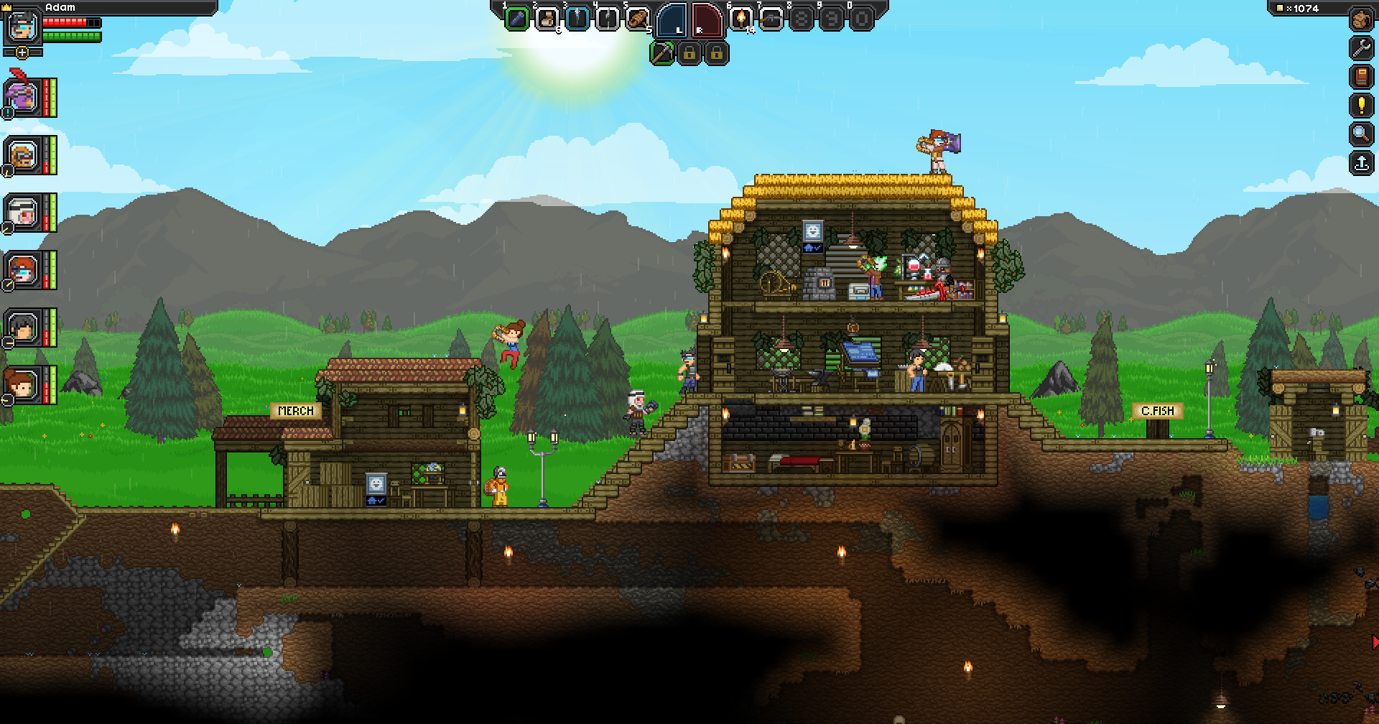

## 4. Analysis

### 4a. Requisites

|  |  |
| --- | --- |
| Requisite | Date achieved |
| The program will allow a player to play in a world, the same world |  |
| The program will allow to play in a multiplayer mode |  |
| The program will allow a player to breaking stones |  |
| The program will allow to quit the game with “ESC” |  |
| The game will use SDL graphics library, and the images will be optimized so that the whole game fits in no more than 5 Mb |  |
| The program will allow to use the mouse |  |
| The intro screen will allow the user to enter a one player or multiplayer or exit the game |  |
| The game can be display a menu options pressing "ESC", and then returned by pressing the same key or clicking continue playing. |  |

### 4b. Basic pseudocode

### 4c. Classes diagram

## 5. Initial planning and expected deliveries

### 5a. Expected deliveries

* **Version 1:** The main menu, Welcome screen, and the GameOverScreen. Still not playable.
* **Version 2:** The Game mode in SDL, can break the stone.
* **Version 3:** Implements the Enemies.
* **Version 4:** Tools in the main game.
* **Version 5:** Implement the house in the map, at top of the map, the bank at base, and to can go at the world again (with animation).
* **Version 6:** Implement the inventory for the player.
* **Version 7-8:** Can drop items when break the stone, save it at inventory.
* **Version 9:** Weapons to the player (melee and range weapons).
* **Version 10:** Rain, randomly in a part of the map (not in all map), snow, and toxic rain, the toxic rain damage the player.
* **Version 11:** Save and load the player, always load at start, and save every X sec.
* **Version 12:** Enemy IA, follow the player, move in a determinate area…
* **Version 13:**  A menu option can change the directory to save the player, change the player with another skin…
* **Version 14-15:** Multiplayer.

### 5b. Real deliveries

## 6. File formats

### 6a. Plain files format

The world saved to a text file with extension “.sb”, which contains the map, as in this example:

………x……….……………………………………………………………………………………………………………

………x…….………………………………………………………………………………………………………………

………x….…………………………………………………________………………………………………………

______________________________________________________________________________________________________________________________________

### 6b. Entity-Relationship Diagram (If needed)

## 7. Problems found and solutions

## 8. Improvements or restrictions to the starting design

## 9. Screenshots of the final project

## 10. Source code of the final project