Exploratory Data Analysis of an IoT-Driven Sports Training Dataset
M. Núñez Robledo
EPS, CEU San Pablo University, Madrid, Spain, miguel.nunezrobledo@usp.ceu.es

Abstract
The increasing integration of wearable technology across various fields, such as health monitoring or lifestyle management, is a growing reality. This trend has also been applied to sports training as a form of tracking physiological and motion signals to gain a better understanding of the athlete`s body, strengths and weaknesses, ultimately for improved performance outcomes.
In this work, an Exploratory Data Analysis was conducted, beginning with a data exploration phase to examine the structure and characteristics of the dataset, followed by data cleaning to avoid potential false patterns or inconsistencies. Subsequent analyses were carried out both individually and between variables to identify strong relationships and determine which variables were key in recognizing a low probability of injury and achieving better athletic performance.

Introduction
In recent years, the integration of Internet of Things (IoT) devices has increased through the development of wearable technologies equipped with sensors that gather, process and provide information which can be used to estimate various physical capacities and conditions, aiming to optimize athletic performance [1].
Beyond simple monitoring, the application of IoT in sports is transforming the way athletes perceive and manage their health. These technologies allow continuous tracking of physiological parameters, offering real-time insights into the athlete’s condition. Such refinements have become key to focusing on injury prevention, fatigue detection and performance optimization using machine learning algorithms [2].
The combination of physiological, motion and contextual information is essential for developing data-driven decision-support systems capable of improving training efficiency and personalization [3].
This study presents an Exploratory Data Analysis (EDA) of an IoT-driven sports training dataset that includes physiological variables, motion signals and contextual information. The main objective of the project is to explore and understand the distributions and relationships among these variables to extract meaningful insights across different types of training, thereby establishing a solid foundation for future research in performance prediction, fatigue detection and injury risk classification.

Exploratory Data Analysis (EDA)
Exploratory Data Analysis (EDA) is a process used to analyze datasets and summarize their main characteristics through various visualization methods. Its principal purpose is to prepare the dataset properly to avoid false assumptions or potential errors, thereby enabling the identification of meaningful patterns within the data to find interesting relationships among variables [4].

3. Methodology

3.1. Data exploration
This is the first step in our data analysis in which the content of the dataset and its main characteristics are examined. During this period, the data types, the presence of all variables and potential missing or inconsistent values are verified [5]. The dataset consists of 500 instances and 23 features. The dataset integrates physiological signals including heart rate (HR), respiratory rate (RR) and body temperature (Temp); motion-related data from accelerometers and gyroscopes that capture linear and angular movement along thee axes, as well as step count (Steps); and session metadata such as age (Age), gender (Gender), sport type (Sport), exercise performed (Exercise) and session duration (Duration). Additionally, it includes advanced features such as Power Spectral Density (PSD) values extracted from selected signals (PSD_HR, PSD_Aceel_X, PSD_Gyro_Y), as well as markers for fatigue (Fatigue) and injury risk (Injury_Risk). The target variable is the overall performance (Performance_Score) of each athlete during the training sessions. A preliminary summary revealed that all columns contain 500 non-null values, indicating a complete dataset with no missing entries.

3.2. Data Cleaning
After the initial exploration, the next step involves removing irrelevant elements and ensuring that each variable has the correct data type.
The columns Athlete_ID and Session_ID were removed from the dataset as they serve only as unique identifiers that do not contribute to the analysis.
Several features initially stored as object data types were converted to more appropriate formats for further analysis. Sport and Exercise were converted into string variables to preserve their textual descriptions as these variables do not follow any hierarchical or ordinal structure. However, some variables were more suitably represented as categorical: Gender was converted into a categorical variable to distinguish these two groups, while Fatigue was transformed into a categorical variable with three levels – Low, Medium, High – representing the fatigue status of each athlete.
Moreover, the variable Injury_Risk, which was originally an integer, was redefined as a categorical variable to more accurately reflect different levels of injury risk. These transformations improved the quality and interpretability of the dataset, ensuring that each feature is represented according to its logical role within the dataset.
Finally, a duplicate check was performed after all data type transformations, confirming that no duplicate records were present in the dataset.
  - Univariate EDA
Before performing analyses involving two or more variables to explore potential relationships, it is essential to first conduct a study and summary of each feature individually. This provides a clear understanding of the data distribution and variability within each variable. A suitable way to represent the distribution of a numerical feature is through visualizations such as histograms, which display the frequency of observations within specific value ranges. In the case of the Age variable, the histogram shown in Figure 1 illustrates the frequency distribution of athletes’ ages across the dataset. It can be observed that the variable is almost evenly distributed but with a few notable peaks at 18, 20, 29 and 33 years old. These four values together account for 33.4% of the entire sample, suggesting that athletes of these ages are slightly more represented than others. The mean of this variable is around 25.75 years, while the median is 25 years, indicating that both measures are nearly equal, which suggests a symmetric distribution. In a field such as sports, where professional careers tend to be shorter, age factor is a key element to analyze as it may influence other aspects of performance [6].

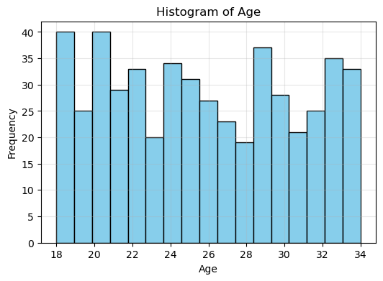
Figure 1. Histogram of Age
Some other aspects to analyze individually are heart rate, respiratory rate and body temperature. This physiological data can be represented using stem plots, which are basically used for highlighting the mode and boxplots, which show how concentrated their values are.
The heart rate (HR) distribution shown in Figure 2 indicates a moderate-to-high variability with a mean of 128.94 bpm, a minimum of 80 bpm and a maximum value of 179 bpm. These relatively high values are consistent with expectations, considering the target heart rate during moderate-intensity exercise typically ranges between 50 and 70% of an individual’s maximum heart rate, which corresponds to approximately 100-170 bpm for individuals within this age range [7]. Regarding the respiratory rate (RR), its distribution appears to be uniform as it is shown in Figure 3. However, the observed values do not align with typical physiological ranges during exercise, which usually fluctuate between 40 and 60 breaths per minute. The maximum value recorded for this feature is 24, suggesting a possible error or calibration issue in the measurement process [8]. In the case of temperature (Temp), the distribution displayed in Figure 4 shows a concentration of values around 36.5 ºC, with some observations extending below 35.5 ºC and above 37.5 ºC. However, scientific evidence shows that athletes typically reach core body temperatures between 38 ºC and 39.5 ºC, and in some cases exceed 40 ºC during high intensity activities [9]. Therefore, the relatively low values recorded do not align with expected physiological values, suggesting that this feature may also have been affected by measurement errors.

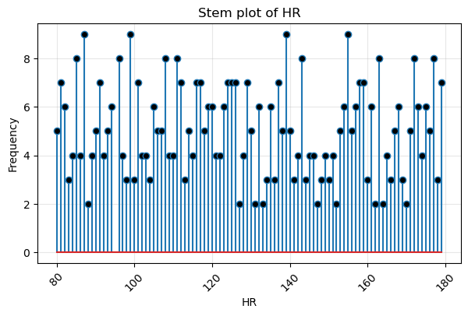
Figure 2. Stem Plot of Heart Rate (HR)
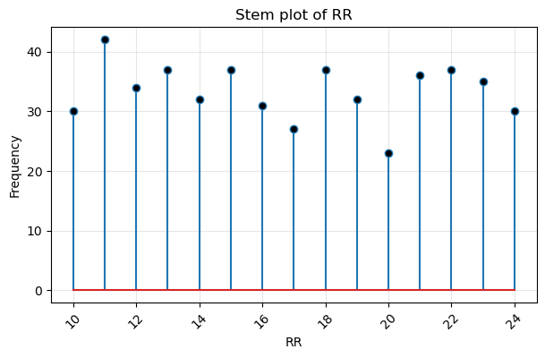
Figure 3. Stem Plot of Respiratory Rate (RR)
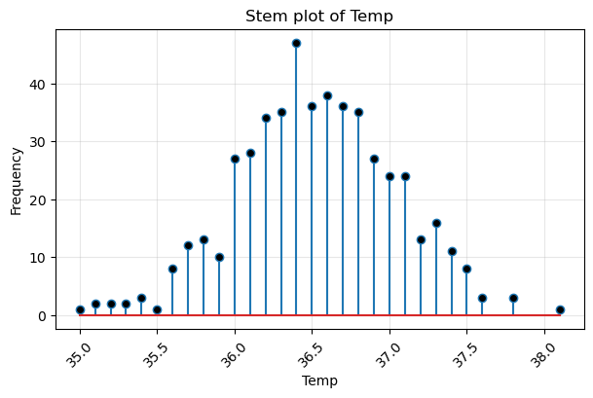
Figure 4. Stem plot of Body Temperature (Temp)
  - Bivariate EDA
This type of analysis is performed to understand the relationships between pairs of variables within the dataset.
In this case, several comparisons were conducted, revealing some interesting patterns. When examining the correlation between numerical variables, a strong relationship was found between heart rate (HR) and the performance (Performance_Score) of the athlete This connection was identified through a correlation matrix, which serves as a graphical tool to measure the strength of relationships between variables using Pearson’s correlation coefficient. This coefficient ranges from -1 to 1, where values closer to these limits indicate stronger relationships [10]. As shown in Figure 5 and Figure 6, the correlation coefficient between HR and Performance_Score is 0.78, indicating a strong linear association. This finding aligns with established physiological principles, which establish that higher heart rates reflect increased physical demand, contributing to improved performance when it is managed appropriately [11].

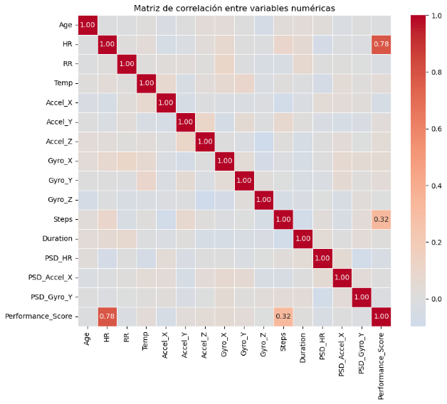

Figure 5. Correlation Matrix of Numerical Variables
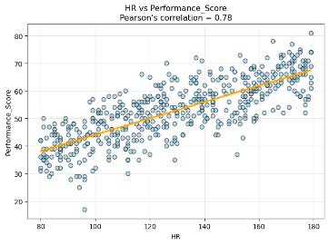
Figure 6. HR vs Performance_Score
Another interesting relationship established after performing nominal-numerical analyses was the one between the injury risk (Injury_Risk) and performance (Performance_Score). As shown in Figure 7 and Figure 8, this relationship was examined using a boxplot and a violin plot. The boxplot displays the distribution of these variables, showing the median, the interquartile range and possible outliers, while the violin plot adds information about the data density across different categories. From these visualizations, it can be observed the higher values are concentrated when injury risk is lower, suggesting that athletes tend to perform better when the probability of injury decreases. Nevertheless, this relationship should not be interpreted as strictly linear. It is well known that maintaining optimal performance requires a balance between adequate training load and recovery, meaning that excessive caution may lead to undertraining and reduced performance, and excessive load increases the probability of an athlete getting an injury [12][13].
After doing the analysis on the variables left, there were not any notable relationships between variables that could be highlighted for a further analysis.

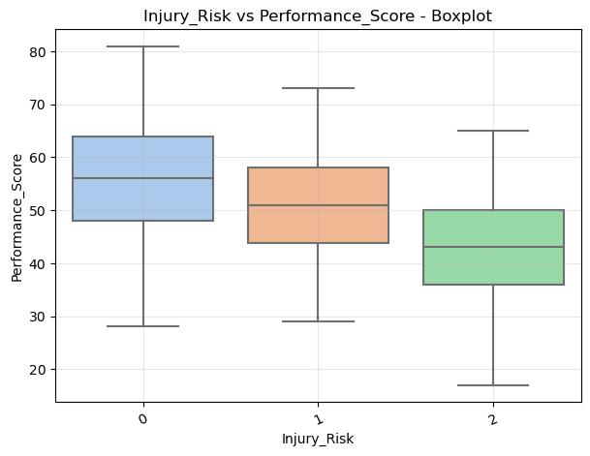
Figure 7. Boxplot of Injury_Risk vs Performance_Score
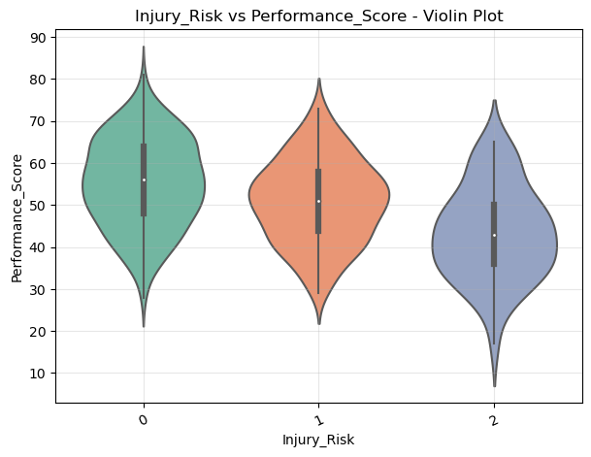
Figure 8. Violin Plot of Injury_Risk vs Performance_Score

Conclusions
This project presented an Exploratory Data Analysis (EDA) which first established that the dataset is complete and well-structured, with no missing values or duplicate entries, and with variables correctly typed and categorized after the data cleaning process.
The univariate analyses showed that physiological variables such as heart rate (HR), respiratory rate (RR) and body temperature (Temp) present standard distributions, although some inconsistencies were detected in their ranges. These discrepancies suggest possible measurement or calibration errors, which should be considered in future model training stages.
Regarding the bivariate analyses, most motion and physiological variables did not show strong relationships with each other. This indicates a relatively homogenous population in terms of physical condition and exercise intensity, which is typical for controlled training environments. However, a strong positive correlation was found between heart rate (HR) and the athlete’s performance (Performance_Score), confirming that higher cardiovascular demand is associated with better training outcomes when adequately managed. Additionally, the relationship between injury risk (Injury_Risk) and performance (Performance_Score) suggested that athletes with a lower probability of injury tend to achieve better training results, reinforcing the importance of balance between training load and recovery.
Overall, the findings of this exploratory analysis provide a solid foundation for future research phases, highlighting both the strengths and limitations of the dataset. Future work should focus on incorporating real-time data, validating physiological ranges and expanding the dataset with additional contextual variables in order to enrich its informational value and enhance the robustness of subsequent analyses.

5. References
[1] Azhagumurugan, Y., Sundaram, J., Dewamuni, Z., Pritika, Y., Sebastian, Y., and Shanmugam, B. “The Role of IoT in Enhancing Sports Analytics: A Bibliometric Perspective.” https://www.mdpi.com/2624-831X/6/3/43 (Accessed: Oct 2025)
[2] Passos, J., Lopes, S. I., Clemente, F. M., and Moreira, P. M. “Wearables and Internet of Things (IoT) Technologies for Fitness Assessment: A Systematic Review.” https://www.researchgate.net/publication/353919663_Wearables_and_Internet_of_Things_IoT_Technologies_for_Fitness_Assessment_A_Systematic_Review (Accessed: Oct 2025)
[3] Li, H. “Intelligent IoT-based Training Decision and Evaluation System for Competitive Aerobics Athletes.” https://link.springer.com/article/10.1007/s10791-025-09709-9 (Accessed: Oct 2025)
[4] Sahoo, K., Samal, A. K., Pramanik, J., and Pani, S. K. “Exploratory Data Analysis using Python.” International Journal of Innovative Technology and Exploring Engineering (IJITEE), vol. 8, no. 12, October 2019. https://www.ijitee.org/wp-content/uploads/papers/v8i12/L35911081219.pdf (Accessed: Oct 2025)
[5] Zheng, C., Zhou, Y. “Multi-modal IoT data fusion for real-time sports event analysis and decision support” https://www.sciencedirect.com/science/article/pii/S1110016825006702 (Accessed: Oct 2025)
[6] ARC Centre of Excellence in Population Ageing Research (CEPAR). “Peak performance Age in Sport” https://cepar.edu.au/sites/default/files/peak-performance-age-sport.pdf (Accessed: Oct 2025)
[7] Iowa Health Care “Target heart rate for exercise” https://uihc.org/health-topics/target-heart-rate-exercise (Accessed: Oct 2025)
[8] European Respiratory Society. “Your lungs and exercise” https://pmc.ncbi.nlm.nih.gov/articles/PMC4818249/ (Accessed: Oct 2025)
[9] Singh, G., Bennett, K. J. M., Taylor, L. and Stevens, C.J. “Core body temperature responses during competitive sporting events: A narrative review” https://pmc.ncbi.nlm.nih.gov/articles/PMC10588574/ (Accessed: Oct 2025)
[10] González, A. “Correlation and Pearson’s coefficient” https://i2pc.es/coss/Docencia/statisticalHelper/correlationCoefficient.pdf (Accessed: Oct 2025)
[11] National Strength and Conditioning Association (NSCA). “Sport Performance and Heart Rate” https://www.nsca.com/education/articles/kinetic-select/sport-performance-and-heart-rate/?srsltid=AfmBOop97wb0sdlep1sM4z-6Fhw8YDjHu_qO1TSrwSZsoBZ8x0rfzL5q (Accessed: Oct 2025)
[12] Clubb, J. Global Performance Insights. “Is there a Tug of War Between Injury Risk and Performance?” https://www.globalperformanceinsights.com/post/is-there-a-tug-of-war-between-injury-risk-and-performance#google_vignette (Accessed: Nov 2025)
[13] Barret, S. HIIT SCIENCE. “Are we doing Performance justice in the world of Sport Science?” https://hiitscience.com/performance-enhancement-injury-prevention/ (Accessed: Nov 2025)

