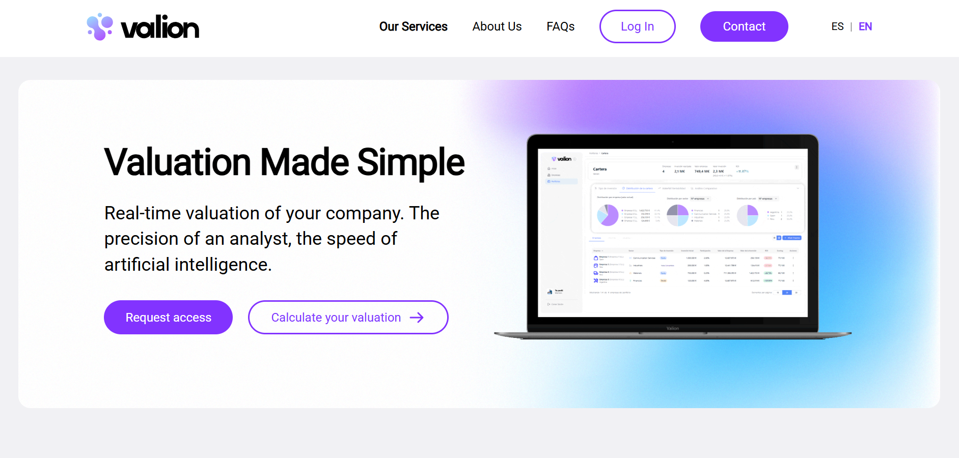

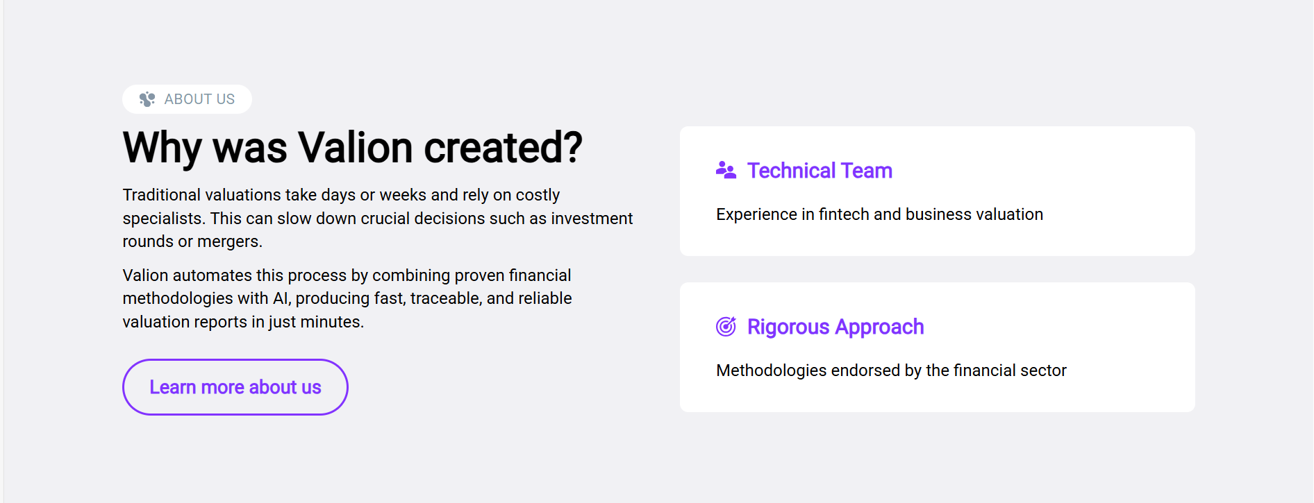
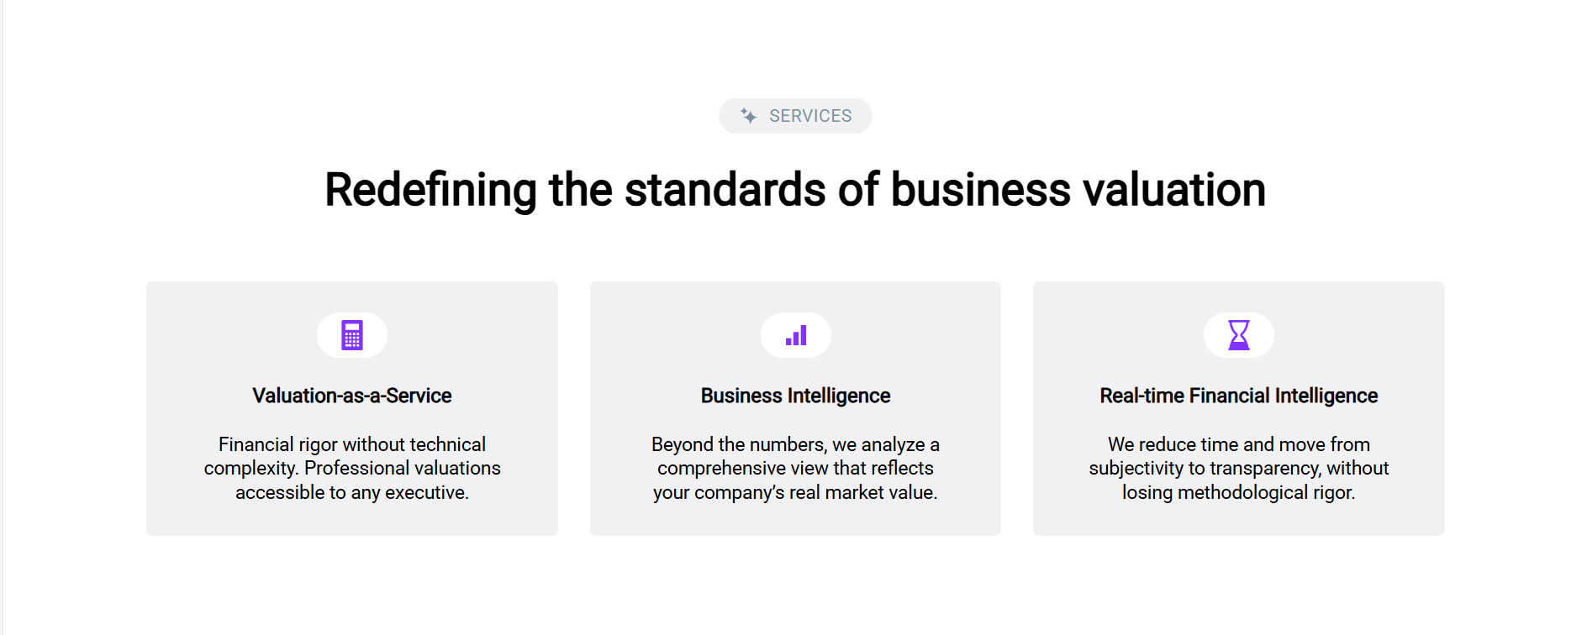
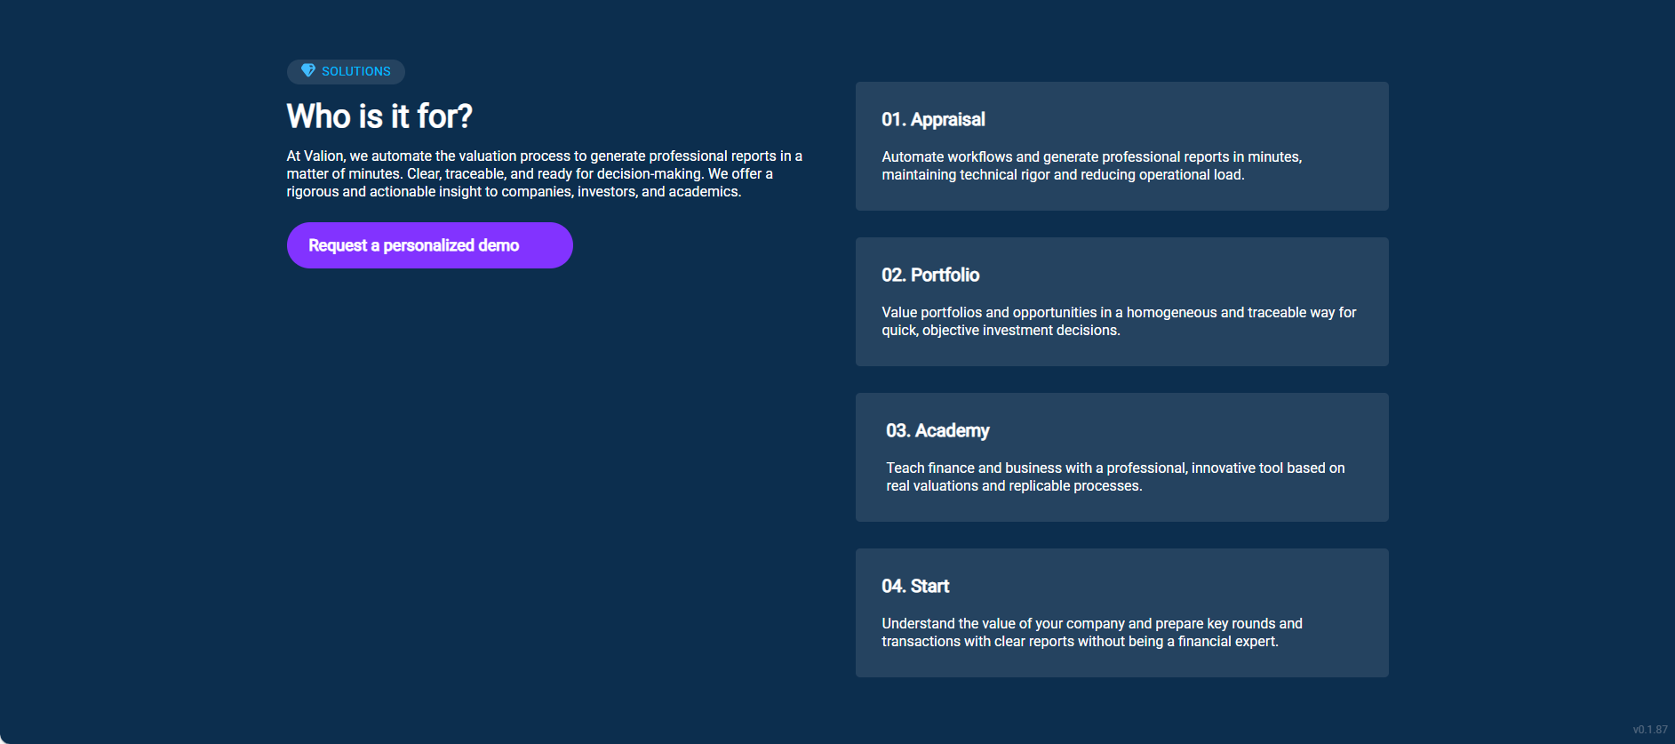
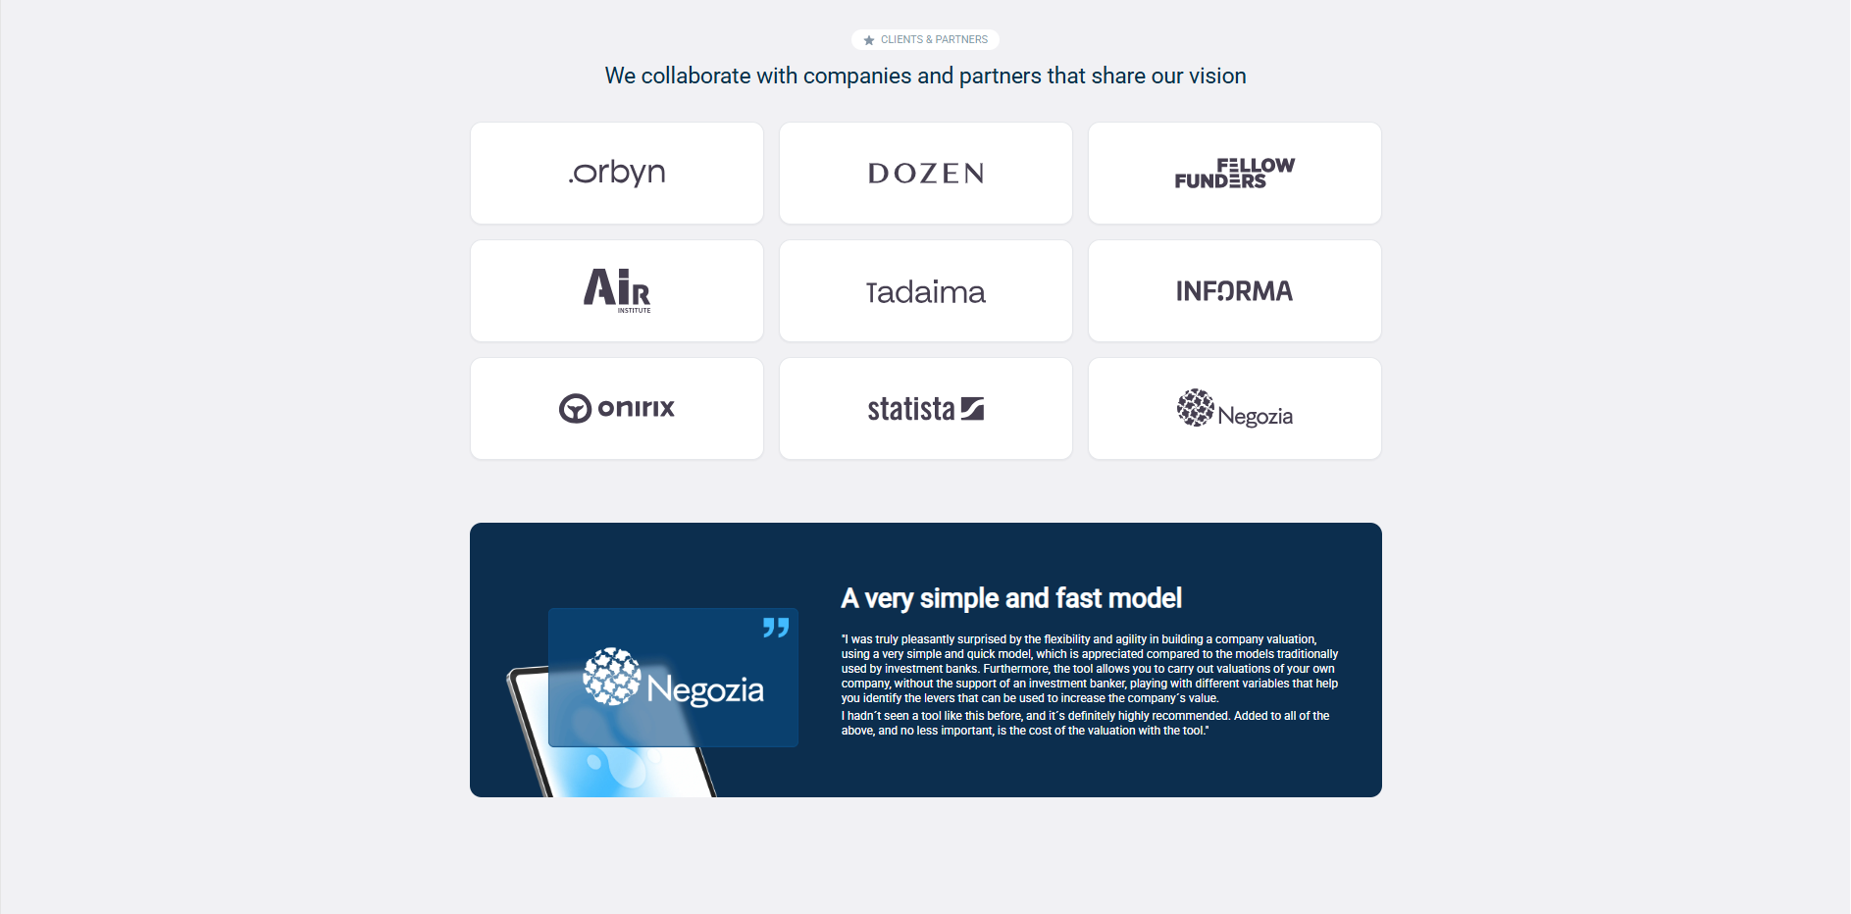
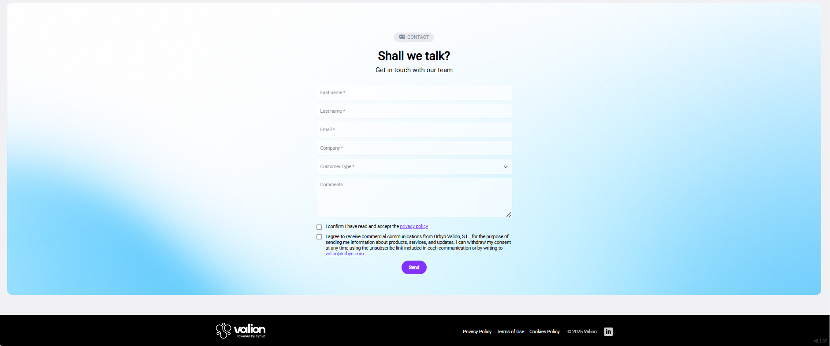

Miguel
Hello everyone, we are Group 7 — Miguel, Diego and Julián.
Today we’re going to talk about a company website called Valion.
It’s a digital platform that helps users calculate the valuation of their companies in real time.
Let’s start by explaining what the website does.
When you open your browser and type the Valion address, you’ll see a very clean and modern website.
On the home page, the slogan says “Valuation Made Simple”.
The platform provides real-time valuation with the precision of an analyst but using the speed of artificial intelligence.
Basically, it helps you execute complex financial calculations automatically, so that companies can know their market value in minutes instead of days.
There are two main buttons on the first page: one to request access, and another to calculate your valuation.
Both are hyperlinks that take you directly to different sections where you can start using the service.

Diego
In the “About Us” section, Valion explains why it was created.
Traditional valuations usually take a long time and depend on expensive specialists.
Valion solves this by combining financial methodology with artificial intelligence.
It produces fast, traceable, and reliable reports.
Then we can see another section called Services, where the company describes two main offers:
- Valuation-as-a-Service, which means anyone can get professional valuations without technical complexity.
- Business Intelligence, which analyzes the company’s data to understand its real market value.
These services help executives and investors make better decisions quickly.

Julián
The next part of the page is called Solutions.
Here we see that Valion is for companies, investors, and even academic institutions.
There are four main options:
- Appraisal, to generate professional valuation reports.
- Portfolio, to analyze investment opportunities.
- Academy, to teach financial concepts.
- Start, to understand a company’s value with clear and fast reports.
Below that, we can see partners and clients, like Tadaima, Onirix, and Statista.
These collaborations show that Valion is trusted by many organizations.
Finally, at the bottom of the website there is a contact form under “Shall we talk?”, where you can send your information to the Valion team.

Miguel (closing)
There is more pages like the about us, the frequently asked questions, etc… improvisation.
Thank you for listening — that was our presentation about Valion!

