# Supporting Information

# Modeling the feedback between decision-making and hydrological vulnerability in urban landscapes

Andres Baeza1, Luis A. Bojorquez-Tapia2, Marco A. Janssen1, and Hallie Eakin1

1) School of Sustainability, Arizona State University, Tempe, Arizona, USA.

2) Laboratorio Nacional de ciencias de la sostenibilidad (LANCIS), Universidad Nacional Autonoma de Mexico (UNAM), Mexico.

## Figures and Tables

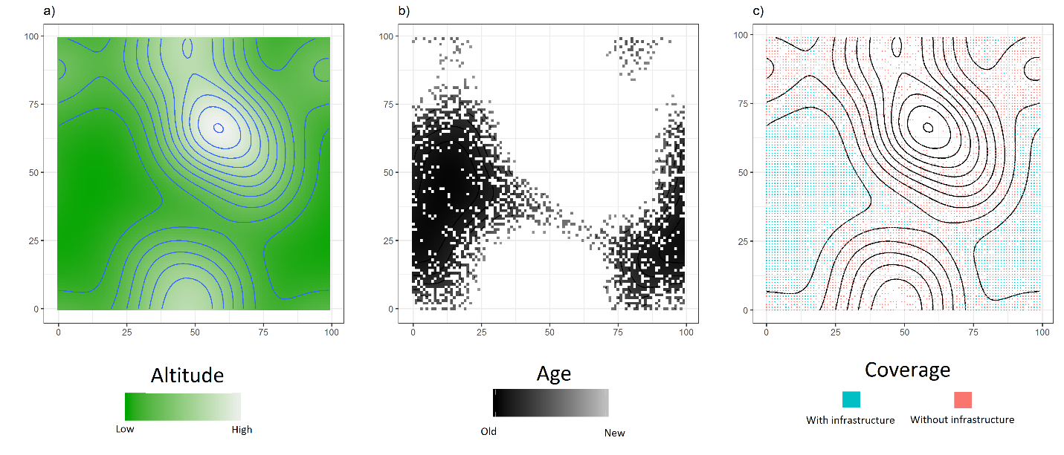

Figure S1: The urban landscape and initial infrastructure conditions

The figure shows the hypothetical landscape and the initial conditions for the age of the infrastructure (center) and the infrastructure coverage (right). These initial conditions are inspired by the conditions of the urban infrastructure systems in Mexico City.

Figure S2: Criteria and criteria weights of each policy scenario

The figure illustrates the diversity of criteria weights that emerge from different optimal policies. The colors represent the different criteria and the tones denote the type of system they represent. The area of the bars filled with lighter colors represents criteria related to the sewer system and the area with solid colors represents criteria related to the potable water system. The first three bars to the left of the plot illustrate the criteria weights of the three designed policies.

**Indicators vs policies**

|  |  |  |  |  |  |  |  |  |  |  |
| --- | --- | --- | --- | --- | --- | --- | --- | --- | --- | --- |
| Policy Scenarios | System/Problem | | | | | | | | | |
|  | Sewer system/Flooding | | | |  | Potable water system/Water scarcity | | | |
| Inequality | Exposure | Social Pressure | Infrastructure | | Inequality | Exposure | Social Pressure | Infrastructure | |
| Age | Coverage | Age | Coverage |
| Expand Access | 0.28 | 9.83 | 11.52 | 16 | 5731 | 0.28 | 11.83 | 13.66 | 19 | 5421 |
| Repair First | 0.25 | 10.72 | 12.49 | 22 | 4828 | 0.26 | 15.08 | 17.36 | 23 | 4656 |
| Squeaky Wheel | 0.37 | 4.47 | 5.54 | 9 | 3464 | 0.39 | 2.85 | 3.79 | 25 | 2284 |
| Maximize access PWS | 0.24 | 6.36 | 7.70 | 29 | 1844 | 0.39 | 11.60 | 13.43 | 9 | 7153 |
| Maximize access SS | 0.35 | 9.84 | 11.42 | 10 | 7153 | 0.27 | 5.18 | 6.38 | 32 | 2208 |
| Minimize social pressure scarcity | 0.41 | 6.67 | 8.06 | 33 | 1703 | 0.38 | 1.80 | 2.61 | 16 | 2494 |
| Minimize social pressure flooding | 0.28 | 3.55 | 4.56 | 8 | 2772 | 0.42 | 8.23 | 9.74 | 44 | 1083 |
| Minimize age PWS | 0.27 | 7.32 | 8.76 | 56 | 0 | 0.38 | 8.67 | 10.17 | 9 | 6543 |
| Minimize age SS | 0.38 | 4.02 | 5.02 | 7 | 2972 | 0.41 | 3.07 | 4.03 | 31 | 1794 |
| Maximize access both systems | 0.24 | 6.36 | 7.70 | 29 | 1844 | 0.39 | 11.60 | 13.43 | 9 | 7153 |
| Minimize social pressure both issues | 0.37 | 3.67 | 4.69 | 10 | 2909 | 0.42 | 2.49 | 3.38 | 30 | 1860 |
| Minimize exposure both issues | 0.37 | 3.67 | 4.69 | 10 | 2909 | 0.42 | 2.49 | 3.38 | 30 | 1860 |
| Minimize age both systems | 0.29 | 4.52 | 5.58 | 11 | 2871 | 0.40 | 7.70 | 9.18 | 12 | 5853 |

Table S1: Indicators of urban vulnerability in each policy scenario

The vulnerability of each infrastructure system is evaluated using five indicators: inequality in exposure, exposure, social pressure, and the age and extent of the infrastructure. The rows indicate the different policy scenarios. The first three scenarios correspond to the designed policies.

R-file to generate this table: table_2_indicatorsResults_ro0_tau300.Rmd

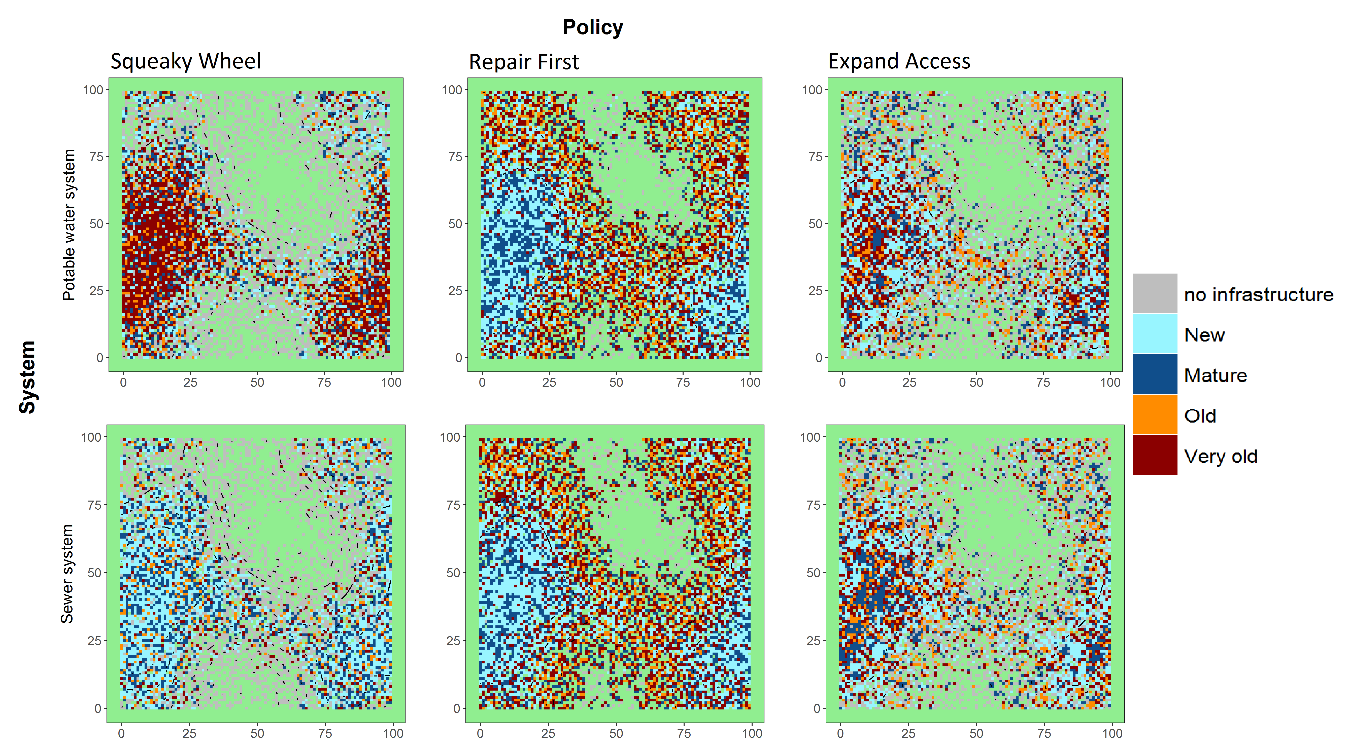

Figure S3: Spatial patterns of infrastructure condition and access under three designed policies in connected systems

The figure illustrates the differences in age and extent of infrastructure systems resulting from three designed policies at the end of the simulation period (new=[0-10[; mature=[10-20[; old=[20-30[; very old=[>30]; green=non-urban areas). This set of results was obtained assuming a connected system where the condition of a neighborhood is influenced by the condition of the neighborhoods in a von Neumann vicinity with .

R-file to generate this figure: SP_ro2tau300.Rmd

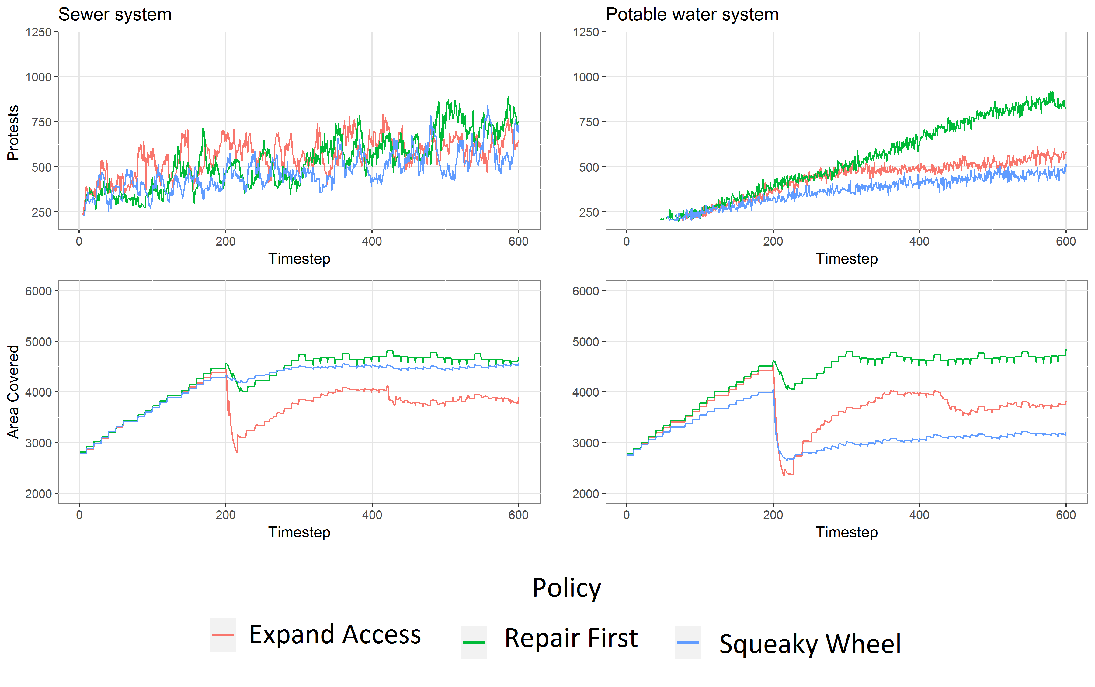

Figure S4: Temporal patterns of two indicators of vulnerability under the three designed policies in connected systems

In scenarios where the condition of the infrastructure is influenced by condition at large scale, investments under the policy Squeaky Wheel are less impactful in reducing protests and social pressure. This is because in connected systems, the consequences of not investing in a neighborhood are felt in other neighborhoods in the vicinity, even in places where the water authority had previously invested, creating a “diffused” cause-effect linkage between investment and exposure.

R-file to generate this figure: time_series_ro2tau300

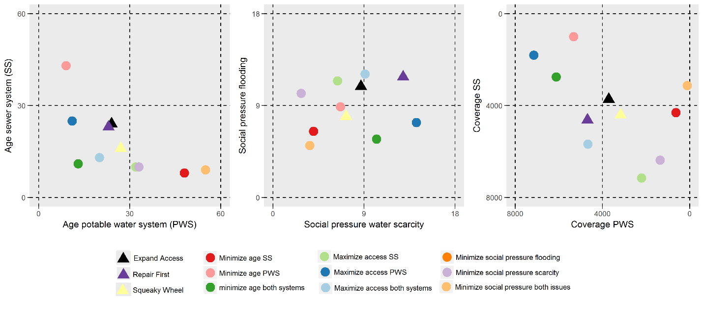

Figure S5: Trade-offs in policy performance for connected systems

The figure shows three indicators of vulnerability: average age of infrastructure systems (left panel), average social pressure (center), and extent of coverage (right panel). The x-axis corresponds to the value of the indicators obtained for the potable water system (PWS) and the y-axis represents the sewer system (SS). Triangles correspond to the three designed policies and circles to the “optimal” policies.

R-file to generate this figure: table_2_indicatorsResults_ro2_tau300.Rmd

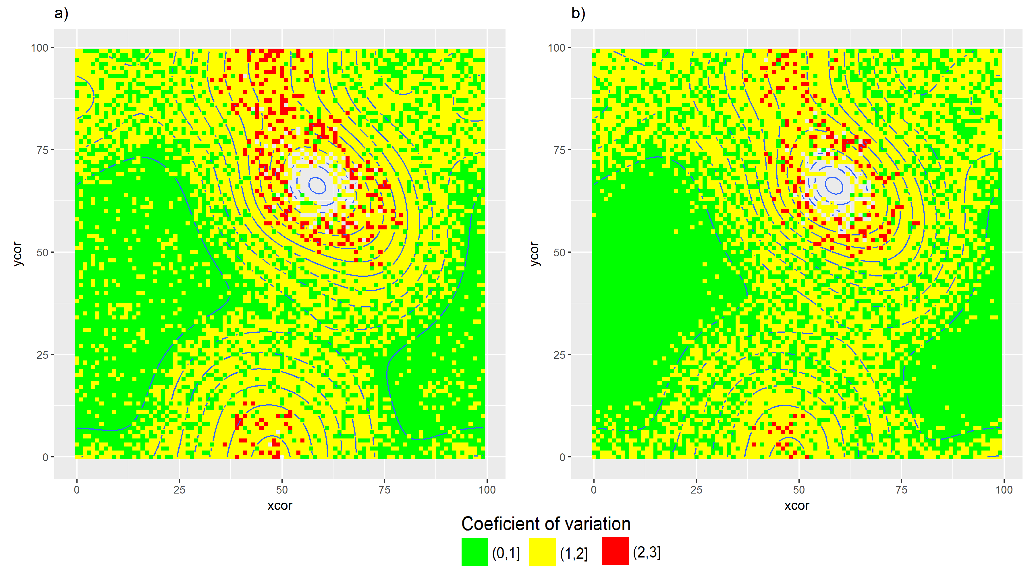

Figure S6: Neighborhood sensitivity to policy change

The figure shows the coefficient of variation (CV) produced by the three policies as a proxy for spatially-explicit indicator of sensitivity to policy change. The CV was calculated using the level of exposure to scarcity and flooding in 60 scenarios chosen at random from the 2,000 total simulations. Neighborhoods more sensitive to changes in policy are those that suffer the burden of scarcity; these are the areas located in the highlands. A similar pattern is observed in terms of flooding, yet neighborhoods located in areas at high risk of flooding are more sensitive to changes in policies.

R-file to generate this figure: sensitivity_to_policyChange.Rmd

# Overview, design, and details: Protocol to describe the socio-hydrological agent-based model

## Introduction

This document provides a detailed description of the Netlogo implementation to simulate the coupling between the decision-making processes of influential actors and infrastructure-related hazards. We describe details of the model, including its purpose, and objectives, and we define the hypothetical multi-attribute landscape, the description of the procedures and its scheduling and the initial conditions of the landscape and location of neighborhoods.

The model simulates the decisions of residents and the water authority in response to socio-hydrological risk. Neighborhoods are located in a landscape with topographic complexity and two problems: water scarcity in the peripheral neighborhoods at high altitude and high risk of flooding in the lowlands, at the core of the city (Fig. S1). The role of the water authority is to decide where investments in infrastructure should be allocated to reduce the risk to water scarcity and flooding events in the city, and these decisions are made via a multi-objective site selection procedure. This procedure accounts for the interdependencies and feedback between the urban landscape and a policy scenario that defines the priorities that the authority places on four criteria (see main document).

Neighborhoods respond to the water authority decisions by protesting against the lack of investment and the level of exposure to water scarcity and flooding (figure 2). Protests thus simulate a form of feedback between local-level outcomes (flooding and water scarcity) and higher-level decision-making. Neighborhoods are located in a landscape with spatially correlated topographic variability (figure 1), that is, a landscape with hills and valleys, where neighborhoods at high altitude are more likely to be exposed to water scarcity and lack infrastructure (figure 1), whereas neighborhoods in the lowlands tend to suffer from recurrent flooding. The frequency of flooding is also a function of spatially uniform rainfall events. Likewise, neighborhoods at the periphery of the urban landscape lack infrastructure and suffer from chronic risk of water scarcity.

Every 10 time-steps, defined as a decision cycle, the problem of whether each neighborhood is suitable for infrastructure investment is solved by the water authority using a multi-criteria evaluation. Then, by sorting neighborhoods according to a distance metric, the procedure selects the number of neighborhoods that maximizes the return of the investment and meets budgetary restrictions. Budget conditions are represented by the number of neighborhoods the authority can respond to in a single time-step given budget constraints. Investment in maintenance or construction of new infrastructure modifies the conditions for the provision of potable water and sewer system in the selected neighborhoods (Figure 2).

### Overview

#### Model objective

The model is inspired by the empirical model developed in the MEGADAPT project (<http://lancis.ecologia.unam.mx/megadapt/>). The goal of the project is to understand how the decisions of dominant actors of the Mexico City water governance system influence the dynamics of socio-hydrological vulnerability. The objective of this hypothetical model (<https://github.com/sostenibilidad-unam/abm2>) is to understand how the vulnerability patterns of an urban environment subjected to risk and exposure associated with water are influenced by the decision-making process of a central authority that manages water-related infrastructure. We focus on the feedback that emerges between the decisions of the water authority and a socio-political factor defined as resident protests, which is driven by their exposure to flooding and scarcity.

#### Agent patches and state variables

There are two types of agents in the model: 1) neighborhoods that experience hazardous events (specifically, scarcity of water and flooding) and 2) a central agent representing a water authority (WA) that has the goal of reducing the risk of hazards by investing limited resources in repairing and creating new pieces of infrastructure in the landscape. These decisions are made by evaluating the state of the system using a multi-criteria decision method.

The topographic configuration of the landscape can be set to three types: a closed watershed with a lower valley in the center and a radial increase in altitude towards the edges; a gradient, in which case it creates a landscape with longitudinal but not latitudinal changes in altitude; and a landscape with many hills, in which case the model selects at random four patches of high altitude and creates valleys using function diffuses. Urban neighborhoods can be supplied with potable water or sewer infrastructure, which in turn reduces the risk of water scarcity and episodic events of flooding. The water authority can take two actions: it can repair the local infrastructure in the neighborhood to reduce flooding or to supply water, and it can create new infrastructure.

#### Process overview and scheduling

When the model is initiated, the landscape and the location of the neighborhoods is set, using the “Create-Landscape” and “Create-District-Infra” procedures. The “GO” procedure activates the sequence of procedures to simulate the dynamic of the system: (ticks in NetLogo). First the “To-Rain” procedure generates a climatic event drawn from a probability distribution and converted to a standardized scale of risk factors between 0 and 1. The second procedure to be activated is “Hazard”. This procedure determines the probability that a flood occurs in each neighborhood and calculates the exposure.

The next procedure, “Vulnerability”, updates for every neighborhood and is the accumulated exposure to both issues (flooding or scarcity). The “To-Protest” procedure determines if protests emerge in the neighborhoods and calculates the level of social pressure, which is defined as the accumulation of protests in a neighborhood over time. The level of social pressure is directly proportional to the level of exposure, the investments made by the water authority, and the tolerance of the residents to exposure. The procedures needed for the water authority agent to calculate the suitability assessment are “Surveillance” and “WA-decision”. The “Surveillance” procedure retrieves the attributes of the landscape that define the criteria needed for the water authority to invoke the suitability analysis. The “WA-decision” procedure standardizes the criteria and calculates the metric of decisions to select neighborhoods. This metric is calculated for each neighborhood based on the value of the criteria, the priorities, and the value functions. Once the metric is calculated for each neighborhood, an optimization procedure is invoked to select the neighborhoods for investment. After the neighborhoods that will receive investments have been identified, the water authority modifies the value of the attributes of the landscape (age and provision) according to the actions taken (maintenance of, or provision of new, infrastructure).

Finally, the “Update-global-and-reporters” procedure updates the indicators of performance, and the procedure “Update-infrastructure” updates the condition of the infrastructure that defines the risk factor related to infrastructure conditions.

## Design

Basic Principles: The principles that dictate the actions of the water authority are built on defining and calculating a metric of decisions with theoretical foundations in multi-criteria decision making theory and analyses (MCDA), as well as using compromise programming (CP) ideas. The aim is to utilize the machinery inherent in MCDA to empirically generate multiple agents affecting and being affected by different attributes in the landscape, both directly and indirectly.

Emergence: In the model, the age of the infrastructure, the number of protests and their location, and the level of inequality in exposure all emerge as a result of the investments made by the water authority, which depend on technical and socio-political criteria.

Observation: At the end of each simulation the model reports the average level of exposure per neighborhood, the average number of protests per neighborhood, the level of inequality in exposure, the average age of the infrastructure, and the number of neighborhoods with functional infrastructure. The model includes the procedure “Time-series” to retrieve the age exposure and extent of infrastructure systems over time in each simulation.

Objectives: The objective or goal of the water authority is to reduce the vulnerability of the city to infrastructure-related hazards by investing in repairs and creating new infrastructure.

Interactions: Residents are linked to the water authority by demanding actions via protesting. The water authority responds to these protests by considering social pressure as a criterion. The policy implemented will determine the importance the water authority gives to social pressure through the value of the criteria weights. In simulations that assume connected systems, the risk of infrastructure failure depends on the condition of the infrastructure in a vicinity determined by a distance.

Scheduling: In each time-step (tick), exposure is calculated in each neighborhood, the neighborhood’s residents protest, and the water authority takes actions. 10 time-steps in a simulation are defined as a cycle of decision. In each cycle of decision, the water authority invokes the suitability assessment and the site-selection procedures that will define the neighborhoods selected for investment until the next cycle of decision. Investment in new infrastructure occurs a single time in each cycle of decision.

Stochasticity: Climatic events are realizations from a log-normal distribution. The frequency of flooding are associated to the magnitude of the climatic event. Protests are created when the tolerance surpasses the value of a random variable simulated using a uniform distribution.

## Details

Initialization:Neighborhoods are placed randomly in the landscape with a probability inversely proportional to their altitude in the landscape (Fig. S1). In addition, the age and provision of infrastructure are proportional to their altitude. Specifically, the probability that a neighborhood has infrastructure provision decreases with altitude:

where tracks the presence or absence of infrastructure system in neighborhood at time (Methods). is the standardized score (obtained through a decreasing linear function) of the elevation at neighborhood , and is a random number from a uniform distribution. Parameter controls the provision of infrastructure to neighborhoods at high altitude. In addition, the model initiates assuming an aged infrastructure that decreases in age in neighborhoods at high altitude to represent differences in age as the urban landscape grows. Formally,

where is the age of infrastructure system in neighborhood at time . is the maximum initial age possible, and is the standardized score obtained through a decreasing linear function of the elevation.

These initial conditions aim to create landscapes inspired by the Mexico City landscape, also present in many other megacities of the developing world. These are areas with highly densified cores with aged infrastructure, and with a less populated periphery that often lacks infrastructure provision.

The user can choose the initial condition of the infrastructure, from a new () to an old system (). The user can also choose between three types of landscape: one with many hills, as used in the main document, one with a gradient, and one with a watershed.

### Disconnected versus connected infrastructure systems: The model results presented in the main documents were obtained assuming that the condition of the infrastructure in one neighborhood does not influence the risk of infrastructure hazards in other neighborhoods. We acknowledge, however, that at fine scales these infrastructure systems are connected, and therefore it is also possible that the condition of the infrastructure in one neighborhood can influence neighborhoods nearby. To account for this potential spatial connectivity, we conducted simulations considering a case in which the risk of infrastructure hazards in one neighborhood is influenced by the condition of the infrastructure in surrounding neighborhoods up to a distance from a focal neighborhood (Methods). In the case of fully disconnected systems, the lack of coverage criterion that is evaluated by the water authorities only considers the local neighborhood and does not incorporate consideration of surrounding neighborhoods. However, for connected system this criterion also considers the proportion of neighborhoods that lack coverage in the same area of influence as the area that defines the risk of infrastructure hazards, . Thus, we assumed that the water authority knows the structure of the systems and the nature of the risk when assessing the suitability of neighborhoods for investment.