[**Advanced Node.js Tutorial**](https://www.youtube.com/playlist?list=PL4IgyW_AvXtRrWE6AdSxRcF9qqfA5oJmP)

## **Course Summary**

# **1** Node != JavaScript

## Architecture - V8 and libuv

* Node is more than a wrapper for V8, it provides APIs for working with OS files, binary data, networking, etc…
* Node is written in C++
* **V8 -** the virtual machine used internally to execute JavaScript code
  + **V8** is node’s default VM
  + Alternatives like Chakra exist
  + Node is **on the path to be V8-agnostic**
  + **V8 Feature Groups -** JavaScript features supported by V8 engine shipped (by node)
    - Shipping: enabled by default
    - Staged: enabled with --harmony flag
    - In Progress: enabled with another flag
    - Can be set at runtime with the v8 module: v8.setFlagsFromString(...)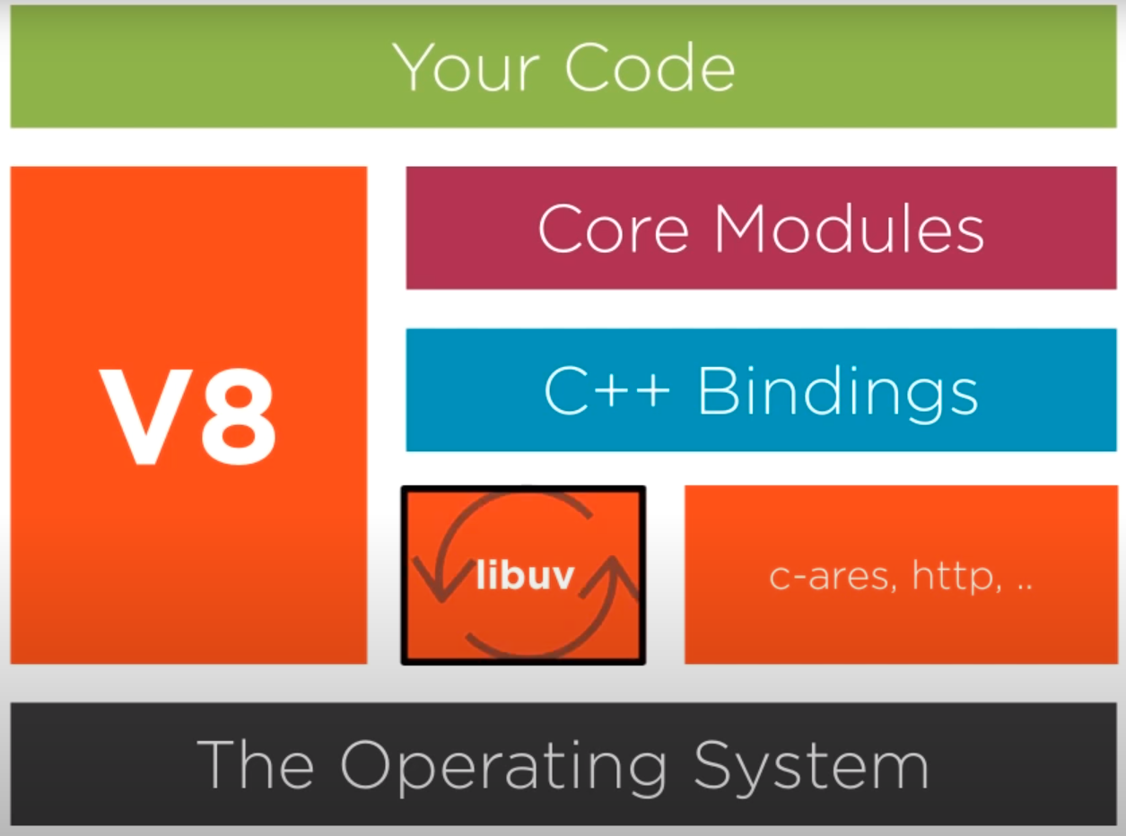
* **libuv -** a C library developed for node to handle the waiting for async events, TCP/UDP sockets, file system, etc
  + libuv provides node with the event loop
  + v8 is single threaded. This makes programming with node easy since we don’t need to worry about locking or race conditions
* other dependencies
  + **http-parser** - mini library to parse http messages
  + **c-ares** - enables performing async DNS queries
  + **openssl** - provides cryptographic utilities
  + **zlib** - provides compression utilities

## CLI and REPL

# **2** Concurrency Model and Event Loop

# **3** Node’s Event-driven Architecture

# **4** Node for Networking

# **5** Node for Web

# **6** Node’s Common Built-in Modules

# **7** Working with Streams

# **8** Clusters and Child Processes