JOURNAL OF MAGNETIC RESONANCE IMAGING 27:685– 691 (2008)

**Review Article**

**The Alzheimer’s Disease Neuroimaging Initiative (ADNI): MRI Methods**

# Clifford R. Jack Jr., MD,1* Matt A. Bernstein, PhD,1 Nick C. Fox, MD,2 Paul Thompson, PhD,3 Gene Alexander, PhD,4 Danielle Harvey, PhD,5 Bret Borowski, RTR,1 Paula J. Britson, BS,1 Jennifer L. Whitwell, PhD,1 Chadwick Ward, BA,1, Anders M. Dale, PhD,6 Joel P. Felmlee, PhD,1

Jeffrey L. Gunter, PhD,1 Derek L.G. Hill, PhD,7 Ron Killiany, PhD,8 Norbert Schuff, PhD,9 Sabrina Fox-Bosetti, PhD,9 Chen Lin, PhD,1 Colin Studholme, PhD,9

Charles S. DeCarli, MD,10 Gunnar Krueger, PhD,11 Heidi A. Ward, PhD,1,12 Gregory J. Metzger, PhD,13 Katherine T. Scott, PhD,11 Richard Mallozzi, PhD,12 Daniel Blezek, PhD,12 Joshua Levy, PhD,14 Josef P. Debbins, PhD,4,12

Adam S. Fleisher, MD,6 Marilyn Albert, PhD,15,16 Robert Green, MD,17 George Bartzokis, MD,3 Gary Glover, PhD,18 John Mugler, PhD,19 and Michael W. Weiner, MD9 for the ADNI Study

The Alzheimer’s Disease Neuroimaging Initiative (ADNI) is a longitudinal multisite observational study of healthy el- ders, mild cognitive impairment (MCI), and Alzheimer’s dis- ease. Magnetic resonance imaging (MRI), (18F)-ﬂuorode- oxyglucose positron emission tomography (FDG PET), urine serum, and cerebrospinal ﬂuid (CSF) biomarkers,

as well as clinical/psychometric assessments are acquire- dat multiple time points. All data will be cross-linked and made available to the general scientiftc community. The purpose of this report is to describe the MRI methods em- ployed in ADNI. The ADNI MRI core established speciftca- tions thatguided protocol development. A major effort was

1Mayo Clinic and Foundation, Rochester, Minnesota, USA.

2National Hospital for Neurology and Neurosurgery, Queen Square, London, United Kingdom.

3Laboratory of Neuro Imaging, Department of Neurology, University of California at Los Angeles School of Medicine, Los Angeles, California, USA.

4Neuroimage Analysis Laboratory, Department of Psychology, Arizona State University, Tempe, Arizona, USA.

5Department of Public Health Sciences, University of California Davis School of Medicine, Davis, California, USA.

6Department of Neuroscience, University of California at San Diego, La Jolla, California, USA.

7Centre for Medical Image Computing, University College London, United Kingdom.

8Department of Anatomy and Neurobiology, Boston University School of Medicine, Boston, Massachusetts, USA.

9University of California at San Francisco, and Center for Imaging of Neurodegenerative Diseases (CIND), Department of Veterans Affairs Medical Center, San Francisco, California, USA.

10Department of Neurology and Alzheimer’s Disease Center, University of California at Davis School of Medicine, Davis, California, USA.

11Siemens Medical Solutions, Erlangen, Germany. 12General Electric Healthcare, Waukesha, WI, USA. 13Philips Medical Systems, Best, The Netherlands. 14The Phantom Laboratory, Greenwich, New York, USA.

15Departments of Psychiatry and Neurology, Massachusetts General Hospital, Boston, Massachusetts, USA.

16Division of Cognitive Neuroscience, Johns Hopkins University School of Medicine, Baltimore, Maryland, USA.

17Genetics Program & Alzheimer’s Disease Center, Boston University School of Medicine, Boston, Massachusetts, USA.

18Lucas Magnetic Resonance Imaging Center, Department of Radiol- ogy, Stanford University, Stanford, California, USA.

19Department of Radiology, University of Virginia School of Medicine, Charlottesville, Virginia, USA.

Contract grant sponsor: the Alzheimer’s Disease Neuroimaging Initia- tive (ADNI; Principal Investigator: Michael Weiner; National Institutes of Health grant U01 AG024904). ADNI is funded by the National Institute on Aging, the National Institute of Biomedical Imaging and Bioengineer- ing, and the Foundation for the National Institutes of Health, through generous contributions from the following companies and organiza- tions: Pftzer Inc., Wyeth Research, Bristol-Myers Squibb, Eli Lilly and Company, GlaxoSmithKline, Merck & Co. Inc., AstraZeneca AB, Novar- tis Pharmaceuticals Corporation, the Alzheimer’s Association, Eisai Global Clinical Development, Elan Corporation plc, Forest Laborato- ries, and the Institute for the Study of Aging (ISOA), with participation from the U.S. Food and Drug Administration.

*Address reprint requests to: C.R.J. Jr., M.D., Department of Radiology, Mayo Clinic, 200 First Street SW, Rochester, MN 55905.

1. mail: [jack.clifford@mayo.edu](mailto:jack.clifford@mayo.edu)

Received November 28, 2006; Accepted May 22, 2007 DOI 10.1002/jmri.21049

Published online 26 February 2008 in Wiley InterScience [(www.](http://www/)

interscience.wiley.com).

© 2008 Wiley-Liss, Inc. 685

sampled at 0, 6, 12, 24, and 36 months. Subjects with

devoted toevaluating 3D *T*1-weighted sequences for mor- phometric analyses. Several options for this sequence were optimized for the relevant manufacturer platforms and then compared in a reduced-scale clinical trial. The proto- col selected for the ADNI study includes: back-to-back 3D magnetization prepared rapid gradient echo (MP-RAGE) scans; B1-calibration scans when applicable; and an axial proton density-T2 dual contrast (i.e., echo) fast spin echo/ turbo spin echo (FSE/TSE) for pathology detection. ADNI MRI methods seek to maximize scientiftc utility while min- imizing the burden placed on participants. The approach taken in ADNI to standardization across sites and plat- forms of the MRI protocol, postacquisition corrections, and phantom-based monitoring of all scanners could be used as a model for other multisite trials.

**Key Words:** MRI; Alzheimer’s disease; clinical trials; imag- ing methods; imaging standardization

**J. Magn. Reson. Imaging 2008;27:685– 691.**

**© 2008 Wiley-Liss, Inc.**

MCI will be sampled at 0, 6, 12, 18, 24, and 36 months. AD subjects will be sampled at 0, 6, 12, and 24 months. Major goals of the ADNI study are: to link all of these data at each time point and make this repository avail- able to the general scientiftc community; to develop technical standards for imaging in longitudinal studies; to determine the optimum methods for acquiring and analyzing images; to validate imaging and biomarker data by correlating these with concurrent psychometric and clinical assessments; and to improve methods for clinical trials in MCI and AD. The ADNI study overall is divided into cores, with each core managing ADNI-re- lated activities within its sphere of expertise: clinical, informatics, biostatistics, biomarkers, and imaging. The purpose of this report is to describe the MRI meth- ods and decision-making process underlying the selec-

tion of the MRI protocol employed in the ADNI study.

Dementia, one of the most feared associates of increas- ing longevity, represents a pressing public health prob- lem and major research priority. Alzheimer’s disease (AD) is the most common form of dementia, affecting many millions around the world. There is currently no cure for AD, but large numbers of novel compounds are currently under development that have the potential to modify the course of the disease and slow its progres- sion. There is a pressing need for imaging biomarkers to improve understanding of the disease and to assess the efftcacy of these proposed treatments. Structural mag- netic resonance imaging (MRI) has already been shown to be sensitive to presymptomatic disease (1–10) and has the potential to provide such a biomarker. For use in large-scale multicenter studies, however, standard- ized methods that produce stable results across scan- ners and over time are needed.

The Alzheimer’s Disease Neuroimaging Initiative (ADNI) study is a longitudinal multisite observational study of elderly individuals with normal cognition, mild cognitive impairment (MCI), or AD (11,12). It is jointly funded by the National Institutes of Health (NIH) and industry via the Foundation for the NIH. The study will assess how well information (alone or in combination) obtained from MRI, (18F)-ﬂudeoyglucose positron emission tomography (FDG PET), urine, serum, and cerebrospinal ﬂuid (CSF) biomarkers, as well as clinical and neuropsychometric assessments, can measure dis- ease progression in the three groups of elderly subjects mentioned above. At the 55 participating sites in North America, imaging, clinical, and biologic samples will be collected at multiple time points in 200 elderly cogni- tively normal, 400 MCI, and 200 AD subjects. All sub- jects will be scanned with 1.5 T MRI at each time point, and half of these will also be scanned with FDG PET. Subjects not assigned to the PET arm of the study will be eligible for 3 T MRI scanning. The goal is to acquire both 1.5 T and 3 T MRI studies at multiple time points in 25% of the subjects who do not undergo PET scan- ning [R2C1]. CSF collection at both baseline and 12 months is targeted for 50% of the subjects. Sampling varies by clinical group. Healthy elderly controls will be

**MATERIALS AND METHODS**

The MRI portion of the ADNI study was divided into three phases: development, preparation, and execution of the study itself. In this report we outline activities of the ftrst two phases. Members of the MRI core estab- lished a basic set of requirements that guided the pro- tocol development process. The overarching principle was to maximize scientiftc value while minimizing pa- tient burden. Speciftc guidelines were:

* 1. The MRI data acquired by ADNI must be consis- tent across sites and over time. That is, similar image qualities (contrast-to-noise, spatial resolu- tion, resistance to artifact, reliability, speed, etc.) must be achieved across sites and platforms over time at each fteld strength.
  2. Based on responses to an initial questionnaire, virtually all participating clinical enrollment sites had access to at least one MRI scanner from GE Healthcare, Philips Medical Systems, or Siemens Medical Solutions. Consequently scanners from only these three vendors were supported. A vari- ety, but not all, of the MRI platforms from each vendor were supported. Speciftcally, some older platforms (e.g., Siemens Vision, or GE Healthcare systems running software earlier than 9.1) were not supported.
  3. Modiftcation to an existing product pulse se- quence on a particular vendor platform was en- couraged, but only if it was both practical and would substantially beneftt the study.
  4. The study emphasis was on brain morphometry; hence the most important image set was the *T*1- weighted 3D volumetric acquisition. Isotropic voxels were desired to avoid a directional bias, but not required. The target voxel size was ap- proximately 1 mm3, with a maximum of 1.5 mm in any one direction.
  5. The whole brain must be covered without image wrap. Given the large number and variety of par- ticipating sites, the imaging volume must be easy for technologists to prescribe regardless of expe- rience level.
  6. Acquisition time for any series should be less than 10 minutes.
  7. Artifact reduction is more important than reduc- tion in acquisition time.
  8. At 3 T the increased signal-to-noise ratio (SNR) compared with 1.5 T was used to increase spatial resolution while increasing the receiver band- width to help compensate for the increased chemical shift and the more rapid susceptibility variation (as measured in hertz) at 3 T.
  9. The 3D *T*1-weighted protocol must operate suc- cessfully with major imaging analysis methods that have been employed in this fteld such as manual and atlas-based region of interest gener- ation, boundary shift integral, voxel-based mor- phometry, and tensor-based morphometry.
  10. ADNI must include phantom-based methods to monitor scanner calibration across all sites over the course of the study.
  11. Post-acquisition correction of certain image arti- facts would be implemented where applicable, such as 3D distortion correction for warping due to gradient nonlinearity.

Several basic decisions about the composition of the MRI protocol for the execution phase were made on the basis of the cumulative experience of members of the MRI core with multisite MRI-based studies, information gleaned from surveys at the participating ADNI clinical sites, and the protocol guidelines established above. Each subject will be enrolled in the study for a 3-year period, and multiple types of data will be collected at each sampling point, so we anticipate a high research burden on each participant. Moreover, ADNI is an ob- servational study, which offers participants no experi- mental treatment. In order to maximize scientiftc value while minimizing patient burden, the MRI core targeted the duration of the patient scanning portion of the ex- ecution phase MRI protocol to approximately 30 min- utes. We also decided to scan the ADNI phantom im- mediately after each patient exam, rather than decoupling phantom and human scanning. Site sur- veys revealed that the average time window allotted for a single MRI examination of the head was approxi- mately 45 minutes. The overall structure of the ADNI MRI execution phase was therefore targeted to be 30 minutes of patient scan time and 15 minutes of phan- tom scan time.

The protocol at a minimum had to include at least one high-quality, high-resolution 3D *T*1-weighted sequence, as well as a second acquisition that provided *T*2- weighted information to ascertain brain pathology. A number of optional additional imaging sequences were considered for the MRI protocol, including MR spectros- copy, diffusion tensor imaging, arterial spin labeling, and ﬂuid attenuated inversion recovery (FLAIR) se- quences. The MRI core decided to limit the scope of the protocol to two domains— high-quality 3D *T*1-weighted morphometric information and a dual contrast proton density/*T*2-weighted sequence for pathology detection. This decision was based on balancing the various com- peting considerations outlined above. Options for this high-quality 3D *T*1-weighted sequence were magnetiza-

tion prepared rapid gradient echo (MP-RAGE; and IR- FSPGR, which is a related technique available on the GE scanners) and spoiled gradient echo (SPGR) or equivalent (spoiled fast low angle shot [FLASH] for Sie- mens systems and *T*1 fast fteld echo [FFE] for Philips systems). We also considered an approach that had been adopted by the Biomedical Informatics Research Network (BIRN) study: generating synthetic *T*1 images by acquiring stand-alone SPGR or equivalent 3D volu- metric data sets with high and low ﬂip angles (13,14).

***Development Phase***

During the development phase a total of 29 sample human studies with *T*1-weighted 3D volumetric studies at 1.5 and 3 T were obtained from various ADNI sites and the MRI vendors. Based on protocol features that worked well across vendor platforms, a set of generic protocols was generated and then reviewed and revised by the MRI core group along with industry and external advisors until a consensus was reached. The generic protocols were adapted to yield vendor-speciftc proto- cols for the preparatory phase study based on availabil- ity of software options. Also, minor protocol differences were introduced at this stage due to vendor-speciftc implementation differences. A customized MP-RAGE pulse sequence was developed for the GE platform to minimize vendor-to-vendor differences. At this stage we also identifted and implemented pulse sequence ftxes required for the *T*1-weighted IR pulse sequences on some platforms, including increased RF bandwidth of the inversion pulse at 3 T and increased gradient area for the end-of-sequence spoiler. Note that these cus- tomization steps resulted in sequences that in some cases were non-product. This in turn meant that ongo- ing support throughout the study by the MRI vendors as systems were upgraded was required. At the conclu- sion of the development phase, vendor-speciftc proto- cols that included the list of 3D *T*1-weighted sequences above (where appropriate by vendor platform) were cre- ated. This protocol was then employed in the prepara- tory phase.

***Preparatory Phase Study***

The ADNI MRI preparatory phase consisted of a mini clinical trial the purpose of which was to select the 3D *T*1-weighted volume sequence that would be employed in the execution phase of the main ADNI study for morphometric assessment. Two endpoints were evalu- ated: ftrst, the ability of the imaging sequence to appro- priately differentiate normal control subjects from AD subjects cross-sectionally; and second, test-retest pre- cision on serial scan pairs obtained in normal elderly control subjects (i.e., a situation in which no systematic biologic change is expected). Six different sites, repre- senting the relevant MRI vendor platforms at 1.5 and 3 T, participated in the ADNI MRI preparatory phase. Over these six sites, 73 normal elderly subjects and 64 AD subjects were scanned once for cross-sectional comparison purposes. The control subjects were scanned again 2 weeks later in order to evaluate preci- sion. Scanning sessions were performed on both

phased-array receive and single-channel T/R birdcage RF coils for some platforms. The data acquired above were submitted for quantitative evaluation using the techniques that will be employed in the main ADNI data analyses: boundary shift integral, voxel-based mor- phometry, tensor-based morphometry, atlas-based hippocampal volumetrics, and also a measure of gray- white matter contrast to noise. In addition, scans were graded qualitatively by a trained individual for artifacts and general image quality on a four-point scale: none, mild, moderate, and severe. Each scan was graded on several separate criteria: blurring/ghosting; ﬂow arti- fact; intensity and homogeneity; SNR; susceptibility ar- tifacts; and gray-white CSF contrast.

**RESULTS**

A total of 208 unique MRI studies in 137 subjects were acquired during the preparatory phase. Plans for anal- ysis of this data as initially outlined were compromised by the discovery of additional image imperfections on some system platforms while the preparatory phase was in progress. These included inconsistent polarity of the readout gradient between vendors that resulted in undesirable cephalic shift of fat over the brain at the base of the skull (Fig. 1) for sagittal acquisitions. Also, with transmit receive (T/R) head coils, the images were unacceptably noisy (Fig. 2a), which was corrected (at the expense of increased imaging time) by increasing the number of slices and the MP-RAGE repetition time, as indicated in Table 1 and illustrated in Fig. 2. Finally, some older systems imposed a 128 limit on the maximal number of slices. This not only degraded the SNR but also precluded sufftcient coverage. Both the change in chemical shift direction and the lifting of the 128 slice limit required further pulse sequence modiftcation. The protocol change to increase SNR for T/R birdcage coils and pulse sequence modiftcation for chemical shift di- rection were made while the preparatory phase was in progress, resulting in undesirable discontinuities in this data.

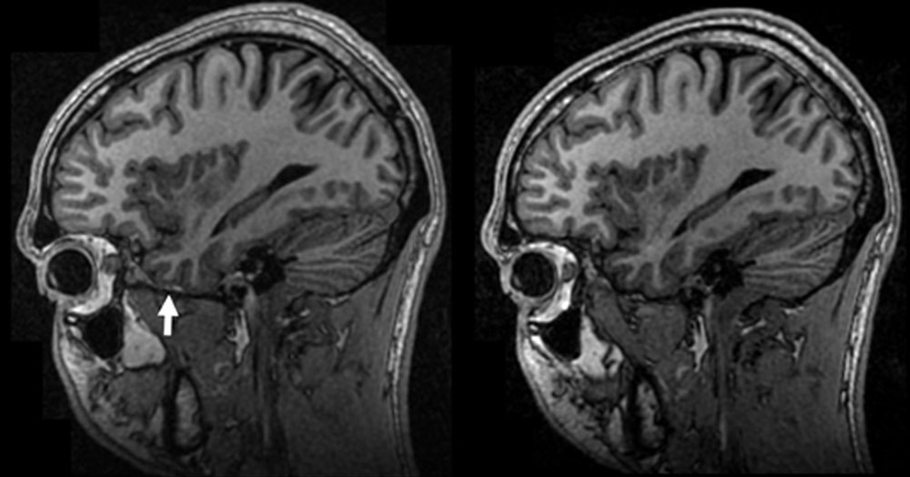

**Figure 1.** Undesirable chemical shift. The manufacturer’s de- fault polarity of the readout gradient in the SI direction for sagittal acquisitions shifted fat over the base of the brain (arrow, left) in the ftrst version of the protocol. This hinders automated brain extraction algorithms. Reversal of this shift (right) required custom alteration of the manufacturer’s prod- uct imaging sequence.

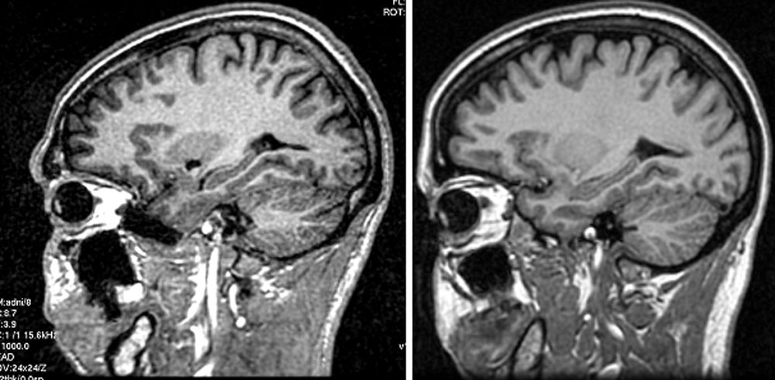

**Figure 2.** Poor SNR with single-channel birdcage coils in ftrst version of protocol. As indicated in Table 1, the protocol using a single-channel birdcage coil differs from the phased array protocol. Left: When 1.5 T images are acquired using the phased array protocol with a birdcage coil, poor SNR results. Right: Making the parameter adjustments listed in Table 1 resolves the problem without increasing chemical shift.

The MRI core along with the external advisors met during the 2004 annual ISMRM meeting in Miami. The purpose of this meeting was to review data from the preparatory phase and select a ftnal protocol for the execution phase of ADNI. A general summary of the qualitative ranking results from best to worst were: MP-RAGE > SPGR > synthetic *T*1. The different scan types were also graded on the basis of quantitative measures made by the individual image analysis groups in the MRI core. These data have appeared or will appear as separate independent publications (15). Overall the results were mixed. There was no clear indication across the different analyses performed that one image type outperformed the other. In addition, where one image type was found to be better than an- other, differences were typically small. There was an overall consensus that the MP-RAGE and SPGR or equivalent sequences outperformed the synthetic *T*1 images. The primary advantages of the SPGR over MP- RAGE were superior SNR and superior performance on applications that placed a premium on brain-CSF seg- mentation. The advantages of the MP-RAGE sequence were superior gray/white contrast to noise, superior performance in some applications requiring cortical segmentation, and imaging times that were under 10 minutes for all vendor platforms at both fteld strengths. The evaluation group also noted that the SNR advan- tage for SPGR was to a large extent present on birdcage coil acquisitions at 1.5 T acquired with the initial un- satisfactory version of the preparatory phase MP-RAGE protocol, which was acquired with birdcage coils. The protocol changes illustrated in Fig. 2 resulted in a sig- niftcant improvement in the performance of MP-RAGE in the various image processing algorithms. The evalu- ation group decided to extrapolate to what we would have seen had the higher SNR protocol been used throughout the entire preparatory phase when weigh-

ing the pros and cons of various MR sequences.

The evaluation group unanimously selected MP- RAGE as the 3D sequence for the ADNI execution phase (Fig. 3). The suggestion was also made to acquire back- to-back MP-RAGE sequences as opposed to the more traditional approach of a single acquisition per exam.

Table 1

Range of Parameters for MP-RAGE Acquisition

*N*z No. of

a TI

Flip

A*z* RBW

Time

*B*0 Coil *N*x *N*y

|  |  |  |  |  |  |  |  |  |
| --- | --- | --- | --- | --- | --- | --- | --- | --- |
|  | | slices |  |  | (ms) (deg) |  | (mm) | (Hz/pixel) (min:s) |
| 1.5T BC | 192 | 192 184–208 | 240 × 240 | 3000 | 1000 8 | Sagittal PEb | 1.2 | 162–180 9:36–9:38 |
|  |  |  |  |  |  | = A/P |  |  |
| 1.5T MA | 192 | 192 160–170 | 240 × 240 | 2300–2400 | 1000 8 | Sagittal PE | 1.2 | 162–200 7:11–7:42 |
| 3.0T MA or | 256 | 256c 160–170 | 256–260 × 240 | 2300 or | 853– 8–9 | = A/P  Sagittal PE | 1.2 | 240–244 9:14–9:22 |
| BC |  |  |  | 3000d | 900 | = A/P |  |  |

FoV (mm) TR

(ms)

Plane

aTR is deﬁned here as the repetition time for the inversion pulses.

bPE is the phase-encoded direction.

c256 is the base resolution. Because the ﬁeld of view is rectangular at 3.0 T, the net number of acquired phase-encoding steps is approximately 0.94 × 256 = 240.

dThe longer value of TR = 3000 at 3 T is used only with pulse sequences where the train of gradient echo readouts represents the in-plane phase encoding. Because there are fewer encoded slices than in-plane phase encodings in the 3 T protocol, the net acquisition time is approximately equal to the TR = 2300 msec case.

MA = multicoil phased-array head coil; BC = birdcage or volume head coil.

The advantage of incorporating back-to-back acquisi- tions as a standard feature of the protocol is that the decision to repeat the scan on the basis of image quality will not be placed in the hands of individual technolo- gists at the sites performing the scans. The ADNI MRI quality control center at the Mayo Clinic will select the

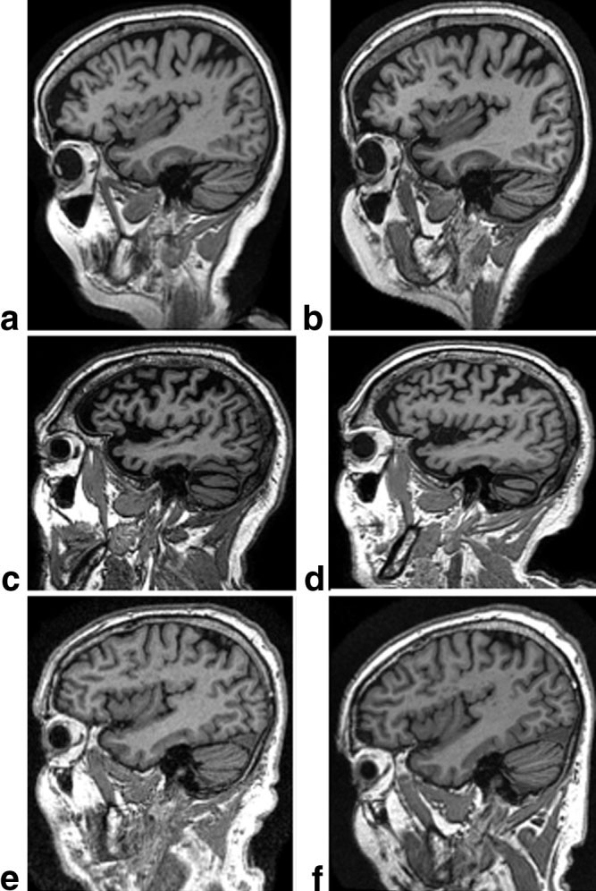

**Figure 3.** Example MP-RAGE images for each manufacturer at 1.5 T (left) and 3 T (right). a,b: GE. c,d: Philips. e,f: Siemens.

better MP-RAGE sequence at each time point based on centralized and standardized criteria. Perhaps most im- portantly, requiring back-to-back MP-RAGE scans should reduce the number of examinations that must be repeated due to poor image quality. This in turn should minimize patient burden and enhance patient retention in the study. Finally, if both MP-RAGE scans are of equivalent high quality, the magnitude images could be combined (typically after spatial registration of the two image volumes) to produce a single image with

an improvement in SNR approaching ]2.

Discussion of the appropriate imaging sequence to employ for cerebral pathology detection centered on FLAIR vs. dual contrast fast spin echo. The 30 minutes allotted to patient scan time could accommodate only one of these additional sequences. Although the FLAIR sequence is highly useful, it was decided that some clinical groups would ftnd a double fast spin echo se- quence more in keeping with their general practice than a stand-alone FLAIR image. This was an important con- sideration because an on-site interpretation of all ADNI MRI studies by a local radiologist for medical alerts is a feature of the overall ADNI study design. The MR core therefore decided on the following for the ftnal format of the ADNI execution phase protocol:

1. Standard prescan and scouting procedure recom- mended by the manufacturer
2. Sagittal 3D MP-RAGE
3. Sagittal 3D MP-RAGE repeat
4. Sagittal *B*1-calibration scan (phased array)
5. Sagittal *B*1-calibration scan (body coil)
6. Axial proton density *T*2 dual contrast FSE/TSE.

These six series are typically completed in 30 minutes or less. Series 4 and 5 are low-resolution maps used to correct for *B*1-intensity variation of the phased array receive coil. Consequently, they are omitted when only a single-channel, T/R birdcage head coil is available. In the case of the Philips scanners, a product *B*1-correc- tion was available at the beginning of the study and was integrated into the protocol. The other two vendors in- troduced product *B*1-corrections later, but reference scans 4 and 5 were not replaced, to help ensure conti-

nuity of the longitudinal data. A list of parameters for series 2 and 3 is provided in Table 1, and representative images for each vendor at both fteld strengths are shown in Fig. 3. Detailed lists of parameters for each ADNI-supported vendor platform can be downloaded at [http://www.loni.ucla.edu/ADNI/Research/Cores/.](http://www.loni.ucla.edu/ADNI/Research/Cores/)

**DISCUSSION**

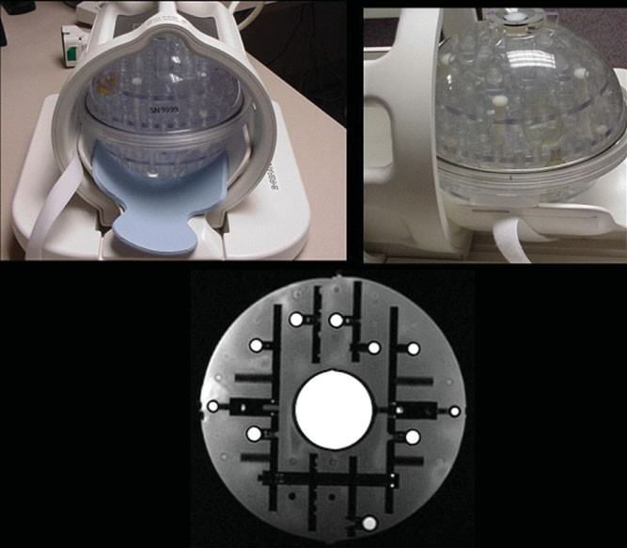The requirements for the ADNI MRI protocol differ from those used to generate a routine clinical protocol. For example, while an experienced radiologist often can “read through” minor artifacts, the automated software programs used for the analysis typically cannot. In fact, as a general rule, the more fully automated the analysis algorithm is, the less tolerant it is to image imperfec- tions. Therefore, smaller ftelds of view that can lead to wraparound artifacts (e.g., the nose onto the back of the head) were avoided, as well as parallel imaging methods like sensitivity encoding (SENSE) that can sometimes result in residual aliasing when there is imperfect cal- ibration. Also, partial *k*-space acquisition was avoided because of the associated artifacts that can result in regions of rapid susceptibility variation. Consequently, the acquisition time of the MP-RAGE series is some- what longer than a corresponding protocol typically used for diagnostic purposes. The ADNI MRI protocol was selected in a data-driven manner with considerable deliberation by a group of experts in the fteld of MRI. Because of the large multicenter nature of ADNI, MRI techniques that were widely available in the 2004 –2005 time frame were given preference, although important pulse sequence changes (like the fat-water chemical shift direction) were allowed. The protocol follows a set of principles (outlined by the MRI core, ADNI executive committee, and external advisory committee) that are

**Figure 4.** ADNI phantom. The ADNI phantom is spherical, with multiple inclusions that are used both for ftducial pur- poses and for SNR and contrast measurements. Image at the bottom is an MRI illustrating the central SNR inclusion as well as smaller spheres for ftducial measurements.

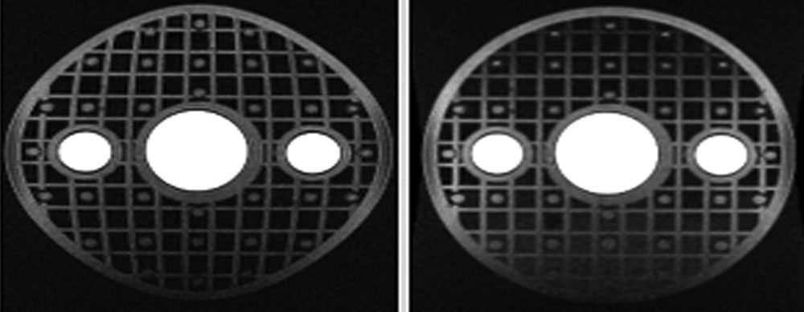

**Figure 5.** Effect of gradwarp. Spherical phantom with recti- linear grid inclusion before (left) and after (right) gradwarp correction.

meant to maximize scientiftc utility while minimizing research burden for participants in ADNI.

In addition to imaging study subjects, ADNI is also acquiring images of a phantom in the same examina- tion period as each human MRI exam (Fig. 4). The phantom was speciftcally designed for ADNI by a subset of the ADNI MRI core along with partners in industry (16 –18). The ADNI phantom and accompanying analy- sis software will measure gradient calibration, residual nonlinearity after 3D distortion (i.e., “gradwarp”) cor- rection, SNR, and contrast. These measurements will be used to monitor scanner performance over time for each scanner involved in the ADNI study. Tolerance speciftcations for each parameter will be established when sufftcient longitudinal data from all participating sites have been acquired and analyzed. These specift- cations will be used to inform sites of any deviation from tolerance limits detected on individual scanners. In ad- dition, the gradient calibration measures acquired at each imaging time point will be linked with its corre- sponding human scan. This will permit retrospective rescaling of human images to correct for drift or discon- tinuities in gradient calibration.

To enhance standardization across sites and plat- forms of images acquired in the ADNI study, post- ac- quisition correction of certain image artifacts has been implemented. These include corrections in image geom- etry for gradient nonlinearity, i.e., 3D gradwarp (19,20); corrections for intensity nonuniformity due to nonuni- form receiver coil sensitivity (21); and correction of im- age intensity nonuniformity due to other causes such as wave effects at 3 T. These corrections are system speciftc. For example, only systems with apparent gra- dient nonlinearity undergo this correction; and the im- plementation of 3D gradwarp (or equivalent) is speciftc for each gradient conftguration (Fig. 5). Similarly, cor- rection for intensity inhomogeneity due to nonuniform sensitivity of multiarray receiver coils was implemented for those systems in which the manufacturer did not provide this feature as a product at the inception of the study (Fig. 6). In addition to the uncorrected original image ftles, the images with all the corrections and some with intermediate steps will be available to the general scientiftc community, as described at http:// [www.loni.ucla.edu/ADNI.](http://www.loni.ucla.edu/ADNI) These data correction proce- dures as well as image quality control procedures are performed at a single site (Mayo Clinic). Image data quality control includes inspection of each incoming image ftle for protocol compliance, clinically signiftcant

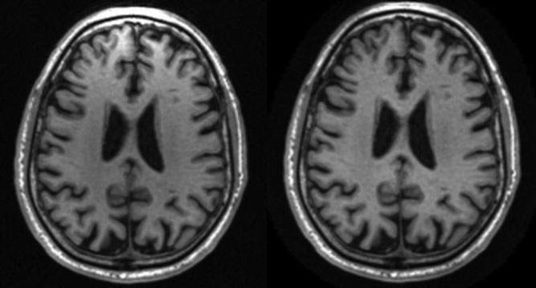

**Figure 6.** Intensity in-homogeneity correction. Phased array coil acquisition at 1.5 T before (left) and after (right) intensity nonuniformity correction. Images have been reformatted from the sagittal into the axial plane to illustrate the intensity in- homogeneity anteriority prior to correction.

medical abnormalities, and image quality. The results of image quality control analysis are uploaded to the ADNI central data base, where this information is linked to the relevant image ftle and is available to the general scientiftc community. The actual image pro- cessing analyses for ADNI are performed at ftve sepa- rate sites.

The approach to standardization across sites and platforms of the MRI protocol and acquisition parame- ters for each imaging sequence, post-acquisition cor- rection of image artifacts, and phantom-based monitor- ing of the instruments themselves could be extended to other multisite trials, including those in other research areas. This approach will minimize variation in the data collected due to technical nonuniformity and thus max- imize across-site sensitivity to true biologic variation. In large multisite studies where the role of MRI is to cap- ture relevant phenotypic information in all study par- ticipants, the importance of standardization super- sedes the natural impulse by MR scientists to employ the most cutting edge MR methods that usually will be unique to each platform and can introduce undesirable technical variability.

**ACKNOWLEDGMENTS**

The authors dedicate this manuscript to the memory of Dr. Leon Thal. Dr. Thal devoted his career to the goal of ftnding a cure(s) for Alzheimer’s disease. He was universally respected and admired and was in- strumental in establishing the ADNI study. See the following web site: <http://www.alzforum.org/> spotlight/Thaltribute.asp#barrett.

**REFERENCES**

1. Fox NC, Warrington EK, Freeborough PA, et al. Presymptomatic hippocampal atrophy in Alzheimer’s disease. A longitudinal MRI

study. Brain 1996;119:2001–2007.

1. Fox NC, Crum WR, Scahill RI, Stevens JM, Janssen JC, Rossor MN. Imaging of onset and progression of Alzheimer’s disease with voxel- compression mapping of serial magnetic resonance images. Lancet 2001;358:201–205.
2. Jack CR Jr, Petersen RC, Xu Y, et al. Prediction of AD with MRI- based hippocampal volume in mild cognitive impairment. Neurol- ogy 1999;52:1397–1403.
3. Jack CR Jr, Shiung MM, Weignad SD, et al. Brain atrophy rates predict subsequent clinical conversion in normal elderly and am- nestic MCI. Neurology 2005;65:1227–1231.
4. Xu Y, Jack C Jr, O’Brien PC, et al. Usefulness of MRI measures of entorhinal cortex vs hippocampus in AD. Neurology 2000;54:1760 – 1767.
5. Dickerson BC, Goncharova I, Sullivan MP, et al. MRI-derived ento- rhinal and hippocampal atrophy in incipient and very mild Alzhei- mer’s disease. Neurobiol Aging 2001;22:747–754.
6. Dickerson BC, Salat D, Bates JF, et al. Medial temporal lobe func- tion and structure in mild cognitive impairment. Ann Neurol 2004; 56:27–35.
7. Killiany R, Gomez-Isla T, Moss M, et al. Use of structural magnetic resonance imaging to predict who will get Alzheimer’s disease. Ann Neurol 2000;47:430 – 439.
8. Killiany RJ, Hyman BT, Gopmez-Isla T, et al. MRI measures of entorhinal cortex vs hippocampus in preclinical AD. Neurology 2002;58:1188 –1196.
9. Du AT, Schuff N, Amend D, et al. Magnetic resonance imaging of the entorhinal cortex and hippocampus in mild cognitive impair- ment and Alzheimer’s disease. J Neurol Neurosurg Psychiatry 2001;71:441– 447.
10. Mueller SG, Weiner MW, Thal LJ, et al. Ways toward an early diagnosis in Alzheimer’s disease: the Alzheimer’s Disease Neuroim- aging Initiative (ADNI). Alzheimers Dementia 2005;1:55– 66.
11. Mueller SG, Weiner MW, Thal LJ, et al. The Alzheimer’s Disease Neuroimaging Initiative. Neuroimaging Clin North Am 2005;15: 869 – 877.
12. Fischl B, Salat DH, van der Kouwe A, et al. Sequence-independent segmentation of magnetic resonance images. NeuroImage 2004;23: S69 –S84.
13. Deoni SC, Peters TM, Rutt BK. High-resolution T1 and T2 mapping of the brain in a clinically acceptable time with DESPOT1 and DESPOT2. Magn Reson Med 2005;53:237–241.
14. Leow AD, Klunder AD, Jack CR Jr, et al. Longitudinal stability of MRI for mapping brain change using tensor-based morphometry. For the ADNI Preparatory Phase Study (2006). NeuroImage 2006; 31:627– 40.
15. Gunter JL, Bernstein MA, Borowski B, et al. Validation testing of the MRI calibration phantom for the Alzheimer’s Disease Neuroim- aging Initiative Study. In ISMRM 14th Scientiftc Meeting and Ex- hibition, 2006, Seattle, WA.
16. Mallozzi RP, Blezek DJ, Gunter JL, Jack CR Jr, Levy JR. Phantom- based evaluation of gradient non-linearity for quantitative neuro- logical MRI studies. In ISMRM 14th Scientiftc Meeting and Exhibi- tion, 2006, Seattle, WA.
17. Mallozzi RP, Blezek DJ, Ward CP, Gunter JL, Jack CR Jr. Phantom- based geometric distortion correction for volumetric imaging of Alzheimer’s disease. In ISMRM 12th Annual Scientiftc Meeting and Exhibition, 2004, Kyoto, Japan.
18. Hajnal JV, Hill DLG, Hawkes DJ. Medical image registration. New York: CRC Press; 2001.
19. Jovicich J, Czanner S, Greve DN, et al. Reliability in multi-site structural MRI studies: effects of gradient non-linearity correction on phantom and human data. NeuroImage 2006;30:436 – 443.
20. Narayana PA, Brey WW, Kulkarni MV, Sievenpiper CL. Compensa- tion for surface coil sensitivity variation in magnetic resonance imaging. Magn Reson Imaging 1988;6:271–274.