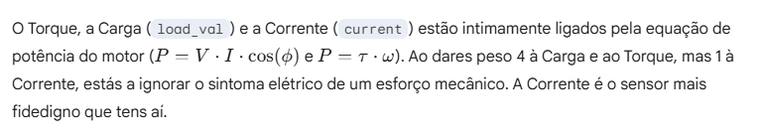

% Pesos Ajustados (Soma ~= 35)
weighting_factors = [ ...
3 , ... % 1 temperature (Inércia lenta. Sintoma tardio)
4 , ... % 2 vibration (Sintoma primário de rolamentos)
2 , ... % 3 rotation speed
1 , ... % 4 voltage (Normalmente constante, peso baixo aceitável)
5 , ... % 5 current (O reflexo instantâneo do esforço mecânico)
2 , ... % 6 pressure
3 , ... % 7 noise_level (Baixou para 3 para não fazer eco com a vibração)
2 , ... % 8 efficiency (Métrica derivada, não é um sensor direto)
3 , ... % 9 load_val (Partilha a importância com o Torque/Current)
3 , ... % 10 torque
2 , ... % 11 maintenance_level (Contexto importante)
3 , ... % 12 operating_mode (Define o baseline esperado)
1 , ... % 13 cooling_type
3 ];... % 14 sensor_status (Se o sensor avisa, é crítico)

https://www.fluke.com/en/learn/blog/motors-drives-pumps-compressors/13-causes-of-motor-failure

https://www.mdpi.com/1996-1073/18/13/3484#:~:text=Sensors%20are%20essential%20for%20monitoring%20electric%20motors,faults%20*%20**Position**%20Ensures%20precise%20motion%20control
CAUSA DE AVARIA | IMPORTÂNCIA | DETEÇÃO
Motor winding insulation breakdown | High | temperature
 |  | voltage
 |  | current
 |  | cooling_type
Harmonic Distortion | Medium | temperature
 |  | efficiency
 |  | maintenance_level
Operational overloads | High | current
 |  | temperature
 |  | vibration
 |  | noise_level
 |  | efficiency
 |  | operating_mode
 |  | torque
 |  | load_val
 |  | cooling_type
wear in mechanical drive components | High | noise_level
 |  | vibration
 |  | temperature
 |  | efficiency
 |  | operating_mode
 |  | torque
 |  | load_val
 |  | maintenance_level
 |  | rotation_speed
bearing failure | High | noise_level
 |  | vibration
 |  | maintenance_level
Misalignment of mechanical drive components | Medium | maintenance_level
 |  | noise_level
 |  | vibration
Arcing across bearing surfaces | High | noise_level
 |  | vibration
 |  | voltage
 |  | rotation_speed

https://www.emerson.com/documents/automation/brochure-electric-motor-problems-diagnostic-techniques-ams-en-6652274.pdf
