Readme

# Test Ruby on Rails – Bergamotte

By: Miguel Angel Higuera

[hmiguelangel@gmail.com](mailto:hmiguelangel@gmail.com)

# Development Gems.

The next RoR gems were used to develop this test:

- **Devise**. User management and authentication tools.

- **ActiveAdmin**. Used to build the admin module.

- **Sqlite3**. As Database Engine.

- **Rails 4.2**. Main Framework.

# Database Tables

- Categories (Product Categories)

- Items

- Admin_users

- Orders

- Products

- Product_items

- Users (Customers)

# Seeds

This seed was added to seeds.rb to create the admin user.

AdminUser.create!(email: 'admin@example.com', password: 'password', password_confirmation: 'password')

# Modules

### Admin Module

You can found it in: <http://0.0.0.0:3000/admin>.

Here you can make management of all information of database including:

- Categories (Product Categories)

- Items

- Admin_users

- Orders

- Products

- Product_items

- Users (Customers)

**Access:** You must enter the user and password combination ([admin@example.com](mailto:admin@example.com) Pass: password)

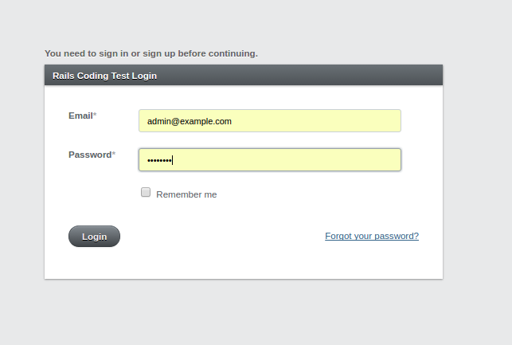

**Menu:** Through the menu you can access information:

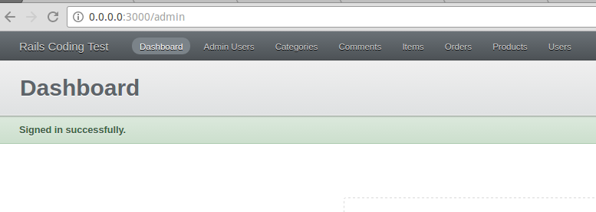

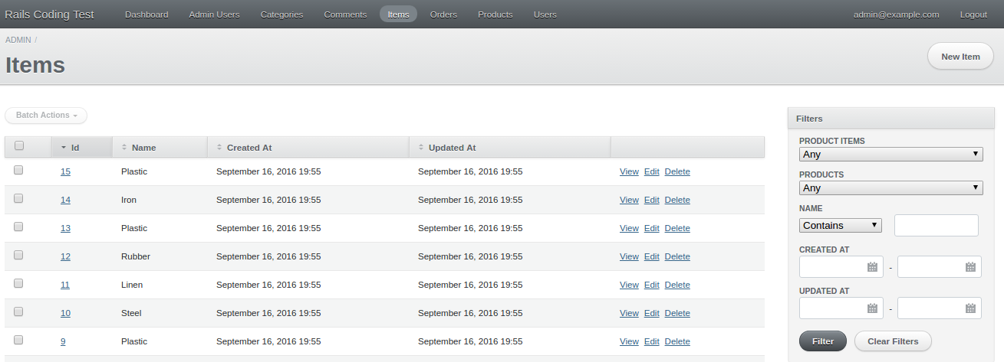

The Product_Items administration is made through the view option of each product

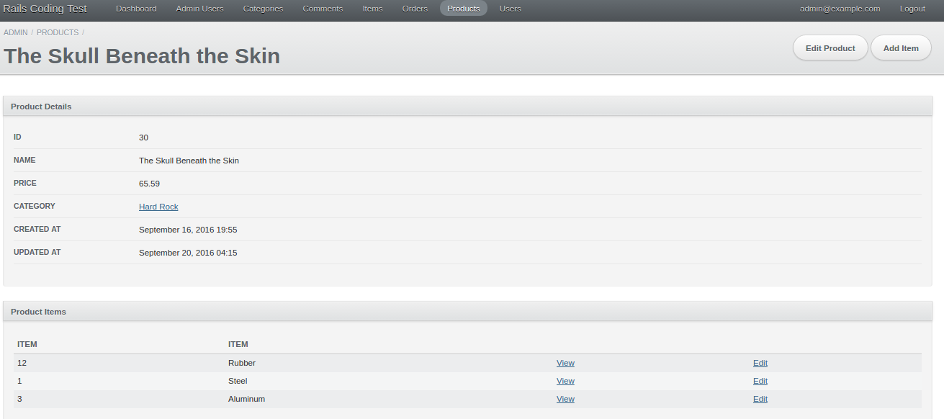

### **Customer Module**

You can found it in the root: <http://0.0.0.0:3000/>

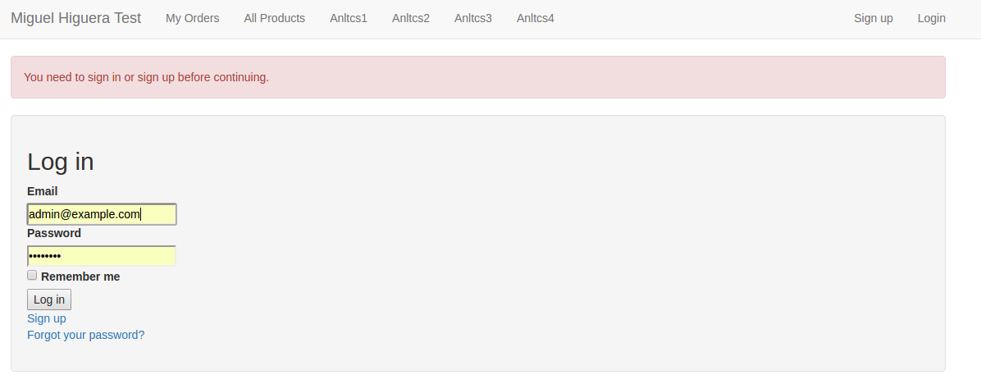

Before the Sign Up / Login you can access all the functionalities required in the link:

<https://github.com/bergamotte/rails-coding-test>

Including:

- My Orders

- Products (New Order)

- Analytics

* Breakdown by product of sold quantities
* Breakdown by items of sold quantities
* Order uniq customer count by number of orders
* Repartition between reccuring and new customers

# **Thank you**