Docker mount
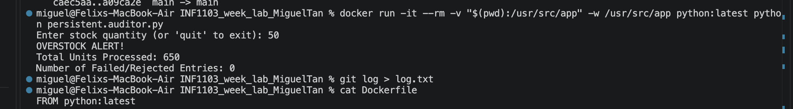

Docker build image
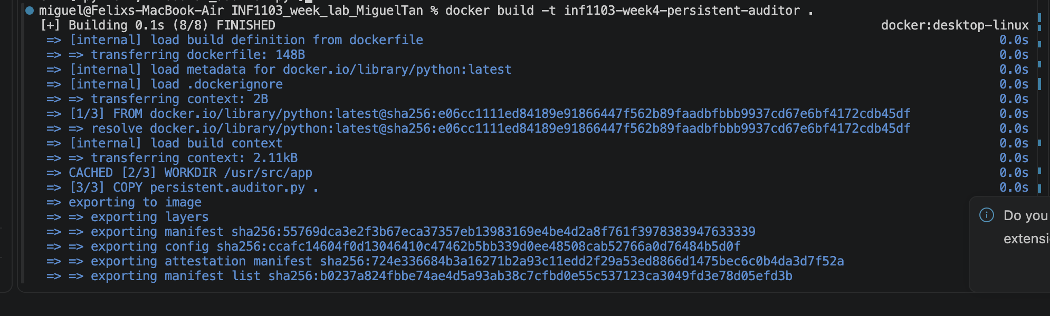

Docker run
