DE Academy — Vending Machine Demand Forecasting
Executive Summary
Predictive demand forecasting and inventory optimization for industrial vending machine restocking

Executive Summary
This project developed a predictive demand forecasting model for industrial vending machine inventory using two years of dispensing and restock transaction data. The analysis covered data cleaning, exploratory analysis, feature engineering, and the evaluation of eight forecasting models — from simple statistical baselines through gradient-boosted tree models. The best-performing model, XGBoost, achieved an 18.8% Mean Absolute Percentage Error (MAPE) on a 30-day holdout period, outperforming both classical statistical models (ARIMA, SARIMAX, Holt-Winters) and simpler baselines. Findings were translated into concrete inventory actions: SKU-level safety stock and reorder points, and a device-level restock priority schedule.
Three findings stand out. First, a single anomalous demand spike (~1,700 units on one day, roughly 4-5x normal volume) heavily influenced forecast error across nearly every model and is worth investigating as a distinct operational event. Second, daily restocking activity is strongly negatively correlated with same-day dispensing volume (Pearson r ≈ -0.90), suggesting restocks are being triggered reactively when a device runs low rather than proactively ahead of demand. Third, no device in the current fleet showed the “high volume, low restock” pattern associated with acute stockout risk — restocking cadence currently appears broadly matched to volume across all four devices in the dataset.

1. Methodology

1.1 Data & Cleaning
The analysis combined two source datasets: dispensing transactions (Inventory_Turnover.csv, one row per SKU dispense event) and restock transactions (Restock_data.csv, one row per restock event, including cost). Both datasets were confirmed free of nulls and duplicate rows. SKU identifiers were stripped of hidden whitespace prior to grouping, since unstripped values were fragmenting identical SKUs into separate groups. Dispensing and restock date columns were converted to true datetime types to enable time-series operations.

1.2 Feature Engineering
- Calendar attributes: day of week, day of month, month, quarter, and a weekend flag.
- Lag features: demand at t-1, t-7, t-14, and t-28 days, with an audited record of which early-period rows had incomplete lag history before those rows were excluded from modeling.
Note on missing values: the NaN values produced during lag-feature creation are an expected mathematical artifact, not a system or data-quality issue. A lag-28 feature, for example, has no value to reference for the first 28 days of the entire series, since no 28-day-prior record exists yet at that point — this is unavoidable for any dataset regardless of source quality. These rows were fully logged (see lag_features_pending_review.csv) and excluded only from model training; they remain in the raw data and do not indicate a fault in the vending machines, the POS system, or the data pipeline.
- Rolling window statistics: 7-day and 30-day rolling mean and standard deviation of demand, computed independently per SKU and per device.
- Restock signal features: days elapsed since a device's last restock, and 7-day/30-day cumulative restock expenditure per device.

1.3 Modeling Approach
The aggregate daily demand series was split chronologically, holding out the final 30 days as a test set — never randomly shuffled, to avoid leaking future information into training. Three baseline benchmarks were established first (Naive, Seasonal Naive using a 7-day lag, and Holt-Winters exponential smoothing) that any more complex model needed to outperform to justify its added complexity. Statistical models (ARIMA and SARIMAX with a weekly seasonal period) were fit next, following a stationarity check (Augmented Dickey-Fuller test) and ACF/PACF diagnostics. Finally, three tree-based machine learning models (Random Forest, XGBoost, LightGBM) were trained on the full engineered feature set, using TimeSeriesSplit cross-validation to ensure every validation fold occurred strictly after its training data in time. All models were scored on the same 30-day holdout using MAE, RMSE, and MAPE.

1.4 Inventory Optimization
Safety stock and reorder points were calculated per SKU using the standard formula: Safety Stock = Z × σ(demand) × √(lead time), and Reorder Point = (average daily demand × lead time) + safety stock, at a 95% service level (Z = 1.65). Demand mean and standard deviation were taken from each SKU's most recent 7-day rolling statistics. Lead time was estimated from the median historical gap between consecutive restocks per device, since a true supplier lead-time field was not present in the source data — this is a stated assumption, not a measured value, and should be replaced with actual supplier lead times if available.

2. Top Insights

2.1 Overall Demand Trend
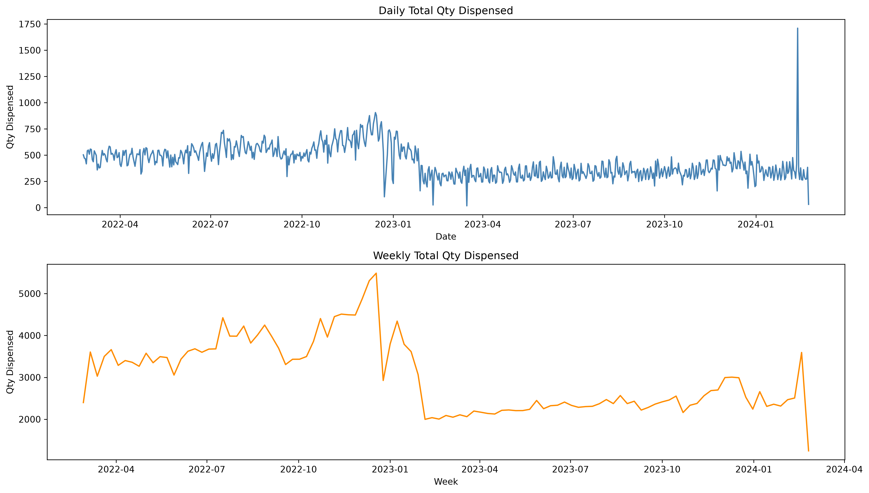
Figure 1. Daily and weekly total quantity dispensed across the full observation period.
Weekly aggregation shows a broadly stable demand level with a moderate weekday-over-weekend effect: average daily quantity dispensed is modestly higher on weekdays (~8.3 units) than weekends (~7.8 units), consistent with a workday-driven usage pattern typical of industrial vending.
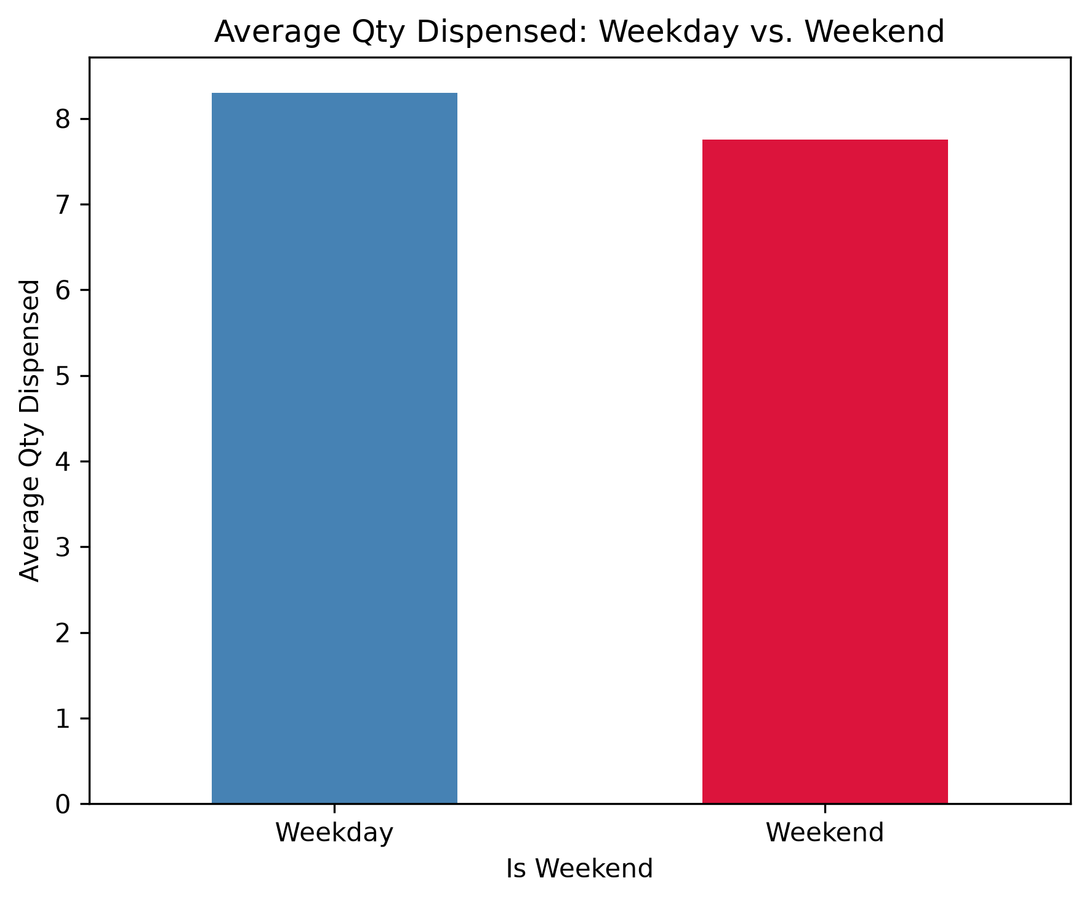
Figure 2. Average quantity dispensed, weekday vs. weekend.

2.2 Seasonality
Formal seasonal decomposition of the top-turnover SKU confirms a consistent weekly (7-day) demand cycle throughout the series. The decomposition also reveals a structural shift: this SKU's trend level was noticeably higher and more volatile through 2022, then dropped to a lower, steadier plateau beginning in early 2023, with partial recovery into 2024. This kind of shift is worth investigating with the operations team (e.g., a device relocation, menu change, or discontinued promotion) rather than treated as pure noise.
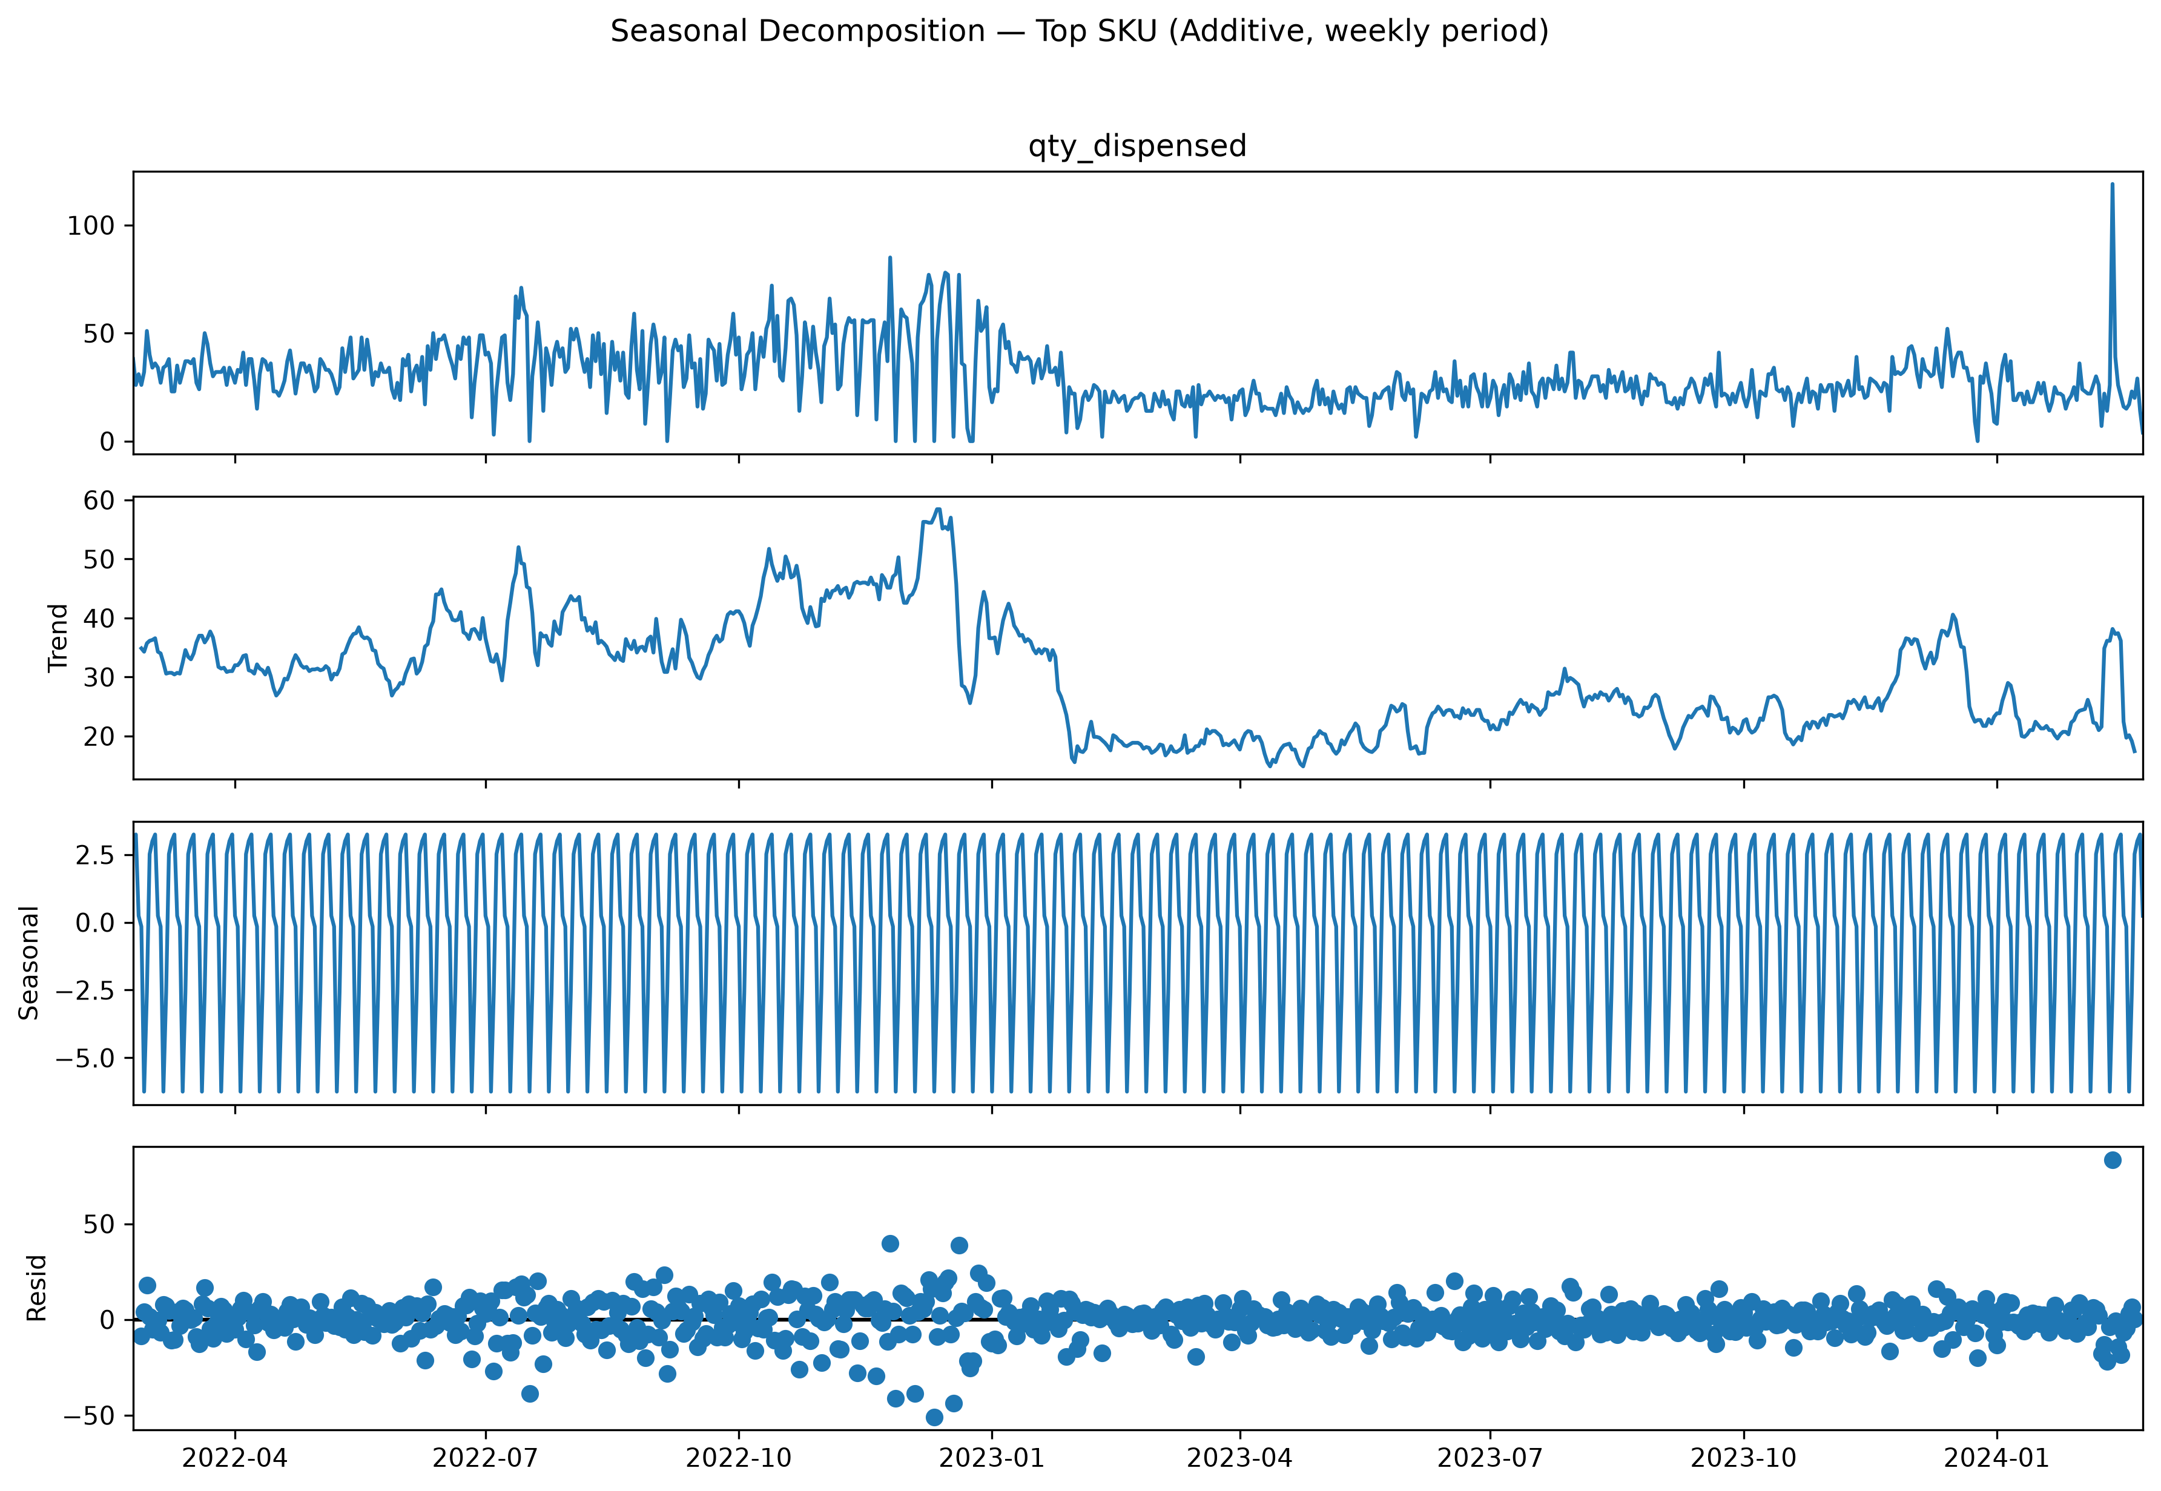
Figure 3. Seasonal decomposition (additive, weekly period) — top SKU by turnover.
Across the top 5 SKUs by turnover, two distinct weekly demand shapes emerged: the single highest-volume SKU follows a clean Monday–Thursday workday pattern with lower weekend demand, while SKUs ranked #2–#5 instead peak on Monday, Thursday, and Sunday, with Friday/Saturday consistently the lowest days. This means a single restocking schedule tuned to one pattern will not fit all top-moving SKUs equally well.

2.3 Product Turnover & Demand Variability
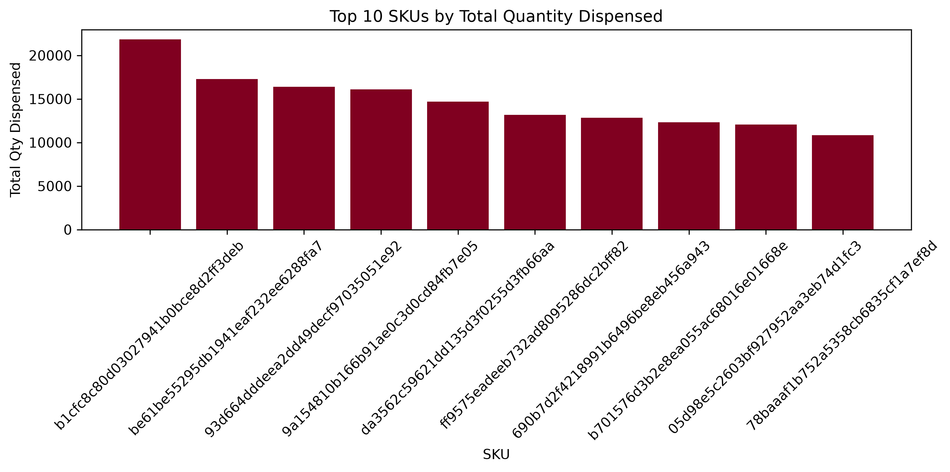
Figure 4. Top 10 SKUs by total quantity dispensed.
One SKU leads meaningfully ahead of the field (~21,800 units), followed by a tight cluster of three SKUs (~16,000–17,300 units), then a longer tail. Demand variability, measured via the coefficient of variation (CV) of each SKU's daily demand, splits the full SKU catalog almost exactly evenly — 41 SKUs High Variance, 41 Low Variance — a direct consequence of using the dataset's own median CV as the classification threshold.
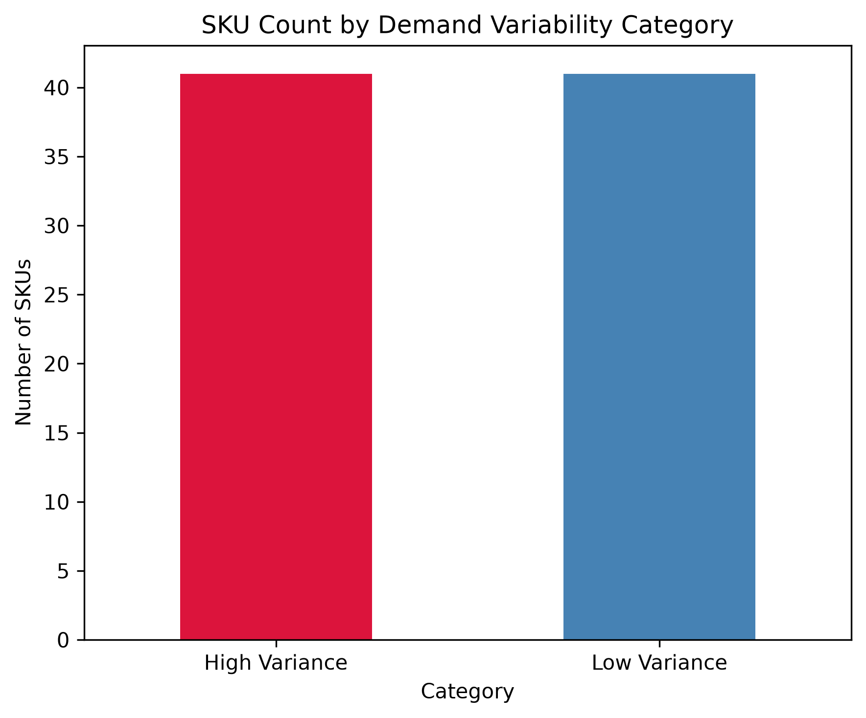
Figure 5. SKU count by demand variability category (High vs. Low Variance).

2.4 Device Utilization
Device-level classification — based on total dispensing volume and restock frequency relative to the fleet median — placed 3 of the 4 devices in the dataset in the “Overused” category (high volume, frequent restocks), one in “Low volume, frequent restocks (inefficient)”, and one “Underused.” Notably, no device fell into the “High volume, low restocks” pattern associated with acute stockout risk, a reassuring finding for current operations.
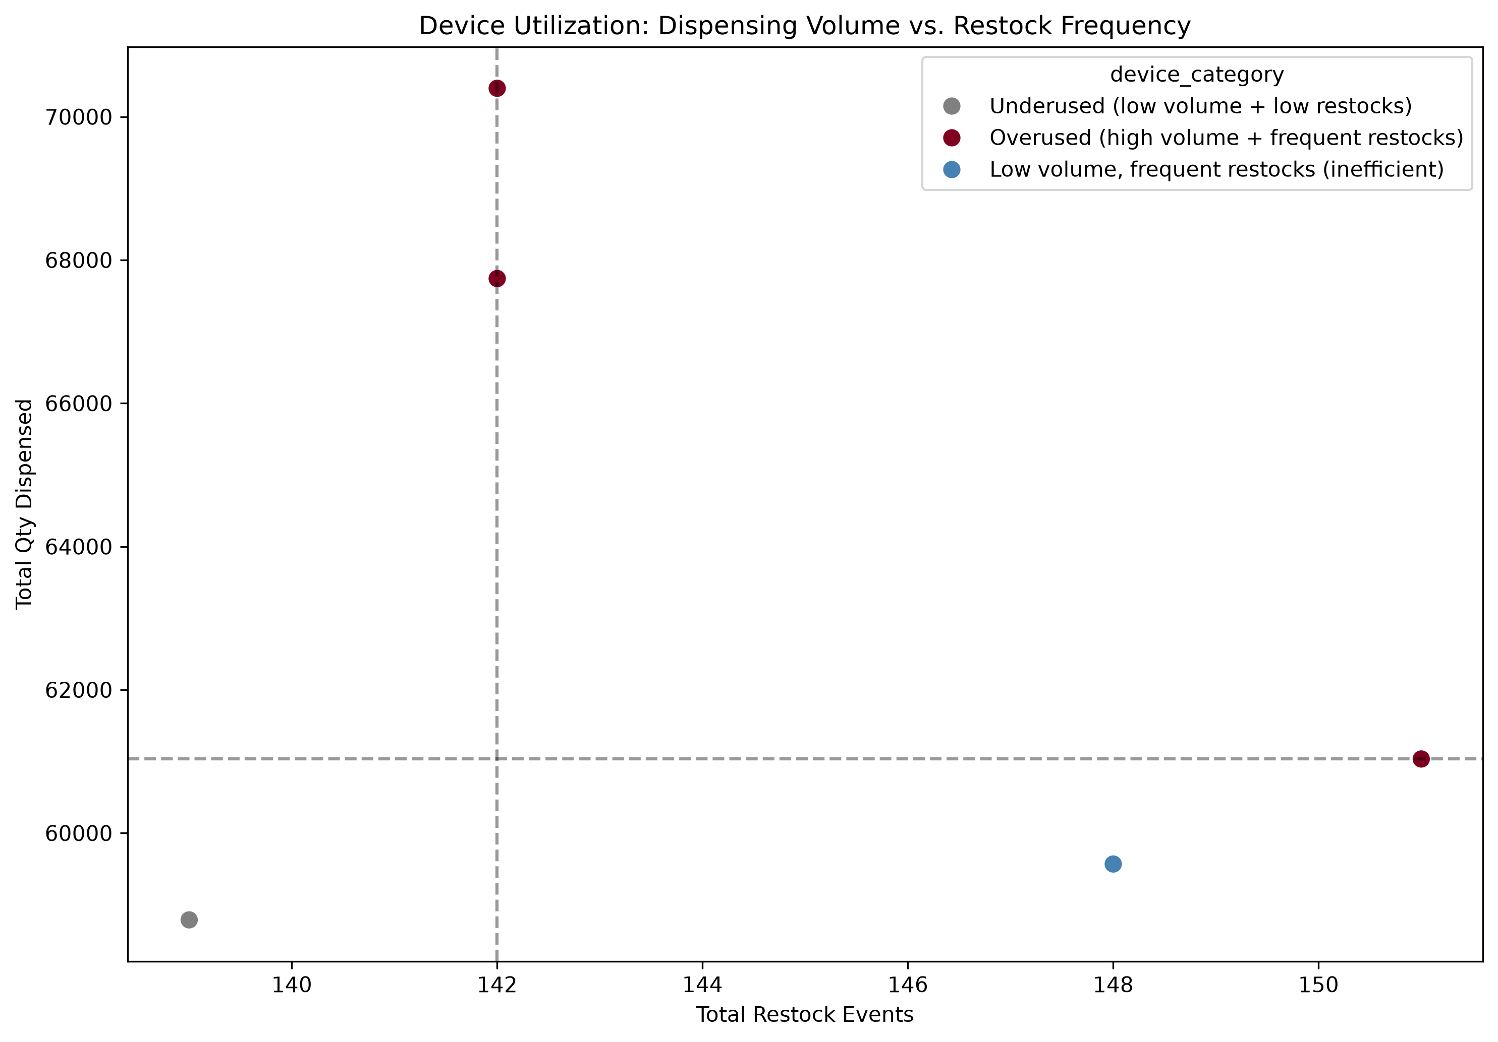
Figure 6. Device utilization — dispensing volume vs. restock frequency, colored by category.

2.5 Demand vs. Restock Correlation
Daily quantity dispensed is strongly negatively correlated with same-day restock frequency (Pearson r ≈ -0.90) and restock expenditure (r ≈ -0.80). Lag correlation analysis shows this negative relationship is strongest at zero lag and weakens (but persists in a repeating weekly ripple) as the lag moves away from zero in either direction. The most plausible interpretation: a device running low or stocked out cannot dispense at full volume, and low stock is exactly the trigger for a same-day restock — meaning restocking currently appears largely reactive to depleted stock rather than proactively scheduled ahead of anticipated demand.
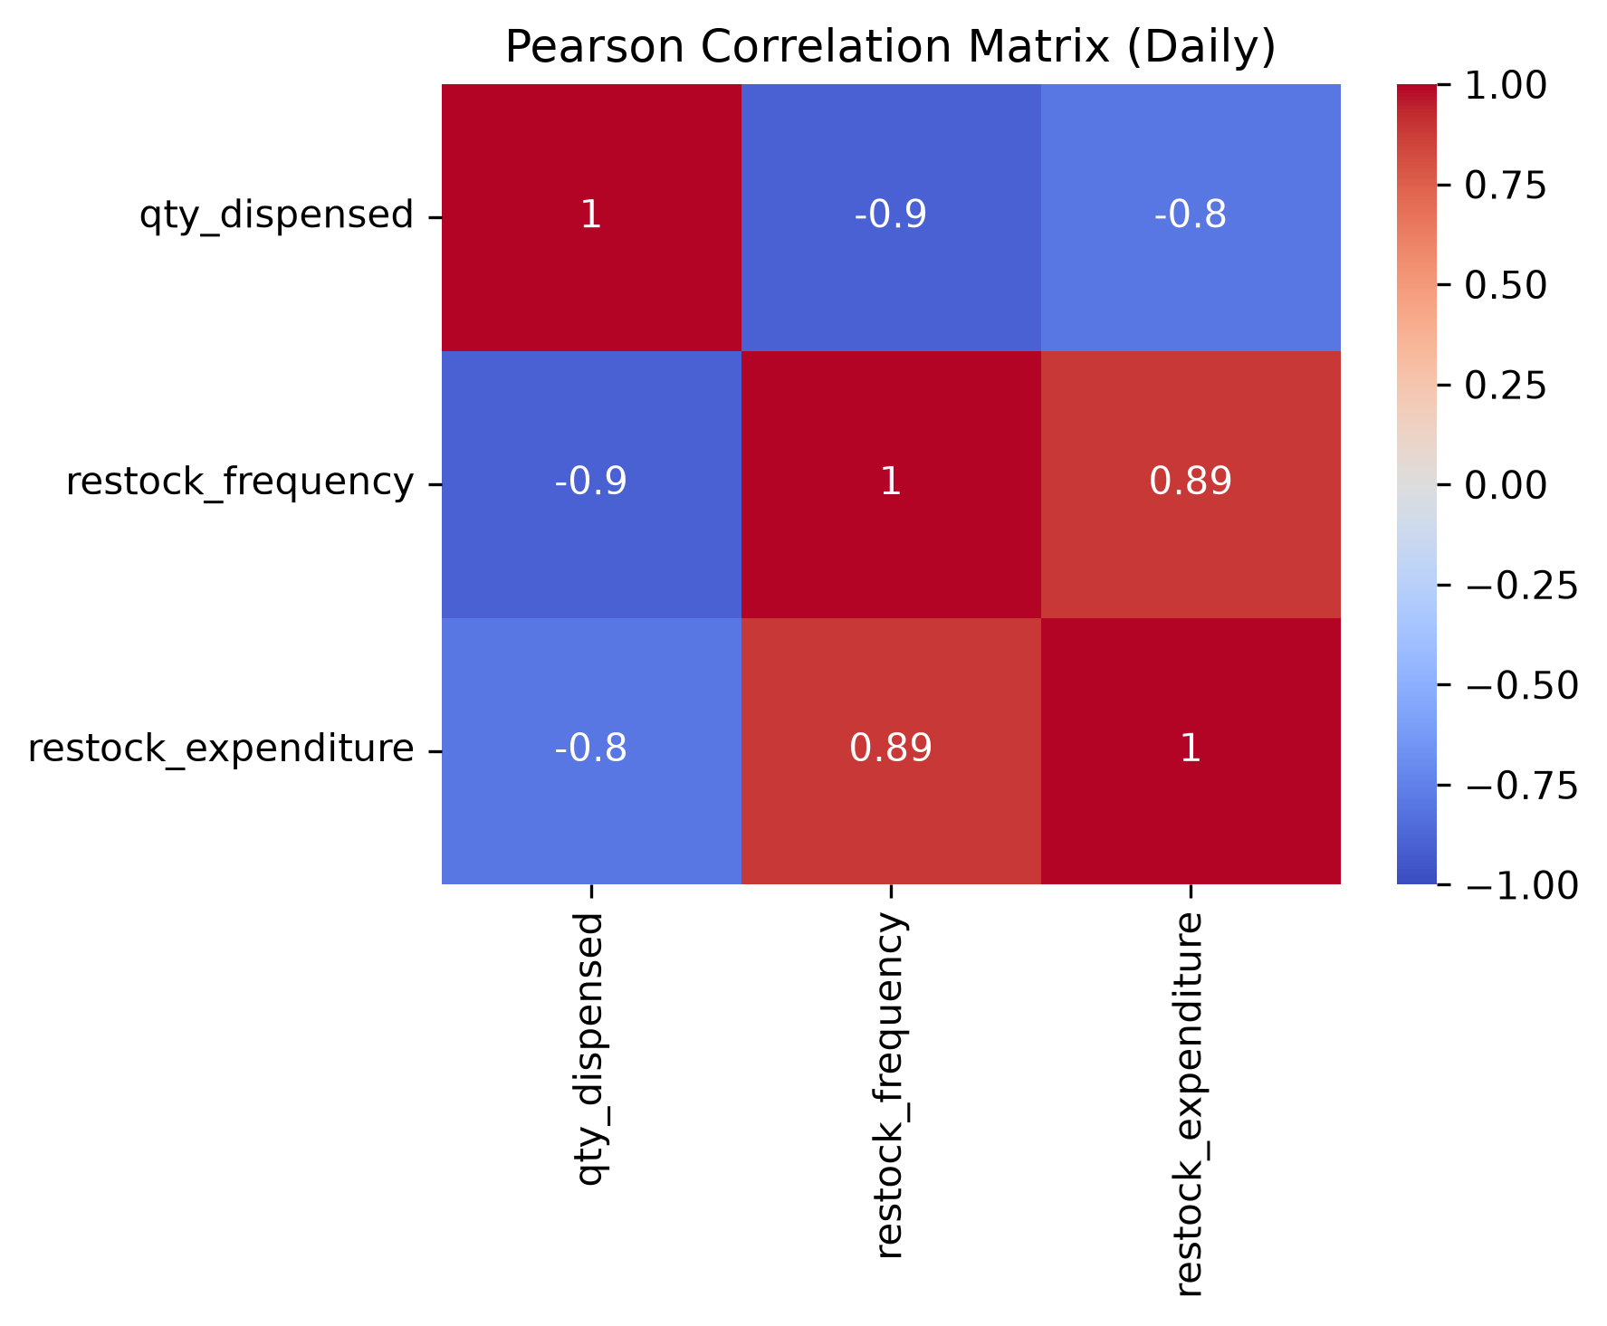
Figure 7. Pearson correlation matrix — daily quantity dispensed, restock frequency, restock expenditure.
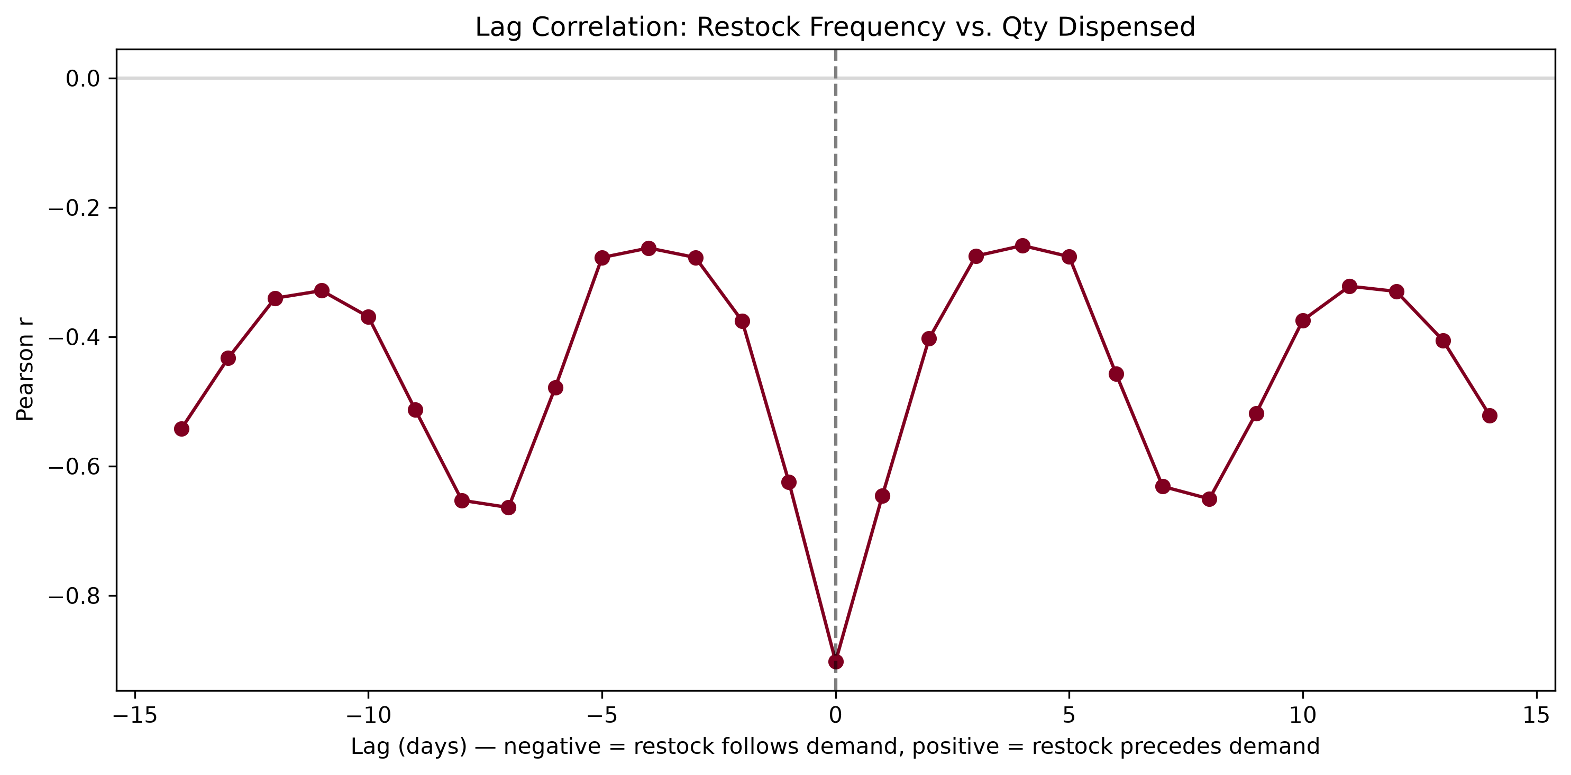
Figure 8. Lag correlation between restock frequency and quantity dispensed, -14 to +14 days.

2.6 Restock Signal Example
For a sampled device, days-since-last-restock stayed within a tight 0–3 day band across nearly the entire observation window (working as designed), with one isolated 6-day gap flagged as an anomaly worth reviewing. Cumulative restock expenditure for this device fluctuated within a stable band with no runaway growth trend, indicating steady operational spend.
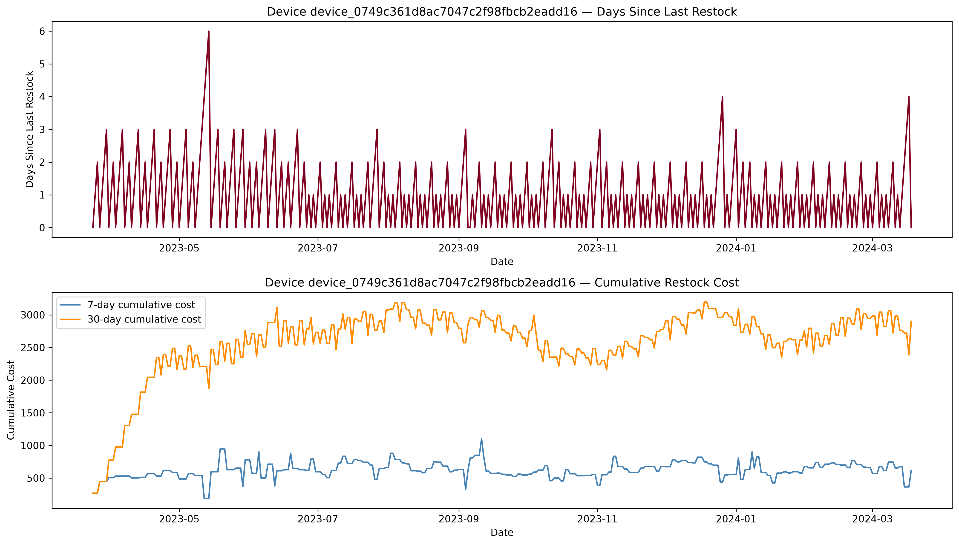
Figure 9. Days since last restock and cumulative restock cost — sampled device.

3. Demand Forecast & Model Performance
Eight models were evaluated on an identical 30-day chronological holdout. Results are ranked by RMSE, the primary metric for this comparison since it penalizes large misses (such as the demand spike discussed below) more heavily than MAE.
Model | MAE | RMSE | MAPE
XGBoost | 91.3 | 231.4 | 18.8%
LightGBM | 100.1 | 238.5 | 39.4%
Random Forest | 87.7 | 243.9 | 22.2%
Seasonal Naive (7-day) | 85.7 | 256.6 | 36.7%
SARIMAX(1,1,1)(1,1,1,7) | 93.7 | 262.5 | 41.5%
ARIMA(7,1,1) | 103.6 | 265.4 | 46.8%
Holt-Winters | 100.0 | 266.8 | 41.8%
Naive (last value) | 108.6 | 267.5 | 48.5%

XGBoost achieved the best overall accuracy — the lowest RMSE and lowest MAPE of any model tested, an 18.8% MAPE compared to 36.7%+ for every statistical model. Notably, Seasonal Naive (7-day) posted the lowest MAE but a considerably worse MAPE and RMSE than XGBoost, indicating it performs adequately on an average day but has larger occasional misses. All three tree-based ML models outperformed every statistical baseline on RMSE.

3.1 The Central Anomaly
A single-day demand spike to roughly 1,700 units — about 4-5x the typical daily volume — occurred in mid-February within the test window. Every statistical model (Holt-Winters, ARIMA, SARIMAX) missed it entirely, forecasting a flat ~300-350 units through the spike. The tree-based models partially reacted: XGBoost and LightGBM rose to roughly 550-600 units on that day, while Random Forest barely moved. This single event is the largest contributor to MAPE across nearly every model in the comparison table, and is very likely the reason XGBoost's edge over the statistical models is as large as it is — it is the only model family that showed any responsiveness to the anomaly.
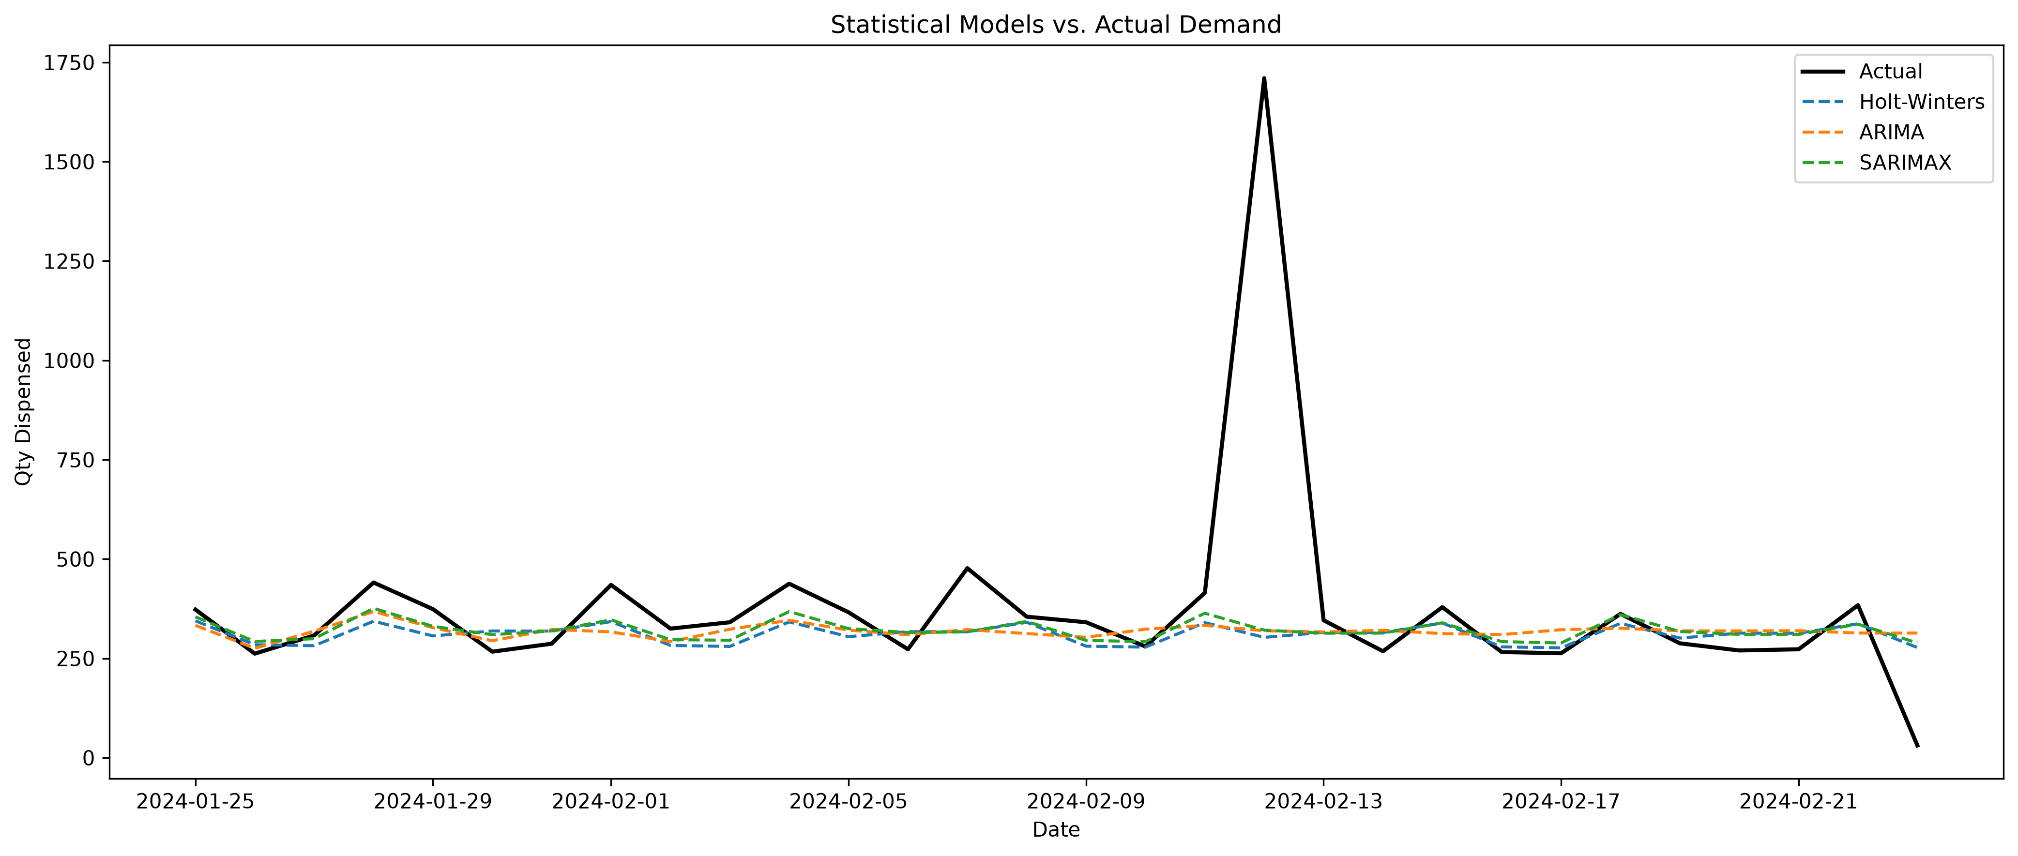
Figure 10. Statistical models (Holt-Winters, ARIMA, SARIMAX) vs. actual demand, 30-day holdout.
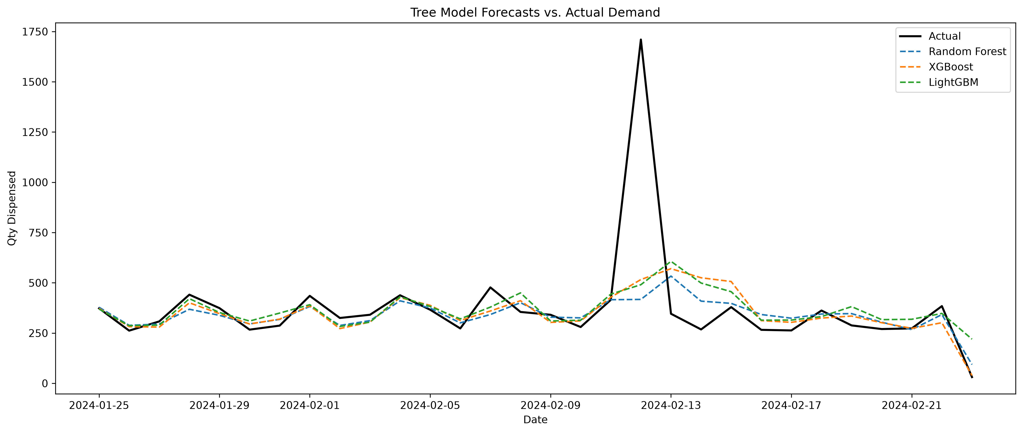
Figure 11. Tree-based models (Random Forest, XGBoost, LightGBM) vs. actual demand, 30-day holdout.
Recommendation: this spike merits direct follow-up with operations to determine its cause (bulk order, promotional event, or a data entry anomaly). If it is a recurring but infrequent event type, a dedicated event/promo flag feature would likely improve forecast accuracy further; if it is a one-off data issue, excluding or capping it may better reflect true model performance.

3.2 What Drives the Best Model
XGBoost's own feature importances confirm which engineered features carried the most predictive weight. The 7-day rolling mean of demand dominates by a wide margin, contributing roughly 62% of total importance — more than every other feature combined. Yesterday's demand (lag-1), day of week, and last week's demand (lag-7) form a clear second tier. Calendar features added purely for seasonality context — is_weekend and quarter — carried effectively zero importance once the stronger lag and rolling-window signals were present, indicating the model found the raw day-of-week and short-term demand history sufficient without them.
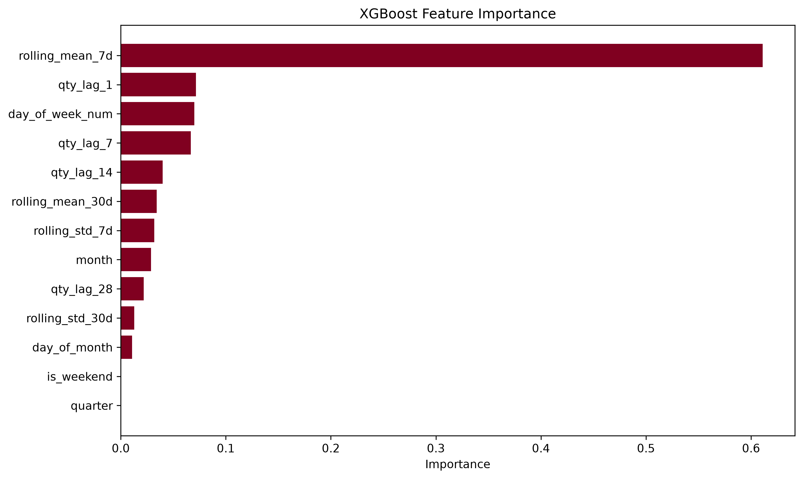
Figure 12. XGBoost feature importance.
This directly validates the rolling-window feature engineering as the single most valuable addition to the modeling pipeline, ahead of the lag features and well ahead of the calendar attributes.

4. Inventory Optimization Recommendations
Model outputs and demand variance were translated into two actionable outputs: SKU-level safety stock and reorder points, and a device-level restock priority schedule.

4.1 SKU Safety Stock & Reorder Points
Calculated at a 95% service level using each SKU's most recent 7-day rolling demand mean and standard deviation, with a 2-day estimated lead time (median historical restock gap). Across the full catalog of 82 SKUs, the five highest-turnover SKUs require the following reorder points:
SKU | 7d Avg Demand | 7d Std Dev | Safety Stock | Reorder Point
da3562c5…fb66aa | 19.4 | 12.4 | 28.9 | 67.8
b1cfc8c8…3deb (top volume) | 17.4 | 7.8 | 18.3 | 53.2
93d664dd…51e92 | 19.3 | 4.8 | 11.2 | 49.7
9a154810…b7e05 | 16.0 | 7.3 | 17.1 | 49.1
be61be55…88fa7 | 14.1 | 6.6 | 15.4 | 43.7

Notably, the SKU with the single highest reorder point (da3562c5…) is not the highest-volume SKU overall — it is driven by unusually high demand volatility (7-day std dev of 12.4, roughly double the next closest top-mover). This illustrates why reorder points should be set from demand variance rather than volume ranking alone: a moderately-sized but volatile SKU can require more buffer stock than a larger but steadier one.

4.2 Device Restock Schedule
Each device was assigned a restock priority tier and review frequency based on its utilization classification (Section 2.4):
Device | Category | Priority | Review Every
device_6726…86bc | Overused | High | 3 days
device_65ae…59349 | Overused | High | 3 days
device_c287…1ce5b5 | Overused | High | 3 days
device_af64…913686 | Low vol., frequent restocks | Low | 14 days
device_0749…eadd16 | Underused | Low | 21 days

No device currently falls into the “Critical” tier reserved for high-volume, infrequently-restocked devices — the fleet's restocking cadence is presently broadly matched to demand. The two lower-priority devices can safely move to a much less frequent review cycle (14 and 21 days respectively) without meaningfully raising stockout risk, freeing operational capacity to focus on the three higher-volume devices.

4.3 Key Assumption to Validate
Lead time in the above calculations was estimated from each device's own historical restock cadence, not a measured supplier lead time. If actual order-to-delivery lead times are available, they should replace this estimate — since lead time enters the safety stock formula under a square root, a more accurate lead time would directly change every safety stock and reorder point figure above.

4.4 Recommendation Freshness
The safety stock and reorder point figures in Section 4.1 are a snapshot: they are calculated from each SKU's most recent 7-day rolling demand statistics as of the date this analysis was run. They should be treated as valid for roughly 30 days from that date, then recalculated using an updated data pull. Demand patterns can shift (as seen in the SKU-level structural break discussed in Section 2.2), so these numbers are a starting operating point rather than a fixed, one-time target — refreshing them on a regular cadence (e.g., monthly) is recommended practice rather than optional.

5. Limitations & Next Steps
- Treat the Section 4.1 safety stock and reorder point figures as a snapshot valid for roughly 30 days; refresh from updated rolling demand data on a regular cadence rather than treating them as fixed.
- Investigate the mid-February demand spike with operations to determine its cause and whether it represents a recurring, forecastable event type.
- Replace the estimated restock-cadence lead time with actual supplier lead times where available, and recompute safety stock and reorder points.
- Consider a business-defined (rather than median-split) threshold for High/Low demand variance classification, since a median split will always produce an approximately even split regardless of the underlying distribution's shape.
- Extend the restock scheduling logic to differentiate by SKU-level weekly demand shape (Section 2.2), rather than a single schedule per device covering all SKUs stocked in it.
- Re-evaluate model rankings after the anomaly investigation, since the current XGBoost advantage is driven substantially by its partial responsiveness to a single outlier event.

