University of St. La Salle
Graduate School Lifecycle Portal
Demonstration Walkthrough & Demo Kit
A step-by-step guide for demonstrating the graduate student lifecycle:
admission handoff • course offering & adjustment • enrollment • research & defense • practicum • graduation • standing changes
Every demo account password is: DemoPass123!

1. About the System
The Graduate School Lifecycle Portal is a web application that gives the University of St. La Salle (USLS) Graduate School a single, consolidated workspace for monitoring and coordinating the full graduate student lifecycle. It replaces the manual, spreadsheet-only process the Graduate School currently uses to track where each student stands.
The application does not replace AIMS, the university's official academic information system. AIMS remains the official source for student identity, enrollment, enrolled subjects, grades, and course completion. Authorized staff export an approved monitoring workbook and import it here; those official values are shown as read-only and are labeled with their source. The portal adds the coordination, decision-support, and exception-reporting layer on top of that official data.
What the portal lets staff do
- Import the Academic Coordinator monitoring sheet and reconcile it into a single student list.
- Set up the subjects offered for a specific semester, together with the schedule and the assigned faculty member.
- Tag students as enrolled in offered subjects, either by uploading a class list or by searching a single student.
- Identify which subjects are needed next term and which students are affected if a subject is not offered.
- Route research submissions, panel matching, and defense scheduling for each student.
- Process standing changes: subject withdrawal, leave of absence, readmission, AWOL, and residency.
- Track graduation eligibility and prepare the Dean-approved endorsement list.

2. System Requirements
To run the demonstration smoothly, the presenting machine should meet the following:
- A modern browser (Google Chrome or Microsoft Edge recommended), kept up to date.
- At least 4 GB of RAM and a few GB of free disk space for the local database and demo files.
- Python 3 and Node.js installed, so the backend server and the built front-end can run locally.
- The demonstration runs locally on the presenter's machine; a live internet connection is only needed for the optional Policy Assistant feature.

3. Before You Start (Setup Notes)
Note: On the first start, the system automatically prepares its demonstration database and seeds all of the demo accounts and sample records described in this document. This runs once and may take a short moment. If a demo account or the login dropdown ever appears empty, restarting the server re-seeds the demonstration data.
Start-up sequence (performed once before the demo):
Step 1. Build the front-end so the latest screens are served.
Step 2. Start the application server. The system seeds the demonstration data automatically on first run.
Step 3. Open the application in the browser at the local address shown when the server starts (the portal runs on port 5050).
Step 4. You will land on the Login screen. Use the accounts in Section 4.
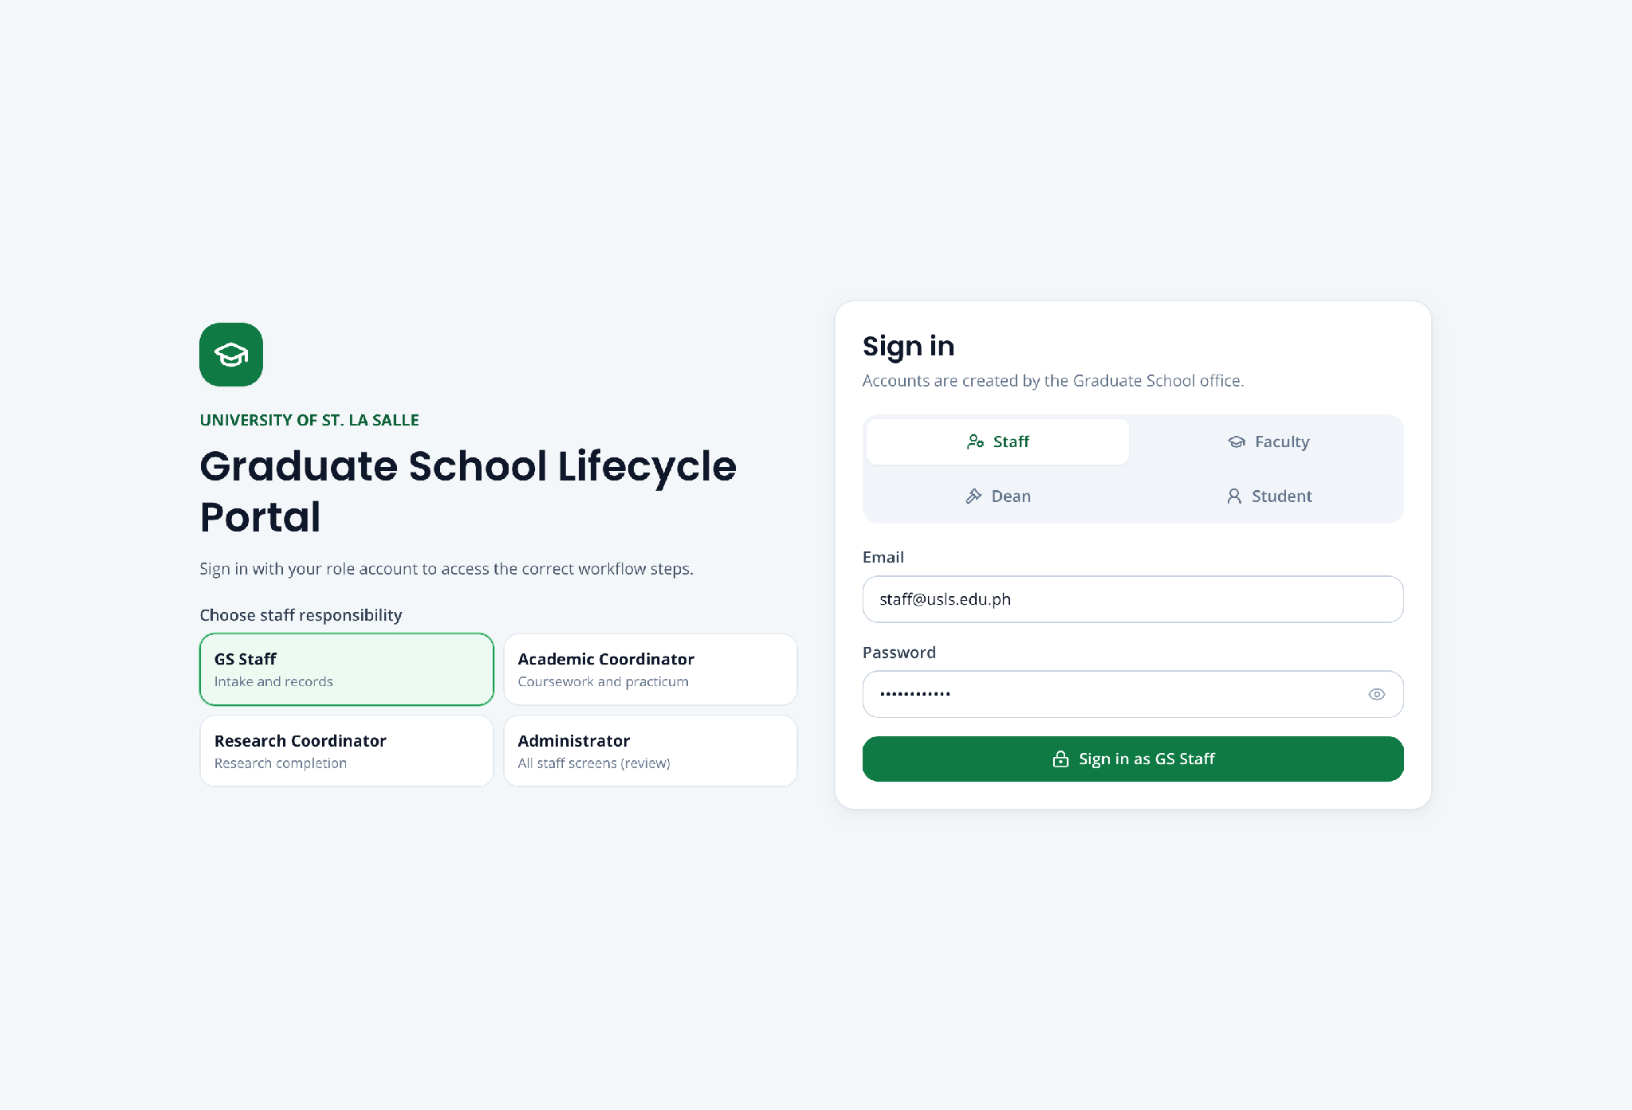
Screenshot — The Login screen, showing the account-type selector and the demo-account shortcuts.

4. Demo Accounts
Every account below uses the same password: DemoPass123! On the Login screen, choose the matching account type (role), enter the email and password, then click Log in. Student demo accounts can also be selected from the demo shortcuts on the Login screen.
Staff and approver accounts
Role | Name | Email (username)
Graduate School Staff | Grace Fernandez | staff@usls.edu.ph
Academic Coordinator | Dr. Ramon Alvarez | academic@usls.edu.ph
Research Coordinator | Dr. Sofia Mendoza | research@usls.edu.ph
Dean (approver) | Graduate School Dean | dean@usls.edu.ph
Registrar (external handoff) | Registrar Office | registrar@usls.edu.ph
Administrator | System Administrator | admin@usls.edu.ph
Student demo accounts (one ready for each case)
Student | Student No. | Email | Ready for
Miguel Yu | 2260004 | student@usls.edu.ph | Research, Panel, Defense
Sofia Reyes | GS-2026-HO-01 | handoff.sofia@usls.edu.ph | Complete student handoff
Anton Bautista | GS-2026-HO-02 | anton.bautista@student.usls.edu.ph | Handoff follow-up
Lianne Mercado | GS-2026-CA-01 | adjustments.lianne@usls.edu.ph | Course-demand example
Roberto Aquino | GS-2026-CA-02 | roberto.aquino@student.usls.edu.ph | Focused subject needs
Clarissa Dela Cruz | GS-2026-ENR-01 | enrollment.clarissa@usls.edu.ph | Single-student enrollment
Martin Gonzales | GS-2026-ENR-02 | enrollment.martin@usls.edu.ph | Offered-subject enrollment
Elena Navarro | GS-2026-WD-01 | withdrawal.elena@usls.edu.ph | Subject withdrawal (MAED-MAJ1)
Joshua Lim | GS-2026-WD-02 | withdrawal.joshua@usls.edu.ph | Subject withdrawal (MAED-MAJ2)
Andrea Villanueva | GS-2026-PRAC-01 | practicum.andrea@usls.edu.ph | Practicum
Bianca Santos | GS-2026-GRAD-01 | graduation.bianca@usls.edu.ph | Graduation application
Maureen Castillo | GS-2026-LOA-01 | maureen.castillo@student.usls.edu.ph | One-semester Leave of Absence
Daniel Fernandez | GS-2026-LOA-02 | loa.daniel@usls.edu.ph | Two-semester LOA policy check
Therese Lacson | GS-2026-READ-01 | readmission.therese@usls.edu.ph | Readmission after approved LOA
Gabriel Domingo | GS-2026-READ-02 | readmission.gabriel@usls.edu.ph | Readmission policy checks
Maya Torres | GS-2026-AWOL-01 | awol.maya@usls.edu.ph | Return from automatic AWOL
Nicolas Valdez | GS-2026-RES-01 | residency.nicolas@usls.edu.ph | Residency policy review
Note: Additional seeded students exist for handoff, course adjustments, readmission, AWOL, residency, and a second student for practicum and graduation, so every list and batch screen has more than one example.

5. Navigating the Portal
After logging in, the left sidebar is grouped into sections. The graduate lifecycle is presented as a numbered sequence so the demonstration can move through it in order.
Lifecycle workflows
- 1 · Student Handoff — import and reconcile the monitoring sheet.
- 2 · Course Adjustments — set up subject offerings and review subject needs.
- 3 · Enrollment — tag students to offered subjects.
- 4 · Research Gate — check each student's required research submissions.
- 5 · Panel Matching — recommend and finalize the defense panel.
- 6 · Defense Scheduling — find a common defense slot.
- 7 · Practicum — track practicum requirements and hours.
- 8 · Graduation — check eligibility and prepare the endorsement list.
Standing changes
- Leave of Absence
- Readmission
- AWOL & Residency
- Withdrawal Requests
Records and support
- Students, Faculty, Monitoring Sheet, Enrollment Class List
- Dashboard and Reports
- Work Queue, Activity Log, Recommendations, and the Policy Assistant
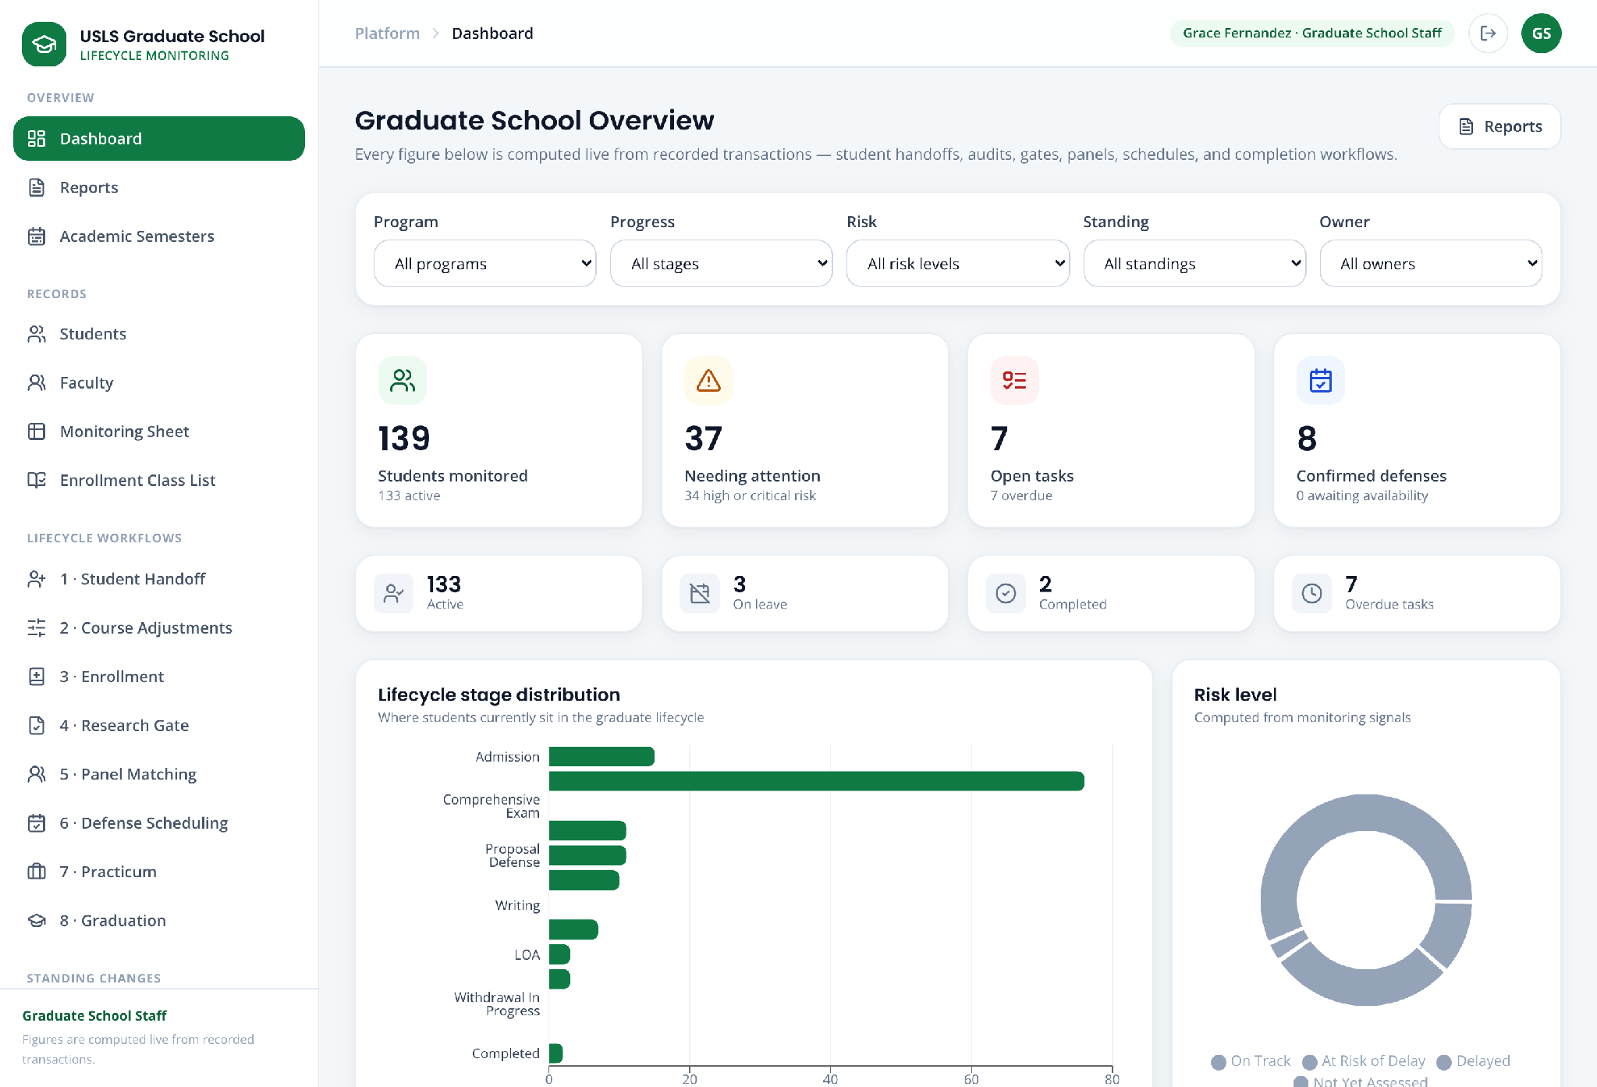
Screenshot — The dashboard after login, showing the sidebar sections and the lifecycle overview.

6. Demonstration Running Order
The cases below are numbered in the order they are demonstrated, which follows the real academic process rather than the sidebar numbering. Course Adjustments has to run before Enrollment because the system will only enroll a student into a published offering. The standalone processes — withdrawal, dropping, leave and AWOL — sit before practicum and graduation because that is where they fall in a student's lifecycle.
Case | What is demonstrated · by whom
Case 1 | Reset the demonstration data
Case 2 | Course Adjustments — demand, Dean approval, offering setup
Case 3 | Enrollment — class-list import and single-student enrollment
Case 4 | Monitoring Sheet — the record the platform maintains
Case 5 | Subject Withdrawal
Case 6 | Dropping a Subject
Case 7 | Policy Assistant — retrieval over the handbook
Case 8 | Leave of Absence
Case 9 | AWOL and Return from AWOL
Case 10 | Research Gate, Panel Matching, and Defense Scheduling
Case 11 | Title Defense
Case 12 | Defense Scheduling and Rescheduling
Case 13 | Proposal Defense
Case 14 | Final Defense
Case 15 | Practicum
Case 16 | Graduation eligibility and endorsement
Case 17 | Reports and Analytics
Case 18 | Best Features — the closing statement
Case 19 | Readmission · reference only
Case 20 | Residency · reference only
Case 21 | Subject-needs evidence in detail · reference only
- Cases 19 to 21 are reference only. They are not part of the live demonstration and are included so the panel can read the process if it is raised.
- The presentation before the demonstration is a problem statement. The best features are presented after the demonstration, not before it.

7. Demonstration Cases
Each case below is self-contained: it names the account to use, the story behind it, the data to enter, and the steps to follow. They are numbered in demonstration order, which is listed in Section 6.
Case | Screens / workflows covered
1 | Student Handoff; Monitoring Sheet; Students directory and full student record
2 | Faculty Profiles; Course Adjustments — Demand & adjustments; Offering setup
3 | Enrollment; class-list import preview; Enrollment Class List; record synchronization
4 | Subject-needs report; affected students; delay impact
8 | Leave of Absence; Readmission; automatic AWOL; Return from AWOL; Residency

Case 1 — Reset the demonstration data
Story:
Before the demonstration begins, the seeded demo students are returned to their starting state so that every case runs from a known position. The reset is per student, not a wipe of the database, and it is performed from the sign-in page without logging in.
Explain this to the panel once, at the start, so that no later step looks like it was prepared in advance.
Accounts used:
Role | Account
No account required | Performed from the Login screen
Password for every demo account | DemoPass123!
Data to use:
Field | Value / instruction
Students to reset | The demo student for each case that will be presented
When | Once, immediately before the demonstration begins
Part A — Reset the demo students
Step 1. Open the portal at the Login screen. Do not sign in yet.
Step 2. Locate the demo-student shortcuts on the Login screen.
Step 3. Reset each student that a later case will use, so each workflow starts from its documented state.
Step 4. Read the confirmation message for each reset before continuing.
Step 5. State plainly that this restores the seeded starting position and does not create, delete or alter any record beyond that student's own workflow state.
Note: The reset exists so the demonstration is repeatable. It is not part of the product's operational workflow and would not be present in a production deployment.

Case 2 — Course Adjustments — demand, Dean approval, offering setup
Story:
Before enrollment opens, the Academic Coordinator reviews faculty profiles, examines live subject demand, prepares an offering draft, routes it for approval, publishes it, and completes the official faculty, section, and schedule setup.
Accounts used:
Role | Account
Academic Coordinator | academic@usls.edu.ph
Dean | dean@usls.edu.ph
Password | DemoPass123! for both accounts
Data to use:
Field | Value / instruction
Program | MAED — Master of Arts in Education
Planning semester | AY 2026–2027, 1st Semester
Faculty | Select a profile whose expertise and availability fit the subject
Part A — Review Faculty Profiles
Step 1. Sign in as Academic Coordinator and open Faculty Profiles from Records.
Step 2. Search by faculty name, department, or specialization. Use the department and availability filters to narrow the list.
Step 3. Compare specialization, login email, account status, availability, and current panel load in the directory before opening a profile.
Step 4. Open the selected faculty profile. Review specialization keywords, preferred teaching subjects, contact/login identity, current teaching and panel assignments, and load limits.
Step 5. Review weekly availability and the calendar-connection status. Treat profile suggestions as decision support, not an automatic assignment.
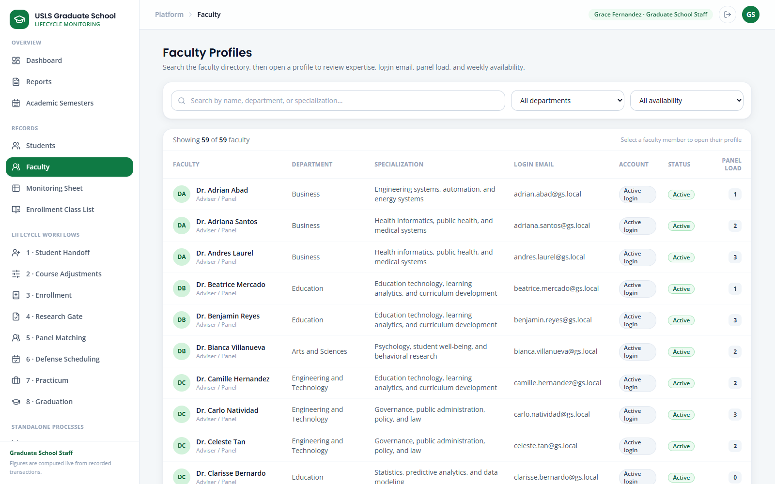
Screenshot — Faculty Profiles directory with expertise, account, availability, and workload columns.
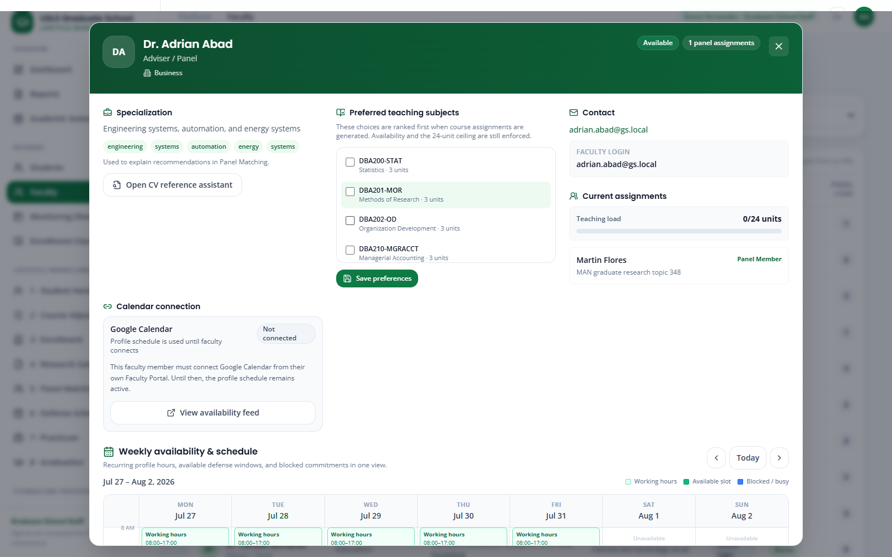
Screenshot — Faculty Profiles detail dialog with specialization, preferred subjects, assignments, and calendar information.
Part B — Build the demand-backed offering draft
Step 6. Open 2 · Course Adjustments and keep the Demand & adjustments tab active.
Step 7. Select MAED and the planning semester. Confirm the plan status shown by the Draft → Submitted → Approved → Published governance strip.
Step 8. Review Students reviewed, Subjects with need, and Student-subject needs. These totals are recalculated from the current student records.
Step 9. Read the Subject-needs report. Compare Students needing with Not taken, then read the named Affected students behind each total.
Step 10. For each proposed subject, review demand, affected students, existing completion/enrollment evidence, and the delay impact if it is withheld.
Step 11. Mark the selected subject as offered, set the required section count, choose the faculty after reviewing Faculty Profiles, and add planning notes.
Step 12. Click Save draft. Reopen the plan if necessary and verify that the subject, section count, faculty choice, and notes were preserved.
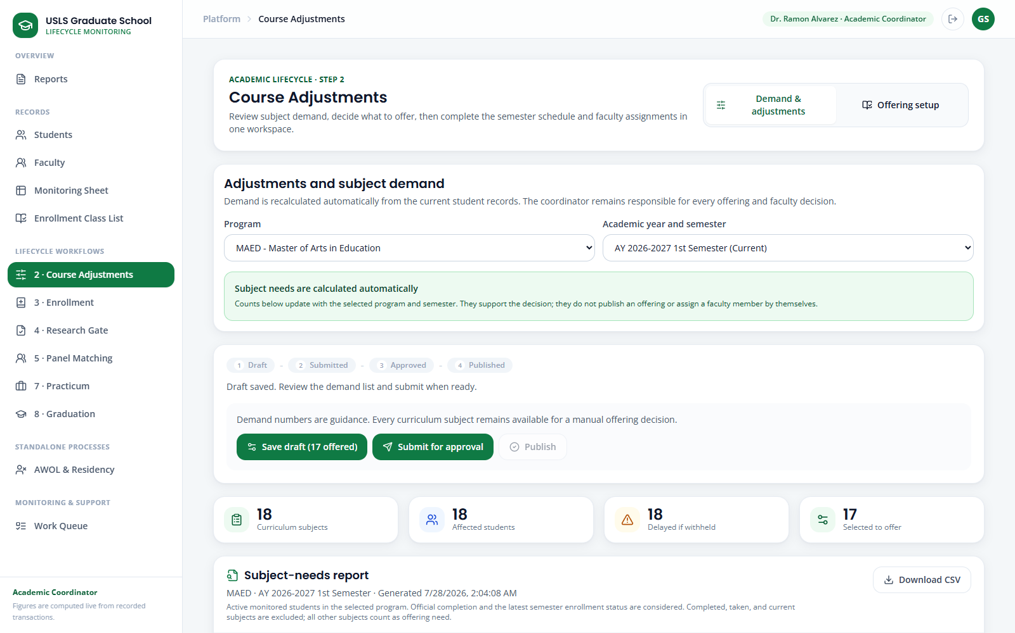
Screenshot — Course Adjustments on Demand & adjustments with the governed plan stages.
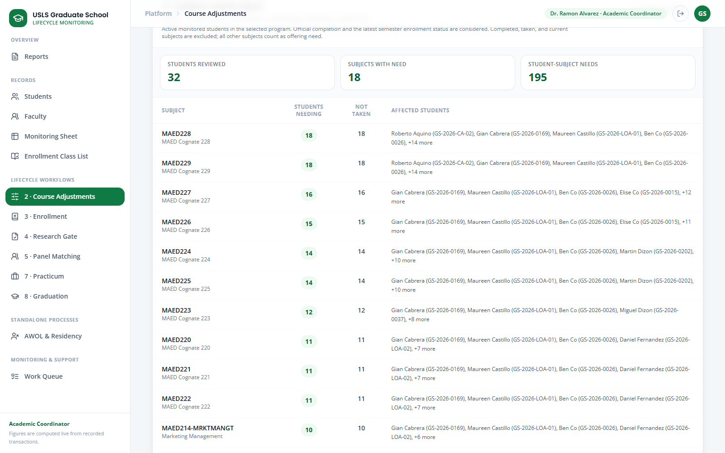
Screenshot — Course Adjustments Subject-needs report with named affected students.
Part C — Approve, publish, and complete setup
Step 13. Click Submit for approval. Confirm that the draft becomes read-only while the Dean decision is pending.
Step 14. Sign in as Dean, open the submitted course-adjustment item, review the evidence and notes, then approve it or return it for revision.
Step 15. Return as Academic Coordinator. If returned, revise and resubmit. If approved, click Publish so the plan becomes the official offering list.
Step 16. Switch to Offering setup in Course Adjustments. Confirm or complete the faculty, section, and schedule for every published subject.
Step 17. Click Save and reopen the same program/semester. Verify that only the published official offerings are available to Enrollment.
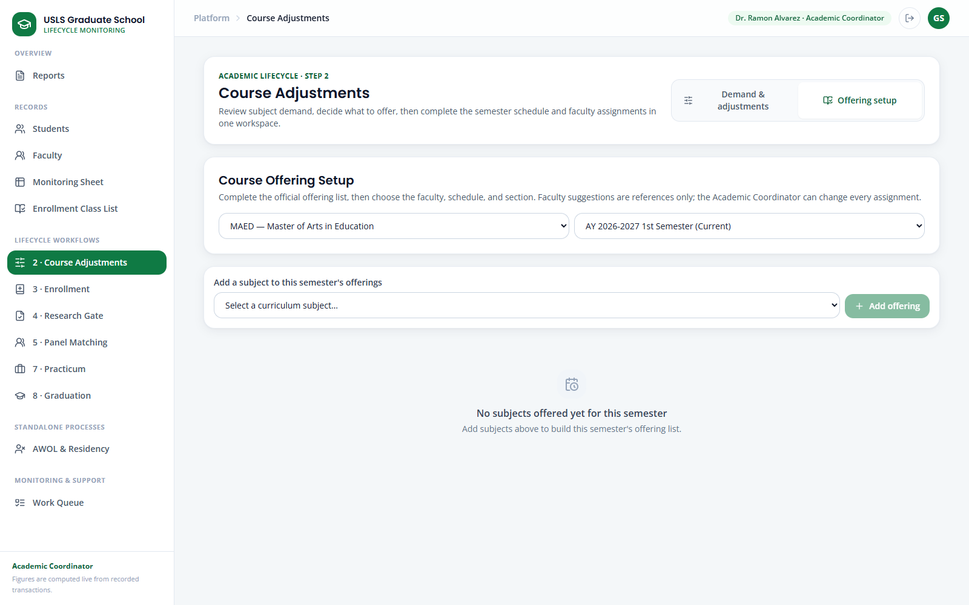
Screenshot — Course Adjustments Offering setup for published faculty, section, and schedule details.
Note: Faculty matching is advisory. The Academic Coordinator owns the assignment, the Dean records the approval, and publication controls what Enrollment can use.

Case 3 — Enrollment — class-list import and single-student enrollment
Story:
After Course Adjustments publishes the official offerings, Graduate School Staff enroll a batch from a Registrar class list or enroll one late student. Both paths synchronize Enrollment Class List, Monitoring Sheet, Students, and the Student Portal.
Accounts used:
Role | Account
Graduate School Staff | staff@usls.edu.ph
Password | DemoPass123!
Data to use:
Field | Value / instruction
Program / semester | Use the published program and semester from Case 2
Class-list template | Documents\Stakeholder_Meeting_Prep\Enrollment_Class_List_Template.csv
Single-student example | Clarissa Dela Cruz — GS-2026-ENR-01
Part A — Preview and confirm a class-list import
Step 1. Open 3 · Enrollment and confirm the selected Program and Academic semester.
Step 2. Confirm that the subject list contains only official published offerings from Course Adjustments.
Step 3. Click Upload class list and select the CSV or XLSX. Student ID and Subject Code must match portal records; Faculty may be included.
Step 4. In Preview class list, review Rows detected, Ready, Already enrolled, and Needs review before any record is changed.
Step 5. Read every row result. Resolve unknown students, mismatched programs, subjects that are not offered, completed subjects, invalid faculty, and faculty conflicts in the source file.
Step 6. Choose another file after corrections and repeat the preview until the intended rows are Ready.
Step 7. Click Confirm import. Valid rows are enrolled; rows that still need review are skipped and remain visible in the result.
Step 8. Record or retain the source reference so the enrollment can be traced to the Registrar class list.
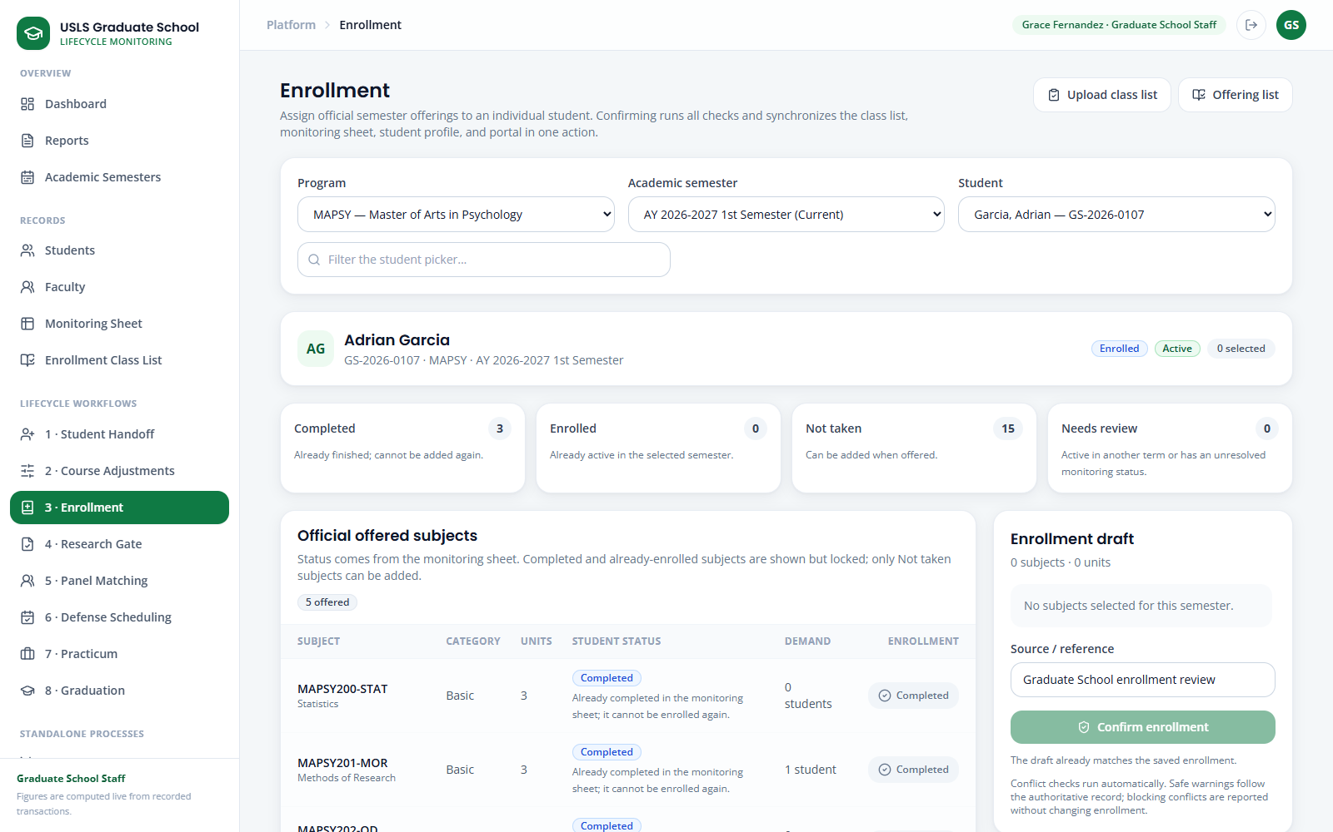
Screenshot — Enrollment with program, semester, student, and synchronization guidance.
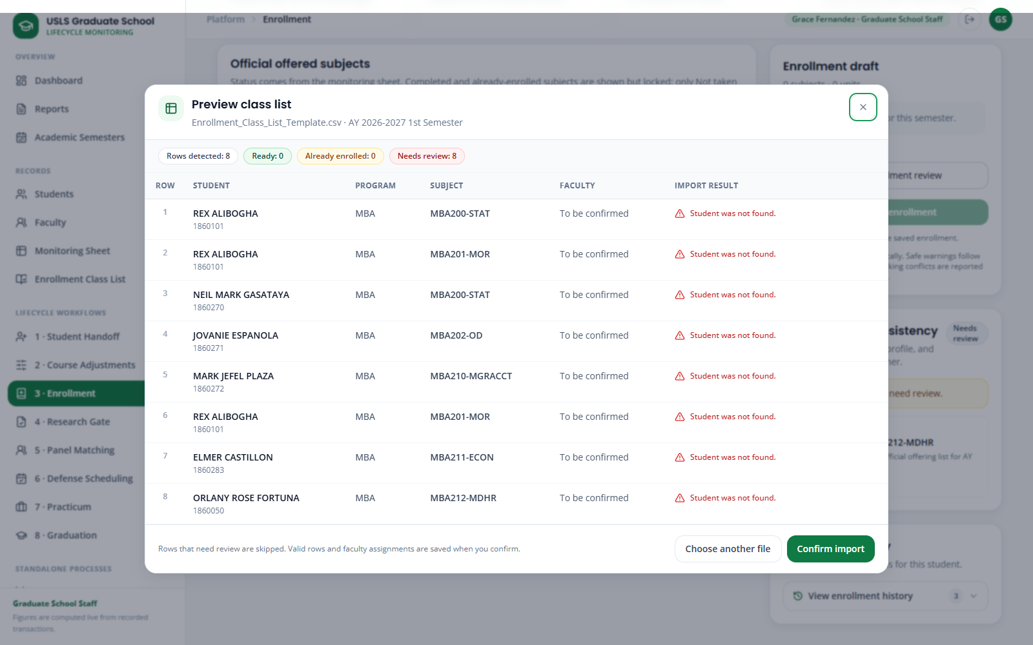
Screenshot — Enrollment Preview class list dialog with row-level validation before confirmation.
Part B — Enroll or update one student
Step 9. Return to Enrollment and use Filter the student picker to find Clarissa Dela Cruz, then select her record.
Step 10. Review the student summary and subject-status totals before selecting a subject.
Step 11. In Official offered subjects, add only subjects marked Not taken. Completed or already-enrolled subjects remain locked.
Step 12. Review the conflict check and the draft summary. Remove any subject that conflicts with the official status or offering.
Step 13. Enter the enrollment source/reference and click Confirm enrollment.
Step 14. For an authorized mid-term status change, click the Enrolled badge, choose Dropped or Withdrawn, and enter the required effective date and note.
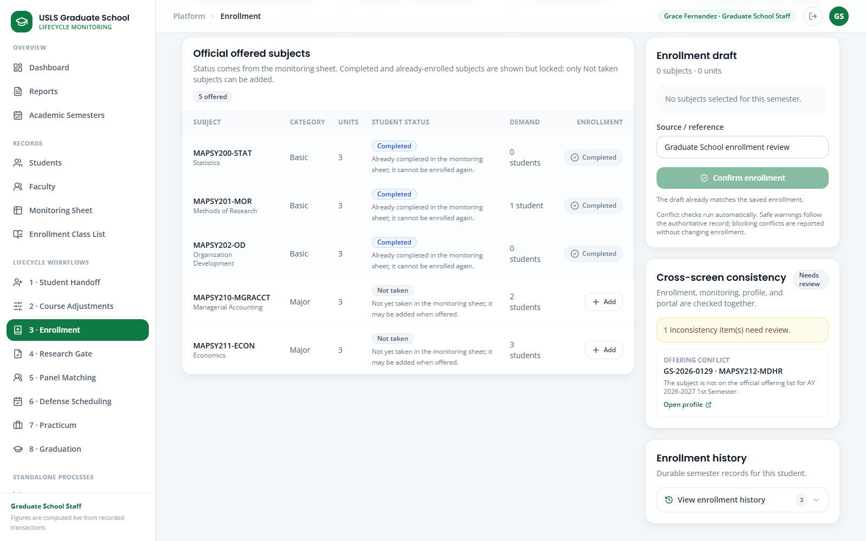
Screenshot — Enrollment Official offered subjects with locked statuses and selectable Not taken subjects.
Part C — Verify all synchronized output screens
Step 15. Open Enrollment Class List, select the same program and semester, and choose All class lists or one subject.
Step 16. Verify the read-only roster, faculty and section details, student count, and status. Use Export CSV for the Registrar handoff if required.
Step 17. Open Monitoring Sheet and confirm the same enrolled, dropped, or withdrawn subject state in the curriculum grid.
Step 18. Open Students and the student's full record. Confirm the enrollment entry and activity log, then verify the same result in the Student Portal.
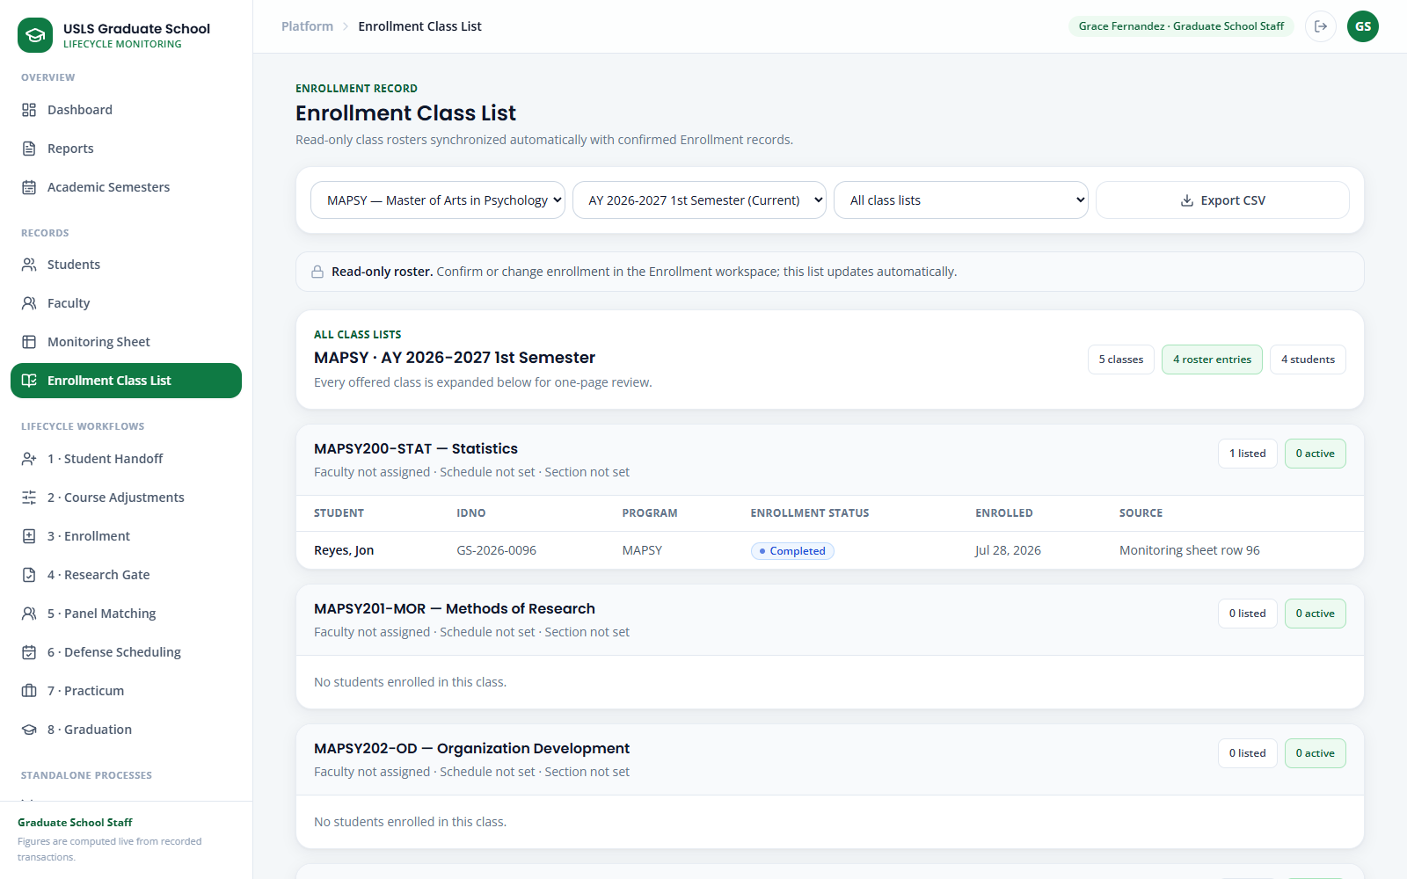
Screenshot — Enrollment Class List with synchronized read-only rosters and CSV export.
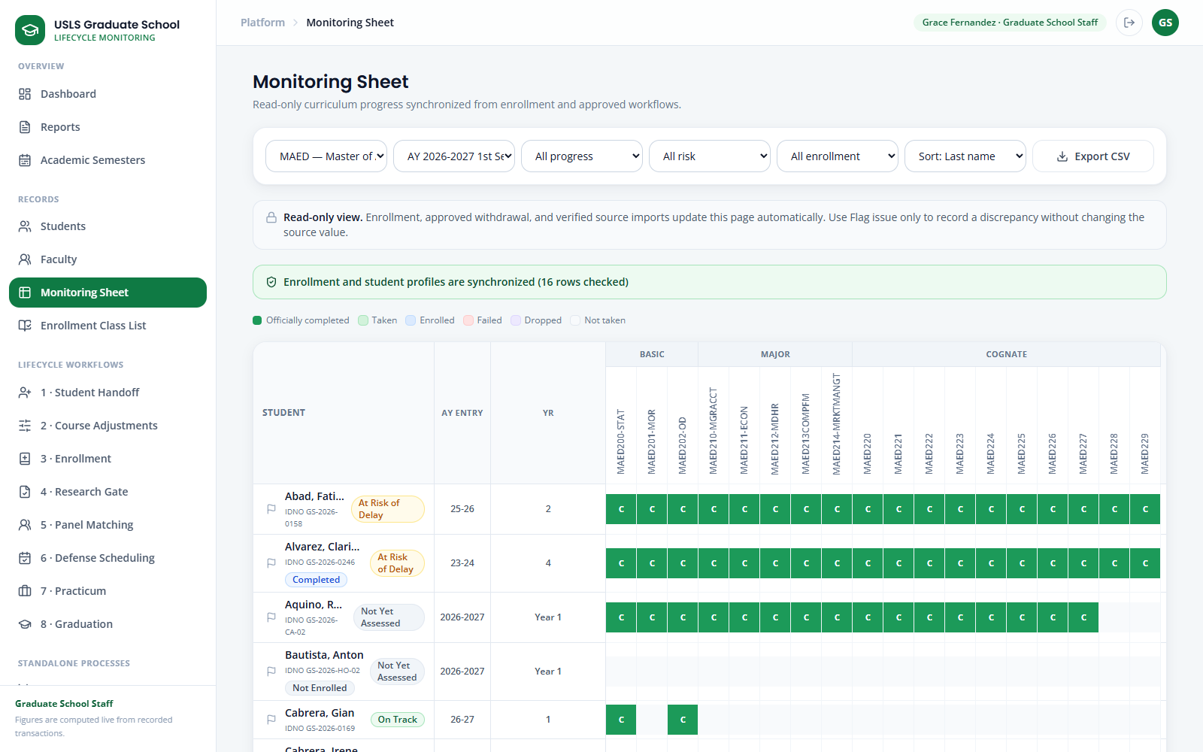
Screenshot — Monitoring Sheet showing the enrollment-synchronized curriculum state.
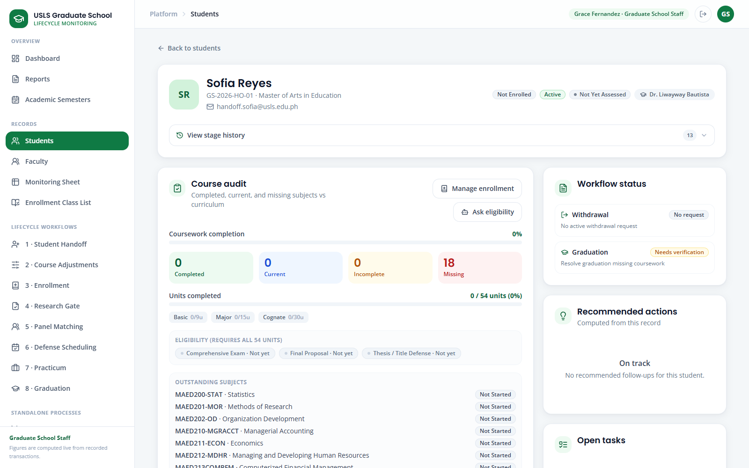
Screenshot — Students full record used to verify the same enrollment outcome and audit trail.
Note: Enrollment Class List is an output screen. Additions and status changes must be made in Enrollment or through a confirmed class-list import.

Case 4 — Monitoring Sheet — the record the platform maintains
Story:
Graduate School Staff receive the Academic Coordinator's official monitoring workbook, import it through Student Handoff, reconcile the result, and verify the same source-backed record in Monitoring Sheet and Students.
Accounts used:
Role | Account
Graduate School Staff | staff@usls.edu.ph
Password | DemoPass123!
Data to use:
Field | Value / instruction
Monitoring workbook | Documents\Monitoring_Sheets\MAED_Monitoring_Sheet.xlsx
Program | MAED — Master of Arts in Education
Verification record | Sofia Reyes — GS-2026-HO-01
Part A — Import and reconcile in Student Handoff
Step 1. Sign in as Graduate School Staff and confirm that the left sidebar shows 1 · Student Handoff under Lifecycle Workflows.
Step 2. Open Student Handoff. Confirm the page title, the Import from monitoring sheet panel, and the guidance that the official source is an AC Student Monitoring Excel workbook.
Step 3. Click Browse files and choose the MAED monitoring workbook. The upload accepts .xlsx or .xlsm in the expected monitoring-sheet format.
Step 4. Verify the selected filename before clicking Import students. Do not continue if the program or workbook version is not the intended source.
Step 5. Click Import students. Wait for the result panel, then review the added, updated, skipped, validation, and conflict counts.
Step 6. Open each validation or conflict item. Confirm whether the issue is a source correction, an identity match, or a duplicate that requires verified handling.
Step 7. Review Upload history. Confirm the workbook name, import time, counts, stored version, and the ability to reopen the reconciliation details.
Step 8. If a source value is wrong, correct the authorized workbook and re-import it. Keep the prior upload as the audit trail; do not rewrite the imported value directly in the portal.
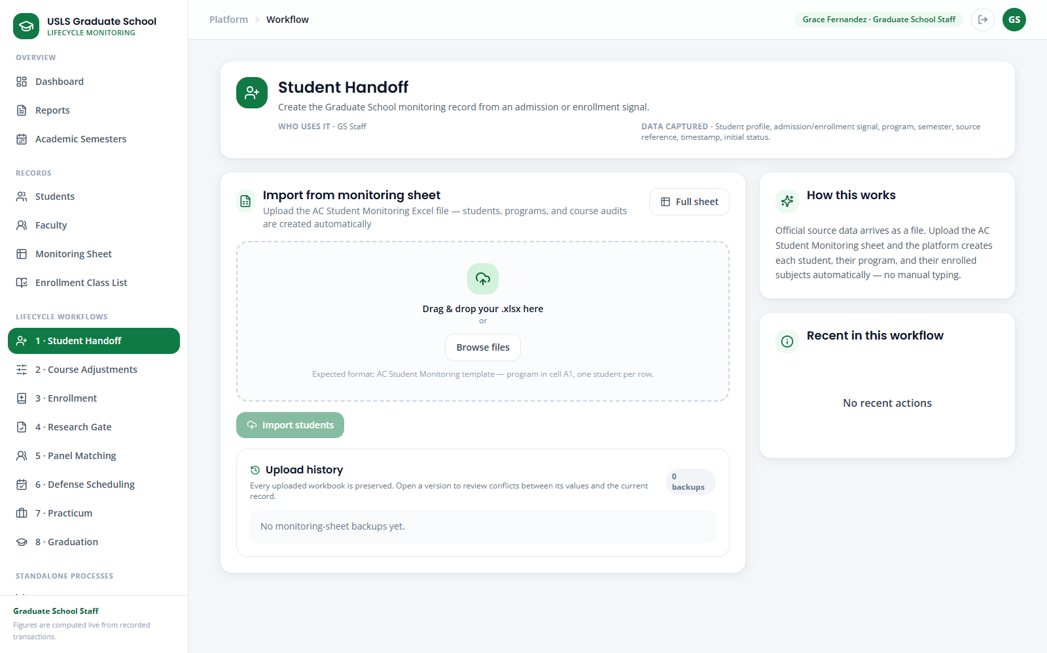
Screenshot — Student Handoff with the monitoring-workbook importer and source guidance.
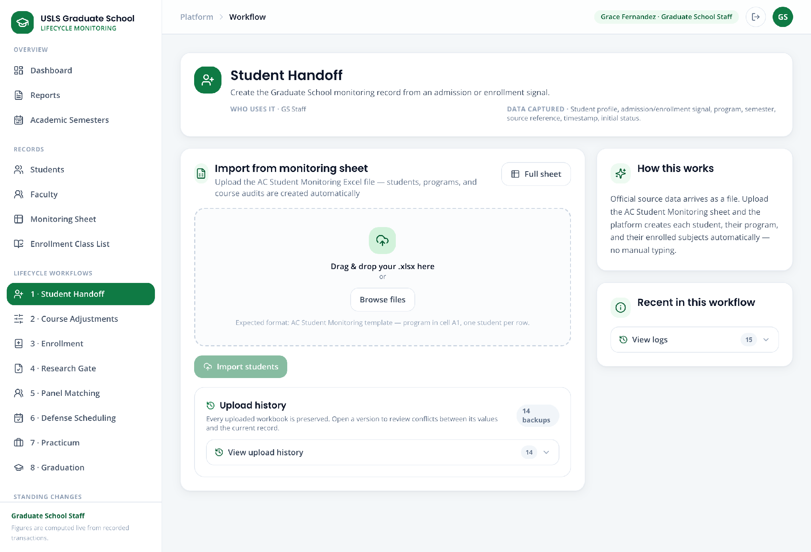
Screenshot — Student Handoff with the preserved upload-history count and log controls.
Part B — Verify the synchronized Monitoring Sheet
Step 9. Open Monitoring Sheet from Records, select MAED, and select the semester represented by the imported workbook.
Step 10. Use Progress, Risk, Enrollment, and Sort filters to narrow the grid. Confirm that the legend distinguishes completed, taken, enrolled, failed, dropped, and not-taken subjects.
Step 11. Read the synchronization notice and the read-only notice. Enrollment, approved standing changes, and verified imports update this screen; the grid itself is not an editing form.
Step 12. Locate Sofia Reyes or another imported record and compare the program, entry year, year level, enrollment tag, risk, and curriculum statuses against the source workbook.
Step 13. Use Flag issue only when a discrepancy must be recorded for follow-up. Add a precise note and keep the source value unchanged until verified.
Screenshot — Monitoring Sheet with program/semester filters, synchronization notice, legend, and read-only curriculum grid.
Part C — Verify the full record in Students
Step 14. Open Students. Use the search box to find Sofia Reyes by student number GS-2026-HO-01 so the identity match is unambiguous.
Step 15. Review the filtered directory row: student, program, lifecycle stage, enrollment, standing, risk, comprehensive-exam state, and adviser.
Step 16. Open Sofia's record. Confirm the profile header, program, standing, enrollment state, progress indicators, curriculum audit, and source references.
Step 17. Scroll through workflow status, research evidence, activity timeline, recommended actions, open tasks, panel, and defense schedule. Verify that no separate shadow record was created by the import.
Step 18. Return to Student Handoff if a mismatch remains, resolve it from the official source, and repeat the Monitoring Sheet and Students checks.
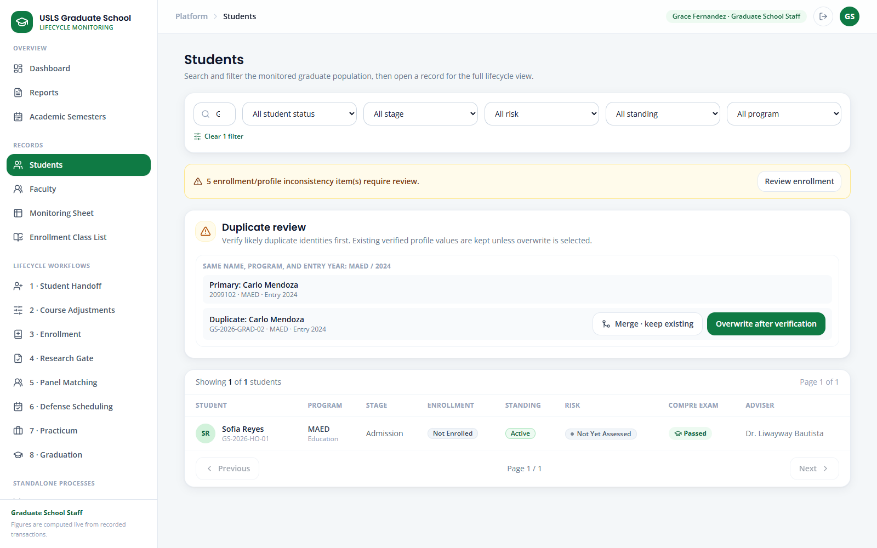
Screenshot — Students filtered to the Student Handoff demo identity by official student number.
Screenshot — Students full lifecycle record for Sofia Reyes.
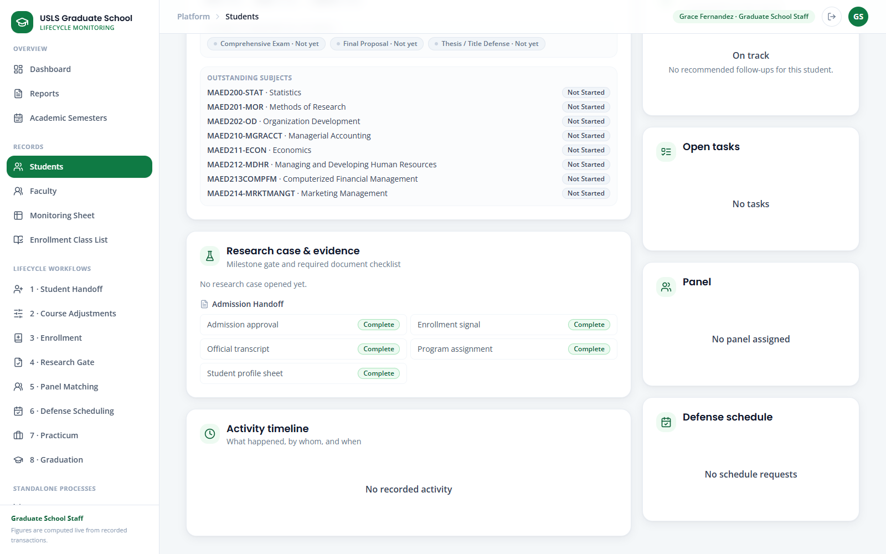
Screenshot — Students record at the Activity timeline and downstream lifecycle checkpoints.
Note: Student Handoff is the source-ingestion screen; Monitoring Sheet is the read-only curriculum view; Students is the complete lifecycle record.

Case 5 — Subject Withdrawal
Story:
Elena Navarro, an Active MAED student enrolled in three subjects, and requests to withdraw from one selected subject through the Student Portal Withdrawal page before classes begin or within the first seven calendar days of class. The system validates the deadline, GS Staff forwards the request to the Dean for approval, then tags only the selected subject as Withdrawn. Elena remains Active, her other subjects are unchanged, and the withdrawn subject receives no grade, academic penalty, or adverse transcript mark.

Role | Account
Student | withdrawal.elena@usls.edu.ph
Dean | dean@usls.edu.ph
Graduate School Staff | staff@usls.edu.ph
Suggested sample information
Elena
- Subject: MAED-MAJ1
- Reason: I need to revise my first-semester study load.

Step 1. On the login page, open Standalone processes → Withdrawal and reset Elena Navarro’s demo.
Step 2. Sign in as Elena and open Subject Withdrawal.
Step 3. Here we can see the Penalty-free withdrawal window noticeand we can see that it states that withdrawal is allowed before classes or during the first seven calendar days of class.
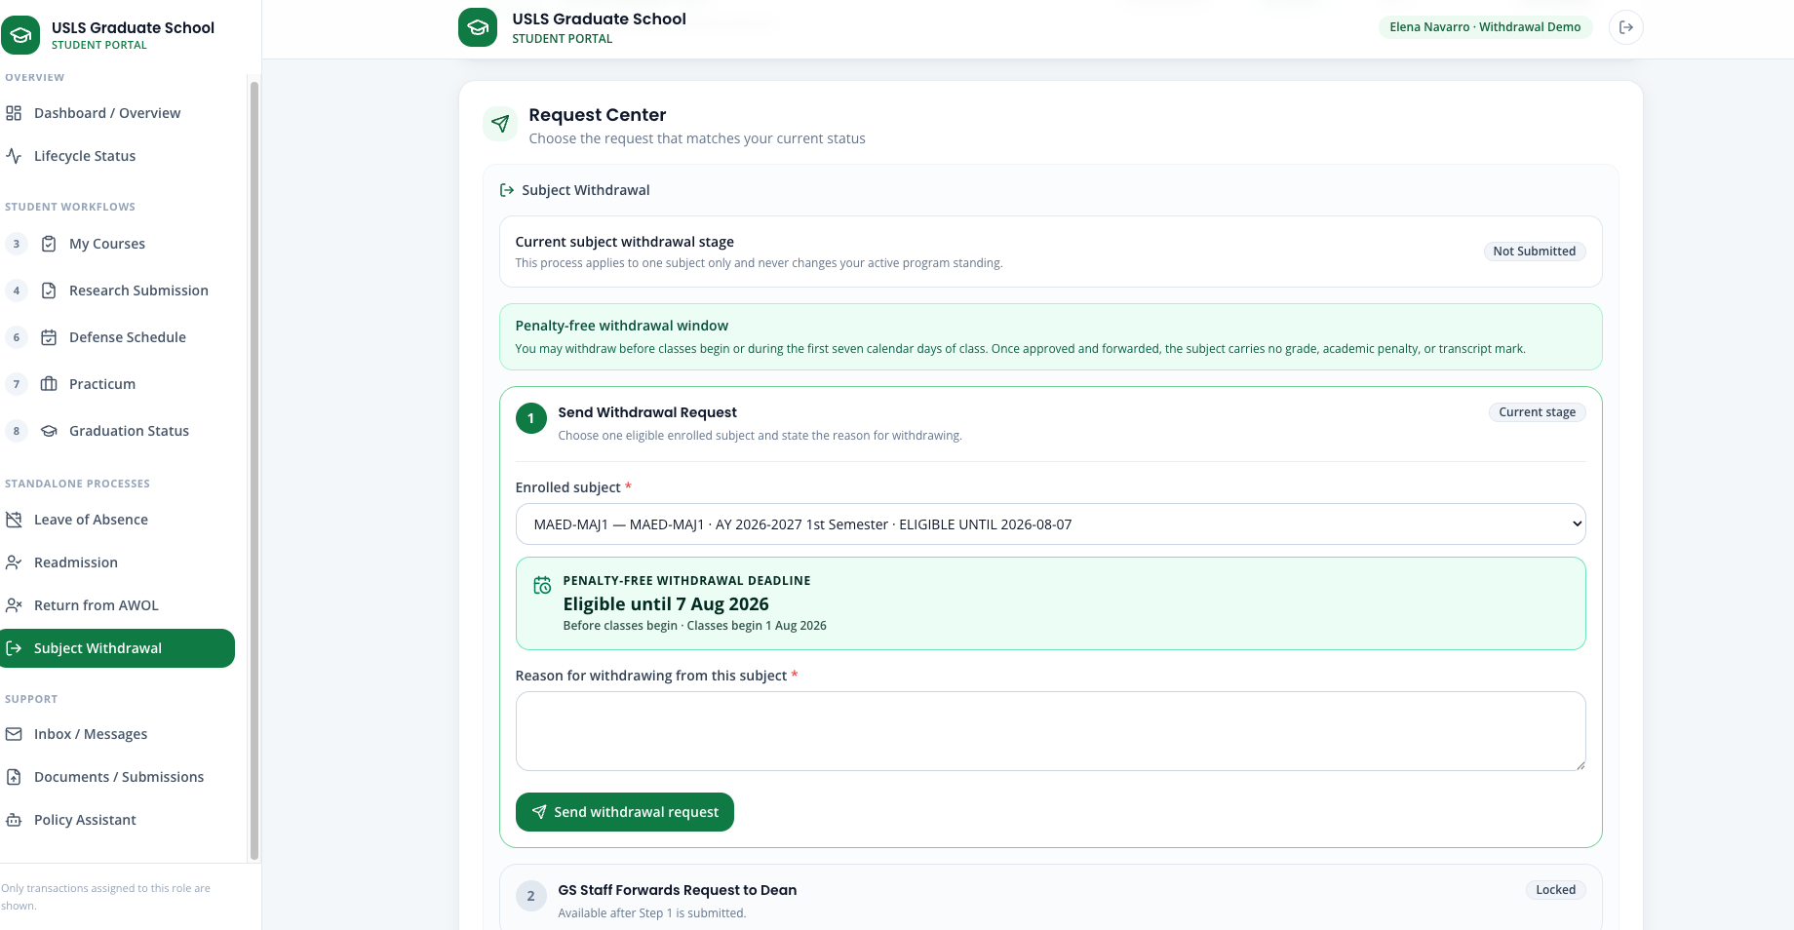
Step 4. Open the subject dropdown and select MAED-MAJ1.
Step 5. Confirm that the selected subject prominently shows Eligible until [displayed deadline].
Step 6. Enter Elena’s reason. (I need to revise my first-semester study load)
Step 7. Select Send withdrawal request.
Step 8. Confirm that the student workflow shows Step 1 · Send Withdrawal Request as complete and Step 2 · GS Staff Forwards Request to Dean as pending.
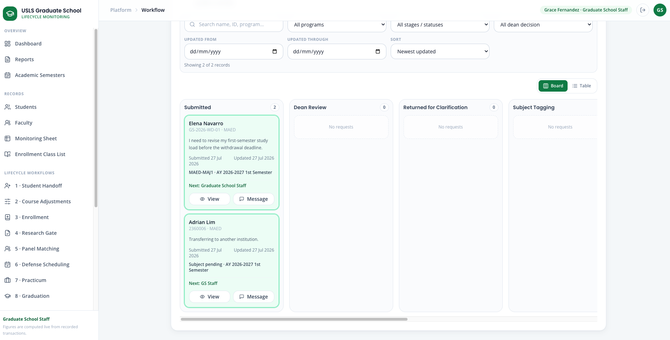
Step 9. Sign in as GS Staff and open Standalone processes → Withdrawal.
Step 10. Open Elena’s request. Here we can see the selected subject she wishes to withdraw from, semester, reason, eligibility window, and recorded deadline. As well as the stage history which is visible for all accounts involved in the withdrawal process to track the process step by step.
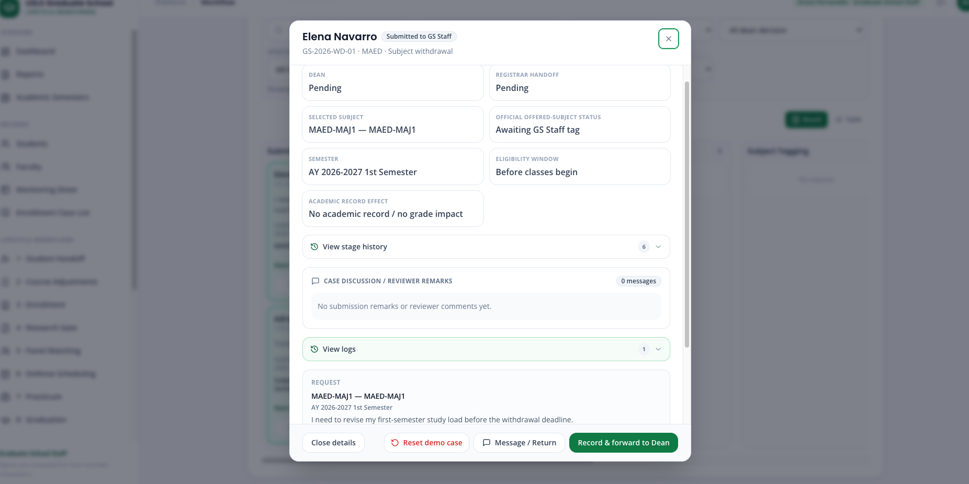
Step 11. Select Record & forward to Dean.
Step 12. Sign in as the Dean and open Withdrawal Requests.
Step 13. Again here the dean can view the selected subject, request date, withdrawal deadline, reason, and workflow timeline.
Step 14. Select Approve.
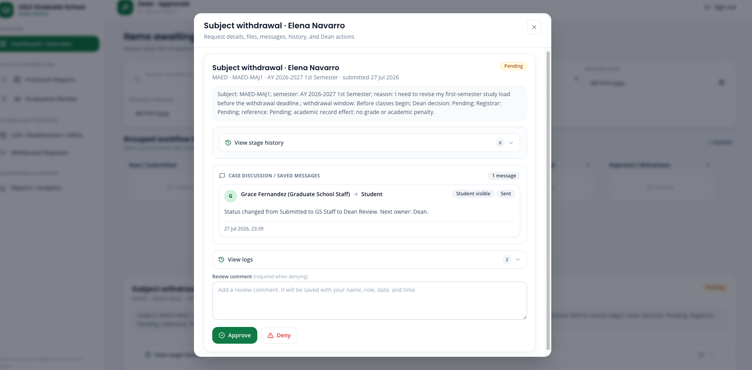
Step 15. Sign back in as GS Staff and reopen Elena’s case.
Step 16. Confirm that the case status is Approved — Awaiting Subject Tag and that the selected subject is still enrolled at this point.
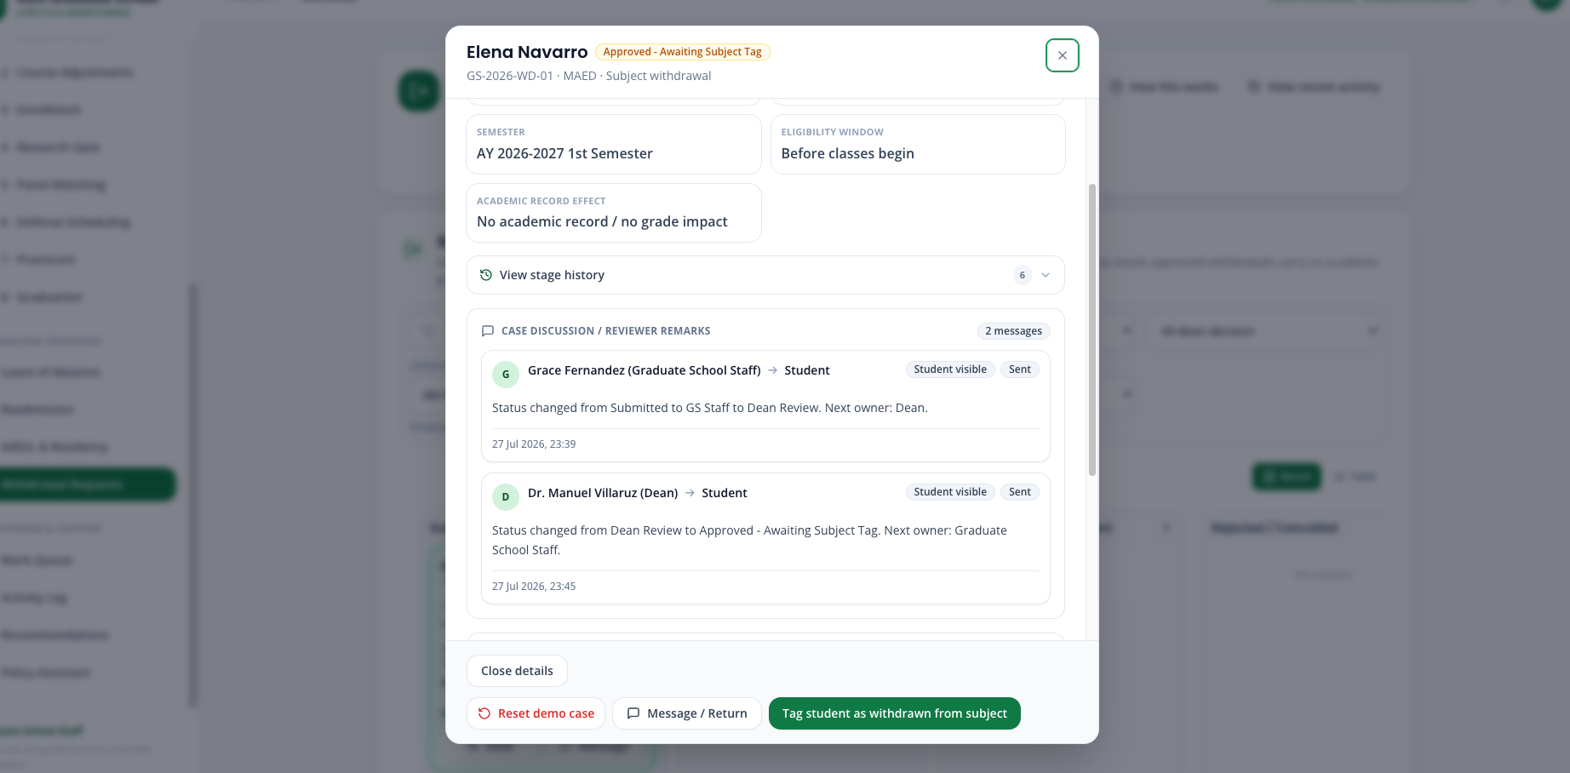
Step 17. Select Tag student as withdrawn from subject.
Step 18. Select Elena or use Select all, then select Download Excel list.
Step 19. When you open the downloaded workbook it should contain the student Elena, the selected subject, semester, Dean decision, deadline, and the statement No academic record / no grade impact.
Step 20. Once the files exported it tell the GS Staff that they must email the downloaded Excel workbook to the Registrar and wait for acknowledgement.
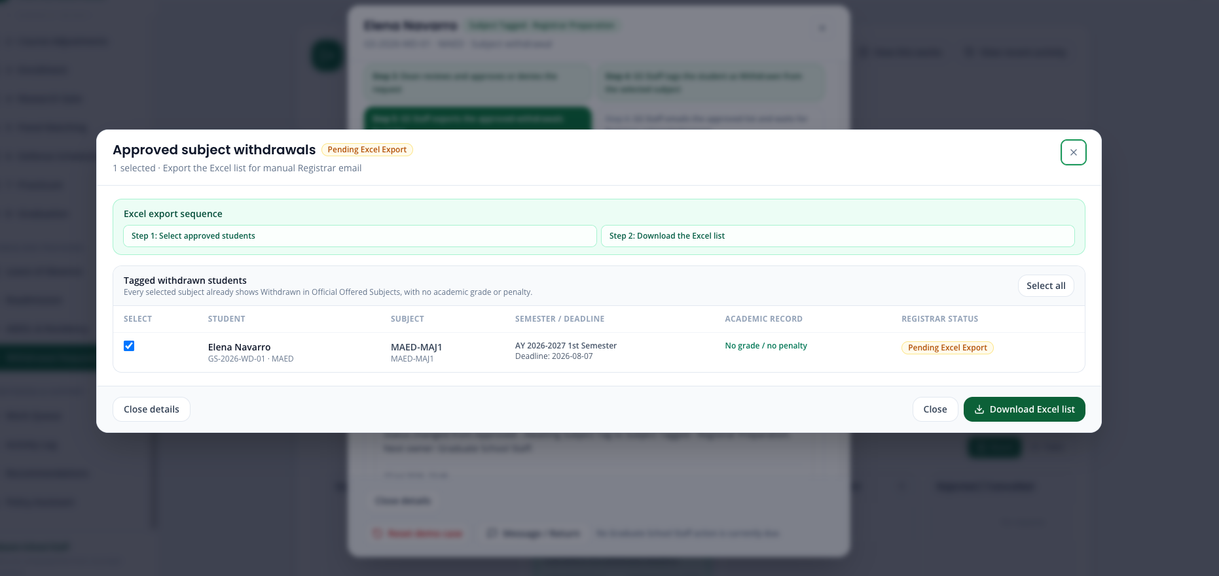
Step 21. Confirm that the case remains Exported — Ready to Send.
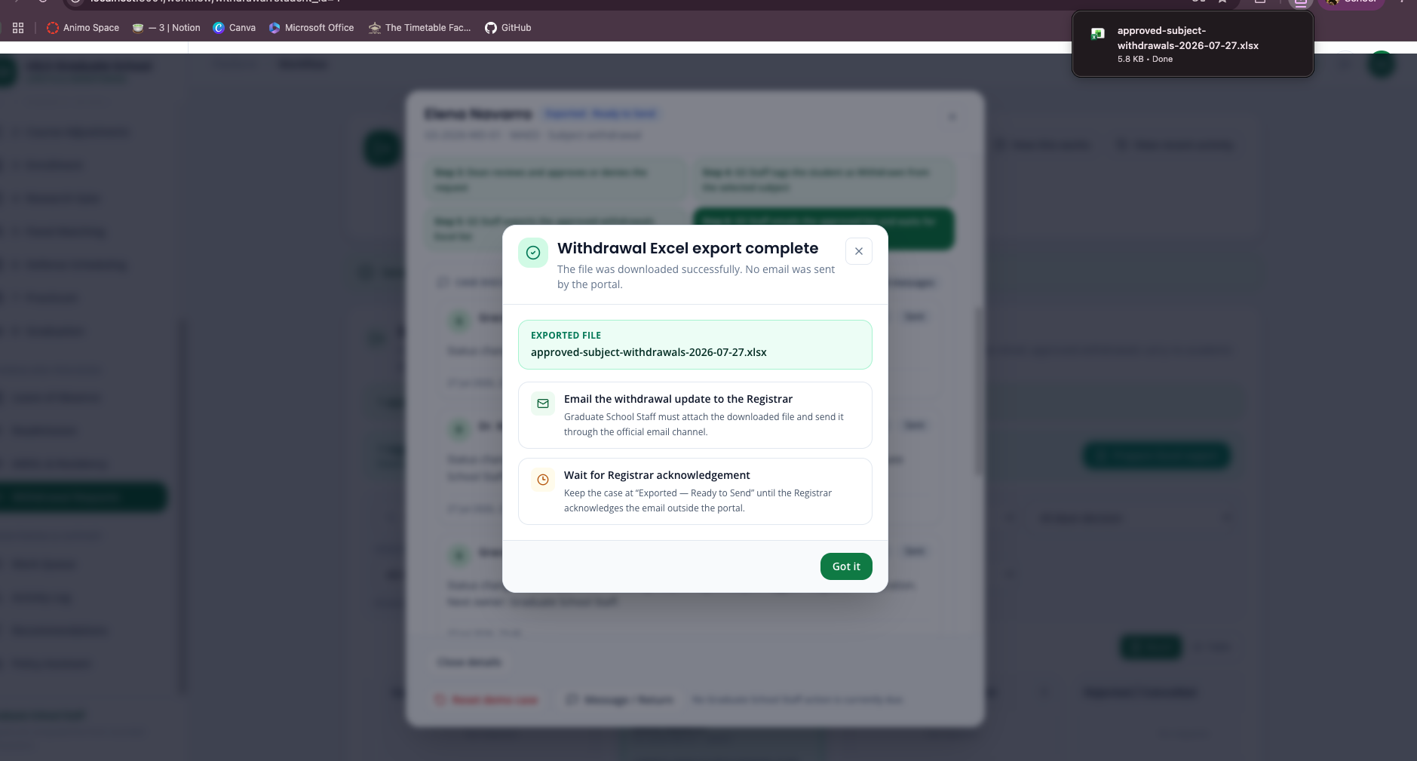
Step 22. So to check we’ll Open 3 · Enrollment and locate Elena in the next semester in Official Offered Subjects.
Step 23. Confirm that only MAED-MAJ1 changes to Withdrawn.
Step 24. Confirm that MAED-MAJ1 displays Withdrawn, while Elena’s program standing remains Active and her other subjects remain unchanged.
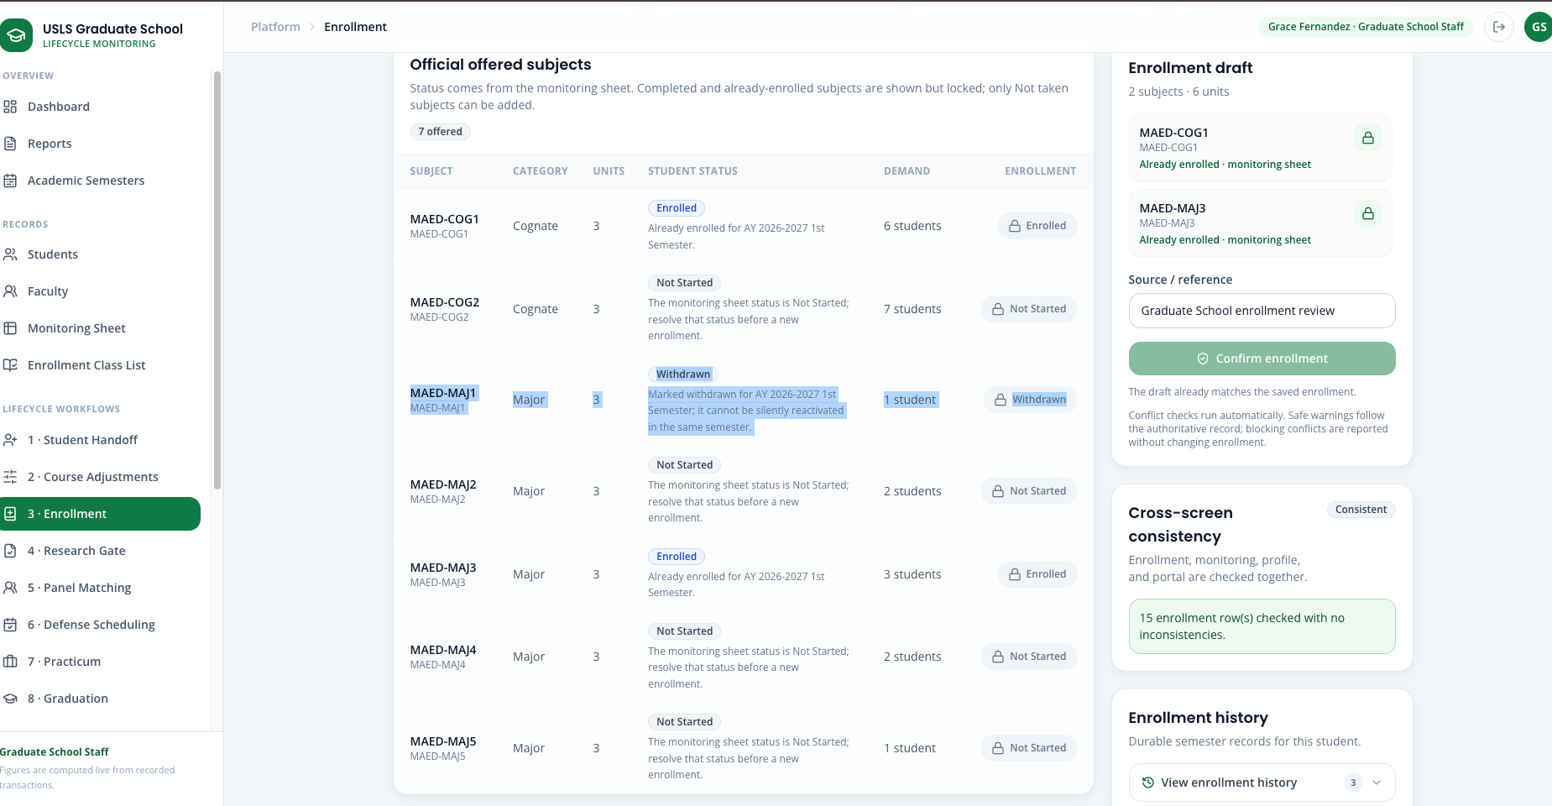
Step 25. Confirm that Elena is listed under Tagged withdrawn students for her next semester.
Step 26. Sign back in as Elena. Confirm the following student workflow results.

Case 6 — Dropping a Subject
Story:
Four weeks into the semester a student drops one enrolled subject. Dropping is the student's right and the official transaction happens with the Registrar; the Graduate School does not approve it and cannot refuse it. What the Graduate School needs is to record that it happened, because a dropped subject changes what that student still needs and therefore what has to be offered next term.
The action is restricted to the Academic Coordinator, who owns the offering and the curriculum consequence.
Accounts used:
Role | Account
Academic Coordinator | academic@usls.edu.ph
Password | DemoPass123!
Data to use:
Field | Value / instruction
Program / semester | MAED, the published semester used in Enrollment
Student | An enrolled student from the confirmed class list
Effective date | The date the Registrar's advice was received
Coordinator note | Required. Record where the information came from
Part A — Record the drop
Step 1. Sign in as the Academic Coordinator. This action is refused for other roles.
Step 2. Open 3 · Enrollment and select the same program and academic semester used in the Enrollment case.
Step 3. Use Filter students to find the student, then open their enrollment record.
Step 4. Click the Enrolled badge on the subject being dropped. The Change student status dialog opens.
Step 5. In New status, confirm that Dropped is the only available option. Withdrawal has a deadline and must be initiated by the student through its own workflow, so it is deliberately not available here.
Step 6. Enter the Effective date.
Step 7. Enter the Coordinator note recording the source of the advice.
Step 8. Confirm that the save action stays unavailable until status, effective date and note are all present, then save.
Step 9. Read the notice below the dialog confirming that dropping is recorded here while withdrawal must be student-initiated.
Part B — Verify the synchronized record
Step 10. Open Monitoring Sheet from Records and select the same program and semester.
Step 11. Locate the student and confirm the dropped subject now reads Dropped.
Step 12. Confirm that the student's other subjects and their standing are unchanged.
Note: The portal has no direct channel from the Registrar. The drop reaches the Graduate School outside the system and is recorded here; no automatic Registrar feed is implemented and none is claimed.

Case 7 — Policy Assistant — retrieval over the handbook
Story:
A staff member needs a policy answer from the Graduate School handbook. The Policy Assistant retrieves the relevant passages from the indexed handbook and research documents and answers from them, returning the source it used so the answer can be checked rather than trusted.
This is decision support, not an official ruling, and it is one of the features that is not record keeping.
Accounts used:
Role | Account
Graduate School Staff | staff@usls.edu.ph
Password | DemoPass123!
Data to use:
Field | Value / instruction
Question to ask | A policy question the handbook actually answers, for example the rule on leave of absence or on residency limits
Second question | An operational question, to show routing to the reports
Part A — Ask a policy question
Step 1. Sign in as Graduate School Staff and open Policy Assistant from Records and support.
Step 2. Enter a policy question drawn from the handbook.
Step 3. Read the answer, then read the source reference returned with it — the document and the passage the answer was drawn from.
Step 4. State that the handbook and research documents are chunked and embedded into a searchable index, and that the index rebuilds itself when the source documents change.
Step 5. State that retrieval runs on semantic vector search with a lexical retriever as a fallback, so the assistant still answers when no API key is configured.
Part B — Show the routing and the scope
Step 6. Ask a question that is really a request for an operational figure.
Step 7. Confirm that it is answered from the verified reports rather than generated.
Step 8. State that answers are scoped by role, so a student cannot obtain staff-only information through the assistant.
Note: The Policy Assistant answers from the provided handbook and research documents. Treat it as decision support with a stated source, never as an official ruling.

Case 8 — Leave of Absence
Story:
Daniel Fernandez files a structured two-semester Leave of Absence. Graduate School Staff run the fixed policy checks and route the case; the Dean records the decision, and only an approval changes the student to On Leave / LOA.
Accounts used:
Role | Account
Student demo | Daniel Fernandez — loa.daniel@usls.edu.ph
Graduate School Staff | staff@usls.edu.ph
Dean | dean@usls.edu.ph
Password | DemoPass123! for every account
Data to use:
Field | Value / instruction
Leave starts | AY 2026–2027 1st Semester
Leave ends | AY 2026–2027 2nd Semester
Reason | Employment / professional obligation
Part A — Student submits in Leave of Absence
Step 1. On the sign-in page, reset Daniel Fernandez's Leave of Absence demo so the purpose-built account returns to its starting state.
Step 2. Sign in as Daniel and open Leave of Absence from Standalone Processes.
Step 3. Review Current stage and open View stage history. Confirm that the four stages are Student application, GS Staff review, Dean decision, and result.
Step 4. Choose the Leave starts and Leave ends semesters. The request must begin in an upcoming semester and may cover one or two consecutive semesters.
Step 5. Choose an allowed Reason category and enter complete Circumstances / remarks. No PDF or RAG extraction is required for this structured form.
Step 6. Click Submit LOA application and read the confirmation.
Step 7. Reopen Leave of Absence and verify that the request is locked as submitted, the stage advances to staff review, and withdrawal remains available only before the Dean decides.
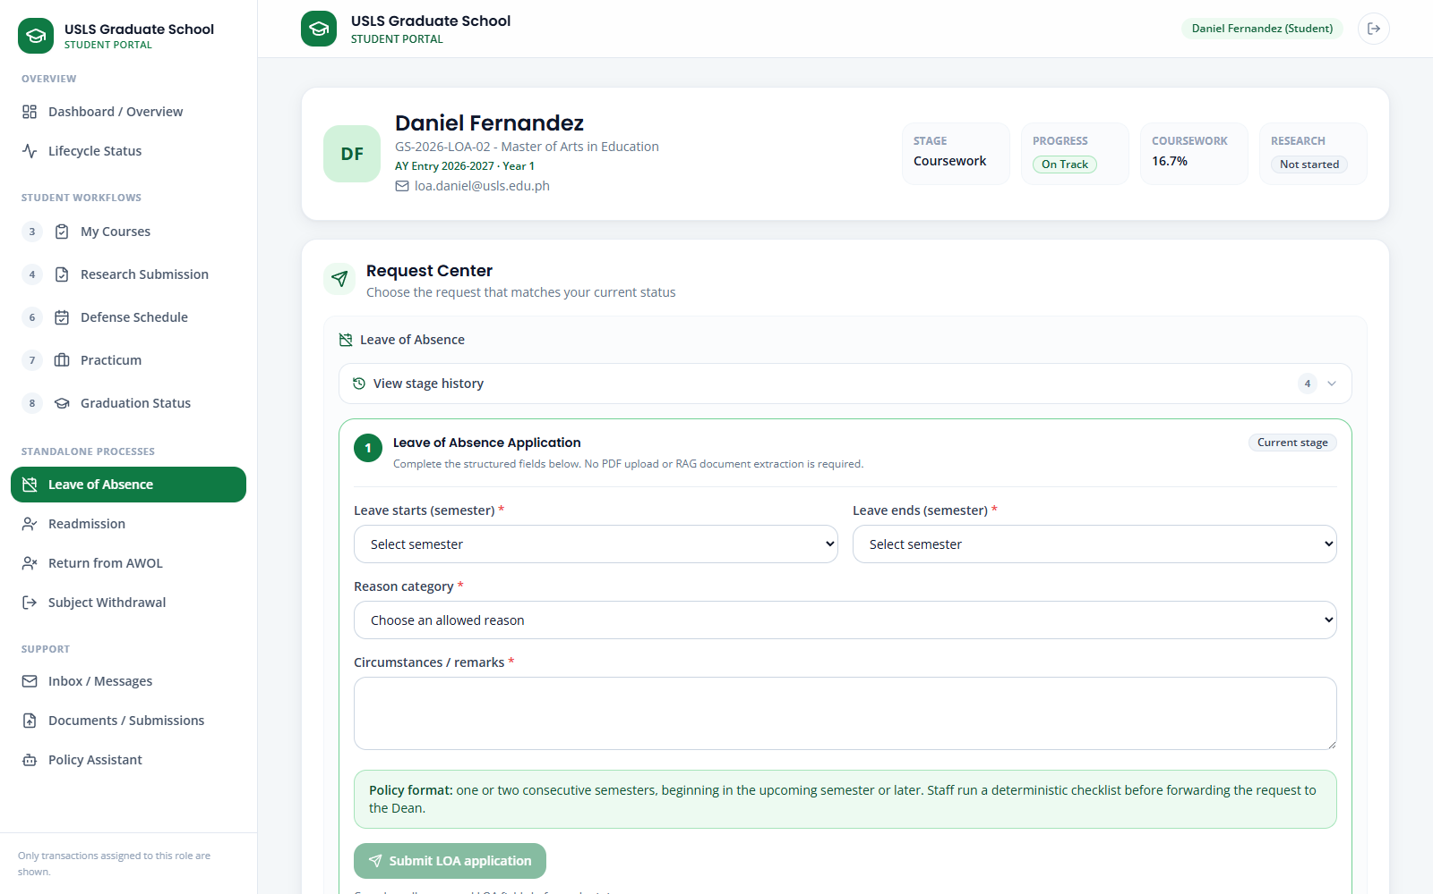
Screenshot — Leave of Absence structured student application.
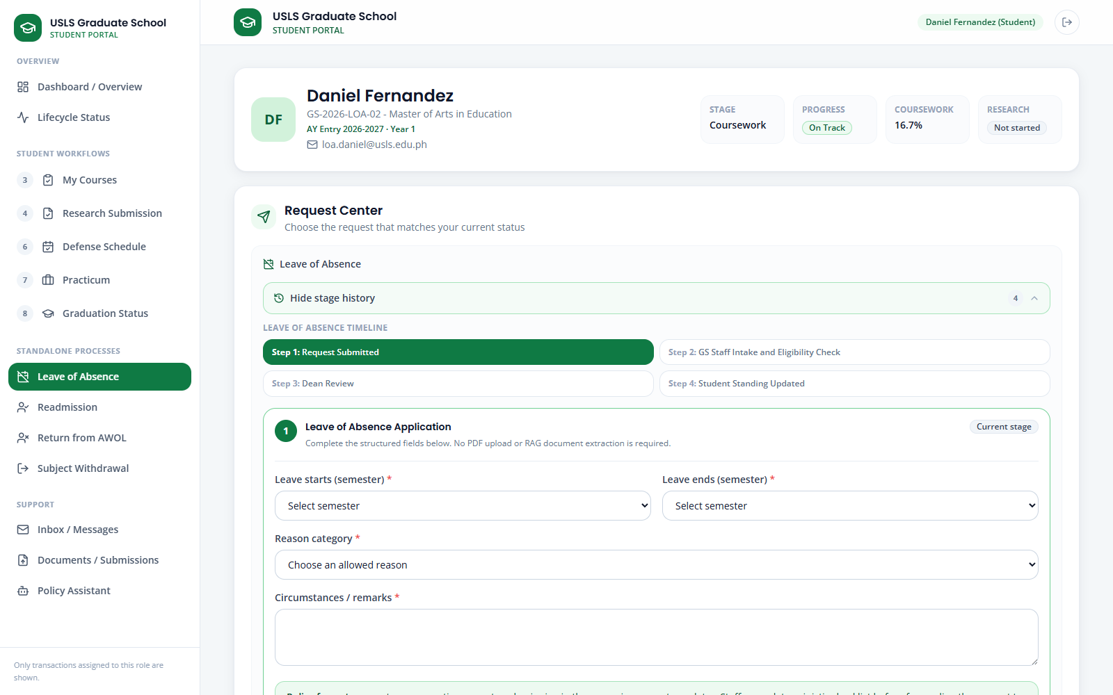
Screenshot — Leave of Absence stage history before submission.
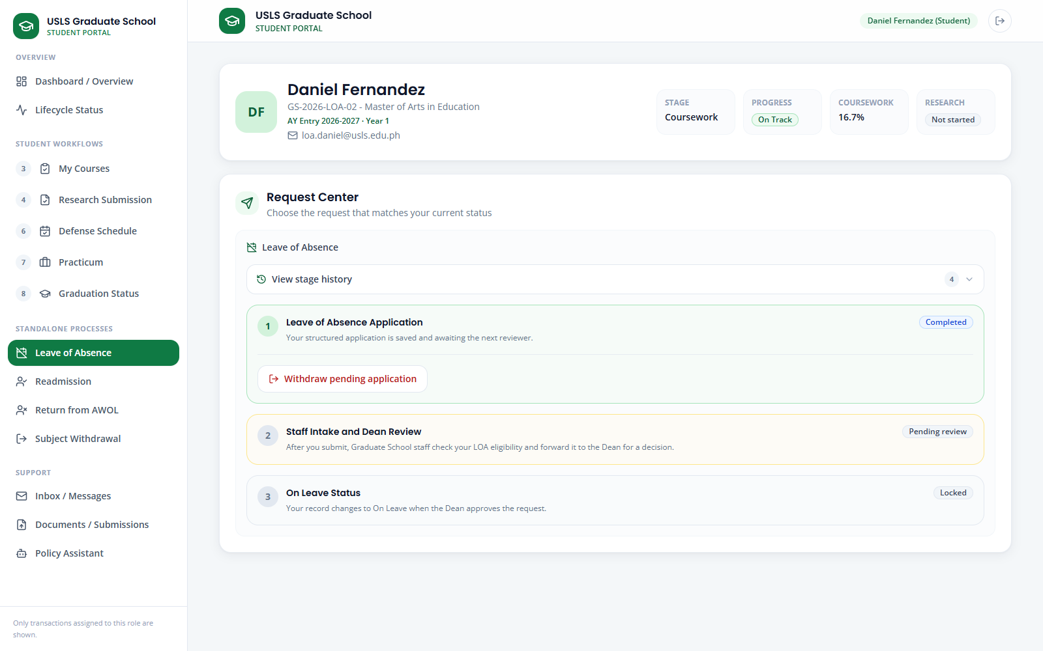
Screenshot — Leave of Absence after the student submission advances to GS Staff.
Part B — Staff reviews in Leave of Absence
Step 8. Sign in as Graduate School Staff and open Leave of Absence.
Step 9. Search Daniel Fernandez in Submitted requests and confirm that the card is in For Review with GS Staff as the next owner.
Step 10. Click Review. Compare the request summary, start/end semesters, reason category, remarks, prior approved leaves, and minimum residency.
Step 11. Click Run policy checker. Read each deterministic check and the recommendation; it supports staff review and does not approve the case.
Step 12. Set Eligibility status / check result, add staff notes, and use Apply suggestion only after verifying that it matches the recorded evidence.
Step 13. Click Forward to Dean. Confirm that the request leaves the staff-review column and the next owner becomes Dean.
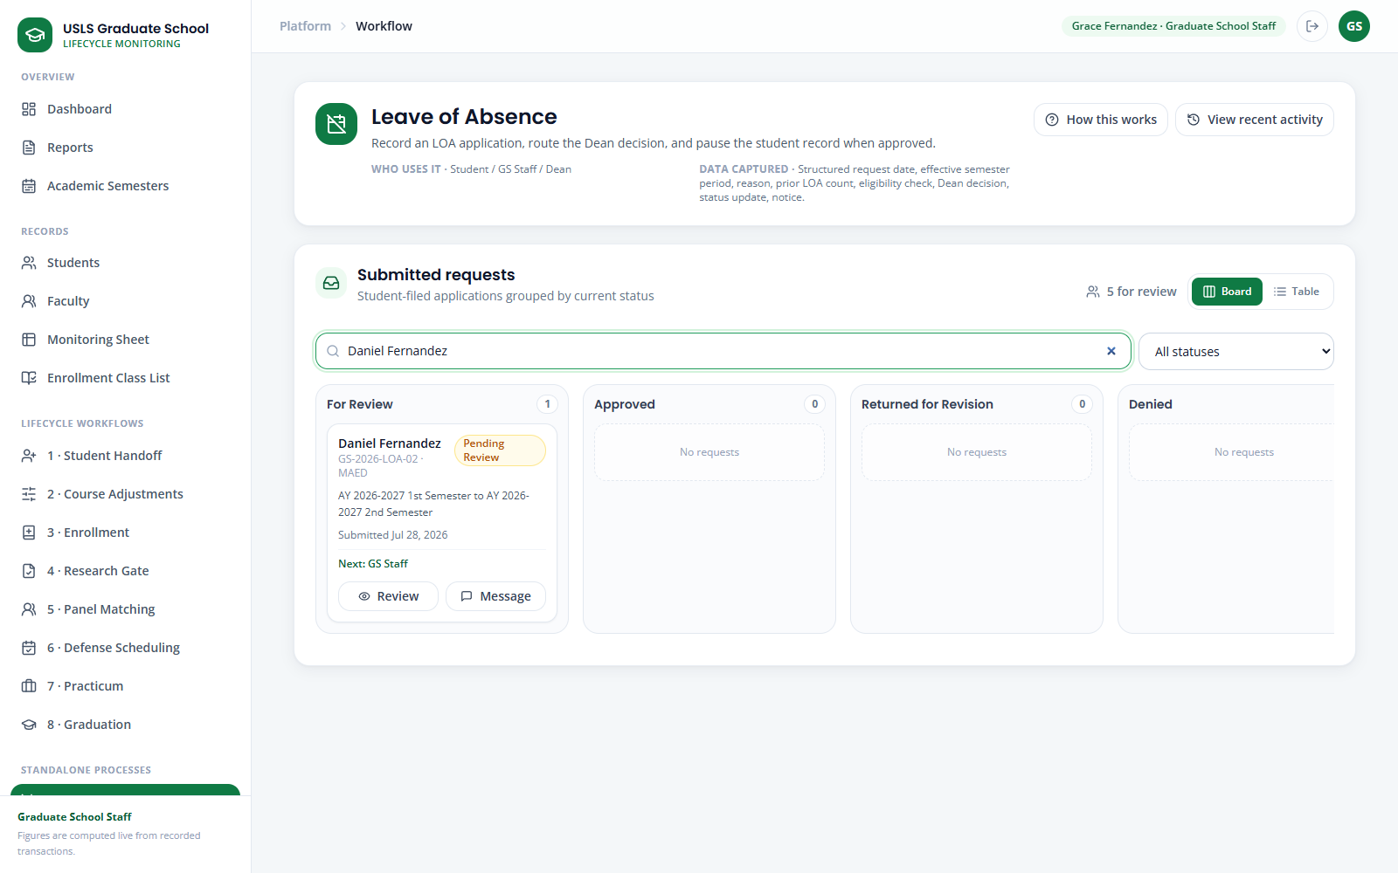
Screenshot — Leave of Absence Submitted requests filtered to Daniel Fernandez.
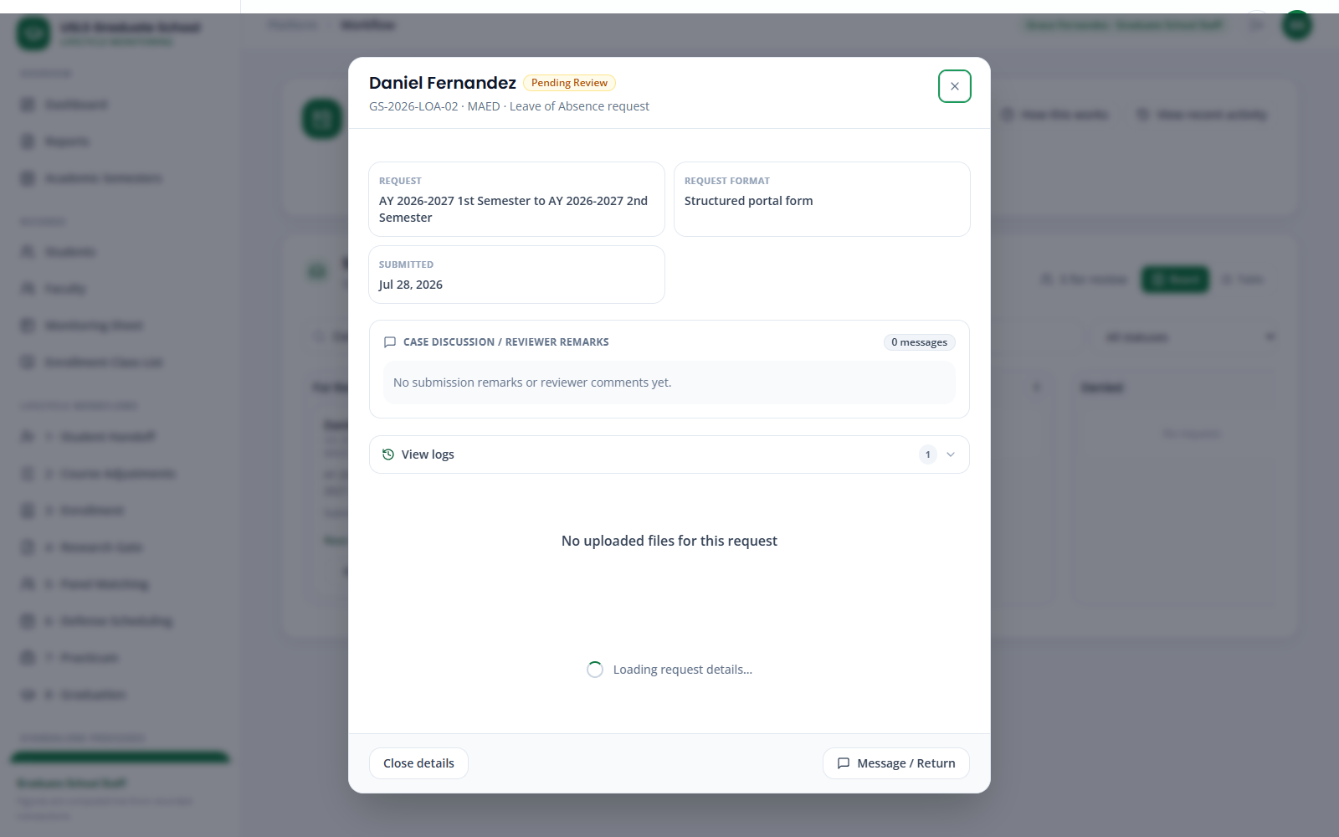
Screenshot — Leave of Absence staff review with the fixed policy checker and Dean-routing action.
Part C — Dean decides in LOA / Readmission / AWOL
Step 14. Sign in as Dean and open LOA / Readmission / AWOL.
Step 15. Search Daniel and review the Leave of Absence request, period, staff notes, case discussion, and logs.
Step 16. Choose Approve, Deny, or Return for revision. Add the required review comment when returning the case, then confirm the recorded action.
Step 17. If approved, verify that the student standing becomes On Leave and the enrollment tag becomes LOA. If denied or returned, verify that standing does not change.
Step 18. As Graduate School Staff, reopen the approved case and export the LOA report for the Registrar when required.
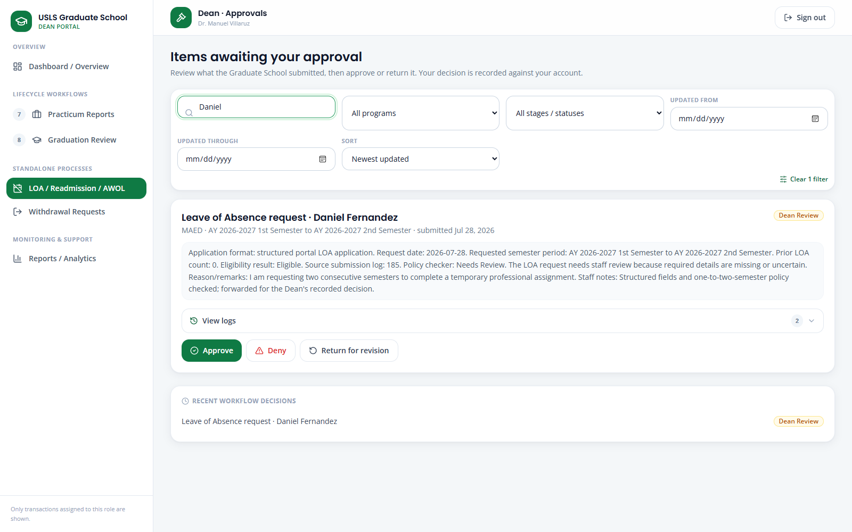
Screenshot — LOA / Readmission / AWOL filtered to Daniel's Leave of Absence decision card.
Note: The policy checker is advisory. The Dean decision is the only action that can apply the On Leave / LOA standing change.

Case 9 — AWOL and Return from AWOL
Story:
Maya Torres is automatically marked AWOL from explicit source evidence. She submits a structured Return from AWOL declaration; staff apply the program-specific residence limits and route the case; the Dean records the return decision.
Accounts used:
Role | Account
Student demo | Maya Torres — awol.maya@usls.edu.ph
Graduate School Staff | staff@usls.edu.ph
Dean | dean@usls.edu.ph
Password | DemoPass123! for every account
Data to use:
Field | Value / instruction
Target return | AY 2026–2027 1st Semester
Last enrolled | AY 2025–2026 2nd Semester
Source | Automatically flagged AWOL standing; no manual declaration
Part A — Verify the automatic AWOL case
Step 1. Reset Maya Torres's AWOL demo so the official standing returns to AWOL Declared with an automatic source.
Step 2. Sign in as Graduate School Staff and open AWOL & Residency.
Step 3. Read the warning that AWOL cannot be declared manually. The system creates it from an imported AWOL standing or a full-semester withdrawal without approved LOA; a missing pre-enrollment record alone is insufficient.
Step 4. Search Maya in AWOL, return, and residency cases. Open the case and verify status, detection source, effective date, and last enrolled semester.
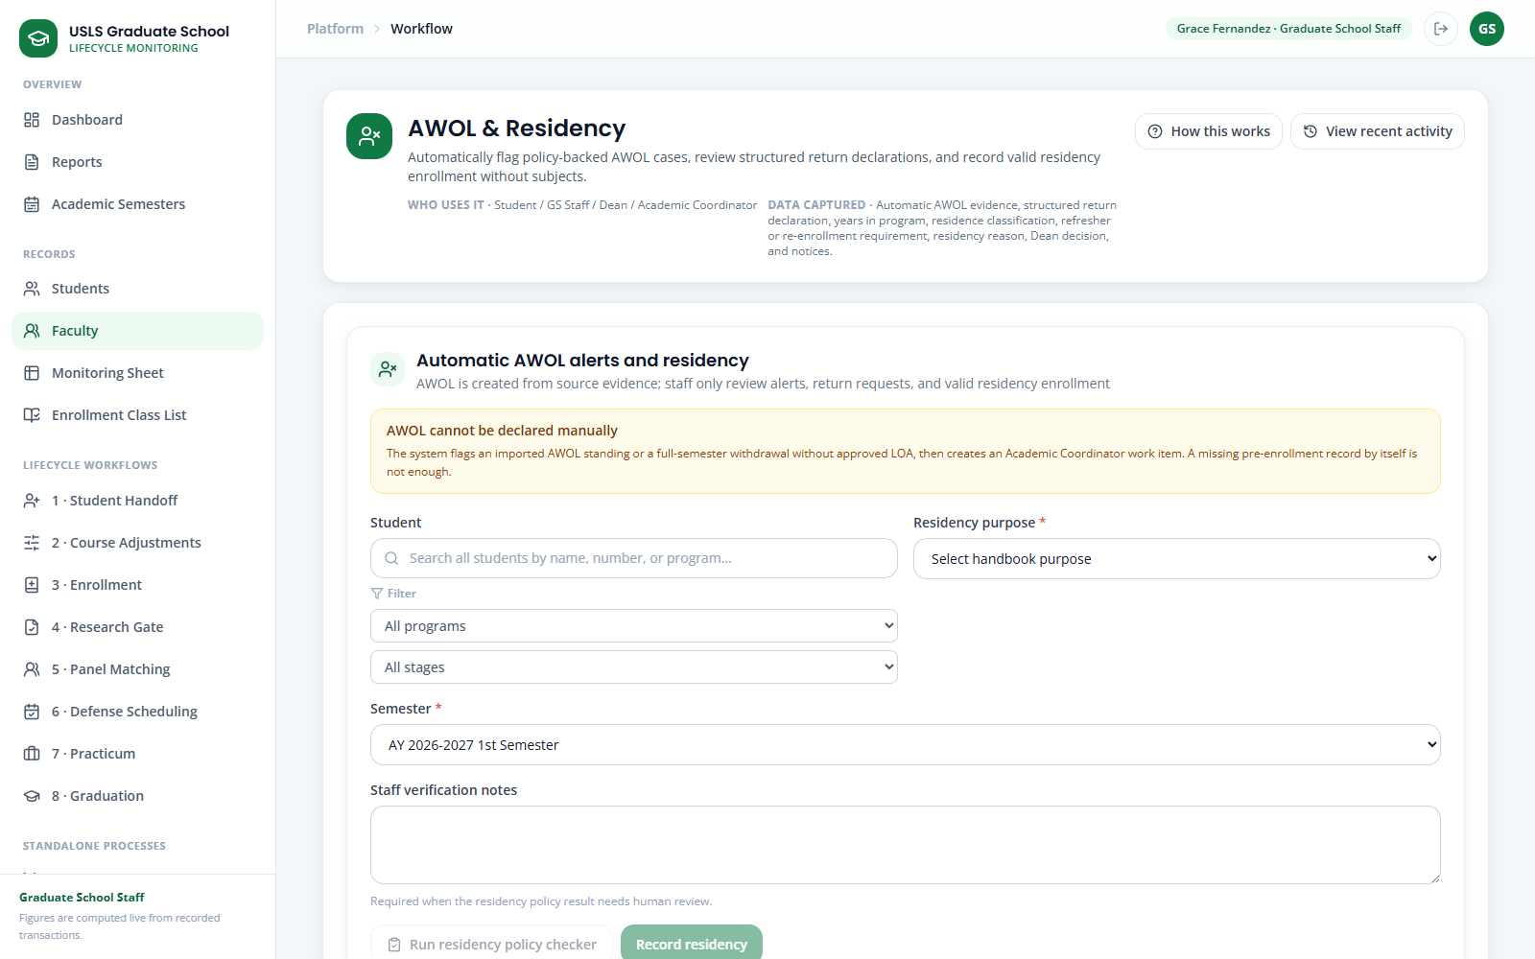
Screenshot — AWOL & Residency with the automatic-AWOL rule and combined case board.
Part B — Student submits in Return from AWOL
Step 5. Sign in as Maya and open Return from AWOL.
Step 6. Confirm the Current AWOL return case and policy classification.
Step 7. Choose the Target return semester and Last enrolled semester.
Step 8. Enter the written intention to resume enrollment and the reason for return.
Step 9. Click Submit return declaration.
Step 10. Reopen Return from AWOL and verify Return Submitted, the saved structured declaration, and GS Staff as the next owner.
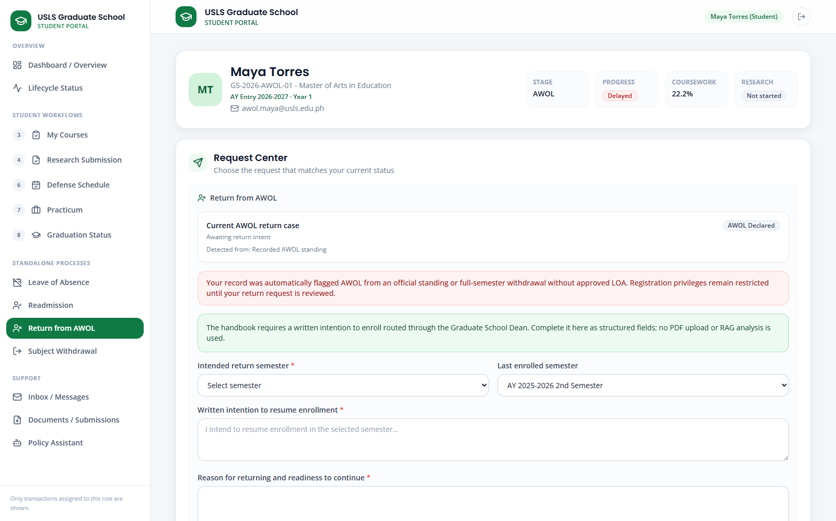
Screenshot — Return from AWOL with the automatic case and structured written declaration.
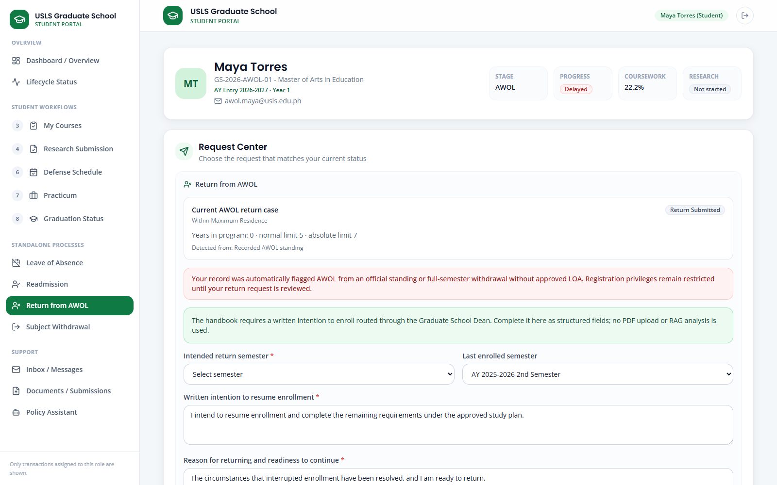
Screenshot — Return from AWOL after submission to Graduate School Staff.
Part C — Staff reviews in AWOL & Residency
Step 11. Sign in as Graduate School Staff, open AWOL & Residency, and search Maya.
Step 12. Open View and compare the return intention, reason, target return semester, last enrollment, years in program, and automatic source.
Step 13. Run the Return-from-AWOL policy checker. Review the master's 5-year normal / 7-year absolute and doctoral 7-year normal / 9-year absolute limits.
Step 14. Read whether the case is within normal residence, needs a graded 6-unit refresher during an extension, or requires full re-enrollment review.
Step 15. Add staff notes and click Forward to Dean.
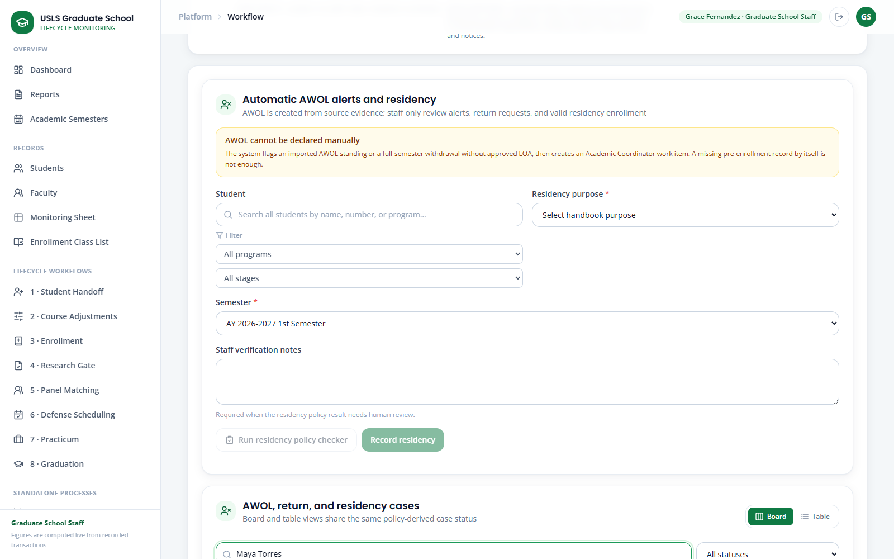
Screenshot — AWOL & Residency filtered to Maya's submitted return case.
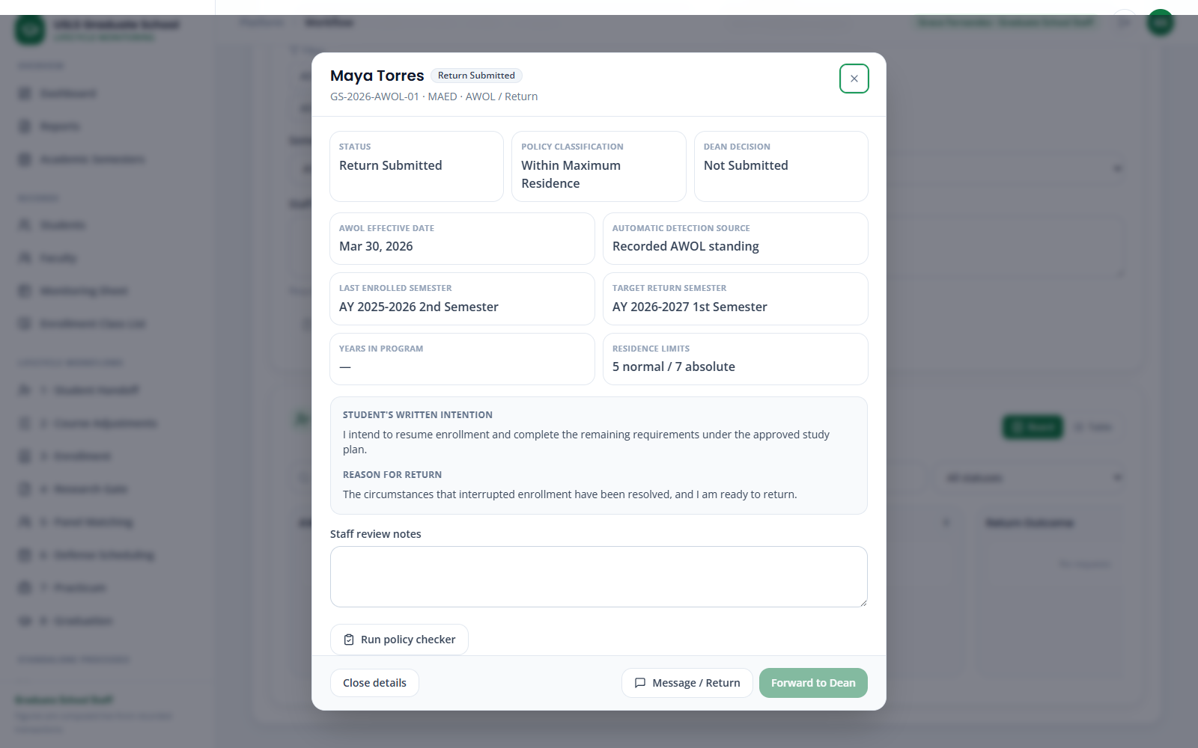
Screenshot — AWOL & Residency return-case detail with written intent and fixed residence-limit review.
Part D — Dean decides in LOA / Readmission / AWOL
Step 16. Sign in as Dean, open LOA / Readmission / AWOL, and search Maya.
Step 17. Review the policy classification, years in program, residence limits, staff notes, discussion, and logs.
Step 18. Choose Approve, Deny, or Return for revision and confirm the decision.
Step 19. Verify the applied result: Active / Not Enrolled within the permitted period, extension with refresher requirement, or re-enrollment review.
Step 20. As Graduate School Staff, export the AWOL return report for the Registrar. Course enrollment remains a separate action.
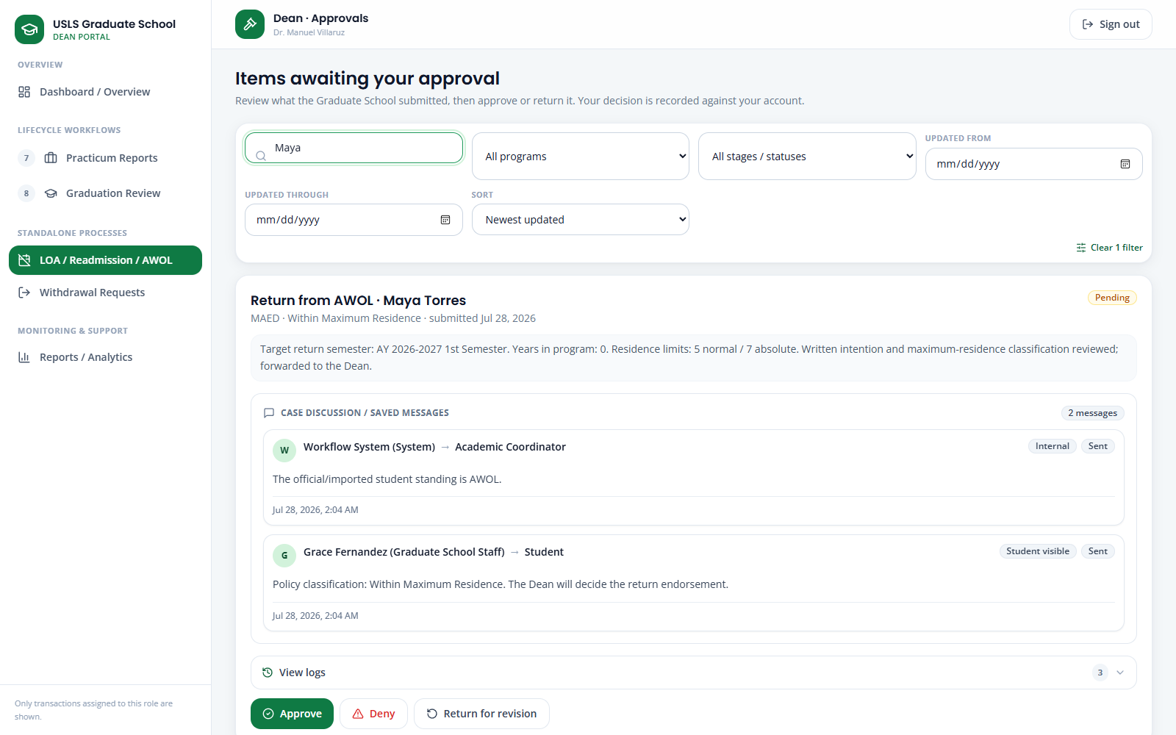
Screenshot — LOA / Readmission / AWOL filtered to Maya's Return from AWOL decision card.
Note: AWOL is a policy-derived standing. Return from AWOL is the student's request and Dean decision flow; it is not the Residency workflow.

Case 10 — Title Defense
Story:
Andrea Mae Villanueva is ready to begin the Title Defense stage. She submits her completed Form 1 Application and three concept papers. Graduate School Staff checks the submitted requirements, the Academic Coordinator endorses Form 1, and GS Staff selects and finalizes the four-person defense panel.
Accounts used:
Role | Account
Standard-case student | andrea.mae.villanueva@student.usls.edu.ph
Graduate School Staff | staff@usls.edu.ph
Academic Coordinator | academic@usls.edu.ph

Part A - Student submission
Step 1. Sign in as Andrea Mae Villanueva.
Step 2. Open Research Submission.
Step 3. Confirm that Andrea’s current research stage is Title Defense.
Step 4. Upload the completed Form 1 Application.
Step 5. Upload all three concept papers.
Step 6. Review the uploaded documents.
Step 7. Select Submit Title Defense for Review.
Step 8. Confirm that the submission status changes to Pending Review.
Step 9. Sign out.
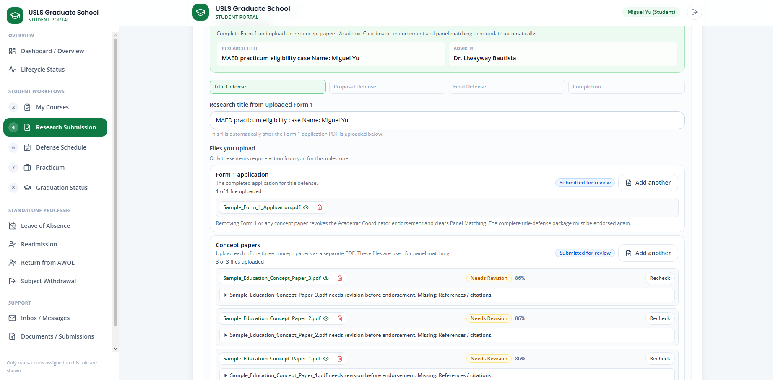
Screenshot — The student Research Submission screen showing the Form 1 Application, three concept papers, and Pending Review status.
Part B - GS Staff requirement verification
Step 10. Sign in as GS Staff.
Step 11. Open 5 · Research Gate.
Step 12. Search for and open Andrea Mae Villanueva’s record.
Step 13. Review the submitted Form 1 Application and three concept papers.
Step 14. Confirm that the files uploaded by Andrea are visible in the staff view.
Step 15. Select Verify Submitted Requirements.
Step 16. Confirm that the submitted requirements are marked as verified.
Step 17. Sign out.
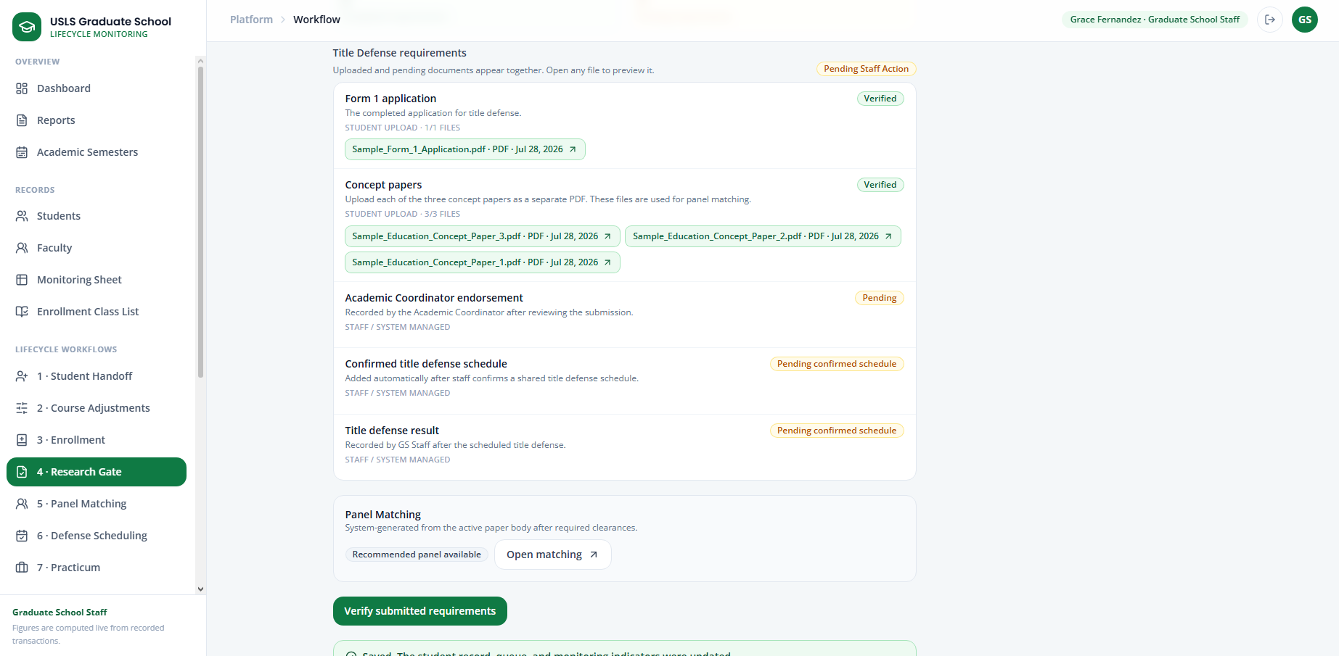
Screenshot — Andrea’s Research Gate record showing the uploaded documents, verified requirements, and pending Form 1 endorsement.
Part C - Academic Coordinator Form 1 endorsement
Step 18. Sign in as the Academic Coordinator.
Step 19. Open 5 · Research Gate.
Step 20. Select Form 1 Endorsements.
Step 21. Open Andrea Mae Villanueva’s Form 1 Application.
Step 22. Review the Form 1 details and submitted concept papers.
Step 23. Draw the Academic Coordinator’s signature in the signature area.
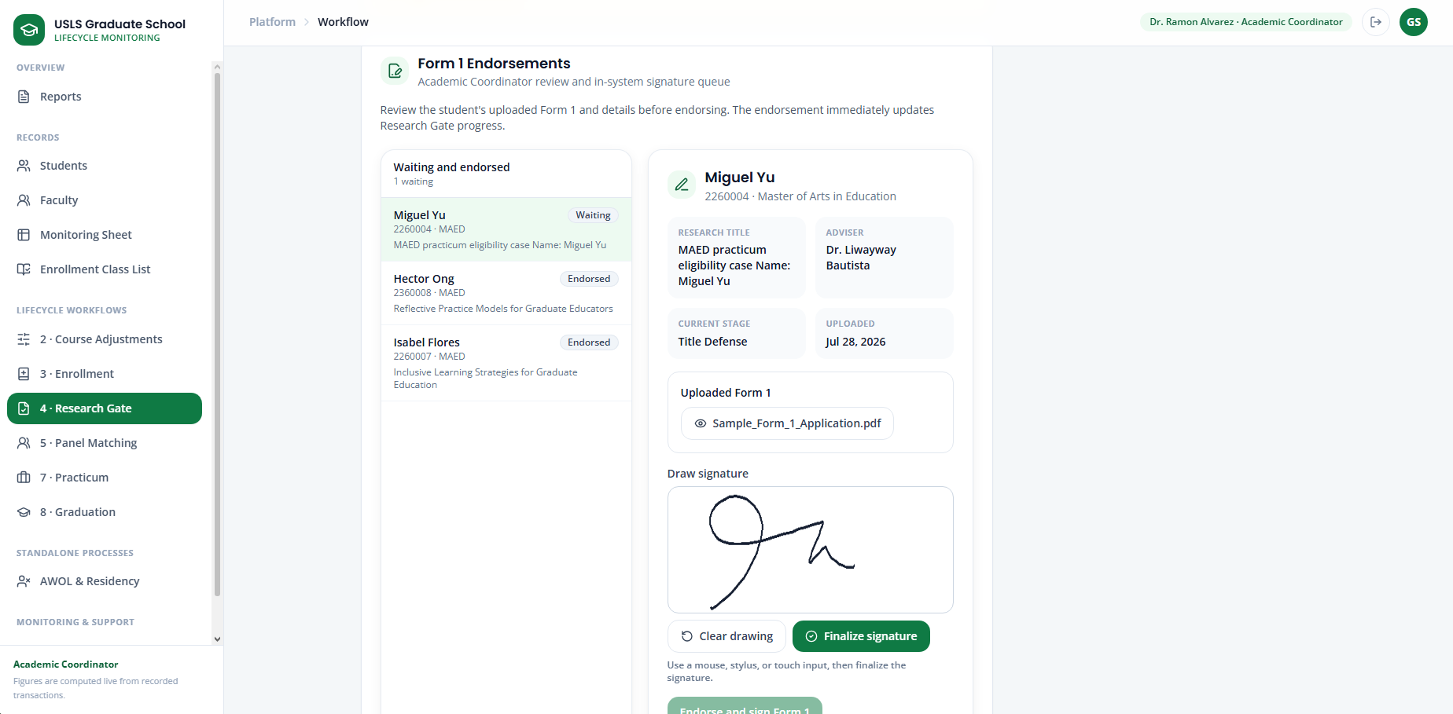
Screenshot — The Form 1 endorsement screen showing the signature area.
Step 24. Select Finalize Signature.
Step 25. Confirm that Form 1 is marked as signed and endorsed.
Step 26. Return to 5 · Research Gate.
Step 27. Confirm that Andrea’s Form 1 endorsement status has been updated.
Step 28. Sign out.
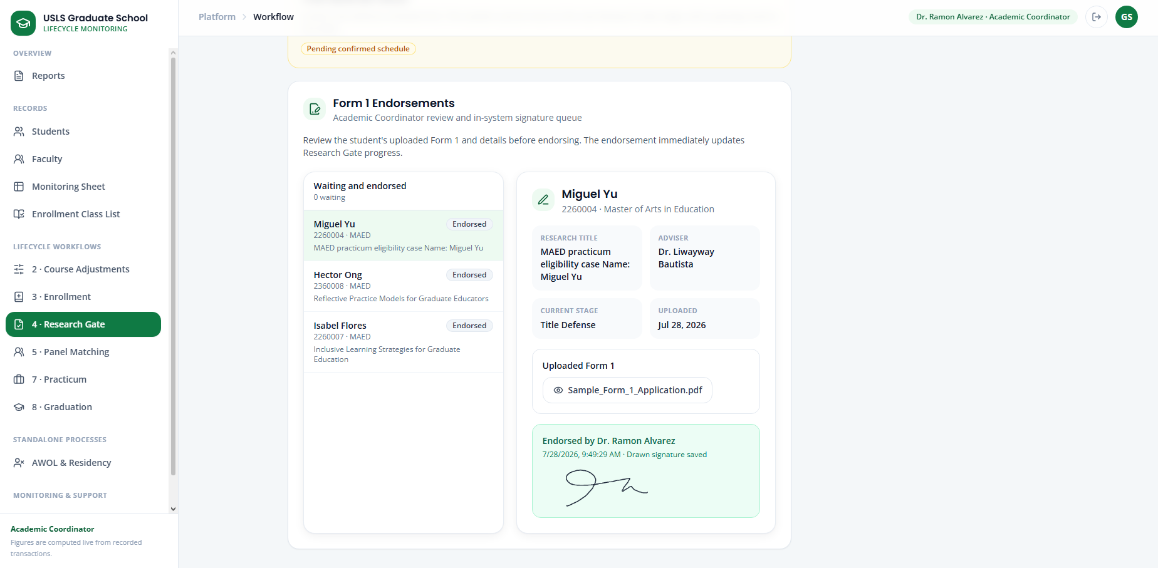
Screenshot — Andrea’s Research Gate record after the Academic Coordinator endorsement has been completed.

Part D - Panel matching and final selection
Step 29. Sign in as GS Staff.
Step 30. Open 6 · Panel Matching.
Step 31. Select Andrea Mae Villanueva.
Step 32. Review the RAG/AI-generated faculty recommendations.
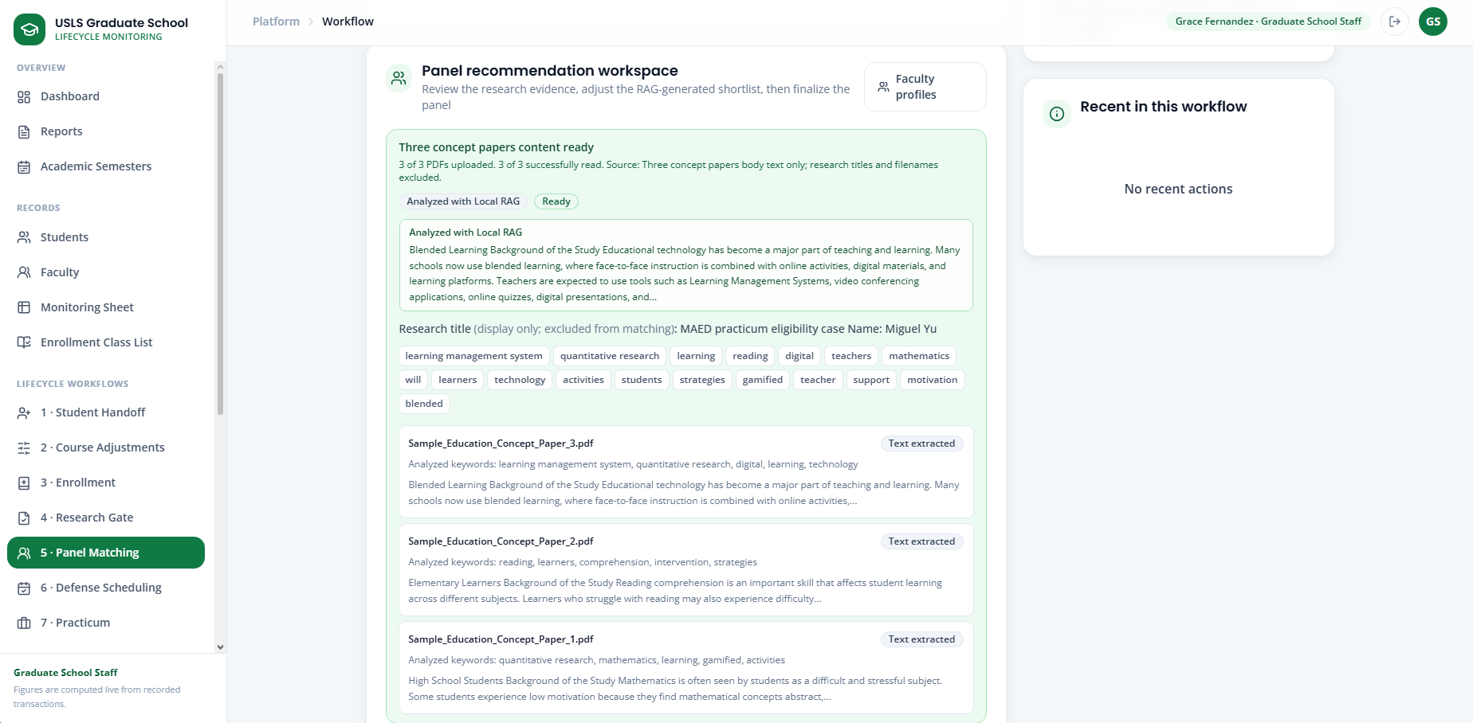
Screenshot — The Panel Matching screen showing RAG-analyzed concept papers to be matched with multiple faculty
Step 33. Review each faculty member’s match score, specialization, matching keywords, and availability.
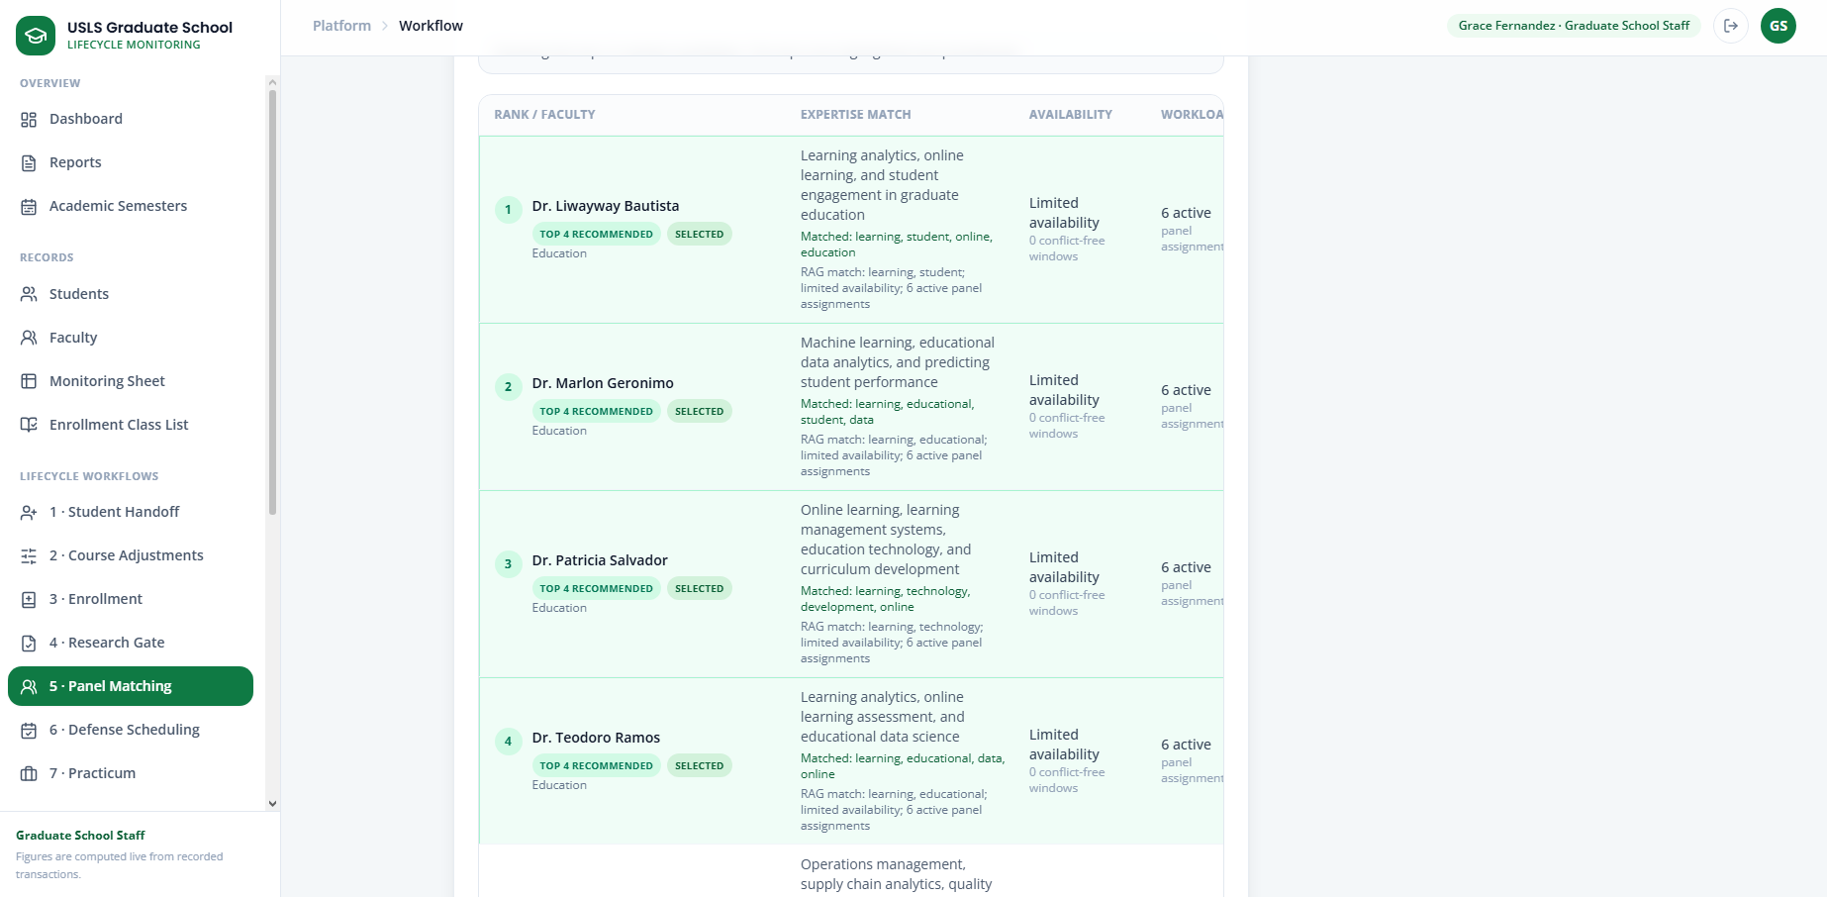
Screenshot —Screen showing faculty member’s match score, specialization, matching keywords, and availability
Step 34. Search for other faculty members if needed.
Step 35. Select four panelists.
Step 36. Assign one selected faculty member as the Panel Chair or Panel Lead.
Step 37. Select Finalize Selected Panel.
Step 38. Confirm that the finalized panel appears in Andrea’s record.
Step 39. Sign out.

Case 11 — Defense Scheduling and Rescheduling
Story:
After Andrea’s research requirements and panel assignments are completed, GS Staff reviews the shared availability of the selected panelists and finalizes the defense schedule. After the defense, only the assigned Panel Chair or Panel Lead can submit the official verdict.
Accounts used:
Role | Account
Student | andrea.mae.villanueva@student.usls.edu.ph
Academic Coordinator | academic@usls.edu.ph
Panel Chair | Depends on chosen panel chair for defense
Part A - Set the defense schedule
Step 1. Sign in as GS Staff.
Step 2. Open 7 · Defense Scheduling.
Step 3. Select Andrea Mae Villanueva.
Step 4. Confirm Andrea’s current research stage and readiness status.
Step 5. Confirm that the required Research Gate documents have been completed and verified.
Step 6. Review the four finalized panelists.
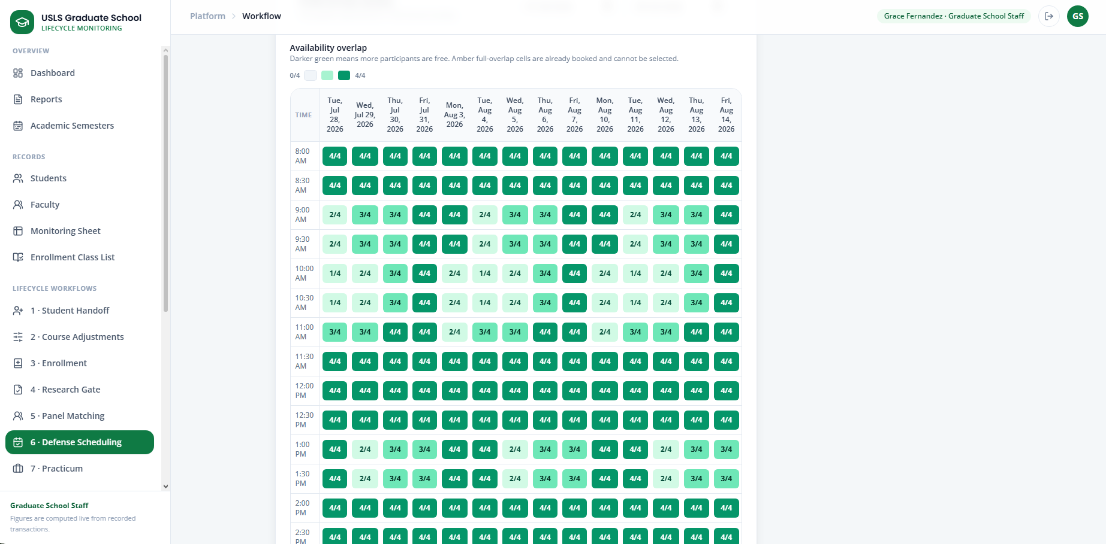
Screenshot — The Defense Scheduling screen showing Andrea’s selected panelists’ availability.
Step 7. Review their availability under Best Shared Options.
Step 8. Select the most suitable common schedule.
Step 9. Review the selected date and time under Final Schedule.
Step 10. Adjust the date, time, venue, or meeting details if necessary.
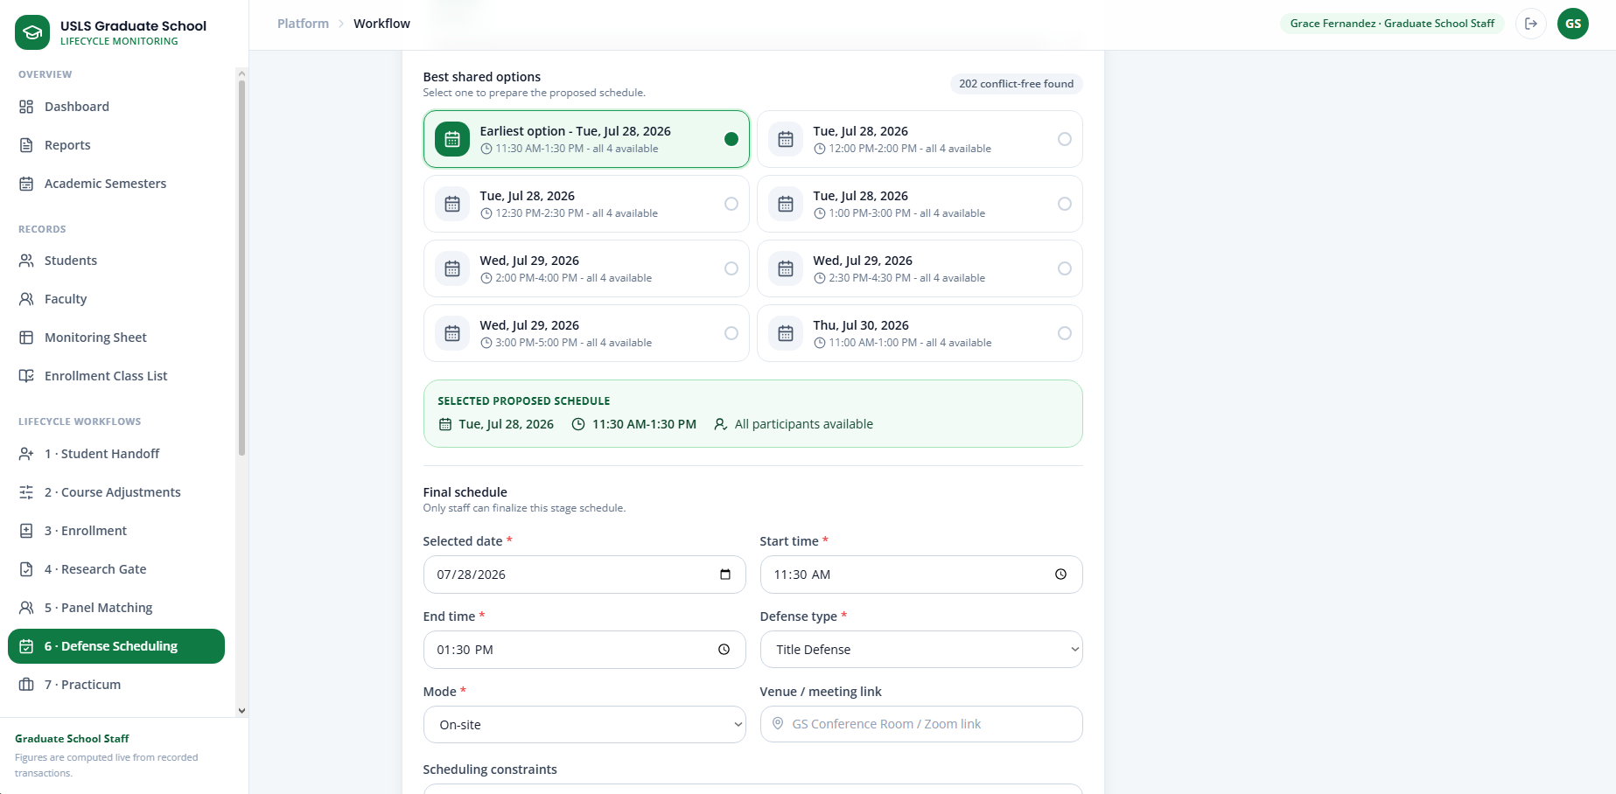
Screenshot — The Best Shared Options section showing common available schedules.
Step 11. Select Set Defense Schedule.
Step 12. Confirm that Andrea’s defense status changes to Scheduled.
Step 13. Sign out.

Part B - Rescheduling
Step 14. If the schedule needs to be changed, sign in as GS Staff.
Step 15. Open 7 · Defense Scheduling.
Step 16. Reopen Andrea Mae Villanueva’s defense record.
Step 17. Select the available Edit Schedule or Reschedule action.
Step 18. Review the panelists’ updated availability.
Step 19. Select a new shared schedule or manually adjust the date and time.
Step 20. Save the updated schedule.
Step 21. Confirm that the schedule status changes to Rescheduled.
Step 22. Sign out.
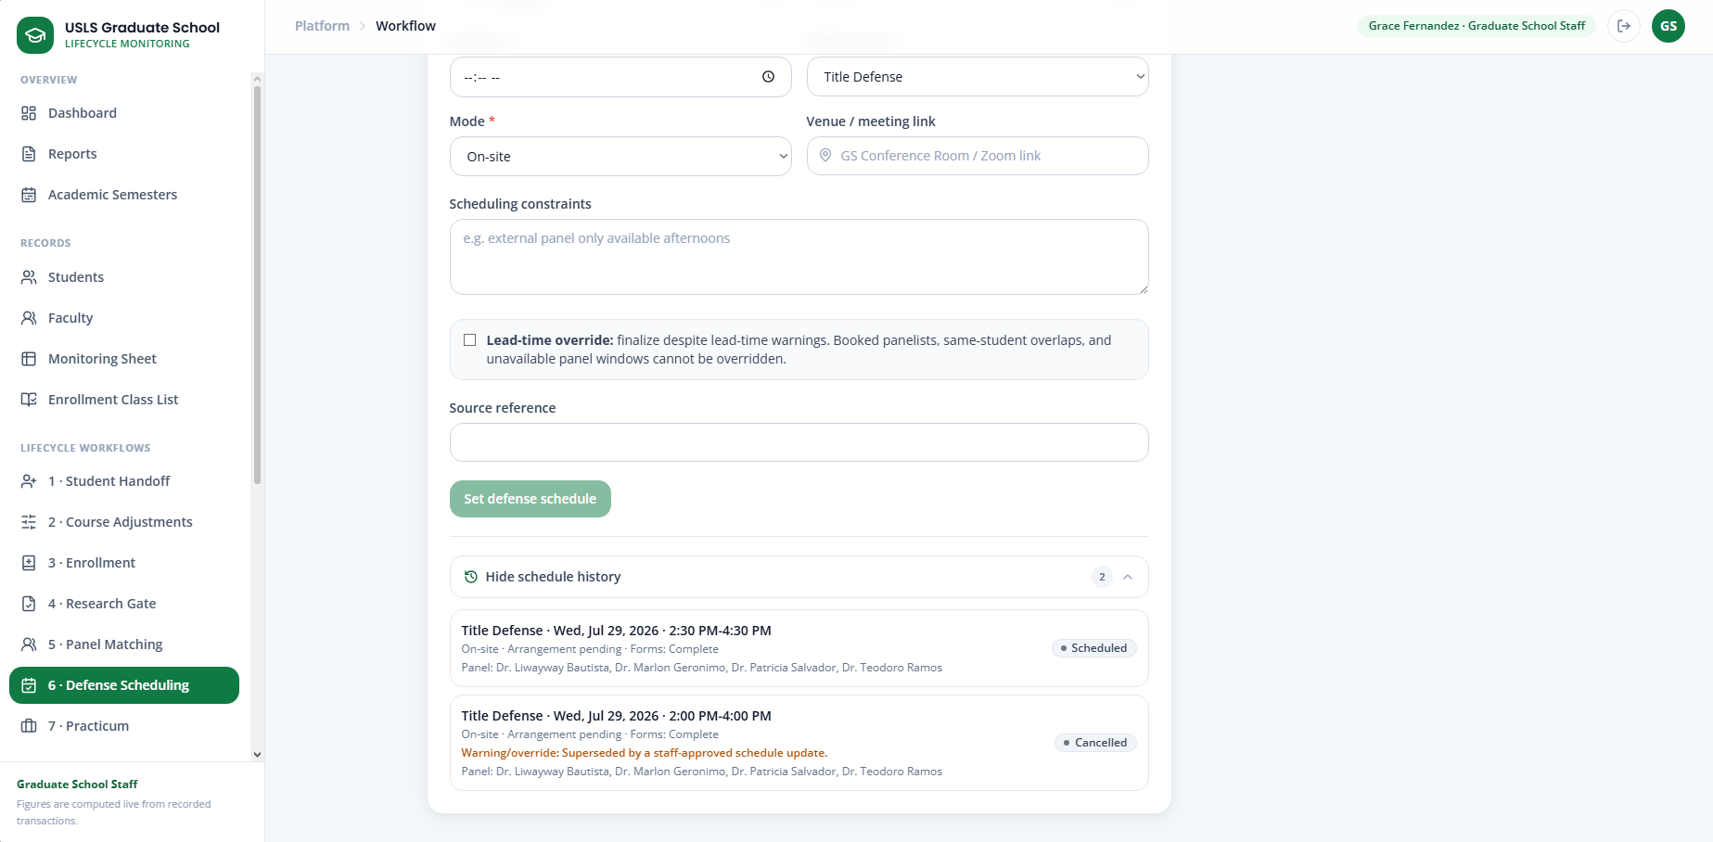
Screenshot — The defense rescheduling screen showing the previous schedule and updated schedule.
Part C - Panel Chair or Panel Lead submits the verdict
Step 23. Sign in using Andrea’s assigned Panel Chair or Panel Lead account.
Step 24. Open Advisees & Research.
Step 25. Go to Panel Papers and Defense Verdicts.
Step 26. Open Andrea Mae Villanueva’s defense record.
Step 27. Review Andrea’s research documents, defense stage, and schedule.
Step 28. Select the appropriate verdict result.
Available verdicts may include:
Passed
Passed with revisions
Deferred
Failed
For Resubmission
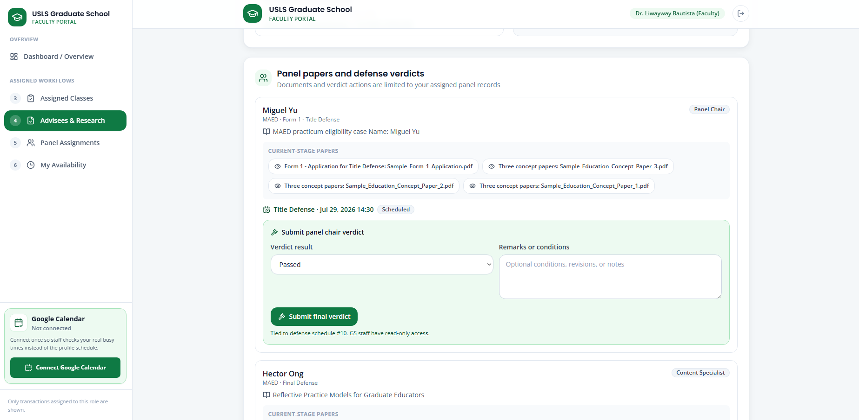
Screenshot — The verdict form showing the selected result and remarks.
Step 29. Enter remarks or required revisions, if applicable.
Step 30. Select Submit Final Verdict.
Step 31. Confirm that the verdict has been recorded.
Step 32. Sign out.

Part D - Unusual case: Student fails the defense
Story:
The assigned Panel Chair determines that Andrea did not pass the defense. The Panel Chair submits a Failed verdict, and Andrea must upload the required documents again for the same research stage.
Step 33. Sign in using Andrea’s assigned Panel Chair or Panel Lead account.
Step 34. Open Advisees & Research.
Step 35. Go to Panel Papers and Defense Verdicts.
Step 36. Open Andrea Mae Villanueva’s defense record.
Step 37. Select Failed as the verdict result.
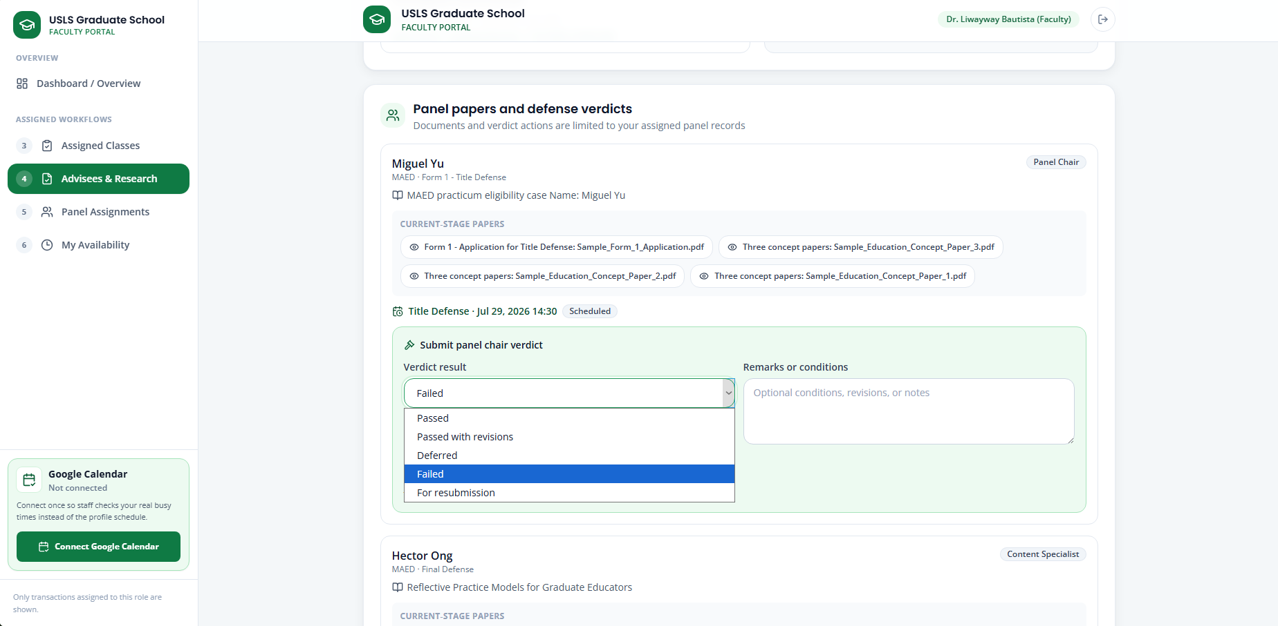
Screenshot —The Panel Chair verdict form showing Failed as the selected result.
Step 38. Enter the following sample remark:
The student must revise and resubmit the required documents before another defense may be scheduled.
Step 39. Select Submit Final Verdict.
Step 40. Confirm that Andrea’s defense status changes to Failed.
Step 41. Confirm that Andrea’s research submission status changes to Resubmission Required.
Step 42. Sign out.

Student Resubmission
Step 43. Sign in as Andrea Mae Villanueva.
Step 44. Open Research Submission.
Step 45. Confirm that Andrea remains in the same research stage.
Step 46. Confirm that the status shows Resubmission Required.
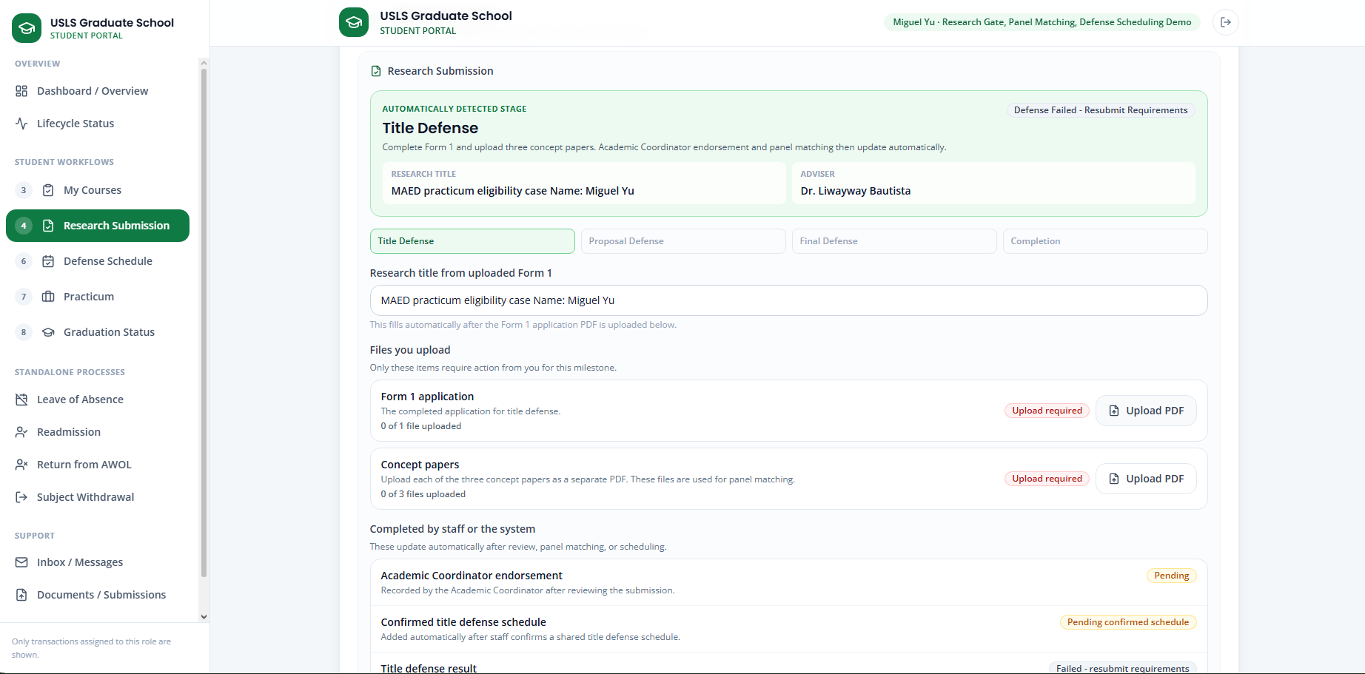
Screenshot — The student Research Submission screen showing the Failed verdict notice and Resubmission Required status.
Step 47. Upload the revised or replacement documents required for the current stage.
For Title Defense, resubmit:
Form 1 Application
Concept Paper 1
Concept Paper 2
Concept Paper 3

For Proposal Defense, resubmit:
Proposal Manuscript
Research Protocol Form 5.2 Ethics Clearance
Proposal Defense Endorsement
Statistical Consultation Form or Qualitative Exemption, Form 4.1
Proposal Manuscript Endorsement

For Final Defense, resubmit:
Final Defense Endorsement
Final Defense Manuscript
Step 48. Review the newly uploaded documents.
Step 49. Select Submit for Review again.
Step 50. Confirm that the submission status changes from Resubmission Required to Pending Review.
Step 51. Sign out.

Case 12 — Proposal Defense
Story:
After completing the Title Defense stage, Andrea submits the requirements for Proposal Defense. Her assigned Faculty Adviser reviews and signs the required papers. The Research Coordinator records the ethics clearance, while GS Staff verifies the complete submission and finalizes the panel before scheduling the defense.
Accounts used:
Role | Account
Student | andrea.mae.villanueva@student.usls.edu.ph
Faculty Adviser | Use Andrea’s assigned adviser account
Research Coordinator | research@gs.local
Graduate School Staff | staff@gs.local

Part A - Student submission
Step 1. Sign in as Andrea Mae Villanueva.
Step 2. Open Research Submission.
Step 3. Confirm that Andrea’s current stage is Proposal Defense.
Step 4. Upload the Proposal Manuscript.
Step 5. Upload Research Protocol Form 5.2 Ethics Clearance.
Step 6. Upload the Proposal Defense Endorsement.
Step 7. Upload the Statistical Consultation Form or Qualitative Exemption, Form 4.1.
Step 8. Upload the Proposal Manuscript Endorsement.
Step 9. Review all submitted documents.
Step 10. Select Submit Proposal Defense for Review.
Step 11. Confirm that the submission is pending adviser signatures and staff verification.
Step 12. Sign out.
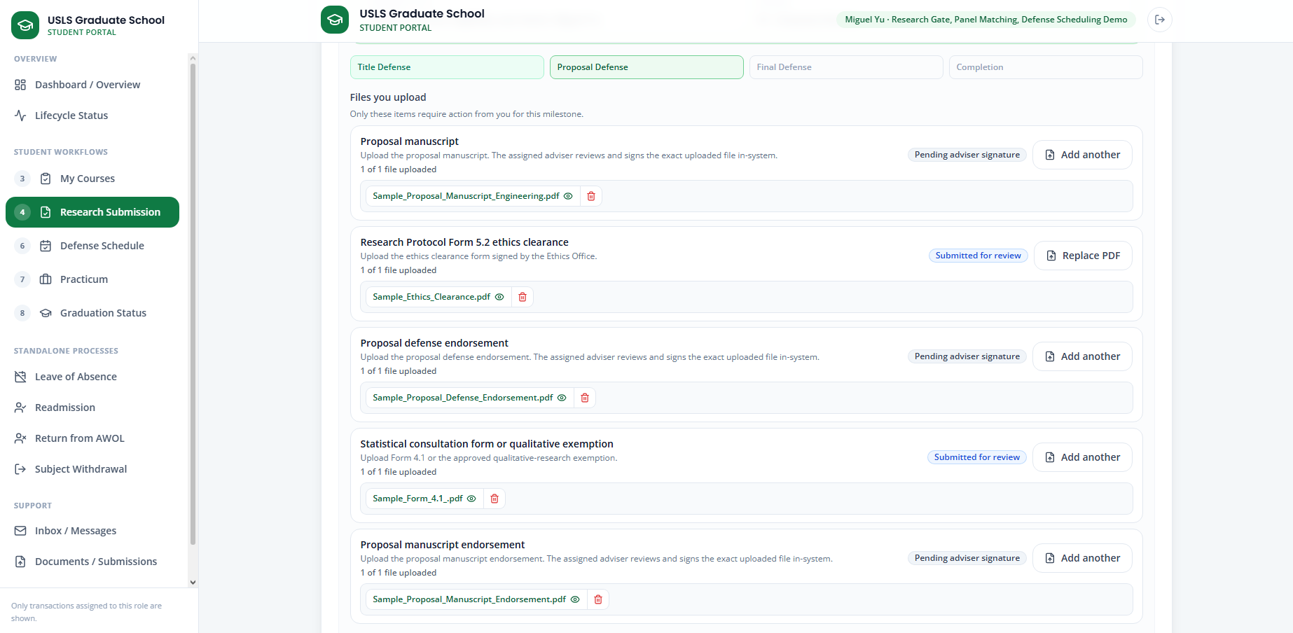
Screenshot — The Proposal Defense submission screen showing all required documents.

Part B - Faculty Adviser signatures
Step 13. Sign in using Andrea’s assigned Faculty Adviser account.
Step 14. Open Advisees & Research.
Step 15. Go to Adviser Paper Signatures.
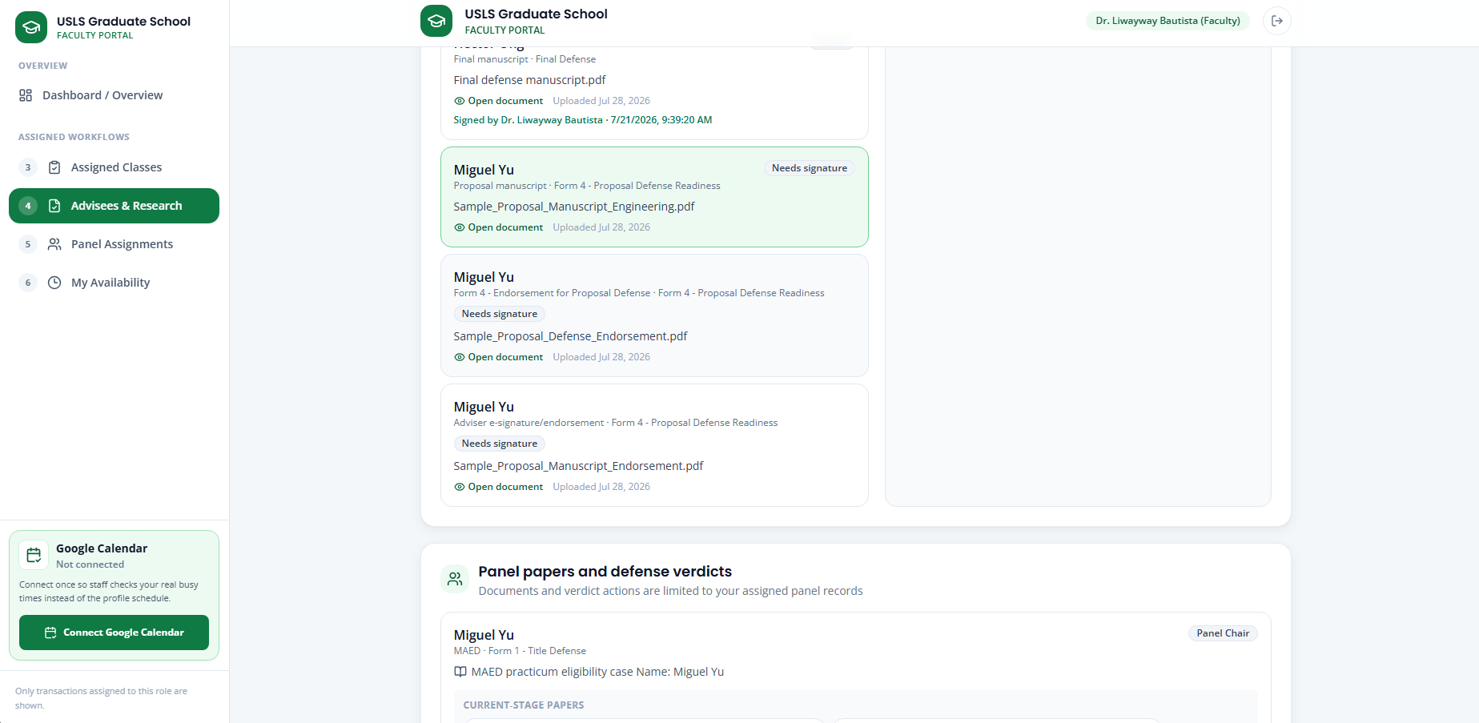
Screenshot — The Adviser Paper Signatures screen showing Andrea’s documents awaiting signature.
Step 16. Select Andrea Mae Villanueva.
Step 17. Open and review the Proposal Manuscript.
Step 18. Draw the adviser’s signature.
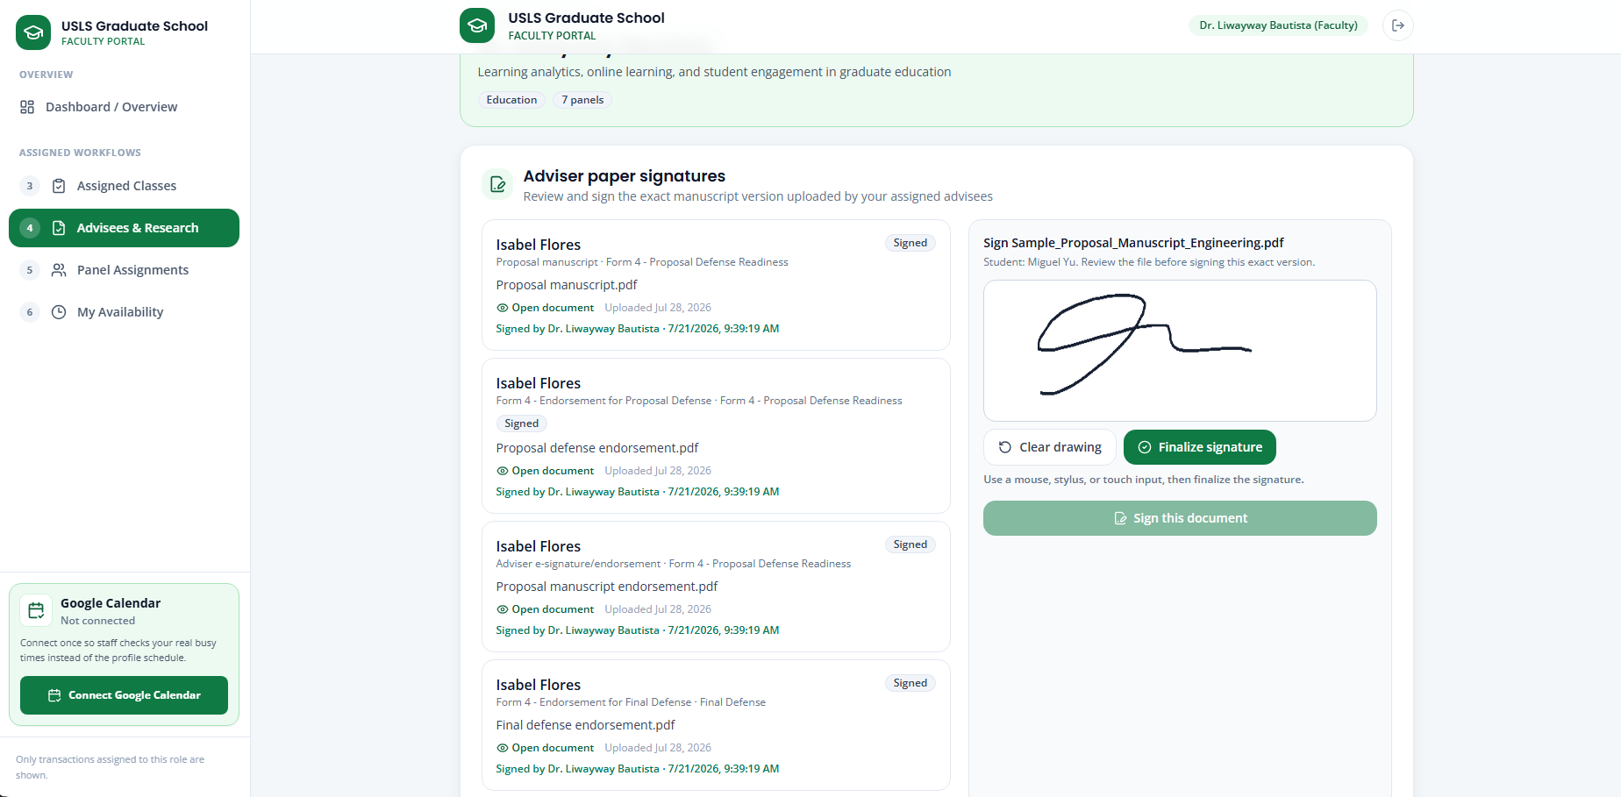
Screenshot — The signature area while signing one of Andrea’s papers.
Step 19. Select Finalize Signature.
Step 20. Select Sign This Document.
Step 21. Open and review the Endorsement for Proposal Defense.
Step 22. Draw the adviser’s signature.
Step 23. Select Finalize Signature.
Step 24. Select Sign This Document.
Step 25. Open and review the Endorsement for Proposal Manuscript.
Step 26. Draw the adviser’s signature.
Step 27. Select Finalize Signature.
Step 28. Select Sign This Document.
Step 29. Confirm that all three documents are marked as adviser-signed.
Step 30. Sign out.

Part C - Research Coordinator ethics clearance
Step 31. Sign in as the Research Coordinator.
Step 32. Open 5 · Research Gate.
Step 33. Select Andrea Mae Villanueva.
Step 34. Review the submitted Form 5.2 Ethics Clearance.
Step 35. Select Record Clearance.
Step 36. Select the appropriate clearance status.
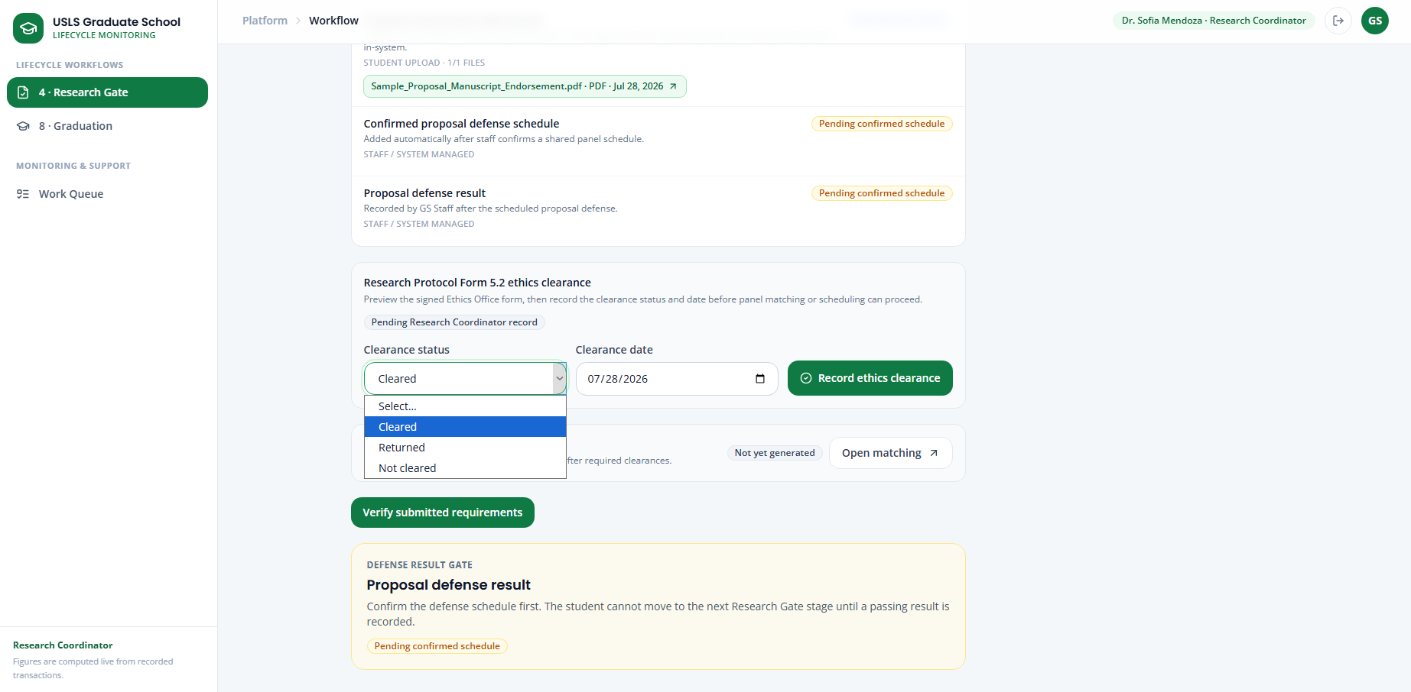
Screenshot — The Research Coordinator ethics clearance screen showing Form 5.2 and the clearance status options.
Step 37. Select Record Ethics Clearance.
Step 38. Confirm that Andrea’s ethics clearance status has been updated.
Step 39. Sign out.

Part D - GS Staff verification and panel matching
Step 40. Sign in as GS Staff.
Step 41. Open 5 · Research Gate.
Step 42. Open Andrea Mae Villanueva’s record.
Step 43. Review all submitted documents.
Step 44. Confirm that the adviser signatures and ethics clearance have been completed.
Step 45. Select Verify Submitted Requirements.
Step 46. Confirm that the Proposal Defense requirements are marked as complete.
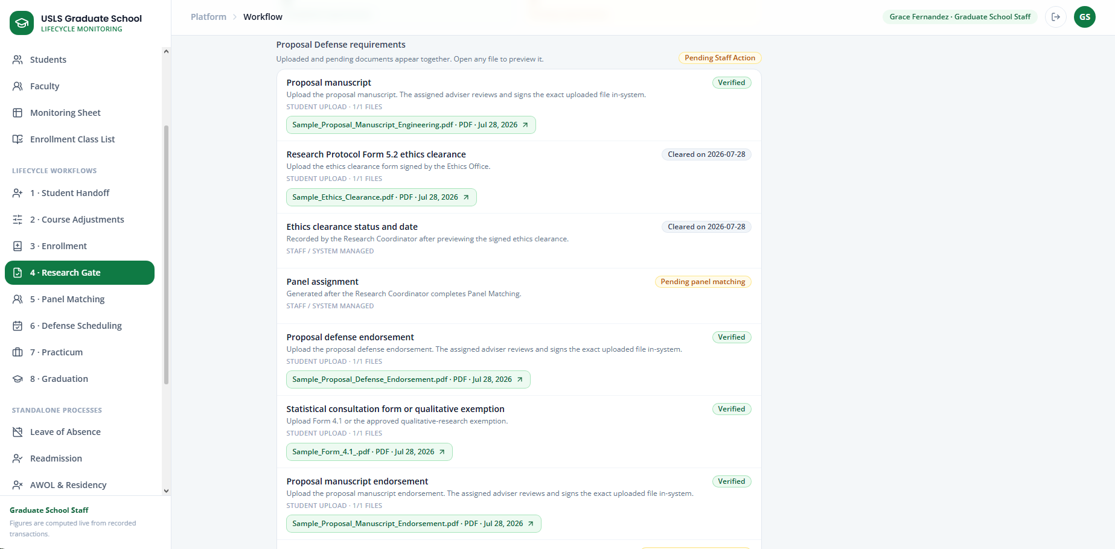
Screenshot — Andrea’s Research Gate record showing completed Proposal Defense requirements.
Step 47. Open 6 · Panel Matching.
Step 48. Select Andrea Mae Villanueva.
Step 49. Review the AI-generated panel recommendations, match scores, specializations, and availability.
Step 50. Select four panelists.
Step 51. Assign one selected faculty member as Panel Chair or Panel Lead.
Step 52. Select Finalize Selected Panel.
Step 53. Confirm that the panel is connected to Andrea’s Proposal Defense record.
Step 54. Continue with the Defense Scheduling and Rescheduling process in Section 10.
Note: If Andrea fails the Proposal Defense, follow the unusual case in Case 8. Andrea must resubmit the Proposal Defense documents and repeat the same review process.

Case 13 — Final Defense
Story:
Andrea submits her Final Defense requirements. Her Faculty Adviser reviews and signs the Final Defense Endorsement and Final Manuscript. GS Staff verifies the documents, finalizes the panel, and schedules the defense. After Andrea receives a passing verdict, she submits the required post-defense documents so her research status can be marked complete.
Accounts used:
Role | Account
Student | andrea.mae.villanueva@student.usls.edu.ph
Faculty Adviser | Use Andrea’s assigned adviser account.
Graduate School Staff | staff@usls.edu.ph
Panel Chair | Depends on chosen panel chair for defense

Part A - Student Final Defense submission
Step 1. Sign in as Andrea Mae Villanueva.
Step 2. Open Research Submission.
Step 3. Confirm that Andrea’s current stage is Final Defense.
Step 4. Upload the Final Defense Endorsement.
Step 5. Upload the Final Defense Manuscript.
Step 6. Review the uploaded documents.
Step 7. Select Submit Final Defense for Review.
Step 8. Confirm that the submission is pending adviser signatures and staff verification.
Step 9. Sign out.

Part B - Faculty Adviser signatures
Step 10. Sign in using Andrea’s assigned Faculty Adviser account.
Step 11. Open Advisees & Research.
Step 12. Go to Adviser Paper Signatures.
Step 13. Select Andrea Mae Villanueva.
Step 14. Open and review the Endorsement for Final Defense.
Step 15. Draw the adviser’s signature.
Step 16. Select Finalize Signature.
Step 17. Select Sign This Document.
Step 18. Open and review the Final Manuscript.
Step 19. Draw the adviser’s signature.
Step 20. Select Finalize Signature.
Step 21. Select Sign This Document.
Step 22. Confirm that both documents are marked as adviser-signed.
Step 23. Sign out.

Part C - GS Staff verification and panel matching
Step 24. Sign in as GS Staff.
Step 25. Open 5 · Research Gate.
Step 26. Open Andrea Mae Villanueva’s record.
Step 27. Review the Final Defense Endorsement and Final Manuscript.
Step 28. Confirm that both adviser signatures have been completed.
Step 29. Select Verify Submitted Requirements.
Step 30. Confirm that the Final Defense requirements are marked as complete.
Step 31. Open 6 · Panel Matching.
Step 32. Select Andrea Mae Villanueva.
Step 33. Review the AI-generated panel recommendations.
Step 34. Select four panelists.
Step 35. Assign one selected faculty member as Panel Chair or Panel Lead.
Step 36. Select Finalize Selected Panel.
Step 37. Confirm that the finalized panel appears in Andrea’s Final Defense record.
Step 38. Continue with the Defense Scheduling and Rescheduling process in Section 10.

Part D - Post-defense document submission
Step 39. After the Panel Chair or Panel Lead submits a passing verdict, sign in as Andrea Mae Villanueva.
Step 40. Open Research Submission or Completion Evidence.
Step 41. Confirm that the post-defense completion section is available.
Step 42. Upload the five required post-defense documents.
The documents may include:
Soft copy of the final manuscript
Panel approval evidence
Turnitin certificate
Form 9 Editor Certification
Form 10 Approval Sheet
Step 43. Review all five uploaded documents.
Step 44. Select Submit Completion Evidence.
Step 45. Confirm that the documents are pending verification.
Step 46. Sign out.

Part E - Completion verification
Step 47. Sign in as GS Staff.
Step 48. Open 5 · Research Gate.
Step 49. Open Andrea Mae Villanueva’s record.
Step 50. Review the five submitted post-defense documents.
Step 51. Select Verify Completion.
Step 52. Confirm that Andrea’s research status changes to Complete.
Step 53. Open the Graduation module.
Step 54. Use Select All Eligible Students or the available eligibility filter.
Step 55. Confirm that Andrea appears among the eligible students because her research requirements have been completed.
Step 56. Sign out.
Note: If Andrea fails the Final Defense, follow the unusual case in Section 8. Andrea must resubmit the Final Defense Endorsement and Final Manuscript and repeat the review, panel matching, scheduling, and verdict process.

Case 14 — Practicum
Story:
Paolo Ramirez, is an MSGC student eligible for Practicum, he submits only 120 of the required 200 practicum hours after his MOA is approved. The GS Staff and the Academic Coordinator review his progress on the Practicum page, while Paolo receives a request through the Student Portal to submit evidence for the remaining 80 hours. The platform keeps his original files, reopens document submission, and requires updated hours and a new certificate PDF.
Program restriction
Practicum is available only to Psychology and Master of Science in Guidance and Counseling students. Students from other programs are excluded from the Practicum page, and the system rejects their practicum uploads and requests.
Accounts used:
Role | Account
Standard-case student | practicum.andrea@usls.edu.ph
Unusual-case student | practicum.paolo@usls.edu.ph
Graduate School Staff | staff@usls.edu.ph
Academic Coordinator | academic@usls.edu.ph
Dean | dean@usls.edu.ph

Step 1. Return to the login page and reset Paolo Ramirez’s Practicum demo.
Step 2. Sign in as Paolo and open 7 · Practicum. Here we can see that his MSGC program is identified as eligible for Practicum.
Step 3. Complete the MOA submission using Paolo’s sample information and upload his signed MOA PDF.
Paolo’s unusual submission
Practicum site: Guidance and Counseling Partner Center
Supervisor: Ms. Angela Cruz
Required hours: 200
Initial completed hours: 120
Initial completion file: Paolo_Ramirez_Initial_Practicum_Certificates.pdf
Additional file: Paolo_Ramirez_Additional_Practicum_Certificate.pdf
Initial remarks: Initial certificates covering 120 completed practicum hours.
Resubmission remarks: The additional certificate covers the remaining 80 practicum hours.
Step 4. Sign in as GS Staff and select Forward to Academic Coordinator.
Step 5. Sign in as the Academic Coordinator and select Mark practicum in progress.
Step 6. Sign back in as Paolo. Enter only 120 completed hours instead of the required 200, upload the initial completion-certificate PDF, and select Submit completion stage.
Step 7. Confirm that the platform records the case as Hours Incomplete. It does not allow the practicum to be marked complete.
Step 8. Sign in as GS Staff, open Paolo’s case, and select Forward documents to Academic Coordinator.
Step 9. Sign in as the Academic Coordinator. Open Paolo’s case and confirm that it displays 120/200 hours.
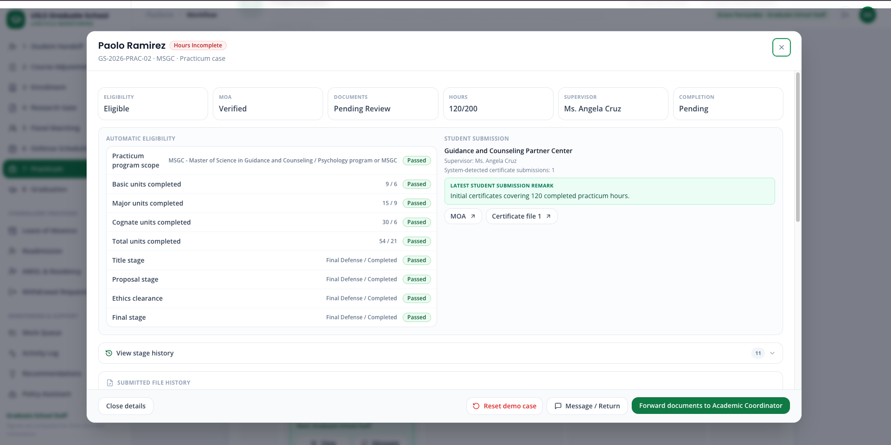
Step 10. Select Request additional certificates. Enter the required reason: Only 120 of the required 200 practicum hours are documented. Upload a new certificate covering the remaining hours.
Step 11. Confirm that Paolo’s case moves to Additional Certificates Requested and is returned to the student.
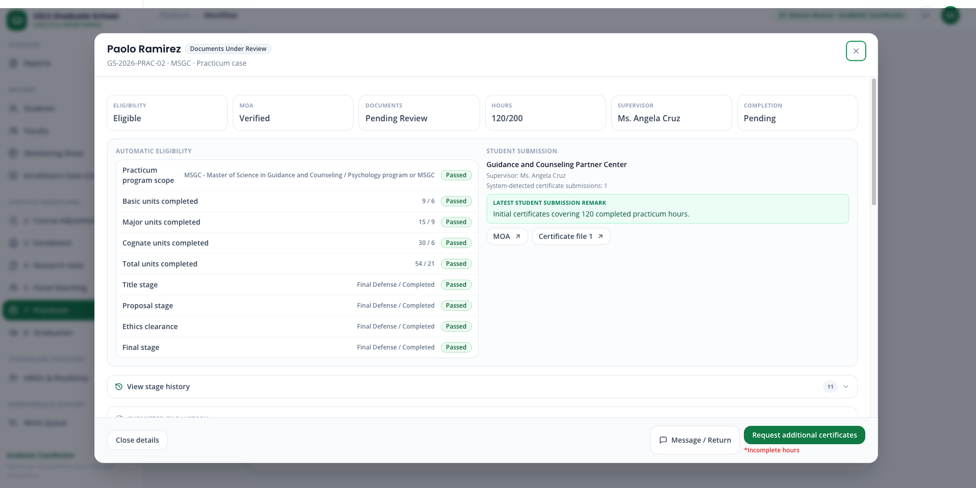
Step 12. Sign back in as Paolo. Here we can see when we open the Request Center we can see the newest messages which is highlighted in green.
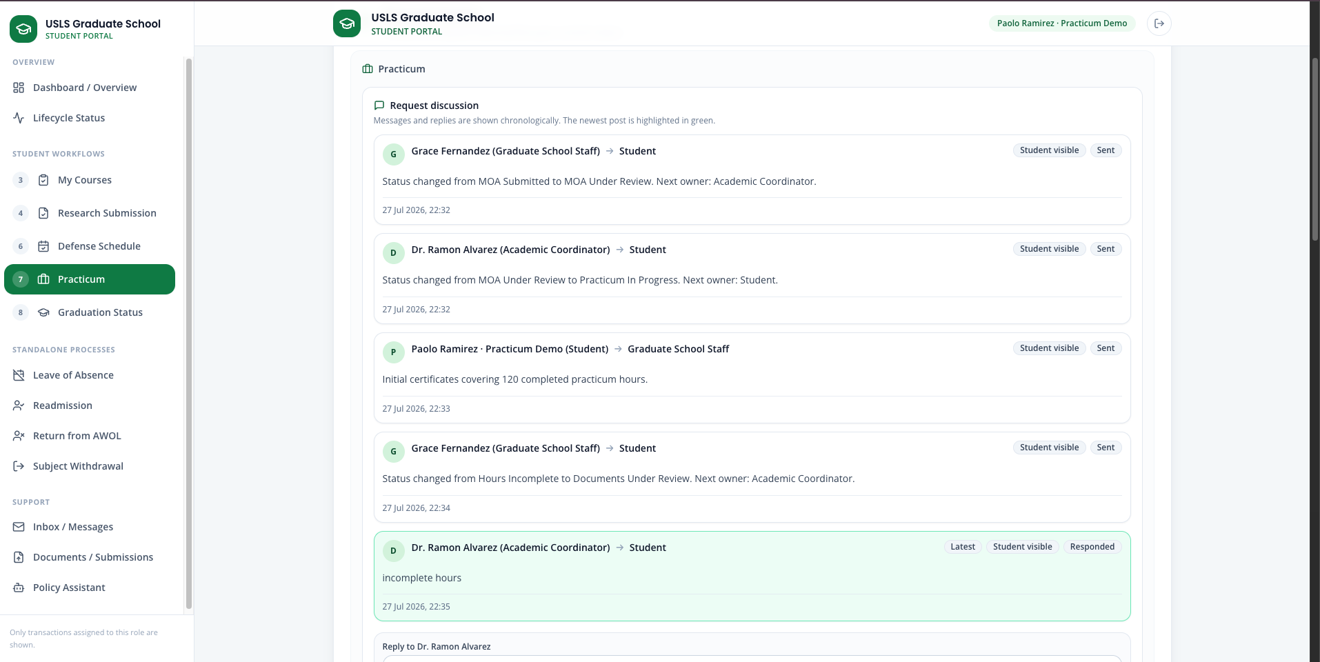
Step 13. Return to Practicum Step 3. Confirm that the earlier PDF remains visible in the file history but cannot be reused as the new response.
Step 14. Enter 200 completed hours and upload Paolo_Ramirez_Additional_Practicum_Certificate.pdf.
Step 15. Add the resubmission remark and select Resubmit completion stage.
Step 16. Sign in as GS Staff and forward the updated documents to the Academic Coordinator.
Step 17. Sign in as the Academic Coordinator. Confirm that the platform now shows 200/200 hours and two submitted certificate files.
Step 18. Select Verify completion, followed by Send status report to Dean.
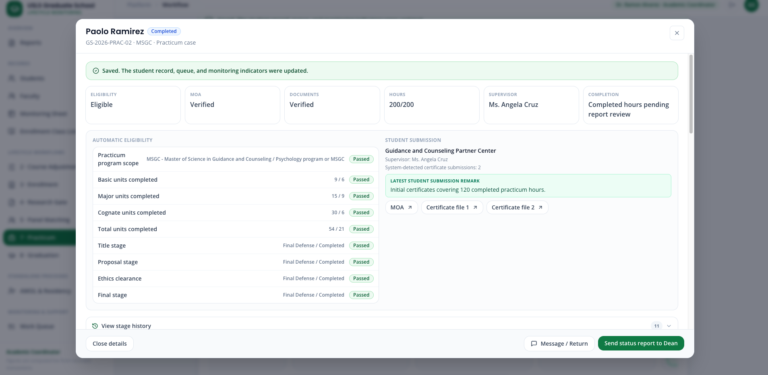
Step 19. Sign in as the Dean and select Mark reviewed.
Step 20. Confirm that Paolo’s final status is Dean Reviewed and that both the original and additional PDFs remain in the audit history.
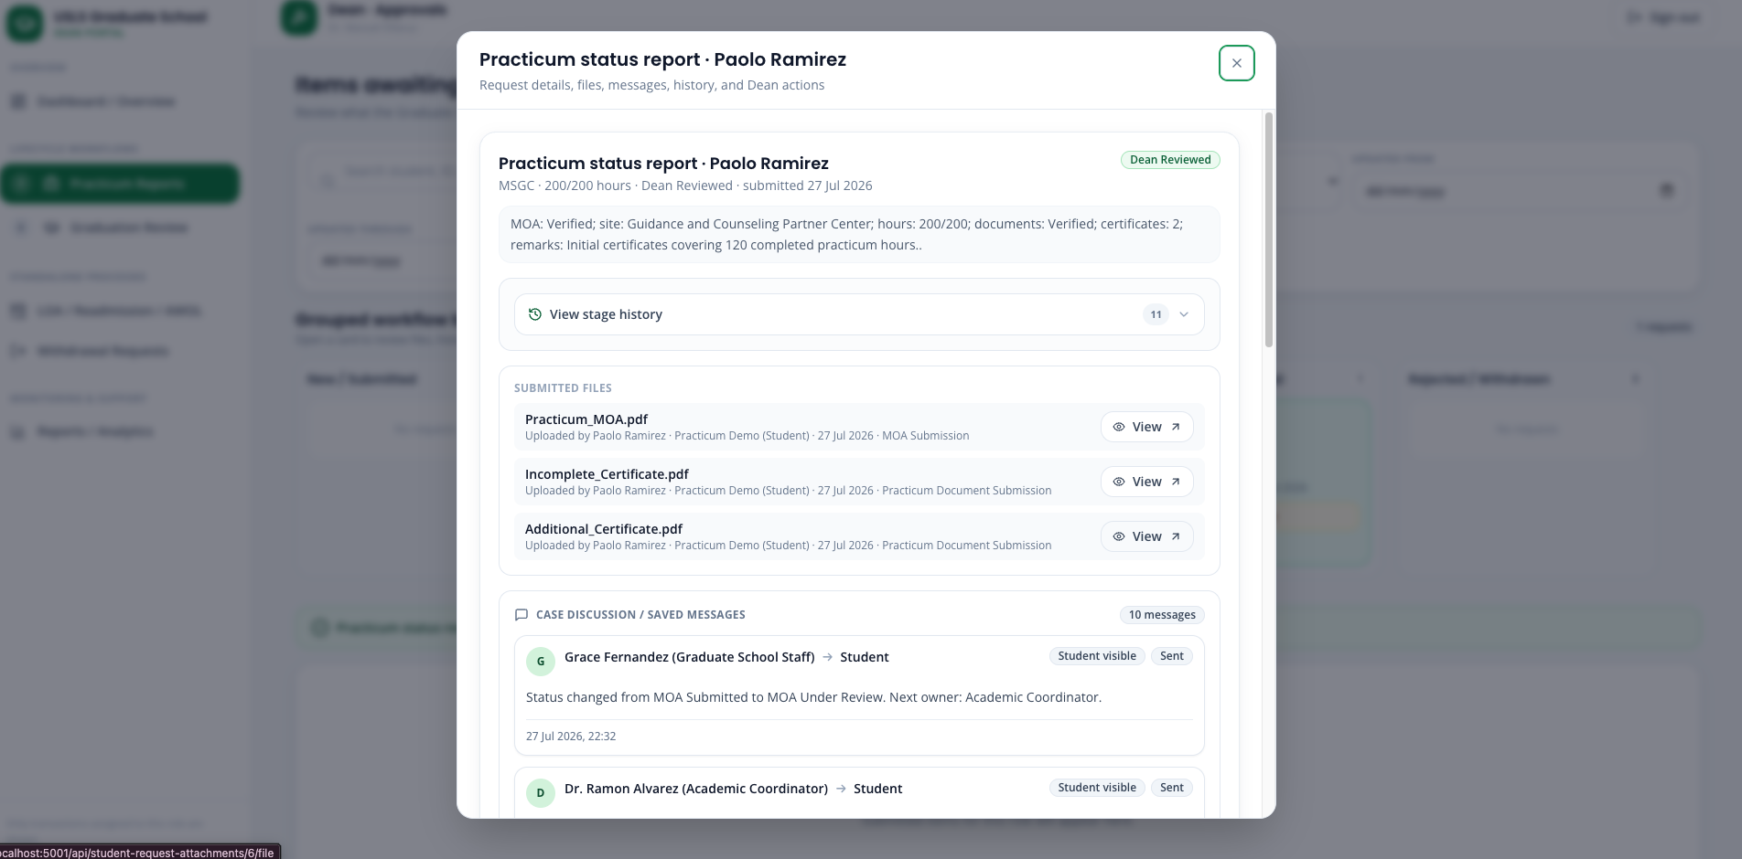

Case 15 — Graduation eligibility and endorsement
Story:
Carlo Mendoza submits a graduation application, but GS Staff finds incorrect information in the PDF before batch creation and endorsement. GS Staff returns the application through the Graduation page, and Carlo receives the correction request in the Student Portal. The system preserves the original PDF, reopens the upload step, and requires a completely new corrected file. After Carlo resubmits, his application returns to Application Submitted, Ready for Batch Creation, while the original PDF and return message remain in the audit history.
Accounts used:
Role | Account
Standard-case student | practicum.andrea@usls.edu.ph
Unusual-case student | practicum.paolo@usls.edu.ph
Graduate School Staff | staff@usls.edu.ph
Academic Coordinator | academic@usls.edu.ph
Research Coordinator | research@usls.edu.ph
Dean | dean@usls.edu.ph
Suggested sample information:
Open graduation school year: AY 2026-2027
Carlo incorrect application: Carlo_Mendoza_Incorrect_Graduation_Application.pdf
Carlo corrected application: Carlo_Mendoza_Corrected_Graduation_Application.pdf
Batch name: Batch 1 July 2026
GS Staff return message: The name and student number in the submitted application do not match the official student record. Upload a corrected signed application.
Optional Dean comment: Graduation candidates reviewed and approved for endorsement.
Important eligibility rule
Students appear on the Graduation page only when coursework, research stages, defense results, post-defense completion documents, and any required practicum are complete.
However, being academically eligible does not automatically allow batch selection:
- Before submitting an application, the student appears in Step 1 · Academically Eligible — Awaiting Student Application.
- After submitting the signed application PDF, the student moves to Step 2 · Application Submitted — Ready for Batch Creation.
- Only students in Step 2 can be selected for a graduation batch.

Step 1. Reset Carlo Mendoza’s Graduation demo.
Step 2. Sign in as Carlo and open 8 · Graduation.
Step 3. Select the current AY 2026-2027 review window and upload Carlo_Mendoza_Incorrect_Graduation_Application.pdf.
Step 4. Select Submit graduation application.
Step 5. Sign in as GS Staff and open 8 · Graduation.
Step 6. Find Carlo in Application Submitted — Ready for Batch Creation.
Step 7. Select the clickable View PDF button beside Carlo’s application status and inspect the submitted PDF.
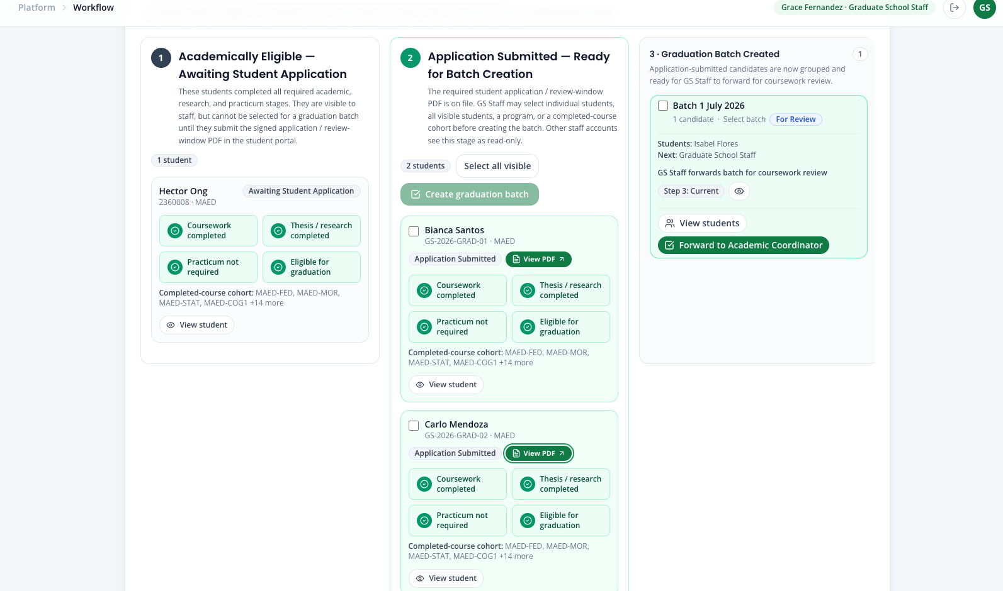
Step 8. Open View student and confirm that the submitted PDF is also available from the student’s case details.
Step 9. Select the red Message / Return button.
Step 10. Set the action to Return for clarification and the recipient to Student.
Step 11. Check Have student resubmit document.
Step 12. Enter: The name and student number in the submitted application do not match the official student record. Upload a corrected signed application.
Step 13. Select the red Return to student button.
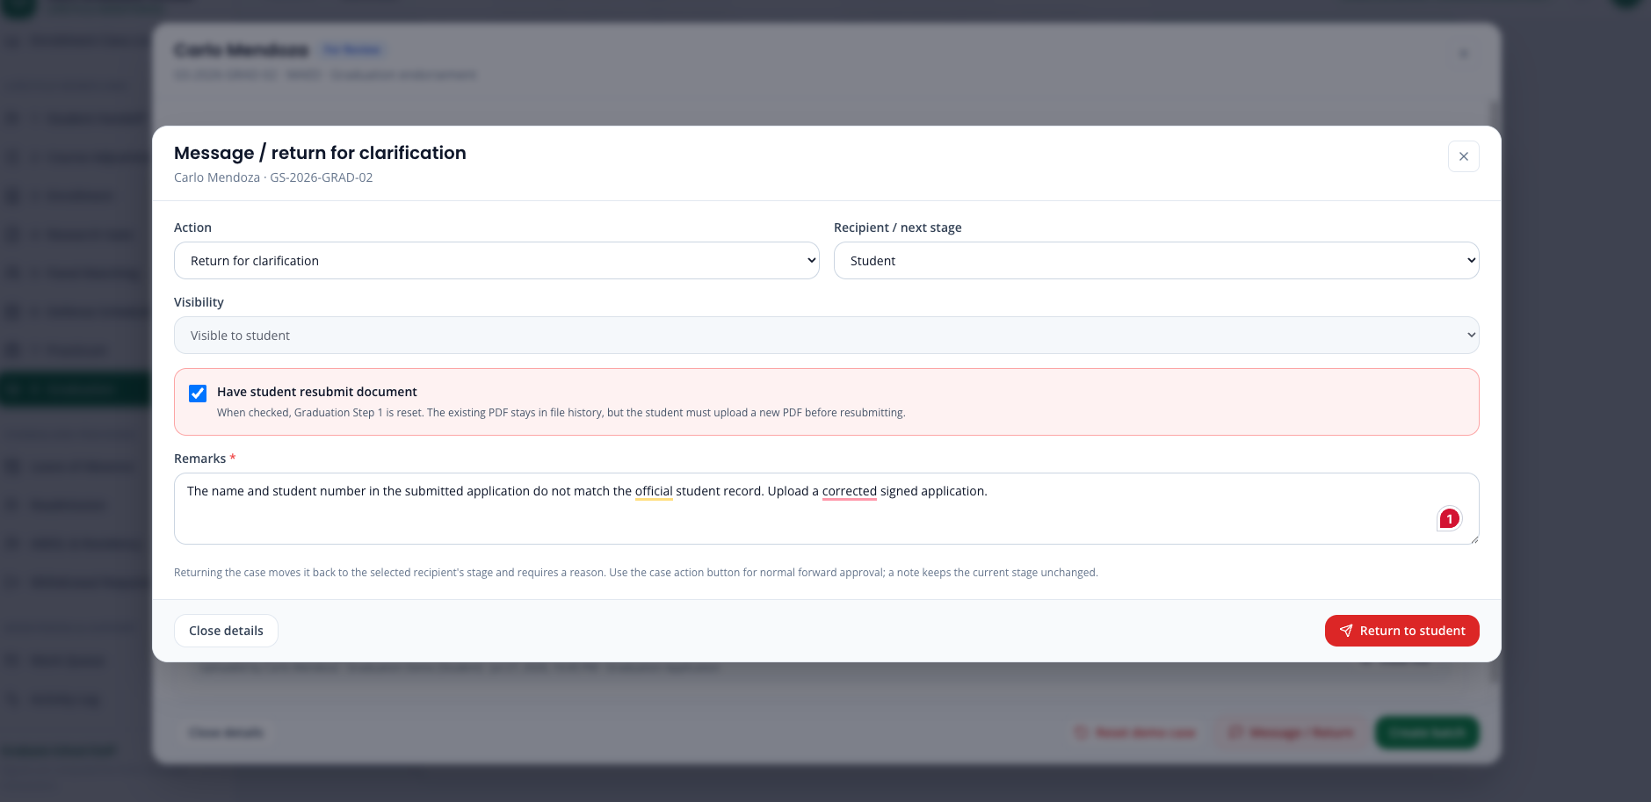
Step 14. Confirm that Carlo moves to Returned for Clarification and cannot be added to a graduation batch.
Step 15. Sign in as Carlo. Open the Request Center and confirm that the newest GS Staff message is highlighted in green.
Step 16. Open Graduation Step 1 and confirm that it has been reset for resubmission.
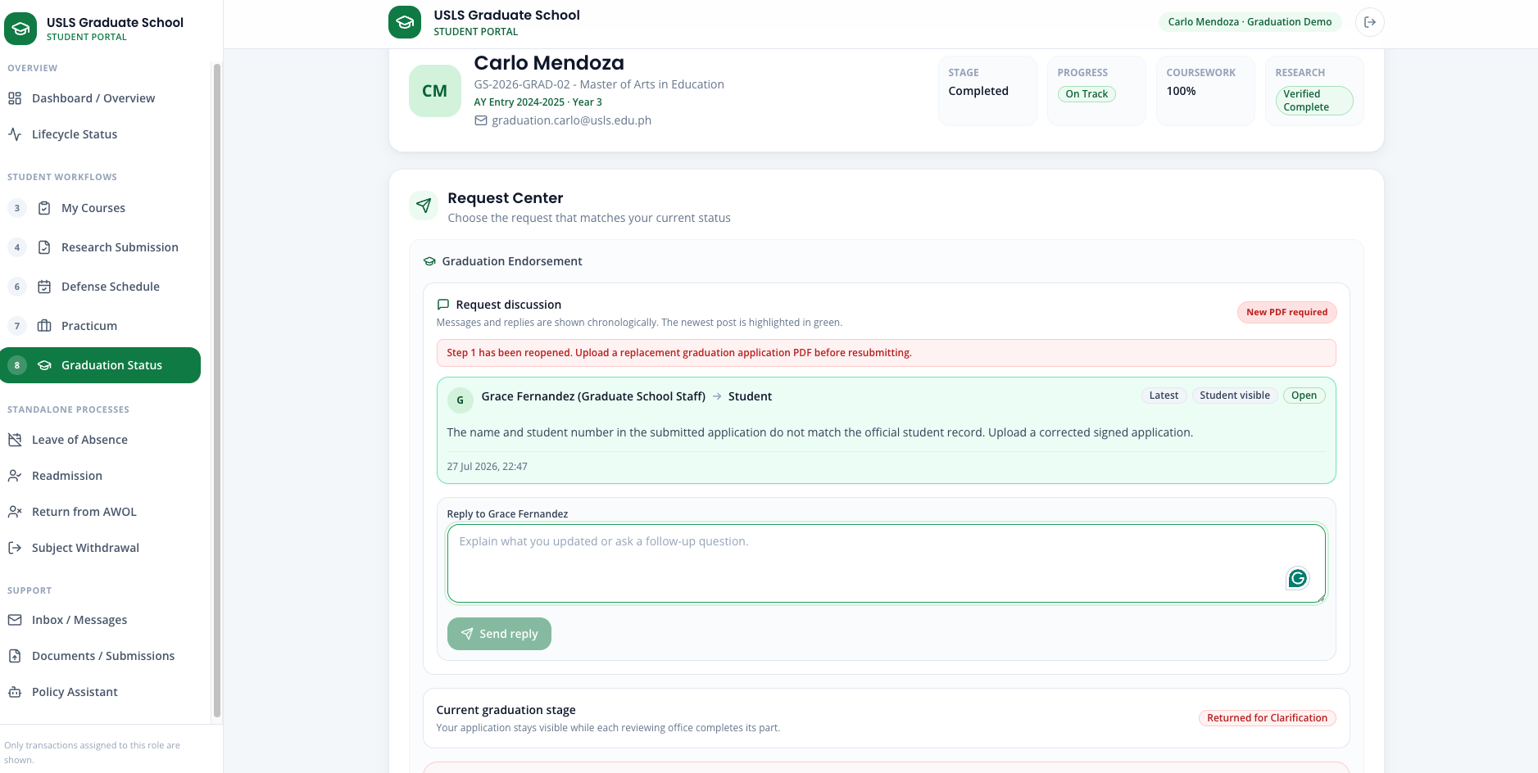
Step 17. Confirm that the incorrect PDF remains visible in the file history but is no longer accepted as the current application.
Step 18. Attempting to reuse the old PDF should be rejected. Upload Carlo_Mendoza_Corrected_Graduation_Application.pdf.
Step 19. Select AY 2026-2027 and select Resubmit graduation application.
Step 20. Sign in as GS Staff. Confirm that Carlo returns to Application Submitted — Ready for Batch Creation with the corrected PDF available through View PDF.
Step 21. Continue Carlo through batch creation, coursework review, research validation, endorsement preparation, Dean approval, and CSV export using the normal steps from Part A.
Step 22. Select Select All Visible and select Create graduation batch.
Step 12. Enter the batch information for Batch 1 July 2026. Confirm that only the current AY 2026-2027 school year can be selected.
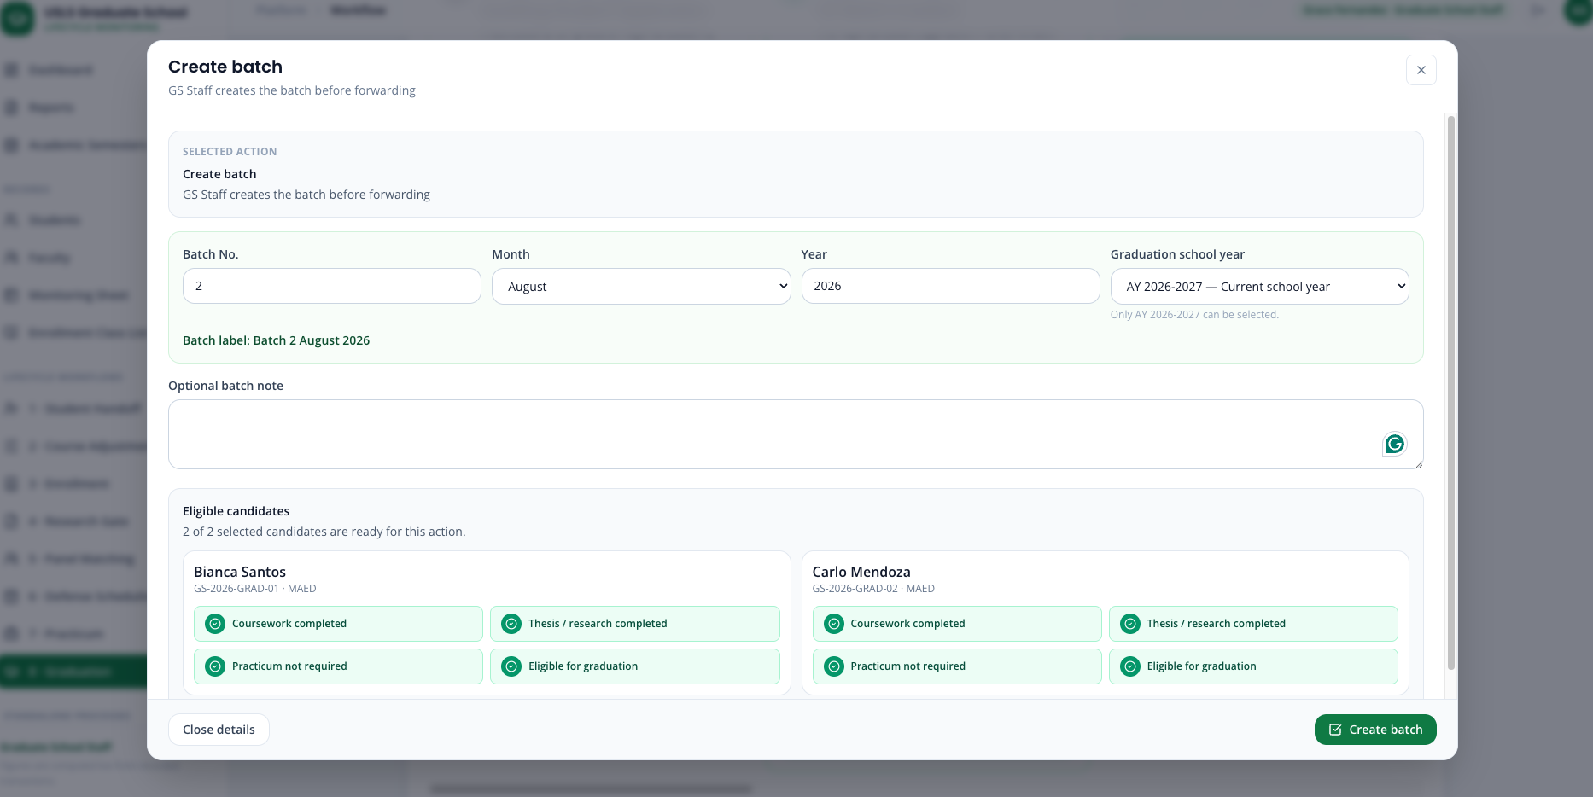
Step 13. Open the newly created batch in Step 3 · Graduation Batch Created and select Forward to Academic Coordinator.
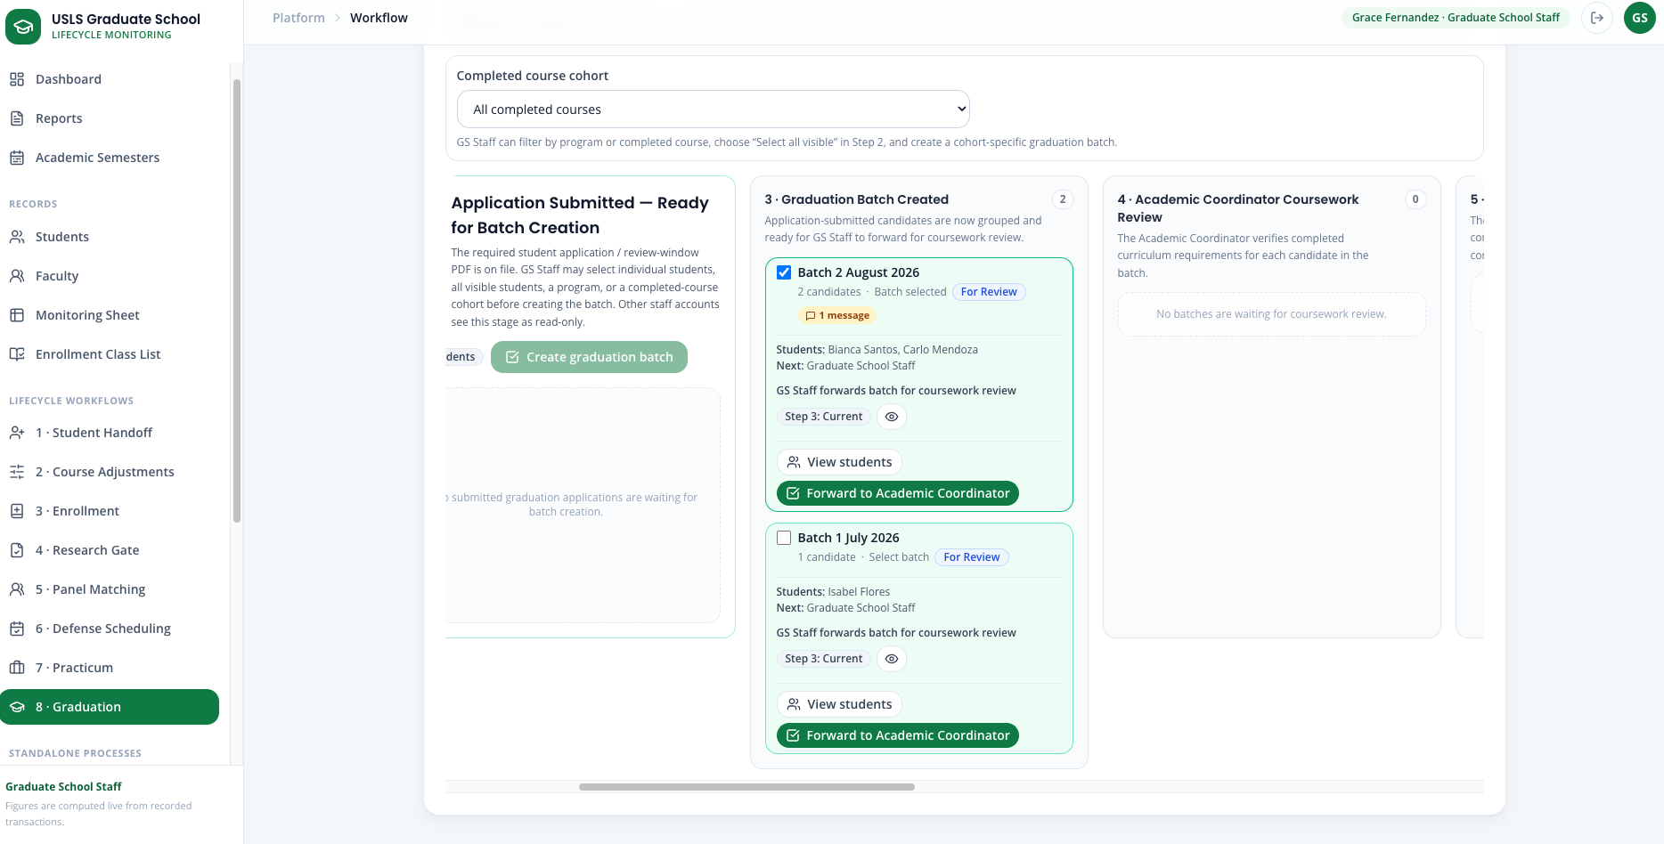
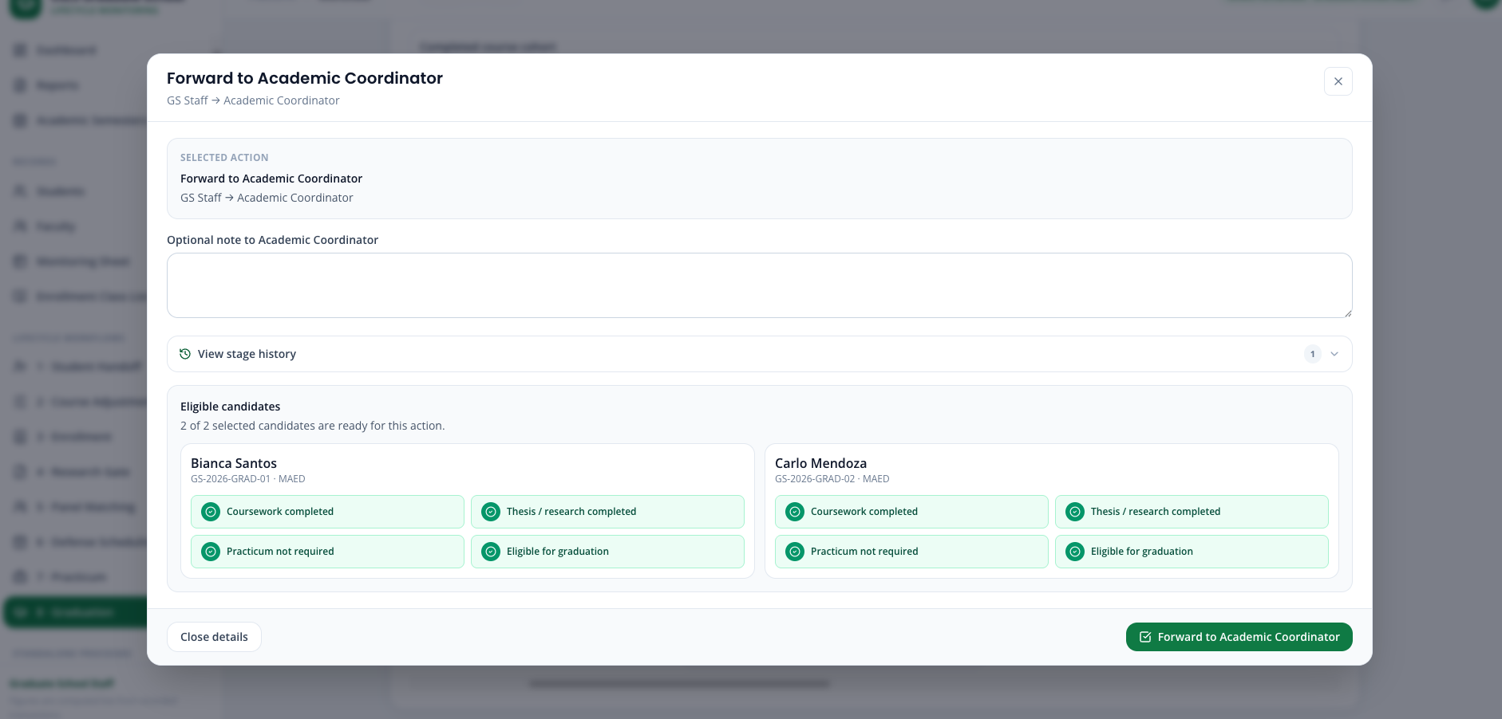
Step 14. Sign in as the Academic Coordinator and open 8 · Graduation.
Step 15. Open the batch in Step 4 · Academic Coordinator Coursework Review and select Check coursework completion.
Step 16. Confirm that Carlo’s completed curriculum is validated and that the batch moves to the Research Coordinator.
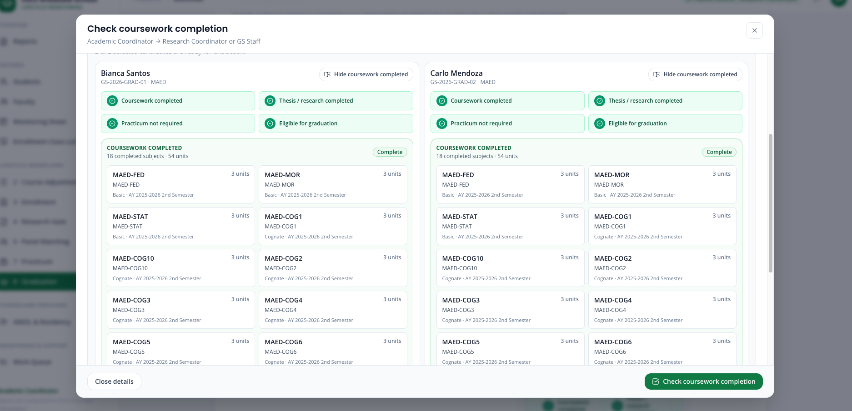
Step 17. Sign in as the Research Coordinator and open 8 · Graduation.
Step 18. Open the batch in Step 5 · Research and Practicum Validation and select Validate research completion requirements.
Step 19. Confirm that the research gates, panel assignments, defense schedules, passing results, completion evidence, and any required practicum are validated.
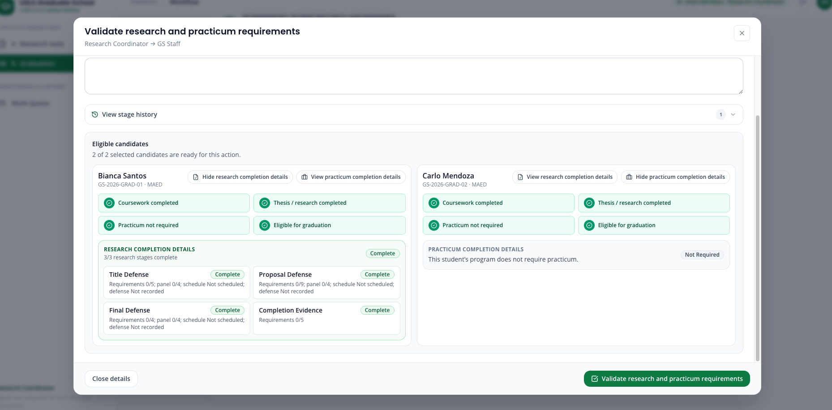
Step 20. Sign in as GS Staff. Open the batch in Step 6 · Endorsement Preparation or Revision and select Prepare endorsement list.
Step 21. Open the prepared batch again and select Send endorsement list to Dean.
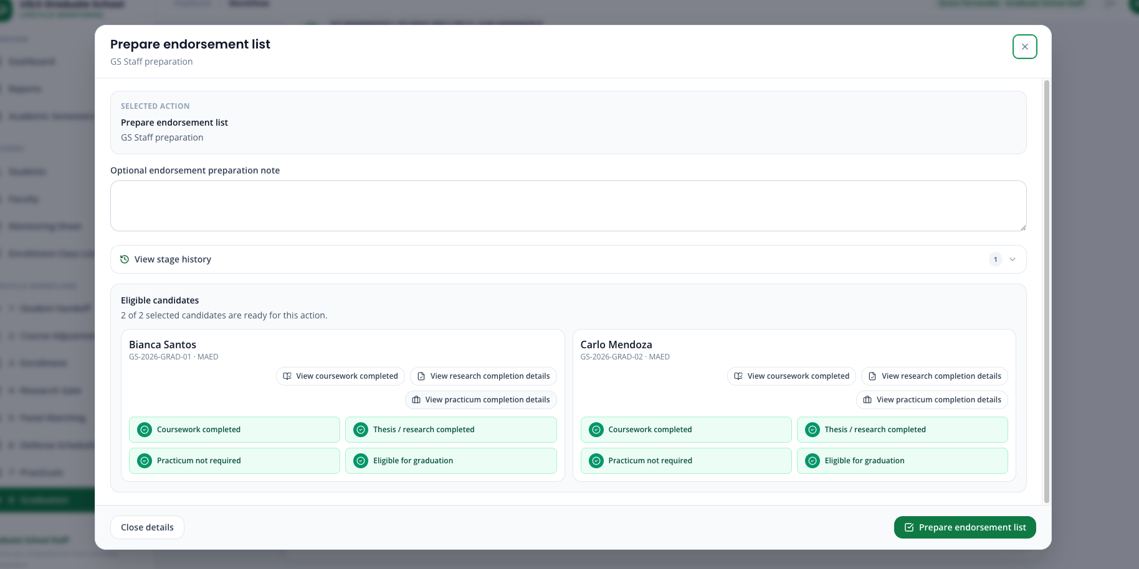
Step 22. Sign in as the Dean and open 8 · Graduation. Confirm that the Dean sees the same staged Kanban workflow and can inspect the students inside the batch.
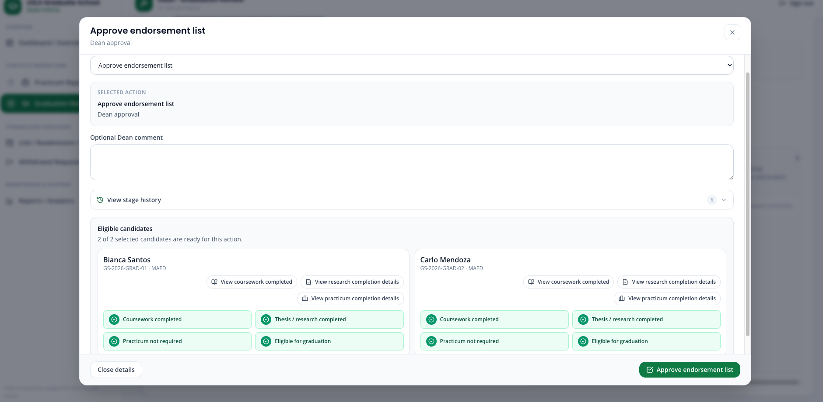
Step 23. Open the batch in Step 7 · Dean Review, review the candidate details, and select Approve and prepare for export.
Step 24. Confirm that the batch moves to Step 8 · Dean Approved and Ready for Export.
Step 25. Select Export approved list. Confirm that the endorsed graduation list downloads as a CSV file.
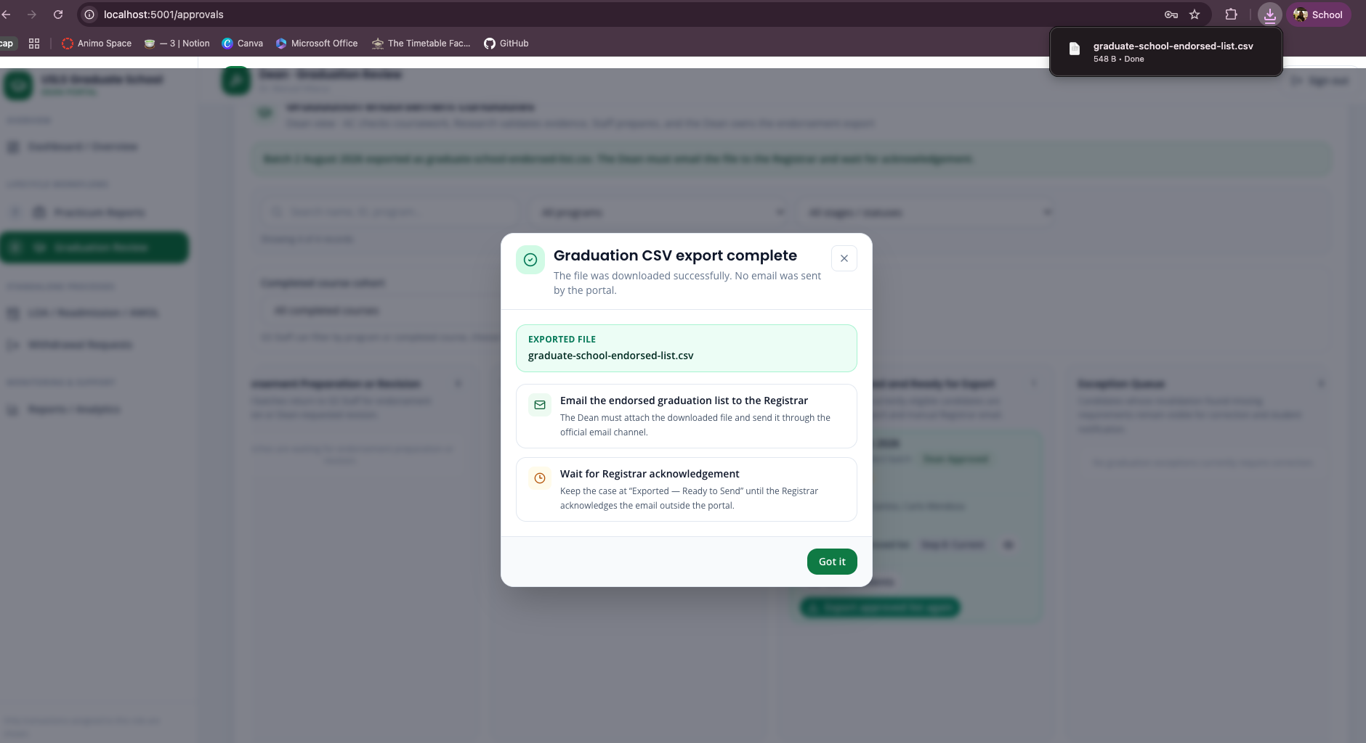
Step 26. Verify the small post-export popup. It must state that the portal did not send an email and that the Dean must email the downloaded CSV to the Registrar and wait for acknowledgement.
Step 27. Confirm that the portal status remains Exported — Ready to Send. It must not falsely claim that an external email or Registrar acknowledgement occurred.

Case 18 — Reports and Analytics
Story:
The lifecycle cases follow one student at a time. This case answers the other question: what does the Graduate School know about all of its students at once. Every figure on these screens is computed from recorded events rather than entered by hand, and the indicators are measurements rather than fixed values.
This is the case that distinguishes the platform from a record-keeping system, and it is presented last so the panel has already watched the events that these figures are computed from.
Accounts used:
Role | Account
Graduate School Staff | staff@usls.edu.ph
Password | DemoPass123!
Data to use:
Field | Value / instruction
Screens | Reports, then the analytics and KPI views
Report set | Seventeen reports in total — ten operational and seven analytics
Indicators | Nine KPI measurements, computed live
Part A — The operational picture
Step 1. Sign in as Graduate School Staff and open Reports.
Step 2. Read the summary counts: students on record, active, at risk, on leave and completed. Read them from the screen rather than from this document.
Step 3. Confirm that the report set covers the agreed operational reports, including at-risk students, graduation candidates, missing requirements, open and overdue tasks, practicum monitoring, research completion, withdrawal requests and leave or readmission activity.
Part B — The analytics that are not record keeping
Step 4. Open Stage bottlenecks. Name the columns: lifecycle stage, students in it, median days in stage, average, longest, and the longest-waiting student.
Step 5. Point out that no part of that row is stored. It is computed from the timestamps of the actions demonstrated earlier.
Step 6. Open Queue aging and backlog and read the open case count and the number older than thirty days.
Step 7. Open the Residency watchlist and confirm that the same handbook residence limits applied to a single student in the AWOL case are applied across the whole population.
Step 8. Open Workload and turnaround, Completion and attrition, Scheduling cycle time and Follow-up closure to confirm the full analytics set is present.
Part C — The indicators
Step 9. Open the KPI view and confirm that nine indicators are computed.
Step 10. Read the basis line under each indicator. Each one states the count it was computed from, so the number can be checked rather than trusted.
Step 11. Draw attention to the audit-logging indicator. Before the demonstration it is below one hundred percent because the research gate, panel matching and defense scheduling workflows have no log entries yet.
Step 12. Confirm that the same indicator has moved after those workflows were demonstrated. The value changed because of recorded activity, not because a figure was edited.
Note: The indicators are measurements, not constants. A value below one hundred percent reflects the current state of the records rather than a defect in the measurement, and the basis line always states what the value was computed from.

Case 19 — Best Features — the closing statement
Story:
The demonstration ends here and the team returns to the closing slides. This is not a screen walkthrough. It names the four features the team considers strongest and, for each one, the reason it is more than record keeping. Every feature named has already been demonstrated, so each point refers the panel back to a case they have watched.
This is presented after the demonstration rather than before it. The presentation that opened the session was a problem statement; the features are only meaningful once the panel has seen them run.
Accounts used:
Role | Account
No sign-in required | Presented over the closing slides
If a screen is requested again | Use the account named in the case referred to
Data to use:
Field | Value / instruction
Feature 1 | Faculty matching for defense panels — demonstrated in Case 10
Feature 2 | Policy Assistant retrieval — demonstrated in Case 7
Feature 3 | Defense scheduling on shared availability — demonstrated in Case 12
Feature 4 | Analytics and computed indicators — demonstrated in Case 17
Time | About ninety seconds in total
Part A — Name the four features
Step 1. Faculty matching. The shortlist is not a keyword search: specialization terms are weighted by how rare they are across all faculty profiles, so a term every faculty member shares counts for far less than a genuine specialism. The reasoning is grounded in each faculty member's own uploaded CV, the match basis is shown on screen, and a person still selects the panel.
Step 2. Policy Assistant. The handbook and research documents are chunked and embedded into an index that rebuilds itself when the sources change. Retrieval is semantic with a lexical fallback, and every answer returns the document and passage it came from, so it can be checked rather than trusted.
Step 3. Defense scheduling. The system reads the panelists' availability, proposes only a slot where the student and every panel member are free, and where availability cannot be established it reports that instead of proposing a slot it cannot support.
Step 4. Analytics and indicators. Seventeen reports and nine indicators computed from recorded events, including the audit-logging indicator that moved during this demonstration because of the workflows the panel watched being recorded.
Part B — State the common thread
Step 5. Say plainly what connects the four: each one takes data the Graduate School already held and produces a decision or a measurement from it, rather than storing and retrieving a record.
Step 6. Invite the panel to return to any screen already demonstrated if they want a feature shown again.
Step 7. Close with the declaration of remaining work, including the correction to the monitoring record's starting point that was raised at the beginning.
Note: The features are presented after the demonstration, on the closing slides, because each of them refers to something the panel has already watched run. Naming them before the demonstration was the arrangement that was corrected at the 3 August consultation.

Case 20 — Readmission · reference only
Story:
Therese Lacson is on an approved Leave of Absence and files a separate Readmission request. Staff verify the future return semester, previous leave, written intention, and checklist before the Dean decides.
Accounts used:
Role | Account
Student demo | Therese Lacson — readmission.therese@usls.edu.ph
Graduate School Staff | staff@usls.edu.ph
Dean | dean@usls.edu.ph
Password | DemoPass123! for every account
Data to use:
Field | Value / instruction
Target return | AY 2026–2027 1st Semester
Previous LOA | AY 2025–2026 1st to 2nd Semester
Checklist | Mark all four structured readmission requirements
Part A — Student submits in Readmission
Step 1. Reset Therese Lacson's Readmission demo from the sign-in page.
Step 2. Sign in as Therese and open Readmission from Standalone Processes.
Step 3. Confirm that the student is On Leave and that Readmission is a separate return process, not an extension of the LOA form.
Step 4. Choose the Target return semester and the Previous LOA start and end semesters.
Step 5. Enter the intention and readiness to resume studies.
Step 6. Mark Structured return intention completed, Updated study plan confirmed, Program or adviser consultation completed, and No pending accountability confirmed.
Step 7. Click Submit readmission request and verify that the next owner becomes Graduate School Staff.
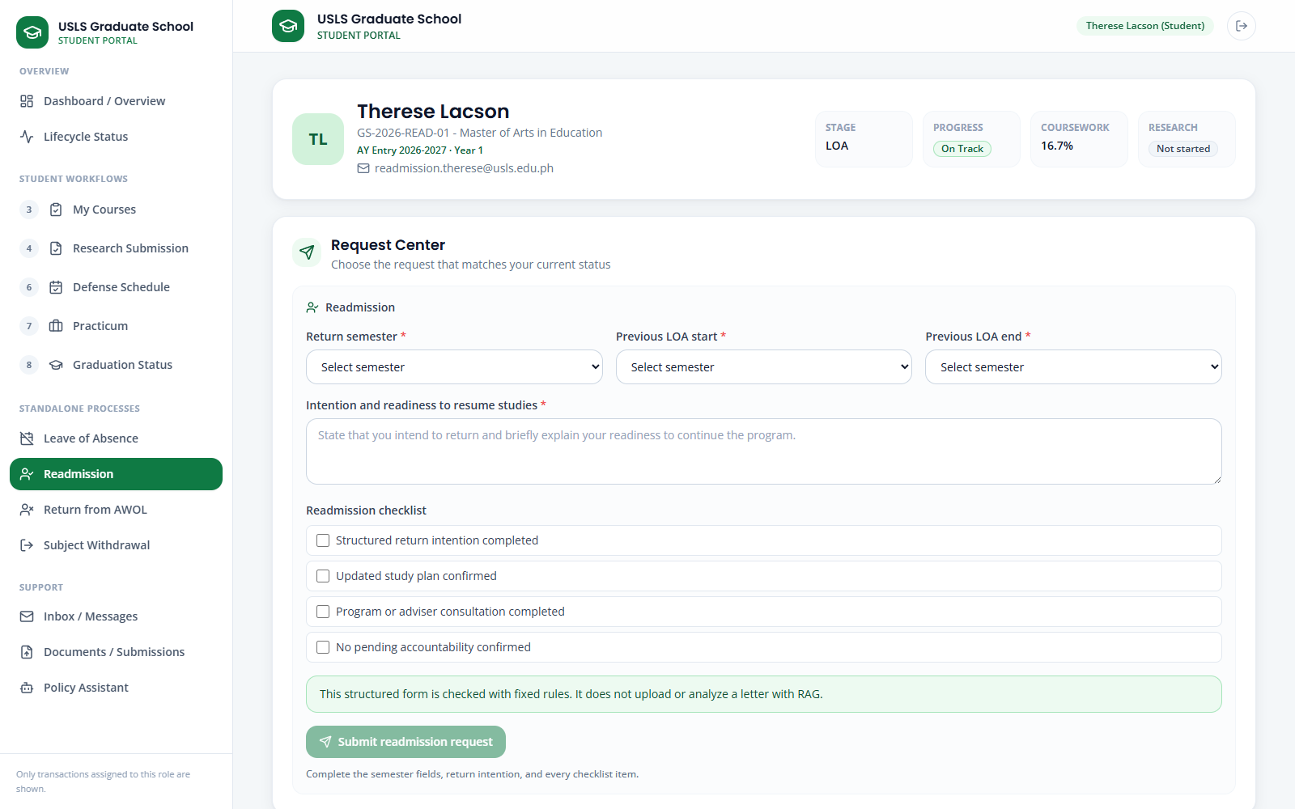
Screenshot — Readmission structured return-semester, prior-LOA, intention, and checklist form.
Screenshot — Readmission after the student request is submitted for staff review.
Part B — Staff reviews in Readmission
Step 8. Sign in as Graduate School Staff and open Readmission.
Step 9. Search Therese in Submitted requests and open Review.
Step 10. Compare the request summary, Target return semester, Previous LOA period, Student's return intention, and Eligibility to return checklist.
Step 11. Run the Readmission policy review and read every fixed check. Record Eligible to Return, Needs Review, Not Eligible, or Pending Requirements.
Step 12. Enter missing requirements and staff notes when applicable. Eligible and Needs Review cases still require a Dean decision.
Step 13. Click Complete review and confirm that the case is routed to the Dean.
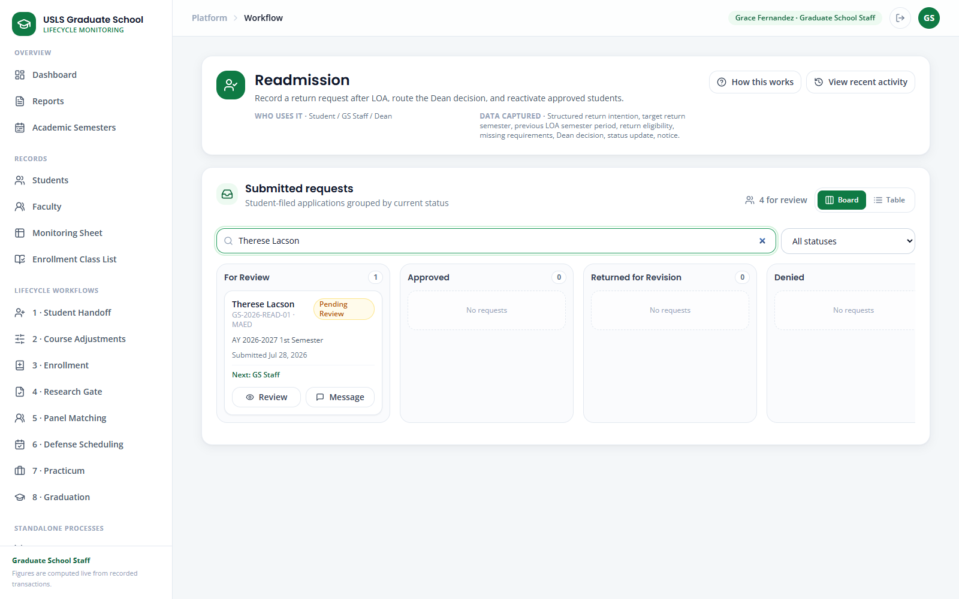
Screenshot — Readmission Submitted requests filtered to Therese Lacson.
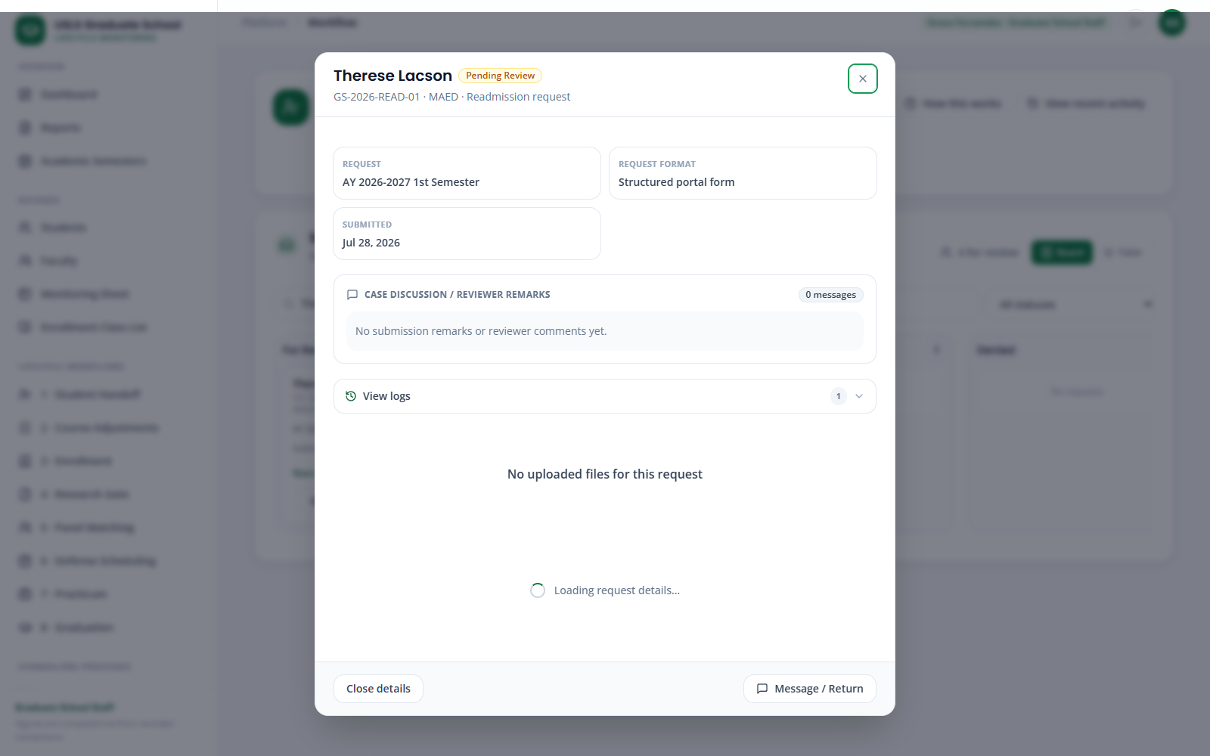
Screenshot — Readmission staff review with policy result, checklist, notes, and Dean routing.
Part C — Dean decides in LOA / Readmission / AWOL
Step 14. Sign in as Dean, open LOA / Readmission / AWOL, and search Therese.
Step 15. Review the return semester, staff eligibility result, missing requirements, discussion, and logs.
Step 16. Approve, Deny, or Return for revision and confirm the recorded decision.
Step 17. On approval, verify Active standing and Not Enrolled status. Enrollment remains a separate Academic Coordinator action; export the Readmission report for the Registrar when required.
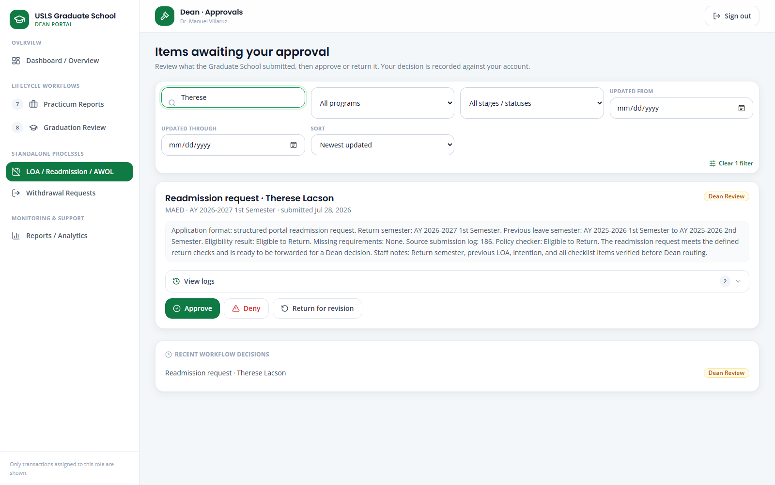
Screenshot — LOA / Readmission / AWOL filtered to Therese's Readmission decision card.
Note: Readmission restores eligibility to return; it does not automatically enroll the student in subjects.

Case 21 — Residency · reference only
Story:
Nicolas Valdez remains academically active without subject enrollment while completing an allowed research-stage activity. Graduate School Staff use the separate Residency policy checker, record the semester, and verify the synchronized Residency status.
Accounts used:
Role | Account
Residency demo student | Nicolas Valdez — residency.nicolas@usls.edu.ph
Graduate School Staff | staff@usls.edu.ph
Academic Coordinator | academic@usls.edu.ph
Password | DemoPass123! for every account
Data to use:
Field | Value / instruction
Student | Nicolas Valdez — GS-2026-RES-01
Semester | Current active planning semester
Purpose | Choose a handbook-supported research/completion purpose
Part A — Run the Residency policy check
Step 1. Reset Nicolas Valdez's Residency demo from the sign-in page.
Step 2. Sign in as Graduate School Staff or Academic Coordinator and open AWOL & Residency.
Step 3. Keep Residency separate from AWOL. Confirm the student is Active and Not Enrolled, not AWOL, On Leave, Withdrawn, or Completed.
Step 4. In Automatic AWOL alerts and residency, search Valdez and select Nicolas.
Step 5. Choose the Semester and a handbook-supported Residency purpose for comprehensive examination, practicum, thesis/dissertation, or publication work.
Step 6. Add Staff verification notes when the evidence needs human confirmation.
Step 7. Click Run residency policy checker.
Step 8. Read every deterministic check and the recommendation. Confirm that Residency does not replace LOA, AWOL, withdrawal, or completed standing.
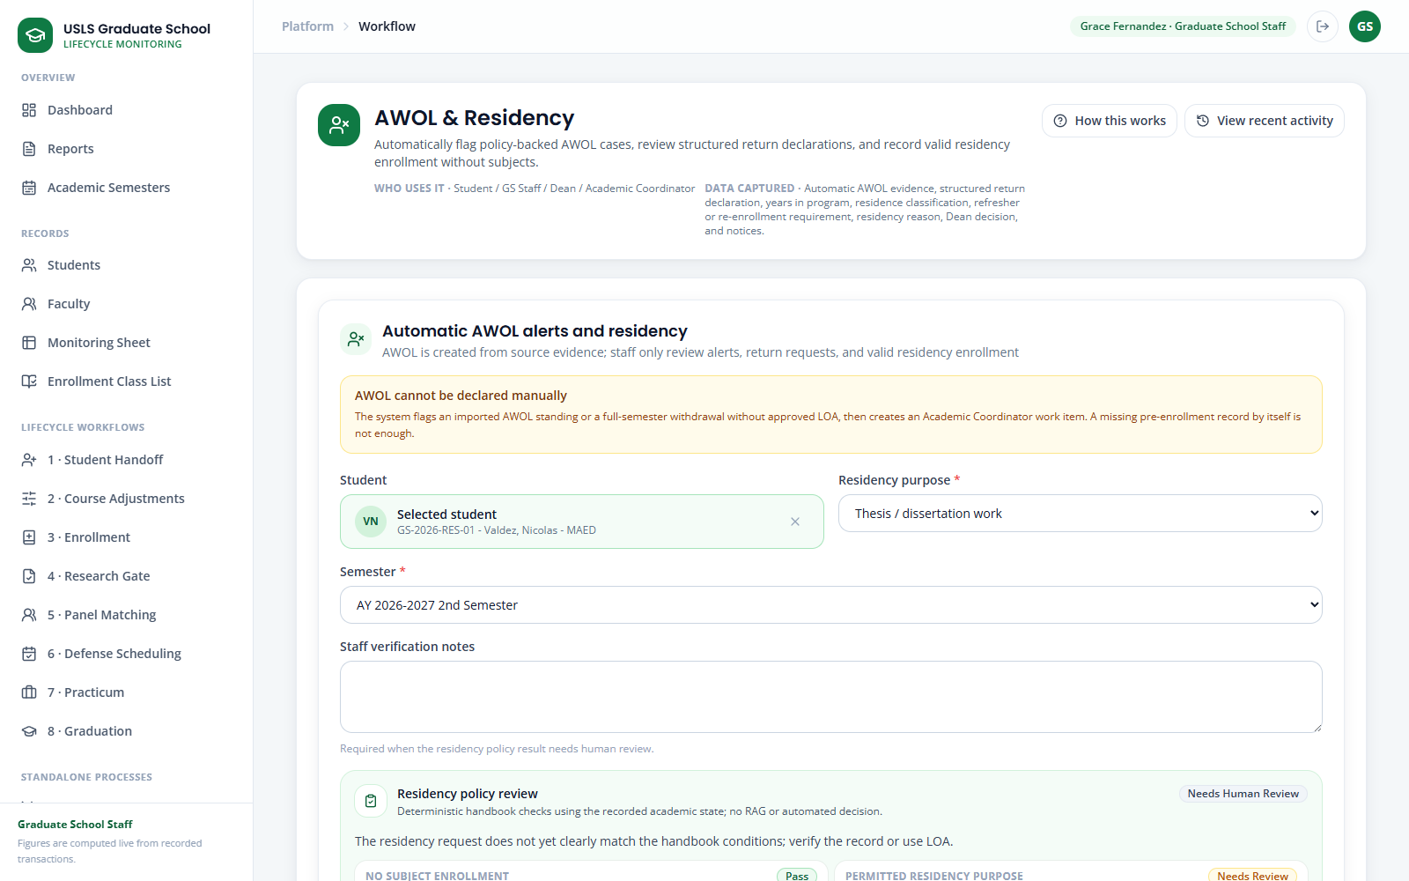
Screenshot — AWOL & Residency with Nicolas selected and the Residency policy review displayed.
Part B — Record and verify Residency
Step 9. Click Record residency only after the checker and evidence support the action.
Step 10. Read the success result. Confirm that term enrollment and monitoring were updated together.
Step 11. In AWOL, return, and residency cases, search Nicolas and verify the Residency card, semester, purpose, and policy status.
Step 12. Open View. Confirm the active Residency status and the Registrar report control.
Step 13. Open Monitoring Sheet and verify the Residency enrollment tag for the selected semester.
Step 14. Open Students, search Valdez, and verify Residency in the directory row.
Step 15. Open Nicolas's full record and confirm Active standing, Residency enrollment, the term record, and the activity entry.
Step 16. Export the Residency report for the Registrar when required.
Step 17. When the period ends, reopen the Residency case and click Close residency. Verify the student returns to the appropriate active enrollment state.
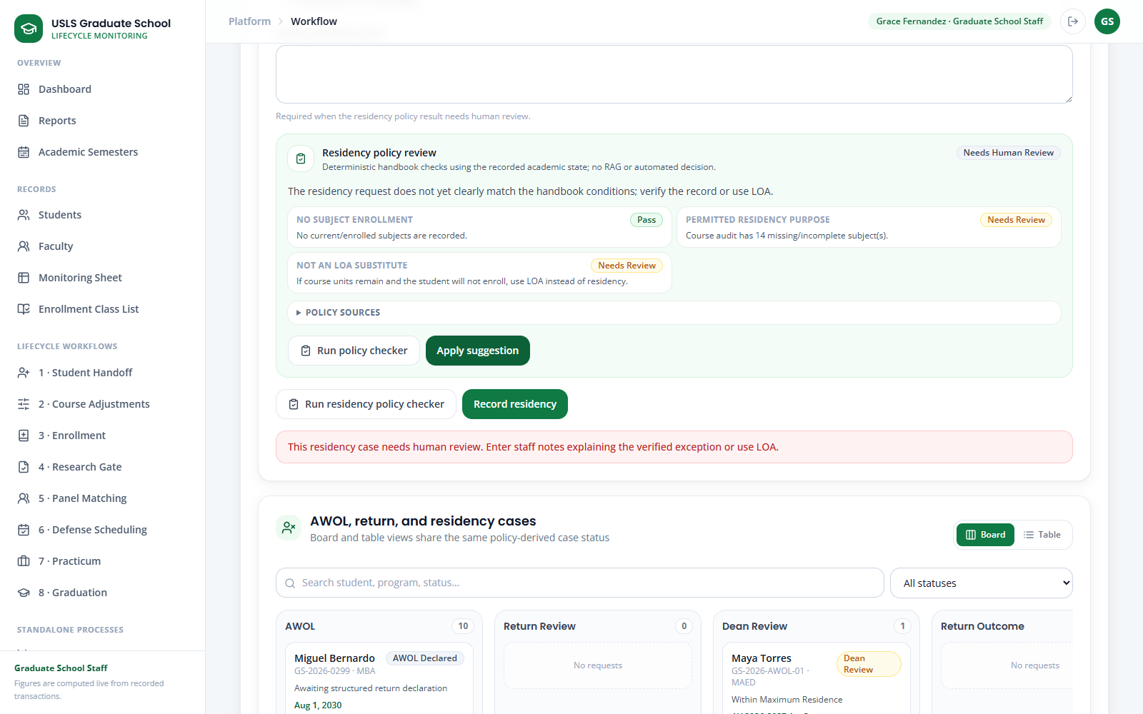
Screenshot — AWOL & Residency immediately after the Residency record is saved.
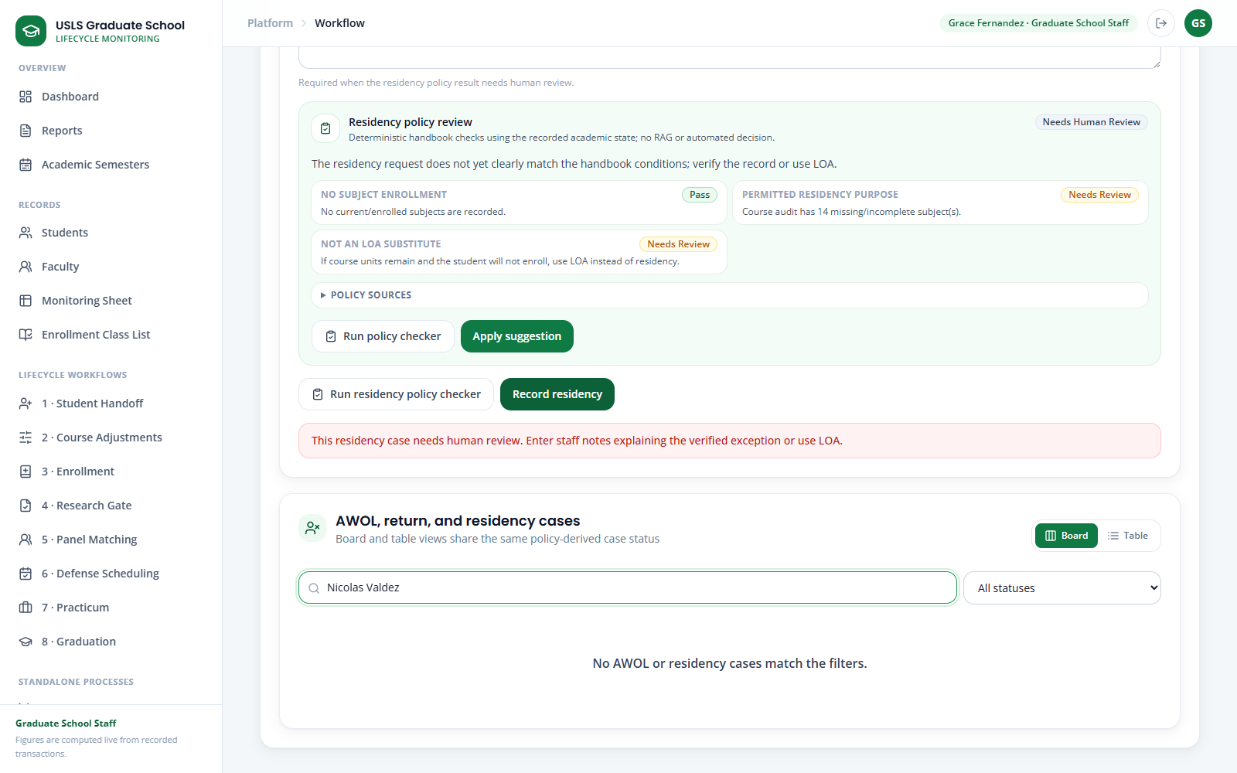
Screenshot — AWOL & Residency case board filtered to Nicolas's active Residency.
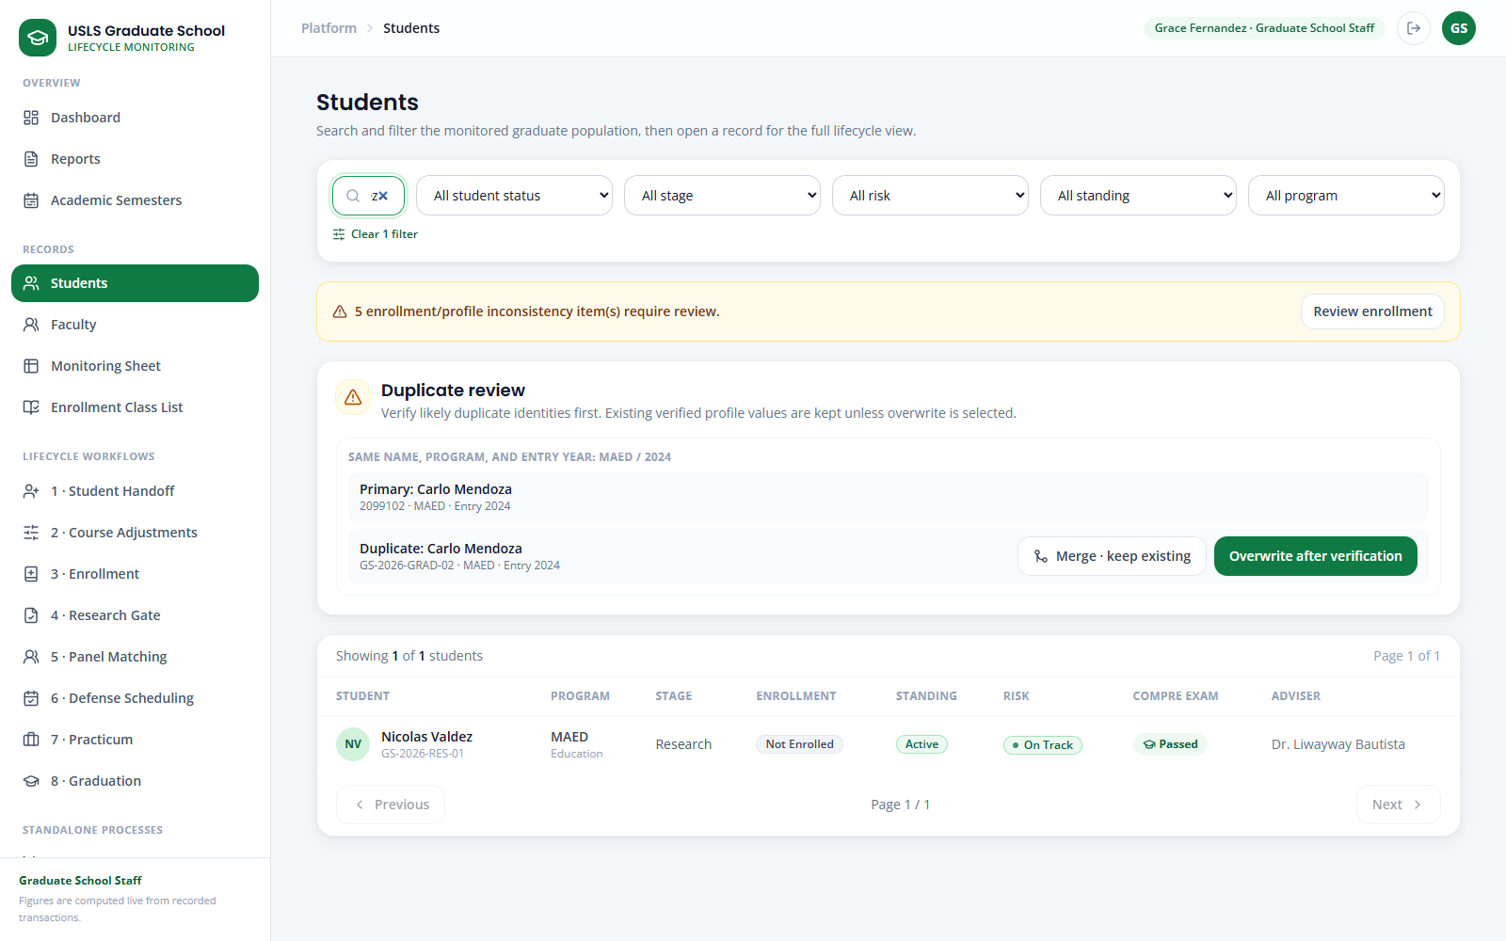
Screenshot — Students filtered to Nicolas after the Residency synchronization.
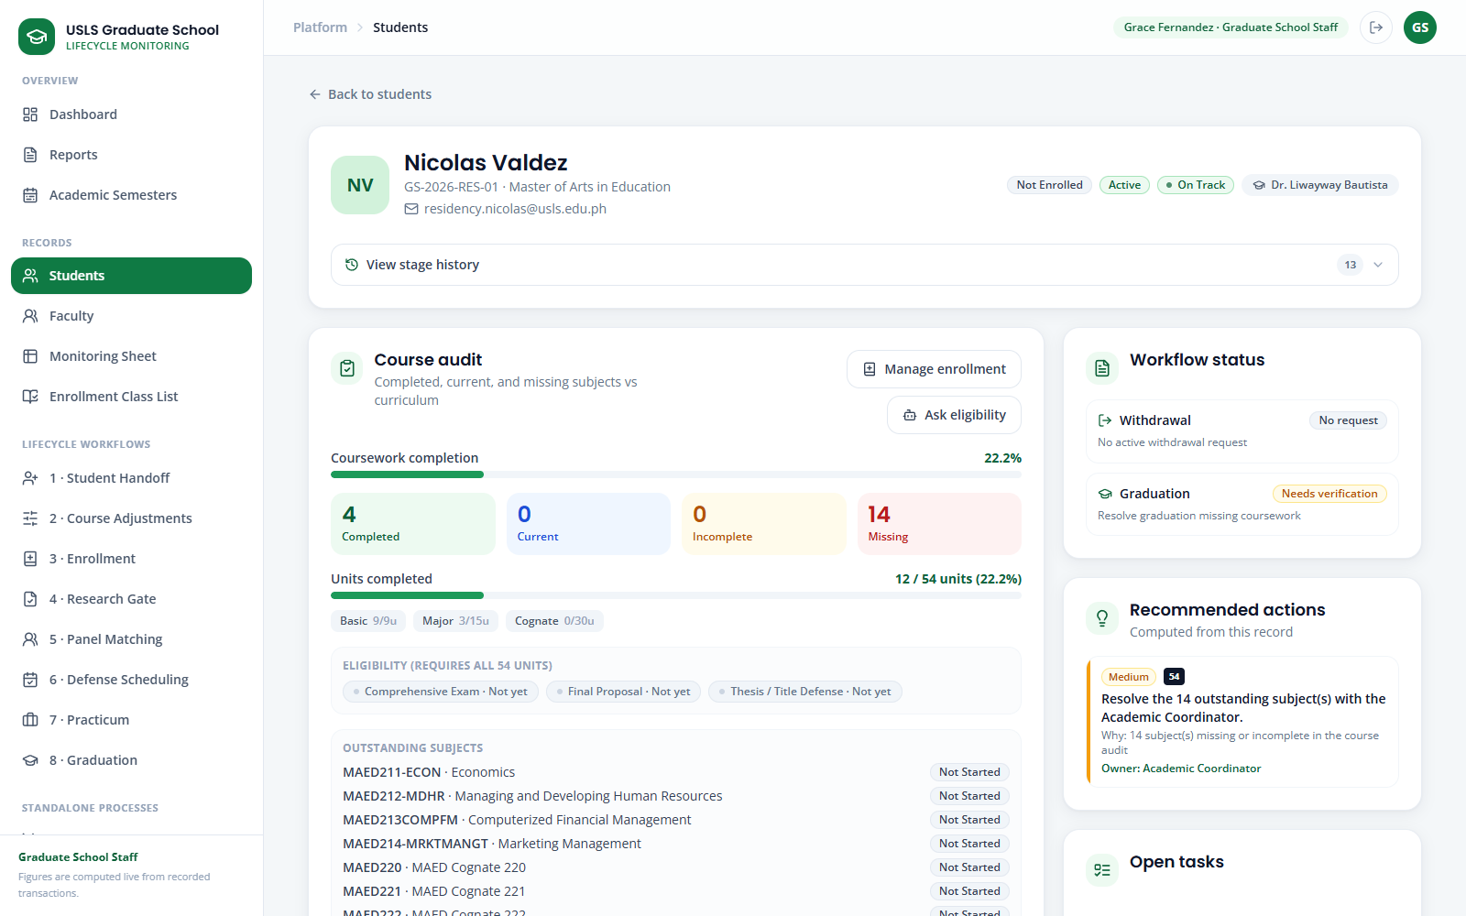
Screenshot — Students full record showing the synchronized Residency state and audit trail.
Note: Residency is a valid active no-subject enrollment state for approved academic work. A student with remaining course units who will stop studying should use the appropriate Leave of Absence process.

Case 22 — Subject-needs evidence in detail · reference only
Story:
The Academic Coordinator needs evidence for the next offering decision. Course Adjustments calculates remaining subject needs and identifies the students who may be delayed if each subject is not offered.
Accounts used:
Role | Account
Academic Coordinator | academic@usls.edu.ph
Password | DemoPass123!
Data to use:
Field | Value / instruction
Program | MAED — Master of Arts in Education
Planning semester | AY 2026–2027, 1st Semester
Part A — Read the subject-needs evidence
Step 1. Open Course Adjustments and select Demand & adjustments.
Step 2. Choose MAED and the planning semester. Confirm that the plan and the demand report refer to the same filters.
Step 3. Read Students reviewed, Subjects with need, and Student-subject needs to understand the scope of the calculation.
Step 4. In Subject-needs report, compare Students needing with Not taken. Completed, taken, and current-subject evidence is excluded.
Step 5. Read Affected students. Verify names and student numbers behind the count instead of making a decision from the total alone.
Step 6. Open the full Students record for a named learner and confirm the remaining curriculum requirement that caused the need.
Step 7. Return to Course Adjustments and compare high-count subjects with single-student subjects whose withholding would still cause delay.
Screenshot — Course Adjustments filters, demand summary, and governed offering plan.
Screenshot — Course Adjustments Subject-needs report with counts and named affected students.
Part B — Carry the evidence into the offering plan
Step 8. Mark only the evidence-supported subjects as offered and set the section count that the affected population requires.
Step 9. Review Faculty Profiles before selecting faculty, then add the planning reason or constraint in the draft notes.
Step 10. Save the draft and confirm the proposed offering does not replace or silently alter any student's curriculum status.
Step 11. Follow the Submit for approval → Dean decision → Publish sequence from Case 2.
Step 12. After enrollment activity changes, reopen Course Adjustments and rerun the same filters to show that the needs are recalculated from current records.
Screenshot — Course Adjustments Offering setup after an evidence-backed plan is approved and published.
Note: The Subject-needs report is deterministic decision support. It does not automatically offer a subject, assign faculty, or publish the plan.

8. Honest Notes & Limitations
For an accurate demonstration, keep these points in mind and state them plainly if asked:
- AIMS is a separate, official university system. This portal does not connect to AIMS live; it uses an approved export/import workbook. Imported official values are read-only here, and corrections are made in AIMS and re-imported.
- The application records and displays enrollment; it does not perform official enrollment in place of the Registrar.
- Grades and course-completion come from the official export, not from manual entry inside the portal.
- Risk is shown as Not Yet Assessed for new or incomplete records instead of an invented Low/Medium/High score, until the official risk rules are confirmed.
- Where the portal shows recommendations (subject needs, faculty, panels), they are suggestions with a stated basis that an authorized person confirms.
- The Policy Assistant answers from the provided handbook and research documents; treat it as decision support, not an official ruling.
- The demonstration data is reset per student from the Login screen before the demonstration begins. The reset restores the seeded starting position for that student's workflow and is not part of the operational product.
- Subject demand is recalculated whenever the Course Adjustments screen is opened with a program and semester selected. It is never stored. Students needing counts the students for whom the subject is next in their curriculum sequence; Not taken is the wider set of every student who has not completed it. Only the first drives the offering decision.
- The monitoring grid is a view, not an editing form. A record changes through the lifecycle action that caused the change, each logged to a person and a date. An authorized single-record correction, with a reason and an audit entry for when the source itself is wrong, is not built and is part of the declared remaining work.
- The lifecycle currently begins by importing a monitoring sheet from outside the platform. The corrected design has the platform maintaining that record itself. This is stated at the start of the demonstration and is the first item of remaining work.
- Dropping and subject withdrawal are student rights transacted with the Registrar. The portal records them; it does not grant them.
- No email leaves the portal. Every Registrar handoff is an export that a person sends, and the status remains Exported — Ready to Send until a person records the acknowledgement.
- Faculty availability is a standing weekly declaration in the profile. It is not a projection of next semester's availability and it does not include undergraduate teaching load, so faculty suggestions are a shortlist the coordinator confirms.
- The portal does not check faculty double-booking or student schedule conflicts when a schedule is assigned. The data required for that check is held; the check is not built.

End of Demonstration Walkthrough

