University of St. La Salle
Graduate School Lifecycle Portal
Demonstration Walkthrough & Demo Kit
A step-by-step guide for demonstrating the graduate student lifecycle:
admission handoff • course offering & adjustment • enrollment • research & defense • practicum • graduation • standing changes
Every demo account password is: DemoPass123!

1. About the System
The Graduate School Lifecycle Portal is a web application that gives the University of St. La Salle (USLS) Graduate School a single, consolidated workspace for monitoring and coordinating the full graduate student lifecycle. It replaces the manual, spreadsheet-only process the Graduate School currently uses to track where each student stands.
The application does not replace AIMS, the university's official academic information system. AIMS remains the official source for student identity, enrollment, enrolled subjects, grades, and course completion. Authorized staff export an approved monitoring workbook and import it here; those official values are shown as read-only and are labeled with their source. The portal adds the coordination, decision-support, and exception-reporting layer on top of that official data.
What the portal lets staff do
- Import the Academic Coordinator monitoring sheet and reconcile it into a single student list.
- Set up the subjects offered for a specific semester, together with the schedule and the assigned faculty member.
- Tag students as enrolled in offered subjects, either by uploading a class list or by searching a single student.
- Identify which subjects are needed next term and which students are affected if a subject is not offered.
- Route research submissions, panel matching, and defense scheduling for each student.
- Process standing changes: subject withdrawal, leave of absence, readmission, AWOL, and residency.
- Track graduation eligibility and prepare the Dean-approved endorsement list.

2. System Requirements
To run the demonstration smoothly, the presenting machine should meet the following:
- A modern browser (Google Chrome or Microsoft Edge recommended), kept up to date.
- At least 4 GB of RAM and a few GB of free disk space for the local database and demo files.
- Python 3 and Node.js installed, so the backend server and the built front-end can run locally.
- The demonstration runs locally on the presenter's machine; a live internet connection is only needed for the optional Policy Assistant feature.

3. Before You Start (Setup Notes)
Note: On the first start, the system automatically prepares its demonstration database and seeds all of the demo accounts and sample records described in this document. This runs once and may take a short moment. If a demo account or the login dropdown ever appears empty, restarting the server re-seeds the demonstration data.
Start-up sequence (performed once before the demo):
Step 1. Build the front-end so the latest screens are served.
Step 2. Start the application server. The system seeds the demonstration data automatically on first run.
Step 3. Open the application in the browser at the local address shown when the server starts (the portal runs on port 5050).
Step 4. You will land on the Login screen. Use the accounts in Section 4.
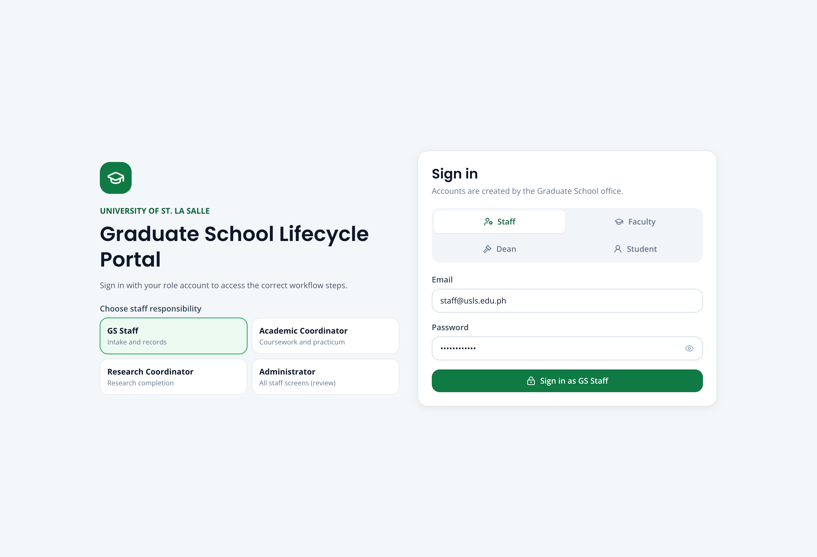
Screenshot — The Login screen, showing the account-type selector and the demo-account shortcuts.

4. Demo Accounts
Every account below uses the same password: DemoPass123! On the Login screen, choose the matching account type (role), enter the email and password, then click Log in. Student demo accounts can also be selected from the demo shortcuts on the Login screen.
Staff and approver accounts
Role | Name | Email (username)
Graduate School Staff | Grace Fernandez | staff@usls.edu.ph
Academic Coordinator | Dr. Ramon Alvarez | academic@usls.edu.ph
Research Coordinator | Dr. Sofia Mendoza | research@usls.edu.ph
Dean (approver) | Graduate School Dean | dean@usls.edu.ph
Registrar (external handoff) | Registrar Office | registrar@usls.edu.ph
Administrator | System Administrator | admin@usls.edu.ph
Student demo accounts (one ready for each scenario)
Student | Student No. | Email | Ready for
Miguel Yu | 2260004 | student@usls.edu.ph | Research, Panel, Defense
Clarissa Dela Cruz | GS-2026-ENR-01 | enrollment.clarissa@usls.edu.ph | Single-student enrollment
Martin Gonzales | GS-2026-ENR-02 | enrollment.martin@usls.edu.ph | Offered-subject enrollment
Elena Navarro | GS-2026-WD-01 | withdrawal.elena@usls.edu.ph | Subject withdrawal (MAED-MAJ1)
Joshua Lim | GS-2026-WD-02 | withdrawal.joshua@usls.edu.ph | Subject withdrawal (MAED-MAJ2)
Andrea Villanueva | GS-2026-PRAC-01 | practicum.andrea@usls.edu.ph | Practicum
Bianca Santos | GS-2026-GRAD-01 | graduation.bianca@usls.edu.ph | Graduation application
Daniel (LOA) | — | loa.daniel@usls.edu.ph | Leave of Absence
Note: Additional seeded students exist for handoff, course adjustments, readmission, AWOL, residency, and a second student for practicum and graduation, so every list and batch screen has more than one example.

5. Navigating the Portal
After logging in, the left sidebar is grouped into sections. The graduate lifecycle is presented as a numbered sequence so the demonstration can move through it in order.
Lifecycle workflows (the main demonstration path)
- 1 · Student Handoff — import and reconcile the monitoring sheet.
- 2 · Course Adjustments — set up subject offerings and review subject needs.
- 3 · Enrollment — tag students to offered subjects.
- 4 · Research Gate — check each student's required research submissions.
- 5 · Panel Matching — recommend and finalize the defense panel.
- 6 · Defense Scheduling — find a common defense slot.
- 7 · Practicum — track practicum requirements and hours.
- 8 · Graduation — check eligibility and prepare the endorsement list.
Standing changes
- Leave of Absence
- Readmission
- AWOL & Residency
- Withdrawal Requests
Records and support
- Students, Faculty, Monitoring Sheet, Enrollment Class List
- Dashboard and Reports
- Work Queue, Activity Log, Recommendations, and the Policy Assistant
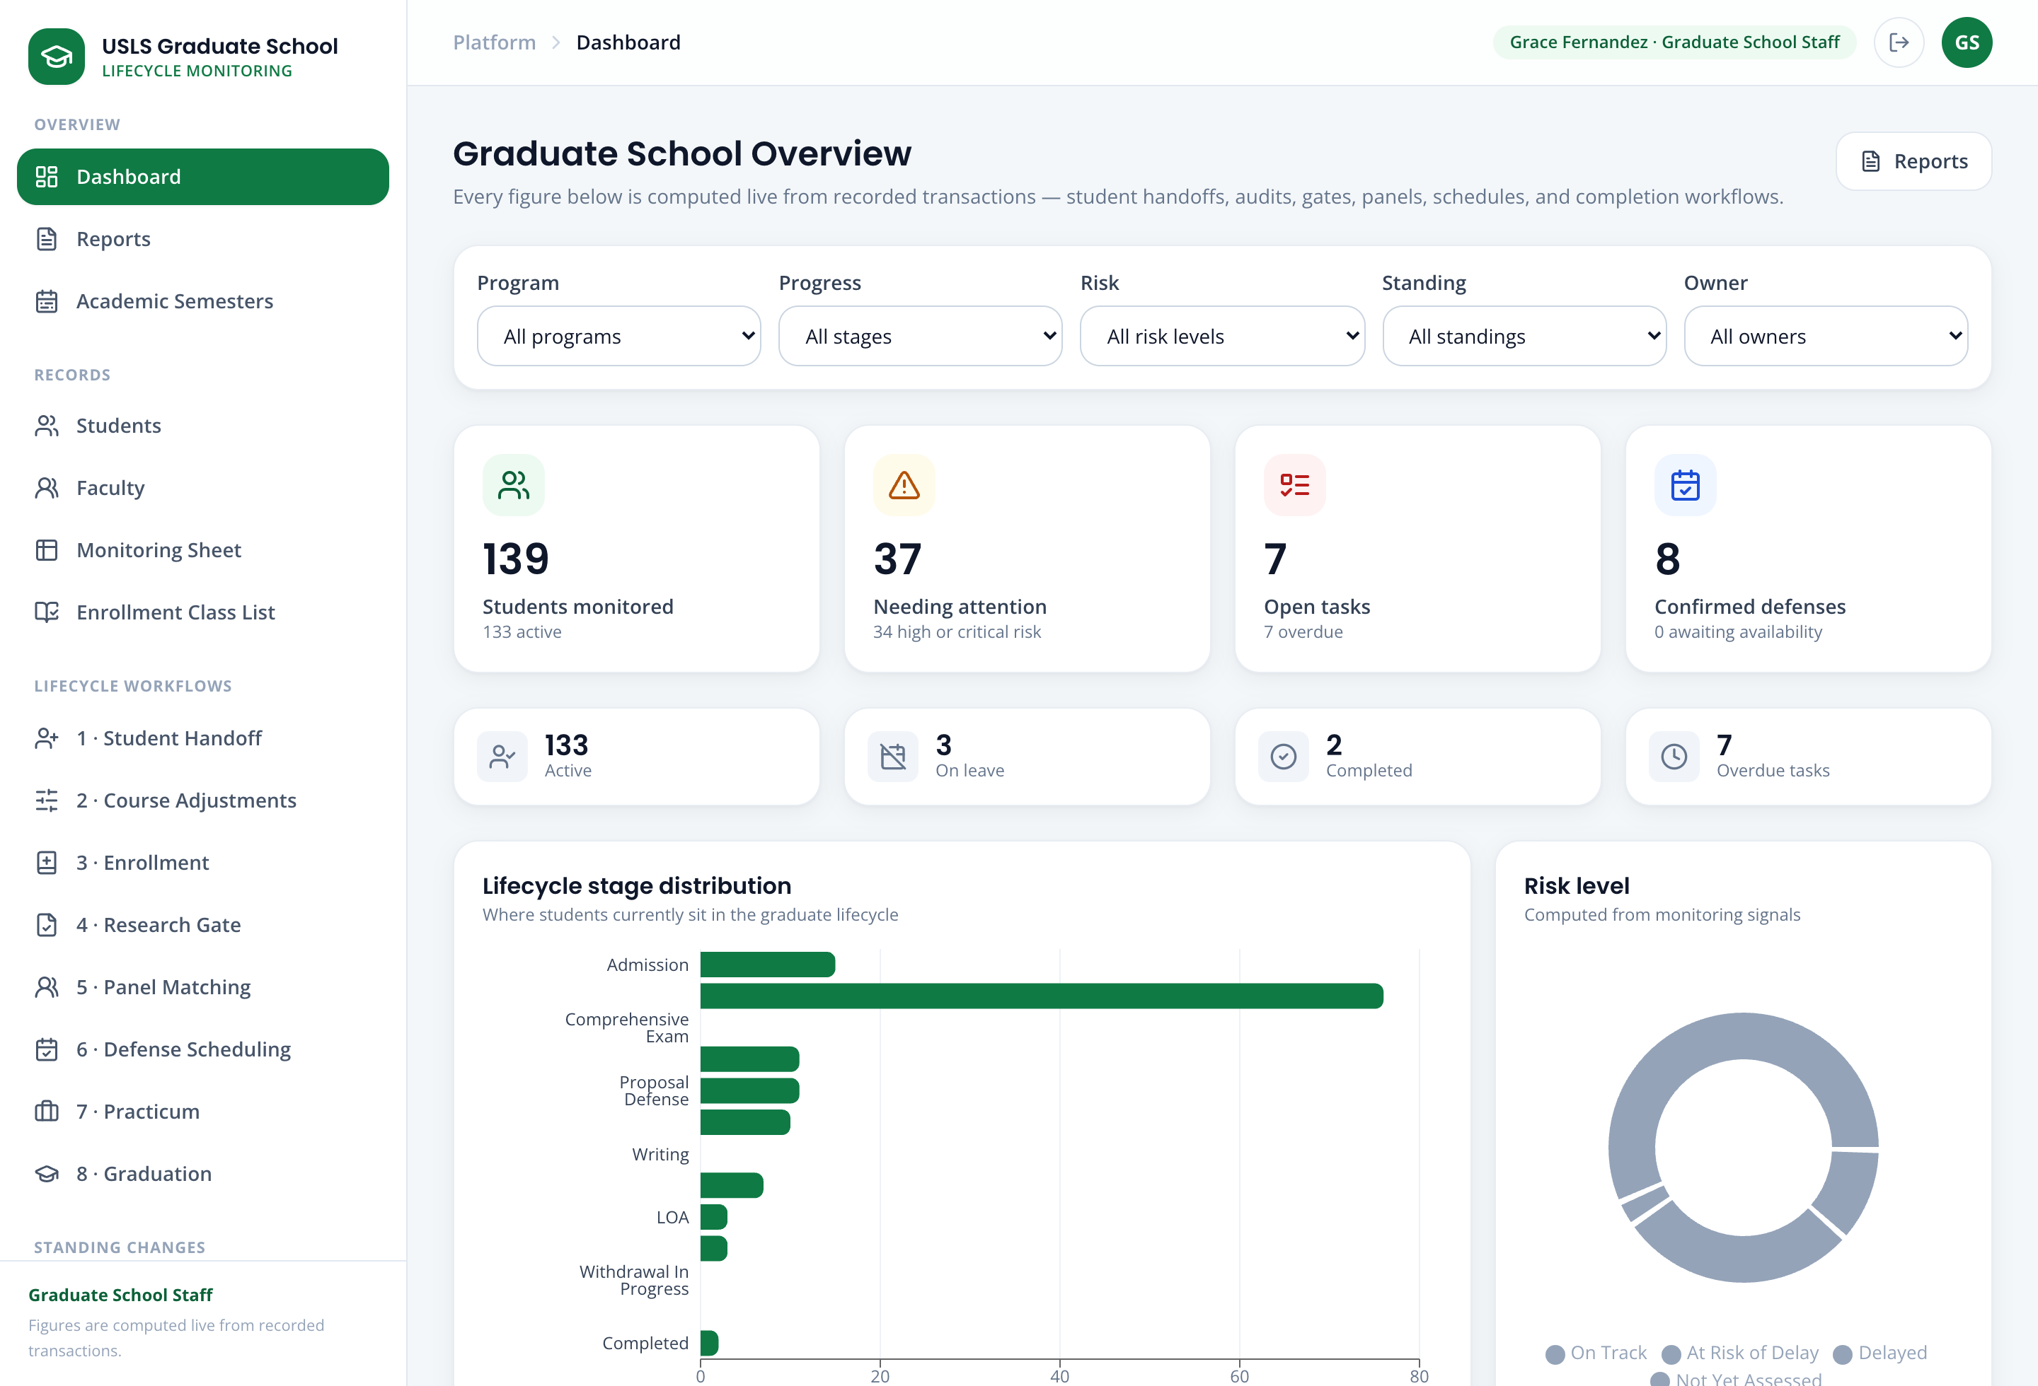
Screenshot — The dashboard after login, showing the sidebar sections and the lifecycle overview.

6. Demonstration Scenarios
Each scenario below is self-contained: it names the account to use, the story behind it, the data to enter, and the steps to follow. Run them in order for a full end-to-end demonstration, or pick individual scenarios.

Scenario 1 — Import and reconcile the monitoring sheet
Story:
At the start of the term break, the Graduate School receives the Academic Coordinator monitoring sheet listing the students, their programs, and the subjects they have completed. Grace Fernandez, the Graduate School Staff, needs to bring that sheet into the portal so the student list is up to date.
Log in as:
Field | Value / Instruction
Account type | Graduate School Staff
Email | staff@usls.edu.ph
Password | DemoPass123!
Steps:
Step 1. From the sidebar, open 1 · Student Handoff.
Step 2. Click Import from monitoring sheet and choose the provided monitoring workbook (.xlsx).
Step 3. The system validates the file and shows the imported students together with their program and completed-subject standing. Existing students are updated in place; genuinely new students are added. No student is created by hand.
Step 4. Review the result, then open View upload history to show the timestamped audit trail of the import.
Note: The imported values (identity, program, completed subjects) are read-only and labeled with their source. If a value looks wrong, staff use Flag issue to record a discrepancy — the portal never edits an official value directly.
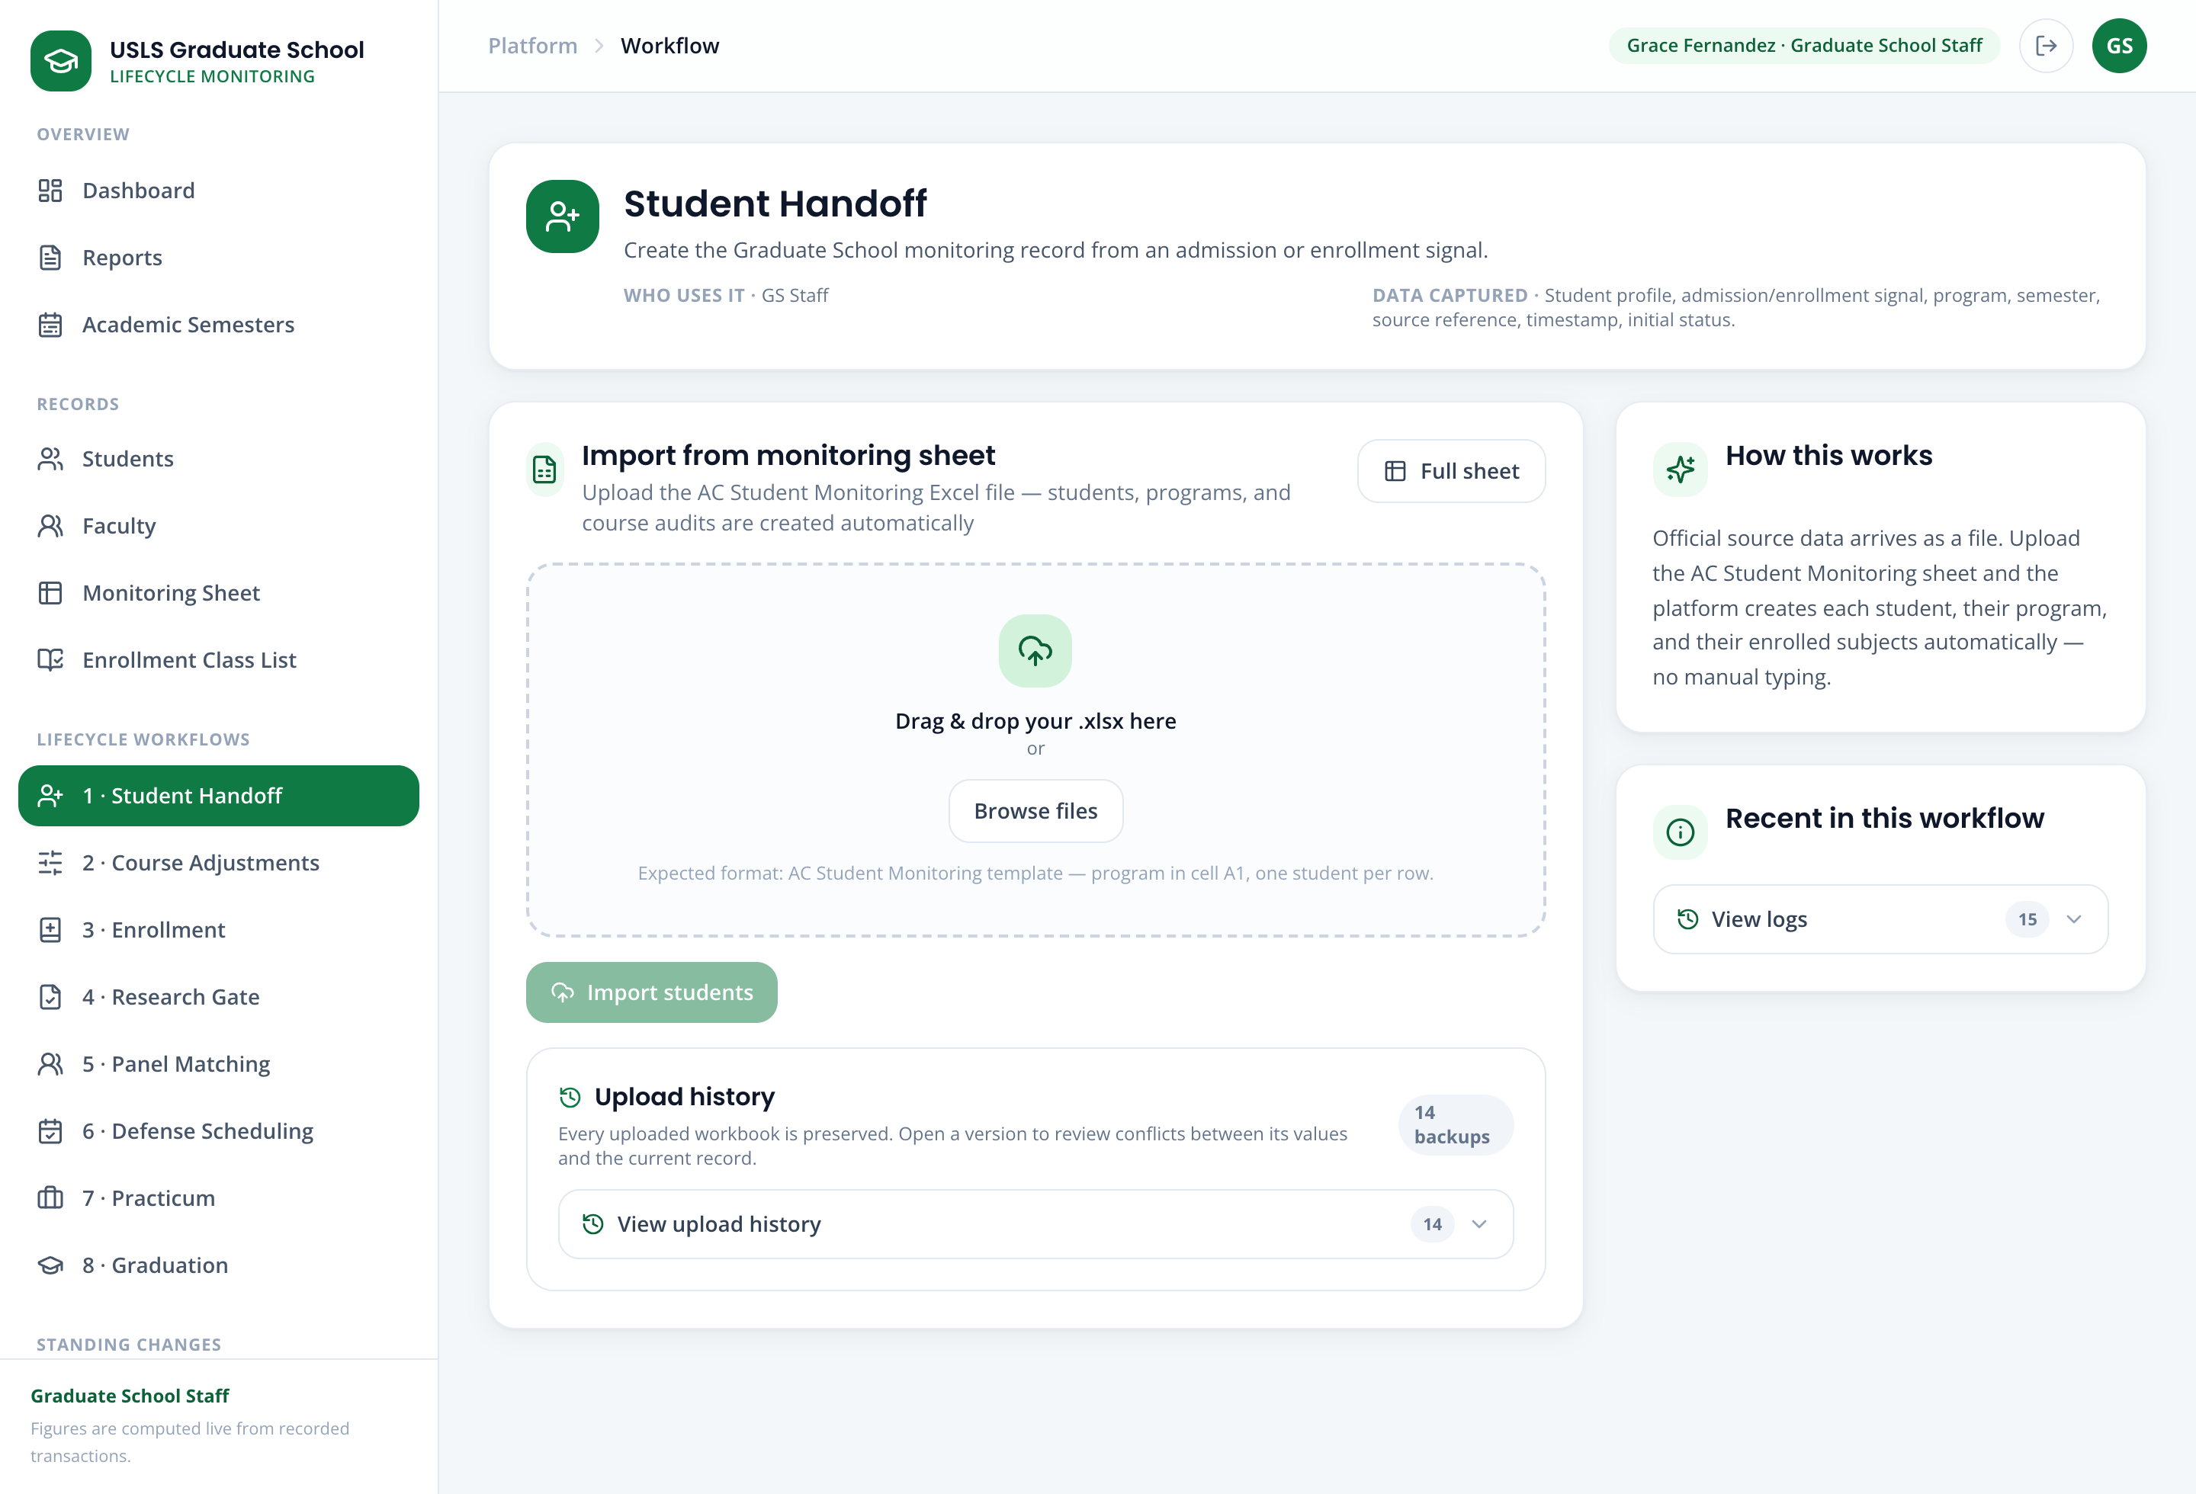
Screenshot — Student Handoff after import, showing the imported students and the upload history.

Scenario 2 — Set up the subjects offered for a semester
Story:
Before students can be enrolled, the Academic Coordinator, Dr. Ramon Alvarez, decides which subjects the program will offer in the upcoming semester, and sets the schedule and the faculty member who will handle each subject. Only the subjects set up here can be used when tagging students as enrolled.
Log in as:
Field | Value / Instruction
Account type | Academic Coordinator
Email | academic@usls.edu.ph
Password | DemoPass123!
Data to use:
Field | Value / Instruction
Program | MAED (Master of Arts in Education)
Academic year & semester | the upcoming planning semester (e.g. 2026–2027, First Semester)
Subject to offer | a MAED major subject from the list
Schedule | e.g. Saturday 8:00–11:00
Faculty | assign an available faculty member (e.g. Dr. Adriana Santos)
Steps:
Step 1. Open 2 · Course Adjustments.
Step 2. Choose the Program and the Planning semester (the upcoming academic year and semester).
Step 3. In the offerings view, mark the chosen subject as Offered, then set its schedule, section, and assigned faculty.
Step 4. Click Save draft to record the offering. The saved subjects become the official offerings for that semester.
Note: The subjects set up here are exactly the subjects that will be available in Scenario 3 when tagging students as enrolled. A subject that is not offered here cannot be enrolled.
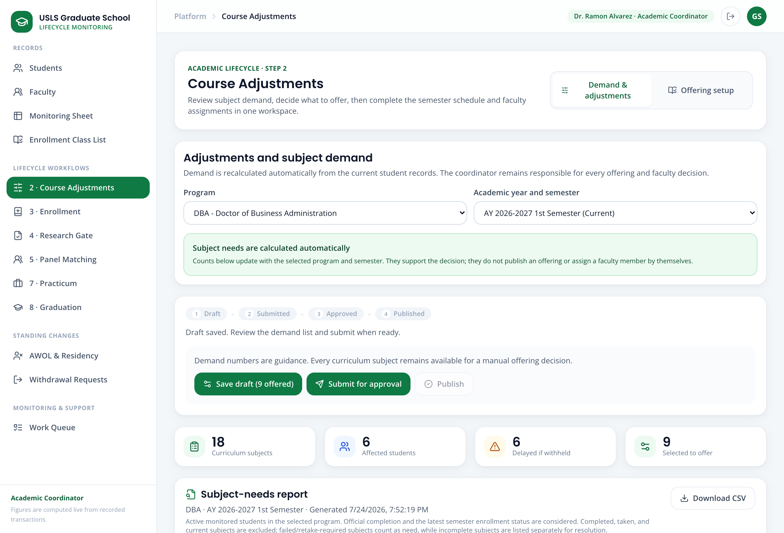
Screenshot — Course Adjustments with a subject marked Offered and its schedule and faculty assigned.

Scenario 3 — Tag students as enrolled in offered subjects
Story:
Now that the subjects are set up, the students need to be tagged as enrolled. The portal supports two ways, and the demonstration shows both: (A) uploading a class list from the Registrar, and (B) searching for a single student and tagging them. Either the Graduate School Staff or the Academic Coordinator can do this.
Log in as:
Field | Value / Instruction
Account type | Graduate School Staff
Email | staff@usls.edu.ph
Password | DemoPass123!
Path A — Upload a class list
Step 1. Open 3 · Enrollment and confirm the Program and Academic semester at the top.
Step 2. Click Upload class list and choose the provided class-list file (.csv or .xlsx). A class list simply contains the student identifier and the subject code.
Step 3. The system shows a preview of what will change: which students will be tagged as enrolled, and any rows it could not match (an unknown student number, or a subject that is not offered).
Step 4. Review the preview and click Confirm import. The matched students are tagged as enrolled and the change is recorded.
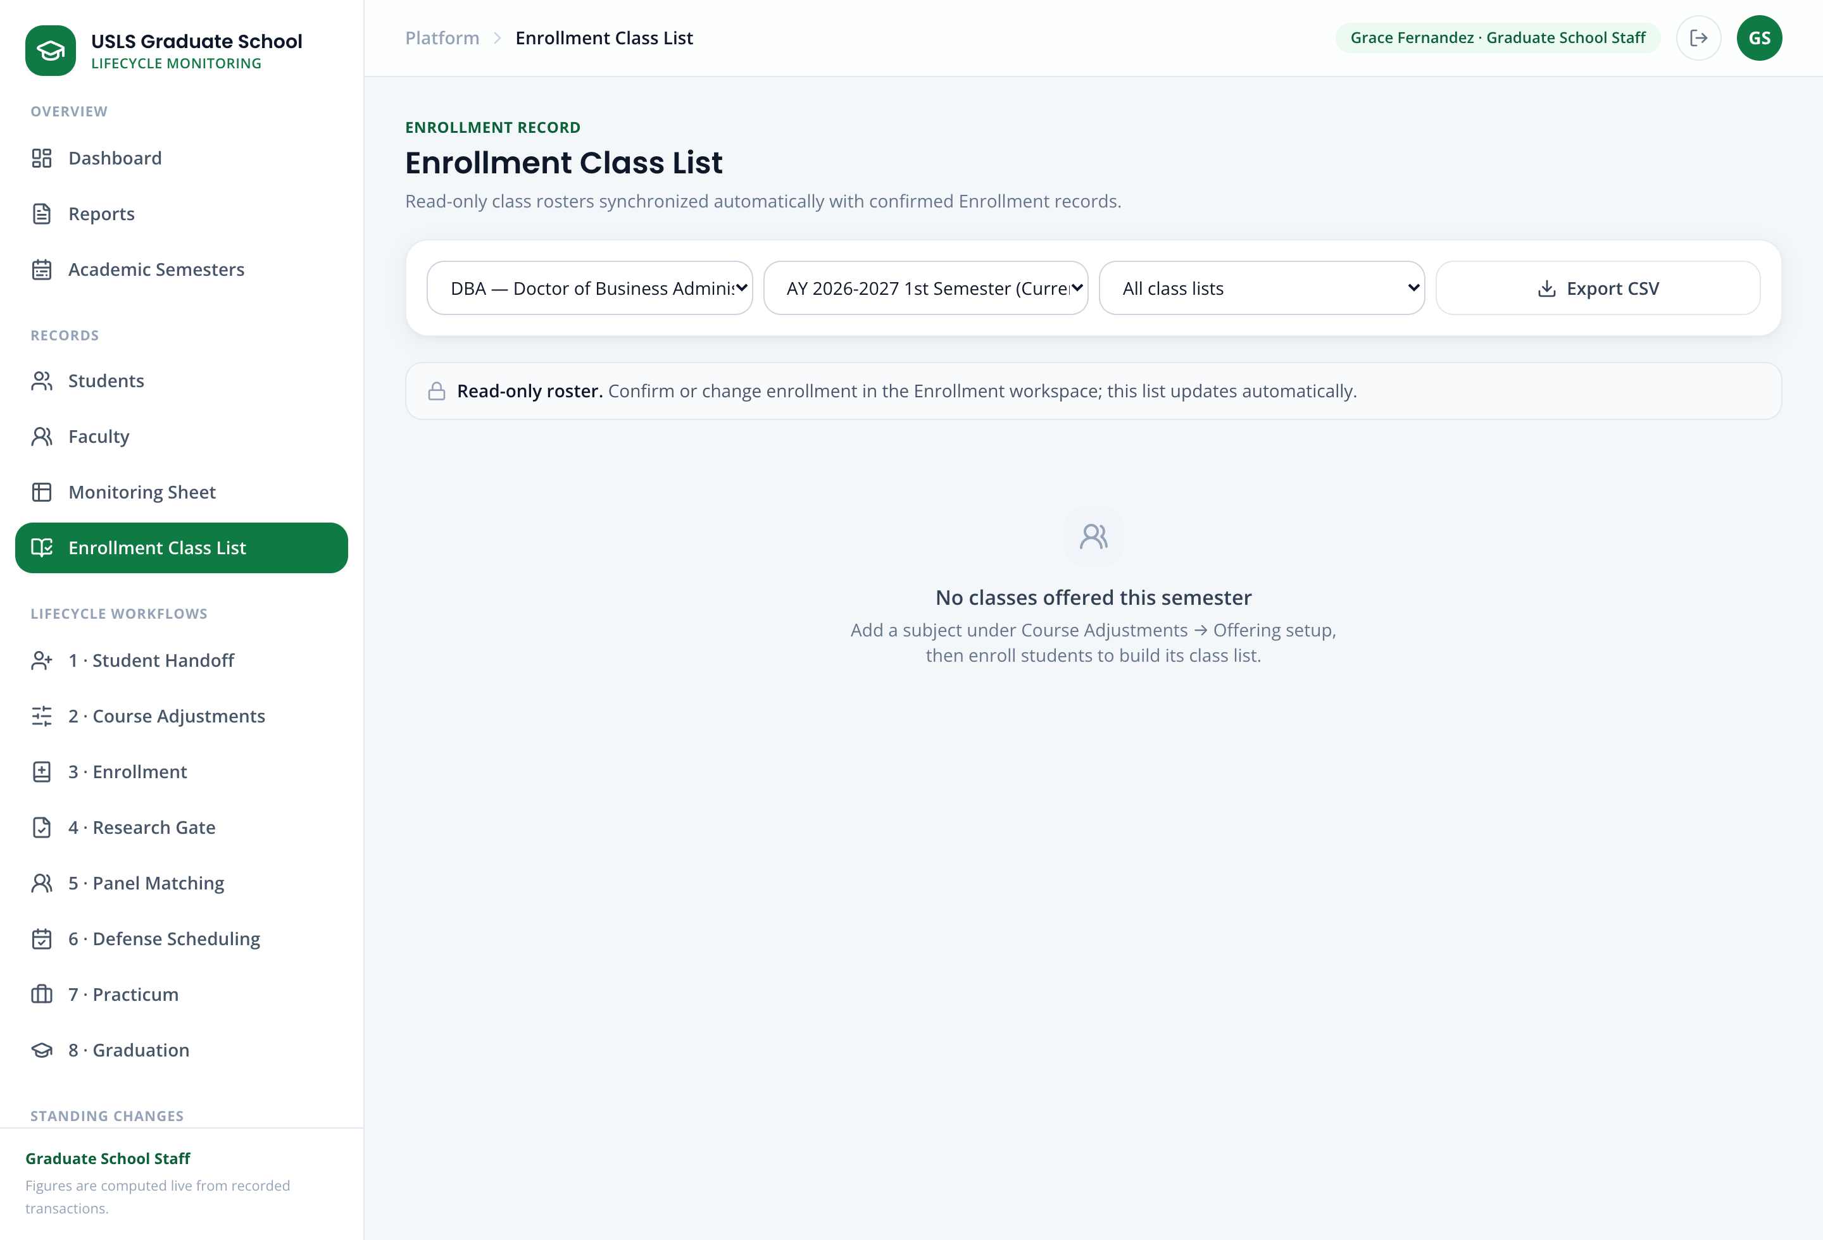
Screenshot — The class-list preview, showing matched students and any rows that could not be matched.
Path B — Search and tag a single student
Use this when a single late student needs to be added without uploading a whole file.
Step 1. Still in 3 · Enrollment, use the student filter to find the student (for this demo, Clarissa Dela Cruz).
Step 2. Select the offered subjects the student should take. Subjects that are not offered this semester cannot be selected.
Step 3. Click Confirm enrollment. The student is tagged as enrolled and the monitoring sheet, class list, and student profile stay in sync.
Note: To demonstrate a mid-term change, use Change student status on an enrolled subject to mark it Dropped or Withdrawn. The portal requires a short coordinator note and an effective date, and records the change in the history.
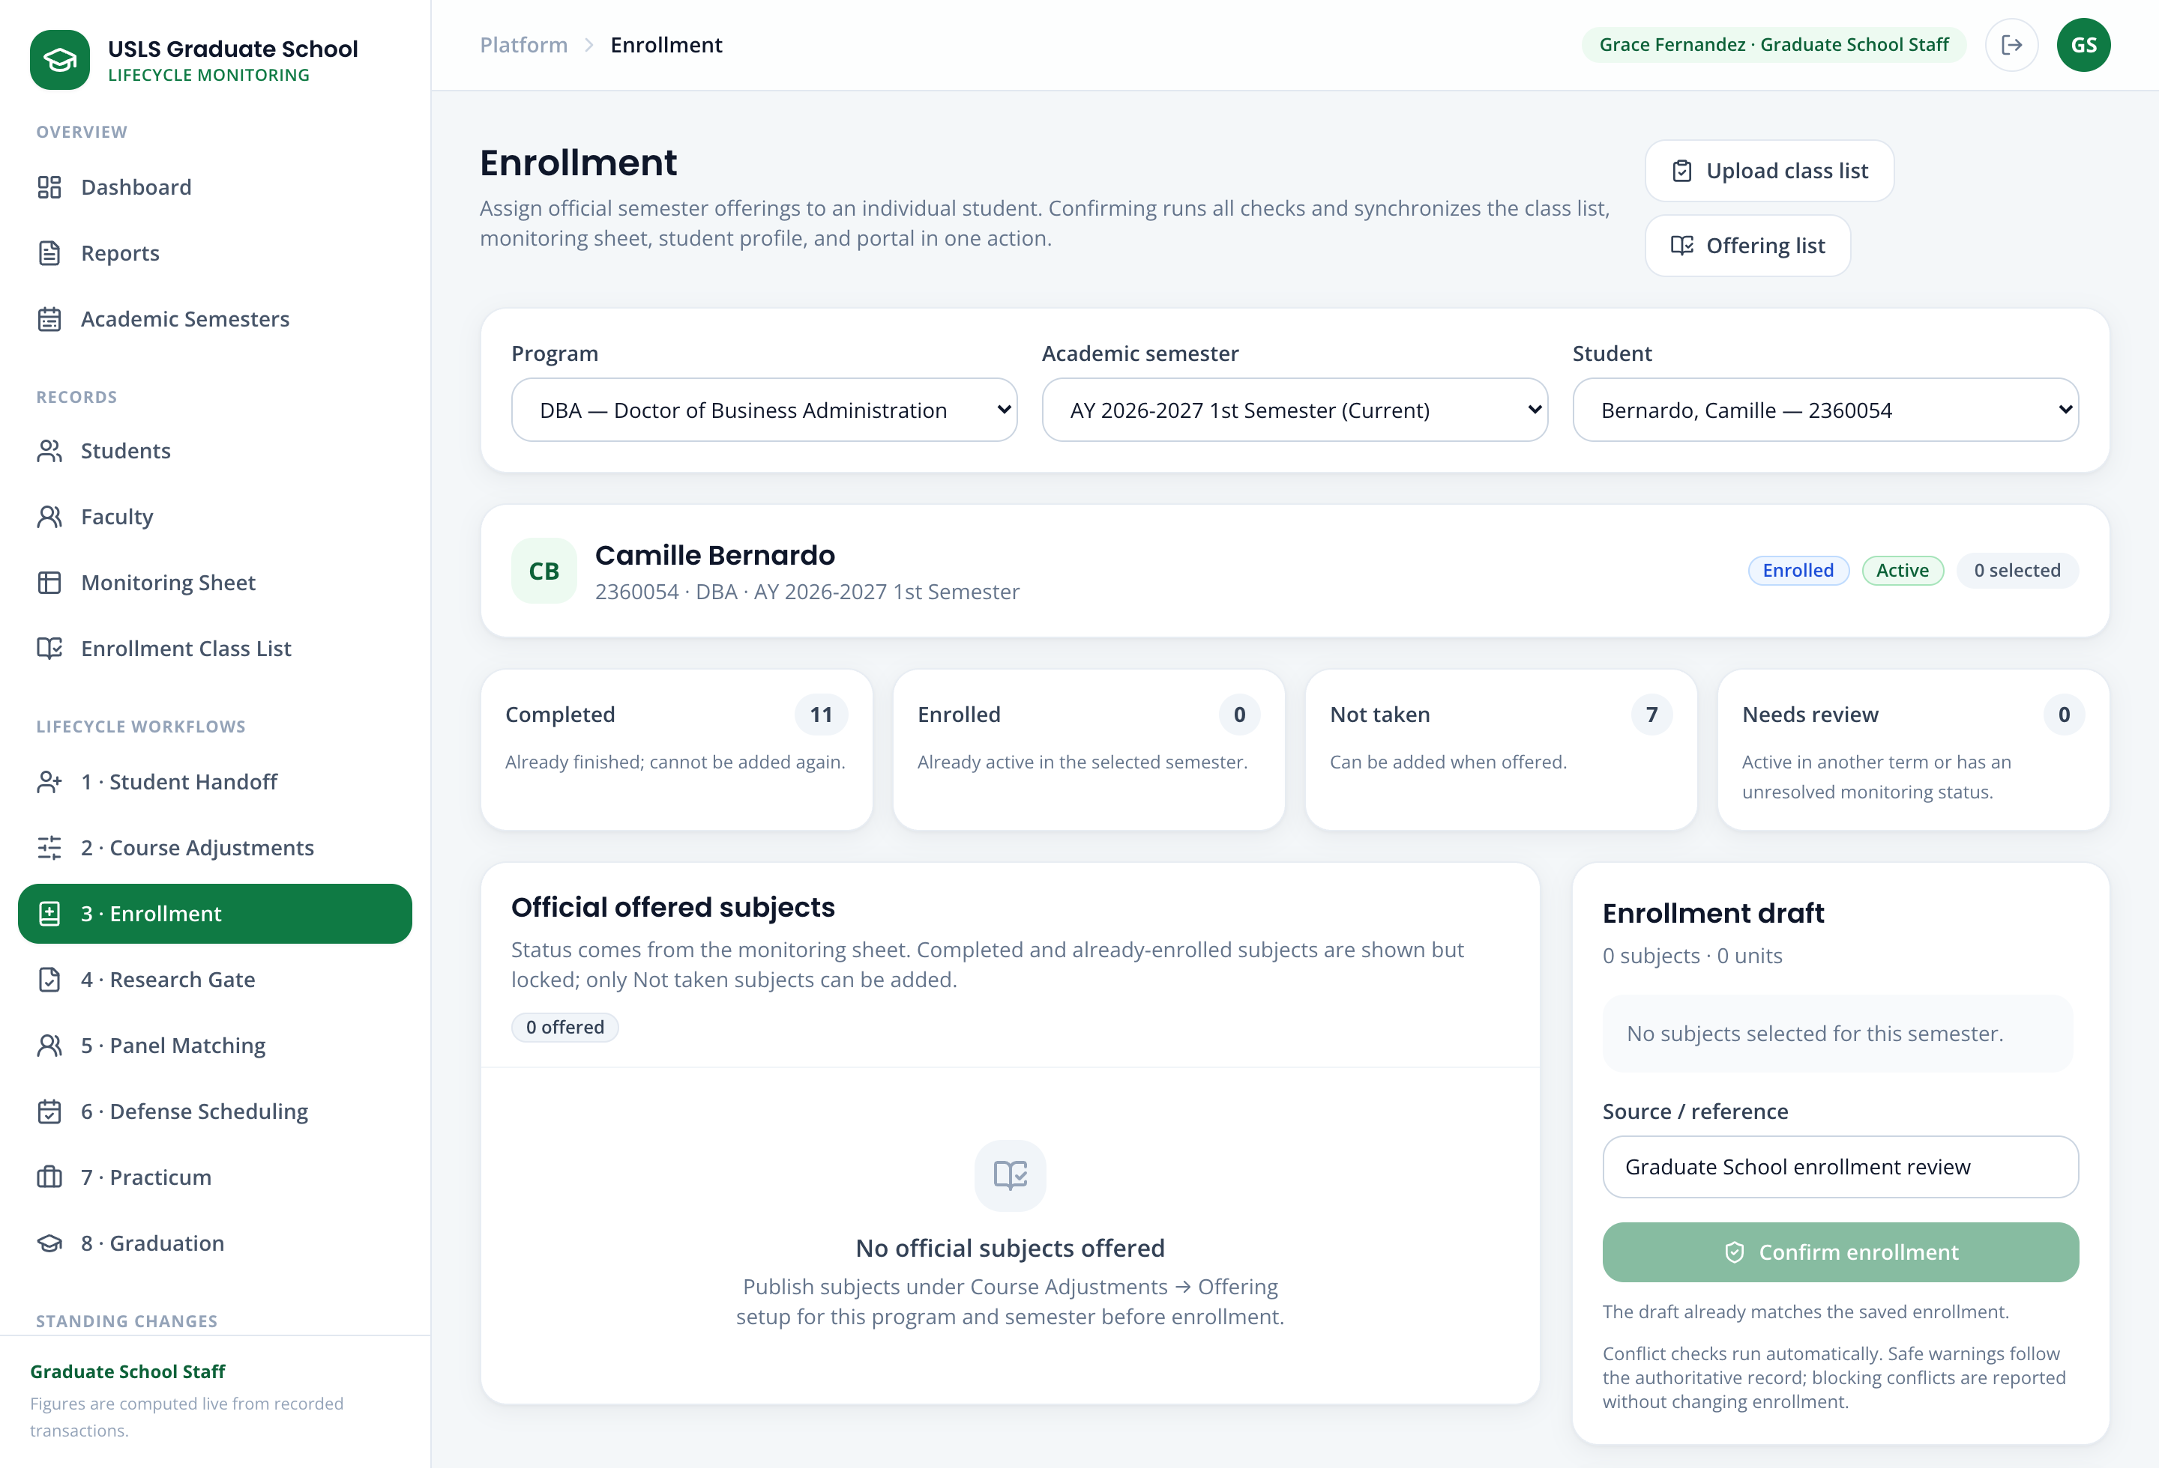
Screenshot — Enrollment showing a single student selected with their offered subjects and the Confirm enrollment action.

Scenario 4 — See which subjects are needed and who is affected
Story:
The Academic Coordinator wants to decide what to offer next term. The portal calculates the subject needs automatically from each student's remaining required subjects, so a single student needing a subject is enough to surface it. It also shows who would be delayed if a subject is not offered.
Log in as:
Field | Value / Instruction
Account type | Academic Coordinator
Email | academic@usls.edu.ph
Password | DemoPass123!
Steps:
Step 1. Open 2 · Course Adjustments.
Step 2. Review the Subject-needs report: each suggested subject lists how many students need it and links to those students.
Step 3. For a subject you are considering not offering, open Affected students / delay impact to see exactly who would be delayed.
Step 4. Use this information to decide the offerings, then confirm the offering decisions.
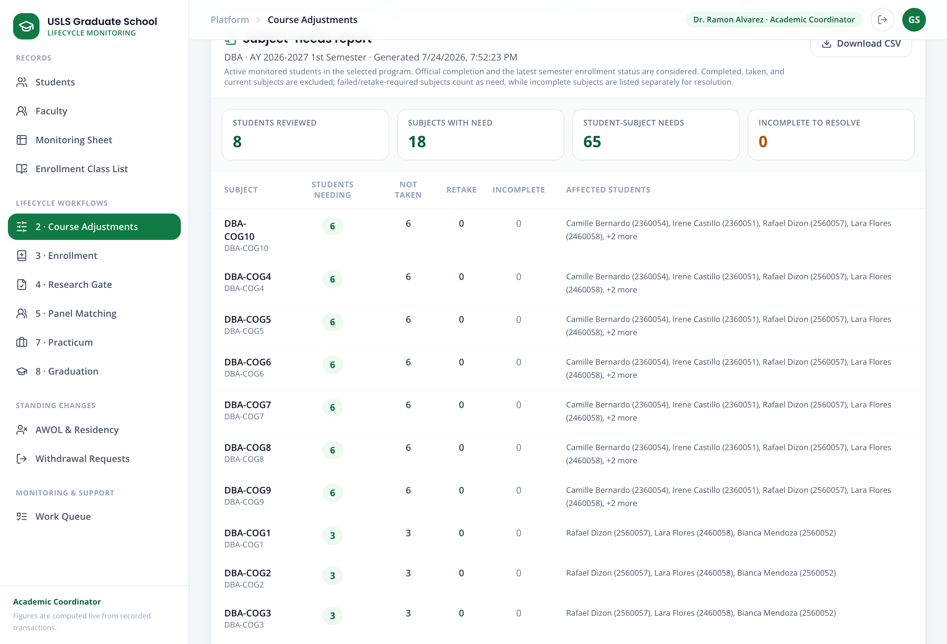
Screenshot — The Subject-needs report with the affected-students / delay-impact detail expanded.

Scenario 5 — Process a subject withdrawal (student → staff → Dean)
Story:
Elena Navarro, an active MAED student, needs to withdraw from one enrolled subject. She submits the request; the Graduate School Staff forwards it; and the Dean makes the decision. Once approved, only that one subject is marked withdrawn — the rest of her enrollment is untouched.
Part 1 — The student submits the request
Field | Value / Instruction
Account type | Student
Email | withdrawal.elena@usls.edu.ph
Password | DemoPass123!
Step 1. Log in as the student and open the withdrawal request.
Step 2. Choose the specific enrolled subject to withdraw and enter the reason, then submit the signed request.
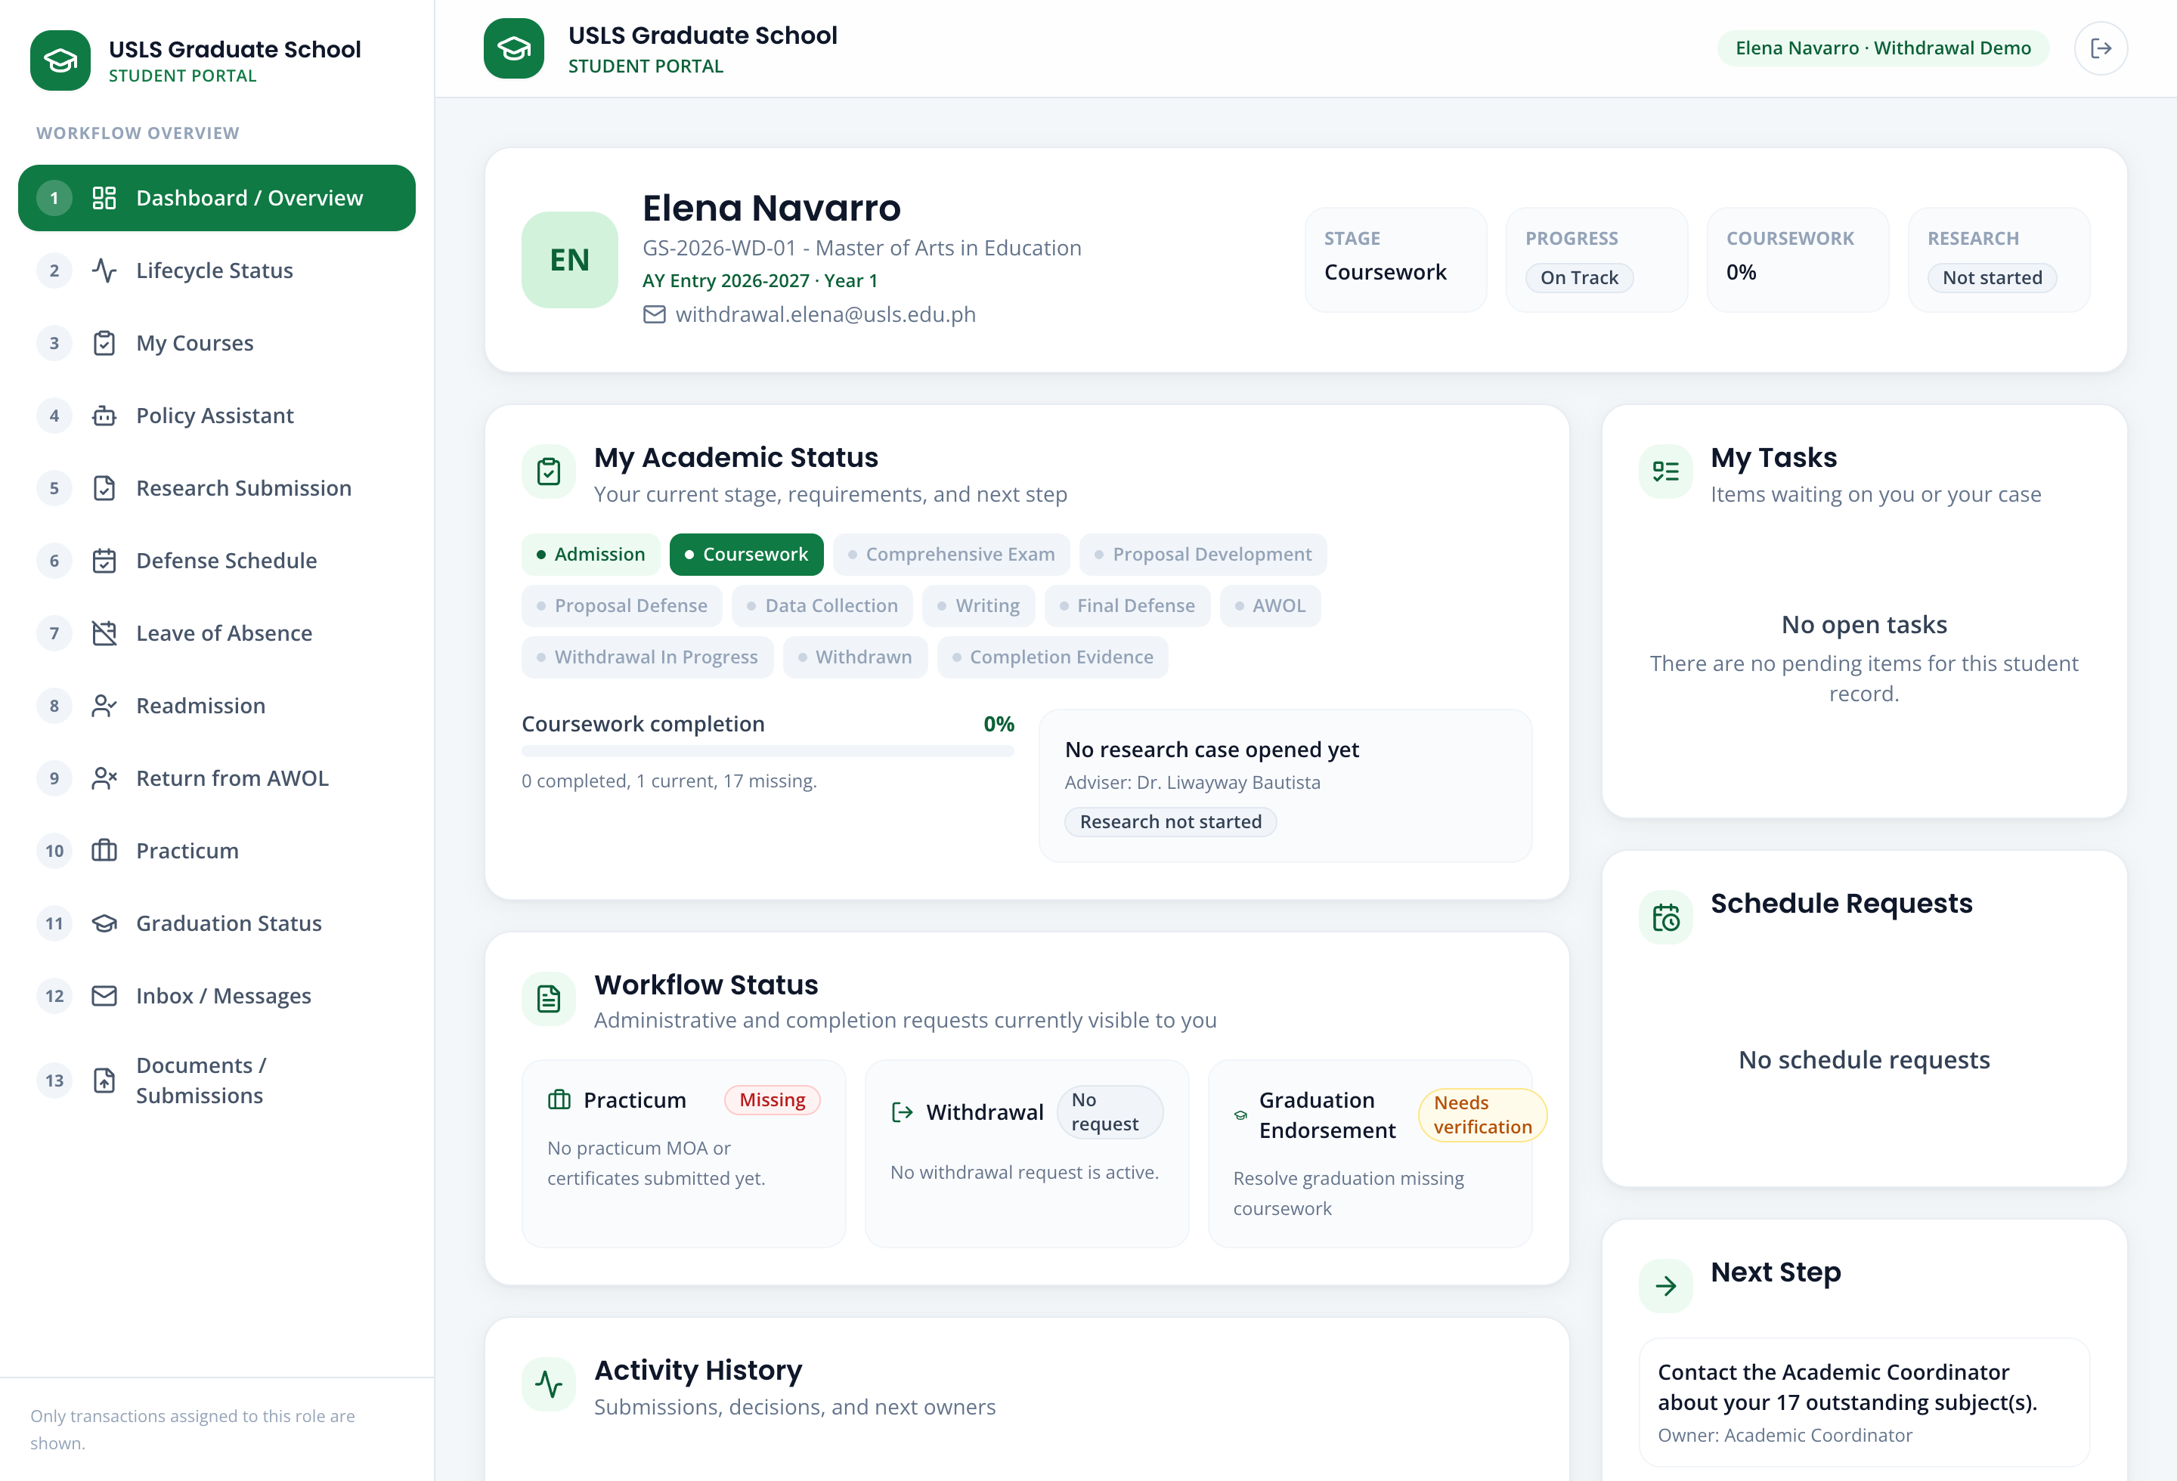
Screenshot — The student's subject-withdrawal request, with one enrolled subject selected.
Part 2 — Staff forwards and the Dean decides
Field | Value / Instruction
Then log in as | Graduate School Staff — staff@usls.edu.ph
And finally as | Dean — dean@usls.edu.ph
Step 3. As Graduate School Staff, open Withdrawal Requests, review the request, and forward it to the Dean.
Step 4. As the Dean, review and record the decision (approve). On approval, the selected subject's status becomes withdrawn and a Registrar report is available for the external handoff.
Note: The internal request status and the official subject status are kept separate. The request moving forward does not imply coordinator approval authority; the Dean is the approver.
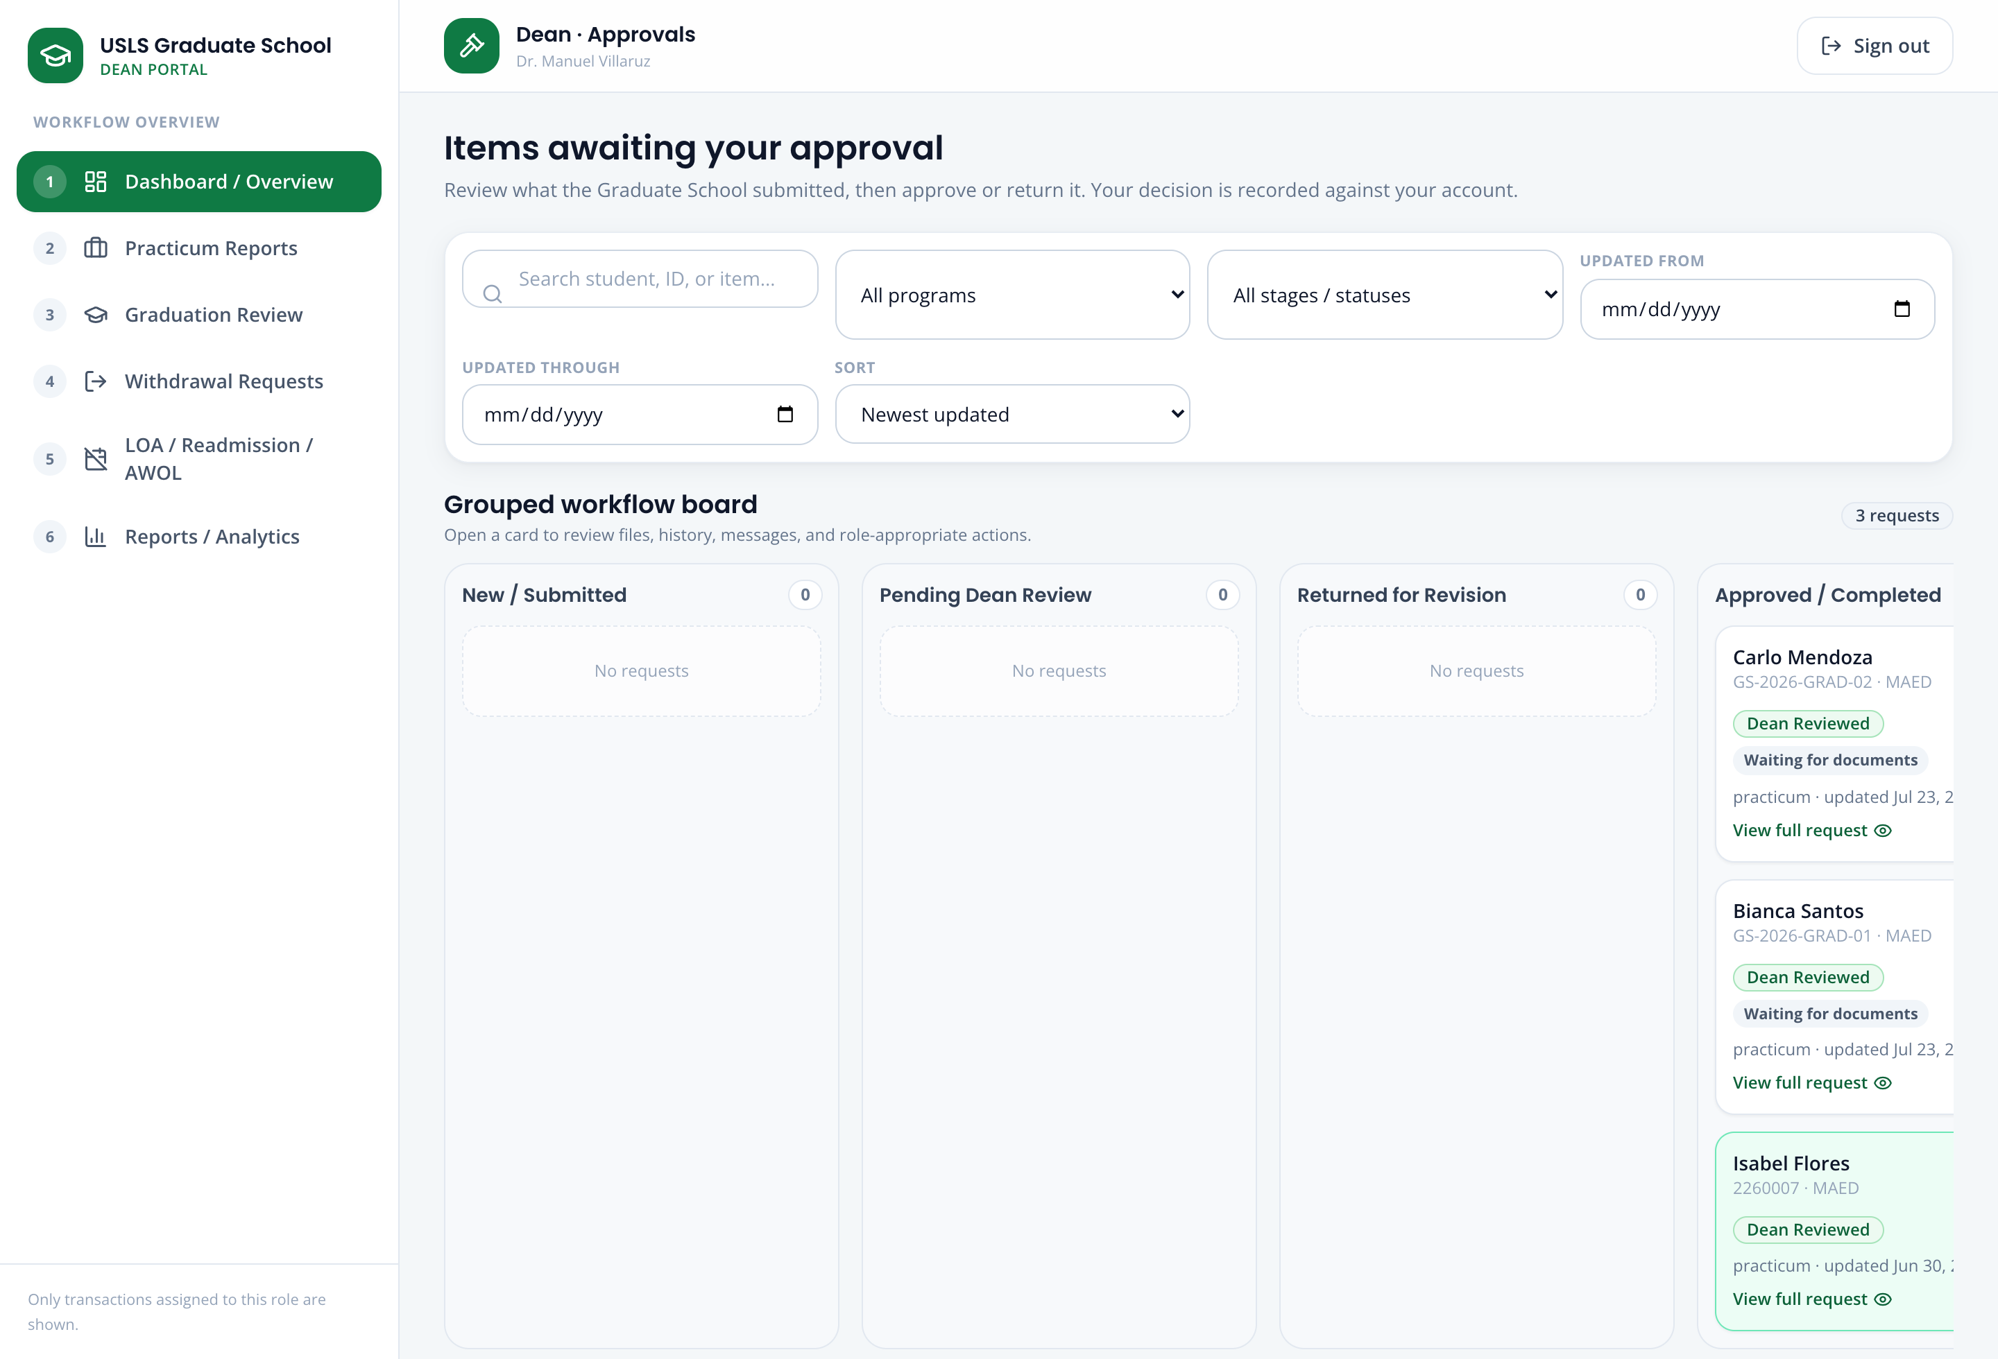
Screenshot — The Dean's withdrawal decision screen and the applied subject status after approval.

Scenario 6 — Research Gate, Panel Matching, and Defense Scheduling
Story:
Miguel Yu is ready to submit his Title Defense requirements. The portal checks his required research submissions, helps staff assemble a qualified panel, and finds a common defense schedule.
Accounts used:
Field | Value / Instruction
Student | student@usls.edu.ph (Miguel Yu)
Coordinator / Staff | research@usls.edu.ph or staff@usls.edu.ph
Steps:
Step 1. As the student, submit the required research forms, then open 4 · Research Gate (as staff) to confirm the submissions are received and marked as submitted versus verified.
Step 2. Open 5 · Panel Matching. Review the recommended panel shortlist, adjust it if needed, and finalize the panel. An adviser designation is required before adviser-related actions.
Step 3. Open 6 · Defense Scheduling to find and confirm the earliest common available slot for the panel.
Note: A submitted file is recorded as received, not as academically validated content. The panel recommendation is a suggestion that an authorized person accepts, modifies, or replaces.
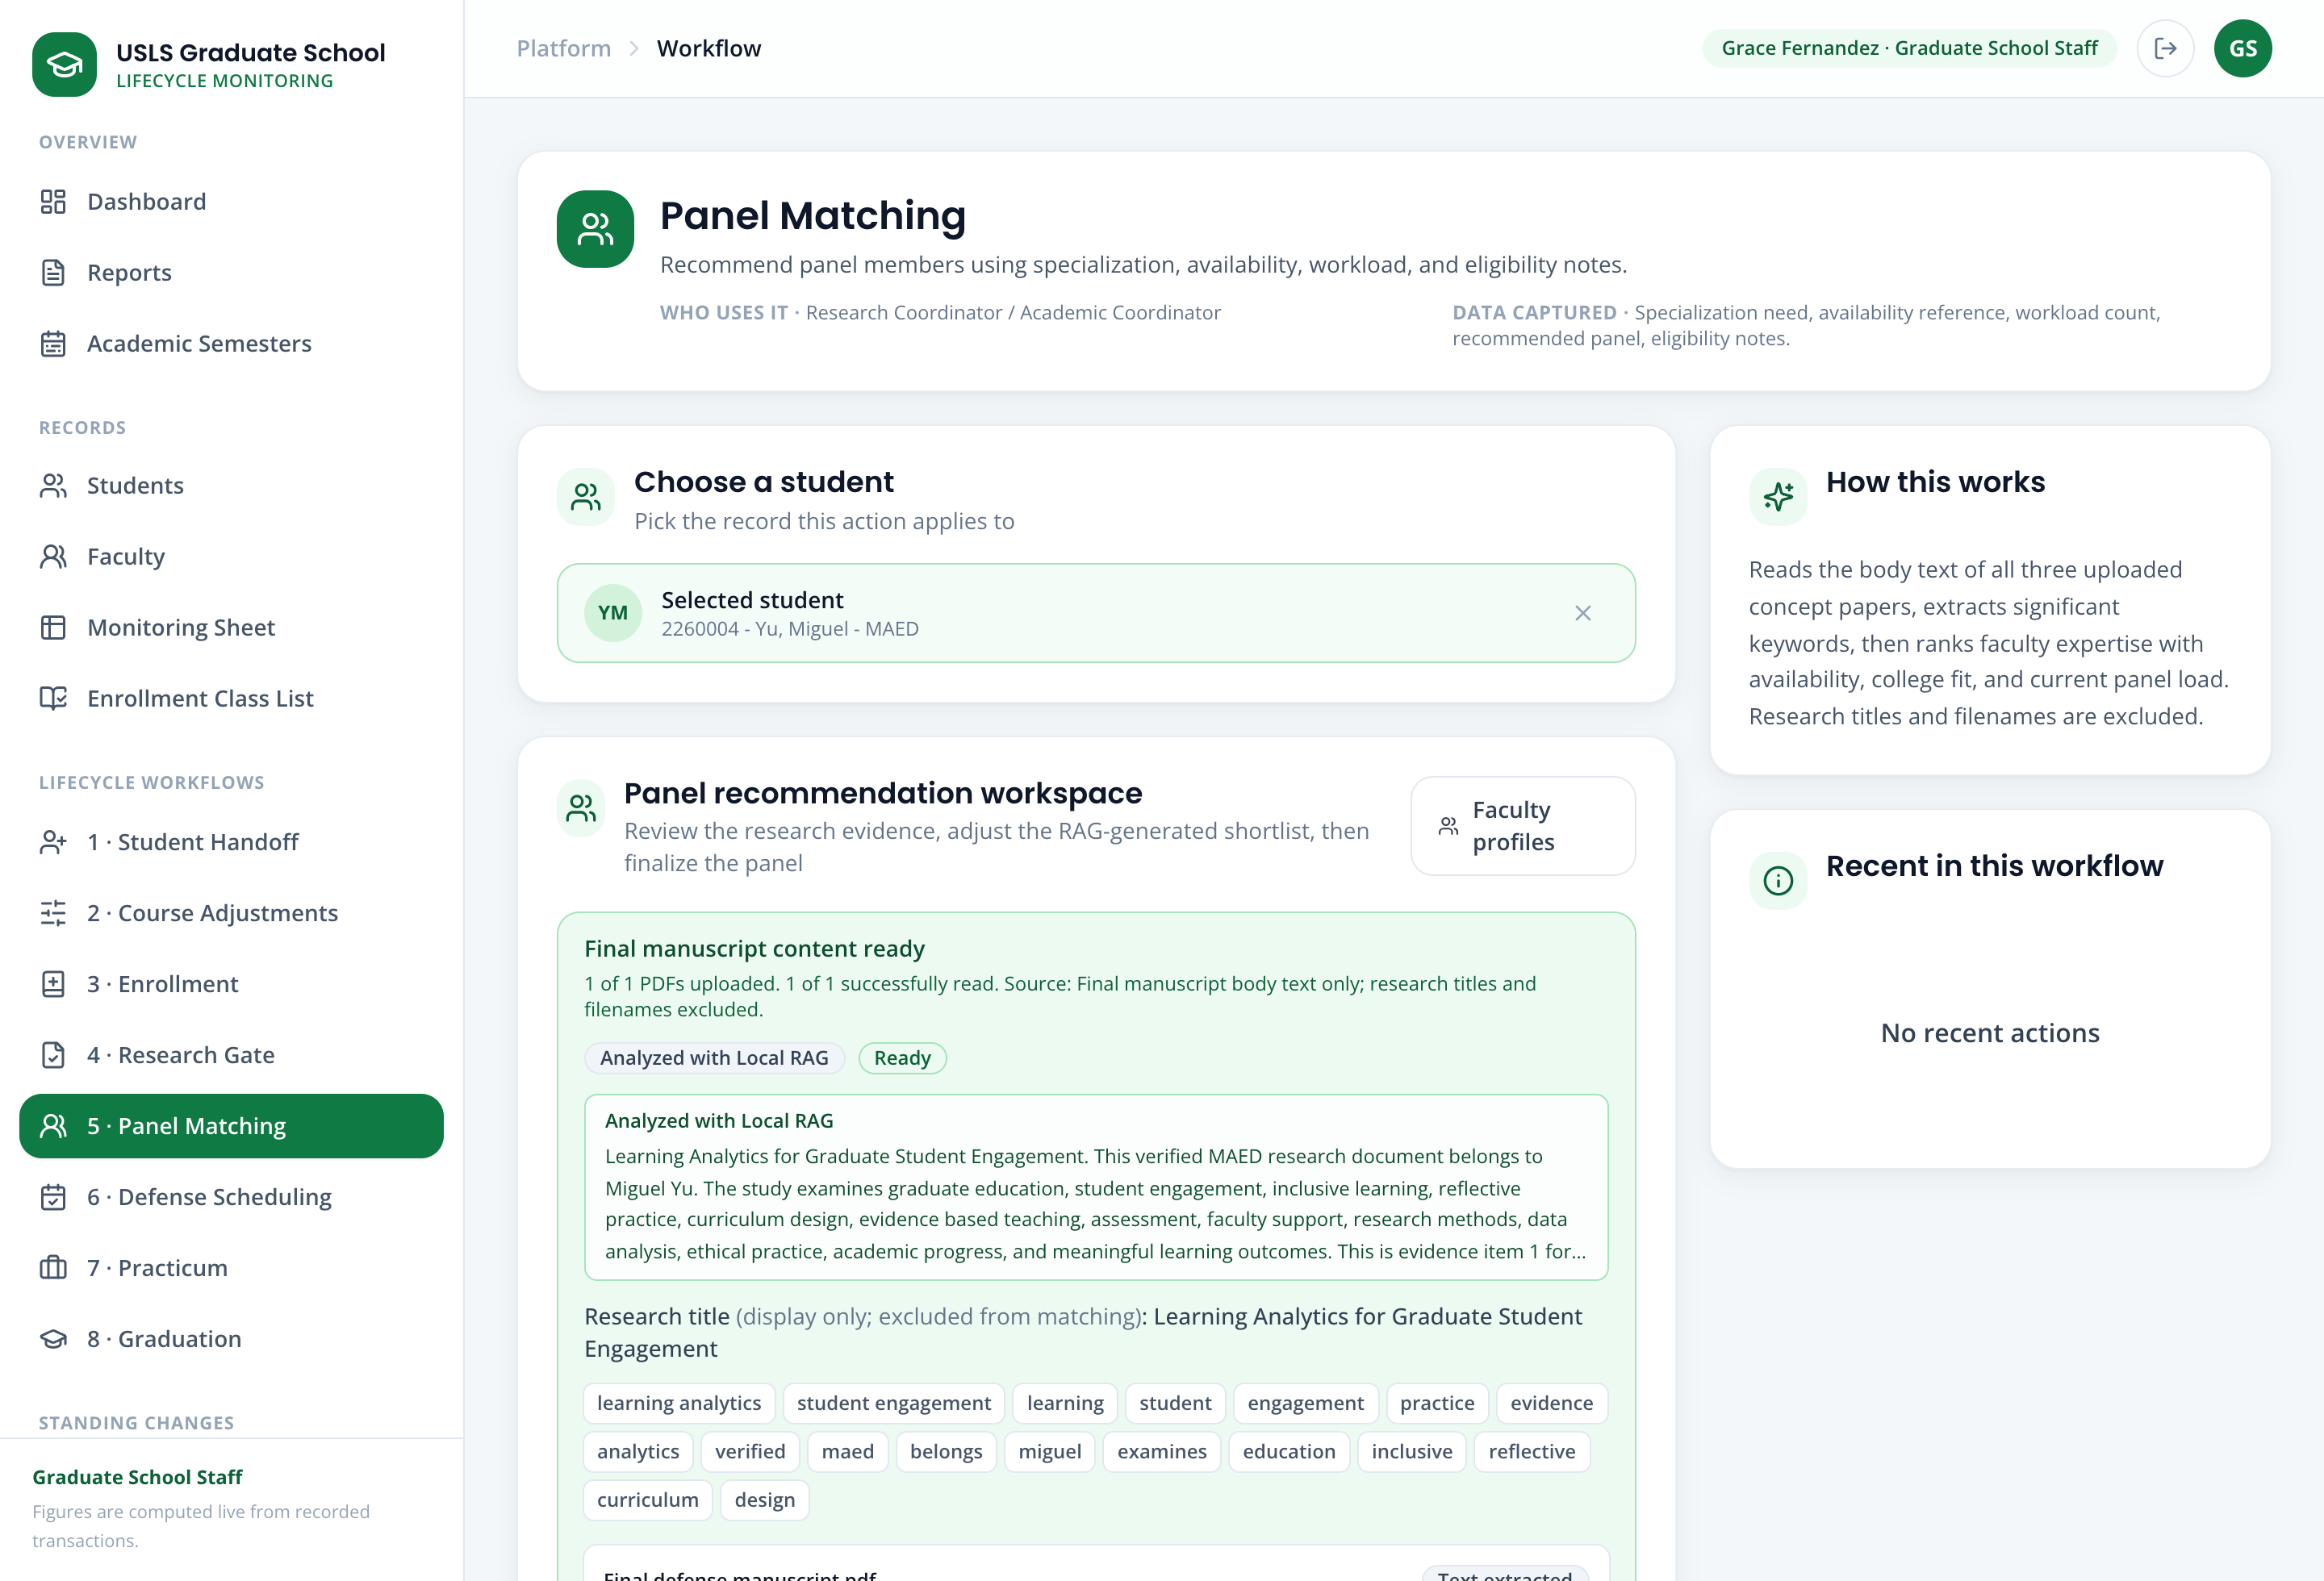
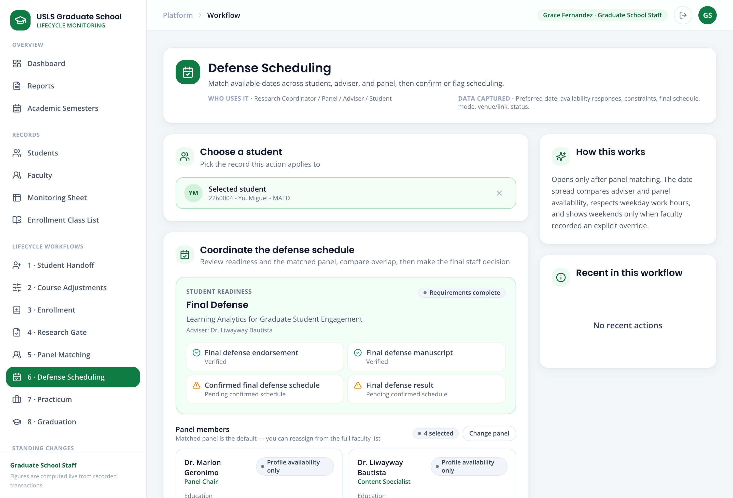
Screenshot — Panel Matching with the recommended shortlist, and Defense Scheduling with the proposed common slot.

Scenario 7 — Graduation eligibility and endorsement
Story:
The graduation review window is open. Bianca Santos applies to graduate. The coordinator checks that her coursework and research requirements are complete, and the Dean approves the endorsement list, which is then exported for the external handoff.
Accounts used:
Field | Value / Instruction
Student | graduation.bianca@usls.edu.ph (Bianca Santos)
Coordinator / Staff | staff@usls.edu.ph
Approver | dean@usls.edu.ph
Steps:
Step 1. As the student, submit the graduation application.
Step 2. As staff, open 8 · Graduation. The candidate appears with a coursework and research check; any missing requirement is stated exactly.
Step 3. Add the eligible candidate(s) to a named endorsement batch and prepare the endorsement list.
Step 4. As the Dean, review and approve the batch. Then export the endorsed list for the external handoff.
Note: The export is recorded accurately as an external handoff. The portal does not claim an email was sent unless an actual integration performed it.
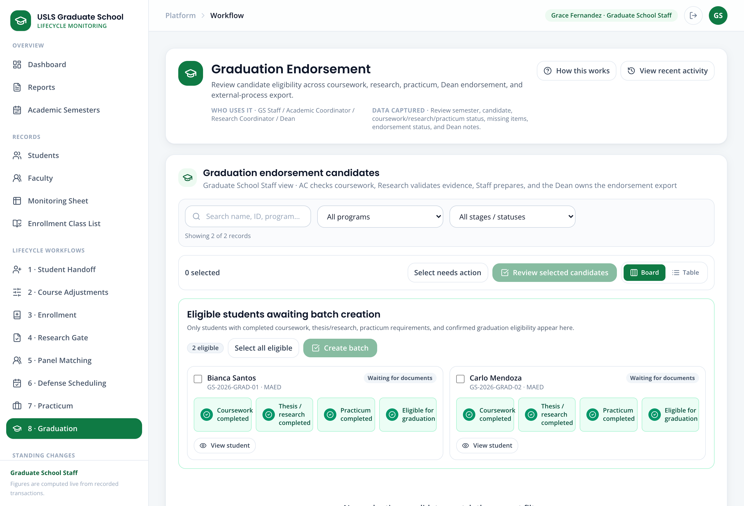
Screenshot — The Graduation screen with the eligibility check, and the Dean-approved endorsement list ready to export.

Scenario 8 — Standing change: Leave of Absence
Story:
A student needs to file a leave of absence. The request is a structured form checked against the handbook rules; it does not require uploading a letter. Readmission, AWOL, and Residency follow the same structured pattern.
Accounts used:
Field | Value / Instruction
Student | loa.daniel@usls.edu.ph
Staff | staff@usls.edu.ph
Approver | dean@usls.edu.ph
Steps:
Step 1. As the student, open Leave of Absence and complete the structured fields (reason, term, expected return).
Step 2. As staff, review the eligibility check (for example, prior approved leaves and minimum residency) and forward the request.
Step 3. As the Dean, record the decision. On approval, the student's standing is updated.
Note: The eligibility figures shown (such as the maximum number of prior leaves) are clearly labeled as prototype values to be confirmed with the stakeholder, not invented policy.
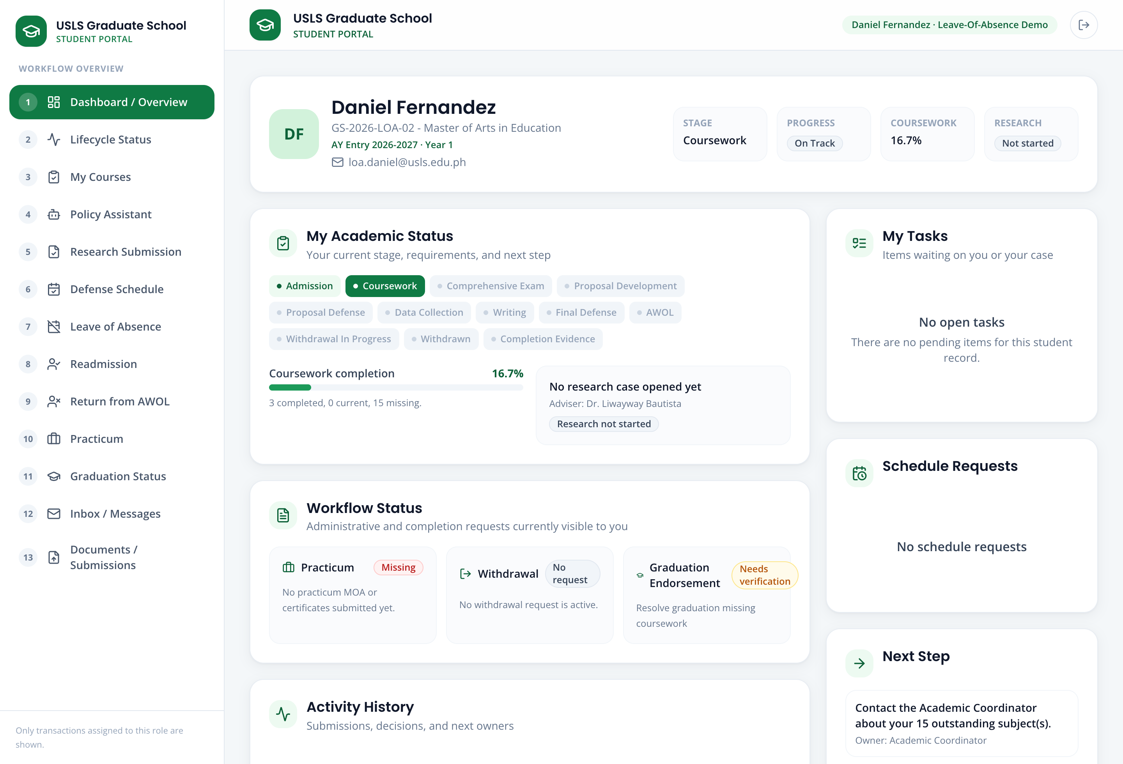
Screenshot — The structured Leave of Absence form and the staff eligibility check.

7. Honest Notes & Limitations
For an accurate demonstration, keep these points in mind and state them plainly if asked:
- AIMS is a separate, official university system. This portal does not connect to AIMS live; it uses an approved export/import workbook. Imported official values are read-only here, and corrections are made in AIMS and re-imported.
- The application records and displays enrollment; it does not perform official enrollment in place of the Registrar.
- Grades and course-completion come from the official export, not from manual entry inside the portal.
- Risk is shown as Not Yet Assessed for new or incomplete records instead of an invented Low/Medium/High score, until the official risk rules are confirmed.
- Where the portal shows recommendations (subject needs, faculty, panels), they are suggestions with a stated basis that an authorized person confirms.
- The Policy Assistant answers from the provided handbook and research documents; treat it as decision support, not an official ruling.

End of Demonstration Walkthrough

