

The Co-operative Bank of Kenya Limited

Co-operative Bank House

Haile Selassie Avenue

P.O.Box 48231-00100 GPO, Nairobi

Tel: (020) 3276100

Fax: (020) 2227747/2219831

**Our Ref: SUSPENSION/009/2019-03-08**

Paul Merson K

PO BOX 23000- 00200

Dear sir/madam

**RE: CO-OPCARD ACCOUNT NO: 009**

Yours sincerely,

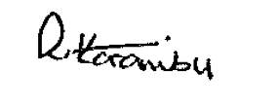

ROSE KARAMBU

**COLLECTIONS SUPPORT MANAGER.**