BD-TrafficGuard
Implementation vs Proposal Analysis
Independent review of the supplied executed Jupyter Notebook, project proposal, and proposal presentation
Prepared from the actual recorded implementation outputs; no notebook cells were rerun.

1. Executive verdict
Overall verdict: The implementation is substantially successful and demonstrates the core BD-TrafficGuard idea, but it is not yet a complete implementation of the full proposal. The strongest result is the explicit corruption-aware YOLO11n model: it preserves almost all clean performance while dramatically reducing the robustness drop on the implemented corruption benchmark. The main unfinished work is the broader research protocol promised in the proposal: missing corruption types, systematic class-wise robustness, most ablations, and the actual two-stage/Faster R-CNN/EfficientNet comparisons.
Core system: IMPLEMENTED — Bangladesh-specific YOLO11n detection/classification pipeline, clean evaluation, corruption benchmark, two robust-training strategies, deployment timing, exports, and qualitative prediction grids.
Full proposal research plan: PARTIALLY IMPLEMENTED — A practical estimate from a weighted workstream rubric is about 73% complete. This is a project-completeness estimate, not a scientific performance score.
Best current model: YOLO11n explicit corruption-aware — Best robustness result in the executed experiments: mean corrupted mAP@0.5:0.95 = 0.9646 and mean robustness drop = 0.22 percentage points.
Main concern: RESEARCH DEPTH — The current notebook is strong as a course/lab implementation, but the evidence is not yet sufficient to claim the full proposal novelty or a publication-grade benchmark.

2. What the proposal promised
The proposal defines the project as robust Bangladeshi traffic-sign detection and recognition under real-world conditions. It explicitly calls for clean baseline training, a controlled corrupted test benchmark, degradation-aware training, clean/corrupted comparison, class-wise analysis, deployment measurements, ablations, and qualitative failure analysis. The proposal also lists Faster R-CNN and EfficientNet/ResNet-style alternatives as candidate models.
- Primary dataset: Bangladesh Road Traffic Sign Dataset; proposal states 10,259 images and 31 classes.
- Core output: bounding box + traffic-sign class label.
- Robustness conditions proposed: blur, motion blur, low brightness, high brightness/glare, rain/fog, partial occlusion, JPEG compression, and small-object scaling.
- Robust training proposed: blur, brightness/contrast, rain/fog/shadow, crop/scale, mosaic/mixup, class-balanced sampling, and optional focal loss.
- Evaluation proposed: mAP@0.5, mAP@0.5:0.95, precision, recall, F1, class-wise recall, robustness drop, FPS/inference time, and model size.
- Ablations proposed: no augmentation vs standard vs degradation-aware; nano vs small; 416/640/960; class-balanced sampling; one-stage vs two-stage.
- Qualitative analysis proposed: difficult correct cases, missed small signs, similar-sign confusion, false positives, and extreme blur/occlusion failures.

3. Implementation inventory
Area | Status | Evidence from notebook
Environment & reproducibility | Implemented | Kaggle, Tesla T4, seed 42, deterministic=True, fixed package versions.
Dataset validation | Implemented | Train/valid/test image-label counts, missing/orphan labels, invalid rows, class distribution, image dimensions, object-size analysis.
Baseline detector | Implemented | YOLO11n pretrained, 50 epochs, 640px, batch 16.
Clean held-out evaluation | Implemented | Official test split, mAP50, mAP50-95, precision, recall, F1.
BD-TrafficSign-C | Implemented, but narrower than proposal | 8 corruption families × 3 severities = 24 corrupted conditions.
Built-in robust training | Implemented | Same YOLO11n architecture with stronger geometric/color/mosaic/mixup augmentation.
Explicit corruption-aware training | Implemented | 65% probability of one random corruption on training images; clean validation/test retained.
Robust-model evaluation | Implemented | Both robust models evaluated on clean + all implemented corruption conditions.
Class-wise analysis | Partial | 31-class AP50/AP50-95 table on clean test; no class-wise corrupted robustness analysis.
Deployment | Implemented | 50-image GPU timing and checkpoint size.
Resolution ablation | Implemented | 416/640/960 evaluation on the baseline checkpoint.
Other ablations | Not executed | Nano vs small, no-augmentation control, class-balanced sampling, etc.
EfficientNet classifier | Scaffold only | Crop-building and classifier code exists but both are disabled.
Faster R-CNN | Scaffold only | Dataset/model/training code exists but training is disabled.
Qualitative predictions | Partial | Clean + several severe corruption grids shown; selection is random rather than error-driven.
Export/report infrastructure | Implemented | CSV/JSON/Excel/archive export logic and 20 result tables.

4. Dataset and data-quality analysis
The executed notebook reports 7,165 training images, 2,046 validation images, and 1,024 test images: 10,235 images total. It reports 7,207, 2,064, and 1,025 annotated objects respectively, for 10,296 objects. All image/label counts match within each split; there are zero missing labels, zero orphan labels, zero invalid label rows, and zero unreadable label files.
Important discrepancy: the proposal/presentation describes 10,259 images, whereas the executed notebook actually processes 10,235 image files. This should be explicitly documented rather than silently treated as the same number.
The class distribution is highly uneven. Two proposed classes (Weight Limit 10T and Weight Limit 27T) have zero samples in train/validation/test. Traffic Merges From Right has 22 total instances but zero test instances. Therefore the nominal 31-class problem does not have a complete 31-class held-out test evaluation.
Object-size analysis is useful: 968 objects (9.40%) are classified as small (<1% image area), 4,360 (42.35%) medium, and 4,968 (48.25%) large. This supports the proposal's concern about small signs, but the implementation does not yet create a dedicated small-object benchmark.

5. Baseline training and clean-test performance
The baseline is YOLO11n pretrained on the official train split for 50 epochs at 640×640 with batch size 16 and seed 42. The notebook records a training time of about 63.10 minutes. The best checkpoint is used for the held-out clean test.
Model | Precision | Recall | F1 | mAP50 | mAP50-95
YOLO11n baseline | 0.9866 | 0.9781 | 0.9823 | 0.9895 | 0.9697
Clean performance is very strong: mAP@0.5 = 0.9895 and mAP@0.5:0.95 = 0.9697, with F1 = 0.9823. The clean result establishes a strong baseline, but the robustness experiments are the more important evidence for this project.

6. Corruption benchmark: what was actually implemented
The notebook creates 8 corruption families with mild, moderate, and severe levels, producing 24 corrupted test conditions from the 1,024-image test set, i.e. 24,576 generated image-condition records. The implemented families are Gaussian noise, Gaussian blur, motion blur, JPEG compression, low light, low contrast, fog, and rain.
This is a good controlled benchmark design because the corruption is applied only to copies of the held-out test images and the original YOLO labels are retained. The evaluation YAML explicitly uses the corrupted images as the test split and does not use them for training.
However, the implemented benchmark is not identical to the proposal. High brightness/glare, partial occlusion, and small-object scaling are missing. Gaussian noise and low contrast were added even though they were not explicitly listed in the proposal.

7. Baseline robustness findings
The baseline is highly stable under rain, fog, Gaussian blur, JPEG compression, and low contrast, but it is clearly vulnerable to severe Gaussian noise and severe motion blur. The baseline mean corrupted mAP@0.5:0.95 is 0.9313 versus 0.9697 on clean data, an average drop of 0.0383 (3.95%).
Corruption | Mean mAP50-95 | Worst mAP50-95 | Mean drop % | Worst drop %
Gaussian noise | 0.7540 | 0.4324 | 22.2469 | 55.4135
Motion blur | 0.9029 | 0.7951 | 6.8898 | 18.0092
Low light | 0.9521 | 0.9219 | 1.8111 | 4.9248
JPEG compression | 0.9659 | 0.9562 | 0.3953 | 1.3918
Low contrast | 0.9662 | 0.9574 | 0.3566 | 1.2654
Gaussian blur | 0.9682 | 0.9616 | 0.1513 | 0.8346
Rain | 0.9699 | 0.9695 | -0.0236 | -0.0188
Fog | 0.9715 | 0.9711 | -0.1892 | -0.1504
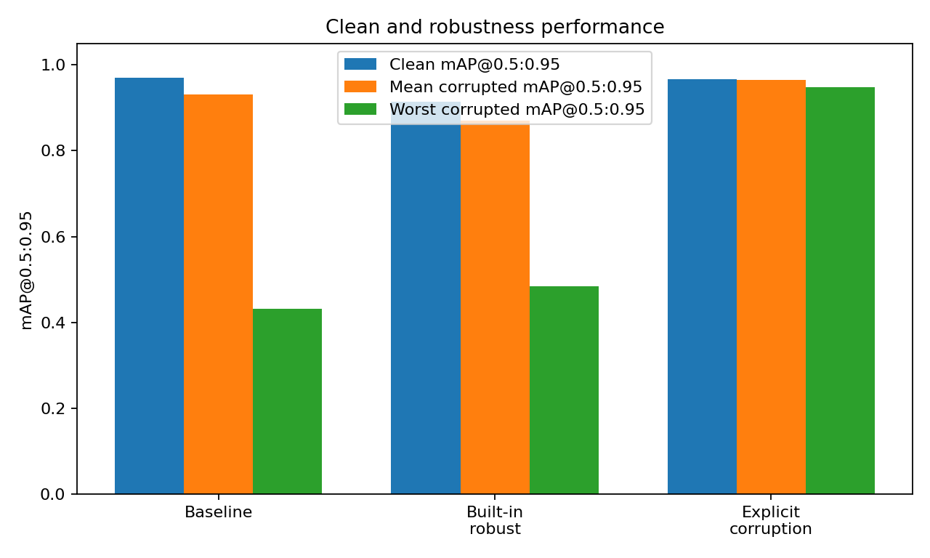
Interpretation: the baseline is not generally fragile to every synthetic degradation. Its main failure mode is additive Gaussian noise, followed by motion blur. This is useful because it gives the robust-training experiment a clear target rather than merely showing a generic performance drop.

8. Robust training comparison
Model | Clean mAP50-95 | Mean corrupted mAP50-95 | Worst corrupted mAP50-95 | Mean drop | Mean drop %
YOLO11n_baseline | 0.9697 | 0.9313 | 0.4324 | 0.0383 | 3.9548
YOLO11n_robust_builtin_aug | 0.9139 | 0.8699 | 0.4843 | 0.0439 | 4.8088
YOLO11n_robust_explicit_corruptions | 0.9668 | 0.9646 | 0.9481 | 0.0022 | 0.2322

8.1 Built-in augmentation model
The built-in robust model keeps the same YOLO11n architecture and uses stronger geometric/color augmentation, mosaic, and mixup. It achieves clean mAP@0.5:0.95 of only 0.9139, substantially below the baseline's 0.9697. Its mean corrupted mAP@0.5:0.95 is 0.8699 and mean robustness drop is 4.81%.
This is an important negative result: simply increasing standard augmentation did not solve the robustness problem. In fact, under this configuration it made the overall robustness summary worse than the clean-trained baseline.

8.2 Explicit corruption-aware model
The explicit model is the strongest result in the notebook. It trains YOLO11n on a copy of the training set where each image has a 65% probability of receiving one randomly selected implemented corruption at one of three severities; validation and test remain clean. This creates a direct training-to-evaluation connection for the robustness problem.
It achieves clean mAP@0.5:0.95 = 0.9668, only 0.0029 below the baseline, while mean corrupted mAP@0.5:0.95 rises to 0.9646 from 0.9313. The mean robustness drop falls from 3.95% to 0.23%, and the worst corrupted mAP@0.5:0.95 rises from 0.4324 to 0.9481.
The relative reduction in average robustness-drop magnitude is about 94%. More importantly, the improvement is not driven by one metric alone: the explicit model also has the highest clean recall (0.9838) and clean F1 (0.9849) among the three models.
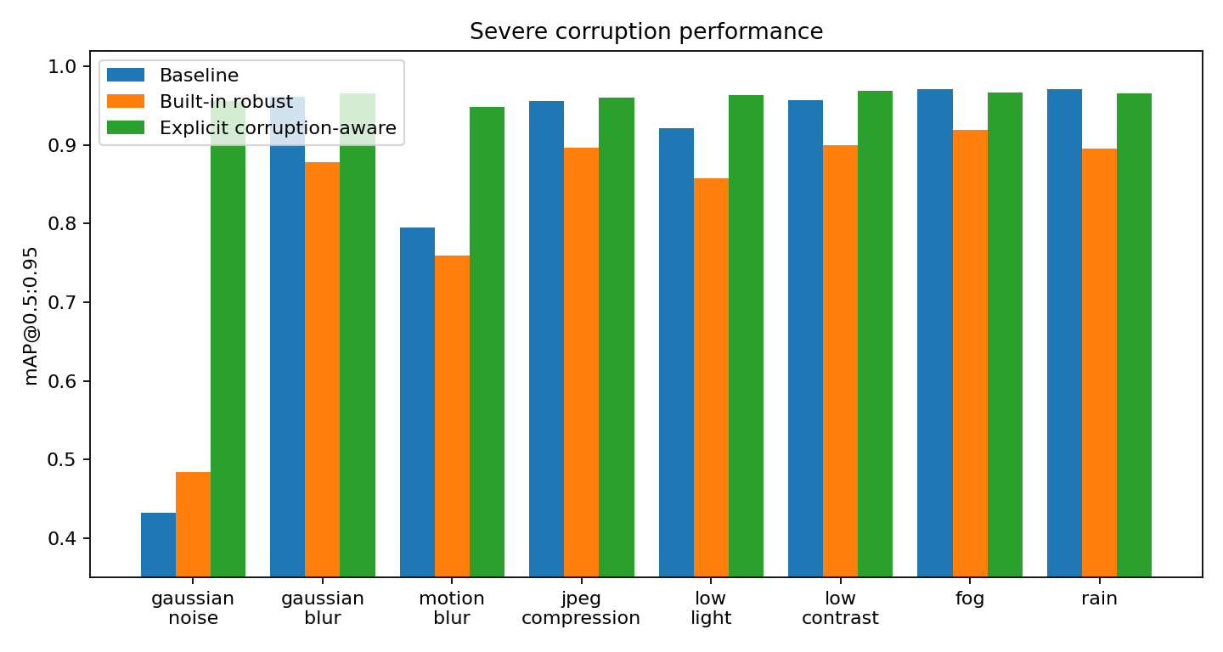

9. Condition-by-condition comparison
The explicit corruption-aware model is especially effective for the hardest baseline failure modes. Severe Gaussian-noise mAP@0.5:0.95 improves from 0.4324 to 0.9558 (+0.5234). Severe motion-blur improves from 0.7951 to 0.9481 (+0.1530). Severe low-light improves from 0.9219 to 0.9636 (+0.0417).
Condition | Baseline | Built-in robust | Explicit corruption-aware
Gaussian Noise / Mild | 0.9685 | 0.8019 | 0.9652
Gaussian Noise / Moderate | 0.8610 | 0.7617 | 0.9627
Gaussian Noise / Severe | 0.4324 | 0.4843 | 0.9558
Gaussian Blur / Mild | 0.9714 | 0.9053 | 0.9667
Gaussian Blur / Moderate | 0.9716 | 0.8928 | 0.9672
Gaussian Blur / Severe | 0.9616 | 0.8785 | 0.9654
Motion Blur / Mild | 0.9697 | 0.9315 | 0.9664
Motion Blur / Moderate | 0.9438 | 0.8958 | 0.9618
Motion Blur / Severe | 0.7951 | 0.7593 | 0.9481
Jpeg Compression / Mild | 0.9721 | 0.9040 | 0.9662
Jpeg Compression / Moderate | 0.9693 | 0.9113 | 0.9651
Jpeg Compression / Severe | 0.9562 | 0.8970 | 0.9608
Low Light / Mild | 0.9693 | 0.9145 | 0.9658
Low Light / Moderate | 0.9651 | 0.8981 | 0.9662
Low Light / Severe | 0.9219 | 0.8582 | 0.9636
Low Contrast / Mild | 0.9706 | 0.9193 | 0.9677
Low Contrast / Moderate | 0.9707 | 0.9128 | 0.9676
Low Contrast / Severe | 0.9574 | 0.9001 | 0.9685
Fog / Mild | 0.9714 | 0.9135 | 0.9665
Fog / Moderate | 0.9721 | 0.9144 | 0.9671
Fog / Severe | 0.9711 | 0.9197 | 0.9666
Rain / Mild | 0.9695 | 0.9100 | 0.9677
Rain / Moderate | 0.9697 | 0.8989 | 0.9654
Rain / Severe | 0.9706 | 0.8959 | 0.9661

10. Class-wise performance
The notebook does implement a 31-class clean-test AP table for the baseline and both robust models. This is a meaningful step toward the proposal's class-wise analysis. However, the proposal specifically emphasizes class-wise robustness and class-wise recall under difficult conditions; the notebook does not compute class-wise recall or per-class robustness drops across the corrupted test sets.
The dataset itself prevents a complete class-wise test analysis: Weight Limit 10T and Weight Limit 27T have no samples anywhere, while Traffic Merges From Right has no test sample. Those classes cannot support a meaningful held-out test comparison.

11. Ablation studies
Only the input-resolution ablation was actually executed. The baseline checkpoint was evaluated at 416, 640, and 960 pixels.
imgsz | mAP50 | mAP50_95
416.0000 | 0.9899 | 0.9642
640.0000 | 0.9895 | 0.9697
960.0000 | 0.9743 | 0.8992
The 640 setting is the strongest of these evaluations at mAP@0.5:0.95 = 0.9697. The 960 evaluation drops to 0.8992. This should not be described as a full training-resolution ablation because the same 640-trained checkpoint is being evaluated at different inference sizes; the models were not separately retrained at each resolution.
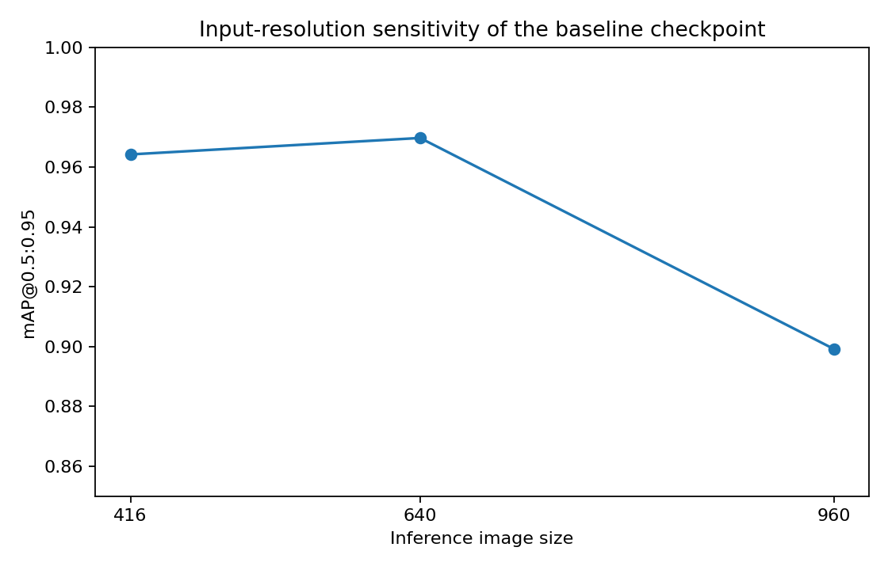
Not executed: no-augmentation vs standard vs degradation-aware control; YOLO11n vs YOLO11s; class-balanced sampling; one-stage vs two-stage comparison.

12. Deployment analysis
Inference speed was benchmarked on 50 test images using the same Tesla T4 environment. The checkpoints are all about 5.23 MB, with roughly 2.59 million parameters and 6.4 GFLOPs reported by Ultralytics.
Model | Size (MB) | Avg ms/image | FPS
YOLO11n_baseline | 5.2305 | 16.5591 | 60.3899
YOLO11n_robust_builtin_aug | 5.2304 | 16.1469 | 61.9315
YOLO11n_robust_explicit_corruptions | 5.2304 | 16.3545 | 61.1454
The explicit robust model runs at about 61.15 FPS in this benchmark, so the lightweight real-time objective is well supported at least on the tested GPU. This should not be generalized to smartphones, Raspberry Pi, Jetson Nano, or CPU deployment because those hardware targets were not benchmarked.

13. Qualitative analysis
The notebook shows clean predictions and severe Gaussian-blur, low-light, fog, and rain examples. The displayed examples generally show successful detections with high confidence. This is useful visual evidence that the model can still detect signs in difficult images.
However, the implementation does not automatically identify false negatives, false positives, localization errors, or class confusions. The examples are randomly sampled rather than selected from actual error cases. Therefore this is better described as qualitative prediction inspection than a complete failure analysis.
- Needed for completion: automatically rank the lowest-confidence/false-negative cases.
- Compare predictions with ground truth and categorize errors by small object, blur, occlusion, lighting, confusing classes, and background false positives.
- Include explicit examples where the baseline fails but the explicit robust model succeeds.

14. Two-stage pipeline and alternative models
The notebook contains code scaffolds for cropping ground-truth signs, training EfficientNet-B0, and training Faster R-CNN. However, the crop dataset build is disabled, EfficientNet training is disabled, and Faster R-CNN training is disabled. Therefore these are not experimental results and must not be presented as completed model comparisons.
This is a major remaining item because the proposal explicitly identifies Faster R-CNN and EfficientNet/ResNet classifiers as candidate baselines and proposes a one-stage vs two-stage ablation.

15. Proposal-to-implementation comparison
Proposal requirement | Implemented? | Assessment | Comment
Bangladesh-specific traffic sign detector | Yes | Strong | YOLO11n on 31-class Bangladesh dataset; bounding-box + class output.
Clean baseline | Yes | Complete | 50-epoch YOLO11n and held-out test evaluation.
Controlled robustness benchmark | Yes | Partial | 24 conditions implemented; 3 proposed condition families are missing.
Robust training | Yes | Strong | Built-in augmentation plus explicit corruption-aware training.
Baseline vs robust comparison | Yes | Complete for implemented conditions | Three-model clean/corrupted comparison and summary metrics.
Class-wise performance | Yes | Partial | Clean AP by class; no corrupted class-wise recall/robustness.
Inference speed/model size | Yes | Complete for tested GPU | 50-image timing; ~5.23 MB checkpoints.
Ablation studies | Partial | Weak | Only 416/640/960 inference-size evaluation actually run.
Two-stage detector + classifier | No | Scaffold only | EfficientNet/Faster R-CNN code exists but experiments are disabled.
Qualitative failure analysis | Partial | Weak/medium | Prediction grids exist, but errors are not systematically mined.
Small/distant sign study | Partial | Weak | Object-size statistics exist; no dedicated small-object corruption/benchmark.
Edge-device deployment | No | Not demonstrated | Only Tesla T4 GPU timing was measured.

16. What is left to implement
High priority: Add the missing robustness conditions: high brightness/glare, partial occlusion, and small-object scaling.
High priority: Run class-wise corrupted evaluation: per-class precision/recall/AP and robustness drop for each corruption/severity.
High priority: Create a true error-analysis pipeline that identifies false negatives, false positives, localization errors, and class confusions.
High priority: Run a no-augmentation control and compare standard YOLO augmentation vs explicit corruption-aware training.
High priority: Train/evaluate YOLO11s or another larger baseline to support the model-size ablation.
Medium priority: Run the EfficientNet-B0 cropped-sign classifier and Faster R-CNN baseline, then compare accuracy, speed, and failure modes.
Medium priority: Add class-balanced sampling if imbalance is a research question; otherwise explicitly justify why it was not used.
Medium priority: Benchmark on an edge target if the project will claim dashcam/mobile readiness.
Medium priority: Document the 10,259-vs-10,235 dataset-count discrepancy and the three classes with no held-out test coverage.
Research-grade: Repeat key experiments across multiple seeds or report variance/confidence intervals before making strong generalization claims.

17. Suggested final experimental story
If the goal is to finish this as a strong Pattern Recognition Lab project, the most defensible story is not that every planned model was implemented. The strongest story is:
- A clean YOLO11n baseline is highly accurate on Bangladeshi road-sign images.
- A controlled Bangladesh-specific corruption benchmark reveals that severe Gaussian noise and motion blur are major vulnerabilities.
- Generic stronger augmentation is not enough and can even reduce robustness under the tested configuration.
- Explicit corruption-aware training preserves clean performance while dramatically improving robustness across the implemented corruption suite.
- The explicit model therefore provides the best current trade-off between clean accuracy, robustness, and real-time inference on the tested GPU.
- The remaining experiments should be framed as extensions needed to complete the broader proposal, not hidden as if they were already done.

18. Honest final verdict
For a university lab/course project: Very strong and clearly defensible. The implementation contains real experimentation, a clean baseline, a meaningful robustness benchmark, two robust-training strategies, quantitative comparison, deployment measurements, and reproducible export logic.
For the exact proposal as written: Partially complete. The core contribution is implemented, but the full proposed research methodology is not. The missing ablations, missing corruption families, missing class-wise corrupted analysis, and disabled alternative models are material gaps.
For a publication-grade claim: Not yet. The explicit robust result is promising, but the benchmark needs broader corruption coverage, systematic error analysis, stronger ablations, clearer dataset accounting, and preferably repeated runs before making strong novelty/generalization claims.
Recommended current final model: YOLO11n_robust_explicit_corruptions. It has clean mAP@0.5:0.95 = 0.9668, mean corrupted mAP@0.5:0.95 = 0.9646, worst corrupted mAP@0.5:0.95 = 0.9481, and mean robustness drop = 0.23%.

19. Sources reviewed
1. bd-trafficguard-complete-implementation (1).ipynb — executed notebook containing the implementation, recorded outputs, metrics, plots, and export logic.
2. bd_trafficguard_project_proposal(1).md — full written proposal and methodology.
3. _218_238_239_BD-TrafficGuard(1).pdf — proposal/presentation deck, including the stated problem, dataset, methodology, future directions, and evaluation plan.
All quantitative values in this report are taken from the recorded notebook outputs or calculated directly from those recorded values. Where a conclusion is an assessment rather than a direct measurement, it is explicitly described as such.

Appendix A — 24-condition robustness table
mAP@0.5:0.95 for each implemented corruption and severity.
Condition | Baseline | Built-in robust | Explicit corruption-aware
Gaussian Noise / Mild | 0.9685 | 0.8019 | 0.9652
Gaussian Noise / Moderate | 0.8610 | 0.7617 | 0.9627
Gaussian Noise / Severe | 0.4324 | 0.4843 | 0.9558
Gaussian Blur / Mild | 0.9714 | 0.9053 | 0.9667
Gaussian Blur / Moderate | 0.9716 | 0.8928 | 0.9672
Gaussian Blur / Severe | 0.9616 | 0.8785 | 0.9654
Motion Blur / Mild | 0.9697 | 0.9315 | 0.9664
Motion Blur / Moderate | 0.9438 | 0.8958 | 0.9618
Motion Blur / Severe | 0.7951 | 0.7593 | 0.9481
Jpeg Compression / Mild | 0.9721 | 0.9040 | 0.9662
Jpeg Compression / Moderate | 0.9693 | 0.9113 | 0.9651
Jpeg Compression / Severe | 0.9562 | 0.8970 | 0.9608
Low Light / Mild | 0.9693 | 0.9145 | 0.9658
Low Light / Moderate | 0.9651 | 0.8981 | 0.9662
Low Light / Severe | 0.9219 | 0.8582 | 0.9636
Low Contrast / Mild | 0.9706 | 0.9193 | 0.9677
Low Contrast / Moderate | 0.9707 | 0.9128 | 0.9676
Low Contrast / Severe | 0.9574 | 0.9001 | 0.9685
Fog / Mild | 0.9714 | 0.9135 | 0.9665
Fog / Moderate | 0.9721 | 0.9144 | 0.9671
Fog / Severe | 0.9711 | 0.9197 | 0.9666
Rain / Mild | 0.9695 | 0.9100 | 0.9677
Rain / Moderate | 0.9697 | 0.8989 | 0.9654
Rain / Severe | 0.9706 | 0.8959 | 0.9661

Appendix B — Completion rubric
Workstream | Weight | Completion | Weighted contribution
Dataset preparation | 1.0000 | 1.0000 | 1.0000
Clean baseline | 1.0000 | 1.0000 | 1.0000
Corruption benchmark | 2.0000 | 0.7500 | 1.5000
Robust training | 2.0000 | 1.0000 | 2.0000
Evaluation metrics | 1.5000 | 1.0000 | 1.5000
Class-wise analysis | 1.0000 | 0.6000 | 0.6000
Ablations | 1.5000 | 0.2500 | 0.3750
Qualitative failure analysis | 1.0000 | 0.5000 | 0.5000
Deployment | 1.0000 | 1.0000 | 1.0000
Two-stage/alternative models | 1.0000 | 0.0000 | 0.0000
Weighted completion estimate = 72.9% (rounded to ~73%). This is a transparent project-management rubric constructed for this review; it is not a standard scientific metric.

