Coursework

Course information
Module: Data Science Applications and Techniques
Module Code: BUCI071H6

Document Owner
Name: Mihaela Manolea (Solcanu)
Student ID: 13805053
E-mail: mihaelasolcanu.52@gmail.com

Question 1

2. Converting the column a into a data type using the ymd() function.

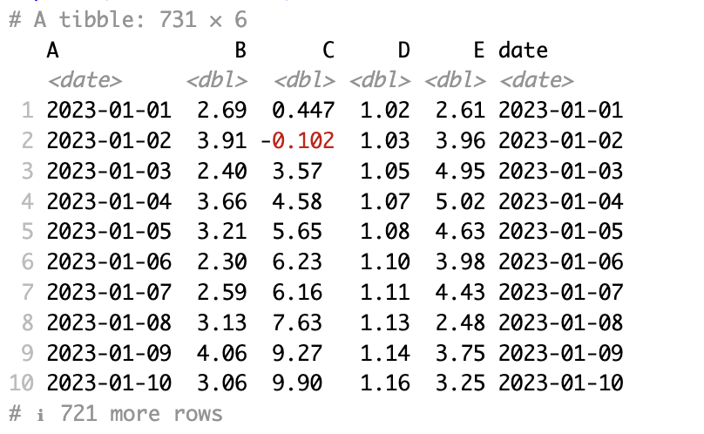

3. Converting to a tsibble using the appropriate field as an index.

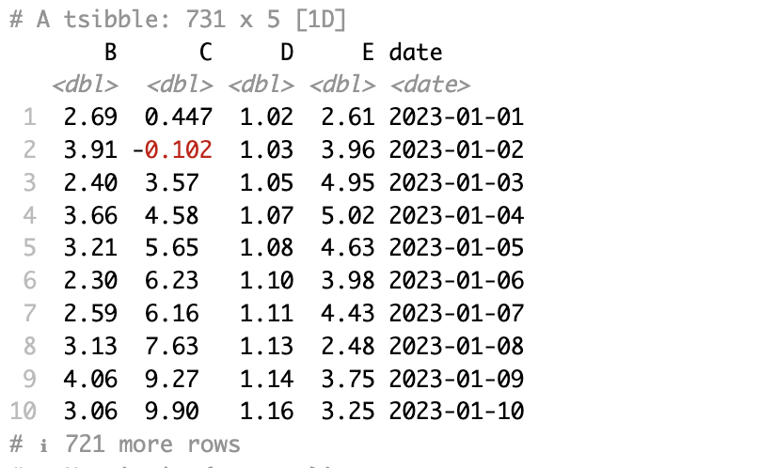

4. To check if the time series is a White Noise, it is necessary to do the ACF plot.

- ACF plot for B column

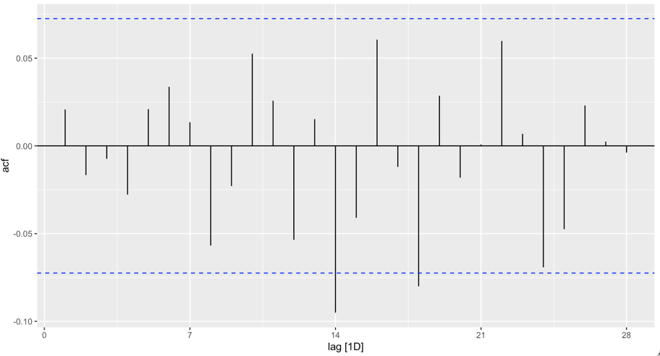

Decision:

Observing the ACF plot for this column, we can see that there are only 2 spikes that fall outside the interval for lags>0. The pattern is a White Noise because the autocorrelations are very close to 0.

- ACF plot for C column

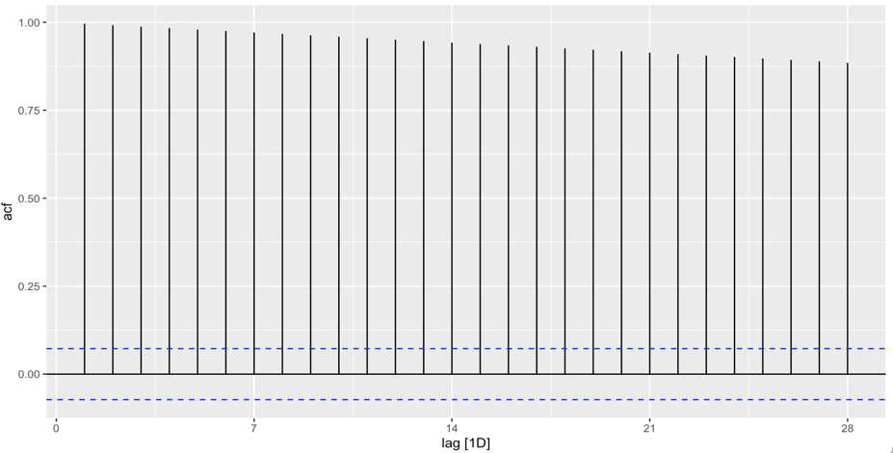

Decision:

The ACF plot for column C shows autocorrelations near 1 that remain large and positive for many lags. There is a presence of strong trends, so there is no White Noise.

- ACF plot for D column

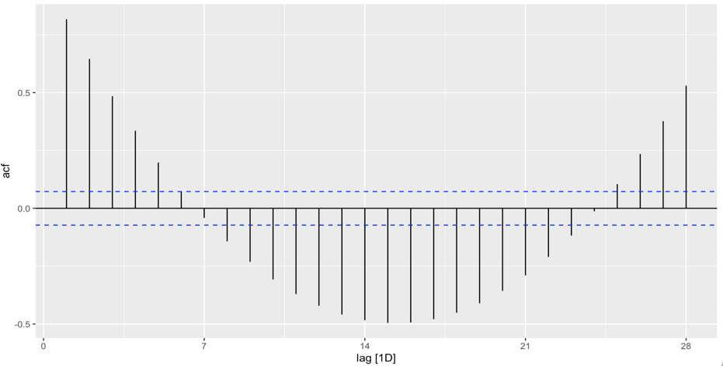

Decision:

The ACF plot for column D shows significant spikes at many lags. Not all ACF values are close to zero, so there is no White Noise.

- ACF plot for the E column

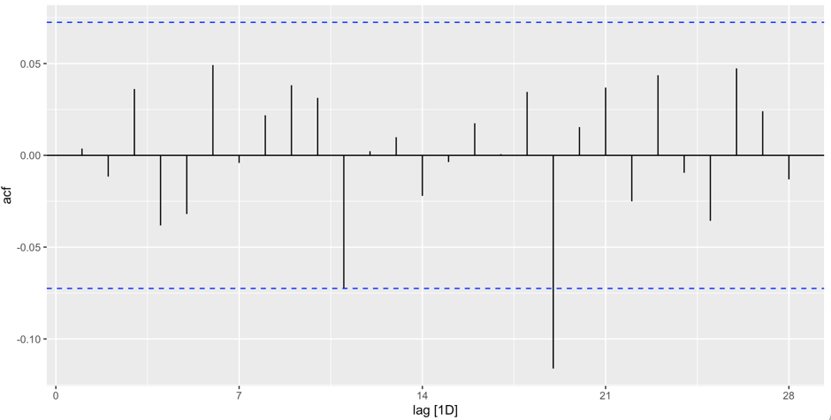
Decision:

The ACF plot for column E has values close to 0. It doesn't show any trend, so there is White Noise.

- ACF plot for adate column

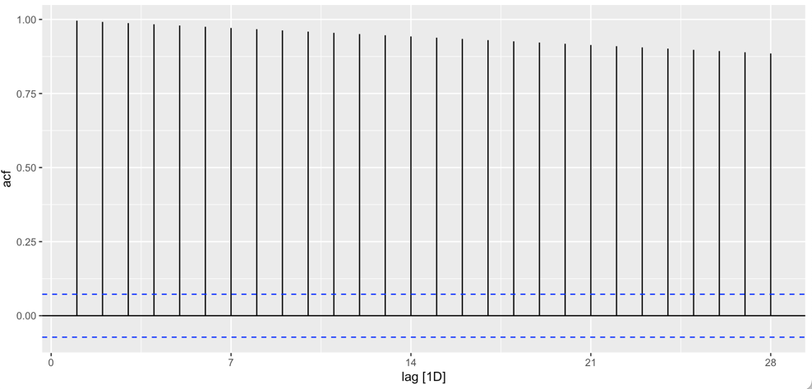

Decision:

The ACF plot for column date shows significant spikes, near 1, at all lags. Every ACF value is not near 0, so there is no White Noise.

5. The B and E are identified as the white noise columns.

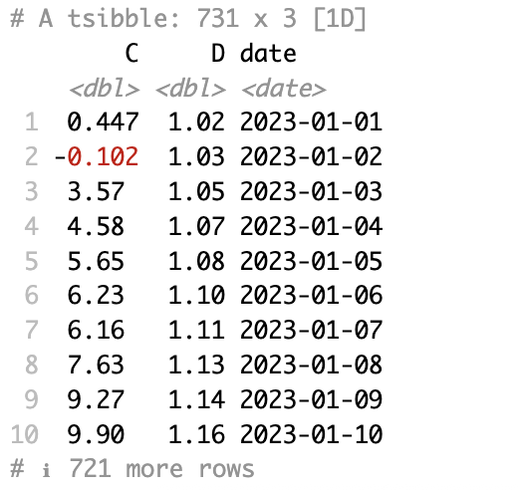

6. Weekly tsibble object:

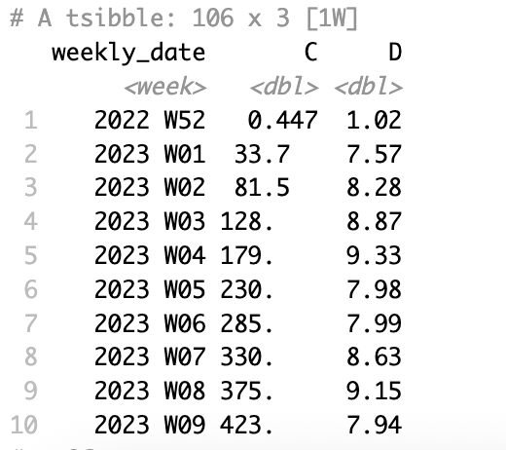

7.

- a) Weekly Time Series for C column

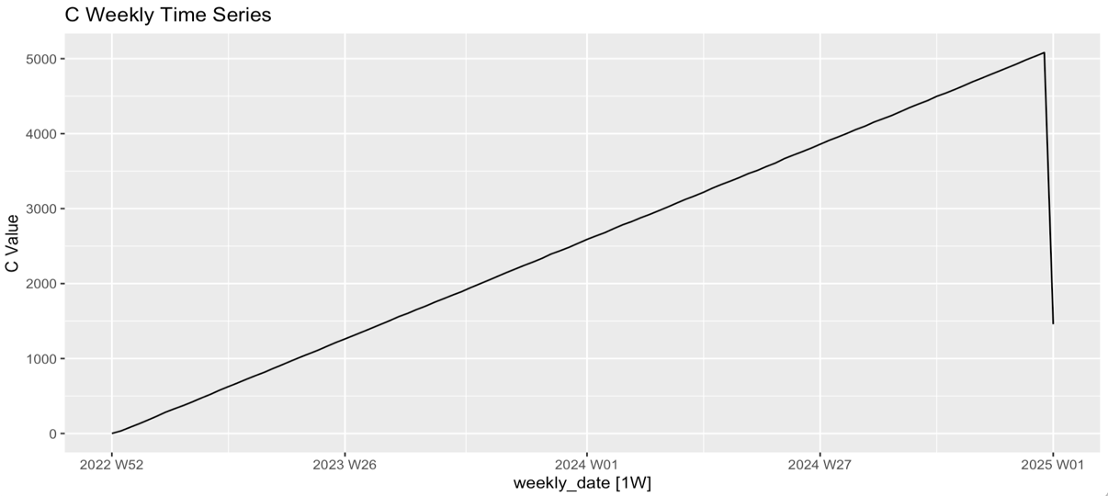
- a) Weekly time series for D column.

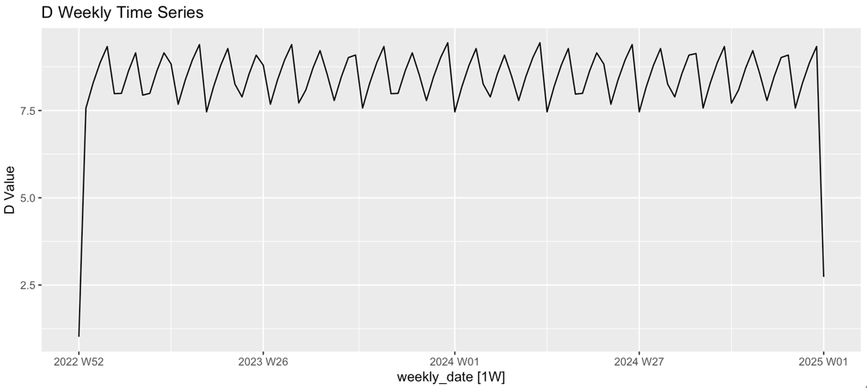

8) Describing the patterns presented.

a) Weekly Time Series for C column:
The value of C presents a clear upward trend in time. The trend is strongly positive with a sudden and sharp drop in 2025. The trend is non-stationary because it is not constant over time. There are no clear seasonal patterns, no regular cycles.

b) Weekly Time Series for D Column
The value of D presents a strong and regular seasonal pattern. At the same time, monthly, the cycle repeats. This trend doesn't present a clear trend, but the pattern remains constant at a specific period. So, the time series is stationary.

Question 2:

- Converting the file to tsibble:

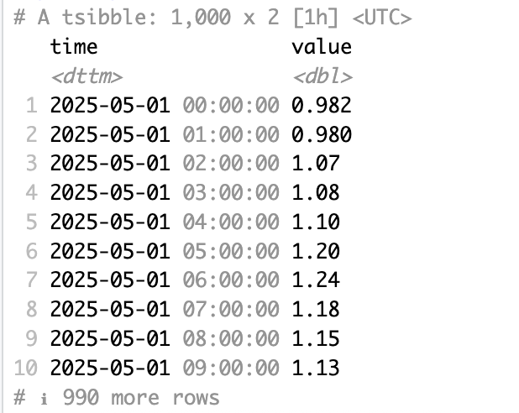

- Transforming data to : log, square root, cube root:

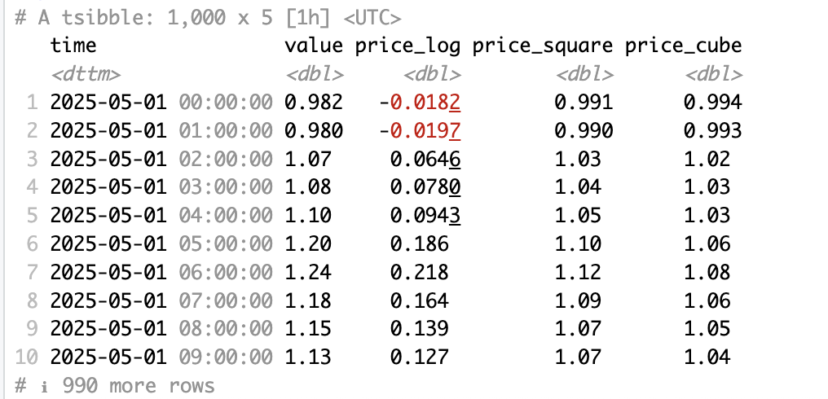

Displaying the graphs:

- Log Transformation:

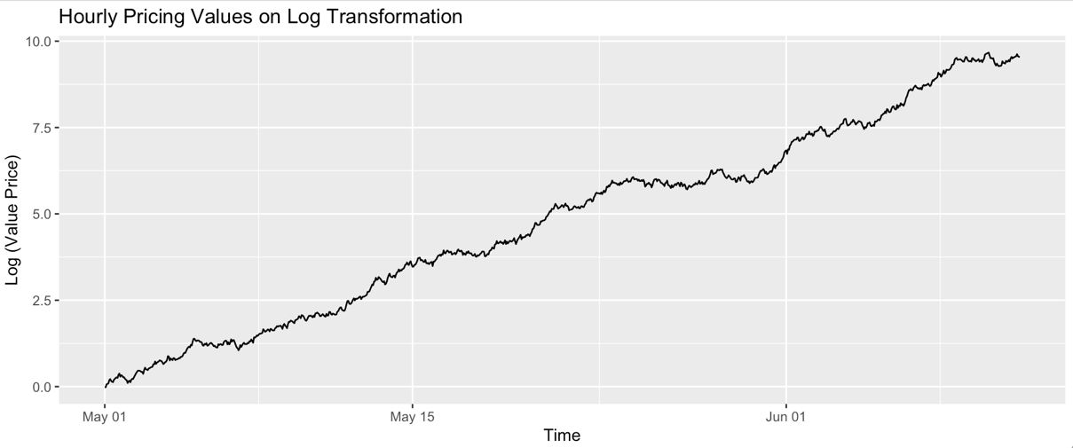

- Square Root Transformation:

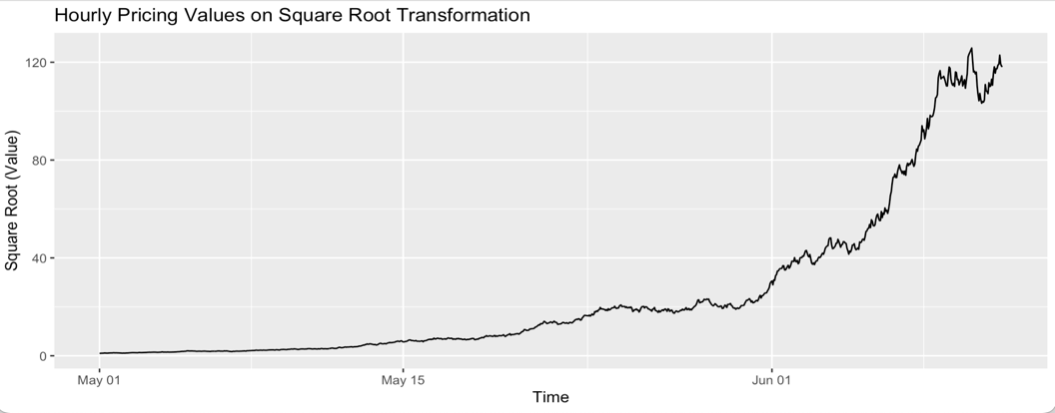

- Cube Root Transformation:

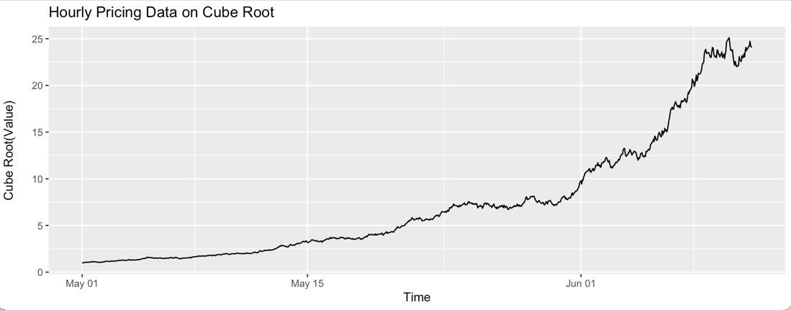

- To use the mean method in a proper way, the data should be stationary. The log transformation shows stability over the entire series, presenting a constant variance. These characterisations are crucial for the mean method.
The square root transformation shows irregular growth, with the majority of the growth being towards the end, which shows the increase in variance at high values, not meeting the requirements for using the mean method.
The cube root shows a stabilisation of the variance, but not as strong as the log transformation, which shows us that this transformation is the least suitable for the mean method.
Observing the 3 transformations, we can say that log transformation is the appropriate choice because it is the most stable transformation, presenting a constant variance, which is very important for the mean method.

- Applying the mean method to forecast the pricing.

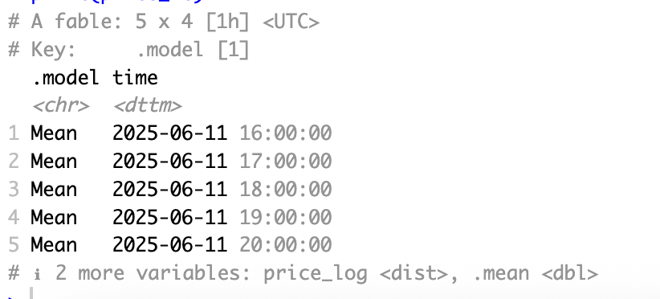

5. Display your forecast on a plot that also shows the data starting from 11th June 2025.

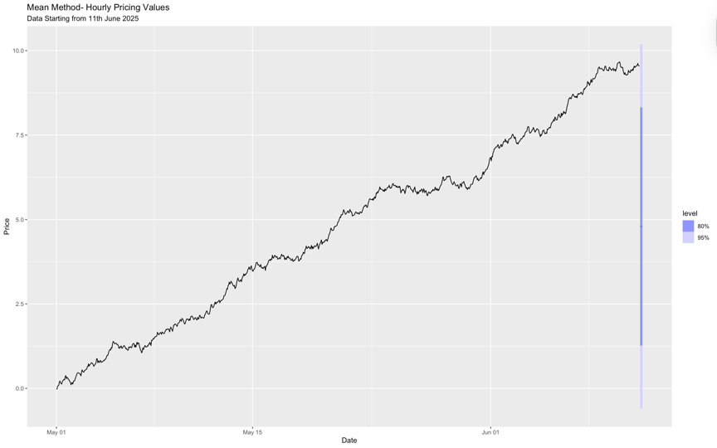

Question 3:

- Converting the data to tsibble. Converting the date column to a time index.

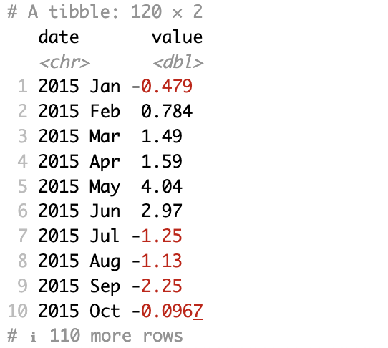

- Split data into:

- Train Data:

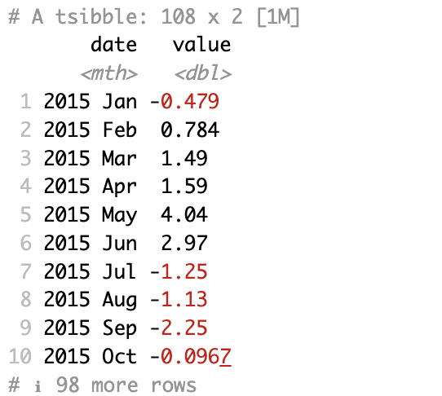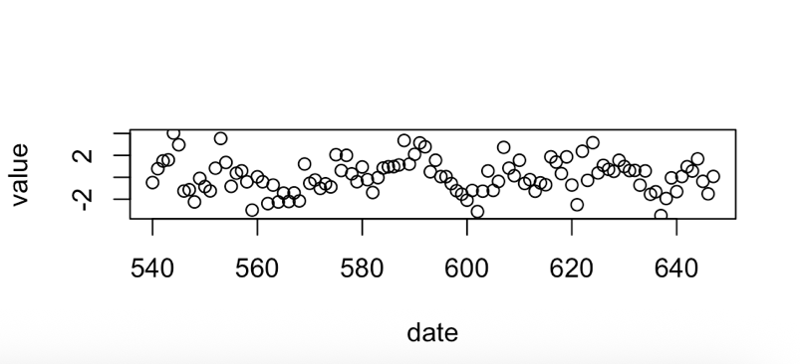

- Test Data:

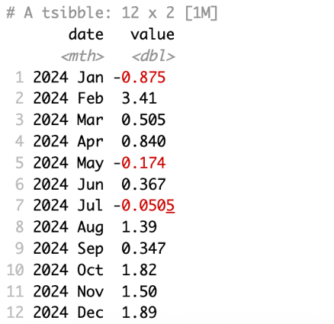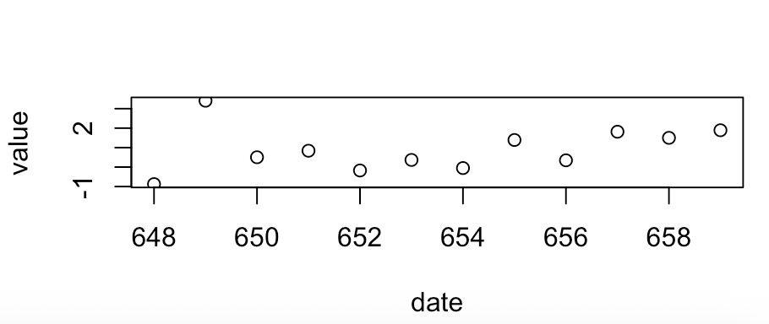

- Fitting ARIMA:

p=1, P=1, m=12.

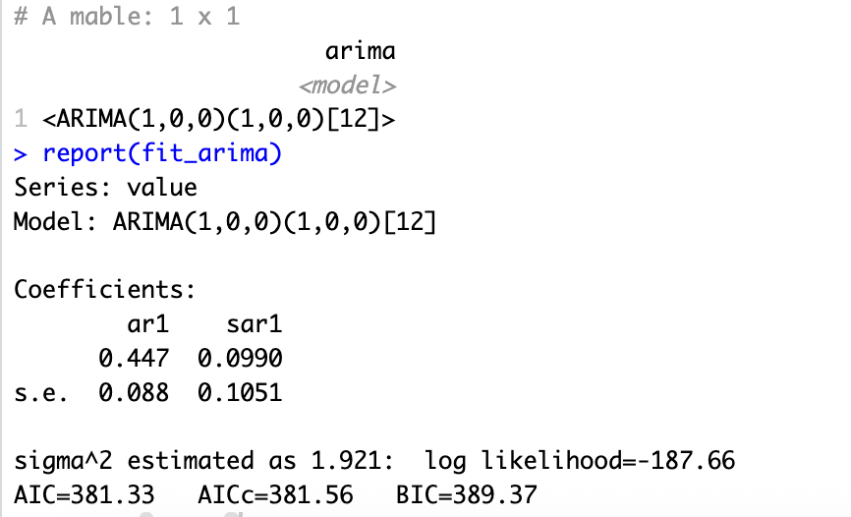

- The exercise tells us that the two parameters p and P are equal to 1, and the rest of the parameters are equal to 0, so:
ARIMA(p,d,q) represents the non-seasonal part of the model. ARIMA(P,D,Q)m represents the seasonal part of the model, and m is the number of observations per year.
p=1 - non-seasonal autoregressive order
d=0 – this series is stationary because this is a non-seasonal differencing order.
q=0 – the 0 value means that the model will not produce any errors in the forecast.
P=1 - seasonal autoregressive order, and it is based on the value of the last 12 periods.
D=0 - no seasonal differencing is applied.
Q=0 - no seasonally lagged forecast errors.

- Fitting an NNAR model with the same seasonal lags and non-seasonal lags as the ARIMA model.

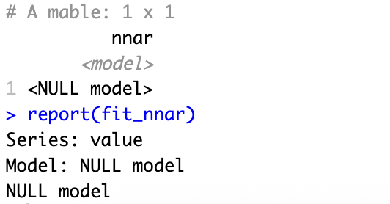

- Forecast the models ARIMA and NNAR:

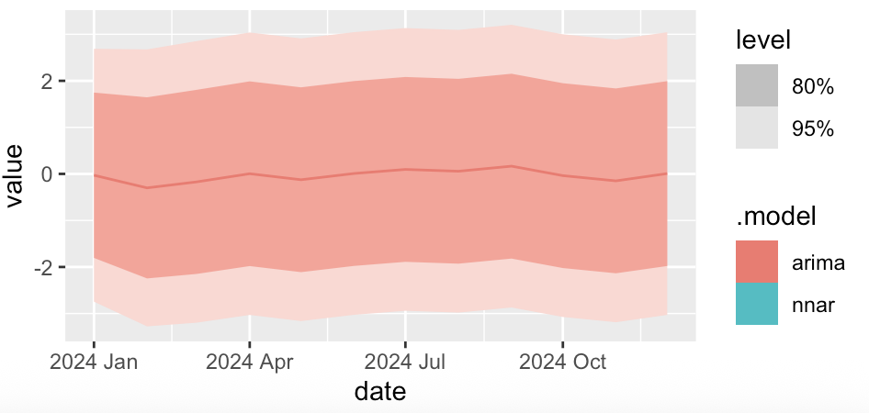

RSME result:

