**Plan – my workflow**

**Get timestamps in milliseconds for the Pupil lab data**

**Merge raw data**

* A strategy will be to loop over each row in the manually annotated Boris data and for each timestamp find the nearest timestamp in the pupil lab data.
* A way to do this is by subtracting the annotated timestamp from all timestamp in the Pupil data and find the row with the lowest divergence; subtract all information from the other columns in this row.
* Loop over every single one.

**Visualizations and potential modelling**

**Questions for meeting 22/04**

* What columns are necessary?
* The time durations for each block are often longer than the time manually annotated with fixations. How come? Did the eyetracker keep recording?
* Is it correctly understood that I should just extract one row of from the pupil data per fixation annotated in the boris data? That is what I’ve currently done.

**Questions for Mihaela.**

* The function to convert from pupil to UNIX is giving me a hard time. I’ve based it exactly on the one from the documentation

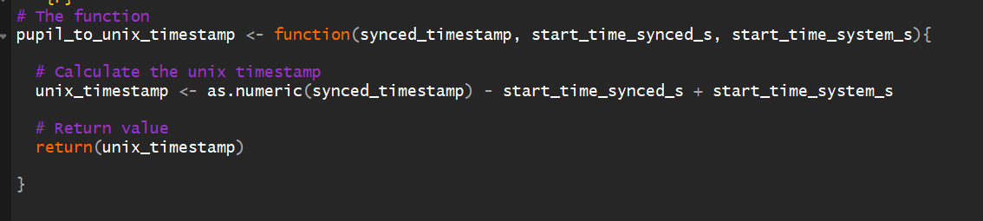

* It says one should add start_time_system_s which is a weird insanely high number from the json file. Then the output is as well a weird insanely high number. If we just don’t, it makes way more sense – and we will get something that seems like timestamps from approx. 0-185.21 (in this case)

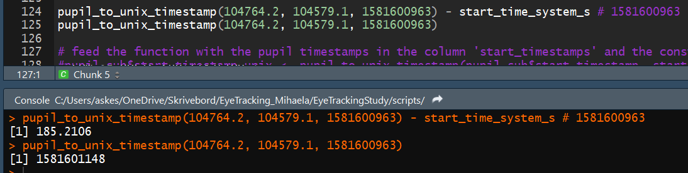

There are some rows in boris with identical timestamp but different information meaning that they will merge with the same row from pupil data

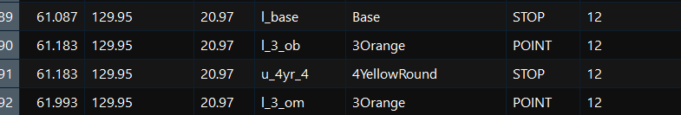

* I don’t understand how one can be looking at 3Orange and 4YellowRound at the same time? Is that on purpose?

There are also a few cases where the timestamp difference between to rows in boris is so small, that they will be assigned the same fixation from the pupil data. I don’t really know what to do about that.

**Meeting 05/05**

* Behaviour column contains u l and ACC BC which is all behaviour and not related to the object looked. Only the L. Thus create code to extract only rows with an l. probably solved with some regular expressions
* Look into the documentation again with calculating timestamps (links in email the 5th of may)
* What start timestamp should I extract? Might not be a big difference but could be relevant.

**To do**

* I have made a function to select only behavior “l”
* Final edit of the readme file
* Create some plots and visualisations similar to what has been done in the little preprint

**Meeting 20/05**

* Create visualisations (from the report)
* Be aware that the first number in the brick names that is the amont of bricks in that category – meaning that some bricks are more likely to be looked at by chance than others.
* (done) All data should be included (as in I should not remove the overlapping durations) that is the way they have been coded.
* (done) Go with export files when calculating time stamps

Meeting 11/6

* Remove grid from the background
* 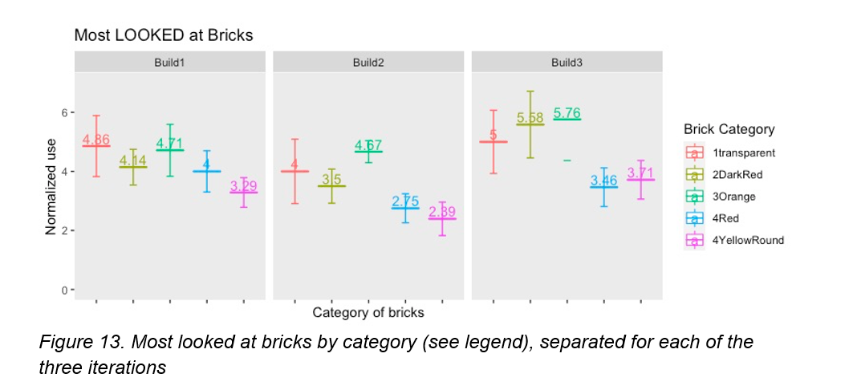
* Counts of how many times each brick has been looked at
* Maybe do it with total fixation duration for most looked at bricks
  + Look at fixation time by fixation duration
  + Look at total fixation by child
* Most used bricks (behaviour U instead of l)
  + + duration
* Remember to normalize by bricks (divide by the number of bricks in each category)

Hypothesis: in the beginning, the kids will look more at the 4 yellow round brick and the transparent – because they attract attention when building a car. Afterwards they are used to them and will switch to look more at the other categories.

* Add predictor with the number of bricks in the same category.