***-Project documentation-***

Created by:

-Neagoi Mihai

-Oltean Andrei

**Tetris**

***1)Game structure:***

The game is divided into 3 classes the Piece class which is the current piece that is running down the board and the PieceArrangement class which stores all the pieces that have been placed. The third class is the game panel which displays everything nice and tidy.

Collision detection has been done in two ways :

**1)** using the checkCollision function which takes as a parameter a direction (character “LDR” - left down right) and return either true or false.

**2)** using handleRotationCol which moves the piece up (after rotating) as long as it is colliding with a placed piece (from pieceArrangement)

***2)Data:***

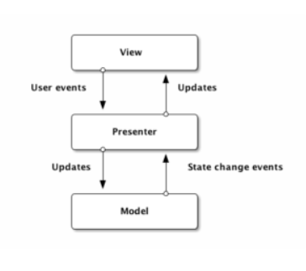

When registering the user must pick a unique nickname and also a unique user/password combination. Then the data is hashed (using sha256 encryption) and introduced into the table.

After each game is finished the game data (lines cleared, score, user etc..) are saved into the database.

The user can see all scored ordered in ascending order in the Scoreboard menu.

***3)How to play:***

When opening the app the user is prompted with a login screen.

You have to register yourself with a name, a password and a nickname. After creating the new user the Register button will drag you bag to the login screen where you can log in with your creditentials.

After pressing “***Log in***” a new screen will pop up, where you must press any key to show the main menu.

There are 3 buttons he can click. “***Start game***” starts the game, “***Scoreboard***” shows the top players along with their nicknames, “***Quit***” exits the game.

After starting the game, the player can move the piece using the arrow keys (left, right, down) and space (to place the piece), also you can rotate the piece with an 90 degree angle, each press of Z on the keyboard, so you can fit it in the best spot.

After the ***Game Over*** screen the user must press **Enter** to proceed to the main menu screen.

The Scoreboard content:

And there are some precautions and warning messages in some cases, where the username/nickname is taken or when the username and password don’t match.

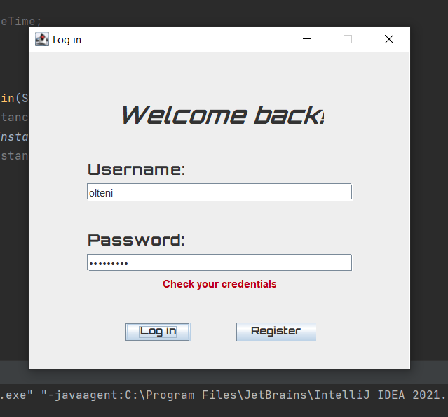

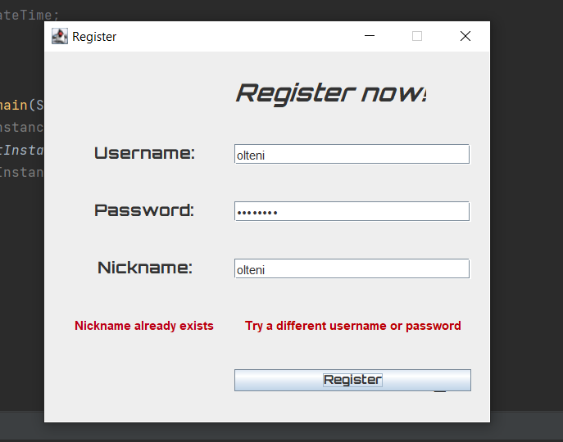

***4)Conclusion:***

We tried our best to reproduce an old game that made an impact on our childhood, working on it was nice and fun and also we developed our programming skills.

***5)Improvements:***

***…***