Movie Booking Web Application

Use-Case Model

Version 1.2

Revision History

|  |  |  |  |
| --- | --- | --- | --- |
| **Date** | **Version** | **Description** | **Author** |
| 19/03/2023 | 1.0 |  | Enache Mihai |
| 16/04/2023 | 1.0 | Changed project idea | Enache Mihai |
| 01/05/2023 | 1.1 | Back to the original project idea | Enache Mihai |
| 20/05/2023 | 1.2 | Final touched on doc | Enache Mihai |

Table of Contents

1. Use-Cases Identification 4

2. UML Use-Case Diagrams 4

# Use-Cases Identification

1. **Actors:**

* **Users** – The primary user of the application who visits the website to search for movies, view showtimes, and book tickets. The customer can create an account, login, and access features such as movie listings, theater locations, ticket booking
* **Admins** – Individuals who are responsible for the management of the website

1. **Scenarios:**

* User Registration
* User/Admin login
* Search a movie (user/admin)
* Add a movie (admin – he has to be logged in to the system)
* Delete a movie (admin – he has to be logged in to the system)
* Edit movie details (admin – he has to be logged in to the system )
* Add a theatre (admin – he has to be logged in to the system)
* Add a show (admin – he has to be logged in to the system)
* Add a screen (admin – he has to be logged in to the system)
* Add seats for a show (admin – he has to be logged in to the system)
* Notify users via email when a new movie has been added (admin – he has to be logged in to the system)
* Book a movie (user - he has to be logged in to the system)
* View movie details (user/admin)

1. **Use-Cases:**
2. **User Registration**

*Level*: User-Goal Level

*Primary* *Actor*: User/Admin

*Main Success Scenario*:

1. The user visits the website and clicks on the *Login* button.
2. A form will displayed to the user and if he doesn’t an account, he can create one by click on the *Sign up* button
3. The website prompts the user to enter his details (*username, email, password)*
4. The user enters their details and submits the form.
5. The user is now registered and can log in to the website (the user is redirected to the *Login* page
6. **User/Admin Login**

*Level:* User-Goal Level

*Primary Actor:* User/Admin

*Main Success Scenario:*

1. The user/admin visits the website and clicks on the *Login* button
2. The user/admin enters his credentials to login (*username, password)*
3. After entering the needed credentials, the user/admin clicks on the *Login* button
4. The user/admin is redirected to the *Home* page
5. **Search a movie**

*Level*: User-Goal Level

*Primary* *Actor*: User

*Main* *Success* *Scenario*:

1. The user visits the website and enters the name of the movie they want to search for in the search box.
2. The website displays a list of movies that match the search query.
3. The user selects the desired movie from the list.
4. The website displays the movie details, including showtimes, theater locations and the seats available for the chosen show for the selected movie
5. **Add a movie**

*Level*: Admin-Goal Level

*Primary* *Actor*: Admin

*Main* *Success* *Scenario*:

1. The admin logs in to the website and click on the *Add Movie* button.
2. The admin is redirected to a form when he can enter the movie details
3. The website prompts the admin to enter the movie details, such as *title*, *genre, description, duration, rating, language, price* and an *image* for the movie (which he can browse for it or drag & drop it)
4. The admin enters the movie details and submits the form by clicking on the *Add Movie* button.
5. The website creates a new movie entry in the database.
6. **Edit a movie**

*Level:* Admin-Goal Level

*Primary Actor:* Admin

*Main Success Scenario:*

1. The admin clicks on the *Show Movie Details* button
2. A table will be displayed. If the desired movie doesn’t appear on the table, the admin can click on the *Load more* button. The displayed movies are limited so not all the movies will be retrieved from the database (for a better performance of the website)
3. When the desired movie appears on the table, the admin clicks on the icon in the *Edit* column of the table
4. The admin is redirected to a form whose fields are filled from the existing details of the movie
5. The admin edits the desired fields
6. The admin clicks on the *Edit Movie* button
7. The admin can go to *Show Movie Details* pageto see if the modifications has been successfully executed
8. **Delete a movie**

*Level*: Admin-Goal Level

*Primary* *Actor*: Admin

*Main* *success* *scenario*:

1. The admin clicks on the *Show Movie Details* button
2. A table will be displayed. If the desired movie doesn’t appear on the table, the admin can click on the *Load more* button. The displayed movies are limited so not all the movies will be retrieved from the database (for a better performance of the website)
3. When the desired movie appears on the table, the admin clicks on the icon in the *Delete* column of the table
4. The admin can go to *Show Movie Details* pageto see if the modifications has been successfully executed
5. **Add a theatre**

*Level*: Admin-Goal Level

*Primary* *Actor*: Admin

*Main* *success* *scenario*:

1. The admin clicks on the *Add Theatre* button
2. The website prompts the admin to enter the theatre name
3. The admin submits the form by clicking on the *Add Theatre* button
4. The website creates a new theatre entry in the database
5. **Add a show**

*Level*: Admin-Goal Level

*Primary* *Actor*: Admin

*Main* *success* *scenario*:

1. The admin clicks on the *Add Show* button
2. The website prompts the admin to choose a theatre, a screen, a movie and to enter the show start time
3. The admin clicks on the *Add Show* button
4. The websites creates a new show entry in the database
5. **Add a screen**

*Level:* Admin-Goal Level

*Primary Actor:* Admin

*Main success scenario:*

1. The admin clicks on the *Add Screen* button
2. The website prompts the admin to choose a theatre and to enter the screen name and capacity
3. The admin clicks on the *Add Screen* button
4. The websites creates a new screen entry in the database
5. **Add a seat**

*Level:* Admin-Goal Level

*Primary Actor:* Admin

*Main success scenario:*

1. The admin clicks on the *Add Seat* button
2. The website prompts the admin to choose a show and to enter the seat number and its availability (true – available, false – taken)
3. The admin clicks on the *Add Seat* button
4. The websites creates a new seat entry in the database
5. **Notify users when a new movie is added**

*Level:* Admin-Goal Level

*Primary Actor:* Admin

*Main success scenario:*

1. The admin clicks on the *Notify* button
2. The website pops up a message of success or error if the notify operation has been executed successfully
3. **Book a movie**

*Level*: User-Goal Level

*Primary* *Actor*: User

*Main* *success* *scenario*:

1. The user clicks on the *View* button to see the movie details
2. The user clicks on the *Book* button
3. The website redirects the user to a booking page and displays the available seats for the selected showtime and theatre location.
4. The website displays the total cost.
5. The user selects the desired seats and clicks on the *Book* button.
6. The page gets reloaded
7. The website creates a new booking entry in the database
8. **View movie details**

*Level:* User-Goal Level

*Primary actor:* User/Admin

*Main success scenario:*

1. The user/admin clicks on the *View* button
2. The user/admin is redirected to a page where he can see the movie details

# UML Use-Case Diagrams

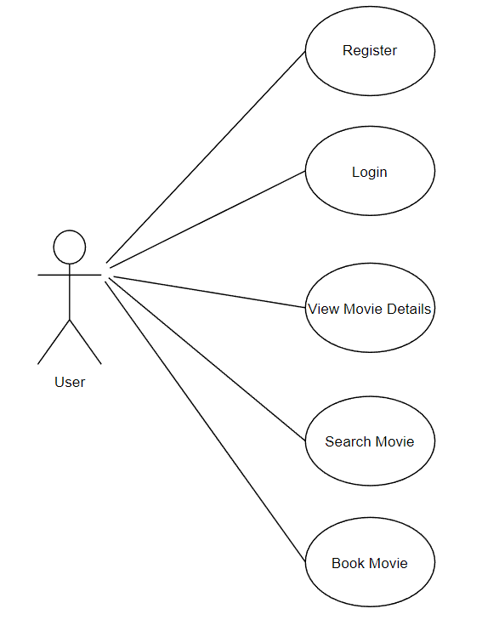

**User UML Use-Case Diagram**

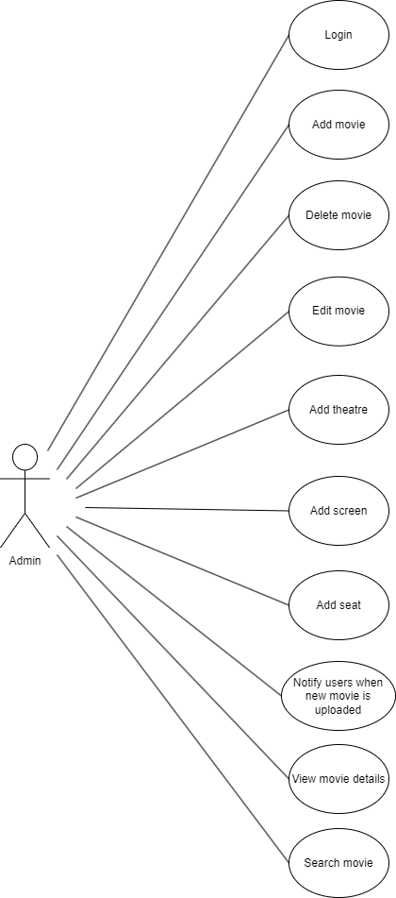

**Admin UML Use-Case Diagarm**