JDK 1.8 [x64](http://download.oracle.com/otn-pub/java/jdk/8u73-b02/jdk-8u73-windows-x64.exe) / [x86](http://download.oracle.com/otn-pub/java/jdk/8u73-b02/jdk-8u73-windows-i586.exe)

IDE Eclipse Mars [x64](https://eclipse.org/downloads/download.php?file=/technology/epp/downloads/release/mars/2/eclipse-jee-mars-2-win32-x86_64.zip) / [x86](https://eclipse.org/downloads/download.php?file=/technology/epp/downloads/release/mars/2/eclipse-jee-mars-2-win32.zip)

Tomcat [x64](http://apache.javapipe.com/tomcat/tomcat-8/v8.0.32/bin/apache-tomcat-8.0.32-windows-x64.zip) / [x86](http://apache.javapipe.com/tomcat/tomcat-8/v8.0.32/bin/apache-tomcat-8.0.32-windows-x86.zip)

[Maven](http://apache.javapipe.com/maven/maven-3/3.3.9/binaries/apache-maven-3.3.9-bin.zip)  
setting maven environment variables:  
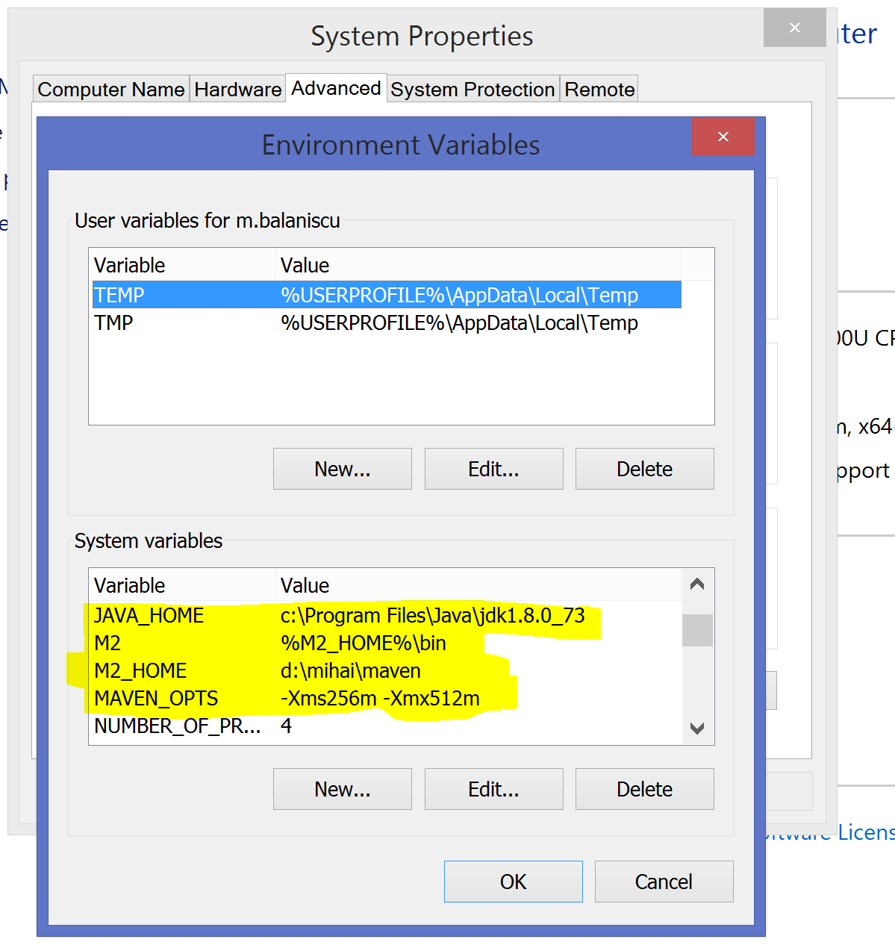

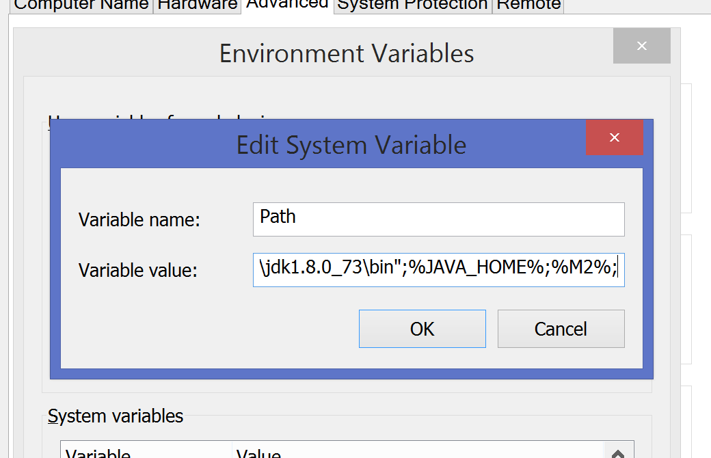

I have the following recommendation:

* Put the content of the server archive (Tomcat archive from above) to a location like: c:\tomcat or d:\tomcat depending on how many partitions you have
* Put the content of the maven archive in a location like: c:\maven or d:\maven
* Put the content of the eclipse archive to c:\eclipse or d:\eclipse
* Make a directory: C:\workspaces or D:\workspaces in order to keep all the work you do with eclipse
  + For our current project make a directory: C:\workspaces\bAIESEC or D:\workspaces\bAIESEC

Opening Eclipse and selecting the workspace directory (for me it also has mihai in path):

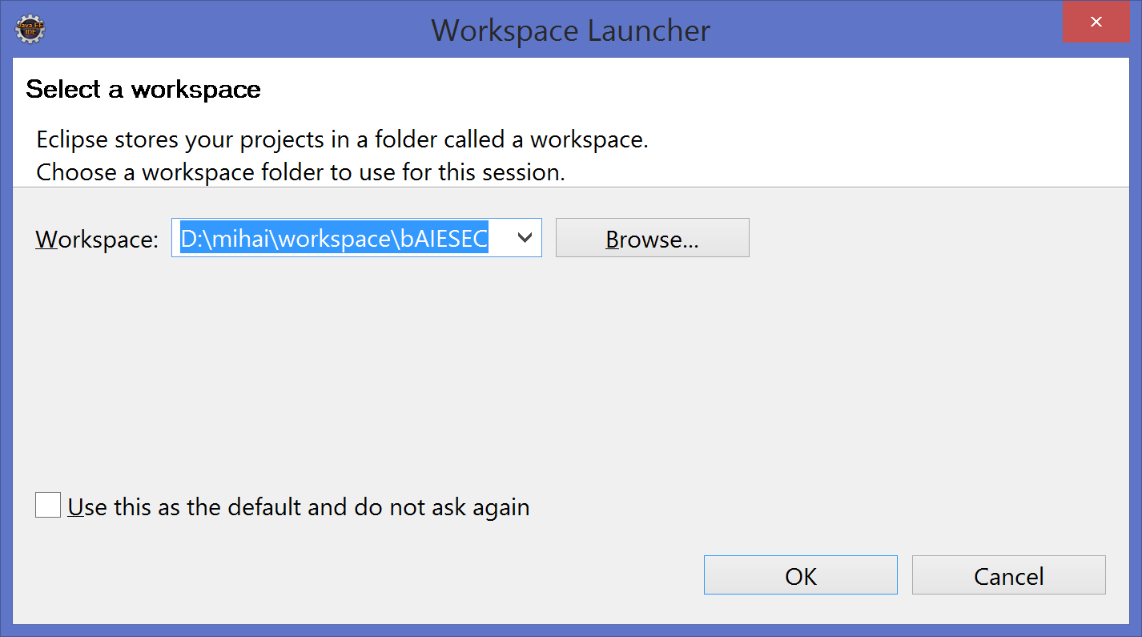

Since we are developers we use the JDK. Go to Window -> Preferences and in the filter input (top left) write ‘jre’ and you will see something like this:

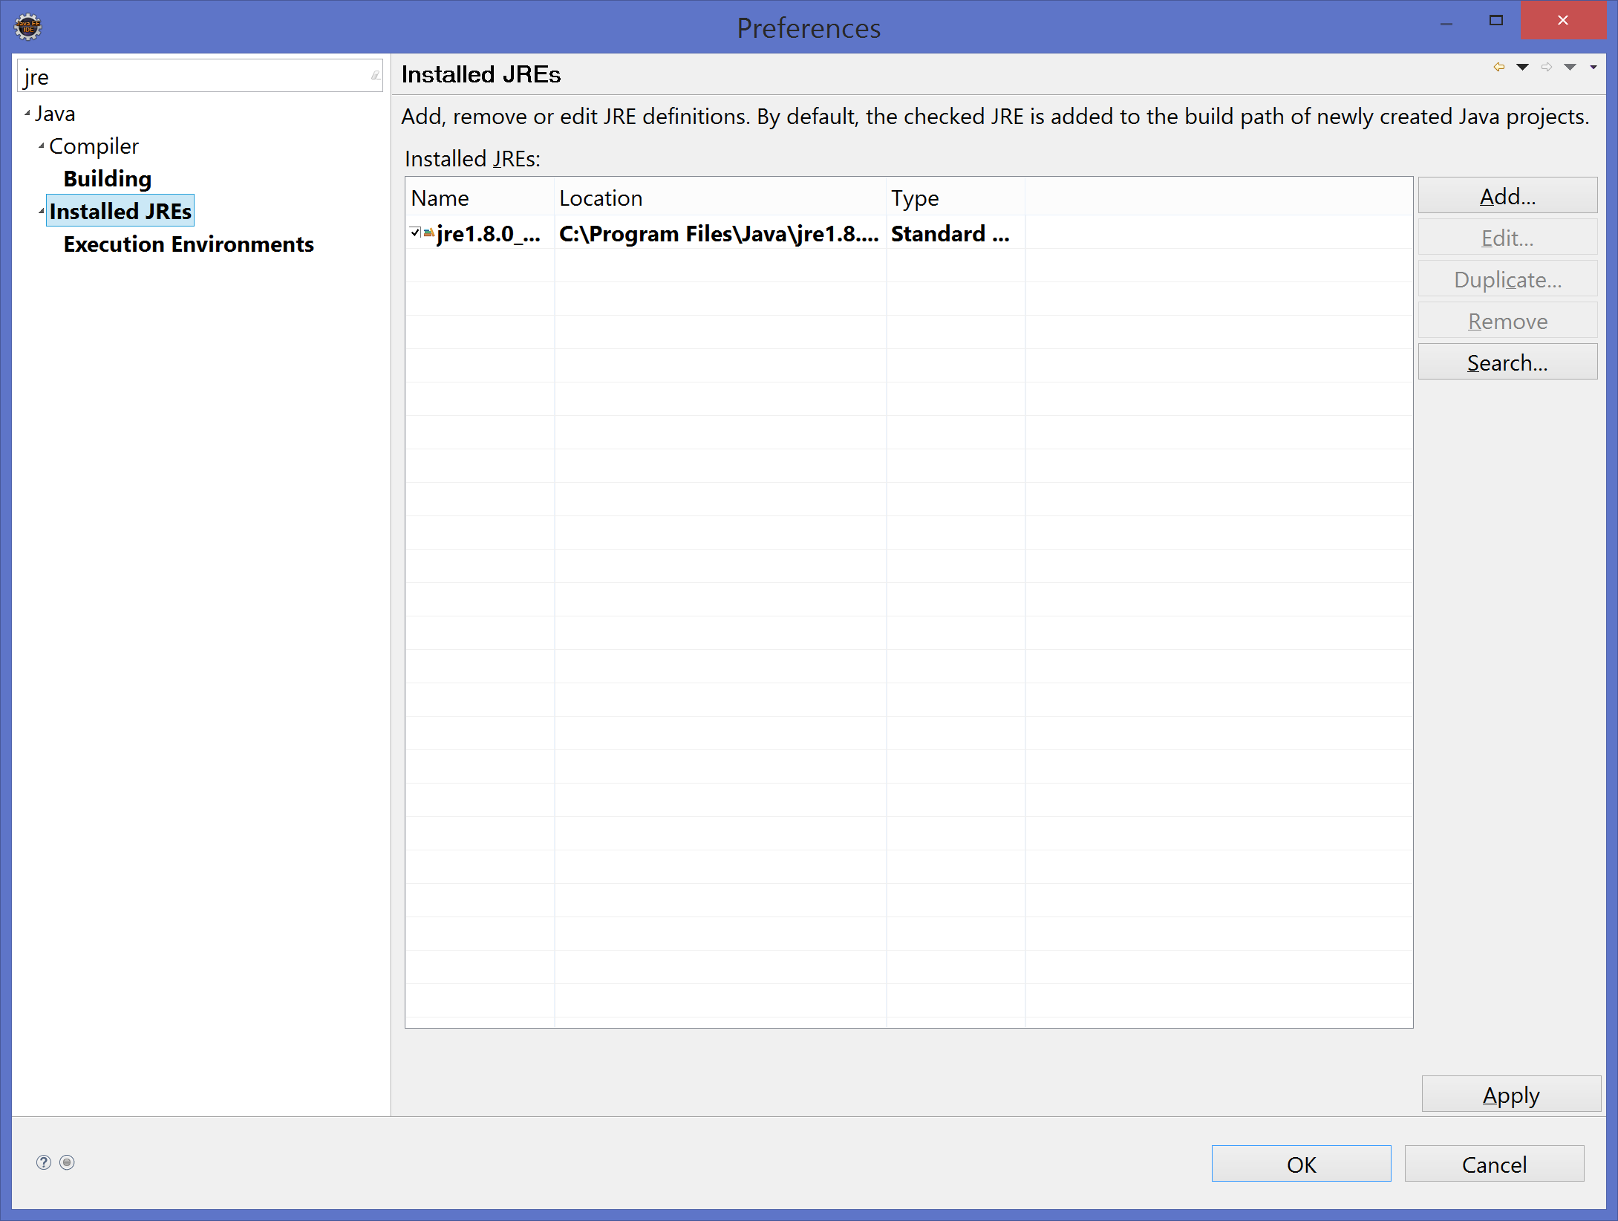

Remove the current JRE and add the JDK (for our example located at: c:\Program Files\Java\jdk1.8.0_73).

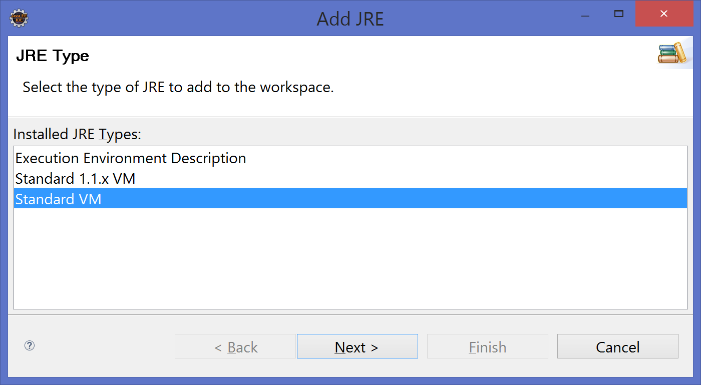

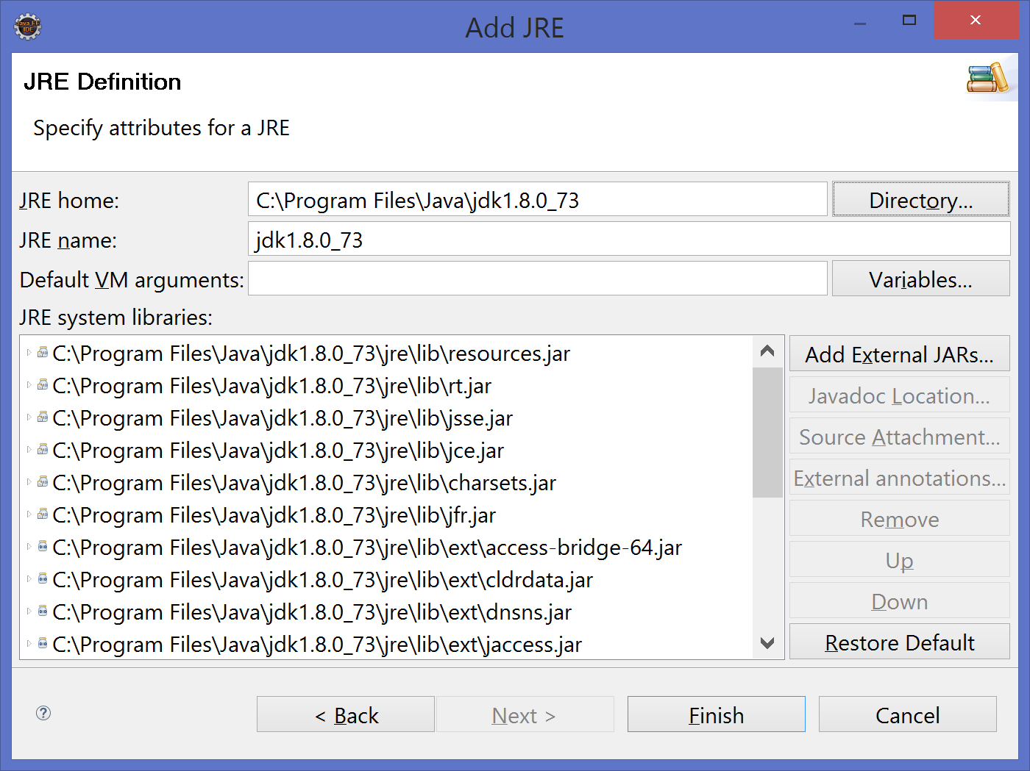

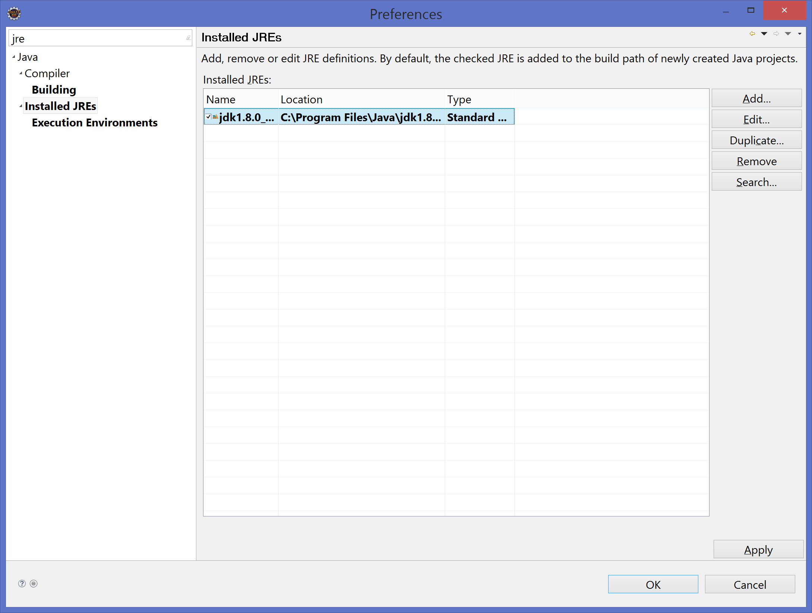

Click Apply (bottom right) to save your changes.

In the filter box write ‘runtime’ and select Runtime Environments from left side:

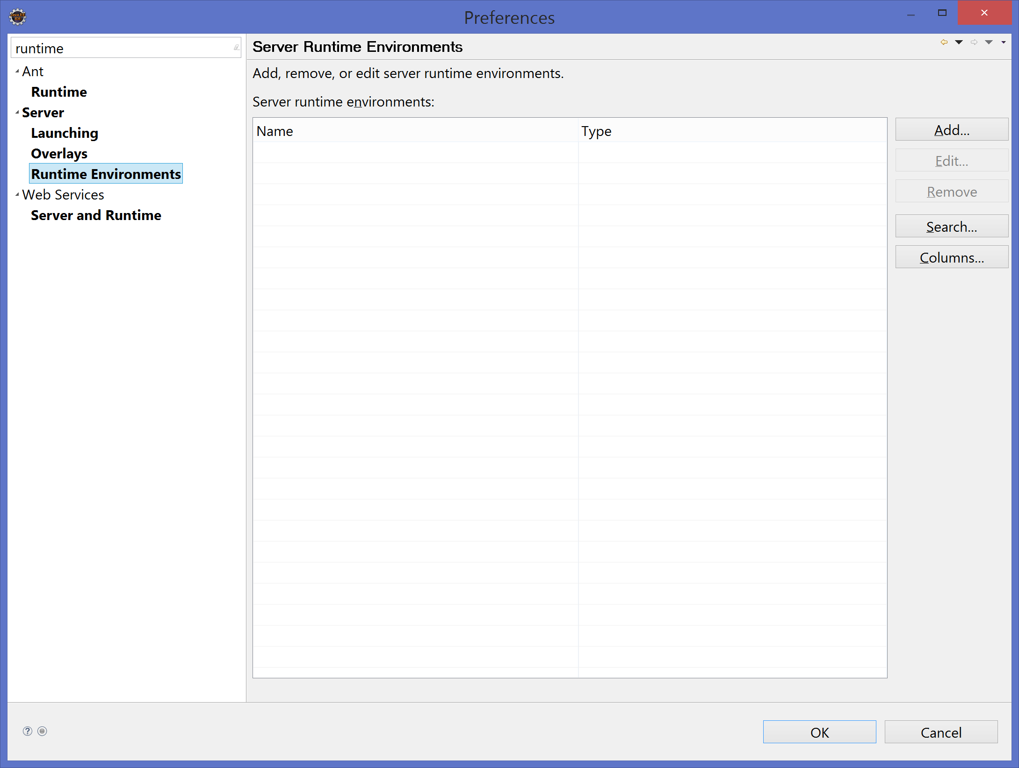

Click on Add (top right):

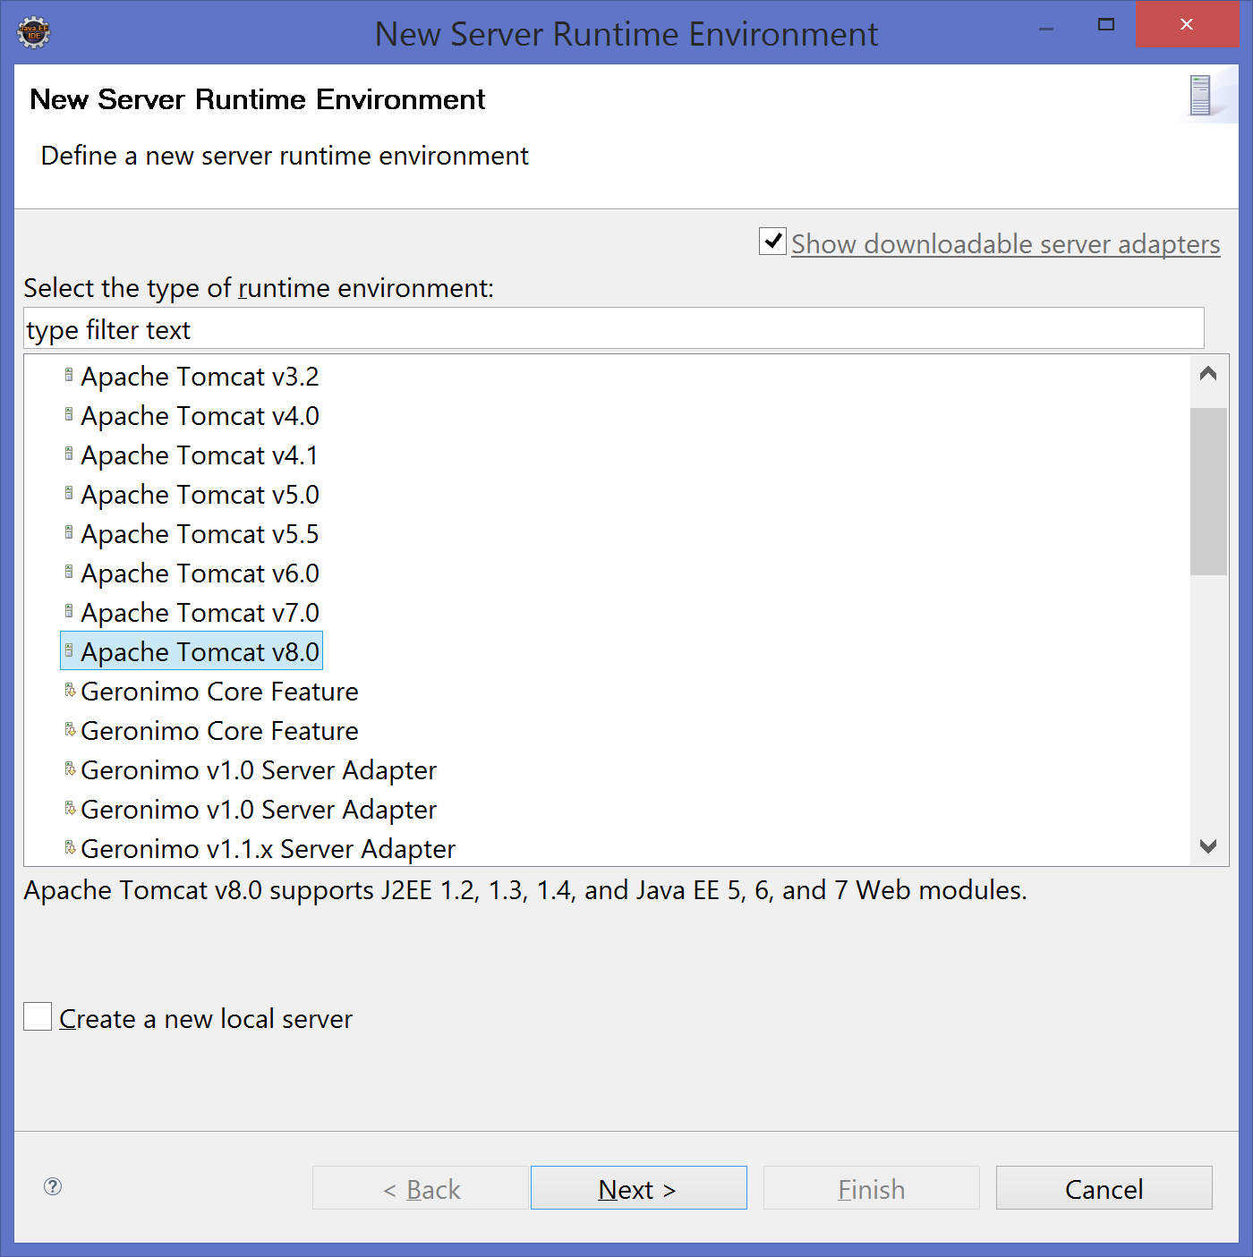

Select Apache Tomcat v8.0 and click Next

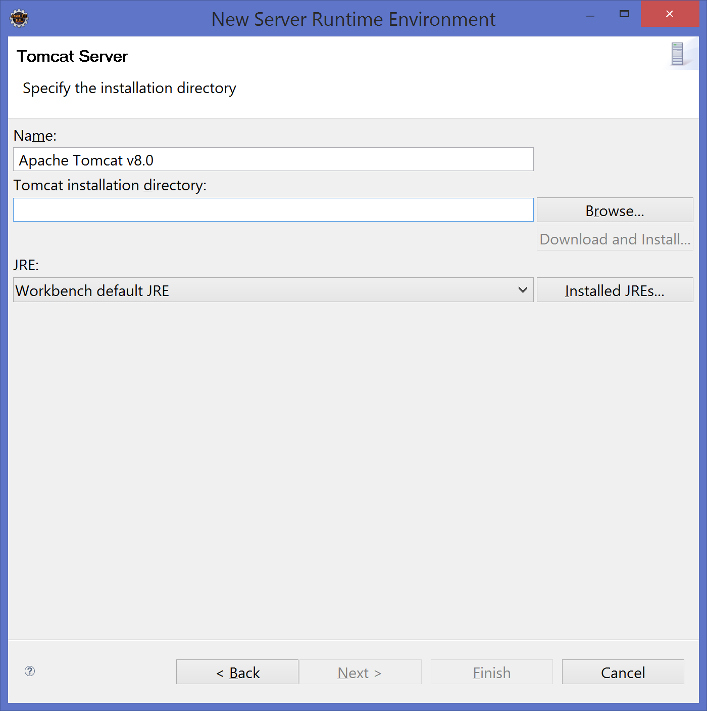

In the Tomcat installation directory write (c:\tomcat or d:\tomcat) or just browse for it ☺

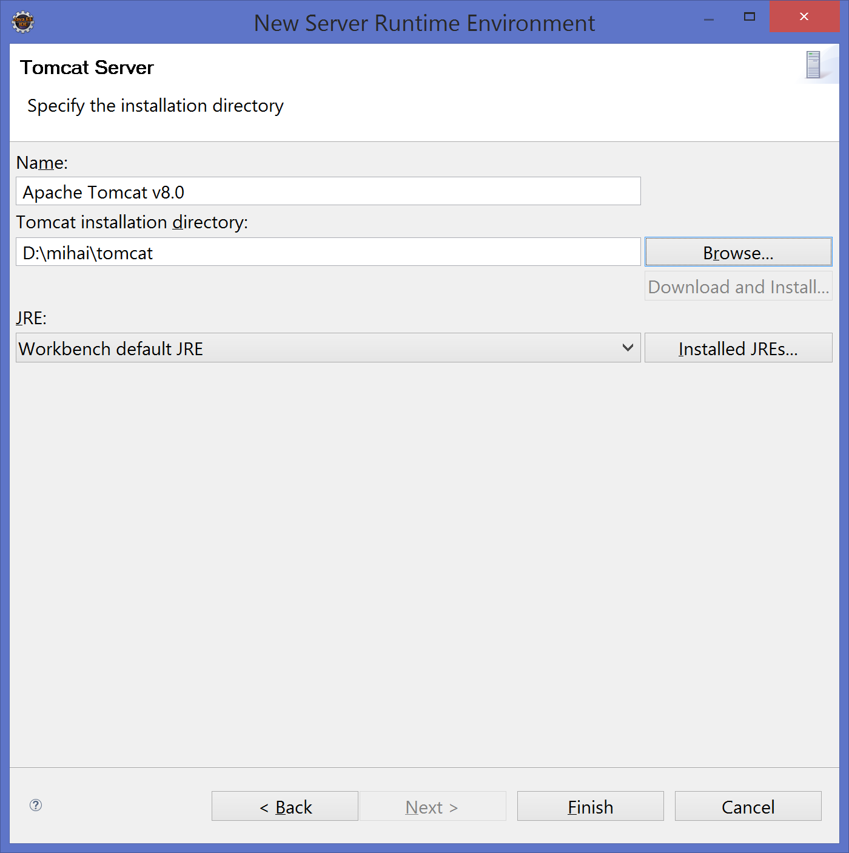

Change the JRE from Workbench default JRE to jdk1.8.0_73

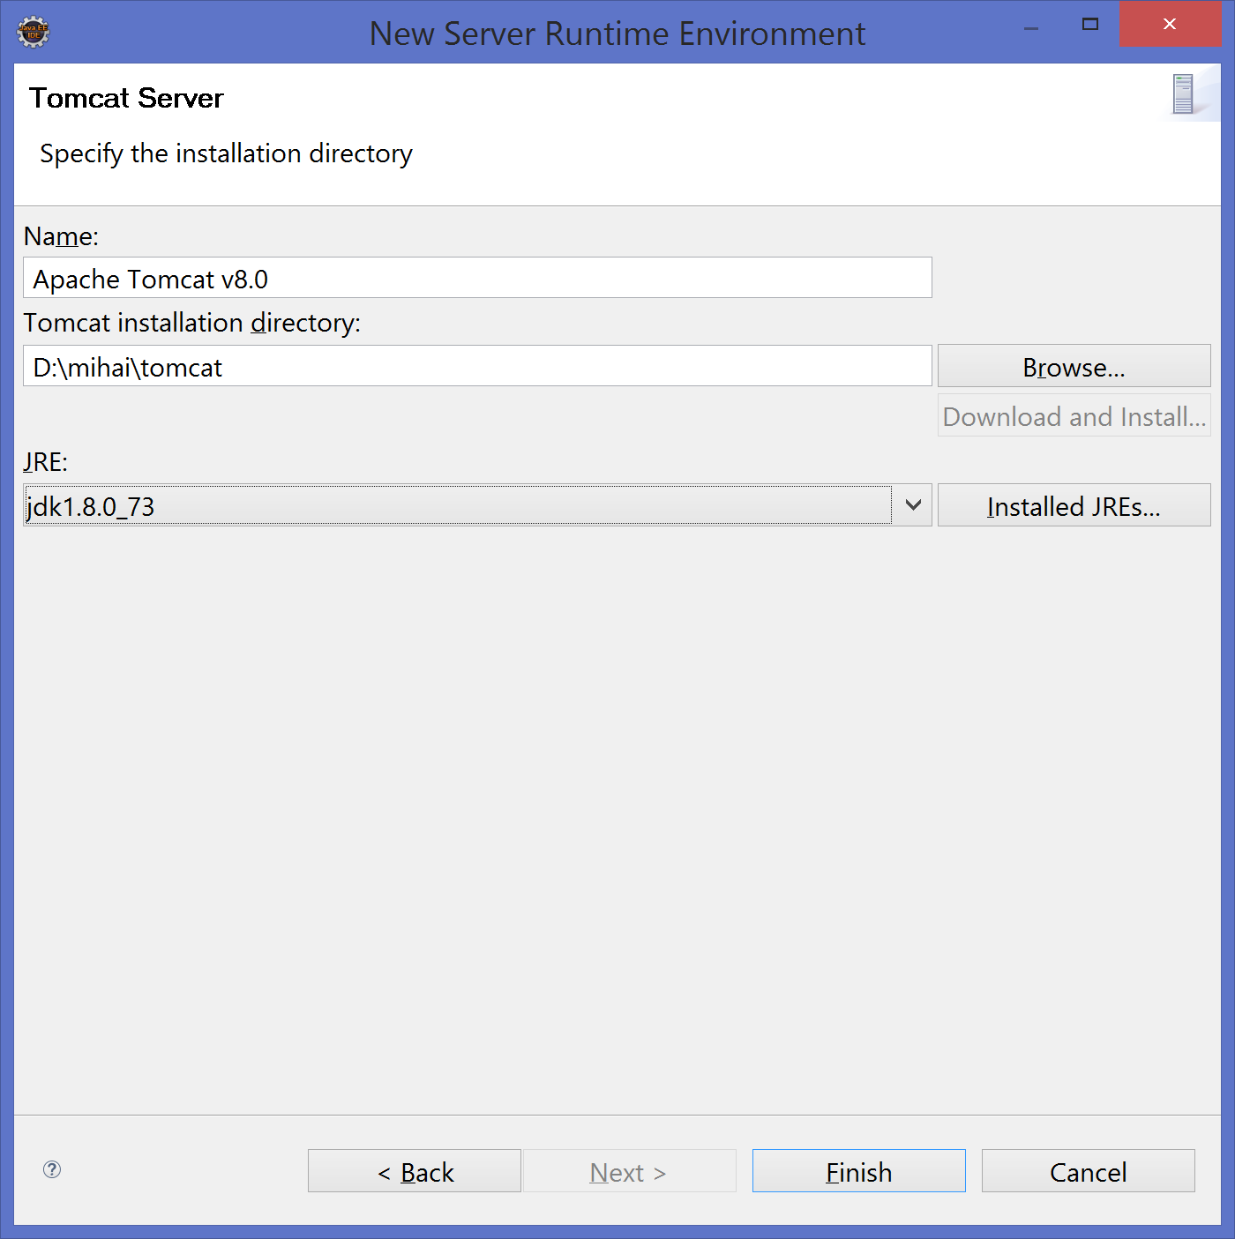

Click Finish, click ok and the initial setup of servers & JDK is done.

Adding a maven archetype to eclipse:

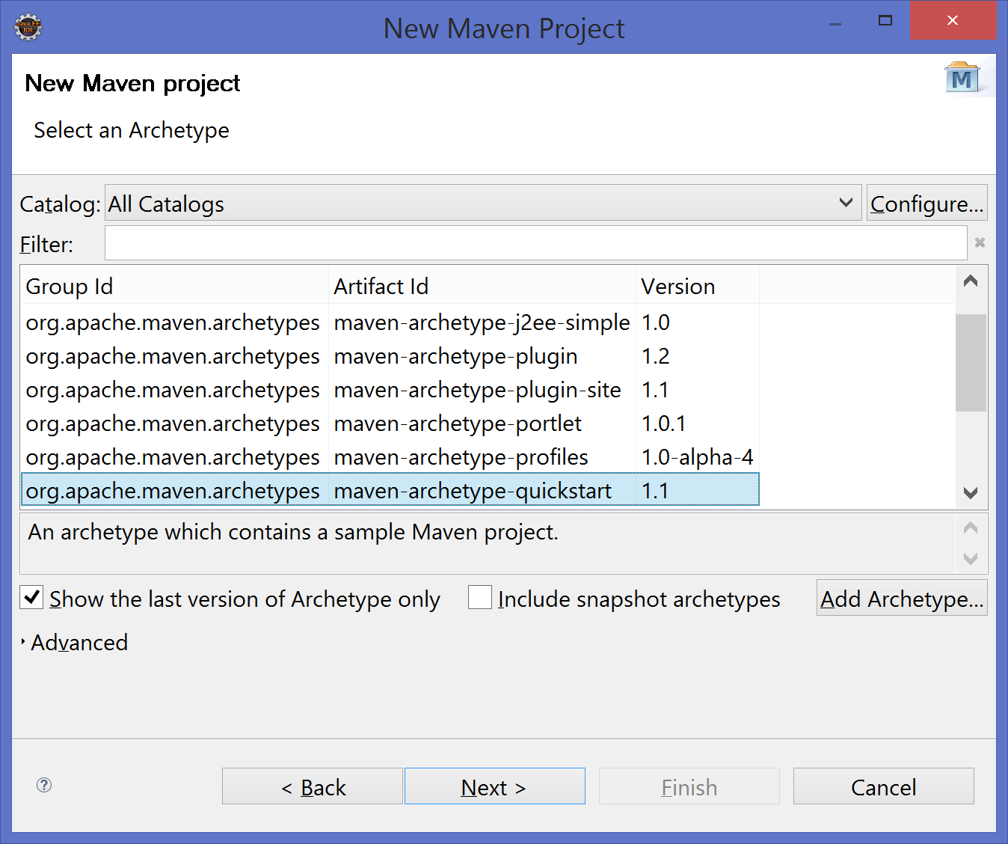

In the archetype selection window click on Add Archetype:

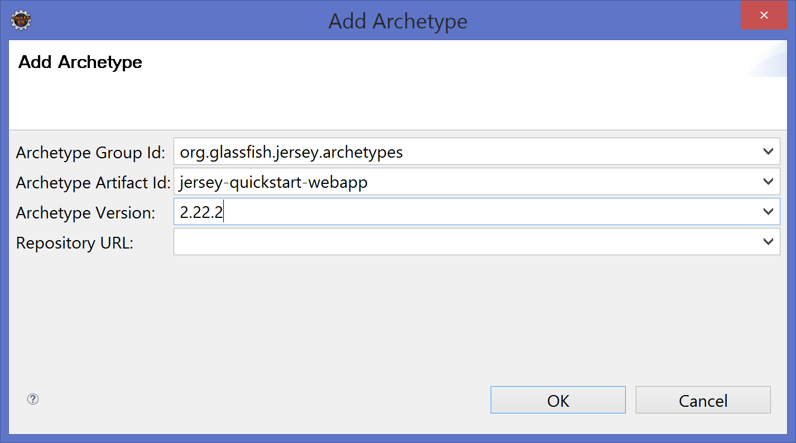

Fill them with the following data:

Archetype Group Id: org.glassfish.jersey.archetypes

Archetype Artifact Id: jersey-quickstart-webapp

Archetype Version: 2.22.2

Leave repository URL empty.

Click ok and then close the maven project creation window in order to update the list of archetypes.

Do again the steps to create the project and the select the one we’ve just added.

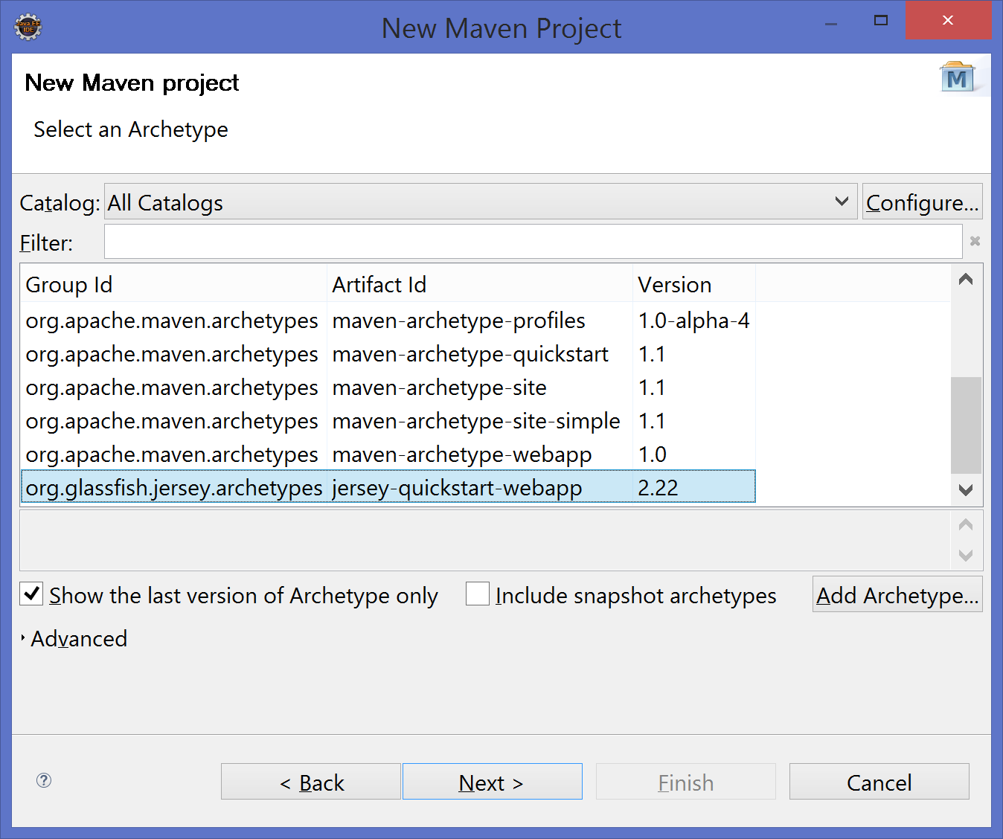

Fill the data on the next page:

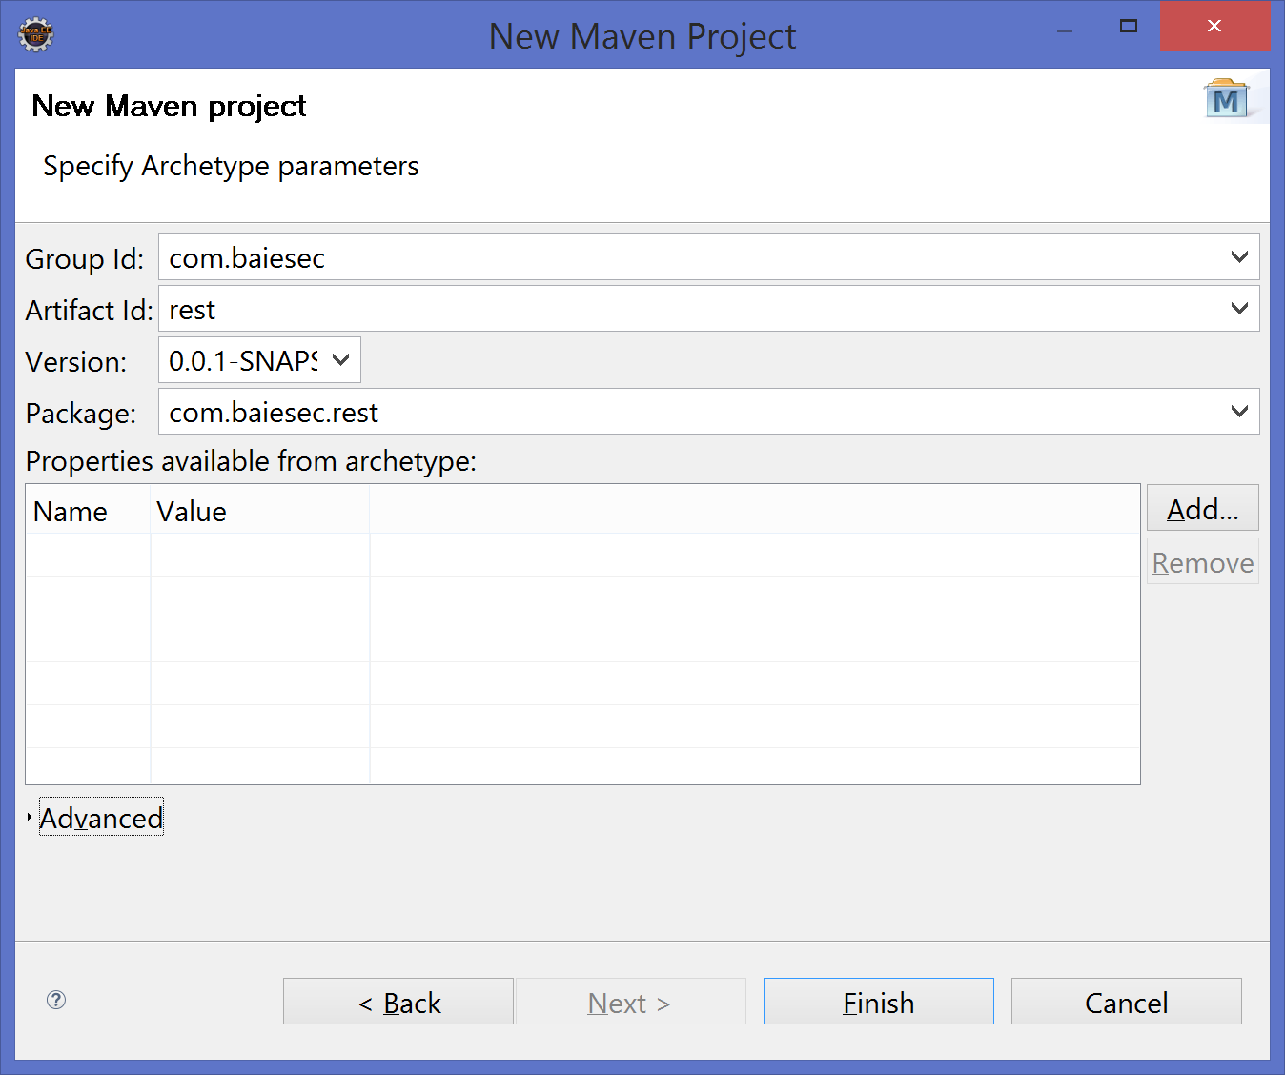

Click on finish and you will have your first rest application with your first resource.

Then go to Servers tab:

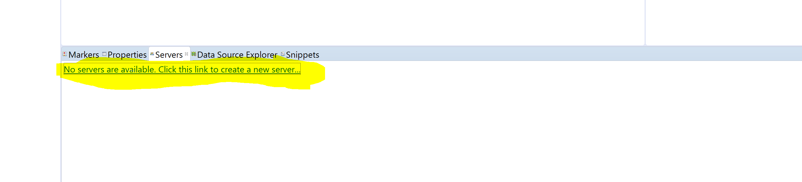

Click on the link to create a new server

You will have selected by default Tomcat v8.0 Server.

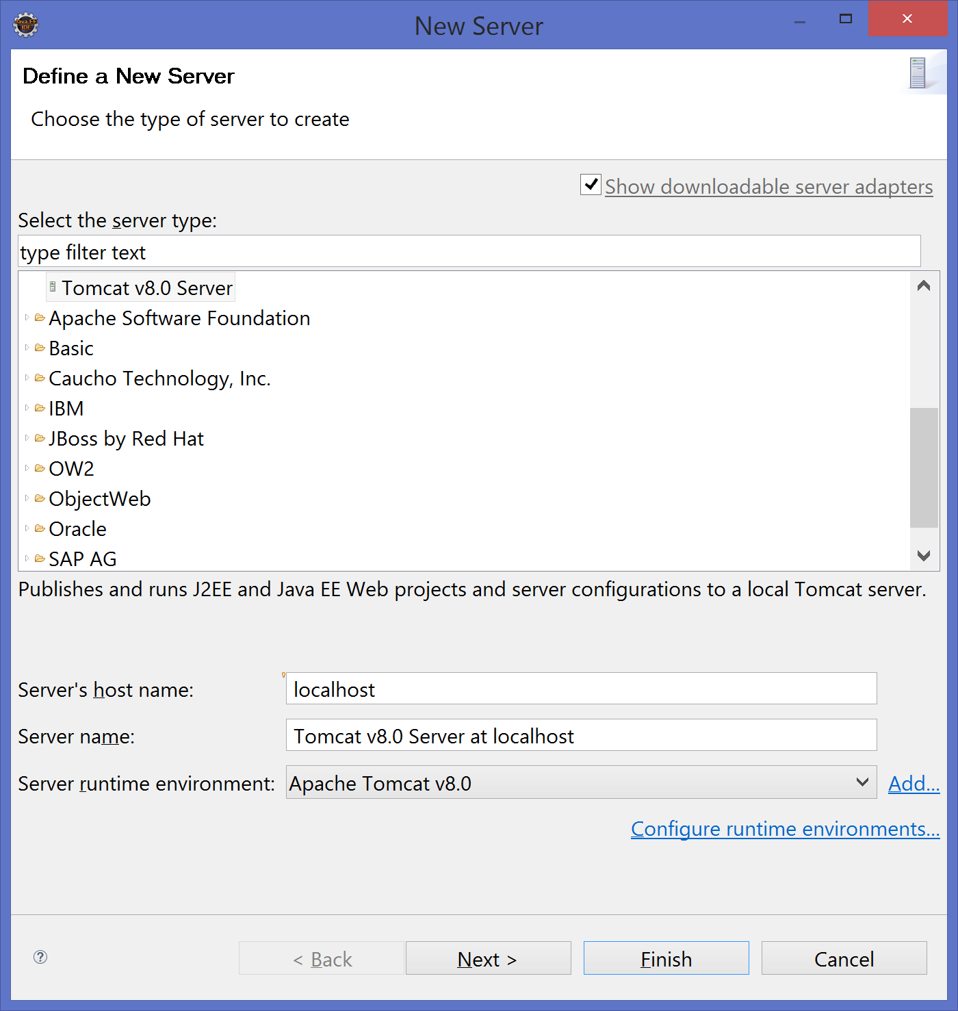

Click on Next and select the projects you want to deploy (rest project).

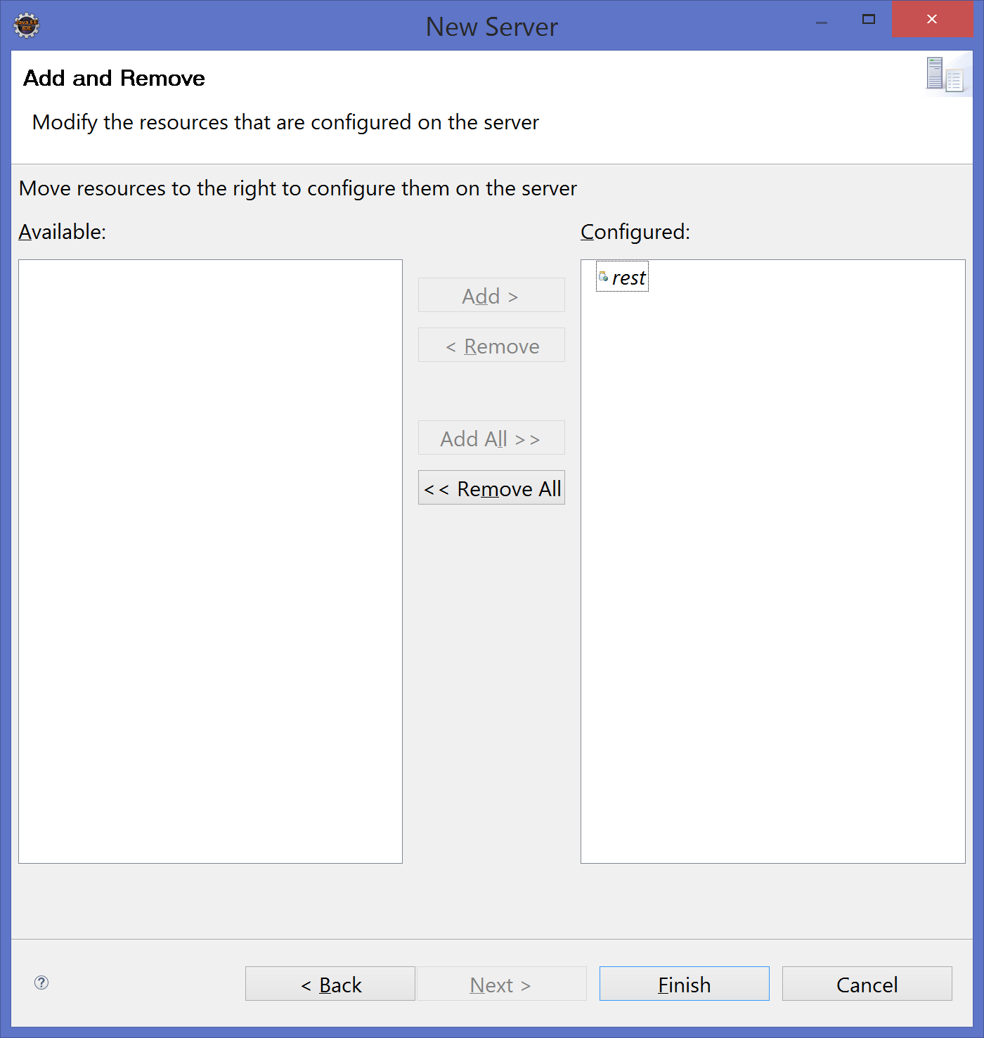

Click Finish and you will have your application (artefact) select for deployment on the server.

In order to get rid of the exception you now have right click on the rest project -> select Properties

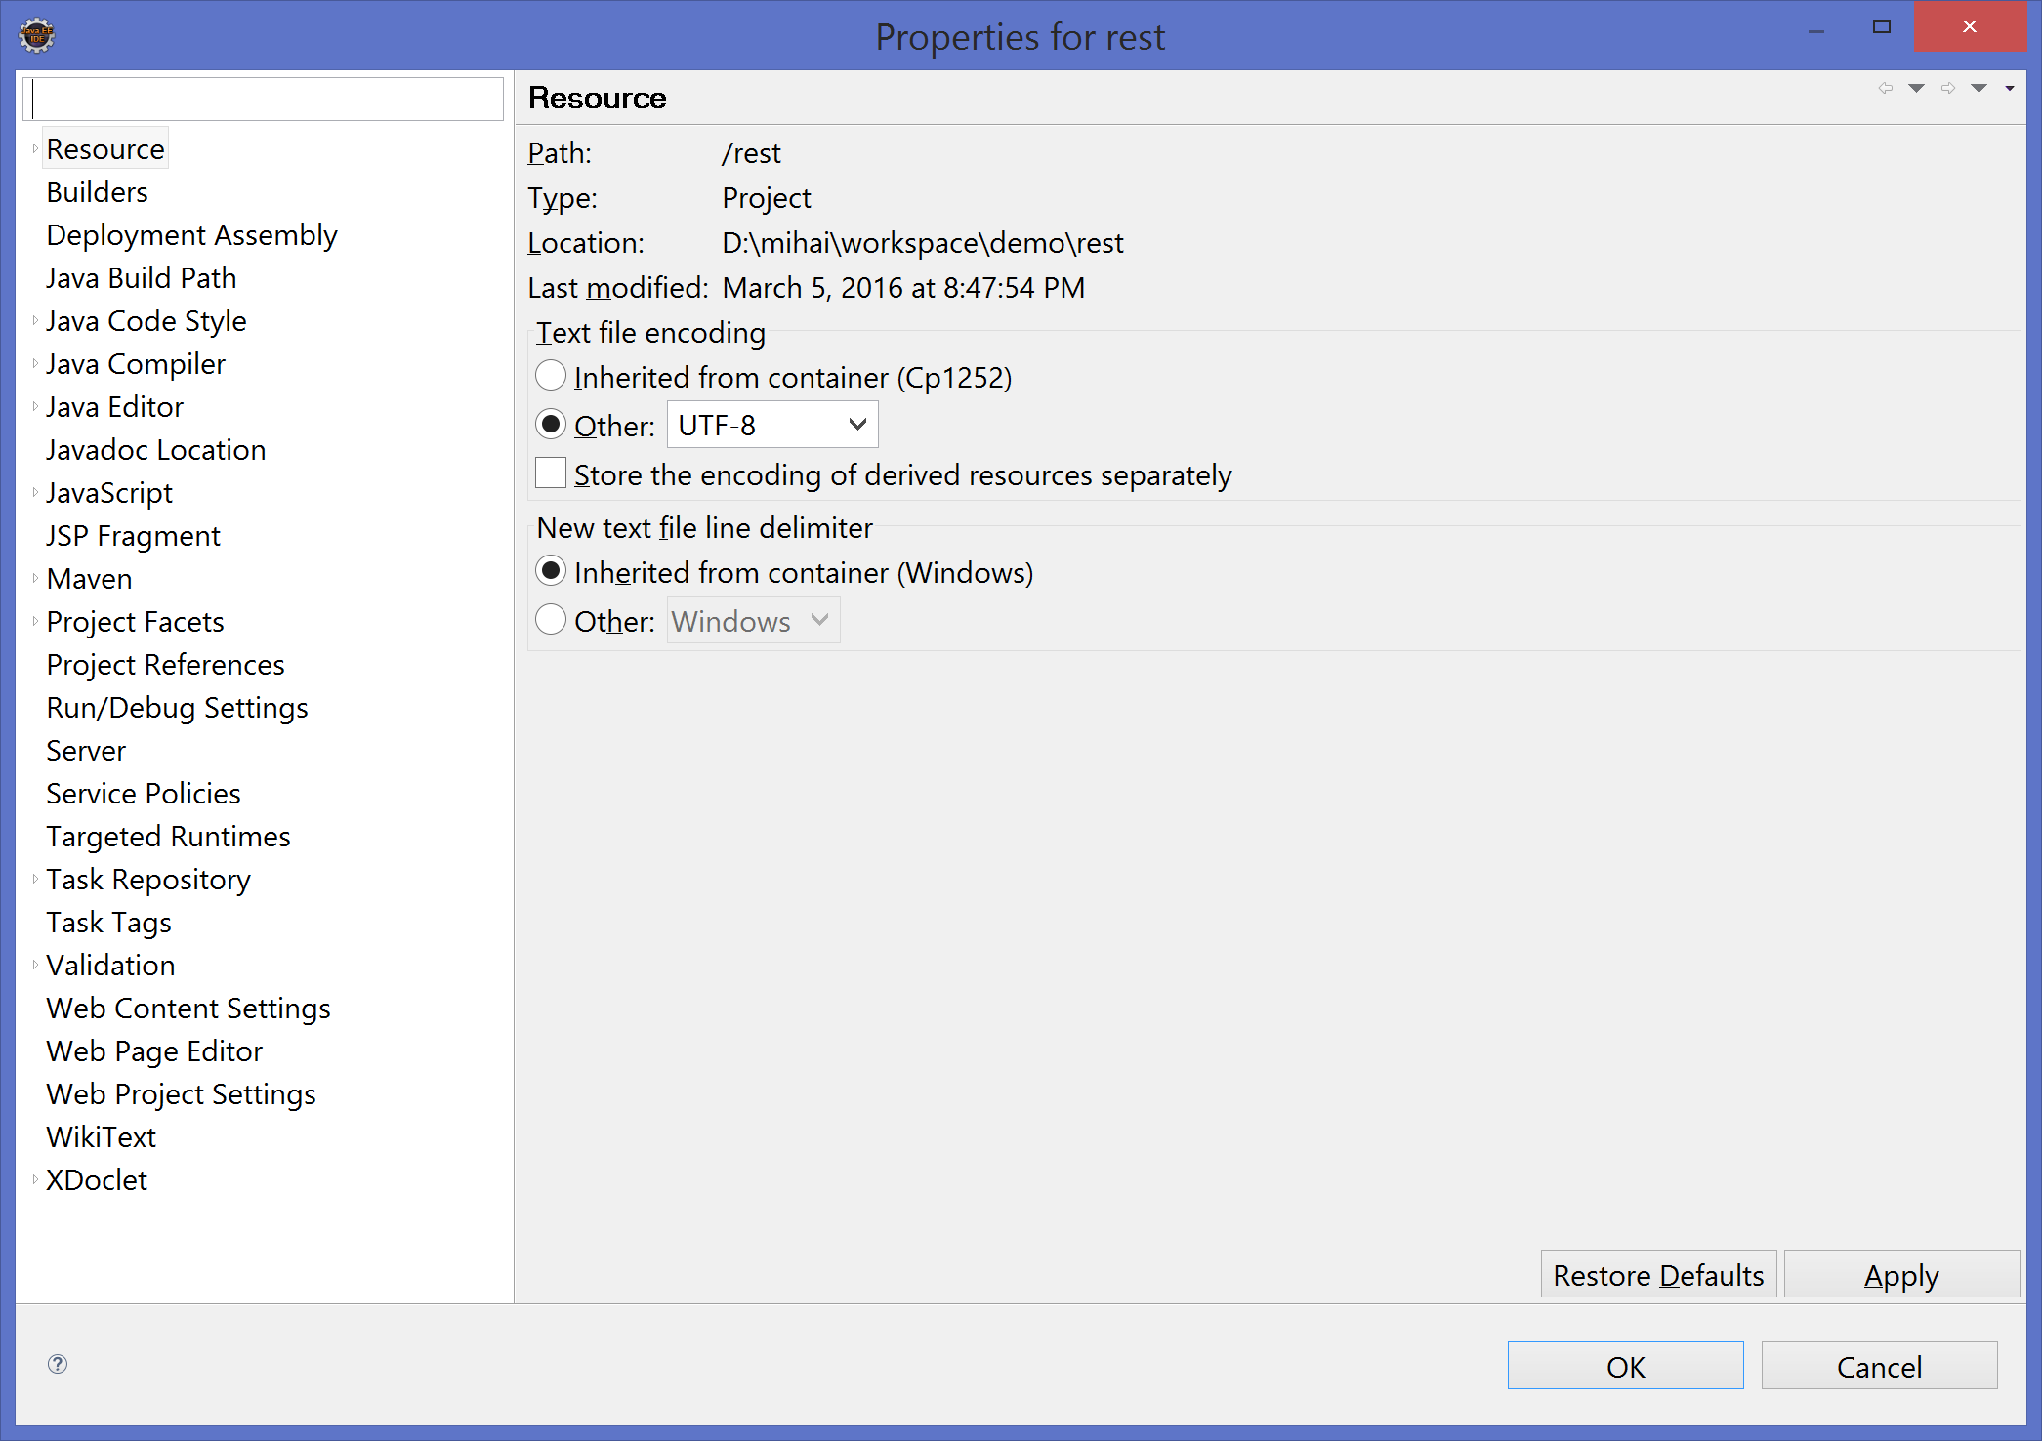

Go to Project Facets and in the top right on runtimes select Apache Tomcat v8.0

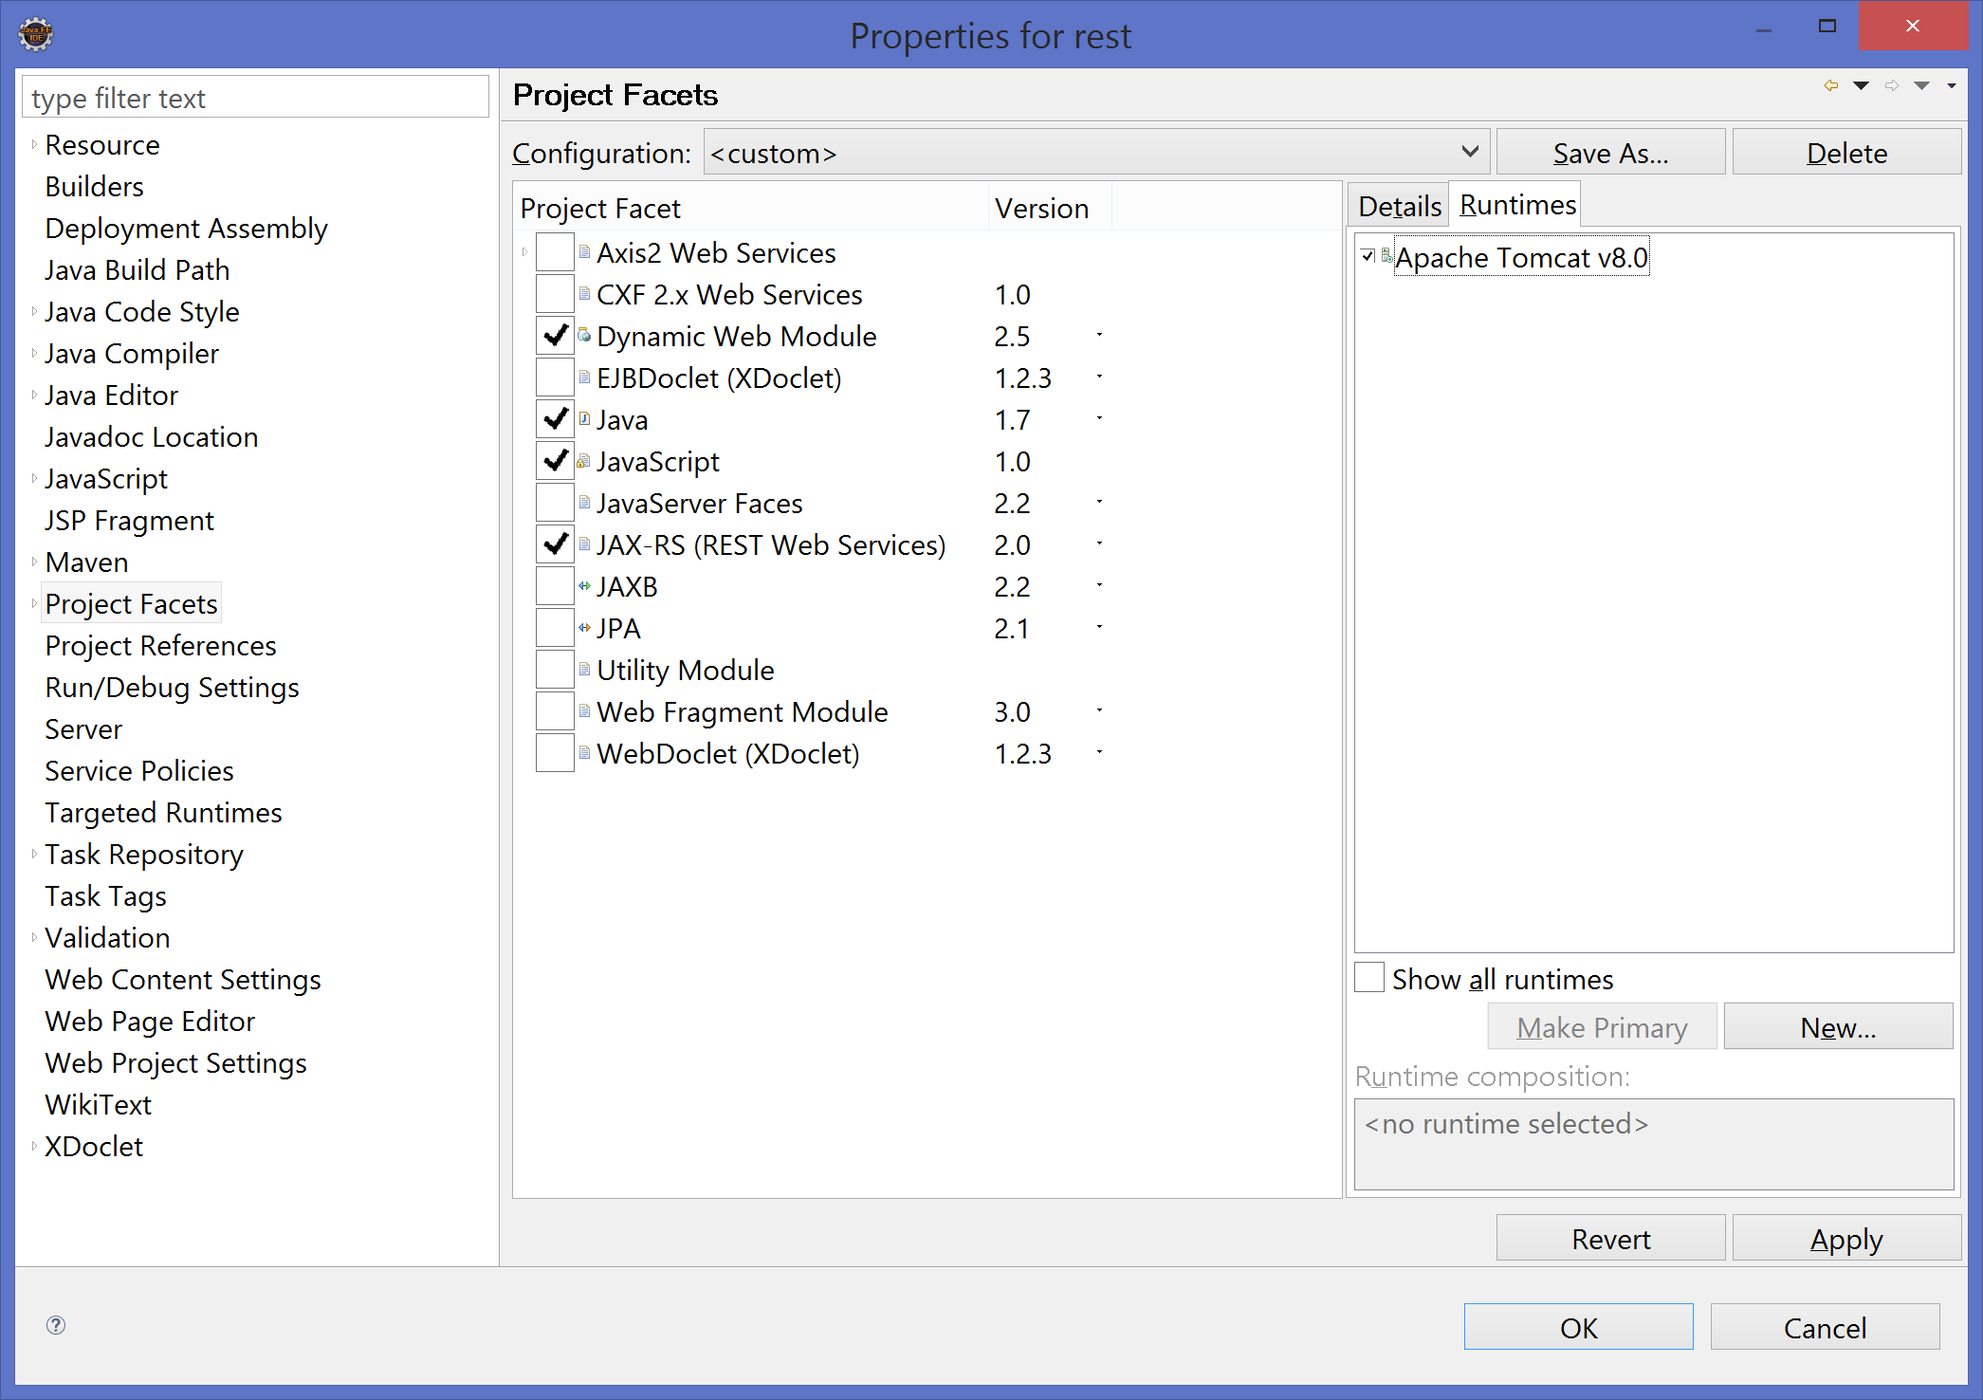

Click on and the exception is gone☺.

Start the server in debug mode (we are developers☺ ) and go to <http://localhost:8080/rest/>

You just created your first web application that points to your first [resource](http://localhost:8080/rest/webapi/myresource).

As you can see your resource is found at location: <http://localhost:8080/rest/webapi/myresource>

In order to make the URL simpler we are going to edit web.xml. As the one attached.

Remove the index.jsp file since we are not going to use it.

Check that the resource is now located at <http://localhost:8080/rest/myresource>.

Do not forget to think on the URLs of your agenda application.