Extract content of archive rest.zip to a location like c:\projects\rest or d:\projects\rest.

Open Eclipse.

Right click on projects view and click on import. From the context menu that opens select Import…

In the filter box write maven. Select Existing Maven Projects and click on next.

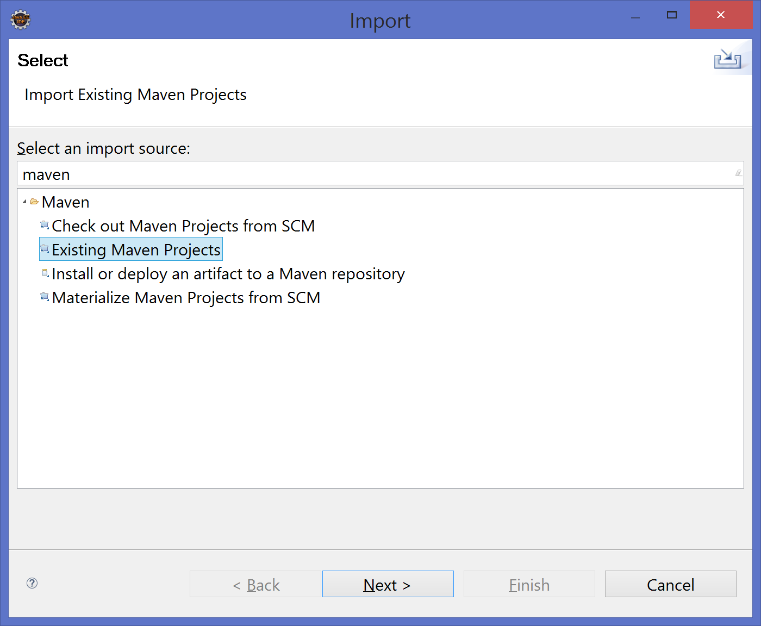

On the next page on Root Directory write the paths from above. Or browse to the pom.xml file from the place where you extracted the content of the provided archive.

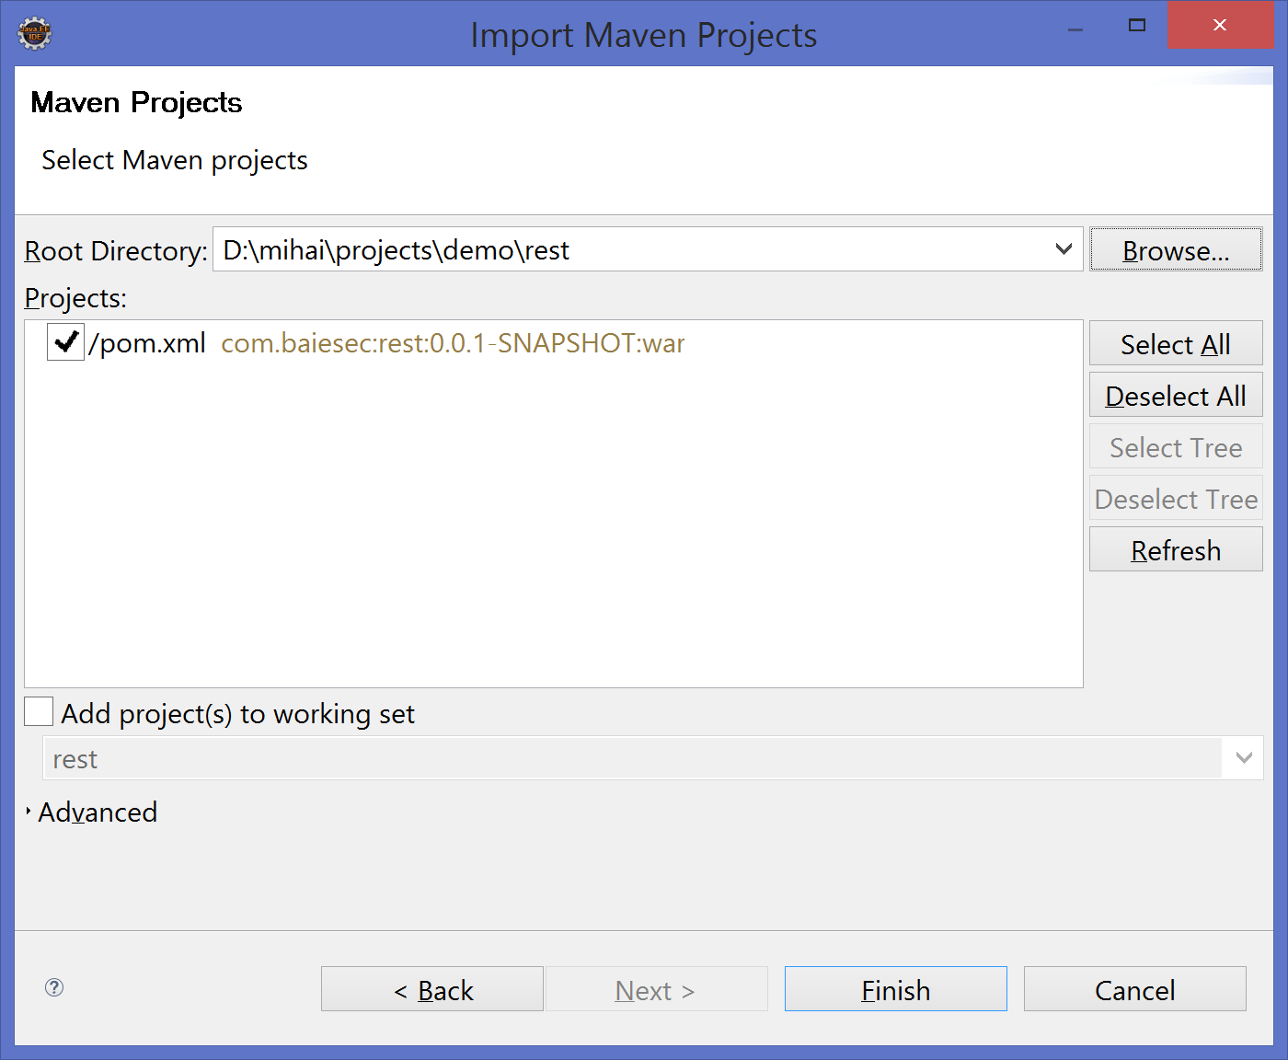

Click on Finish and your project should be imported.

In order to not see the HttpServlet exception check the document Setting_up_environment.docx provided on the facebook group ☺.