JDK 1.8 [x64](http://download.oracle.com/otn-pub/java/jdk/8u73-b02/jdk-8u73-windows-x64.exe) / [x86](http://download.oracle.com/otn-pub/java/jdk/8u73-b02/jdk-8u73-windows-i586.exe)

IDE Eclipse Mars [x64](https://eclipse.org/downloads/download.php?file=/technology/epp/downloads/release/mars/2/eclipse-jee-mars-2-win32-x86_64.zip) / [x86](https://eclipse.org/downloads/download.php?file=/technology/epp/downloads/release/mars/2/eclipse-jee-mars-2-win32.zip)

Tomcat [x64](http://apache.javapipe.com/tomcat/tomcat-8/v8.0.32/bin/apache-tomcat-8.0.32-windows-x64.zip) / [x86](http://apache.javapipe.com/tomcat/tomcat-8/v8.0.32/bin/apache-tomcat-8.0.32-windows-x86.zip)

[Maven](http://apache.javapipe.com/maven/maven-3/3.3.9/binaries/apache-maven-3.3.9-bin.zip)  
setting maven environment variables:  
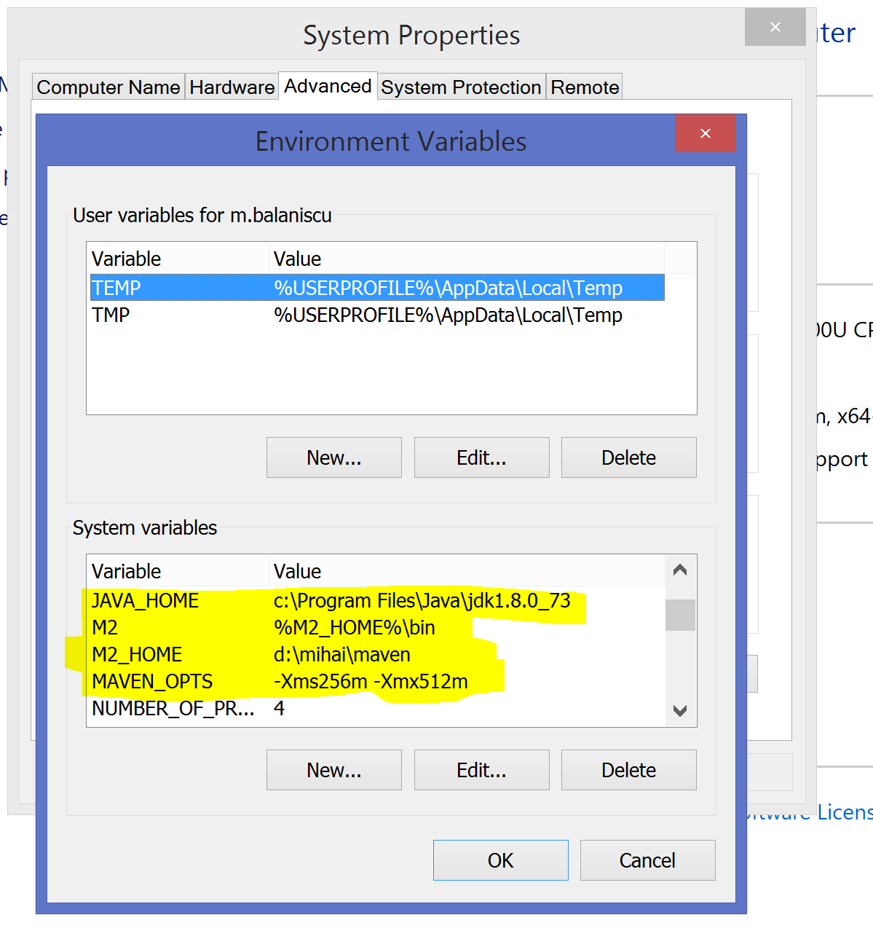

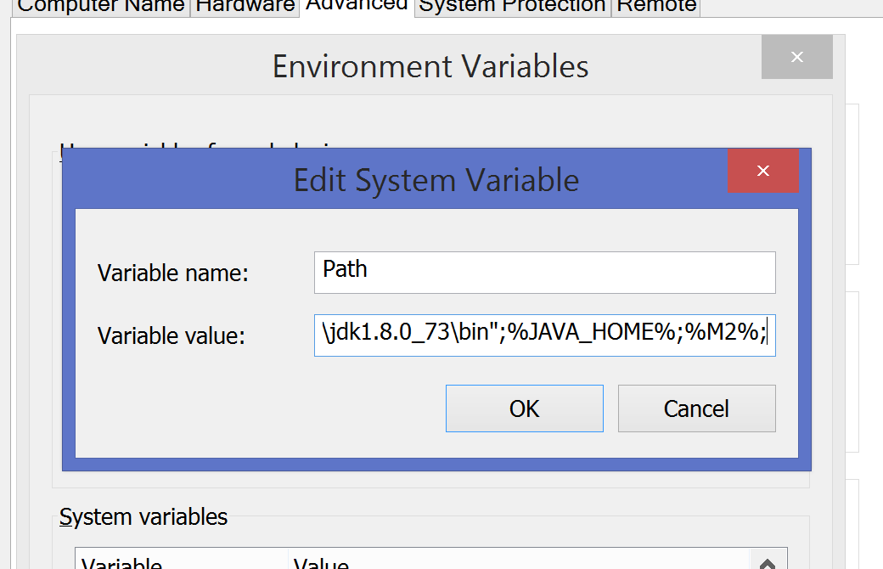

I have the following recommendation:

* Put the content of the server archive (Tomcat archive from above) to a location like: c:\tomcat or d:\tomcat depending on how many partitions you have
* Put the content of the maven archive in a location like: c:\maven or d:\maven
* Put the content of the eclipse archive to c:\eclipse or d:\eclipse
* Make a directory: C:\workspaces or D:\workspaces in order to keep all the work you do with eclipse
  + For our current project make a directory: C:\workspaces\fiipractic or D:\workspaces\fiipractic

Opening Eclipse and selecting the workspace directory (for me it also has mihai in path):

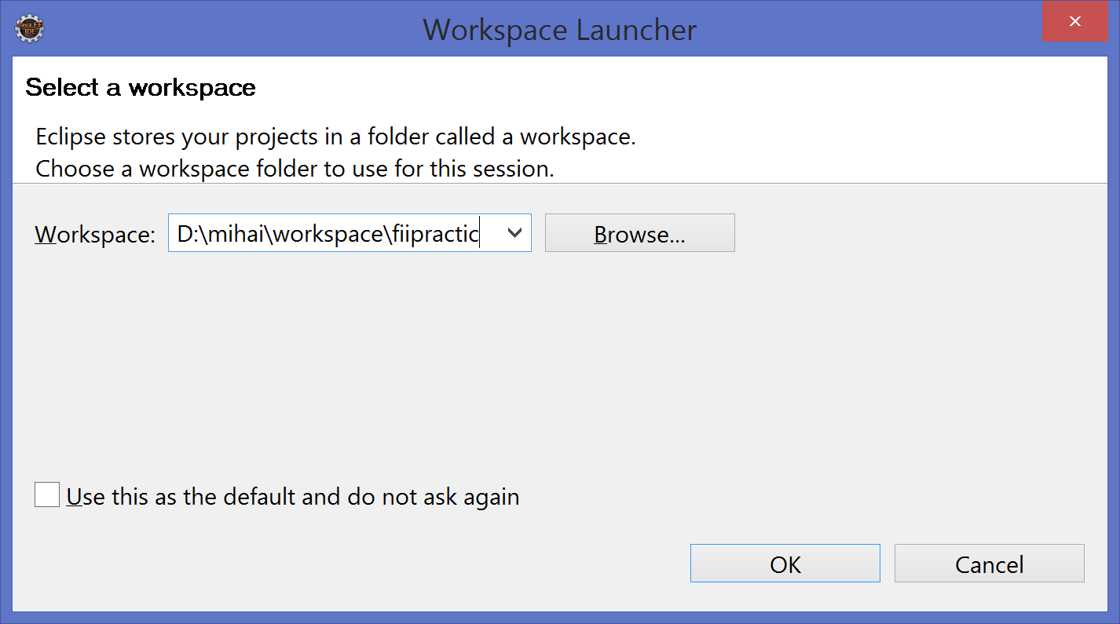

Since we are developers we use the JDK. Go to Window -> Preferences and in the filter input (top left) write ‘jre’ and you will see something like this:

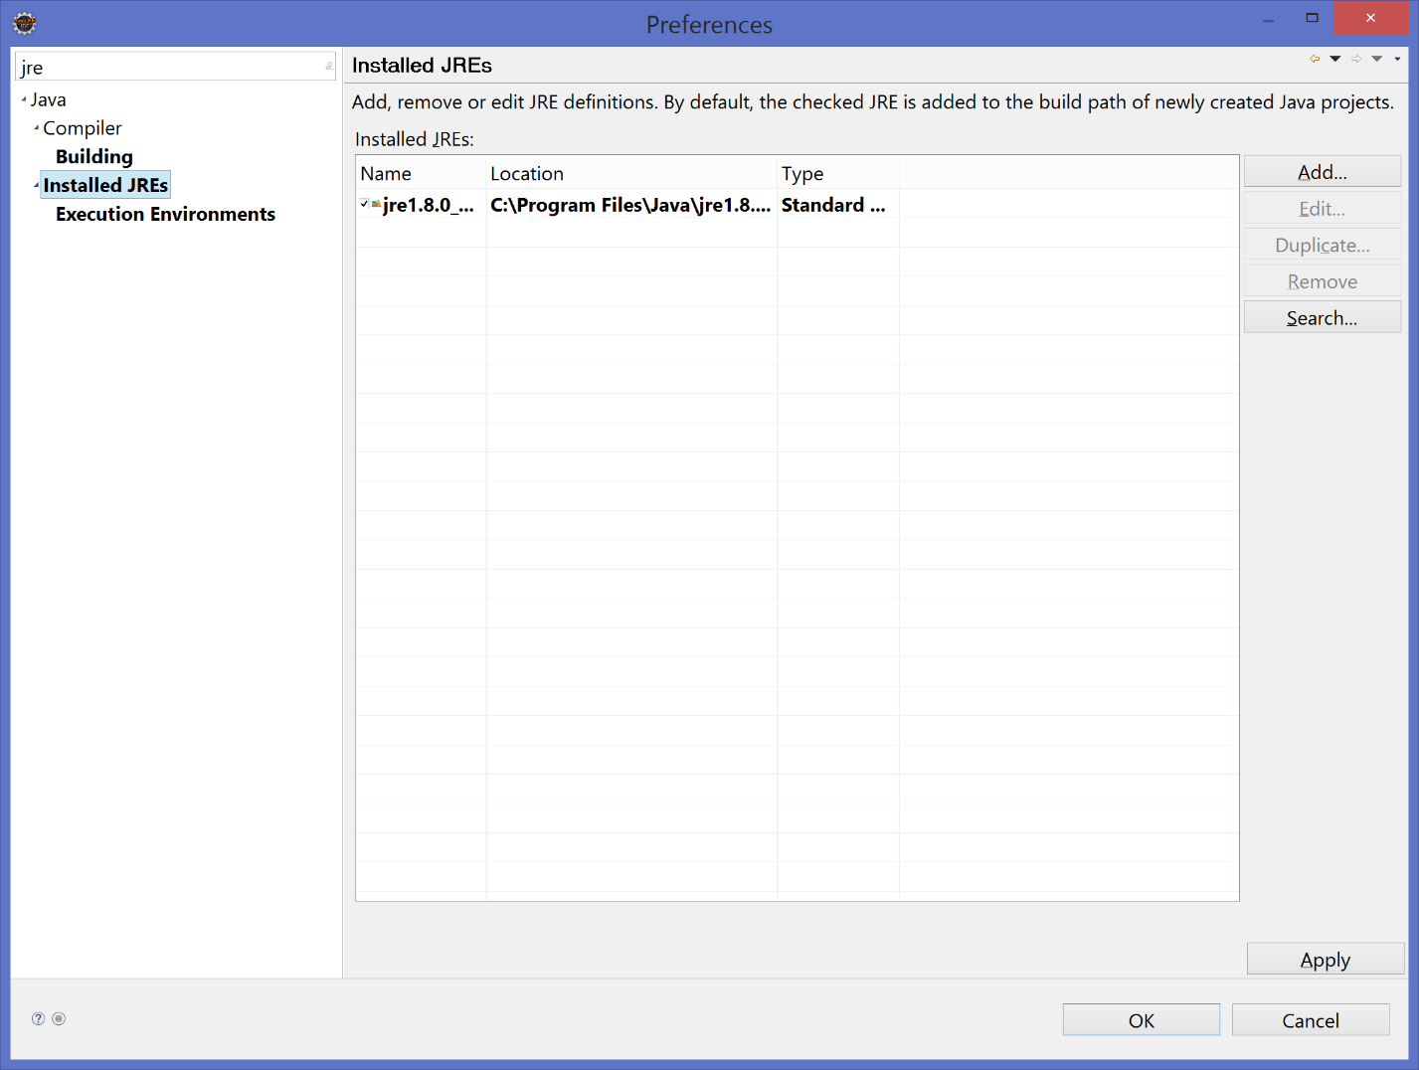

Remove the current JRE and add the JDK (for our example located at: c:\Program Files\Java\jdk1.8.0_73).

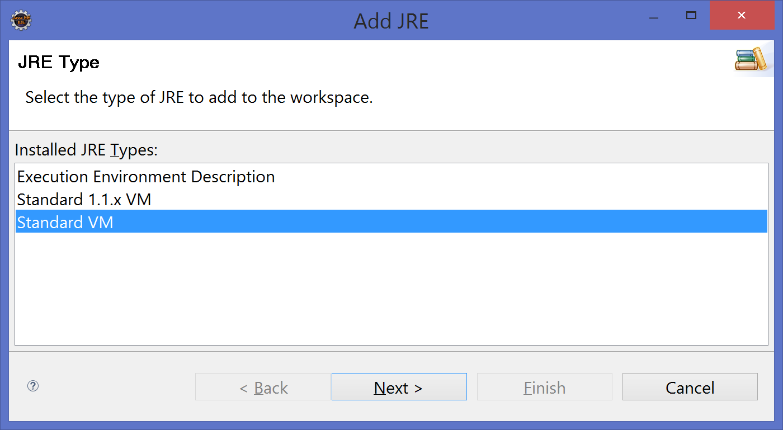

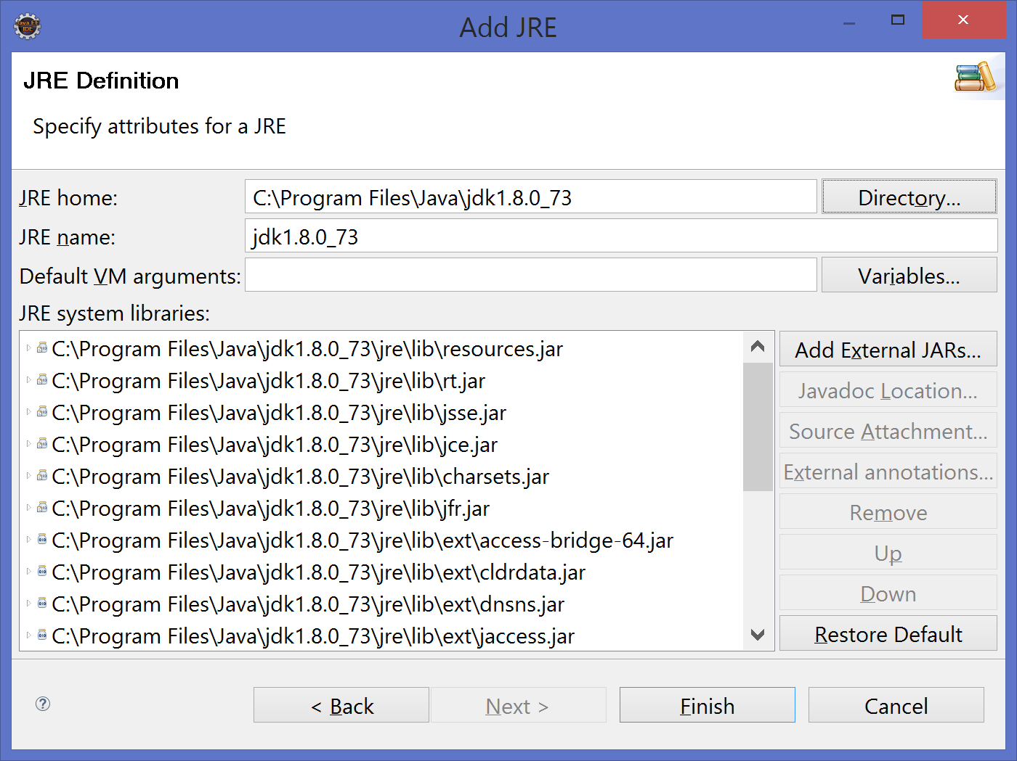

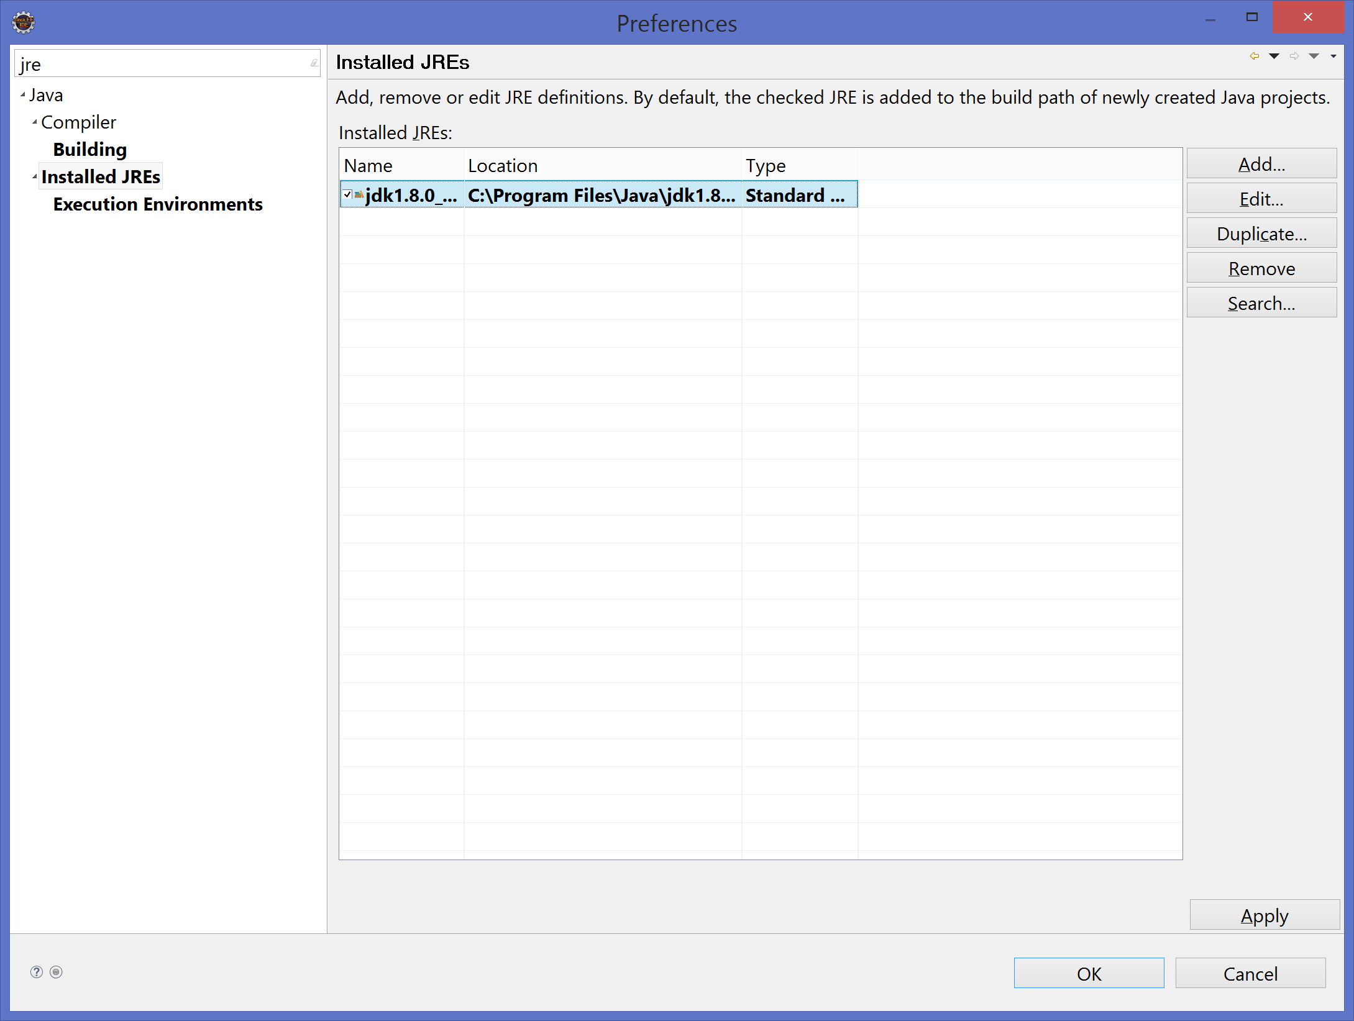

Click Apply (bottom right) to save your changes.

In the filter box write ‘runtime’ and select Runtime Environments from left side:

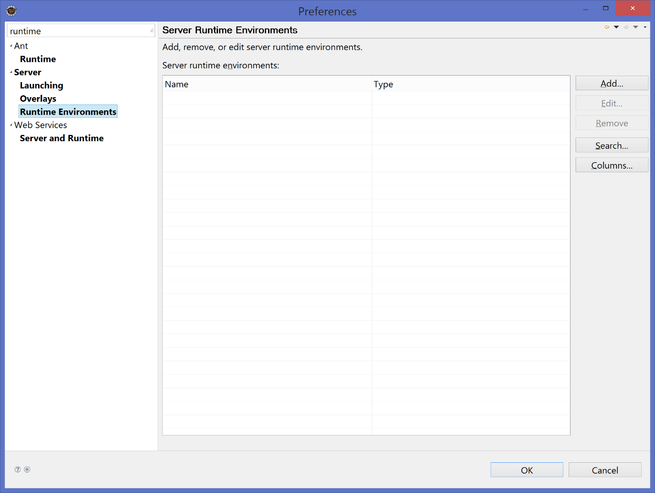

Click on Add (top right):

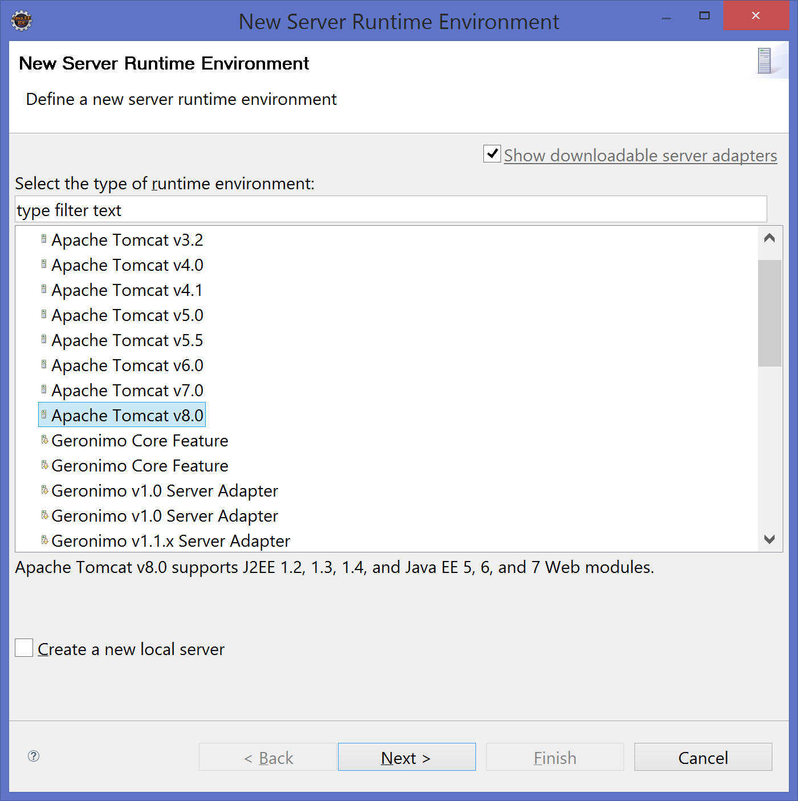

Select Apache Tomcat v8.0 and click Next

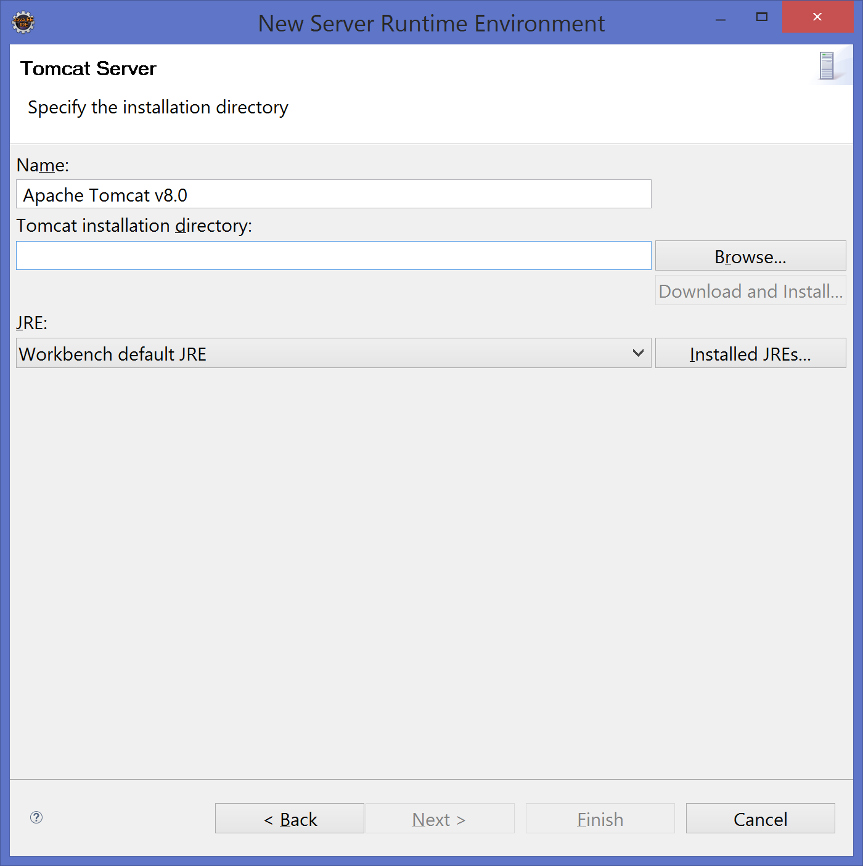

In the Tomcat installation directory write (c:\tomcat or d:\tomcat) or just browse for it ☺

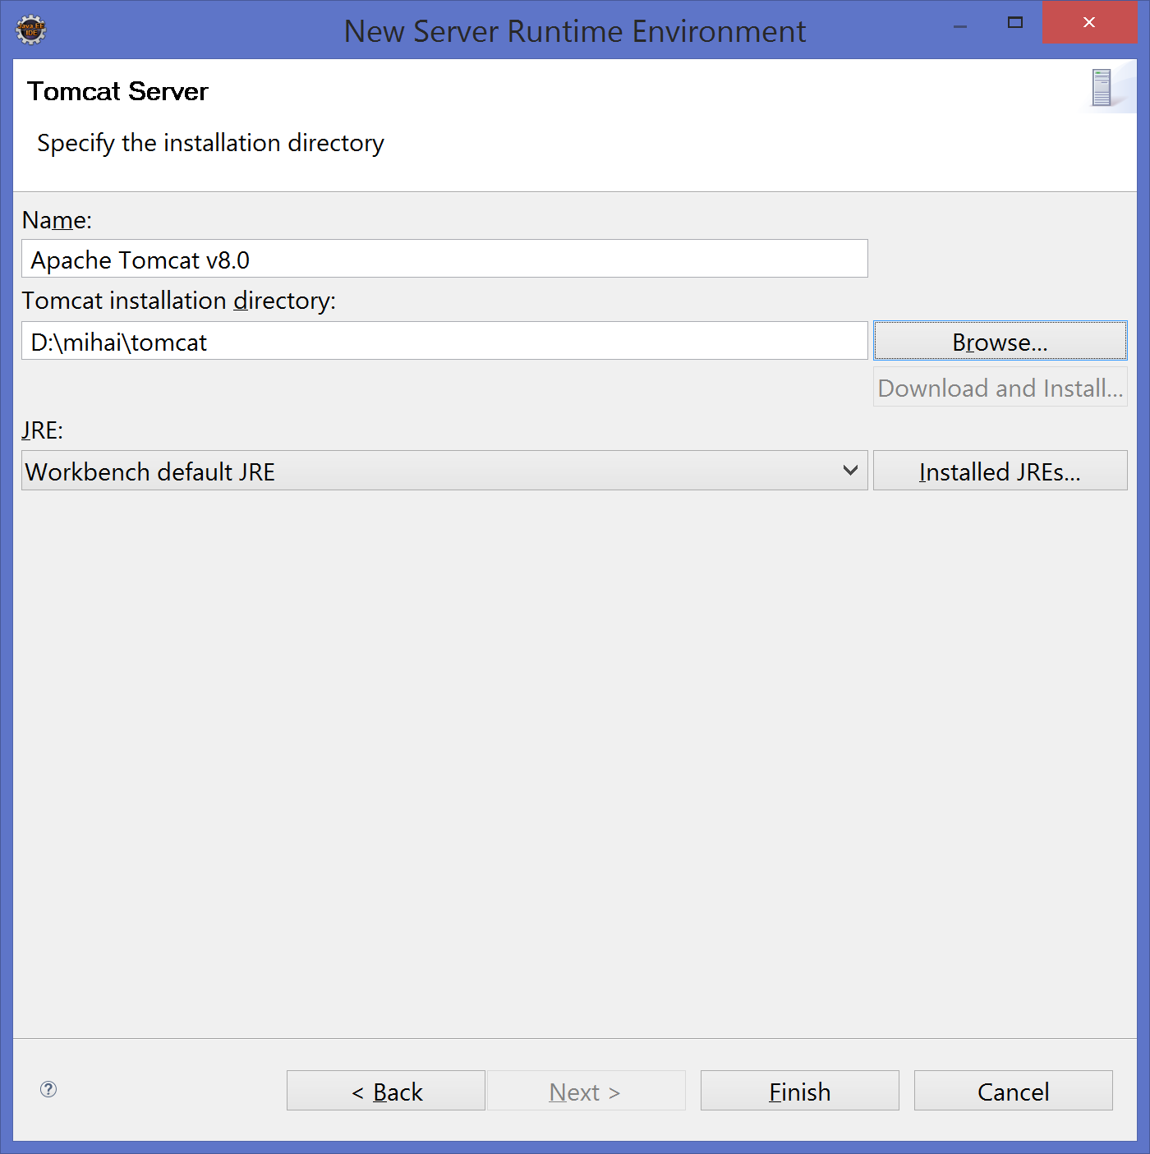

Change the JRE from Workbench default JRE to jdk1.8.0_73

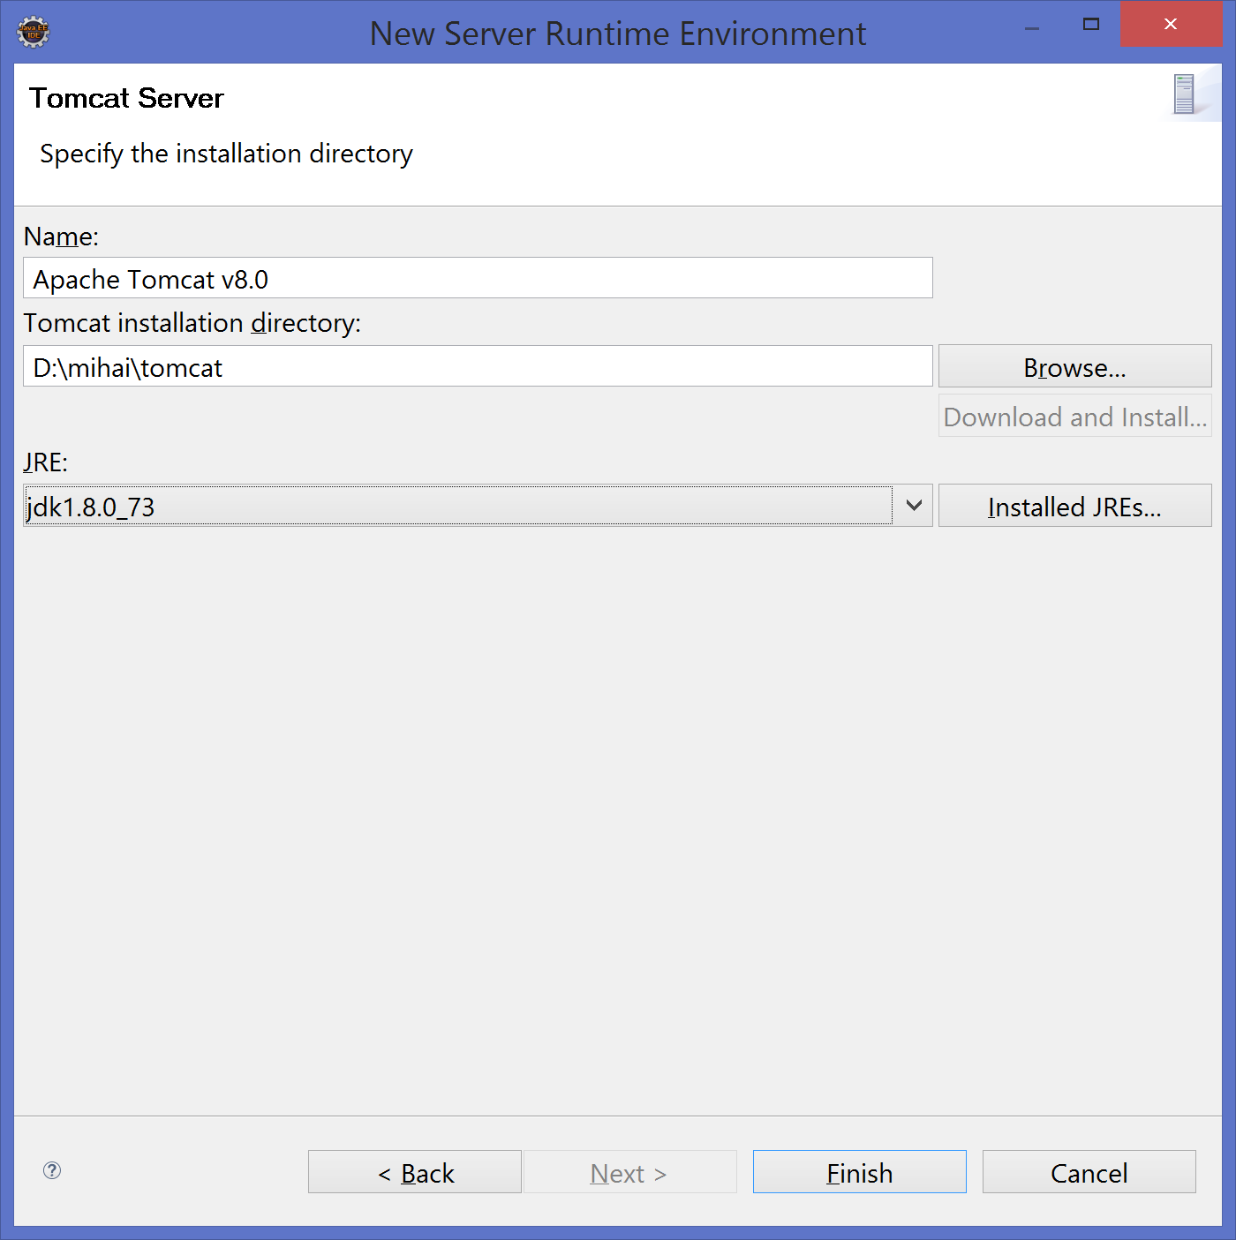

Click Finish, click ok and the initial setup of servers & JDK is done.