Hate Speech Detector — method comparison
Comparison of 5 independent hate-speech detection methods plus an equal-vote ensemble, evaluated on 20 comments (the built-in demo set). Metrics computed with hateblocker's classification_metrics().

Metrics
Method | Accuracy | Balanced Acc. | Precision | Recall | F1 | Macro F1 | Avg. Precision | ROC-AUC
Keyword Matching | 0.600 | 0.600 | 1.000 | 0.200 | 0.333 | 0.524 | 0.600 | 0.600
TF-IDF + Logistic Regression | 0.750 | 0.750 | 1.000 | 0.500 | 0.667 | 0.733 | 0.981 | 0.980
Word2Vec + Logistic Regression | 0.850 | 0.850 | 0.889 | 0.800 | 0.842 | 0.850 | 0.942 | 0.940
Sentence Embedding k-NN | 1.000 | 1.000 | 1.000 | 1.000 | 1.000 | 1.000 | 1.000 | 1.000
Fine-tuned Transformer | 0.600 | 0.600 | 1.000 | 0.200 | 0.333 | 0.524 | 0.753 | 0.700
Ensemble (equal vote) | 0.850 | 0.850 | 1.000 | 0.700 | 0.824 | 0.847 | 0.991 | 0.995

Confusion matrices

Keyword Matching
 | Predicted not hateful | Predicted hateful
Actually not hateful | 10 | 0
Actually hateful | 8 | 2

TF-IDF + Logistic Regression
 | Predicted not hateful | Predicted hateful
Actually not hateful | 10 | 0
Actually hateful | 5 | 5

Word2Vec + Logistic Regression
 | Predicted not hateful | Predicted hateful
Actually not hateful | 9 | 1
Actually hateful | 2 | 8

Sentence Embedding k-NN
 | Predicted not hateful | Predicted hateful
Actually not hateful | 10 | 0
Actually hateful | 0 | 10

Fine-tuned Transformer
 | Predicted not hateful | Predicted hateful
Actually not hateful | 10 | 0
Actually hateful | 8 | 2

Ensemble (equal vote)
 | Predicted not hateful | Predicted hateful
Actually not hateful | 10 | 0
Actually hateful | 3 | 7

ROC & Precision-Recall curves
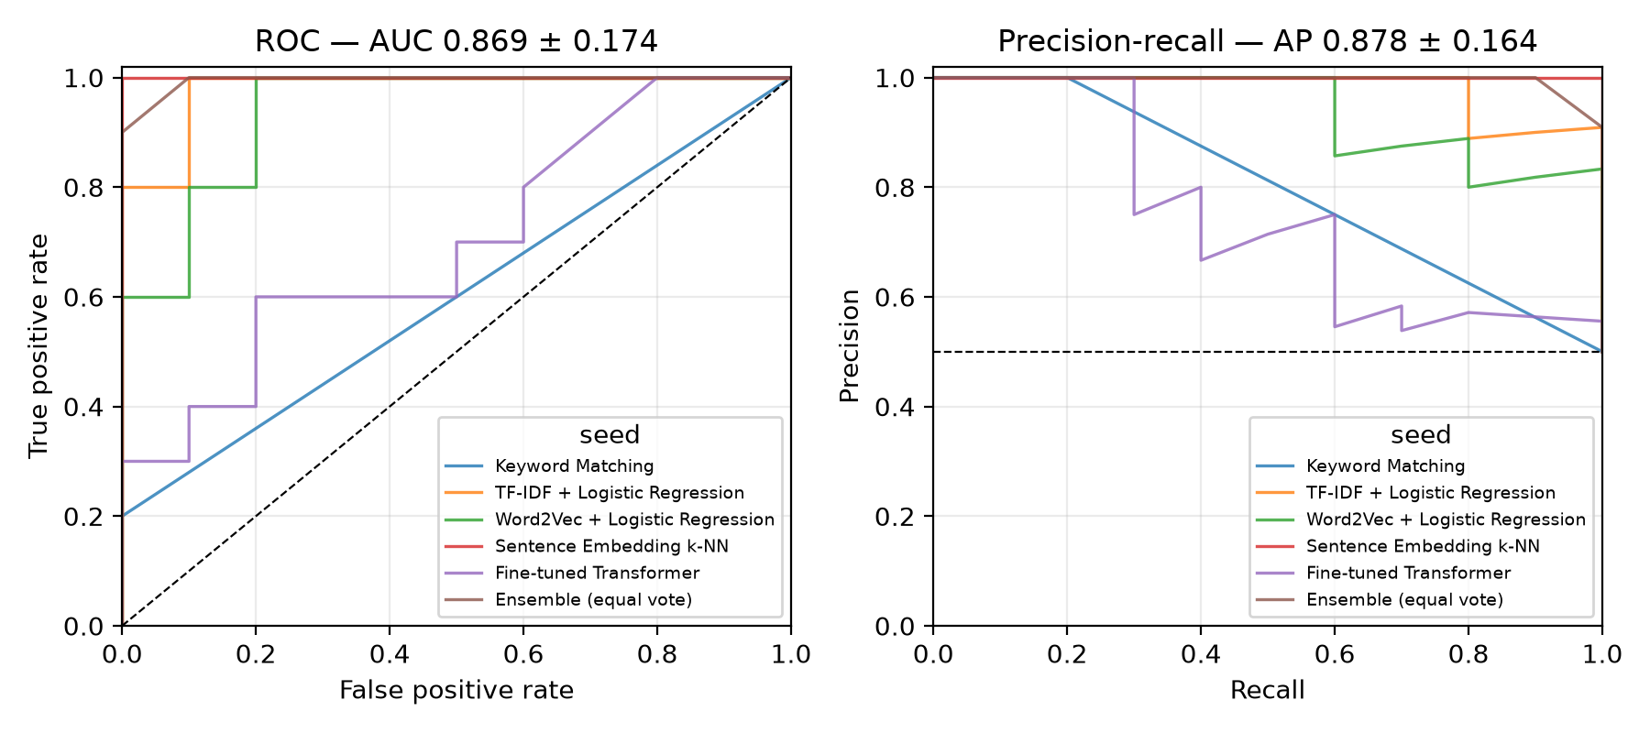
One line per method (the ensemble's curve is stepped since its score is a vote share over only 5 methods, not a continuous probability). The legend title says "seed" because it's hateblocker's own plotting code, reused as-is.

