Hate Speech Detector — method comparison
Comparison of 5 independent hate-speech detection methods plus an equal-vote ensemble, evaluated on 863 comments (the real hateblocker test split (curvemaria/patrick/rafael, held-out 15%)). Metrics computed with hateblocker's classification_metrics().

Metrics
Method | Accuracy | Balanced Acc. | Precision | Recall | F1 | Macro F1 | Avg. Precision | ROC-AUC
Keyword Matching | 0.917 | 0.604 | 0.385 | 0.238 | 0.294 | 0.625 | 0.157 | 0.604
TF-IDF + Logistic Regression | 0.833 | 0.669 | 0.213 | 0.476 | 0.294 | 0.600 | 0.305 | 0.758
Word2Vec + Logistic Regression | 0.737 | 0.610 | 0.131 | 0.460 | 0.204 | 0.523 | 0.159 | 0.635
Sentence Embedding k-NN | 0.482 | 0.669 | 0.113 | 0.889 | 0.200 | 0.409 | 0.124 | 0.684
Fine-tuned Transformer | 0.905 | 0.539 | 0.212 | 0.111 | 0.146 | 0.548 | 0.147 | 0.624
Ensemble (equal vote) | 0.895 | 0.673 | 0.325 | 0.413 | 0.364 | 0.653 | 0.243 | 0.776

Results on Hate-Qualified Comments Only
The same set restricted to comments qualified as hate speech (the subset that actually reached legal review) — the fairer comparison for general-purpose hate-speech methods that were never trained to predict criminal liability specifically.
Method | Rows | Accuracy | Precision | Recall | F1
Keyword Matching | 284 | 0.785 | 0.536 | 0.238 | 0.330
TF-IDF + Logistic Regression | 284 | 0.704 | 0.370 | 0.476 | 0.417
Word2Vec + Logistic Regression | 284 | 0.651 | 0.309 | 0.460 | 0.369
Sentence Embedding k-NN | 284 | 0.496 | 0.292 | 0.889 | 0.439
Fine-tuned Transformer | 284 | 0.757 | 0.350 | 0.111 | 0.169
Ensemble (equal vote) | 284 | 0.764 | 0.464 | 0.413 | 0.437

Confusion matrices

Keyword Matching
 | Predicted not hateful | Predicted hateful
Actually not hateful | 776 | 24
Actually hateful | 48 | 15

TF-IDF + Logistic Regression
 | Predicted not hateful | Predicted hateful
Actually not hateful | 689 | 111
Actually hateful | 33 | 30

Word2Vec + Logistic Regression
 | Predicted not hateful | Predicted hateful
Actually not hateful | 607 | 193
Actually hateful | 34 | 29

Sentence Embedding k-NN
 | Predicted not hateful | Predicted hateful
Actually not hateful | 360 | 440
Actually hateful | 7 | 56

Fine-tuned Transformer
 | Predicted not hateful | Predicted hateful
Actually not hateful | 774 | 26
Actually hateful | 56 | 7

Ensemble (equal vote)
 | Predicted not hateful | Predicted hateful
Actually not hateful | 746 | 54
Actually hateful | 37 | 26

ROC & Precision-Recall curves
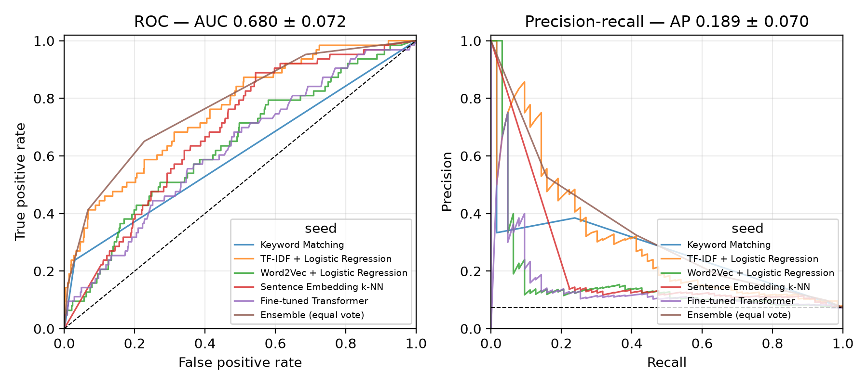
One line per method (the ensemble's curve is stepped since its score is a vote share over only 5 methods, not a continuous probability). The legend title says "seed" because it's hateblocker's own plotting code, reused as-is.

