**Package specifications:**

It’s a folder containing the following:

* Workflows
* Folder with:
  + Main Excel file with the products to be compared (Main.xls)
  + Excel files for each product generated by robot to keep the historical prices
  + Template for the notification email sent (.txt)

**Summary:**

A robot that will perform a daily checkup of the actual prices for a list of products, with the aim to inform the user through an email when the price went down, recommending to buy the product.

It is made up by different workflows:

* The price for each product is checked daily on a defined list of websites and the prices are copied into the price history excel file.
* If the daily cheapest offer is better than the target price set in the main file (list of products), an email will be sent to the person in charge, containing the new price, the target price and the store where the product can be found at that price. The price in the list of products is updated with the smallest value found in the market.

**Screenshots & Videos:**

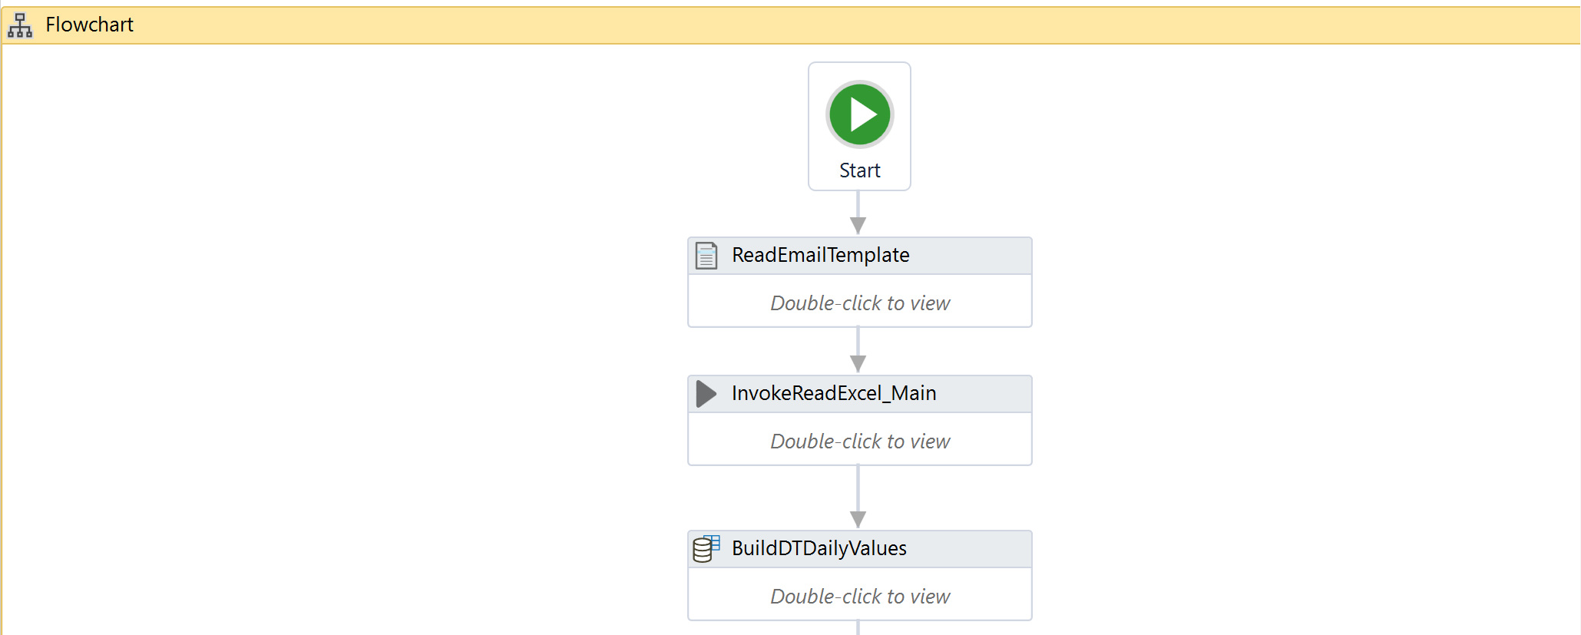

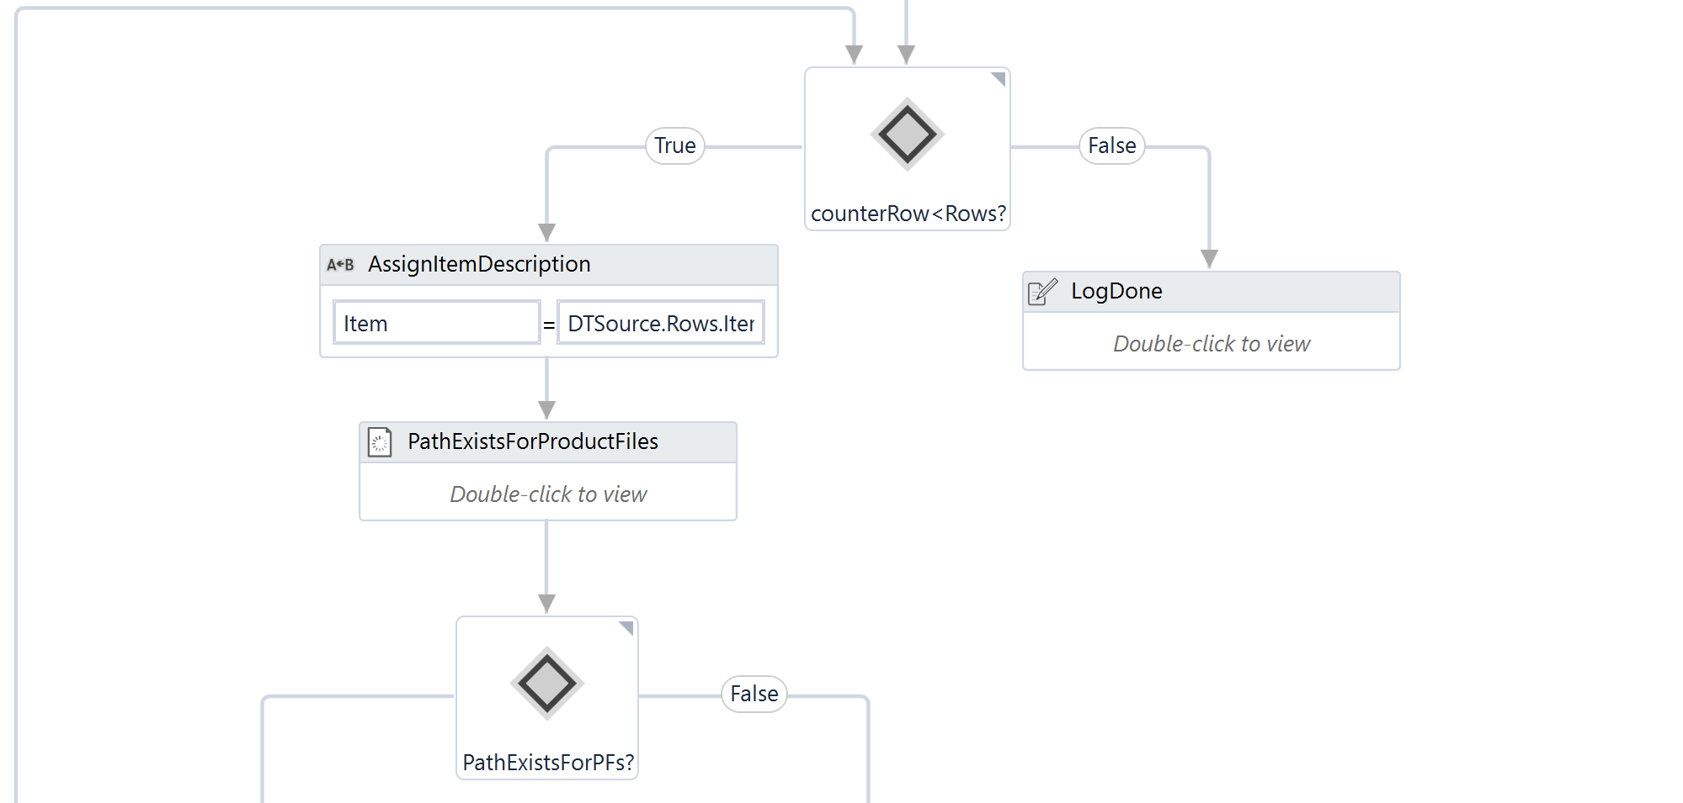

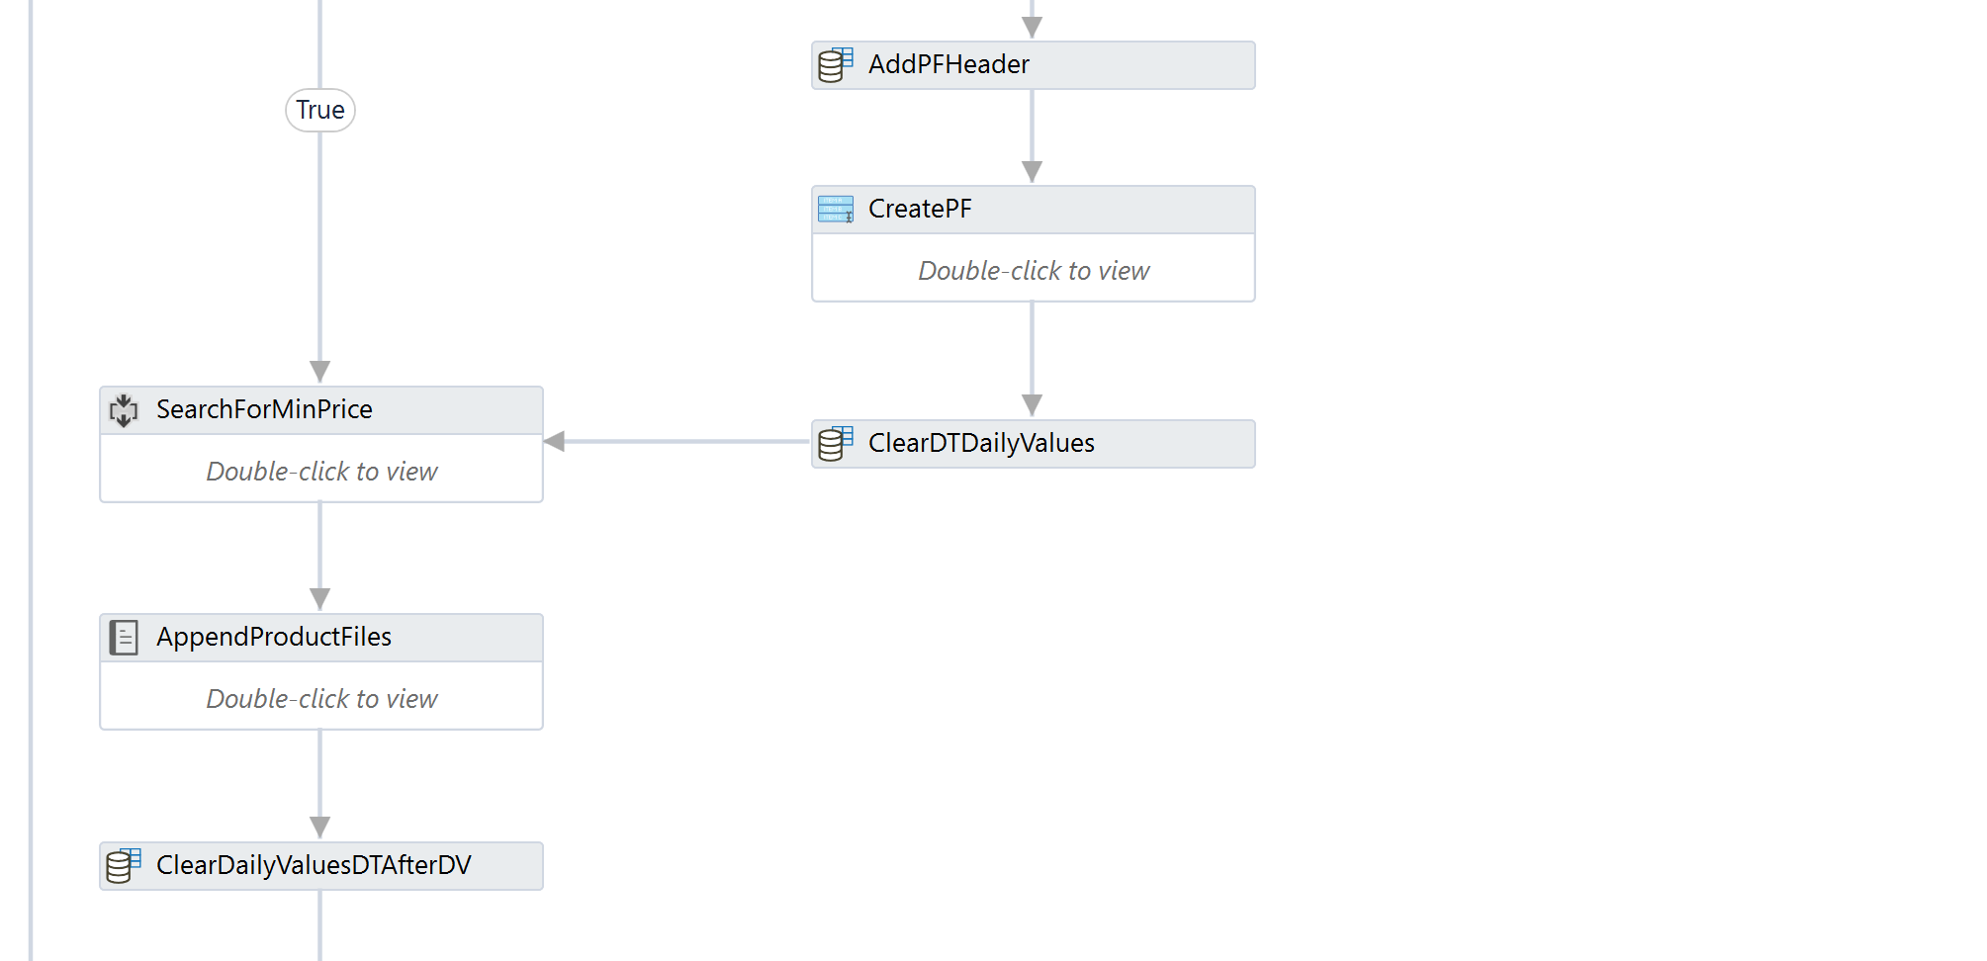

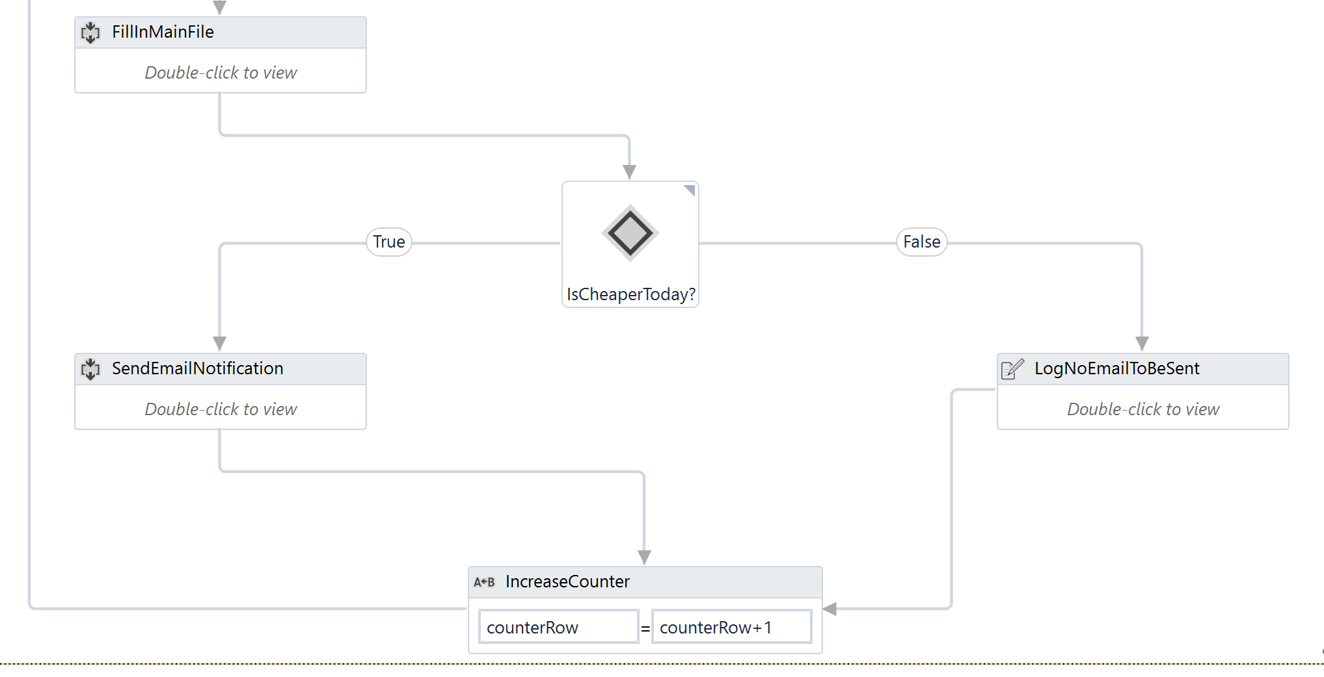

**Compatibility:**

UiPath 2018.3

Used with Chrome, Outlook and Microsoft Excel

**Documentation:**

* Open the “Main.xlsx” file and add all the products that you are looking for, together with the target price and you email address. Use explanatory Item Descriptions.
* If you want to check the historical price, open the corresponding Excel file for more details.

**Installation guide:**

* Open the robot
* Close all related Excel Files and Chrome windows
* Run the robot (it can also be set to run automatically every day)
* The emails will be sent automatically and all the excel files will be updated