Litho InSight

Application UX and UI Design Guidelines

Author: Catalin Tudorache

Contents

1. Purpose and Scope 2

2. Stakeholder Representation 2

3. Application Description 2

4. Application UI Components 2

5. UX Design Guidelines 4

5.1. Top Menu 4

5.2. Side Menu 4

5.2.1. User Information 4

5.2.2. Project Information 4

5.2.3. Navigation Menu 4

5.3. Status Bar 4

5.4. Content 4

6. UI Design Guidelines 4

# Purpose and Scope

TODO: purpose and scope of this document

# Stakeholder Representation

TODO: key stakeholders and expectations

# Application Description

TODO: problem statement

# Application UI Components

The following image represents a breakdown of the main LIS application components:

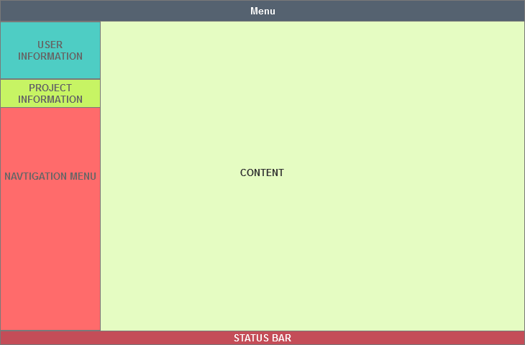

Figure 1 - Litho InSight Main components

# UX Design Guidelines

## 5.1. Top Menu

## 5.2. Side Menu

### 5.2.1. User Information

### 5.2.2. Project Information

### 5.2.3. Navigation Menu

## 5.3. Status Bar

## 5.4. Content

# UI Design Guidelines