Student’s Individual Study #1.
Statement.
Bulushev Mikhail (no team), information systems

Topic
Project introduction, machines provisioning

Target
Create a clear definition of the individual project, create an architecture of the system and prepare machine(s) for it.

Tasks

1. Choose and describe a project
Title: SSH bastion (from samples, but with HA)
Legend: An IT organization has a large infrastructure with numerous virtual machines. It needs a special gateway for their operations employees to perform authorized access to all machines
Main оbjectives (targets): Create a failover access gateway (two servers behind a load balancer) with centralized user management and passwordless authentication. Provide centralized user management (SSO), login via QR code (Device Flow) using phone. Allow access to the test server only through SSH-bastion, synchronizing home directories via NFS (overall 6 servers: load balancer, identity provider, two bastions, nfs storage and test server with db)
Key tasks:
- Set up all VMs (5+1 copy) (install OS, configure it, create users and give them a permissions)
- Configure Load balancer
- Setup Identity Stack - run an OAuth2.0 (keycloak + openldap) implementation on some of the server, configure it to be accessible (realm, federation, client)
- Setup NFS server (WIP)
- Setup NFS clients and System Security Services Daemon (SSSD) on bastions to see users from ldap
- Install and configure PAM (pam + python script with qrcode lib) for SSH-Bastion to authenticate SSH clients through OAuth2.0 server. Configure SSHD also
- Apply network policies to allow ssh connection to the test server only through SSH-Bastion, and restrict other network traffic
- For one of the user (E.g. dba) create an ability to connect to the test server and have an admin access to database installed on it

2. Create an architecture of your project
Hostname | Role | Description
lb-node | Load Balancer | HAProxy allow connection to 22 port and balance trafik
idp-node | Identity & Auth | Linux containers with Keycloak (Auth) и OpenLDAP (Users Directory)
bastion-01 | SSH Gateway 1 | Fedora + SSSD (LDAP) + Python PAM Script
bastion-02 | SSH Gateway 2 | Copy of bastion-01
storage-node | NFS Storage | Story home directories of users - persistence of data
test-server | Target | Some business postgesql
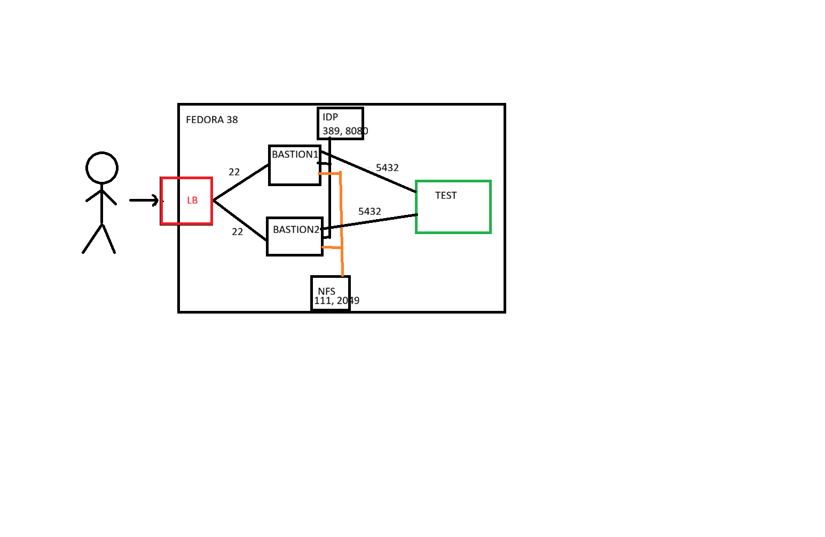
Flow:
- ssh to host
- lb transfer request
- SSSD -> LDAP -> return UID
- PAM -> python script
- QR in cli
- user scan -> login
- mount /home/*user* to NFS

3. Prepare machines for your project
I choice Vagrant with vmbox provider, since I like IaaC principle, vmbox has local network and I down wanna setup proxmox on my local server (for now, maybe I will migrate later)
(Vagrant file also attached to task)
For box I choose generic/fedora38 (official fedora/41-cloud-base suddenly not downloadable) image since it’s the latest box and fedora is free RHEL-based distro
