Student’s Individual Study #5.
Statement.

Bulushev Mikhail (no team), Information Systems

Topic: Monitoring & Observability.
Target: Making your system observable.

1. Defining logging mechanism
Audit events flow to journald via audisp-syslog and then to storage-node via journal-upload over plain HTTP (port 19532). This port will be opened in firewalld
auditd → audisp-syslog → journald → systemd-journal-upload (port 19532) → systemd-journal-remote (storage-node)
logging client has journald config:
[Journal]
Storage=persistent
ForwardToSyslog=no
URL=http://192.168.56.50:19532
logging server has default journald config but with changed ExecStart:
ExecStart=/usr/lib/systemd/systemd-journal-remote --listen-http=-3 --output=/var/log/journal/remote/ --split-mode=host
Also exists cron job to delete 30+ days old journals
journalctl --directory=/var/log/journal/remote --vacuum-time=30d

2. Setting up logging and create a tooling
Ansible roles:
- audit on all
- logging_server on storage
- logging_client on idp, lb, bastions, target
*show ansible roles*
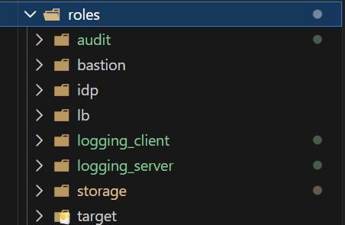
*show scripts*
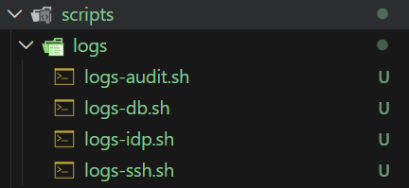
- logs-ssh.sh [pattern] - SSH + PAM + pam-keycloak-oidc auth, via _SYSTEMD_UNIT=sshd.service + SYSLOG_IDENTIFIER=sshd + SYSLOG_IDENTIFIER=pam-keycloak-oidc.
- logs-idp.sh [pattern] - Keycloak + OpenLDAP (keycloak.service + slapd.service).
- logs-db.sh [pattern] - PostgreSQL 16 on test-server (postgresql-16.service).
- logs-audit.sh <key> [host] - fleet-wide audit filter keyed by rule tag (identity, sshd, pg_hba, …) with optional host substring match.

3. Setting up an auditing system
Role ansible/roles/audit installs audit on every host, enables the audisp-syslog plugin (plugins.d/syslog.conf, type = always, LOG_INFO) so every audit event is mirrored into journald - which is exactly what feeds it to the shipper from step 2. That's the design trick that makes a single journalctl query on storage-node return audit hits from the entire fleet.

Rule files are layered by inventory group:
- 50-secos-base.rules.j2 - applied everywhere. Covers credential stores (/etc/shadow, passwd, gshadow, group), sudoers, PAM, sshd config, SSSD, firewalld, auditd self-tamper (/etc/audit, auditctl, auditd, /var/log/audit/), priv-mgmt binaries (sudo, visudo, useradd, passwd, …), syscalls for kernel modules (init_module/finit_module/delete_module), time changes (adjtimex, settimeofday, clock_settime, /etc/localtime), and non-root mounts
- 60-secos-storage.rules.j2 - /etc/exports, /etc/fstab, /etc/mdadm.conf, exportfs exec (keys: nfs_cfg, fstab, raid_cfg, nfs_cmds)
- 60-secos-idp.rules.j2 - Keycloak conf + import dir + unit file, OpenLDAP slapd.d and /var/lib/ldap (keys: keycloak_cfg, ldap_cfg, ldap_data)
- 60-secos-lb.rules.j2 - HAProxy config (haproxy_cfg)
- 60-secos-bastions.rules.j2 - pam-keycloak-oidc binary + TOML, autofs maps (pam_oidc_cfg, pam_oidc_bin, autofs_cfg)
- 60-secos-target.rules.j2 - PostgreSQL pg_hba.conf, postgresql.conf, DBA sudoers (pg_hba, pg_cfg, pg_sudoers)

Each task deploys its file conditionally on group_names, and keys are chosen so ausearch -k <key> / logs-audit.sh <key> returns one failure class at a time

Handlers (handlers/main.yml) use the two paths auditd actually honors on Fedora: /usr/sbin/service auditd restart for plugin changes (systemctl won't restart PID-1-managed auditd) and augenrules --load when any rule file changes

