Industrial Protocol Integration System
Architecture Documentation

Document Overview
This document describes the architecture of the Industrial Protocol Integration System, a distributed integration platform that connects existing industrial machines with workplace applications while providing centralized telemetry, configuration, monitoring, reporting, and analytics. The architecture is organized around independent Area Gateways for local machine communication and a Central Panel for centralized capabilities. The document follows an arc42-oriented structure and uses C4 views where they provide useful architectural context.
The architecture is designed to:
• preserve existing machines and workplace applications;
• abstract heterogeneous industrial protocols behind standardized interfaces;
• keep local production communication independent from central services;
• collect telemetry reliably across multiple production Areas;
• centralize configuration, monitoring, reporting, and operational visibility.

Document Plan
Section | Purpose
1. Introduction & Goals | Motivation, current-system problems, goals, quality goals, and scope.
2. Constraints | Technical, operational, and legacy constraints that limit the solution space.
3. Context & Scope | Business and technical context, communication partners, and system boundary.
4. Solution Strategy | Fundamental architectural strategies used to shape the solution.
5. Building Block View | Internal structure of the Area Gateway and Central Panel.
6. Runtime View | Important runtime scenarios for telemetry, workplace communication, recovery, and configuration.
7. Deployment View | Distribution of Areas, gateways, central infrastructure, RabbitMQ, and storage.
8. Architectural Decisions | Accepted ADRs and their context, decisions, and consequences.
9. Quality Requirements | Quality tree, concrete quality scenarios, availability, performance, and security boundaries.
10. Risks & Technical Debt | Known architectural risks, limitations, and intentionally deferred work.
11. Glossary | Project-specific domain and architectural terminology.

Industrial Protocol Integration System

1. Introduction & Goals

1.1 Introduction
The Industrial Protocol Integration System is intended to provide a standardized integration layer between existing industrial machines, local workplace applications, and central monitoring and configuration services.
The production environment consists of multiple machines from different vendors. These machines already exist and expose different industrial communication protocols, such as OPC UA, OPC Classic, Modbus/TCP, or vendor-specific interfaces.
Existing workplace applications communicate with these machines in order to read production data, receive status information, and, where required, execute commands or write values.
Historically, these integrations were implemented individually for particular machines and workplaces. As the number of machines, protocols, and workplace applications increased, this approach resulted in duplicated integration logic, strong dependencies between applications and machines, and limited possibilities for centralized telemetry and monitoring.
The goal of the new architecture is therefore not to replace the existing machines or workplace applications, but to introduce a common integration layer around them.

1.2 Existing System and Architectural Problems
Before introduction of the Industrial Protocol Integration System, workplace applications communicate directly with industrial machines or use individually developed machine-specific integrations.
Each integration may therefore depend on a particular industrial protocol, machine model, vendor interface, or data representation.
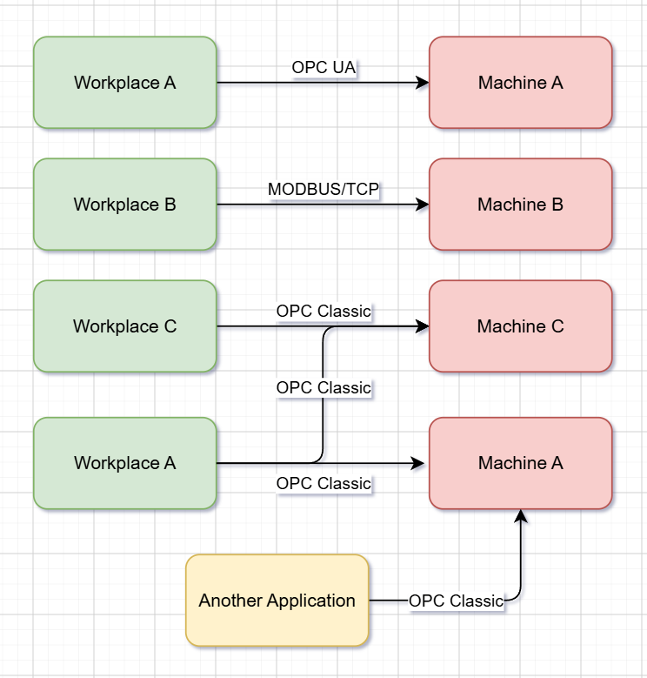

Problems of the Existing Architecture:

Problem | Consequence
Protocol-specific workplace integrations | Workplace applications require knowledge about machine-specific protocols, interfaces, or data structures.
Tight coupling between workplaces and machines | Changes to a machine, protocol, address structure, or vendor interface can require modifications to workplace software.
Too many connections to a single machine | Multiple workplace applications may establish separate connections to the same machine. This increases the number of sessions, consumes machine and network resources, may exceed machine-specific connection limits, and reduce communication performance.
Duplicated integration logic | Connection handling, conversion, error handling, reconnect behavior, and similar functionality may be implemented independently by multiple applications.
No common centralized telemetry path | Machine states, measurements, communication failures, and integration health cannot be collected and evaluated consistently from one central location.
Limited observability | Troubleshooting requires investigation of individual workplace applications and machine connections instead of a standardized integration layer.
Increasing maintenance complexity | The number of direct dependencies grows as additional workplaces, machines, and protocols are introduced.

1.3 Goals of the New Architecture
The new architecture shall introduce a standardized integration layer while preserving the existing production environment.
The main architectural goals are:
- Decouple workplace applications from industrial protocols.
Workplace applications should communicate through standardized interfaces instead of implementing OPC UA, Modbus, OPC Classic, or other machine-specific protocols directly.
- Centralize machine communication within production areas.
Machine-specific communication and protocol handling should be moved out of individual workplace applications into a common integration layer. Multiple workplace applications should be able to consume machine data through this shared layer, reducing the number of direct connections established to individual machines.
- Support heterogeneous industrial protocols.
The architecture should allow different machine protocols to coexist behind a common integration model.
- Preserve existing workplace applications.
Existing workplaces should require only the minimum changes necessary to use the new integration interfaces and should not need to be completely rewritten.
- Provide centralized telemetry.
Machine measurements, events, communication states, and gateway health information should be transferable to a Central Panel for monitoring and analysis.
- Keep local production communication independent from central services.
Communication between local workplaces and machines should not require the Central Panel or the central telemetry infrastructure to be continuously available.
- Improve extensibility.
Additional machines, protocols, workplaces, and production areas should be introducible without redesigning the complete system.
- Improve fault isolation.
Failures within one production area should have minimal influence on other production areas.
- Improve maintainability and observability.
Integration behavior, failures, connection states, and message processing should be easier to understand, monitor, and troubleshoot.

1.4 Quality Goals
The following quality goals have the highest architectural priority.

Priority | Quality Goal | Description
1 | Interoperability and Extensibility | Different industrial protocols and machine types can be integrated through clearly separated protocol-specific adapters without requiring changes to consuming workplace applications.
2 | Reliability and Fault Isolation | Temporary failure of central services or another production area should not unnecessarily interrupt local machine-to-workplace communication.
3 | Maintainability | Machine communication, protocol handling, local workplace communication, telemetry, configuration, and persistence should remain separated into understandable architectural responsibilities.
4 | Scalability | Additional machines, workplaces, and production areas should be supported primarily by adding or configuring integration components rather than redesigning the architecture. The number of direct connections to an individual machine should remain controlled as the number of workplace applications increases.
5 | Operability and Observability | Communication status, failures, stale connections, connection counts, and relevant telemetry should be observable in a consistent manner.

Detailed and testable quality scenarios are specified in Section 9 – Quality Requirements.

1.5 Scope of the Architectural Improvement
The architecture focuses on improving the integration between existing machines and software systems.
It does not attempt to replace the industrial machines, redesign their internal control logic, or completely replace existing workplace applications.
The main architectural change is the introduction of a standardized integration layer that separates machine-specific communication from workplace applications, controls the number of connections established to each machine, and provides an additional path for centralized telemetry and configuration.
The resulting target architecture is described in the following sections, beginning with the architectural and technical constraints in Section 2 and the system context and boundaries in Section 3.

2. Constraints
The architecture of the Industrial Protocol Integration System is influenced by several technical, organizational, and operational constraints originating from the existing production environment.
These constraints limit the available solution space and must be respected by the target architecture.

2.1 Existing workplace applications must be preserved
The existing workplace applications are already used in production and cannot be completely rewritten or replaced as part of this project.
The integration architecture must therefore allow existing applications to continue fulfilling their current responsibilities while requiring only limited adaptations for communication with the new integration layer.

2.2 Existing machines cannot be replaced or fundamentally modified
The industrial machines are already installed and operational.
The project cannot assume modifications to:
- machine firmware;
- PLC programs;
- vendor-specific communication interfaces;
- supported industrial protocols;
- internal machine control logic.
The integration system must adapt to the interfaces already provided by the machines.

2.3 Existing machine communication protocols must be supported
Machines in the production environment use different industrial communication technologies, including protocols such as:
- OPC UA;
- OPC Classic;
- Modbus/TCP;
- vendor-specific interfaces.
The architecture cannot require all machines to expose one common protocol.
Protocol differences must therefore be handled by the integration system.

2.4 Production operation must remain independent from central services where possible
Local communication between workplaces and machines is part of the production process.
Temporary unavailability of central monitoring, telemetry, or management services should therefore not unnecessarily interrupt communication required for local production operation.
The architecture must distinguish between communication required locally for production and functionality that can depend on central infrastructure.

2.5 Production environments may contain multiple independent machine groups
Machines and workplaces are distributed across different parts of the production environment.
Communication architecture must therefore support logical or physical separation of machine groups and must not assume that all industrial communication can or should be routed through one central runtime instance.

2.6 Network connectivity cannot be assumed to be permanently available
Connections between production infrastructure and central services may temporarily become unavailable because of:
- network failures;
- maintenance;
- service restarts;
- infrastructure outages.
The architecture must tolerate temporary connectivity interruptions where technically reasonable.

2.7 Direct machine connections must remain controlled
Industrial machines may support only a limited number of simultaneous client connections or sessions.
The architecture should therefore avoid uncontrolled growth of direct machine connections as additional workplace applications are introduced.
Multiple consumers should be able to use machine information without each consumer necessarily establishing an independent machine connection.

2.8 Machine-specific behavior cannot be completely eliminated
Although the system should provide standardized interfaces to consumers, individual industrial protocols and machines may expose capabilities that cannot be represented identically across all machine types.
The architecture must therefore allow protocol-specific or machine-specific behavior where necessary instead of assuming complete technical uniformity.

2.9 Existing customer systems remain outside the ownership of the integration platform
Existing customer applications, databases, and production systems that are not part of the Industrial Protocol Integration System remain externally owned systems.
The new architecture may integrate with them but should not assume responsibility for redesigning or replacing their internal data models or business logic.

2.10 The system operates in an industrial environment
The solution is intended to run as part of an existing production infrastructure.
Deployments, updates, failures, and restarts must therefore consider the impact on active production processes.
Architectural solutions that require unnecessary interruption of machine communication should be avoided.

2.11 Hard real-time control is outside the project scope
The Industrial Protocol Integration System is designed for machine integration, data distribution, telemetry, configuration, and application-level communication.
It is not intended to replace PLC-level or other deterministic real-time control mechanisms.
Functions requiring strict deterministic timing or hard real-time guarantees must remain sufficiently close to the machine or within dedicated industrial control systems.

2.12 Machine safety logic remains outside the integration system
Safety-critical machine behavior must remain implemented within the appropriate industrial control and safety systems.
The integration platform must not become the sole mechanism responsible for safety-critical machine control.

2.13 Existing production databases are not redesigned by this project
Where customer applications already maintain their own operational or business databases, those databases remain outside the architectural ownership of the integration platform unless an explicit integration interface is required.
The system may collect its own telemetry, configuration, and integration-related data without replacing the customer's existing business data storage.

3. Context & Scope
This section describes the environment of the Industrial Protocol Integration Solution and its interfaces with existing production systems and users.
The solution consists of two major software systems:
- Area Gateway – provides standardized access to industrial machines for local workplace applications and forwards relevant information to central services.
- Central Panel – provides centralized telemetry, reporting, visualization, configuration, and system monitoring.
Both systems belong to the Industrial Protocol Integration Solution. Their internal architecture is intentionally not shown in this section and is described later in the Building Block View.
Existing machines, workplace applications, reporting applications, and users remain outside the solution boundary.

3.1 Business Context
The Business Context describes who interacts with the Industrial Protocol Integration Solution and for what purpose, independently of concrete communication technologies.

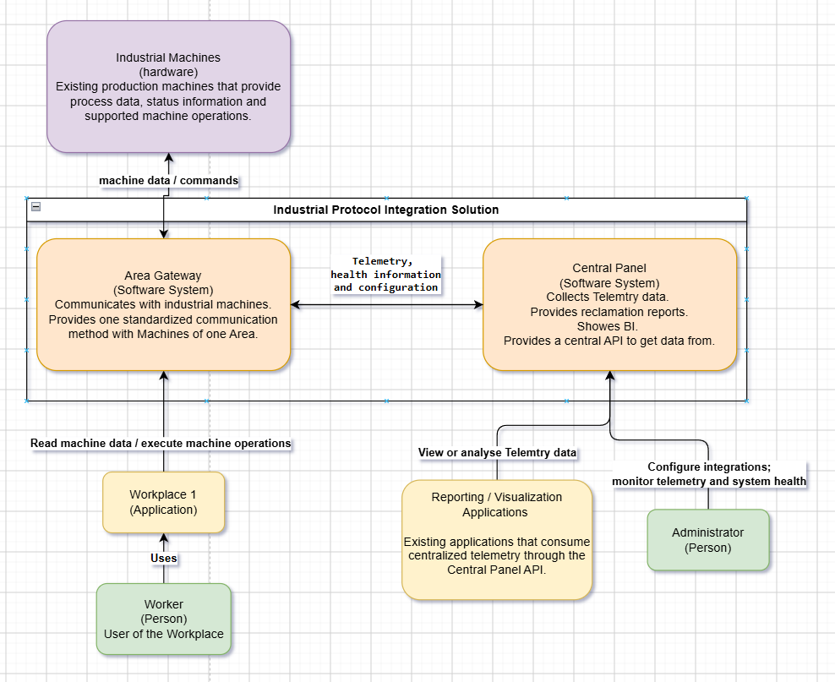

Communication Partner | Interaction with the Solution | Purpose
Industrial Machines | Exchange machine data and supported machine operations with the Area Gateway | Provide production values, status information and machine functionality required by workplace applications
Workplace Applications | Access machine data and execute supported machine operations through the Area Gateway | Allow existing production workplaces to interact with machines without implementing machine-specific communication independently
Worker | Uses an existing Workplace Application | Operates the workplace as part of the production process
Reporting / Visualization Applications | Consume centralized telemetry through the Central Panel | Display or analyse production and telemetry information
Administrator | Uses the Central Panel | Configures integrations and monitors telemetry and overall integration health
The Area Gateway and Central Panel have different responsibilities but exchange information as part of the same integration solution.
The Area Gateway provides the Central Panel with:
- telemetry data;
- integration and communication status;
- health information.
The Central Panel provides centralized configuration information required by the integration environment.
Local workplace-to-machine communication is handled by the Area Gateway and is therefore separated from centralized telemetry and management functionality.

3.2 Technical Context
The Technical Context describes how the communication relationships shown in the Business Context are technically realized.
It focuses on system boundaries and communication technologies. Internal implementation details such as databases, internal services, protocol adapter structure, or message-processing components are described in later sections.
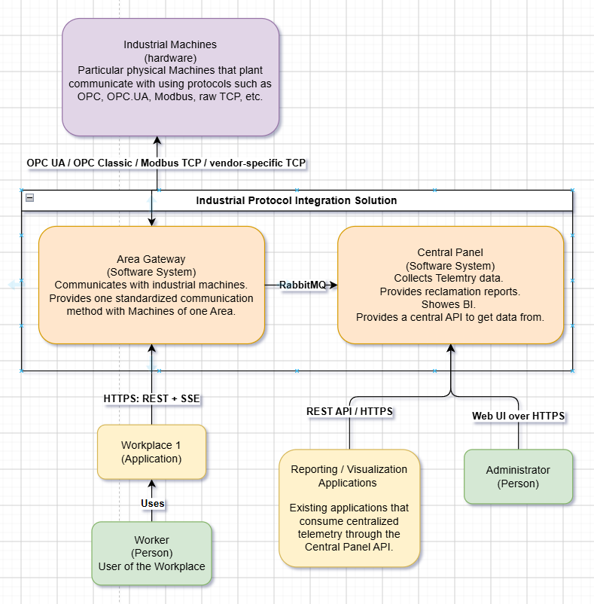

Communication | Technical Interface | Description
Industrial Machines ↔ Area Gateway | OPC UA, OPC Classic, Modbus/TCP, vendor-specific TCP-based protocols | The Area Gateway communicates with existing machines using the protocols already provided by the industrial equipment
Workplace Applications ↔ Area Gateway | HTTPS: REST API + Server-Sent Events (SSE) | REST is used for request/response operations and supported machine commands; SSE provides continuous machine-data updates to workplace applications
Area Gateway → Central Panel | RabbitMQ over AMQP | Telemetry and integration-related information are transferred asynchronously from Area Gateways toward central processing
Reporting / Visualization Applications → Central Panel | REST API over HTTPS | External applications consume centralized telemetry and reporting data through the Central Panel API
Administrator → Central Panel | Web UI over HTTPS | Administrators access configuration, telemetry, and system-health functionality through the Central Panel web interface

3.3 System Boundary
The Industrial Protocol Integration Solution is responsible for the integration between existing industrial equipment, workplace applications, and centralized telemetry and management functionality.
The solution includes:
- machine communication and protocol integration;
- standardized access to machine data and supported operations;
- distribution of machine information to workplace applications;
- centralized telemetry collection;
- integration configuration;
- integration-health monitoring;
- interfaces for reporting and visualization applications.
The following elements remain outside the solution boundary:
- industrial machine hardware and internal machine control logic;
- PLC and safety-control logic;
- existing workplace business logic;
- existing reporting and visualization applications;
- physical network infrastructure;
- customer-specific infrastructure and business systems not directly owned by the integration solution.
The diagrams in this section show the logical context of the solution. They intentionally contain only one generic Area Gateway.
A production installation may contain several Area Gateway instances serving different groups of machines and workplaces. The concrete distribution of gateways, machines, workplaces, and central infrastructure is described in Section 7 – Deployment View.

4. Solution Strategy

The solution introduces a distributed integration layer between existing industrial machines and software applications.

The main architectural strategies are:

- Centralize machine communication in dedicated gateways.
Machine-specific protocols and connection handling are moved out of workplace applications into a shared integration layer.
- Distribute gateways by production area.
Instead of using one central gateway for all machines, separate Area Gateways are used to reduce the impact of failures and keep local production communication independent.
- Separate local communication from central services.
Workplace-to-machine communication is handled locally through the Area Gateway and must not depend on continuous availability of the Central Panel.
- Use standardized interfaces toward applications.
Workplace applications interact with the Area Gateway through application-level interfaces instead of machine-specific industrial protocols.
- Collect telemetry centrally and asynchronously.
Area Gateways forward telemetry and integration status to the Central Panel through asynchronous messaging, allowing central processing to be decoupled from local machine communication.
- Centralize management while keeping execution distributed.
Configuration, monitoring, reporting, and telemetry access are provided centrally, while actual machine communication remains the responsibility of the Area Gateways.

These strategies address the main architectural goals of interoperability, fault isolation, maintainability, scalability, and operational independence.

5. Building Block View
The Building Block View describes the internal structure of the two main software systems of the Industrial Protocol Integration Solution:
- Area Gateway
- Central Panel

5.1 Area Gateway (Whitebox)

5.1.1 Container View
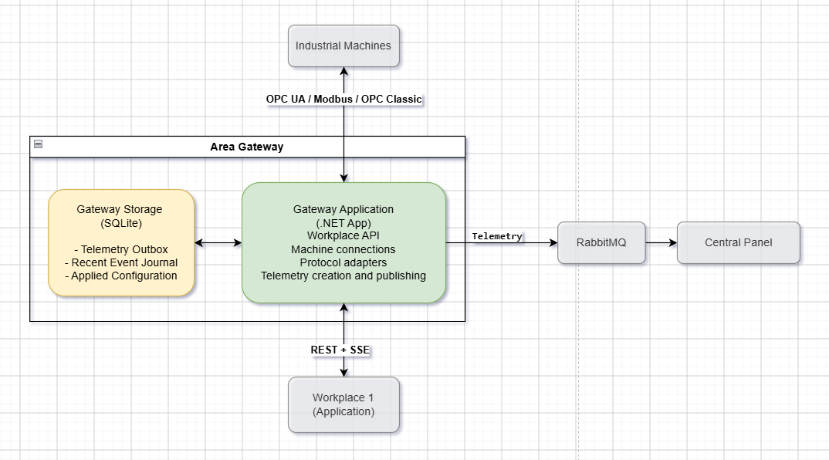
The Area Gateway consists of two containers.
Container | Technology | Responsibility
Gateway Application | .NET Application | Communicates with industrial machines, maintains machine connections, exposes the Workplace API, creates telemetry, and exchanges information with central services.
Gateway Storage | SQLite | Provides local persistence for the Telemetry Outbox, Recent Event Journal, and Applied Configuration.

Rationale
Machine communication and application-level integration are concentrated in one Gateway Application so that workplace applications do not need to maintain their own industrial-protocol implementations or machine connections.
Local SQLite storage provides the Area Gateway with the persistence required for telemetry delivery, workplace recovery, and configuration retention without introducing an additional database server within every production area.
The Gateway Application communicates with:
- Industrial Machines through their existing industrial protocols;
- Workplace Applications through REST and SSE;
- RabbitMQ for centralized telemetry delivery;
- Central Panel for central processing and configuration.

5.1.2 Gateway Application – Component View
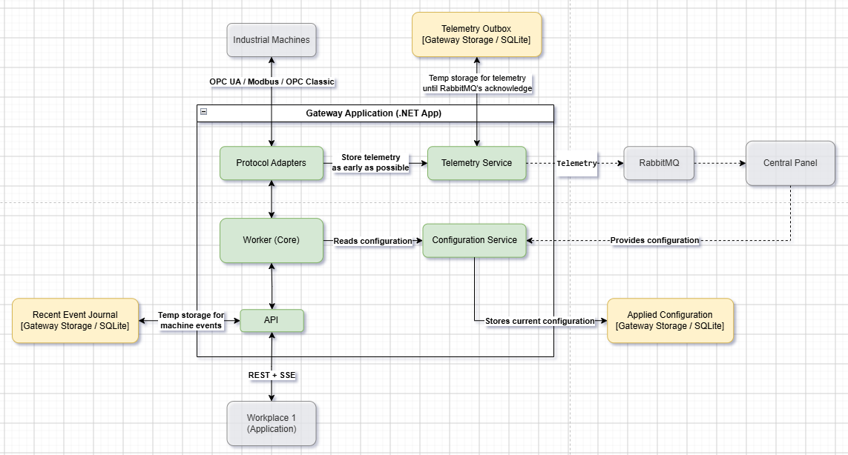
The Gateway Application is decomposed into the following architecturally relevant components.
Component | Responsibility
Protocol Adapters | Implement communication with the supported industrial protocols and provide access to machine data and operations.
Worker (Core) | Coordinates the main runtime behavior of the gateway and the communication between machine integration and workplace functionality.
API | Provides REST operations and SSE streams to workplace applications.
Telemetry Service | Receives machine telemetry, persists it temporarily in the Telemetry Outbox, and forwards it through RabbitMQ.
Configuration Service | Receives configuration provided by the Central Panel, stores the current configuration locally, and provides it to the gateway runtime.
Protocol Adapters
Protocol Adapters encapsulate communication with industrial machines using protocols such as OPC UA, Modbus, and OPC Classic.
They isolate protocol-specific communication from the remaining gateway functionality.
Worker (Core)
The Worker represents the central runtime logic of the Gateway Application.
It coordinates machine communication through the Protocol Adapters and provides the functionality required by the Workplace API. It operates according to the configuration supplied by the Configuration Service.
API
The API is the communication boundary between the Area Gateway and existing workplace applications.
It provides:
- REST for request/response operations;
- SSE for continuous machine-data delivery.
Recent machine events are temporarily stored in the Recent Event Journal to support recovery of workplace communication.
Telemetry Service
The Telemetry Service handles the central telemetry path.
Telemetry is stored in the local Telemetry Outbox as early as possible and then forwarded to RabbitMQ. Outbox entries remain available until successful acknowledgement by RabbitMQ.
This separates telemetry creation from the availability and processing speed of the Central Panel.
Configuration Service
The Configuration Service handles configuration supplied by the Central Panel.
Received configuration is stored as the current Applied Configuration in Gateway Storage and is made available to the gateway runtime.
This allows the Area Gateway to retain its currently valid configuration locally.

5.1.3 Gateway Storage
Each Area Gateway has one local SQLite database.
The Component Diagram shows its three logical responsibilities separately to make their architectural purposes explicit.
Logical Storage | Purpose
Telemetry Outbox | Temporarily stores telemetry until successful acknowledgement by RabbitMQ.
Recent Event Journal | Temporarily stores recent machine events required for workplace recovery.
Applied Configuration | Stores the current configuration used by the Area Gateway.
All three logical storage areas belong to the same Gateway Storage / SQLite container shown in the Container Diagram.

5.2 Central Panel (Whitebox)
The Central Panel provides the centralized part of the Industrial Protocol Integration Solution.
It receives and permanently stores telemetry from Area Gateways, provides centralized configuration management, exposes telemetry to other applications, and offers a common dashboard for monitoring and administration.

5.2.1 Container View
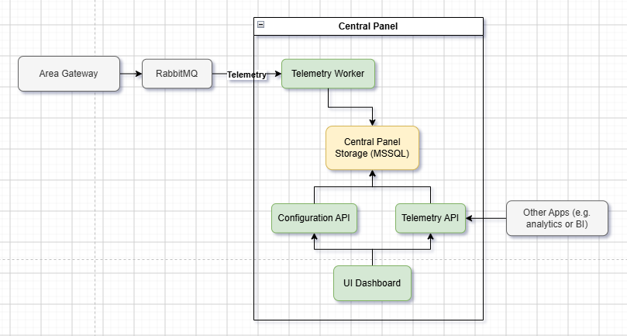

The Central Panel consists of the following containers.

Container | Technology | Responsibility
Telemetry Worker | Worker Service | Consumes telemetry delivered through RabbitMQ, processes and normalizes incoming data, and persists it in the Central Panel Storage.
Central Panel Storage | Microsoft SQL Server | Provides persistent central storage for telemetry, configuration, and integration-related metadata.
Telemetry API | API Application | Provides access to persisted telemetry and related information for the UI Dashboard and external applications.
Configuration API | API Application | Manages configuration of machines, Areas, and Area Gateways and persists this configuration centrally.
UI Dashboard | Web Application | Provides the main user interface for telemetry visualization, business analytics, system-health monitoring, and integration configuration.

Rationale
Telemetry processing is separated from interactive API and UI functionality through a dedicated Telemetry Worker. This allows incoming telemetry to be processed independently of dashboard usage or requests from other applications.
The Central Panel Storage acts as the authoritative persistent data store for the centralized part of the solution. Applications consume historical and current centralized information from this database instead of communicating directly with industrial machines.
Telemetry and configuration functionality are exposed through separate APIs because they serve different responsibilities and can evolve independently.

5.2.2 Telemetry Worker
The Telemetry Worker is responsible for the central telemetry ingestion path.
Telemetry produced by Area Gateways is delivered through RabbitMQ. The Telemetry Worker consumes these messages, processes and normalizes their content, and persists the resulting information in the Central Panel Storage.
The worker operates independently from the Central Panel UI and APIs.

5.2.3 Central Panel Storage
The Central Panel uses a dedicated Microsoft SQL Server database for persistent central data.
The database stores:
- normalized telemetry and machine history;
- machine and integration configuration;
- Area and Area Gateway configuration;
- metadata required for centralized monitoring and management.
This database belongs exclusively to the Central Panel and is separate from the customer's existing business database.

5.2.4 Telemetry API
The Telemetry API provides application-level access to telemetry stored by the Central Panel.
It is used by:
- the Central Panel UI Dashboard;
- reporting and visualization applications;
- analytics and BI applications;
- other applications requiring centralized machine or telemetry information.
These consumers can therefore access persisted machine information without establishing direct connections to industrial machines or Area Gateways.

5.2.5 Configuration API
The Configuration API provides centralized management of integration configuration.
It manages configuration related to machines, Areas, and Area Gateways and stores the resulting configuration in the Central Panel Storage.
The API is used by the UI Dashboard for administrative configuration operations and provides the centralized source of configuration required by Area Gateways.

5.2.6 UI Dashboard
The UI Dashboard is the main user-facing application of the Central Panel.
It uses the Telemetry API and Configuration API to provide a centralized view of the integration environment.
The dashboard supports:
- telemetry visualization;
- business analytics and reporting;
- machine and Area Gateway status;
- system-health monitoring;
- configuration of machines, Areas, and Area Gateways.
The dashboard does not communicate directly with industrial machines. Machine communication remains the responsibility of the corresponding Area Gateways.

6. Runtime View

The Runtime View describes the most important dynamic interactions between the building blocks introduced in Section 5.
The selected scenarios focus on the behavior that is architecturally relevant for the solution:
- reliable telemetry delivery from an Area Gateway to the Central Panel;
- recovery from communication and processing failures;
- local machine-to-workplace communication;
- workplace reconnection and event replay;
- centralized configuration updates.

6.1 Telemetry Delivery: Area Gateway to Central Panel
This scenario shows the normal telemetry delivery path from an industrial machine through the Area Gateway and RabbitMQ into the Central Panel.
[Insert: Sequence Diagram – Message Delivery: Area Gateway → Central Panel]
Flow
1. A machine produces an event.
The Area Gateway receives the event through the corresponding industrial protocol and converts it into the representation required for telemetry processing.
2. The Area Gateway persists the telemetry event locally.
The event is passed to the Telemetry Service and synchronously stored in the local Telemetry Outbox before asynchronous delivery begins.
3. The Telemetry Service publishes the event to RabbitMQ.
Pending Outbox entries are published asynchronously. The entry remains in the Outbox until RabbitMQ confirms successful receipt of the message. After broker acknowledgement, the corresponding Outbox entry can be removed.
4. The Central Panel consumes and persists the telemetry event.
The Telemetry Worker consumes the message from RabbitMQ, processes and normalizes it where required, and stores the resulting telemetry data in the Central Panel Storage.
5. The Telemetry Worker acknowledges successful processing.
RabbitMQ is acknowledged only after the telemetry event has been successfully persisted. The message can then be removed from the queue.
This results in two separate delivery guarantees: the Area Gateway retains telemetry until RabbitMQ accepts it, while RabbitMQ retains the message until the Central Panel successfully processes it.

6.2 Telemetry Delivery: Handling Communication and Processing Failures
This scenario describes how telemetry delivery behaves when the Area Gateway, network, RabbitMQ connection, or Central Panel processing path becomes temporarily unavailable.
[Insert: Sequence Diagram – Message Delivery: Area Gateway → Central Panel – Failure Handling]
Flow
1. An event can be lost before it reaches the Area Gateway.
A network interruption between a machine and the Area Gateway may prevent an event from being received at all. Where supported by the machine interface, for example by an OPC UA server exposing historical data, a protocol adapter may retrieve missing information after reconnection. This capability is machine- and protocol-dependent and is therefore not guaranteed by the integration solution.
2. Received telemetry is immediately persisted in the Telemetry Outbox.
Once an event reaches the Area Gateway, it is stored locally before publication to RabbitMQ is attempted.
3. Area Gateway or network failure does not remove pending telemetry.
If the Gateway Application stops, RabbitMQ is unavailable, or the connection is interrupted before successful publication, the telemetry remains in the Outbox. After the system or connection becomes available again, the Telemetry Service reads the pending entries and resumes publication.
4. Central processing failures are handled through controlled message retries.
The Telemetry Worker consumes messages from RabbitMQ. If processing or persistence fails, the message is not acknowledged as successfully processed and is retried according to the configured delivery policy.
5. Messages that repeatedly fail are isolated in a Dead-Letter Queue (DLQ).
After the configured retry limit is reached, the failing message is routed to a DLQ instead of blocking normal telemetry processing.
6. DLQ remediation is an operational responsibility.
The architecture provides isolation of failed messages through the DLQ. The final operational strategy—such as manual inspection, correction and replay, or automated reprocessing—is intentionally left to the deployment environment and operational requirements.

6.3 Message Delivery: Area Gateway to Local Workplace
Local workplace communication is handled entirely within the production area and does not depend on the Central Panel.
The runtime scenario contains two independent flows: continuous machine-event delivery and execution of workplace commands.
[Insert: Sequence Diagram – Message Delivery: Area Gateway → Local Workplace]
Machine Event Delivery
1. The Workplace establishes an SSE connection.
The Workplace opens a persistent SSE connection to the Area Gateway and remains ready to receive machine events.
2. A machine event is received by the Area Gateway.
The corresponding Protocol Adapter receives the machine event and the Area Gateway processes it for internal distribution.
3. The event is stored in the Recent Event Journal.
Replayable events receive a monotonically ordered Sequence_ID and are temporarily persisted in the local Event Journal.
4. The Area Gateway publishes the event through the SSE endpoint.
The event, including its sequence identifier, is forwarded to the active SSE stream.
5. The Workplace receives the event.
The Workplace processes the event and remembers its identifier so that missing events can later be requested after a connection interruption.
Workplace Command Execution
1. The Workplace submits a command through the REST API.
For example:
POST /machines/{id}/commands/{command}
2. The API validates the request.
The Area Gateway verifies that the requested machine, command, and supplied parameters are valid and allowed.
3. The validated command is forwarded to the gateway runtime.
The API passes the approved operation to the machine-communication logic.
4. The Area Gateway executes the operation on the machine.
The appropriate Protocol Adapter translates the operation into the corresponding industrial protocol request and performs the machine write or command execution.

6.4 Local Workplace Communication: Connection Recovery
The Recent Event Journal provides short-term recovery when the SSE connection between a Workplace and its Area Gateway is interrupted.
[Insert: Sequence Diagram – Area Gateway → Local Workplace – Connection Recovery]
Flow
1. The SSE connection is lost.
The Workplace temporarily stops receiving live machine events.
2. The Workplace reconnects with its last processed event identifier.
During reconnection, the Workplace provides the last successfully processed event ID, for example:
Last-Event-ID: 18422
3. The Area Gateway determines which events were missed.
The SSE/API functionality queries the Recent Event Journal for events with:
Sequence_ID > 18422
4. The Event Journal returns the available missing events.
For example:
18423, 18424, 18425
5. The missing events are replayed in sequence.
The SSE endpoint sends the recovered events to the Workplace in their original sequence order.
6. Live SSE delivery continues.
After replay is complete, the Workplace continues receiving new events through the normal live stream.
This recovery mechanism is limited by the retention period of the Recent Event Journal. It provides short-term communication recovery rather than permanent event history.

6.5 Configuration Update through the Central Panel
Configuration changes are created centrally, published explicitly, retrieved by the corresponding Area Gateway, validated locally, and activated only after successful validation.
[Insert: Sequence Diagram – Configuration Update]
The configuration lifecycle is divided into four stages.

6.5.1 Create and Save Draft
1. The Engineer edits an Area Gateway configuration.
Configuration changes are made through the Central Panel UI Dashboard.
2. The UI Dashboard saves the configuration as a draft.
The Dashboard sends the changed configuration to the Configuration API.
3. The Configuration API persists the draft.
The new version, for example v42, is stored in the Central Panel Storage with draft status. It is not yet distributed to an Area Gateway.

6.5.2 Publish Configuration
1. The Engineer explicitly publishes the draft.
After reviewing the configuration, the Engineer selects the publish action in the UI Dashboard.
2. The UI Dashboard sends the publish request to the Configuration API.
3. The Configuration API marks version v42 as published and available for retrieval.
The previously applied configuration remains active until the Area Gateway successfully validates and activates the new version.

6.5.3 Area Gateway Retrieves and Validates Configuration
1. The Area Gateway periodically checks for a newer published configuration.
The Gateway Configuration Service queries the Central Panel Configuration API using its currently applied configuration version.
2. The Configuration API returns the latest published configuration when a newer version exists.
3. The Area Gateway stores the received version as a candidate configuration.
The candidate is persisted in the local Gateway Storage before it replaces the currently applied configuration.
4. The candidate configuration is validated.
The Area Gateway validates the configuration structure, required values, machine definitions, nodes, and other applicable integration settings.
5. Validation succeeds.
The validator reports that the candidate can be used by the Gateway Application.
6. The candidate is marked as valid.
At this point the configuration is ready for activation, while the previously applied version remains available until the activation step succeeds.

6.5.4 Activate New Configuration
1. The Area Gateway activates the validated configuration version v42.
2. The currently applied configuration is replaced.
Version v42 becomes the new Applied Configuration, replacing version v41.
3. The Area Gateway reports successful activation to the Central Panel.
The Configuration Service informs the Configuration API that version v42 has been successfully applied.
4. The Central Panel updates the configuration state.
Version v42 is marked as applied, while the previous version is marked as superseded.
This lifecycle prevents an edited or merely published configuration from immediately replacing a working gateway configuration. A new version becomes operational only after it has been retrieved, validated, and successfully activated by the corresponding Area Gateway.

7. Deployment View

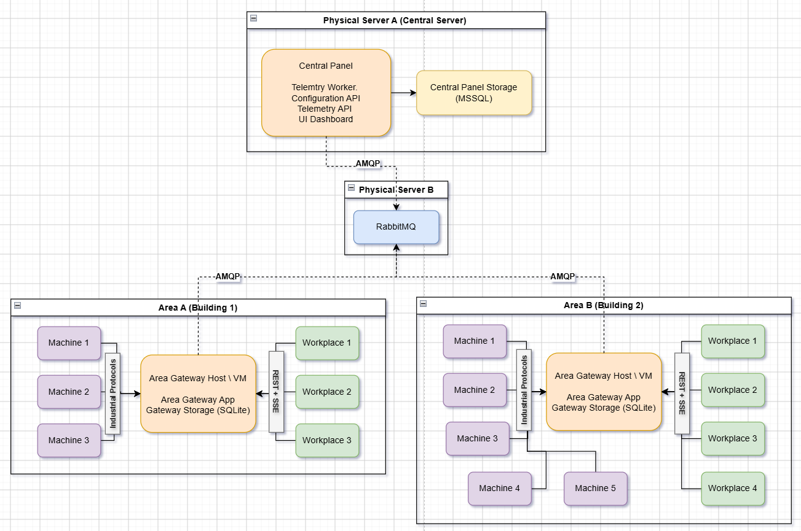

The deployment is divided into multiple independent production areas and centralized infrastructure.
Area A (Building 1) and Area B (Building 2) represent physically separated production areas. Each area contains its own machines, workplace applications, and a dedicated Area Gateway Host, which may be deployed as a virtual machine or a dedicated server. Each Area Gateway communicates only with the machines and workplaces assigned to its area. This keeps local production communication independent between buildings and limits the impact of an Area Gateway failure to the affected area.
Machine communication uses the corresponding industrial protocols, while workplaces communicate with their local Area Gateway through REST and SSE.
The centralized infrastructure is distributed across two physical servers:
- Physical Server A hosts the Central Panel and its Microsoft SQL Server storage. The Telemetry Worker, Configuration API, Telemetry API, and UI Dashboard are deployed here.
- Physical Server B hosts RabbitMQ and therefore forms an independent telemetry-buffering layer.
Area Gateways publish telemetry to RabbitMQ using AMQP. Separating RabbitMQ from the Central Panel provides an additional failure boundary: if Physical Server A or the Central Panel becomes unavailable, Area Gateways can continue publishing telemetry to RabbitMQ on Physical Server B. The messages remain stored there until the Telemetry Worker becomes available again and processes them into the Central Panel Storage.
The local Gateway Storage additionally protects telemetry before it has been successfully accepted by RabbitMQ, providing another level of resilience against temporary network or broker outages.

8. Architectural Decisions
This section records the architectural decisions that have a significant impact on the structure, reliability, scalability, or evolution of the Industrial Protocol Integration Solution.
Detailed implementation choices that do not significantly affect the architecture are intentionally omitted.

ADR-001 – Distribute Machine Integration by Production Area
Status: Accepted
Context
A single centralized gateway for all machines would create a common failure point and would make local production communication dependent on central infrastructure.
Decision
Each production area receives its own Area Gateway responsible for the machines and workplaces assigned to that area.
Consequences
- Failure of one Area Gateway affects only its production area.
- Local machine communication remains close to the production environment.
- Additional areas can be introduced by deploying additional Area Gateways.
- Every Area Gateway requires its own deployment, configuration, and local storage.

ADR-002 – Keep Workplace Communication Local
Status: Accepted
Context
Workplace applications require direct access to machine information and commands during normal production operation.
Routing this communication through the Central Panel or RabbitMQ would introduce unnecessary latency and central dependencies.
Decision
Workplaces communicate directly with their local Area Gateway using REST and SSE.
The Central Panel is not part of the runtime path between workplaces and machines.
Consequences
- Local production remains operational when central services are unavailable.
- Communication latency stays local to the production area.
- Central telemetry infrastructure cannot become a dependency for normal workplace operation.
- The Area Gateway becomes a critical component within its individual area.

ADR-003 – Isolate Industrial Protocols Behind Protocol Adapters
Status: Accepted
Context
Existing machines expose heterogeneous interfaces such as OPC UA, OPC Classic, Modbus/TCP, and vendor-specific protocols.
Allowing workplace applications to communicate through these protocols directly would duplicate integration logic and tightly couple applications to machines.
Decision
Industrial protocol communication is implemented through Protocol Adapters inside the Area Gateway.
Workplace applications use standardized application-level interfaces instead of machine-specific protocols.
Consequences
- Industrial protocol details are isolated from consumers.
- New protocols can be introduced through additional adapters.
- Multiple workplaces can share gateway-managed machine connections.
- Protocol-specific capabilities may still require specialized adapter logic.

ADR-004 – Use RabbitMQ for Asynchronous Central Telemetry
Status: Accepted
Context
Telemetry must be collected centrally, but local gateways should not depend on the availability or processing speed of the Central Panel.
Decision
Area Gateways publish telemetry asynchronously through RabbitMQ. A dedicated Telemetry Worker in the Central Panel consumes and persists the messages.
Consequences
- Telemetry producers and consumers are decoupled.
- Central processing can temporarily stop while RabbitMQ retains pending messages.
- Retry, acknowledgement, and dead-letter mechanisms can be applied centrally.
- RabbitMQ becomes an additional infrastructure component that must be operated and monitored.

ADR-010 – Use AMQP as the Common Messaging Protocol
Status: Accepted
Context
The solution requires reliable asynchronous communication between Area Gateways, RabbitMQ, and the Central Panel.
Using different messaging protocols for different parts of the telemetry path, for example MQTT on the Area Gateway side and AMQP on the Central Panel side, would increase implementation and operational complexity without providing sufficient benefit for the current requirements.
Decision
Use AMQP as the common messaging protocol for communication between Area Gateways, RabbitMQ, and the Central Panel telemetry consumer.
The same protocol is therefore used on both producer and consumer sides of the central telemetry pipeline.
Consequences
- Only one messaging protocol needs to be implemented, configured, monitored, and maintained.
- Area Gateway and Central Panel messaging behavior remains consistent.
- Operational troubleshooting is simplified.
- The system avoids introducing an additional messaging technology without a concrete architectural need.
- If future machine or edge scenarios require another protocol such as MQTT, it can be introduced explicitly where justified.

ADR-005 – Persist Telemetry in a Local Outbox Before Publication
Status: Accepted
Context
An Area Gateway may lose connectivity to RabbitMQ or restart after receiving a machine event but before successfully publishing it.
Decision
Telemetry is persisted to the local SQLite Telemetry Outbox before asynchronous publication begins.
The Outbox entry is removed only after RabbitMQ acknowledges successful receipt.
Consequences
- Temporary broker and network outages do not immediately result in telemetry loss.
- Pending telemetry survives Gateway Application restarts.
- RabbitMQ and the Outbox protect different parts of the delivery chain.
- Local storage capacity must be monitored if central connectivity is unavailable for an extended period.

ADR-006 – Provide Short-Term Workplace Event Replay
Status: Accepted
Context
SSE connections between workplaces and Area Gateways may be temporarily interrupted. Without recovery support, events generated during the interruption would be missed by the Workplace.
Decision
Replayable machine events are temporarily stored in a Recent Event Journal with ordered sequence identifiers.
After reconnecting, a Workplace provides its last successfully processed event ID and the Area Gateway replays the available missing events before continuing the live stream.
Consequences
- Short communication interruptions can be recovered without querying machines again.
- Workplace applications can maintain event continuity across SSE reconnects.
- The journal is intentionally temporary and does not provide permanent event history.
- Recovery is possible only while the requested events remain within the configured retention period.

ADR-007 – Centralize Configuration, but Keep the Applied Configuration Locally
Status: Accepted
Context
Configuration of Areas, machines, and Area Gateways must be centrally manageable, while an Area Gateway should not stop operating if the Central Panel becomes temporarily unavailable.
Decision
The Central Panel is the authoritative source of configuration.
Area Gateways retrieve published configuration through the Configuration API, validate it locally, and store the successfully applied version in their local SQLite storage.
A new configuration becomes operational only after successful local validation and activation.
Consequences
- Configuration can be managed from one central location.
- Area Gateways retain their currently applied configuration during central outages.
- Invalid configuration does not immediately replace a working configuration.
- Configuration versions and their states must be tracked explicitly.

ADR-008 – Separate RabbitMQ and the Central Panel into Different Physical Failure Domains
Status: Accepted
Context
Telemetry is considered important. If RabbitMQ, the Telemetry Worker, and the Central Database were hosted on the same physical server, failure of that server would make the complete central telemetry path unavailable at once.
Decision
RabbitMQ is deployed on Physical Server B, while the Central Panel and Central Panel Storage are deployed on Physical Server A.
Consequences
- Failure of the Central Server does not immediately prevent Area Gateways from publishing telemetry.
- RabbitMQ can retain telemetry until the Telemetry Worker becomes available again.
- Gateway Outboxes continue protecting telemetry when RabbitMQ itself or the network toward it is unavailable.
- RabbitMQ remains a single infrastructure failure point in the initial deployment; higher availability can later be introduced through clustered broker nodes if required.

ADR-009 – Keep Integration Data Separate from the Existing Customer Database
Status: Accepted
Context
The customer's existing business database already belongs to existing applications and must remain unaffected by the integration project.
The new solution also requires dedicated persistence for telemetry, configuration, and gateway recovery mechanisms.
Decision
The integration solution owns its own databases:
- one SQLite Gateway Storage per Area Gateway;
- one Central Panel Storage (Microsoft SQL Server) for centralized telemetry, configuration, and integration metadata.
The existing customer business database remains outside the architectural ownership of the solution.
Consequences
- Existing database schemas and applications remain unaffected.
- Integration data has clearly defined ownership.
- Area Gateways can persist local recovery information independently.
- Synchronization between the integration system and customer business data must use explicit interfaces if such integration is required in the future.

9. Quality Requirements

The most important quality characteristics of the Industrial Protocol Integration Solution are reliability, fault isolation, interoperability, extensibility, maintainability, scalability, and operability.
The initial deployment does not aim to provide full high availability. Instead, the architecture is designed to preserve local production communication and telemetry data during common temporary failures and to allow additional availability mechanisms to be introduced later if required.

9.1 Quality Tree
Quality
│
├── Reliability
│ ├── Telemetry durability
│ ├── Recovery after communication failures
│ └── Workplace event recovery
│
├── Fault Isolation
│ ├── Area independence
│ └── Independence from central services
│
├── Interoperability & Extensibility
│ ├── Multiple industrial protocols
│ ├── New protocol adapters
│ └── Standardized workplace interface
│
├── Scalability
│ ├── Additional Areas
│ ├── Additional machines and workplaces
│ └── Controlled machine connection count
│
├── Maintainability
│ ├── Separation of responsibilities
│ └── Independent evolution of integration components
│
└── Operability
├── Health visibility
├── Failure diagnosis
└── Central monitoring

9.2 Quality Scenarios
ID | Quality Attribute | Scenario | Expected Response / Measure
QR-01 | Reliability | The Central Panel or Physical Server A becomes temporarily unavailable. | Local machine-to-workplace communication continues in every unaffected Area. Area Gateways continue publishing telemetry to RabbitMQ while it is available. Stored messages are processed after the Central Panel returns.
QR-02 | Reliability | RabbitMQ or the network connection between an Area Gateway and RabbitMQ becomes temporarily unavailable. | Telemetry already received by the Area Gateway remains in the local Telemetry Outbox and is published after connectivity is restored.
QR-03 | Reliability | The Gateway Application restarts after telemetry has been stored locally but before it has been published. | Pending Outbox messages survive the restart and are processed after the Gateway Application starts again.
QR-04 | Reliability | The Telemetry Worker receives a message but fails before successfully persisting it in the Central Panel Storage. | The message is not acknowledged as successfully processed and remains available for retry. Repeatedly failing messages can be isolated through the DLQ.
QR-05 | Reliability | A Workplace loses its SSE connection for a period shorter than the configured Event Journal retention period. | After reconnecting with its last processed event ID, available missed events are replayed in sequence before normal live delivery continues.
QR-06 | Fault Isolation | An Area Gateway in Area A fails. | Machine/workplace communication in Area A is affected, but Area B and other Areas continue operating independently.
QR-07 | Fault Isolation | Central telemetry or management infrastructure is unavailable. | Local communication between machines and workplaces does not depend on the Central Panel or RabbitMQ and therefore continues within each operational Area Gateway.
QR-08 | Interoperability | A new machine uses an already supported industrial protocol. | The machine can be integrated primarily through configuration without changes to workplace applications.
QR-09 | Extensibility | A machine using a new industrial protocol must be supported. | A new Protocol Adapter can be introduced without changing the standardized Workplace API or requiring protocol-specific logic in workplace applications.
QR-10 | Scalability | A new production building or Area is introduced. | A new Area Gateway can be deployed and configured without architectural changes to existing Areas.
QR-11 | Scalability | Additional workplaces start consuming information from an already integrated machine. | The number of direct industrial-protocol connections to the machine should not grow proportionally with the number of workplaces; machine connections are managed and shared by the Area Gateway where supported by the protocol.
QR-12 | Maintainability | Telemetry processing or reporting functionality changes. | Changes to central telemetry functionality should not require modifications to machine protocol adapters or existing local Workplace interfaces unless the underlying integration contract changes.
QR-13 | Maintainability | A machine-specific communication implementation must be changed. | The change should remain primarily isolated to the corresponding Protocol Adapter and related machine integration logic.
QR-14 | Operability | A machine, Area Gateway, or central processing component becomes unavailable or unhealthy. | Its health or communication state should be observable through the Central Panel and/or the customer's existing monitoring infrastructure.
QR-15 | Configuration Reliability | A newly published Area Gateway configuration is invalid. | The candidate configuration is rejected during validation and does not replace the currently applied working configuration.

9.3 Performance and Timing
The system is intended for industrial integration and application-level machine communication, but it is not designed for hard real-time or deterministic control.
Local workplace communication is intentionally kept within the production Area to avoid unnecessary dependency on central infrastructure and to minimize additional network latency.
No strict end-to-end latency SLA is defined for the initial architecture. Concrete timing limits should be derived from the requirements of the machines and workplace applications during implementation and acceptance testing.
Functionality requiring deterministic or safety-critical response times must remain within the machine, PLC, or another dedicated real-time control system.

9.4 Availability
The initial architecture improves resilience but does not provide complete high availability.
In particular:
- each Area initially contains a single Area Gateway instance;
- RabbitMQ is initially deployed as a single broker instance;
- the Central Panel and Central Panel Storage reside on one physical Central Server.
The architecture limits the consequences of these failures through Area isolation, local persistence, the Telemetry Outbox, RabbitMQ persistence, and separation of RabbitMQ from the Central Server.
If stronger availability requirements are introduced, possible extensions include:
- redundant or active/standby Area Gateways;
- clustered RabbitMQ with replicated queues;
- redundant Central Panel instances;
- high-availability database deployment.
These mechanisms are considered evolution options rather than requirements of the initial deployment.

9.5 Security
The initial architecture assumes deployment inside the customer's controlled industrial and enterprise network.
The system should use authenticated and authorized access for Central Panel administration and protected application-level communication where required. Existing customer network-security, host-security, and infrastructure-monitoring mechanisms remain part of the surrounding environment.
A dedicated high-security or zero-trust architecture is not part of the current project scope.

9.6 Quality Boundaries
The architecture cannot guarantee recovery of information that was never successfully received by an Area Gateway.
For example, a machine event may be lost during a communication interruption between the machine and the Area Gateway. Recovery in such cases depends on capabilities of the corresponding machine protocol or server, such as historical-data support.
Similarly, temporary event replay for workplaces is limited by the configured retention period of the Recent Event Journal.
These limitations define the boundary of the reliability guarantees provided by the integration solution.

10. Risks & Technical Debt
This section summarizes the most important known architectural risks and intentionally deferred technical improvements.
Risks are ordered approximately by their potential impact on production operation and telemetry reliability.

10.1 Architectural Risks
Priority | Risk | Impact | Mitigation / Current Protection
High | Single Area Gateway per production area | Failure of an Area Gateway interrupts machine integration and workplace communication within the affected Area. | Failures are isolated to one Area. A future deployment can introduce an active/standby Gateway if higher availability is required.
High | Single RabbitMQ instance | Failure of the RabbitMQ server temporarily stops central telemetry ingestion from all Areas. | Each Area Gateway retains unpublished telemetry in its local Outbox until RabbitMQ becomes available again. A RabbitMQ cluster can be introduced if higher availability becomes necessary.
High | Central Server is a single failure point for central functionality | Failure of the server hosting the Central Panel and Central Panel Storage makes telemetry querying, configuration management, dashboards, and telemetry persistence temporarily unavailable. | RabbitMQ is deployed on a separate physical server and continues buffering telemetry until the Central Server returns. Local Area communication remains unaffected.
High | Machine events can be lost before reaching the Area Gateway | A network interruption between a machine and its Area Gateway can result in missing events if the machine does not provide historical/replay capabilities. | Where supported, protocol adapters can recover data from machine-side history, for example OPC UA Historical Access. This cannot be guaranteed for all machines and protocols.
Medium | Local Outbox can grow during long central outages | If RabbitMQ remains unavailable for a long period, the Gateway SQLite database can consume significant disk space and eventually exhaust local storage. | Monitor Outbox size and available disk capacity. Define operational limits and alerting according to expected telemetry volume.
Medium | At-least-once telemetry delivery can produce duplicates | Failure between central persistence and message acknowledgement can cause RabbitMQ to redeliver an already processed event. | Telemetry messages require stable identifiers and central processing should be idempotent or otherwise capable of recognizing duplicate events.
Medium | Recent Event Journal has limited retention | A Workplace disconnected longer than the retention period may no longer be able to recover every missed SSE event. | Retention is intentionally limited because the journal provides short-term recovery rather than permanent event history. Longer retention can be configured if required.
Medium | Telemetry volume may exceed initial assumptions | A large increase in machines, event frequency, or number of Areas can increase RabbitMQ backlog, SQL storage requirements, and Telemetry Worker processing load. | Monitor throughput and backlog. The Telemetry Worker can later be scaled or messaging/storage architecture reevaluated if actual load requires it.
Medium | Area Gateway can become a local capacity bottleneck | Large numbers of machines, subscriptions, workplaces, or high-frequency signals may exceed the capacity of one Gateway instance. | Area-based distribution already limits the scope of each Gateway. Large Areas can be partitioned between additional Gateway instances, with every machine assigned to exactly one active Gateway.
Medium | Conventional load balancing is unsuitable for Area Gateways | Area Gateways maintain long-lived, stateful connections to industrial machines and own local runtime and persistent state. Running multiple active Gateway instances for the same machines behind a conventional load balancer could cause duplicate subscriptions and telemetry, competing machine commands, additional machine sessions, and inconsistent state. | Do not scale Area Gateways through generic active-active load balancing. For additional capacity, partition machines between Gateway instances. For higher availability, prefer an active/standby deployment with controlled failover and explicit machine ownership.
Medium | Industrial protocol and vendor differences | Some machines may expose capabilities, error behavior, connection limits, or data semantics that cannot be represented uniformly. | Protocol-specific behavior is isolated behind adapters. Machine-specific extensions may still be required where a normalized model is insufficient.
Low / Scope Boundary | Hard real-time communication is not guaranteed | Very low-latency or deterministic machine-control requirements may not be achievable through the Area Gateway and application-level protocols. | Hard real-time and safety-critical control remains outside the integration system and should execute on PLCs, machines, or dedicated real-time components.

10.2 Technical Debt and Deferred Work
The following items are known gaps or intentionally deferred improvements rather than flaws that must be solved for the initial deployment.
Technical Debt | Description | Suggested Resolution
DLQ remediation process is not defined | Messages that exceed the RabbitMQ retry limit are moved to the Dead-Letter Queue, but the operational process for inspection, correction, replay, or deletion is not yet defined. | Define an operational DLQ workflow together with the customer and operations team.
No Area Gateway high availability | Every production Area initially relies on one Gateway instance. | Introduce active/standby Gateway deployment if Area availability requirements justify the additional complexity.
Area Gateway failover strategy is not defined | Conventional load balancing cannot safely provide Area Gateway redundancy because Gateway instances maintain stateful machine connections and local persistent state. | If higher Area availability becomes necessary, design an active/standby failover mechanism with explicit machine ownership and state recovery instead of generic active-active load balancing.
RabbitMQ is not clustered | RabbitMQ is separated from the Central Server but still runs as a single broker instance. | Introduce a multi-node RabbitMQ cluster with replicated/quorum queues if central telemetry availability requirements increase.
Central Panel has no redundant deployment | APIs, UI Dashboard, Telemetry Worker, and Central Panel Storage rely on one Central Server in the initial deployment. | Introduce redundant application instances and database HA when required by availability targets.
Operational alerting thresholds are not yet defined | The architecture exposes health information, but concrete thresholds for Outbox growth, queue backlog, disconnected machines, database capacity, and failed messages are not yet specified. | Define monitoring and alerting rules together with the customer's operational environment.
Telemetry capacity limits have not yet been validated with production load | Actual event frequency, message size, retention period, and number of future Area Gateways may differ from initial assumptions. | Perform load and endurance testing with representative production telemetry and derive concrete capacity limits.
Configuration rollback procedure requires further definition | Configuration versions are stored and activation is validated, but the exact operational procedure for automatic or manual rollback after post-activation problems is not yet fully specified. | Define rollback rules and whether previous configuration versions can be reactivated automatically or only by an administrator.

10.3 Risk Summary
The most significant limitation of the initial deployment is that it provides data durability and fault isolation, but not complete high availability.
The architecture already reduces the impact of failures through:
- independent Area Gateways;
- local Telemetry Outboxes;
- short-term Workplace Event Journals;
- persistent RabbitMQ messaging;
- separation of RabbitMQ and the Central Panel across different physical servers;
- locally stored Applied Configuration.
Area Gateway scalability must also respect the stateful nature of machine communication. Additional capacity should therefore be achieved primarily by partitioning machines between Gateway instances, while higher availability should use a controlled active/standby failover model rather than conventional active-active load balancing.
However, individual Area Gateways, RabbitMQ, and the Central Server remain single failure points within their respective scopes.
These limitations are accepted for the initial deployment and can be addressed incrementally if future quality requirements justify the additional infrastructure and operational complexity.

11. Glossary

This glossary defines the most important domain-specific and architectural terms used throughout the documentation.

Term | Definition
Area | A logical or physical production segment, for example a building or production zone, containing a group of machines and workplaces served by a dedicated Area Gateway.
Area Gateway | Local integration system responsible for communicating with industrial machines within an Area and providing standardized access to them for Workplace applications. It also forwards telemetry to the Central Panel.
Gateway Application | Main application of an Area Gateway containing machine communication, workplace integration, telemetry handling, and configuration functionality.
Gateway Storage | Local persistent storage owned by an Area Gateway. It contains the Telemetry Outbox, Recent Event Journal, and Applied Configuration.
Central Panel | Centralized part of the solution responsible for telemetry processing and storage, configuration management, monitoring, reporting, analytics, and centralized APIs.
Machine | Existing industrial equipment integrated with the solution through its available communication interface. Internal machine control logic remains outside the solution.
Workplace | Existing production application that accesses machine data and executes supported machine operations through an Area Gateway.
Protocol Adapter | Area Gateway component that isolates machine- and protocol-specific communication from the remaining gateway functionality.
Telemetry | Machine and integration data collected centrally for persistence, monitoring, reporting, analytics, and system-health observation.
Telemetry Outbox | Durable local storage for telemetry that has not yet been successfully accepted by the central messaging infrastructure.
Recent Event Journal | Short-term local storage of replayable machine events used to recover events missed by a Workplace during a temporary connection interruption.
Applied Configuration | Last successfully validated and activated configuration currently used by an Area Gateway.
Configuration Candidate | Newly retrieved configuration version that has not yet replaced the currently applied configuration and must first be validated and activated.

