|  |  |  |
| --- | --- | --- |
| Use case name | Product is sold | |
| Actors | Employee and Customer | |
| Pre-conditions | Product is in stock | |
| Post-conditions | Product is sold and is not anymore in stock | |
| Frequency | Every time it needs | |
| Main Success Scenario (Flow of events) | **Actor(Action)** | **System(Response)** |
| 1.Customer chooses a product and a quantity of it | - |
| 2.Employee types product’s barcode | 3.System finds the product |
| 4.Employee types the amount customer wants to buy | 5.System checks if the typed amount is available |
| 6.Employee types the customer id | 7.System finds customer and calculates total price |
|  | 8. The system get the current date automatically |
| 9.Employee finishes the sale | 10.System reports that the sale is created |
| Alternative flows | 2a. Employee types invalid barcode  3a. The system returns no products  6a. Employee types invalid customer’s id  11a System reports that a sale is not created | |

1. Iteration:

Use case: Product is sold

Fully dressed use case

Fully dressed table about the product is sold. The main actors here are employees and customer. Pre-conditions are when the products are in stock .Post-conditions are when every time it needs.

System sequence diagram:

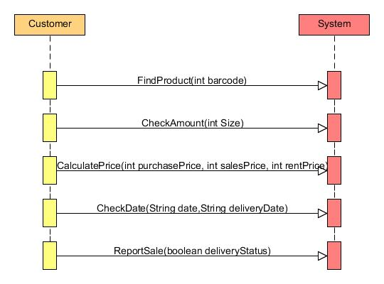

System sequence diagram about the product is sold. The main actors here are employees and customer. And the main methods are FindProduct, CheckAmount, CalculatePrice, CheckDate and ReportSale.

Operation contracts:

|  |
| --- |
| Operation: FindProduct  Use case: Product is sold  Pre-condition: Product is in stock  Post-condition:   * Product is found by the system * Product is sold and is not anymore in stock |

|  |
| --- |
| Operation: CheckAmount  Use case: Product is sold  Pre-condition: Product is in stock  Post-condition:   * Amount is check by the system if it is available or not * Product is sold and is not anymore in stock |

|  |
| --- |
| Operation: CalculatePrice  Use case: Product is sold  Pre-condition: Product is in stock  Post-condition:   * Product is found by the system * Total price is calculated * Product is sold and is not anymore in stock |

|  |
| --- |
| Operation: CheckDate  Use case: Product is sold  Pre-condition: Product is in stock  Post-condition:   * Date is checked by the system is it valid or not * Product is sold and is not anymore in stock |

|  |
| --- |
| Operation: ReportSale  Use case: Product is sold  Pre-condition: Product is in stock  Post-condition:   * Product is reported by the system that it crated sale * Product is sold and is not anymore in stock |

Operation contract about the product is sold. The are four main operation which are FindProduct, CheckAmount, CalulatePrice, CheckDate and ReportSale.