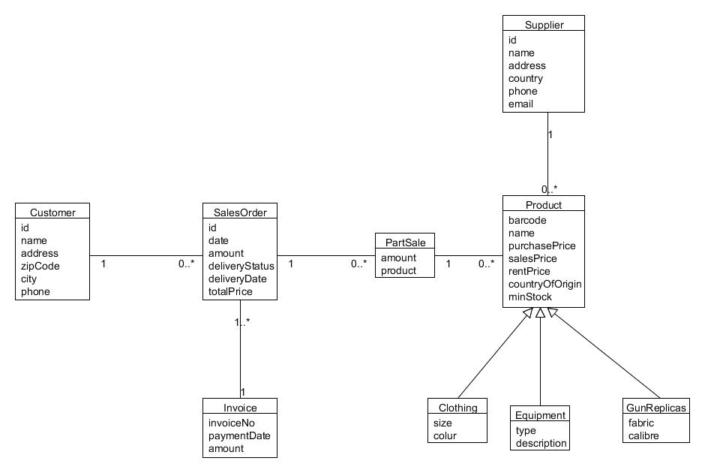

In our domain model we have class Customer with variables id, name, address, zipCode, city and phone. The Customer class is connected with SalesOrder with one to many. In the SalesOrder we have id, date, amount, deliveryStatus, deliveryDate and totalPrice and also the SalesOrder class is connected with Invoice class witch have variables invoiceNo, paymentDate and amount. The SalesOrder is also related with the PartSale class and the contractor class which is connected. The Product have barccode, name, purchasePrice, salesPrice, rentPrice, countryOfOrigin, minStock. Lease class have the data, productID, productBarcide, productAmount, period, employeeID, customerID. Product is connected with the supplier class. The supplier have id, name, address , country, phone and email.