Functional Programming in Haskell

Alan Perlis once said A language that doesn't affect the way you think about programming, is not worth knowing. Judging by the number of Stack Overflow questions and the impressive number of articles and posts on reddit, Slashdot or blogs, it is clear that the Haskell language deserves to be known. In fact, functional programming is indeed a domain which every hacker should be accustomed with.

History made it so that the commonest programming languages of today are in the imperative camp. There, the code is nothing more than a set of orders given to the computer. However, very few programmers know that the imperative programming paradigm is but one of the fourth invented by the mathematicians which laid out the bases of Computer Science. Hardly alike, these paradigms are linked together by one thing: the Church-Turing thesys which says that no paradigm can be used to solve more problems than the other ones. However, code can be written more easily in the functional paradigm than in the imperative one for some problems. In today's languages landscape one sees an astonishing fact: even if all four paradigms were created roughly at the same time, the fact that the von Neumann computer model is so successful has made the imperative languages be the predominant ones in the field. Still, the other ones have their uses too, especially in Artificial Intelligence. The oldest programming language still in use today – LISP – was created by John McCarthy for Artificial Intelligence studies.

An important moment in the history of programming languages is represented by the influential article of John Bachus Can Programming Be Liberated From the von Neumann Style? A Functional Style and its Algebra of Programs. An important point is made there: functional programs can be more easily composed by assembling previously teste components. Basically, this article is the catalyst for the apparition of new functional programming languages beside LISP. In 1970s there were no less than 10 new languages. From them, the ML family languages stand aside, being represented by two languages: OCaml which is still in use today and Miranda.

It was from these languages where members of the 1990 committee for inventing a new language started their work. They wanted an open standard capable of allowing and encouraging research in programming languages design and compilers. In the end, they have created Haskell.

In time, this language managed to become a powerful programming language. Now, it is used in various domains, for example in Artificial Intelligence, Security, Web Development and Operating Systems. Many of the novelties which were created for this language later found their way into C++, Java, etc.

This development couldn't be possible without the community which exists around the language (the #haskell IRC channel on Freenode, special groups and tags on Reddit and Stack Overflow, many blog articles collected weekly by Haskell Weekly News and twice a year by Haskell Communities and Activities Report) but it is also due to the great number of online resources for language learning (The Monad Reader, wikis and wikibooks, etc.).

Famous names from IT industry are using Haskell today, either in development or on local, small-scale projects: NASA, Galois, Facebook, Google, Microsoft, Jane Street, etc. The first Perl6 intrepreter was written entirely in Haskell. Tools for automatic program validation and theorem proving are developed in this language (sometimes with some Ocaml parts).

But why is this language so attracive? The common answer has two aspects: the declarative style and a certain guarantee of code corectness. Functional programs are extremely concise, the focus is on what the code should do instead of how it should do it. For example, here follows a quick-sort listing (always choosing as pivot the first element from the list):

sort [] = []
sort (x:xs) = lesser ++ x:greater
where
lesser = sort [a | a <- xs, a < x]
greater = sort [a | a <- xs, a >= x]

Compare this code with the lengthy implementation of the same algorithm in your favorite language. Clearly, functional code benefits from the declarative aspect: code is more easily read, unknown syntax elements can be skipped over, their meaning understood from the context.

To help prove code validation Haskell has static typing: each expression has a type which is known from the compile time. There is no explicit conversion between similar types: the programmer is in charge with doing them where and when they are needed. Some researchers have promoted the idea that a good type system usage can lead to guaranteeing an important invariant: if the code compiles there's a high chance that it is also correct. Quite often, this is true. In fact, what is recommended is to transform the most frequent runtime errors into compile time error. As an example, let's look at the null-pointer-exception problem: a special type called Maybe is used in Haskell: the programmer will return values encapsulated into this container from functions which can fail and the compiler will ensure that every caller will test whether the call succeeded or failed. At an extremity, there are web frameworks where every string is of a different type: one can no longer confound CSS with HTML and SQL injection and similar attacks are no longer possible.

Another advantage of static typing is the fact that functions are searchable by knowing only their type. There are even two search engines for that: Hayoo and Hoogle. Both are able to generalize as much as possible the arguments and both are capable of offering good and eloquent suggestions. After a time, it is possible to arrive at a puzzle-solving like programming: the pieces are the functions which will remain into the end program.

An important characteristic of the language is it's purity. Every program must interact with the outside world (reading data, sending data, etc.) Haskell is no different. However, his functions for this are marked differently from the types point of view. Any function with lateral effects is marked IO. And, if a programmer could extract the values from Maybe, this is no longer true for IO. This enforces that every function with lateral effects is only called from functions marked as having lateral effects. In practice, the code is divided into two parts: the purely functional code for data manipulation and imperative code for interacting with the outside world. It is this segregation which prompted Simon Peyton Jones – one of the language's founders – to consider Haskell as being the best imperative programming language.

This segregation also helps in code parallelization. It is very easily to do this in Haskell: since pure functions have no lateral effects they can be called in every order, as many times as possible and their results can be memoized in caches. It is too easy to write lock-less code.

Another advantage of the language is it's lazyness. The programmer is able to write code which works with infinite structures as long as they have a finite representation and only a finite number of elements is needed. Think of the the infinite sequences from maths: they can be represented by a recurrence relation and you are only interested in the first few terms and some specific properties.

However, even if laziness allows us to write circular programs and work using infinite sequences, sometimes this harms in analyzing program's performance. Luckily, Haskell has constructs for controlling evaluation type. Thus it is possible to enforce strictness and eagerness at function level. On the other side, lazy eveluation ensures that only the needed data is computed, loosing as few clock cycles as possible.

Finally, by using all of the language's features it is possible to write code with near C performance. The advantage of using a functional language becomes more evident now: a declarative code can be read even after 2-3 months have passed since it was first written.

Haskell code can be either interpreted or compiled. Using the GHC (The Glorious Glasgow Haskell Compiler Collection) suite toghether with Haskell Platform is recommended. Thus, all of the language's features and some higher level libraries which are consistently checked and performance improved are available. The GHC suite comes with a compiler (ghc) and an interprerer (ghci). The later enables rapid prototyping of applications, code testing and type evaluation. The compilers is used to generate an executable with the same performance as classical languages. Finally, there are tools in the Haskell Platform suite for profiling and optimizing the code.

Considering that enough details were presented and that the passion to learn the language is ignited it is time to go to some syntax elements. In the end, we will write a simple code for a simple problem: find the order of a permutation. For example, the order of (3 4 2 1 5) is 4: starting from (1 2 3 4 5) we get to (3 4 2 1 5), then (2 1 4 3 5), (4 3 1 2 5) and back to (1 2 3 4 5).
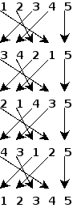
A permutation will be represented by using a list of numbers from 1 to n. In Haskell, [1, 2, 3] is the list of the first 3 natural numbers. To have a generic code, we can use a generator, like in [ 1 .. n]. A Haskell list allows only prepending elements by using the : operator. The empty list is []. List elements must all have the same type and can be accessed via !! operator..

Most of the functional programming functions are recursive. This enables using structural induction to prove code corectness. For example, the following function computes the length of a list:

length [] = 0
length (x:xs) = 1 + length xs

The first line declares that length of any empty list is 0. The second says that the length of a list formed by prepending an element to a list xs is 1 greater than the length of the list xs.

Programmers accustomed with compiler structures and low-level programming will say that recursivity eat stack space and must be avoided. However, GHC compiler can do some code transfromation arriving at tail recursion: each recursive call replaces the stack frame of the previous call such that the result is given back directly to the caller.

If you look closely at the 2 lines of length, you'll see that there is exactly one line per each constructor. Almost all functions in functional programming use the same pattern of deconstructing the data type: write an expression for each constructor of the type.

Consider now the following two functions. The first one computes the sum of a list while the second the product of its elements.

sum [] = 0
sum (x:xs) = x + sum xs

product [] = 1
product (x:xs) = x * product xs

As you see, there's a common pattern: starting from an initial element to be used for the empty list and a binary operation we get to a single result by “folding” the list. This pattern is captured by Haskell via two functions (depending on the direction of the reduction):

foldr f e [] = e
foldr f e (x:xs) = f x (foldr f e xs)

foldl f e [] = e
foldl f e (x:xs) = foldl f (f e x) xs

Observe that one of the 2 functions is tail-recursive from the beginning: one of the call arguments is updated with the partial result. The difference between the two functions is observable from the following image:

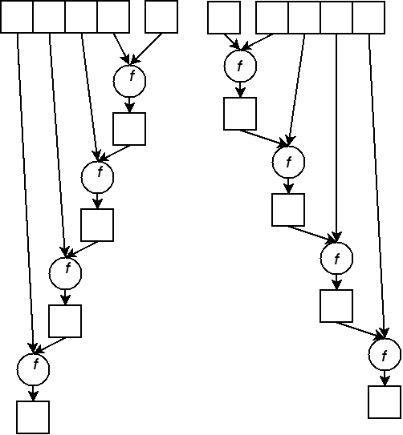
Other two important patterns are map and filer, illustrated by the following code and images:

map f [] = []
map f (x:xs) = f x : map f xs

filter p [] = []
filter p (x:xs)
| p x = x : filter p xs
| otherwise = filter p xs

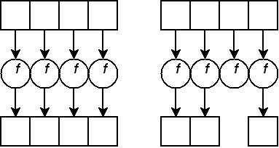

Using these patterns enable us to write less code (remember DRY principle) which is also easy to prove for corectness. Finally, the compiler can further optimize our code if using said functions.

Now, let's write code to apply a permutation on a list: for each element from the permutation we give back the corresponding element from the list (using !! to get the elements and map to apply this operation on all elements).

applyPerm :: [Int] -> [Int] -> [Int]
applyPerm l p = map (\i -> l !! (i - 1)) p

With this function we can compute the answer of our problem using until. This is the equivalent of imperative while: having a predicate and a function for iterating between states it starts from an initial state and returns the state where the predicate becomes True.

computeOrder :: [Int] -> Int
computeOrder perm = fst $ until test f $ f init
where
l = length perm - 1
test p = snd p == [1 .. l]
f (a, list) = (a+1, applyPerm list perm)
init = (0, [1 .. l])

How does it work? Starting from a permutation, we use applyPerm to modify the current state from until. A state has two values: a counter and a list, the result of permuting the first natural numbers.

Using ghci, we test the code:

*Main> computeOrder [3,4,2,1,5]
4

The result is the expected 4. We can test this by using iterate to infinitely call a function and collect all values, generating the list [x, f x, f (f x), ...]. Finally, we use take to select only the first elements of the list, taking advantage of laziness to get only the needed elements:

*Main> take 5 $ iterate (flip applyPerm [3, 4, 2, 1, 5]) [1..5]

[[1,2,3,4,5],[3,4,2,1,5],[2,1,4,3,5],[4,3,1,2,5],[1,2,3,4,5]]

Next time we'll get into more elements of Haskell's syntax: how to define new types and how to use them.

