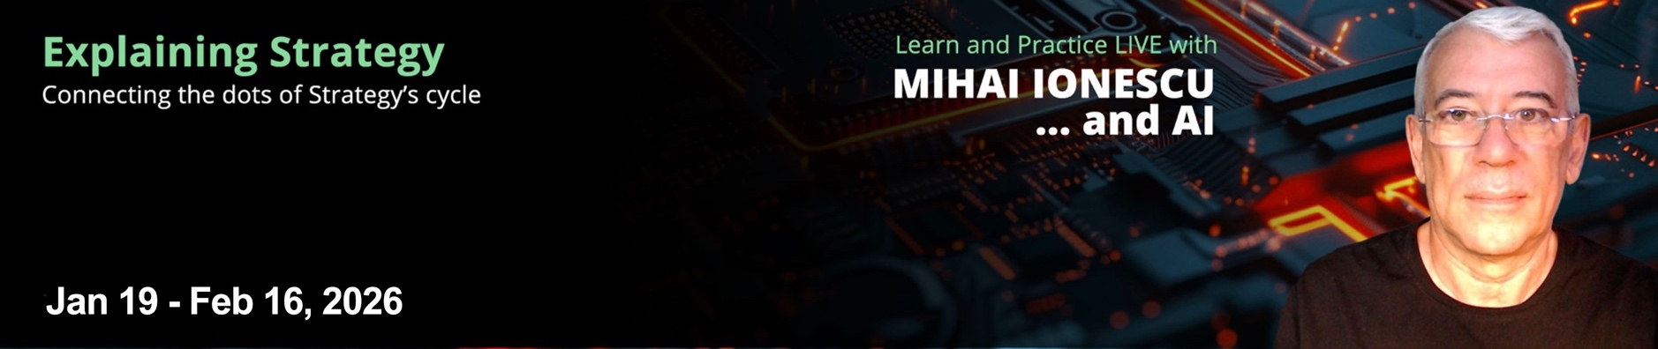

April 7-30, 2026


OVERVIEW
Explaining Strategy was born
from the practice of testing how
the key concepts and theories of
Strategy work for real people in
real organizations.

The Strategy Management discipline has been built over several decades of emerging ideas that have been confirmed or rejected by the test of practice. Unfortunately, some of the failed ideas still float around, making it more difficult for us to understand with clarity how Strategy’s processes should work.

The Explaining Strategy applicative course is aimed at connecting the dots of the key concepts, theories, and frameworks that are placed at the foundation of the Strategy, providing an integrative view that allows us to separate the signal from the noise in understanding how Strategy should best be built and managed.
2 Schedule at a glance

Course Start Date | April 7, 2026
Course Duration | 4 Weeks plus  3h Kick-off meeting 3h Wrap-up meeting
Course Sessions | 3 x 3h live sessions,  every Tuesday
Practice Sessions | 3 x 3h live sessions,  every Thursday

We are looking at all available thought processes that we can use to design and implement the Strategy, identifying their inputs & outputs, and understanding what is strictly necessary for an integrated system, and what is redundant, or doesn’t fit with the rest.

This course is not only about explaning Strategy. It is also about testing how its concepts work in practice. For this reason, the course sessions are a balanced mix of showing and doing, including an AI-powered process of designing Strategy’s and Strategic Plan’s models, enabled by Rapid Strategy, a new app that guides participants through the 28 Practice Sessions steps.
Practice Sessions
This is a unique opportunity to test the concepts and methods presented in the course, by using the RapidStrategy app that is available as a practice environment for building the Strategy model and the Strategic Plan model, for each participant's own Case Study. The practice process is AI-driven, giving you an insight into Strategy and AI working together in an incremental multi-step process.

Each cohort team member is assisted by AI to define a Case Study, based on a real company profile. Then, the AI-driven workflow goes step by step for building the Strategy models applicable to their case. The team discussions are encouraged and separate virtual meeting rooms are provided during the Practice Sessions.

Key Concepts

Strategy's main challenge is to provide the best-fit solutions for specific types of customer Jobs-to-Be-Done.
Strategy is continuously adaptive because not all hypotheses upon which it is built can be valid.
Strategy is managed in a continuous, overlapping cycle of formulation and execution that feed into each other.
Strategy's choices aim to maintain an ambidextrous wave of parallel, transient competitive advantages.
Strategy’s choices are positioning the organization within the market-solutions space, and are selected from a reference cognitive model of choices types.
Selecting Strategy's choices is enabled by experimentation and based on anticipated influences inferred from the analysis of trends and weak signals.
Strategy’s choices must be supported by a set of required activities and capabilities
Strategy's execution must close the gaps between the existing and the desired positioning and between the existing and the required capabilities and activities.
Strategy’s execution is driven by the cause-effect related and aligned objectives achieved through the effects of initiatives with monitored outcomes.
What you’ll learn:

Understand Strategy’s integrative role
Grasp the essentials of the interdependent relationships between the processes of Strategy Experimentation, Strategy Formulation, and Strategy Execution, and better understand how the outcome of the thinking process from each of them flows into the next, in a closed loop system.

Get clarity on how Strategy is adaptive
Understand how the traceability of the chains of hypotheses that we employ when deciding on the components of our Strategy’s models allows us to find out which of those hypotheses turned out to be invalid and how we adapt our models, as a consequence of that.


Practice the design of Strategy models
This course is not only theory. We practice what we preach and so can you in the Practice Sessions, during which we will experience the effective team decision-making, enabled by an online platform that allows us to design our own Strategy and Strategic Plan models.

Due to interactivity reasons, there are limited seats available for each cohort. Ready to get clarity on how the full Stategy works? Learn more in the Enrollment page.

Enroll to your time-zone cohort:

Americas EMEA ASIA PACIFIC

Contact us to learn more about private group opportunities.



The course structure:

" Case Teamwork

The course is organized on four cohorts of maximum 5 people, which form a team.
Each team works during the coach-lead practice sessions on creating a Strategy model and a Strategic Plan model for the case that they selected from a set of cases available or proposed by a team member.
At each step of the methodology, the workspace AI-powered app suggest model components that must be decided upon for that step, then the process advances to the next step.
The RapidStrategy app workspace uses 28 speps that provide a separate course participant environment working on their own Case Studies.
The platform facilitates the communication between team members during the practice sessions, as well as outside of the session times, 24/7 every day, for the whole duration of the course.
A separate video-conferencing platform is made availabl 24/7 to each team for instant team meetings related to the case study practice exercise, together with a discussions board for off-line team conversations.
The course runs on the  platform.
Kick-off session
Items:
- Sessions Intro
- Framework Intro
- Sessions Agenda
- Practice Platform
Strategy Formulation 1
Stages:
I. Product Experiments
II. Choices Experiments
1. Trends & Signals Spyglass
2. Choices Compass
Strategy Formulation 2
Stages:
3. Capabilities Factory
4. Gaps Closing Scheduler
5. Feasibility & Viability Gateway
Strategic Planning
Stages:
6. Planning Board
7. Alignment Concerto
8. Operations Bridge
Strategic Plan Execution
Stages:
9. Execution Pit Stop
10. Hypotheses Test Bench
Items:
- Wrap-up & Conclusions

The practice workflow:
These are the steps of the practice workflow that represents each participan's journey through the process of formulating the Strategy for they Case Study company and building the Strategic Plan for implementing it.

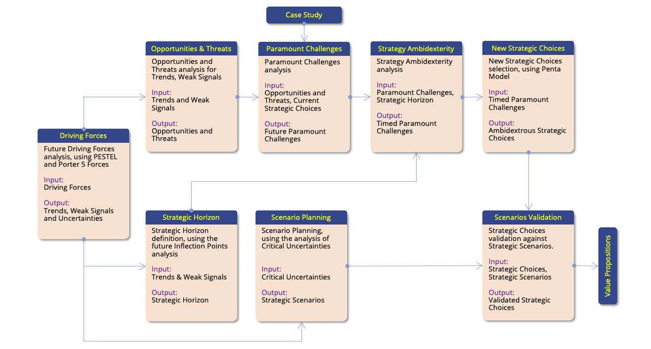
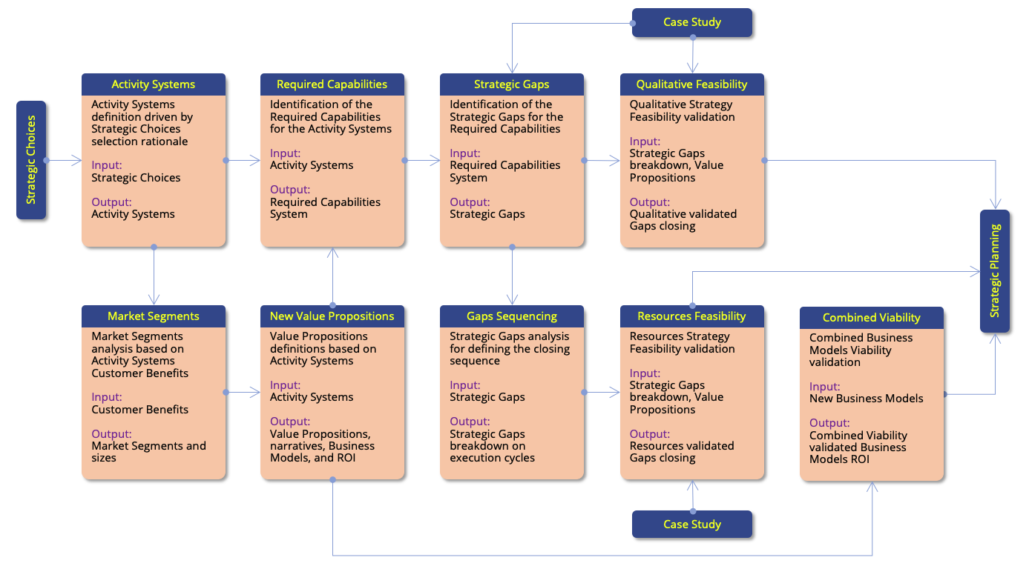

The Practice Workflow (continued)
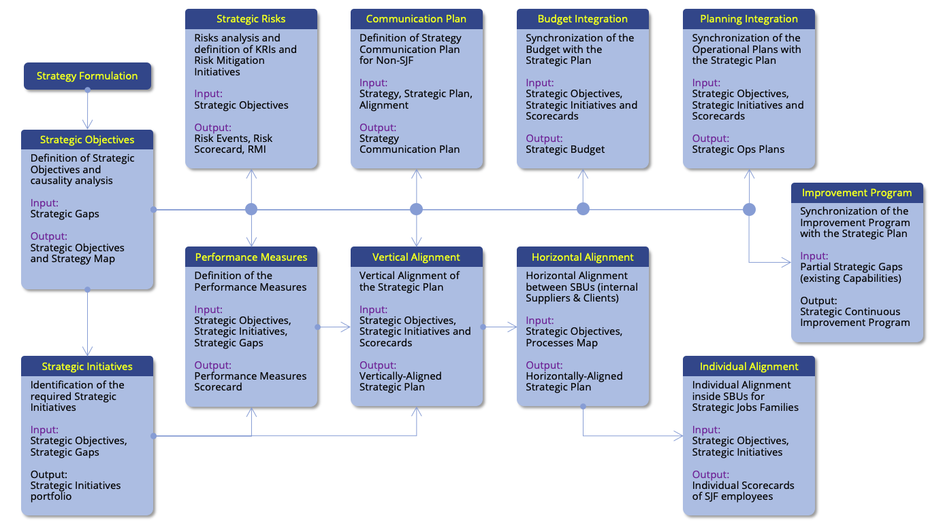

The user interface (the RapidStrategy platform screenshot)
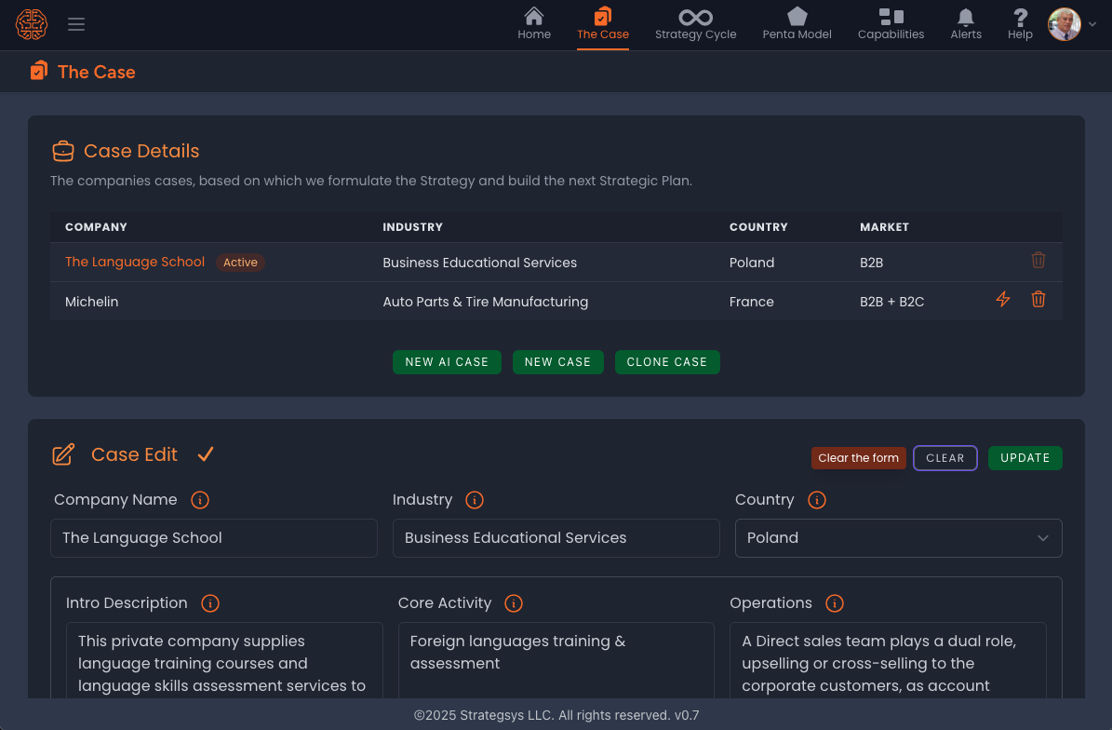



The cohort schedule:

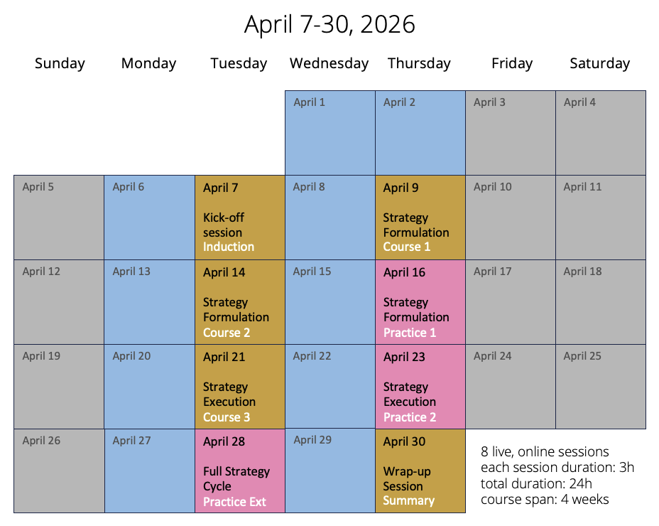
For more information about the course and enrollment, visit the course website:
https://explaining-strategy.com

The sessions times:
Each cohort has allocated a time mapped against specific time-zones, allowing everybody to attend one of the three live sessions delivered during each day of the course, irrespective of where they live in the world.


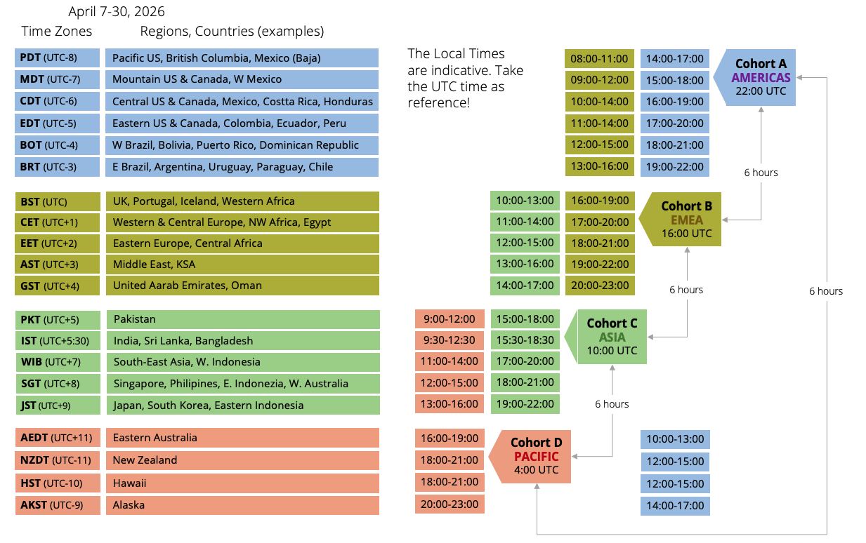

The course is delivered by:
Strategsys LLC, 300 Delaware Ave., Ste. 210 #580,
Wilmington, DE, United States of America
Web: https://strategsys.com
Email: info@strategsys.com
Phone: +1(302) 830-3715

