- Business modeling

- business use case diagrams:
- business use case 1

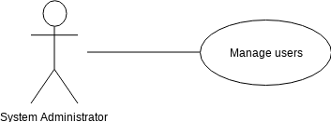

- business use case 2

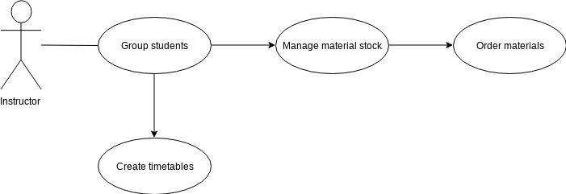
- business use case 3

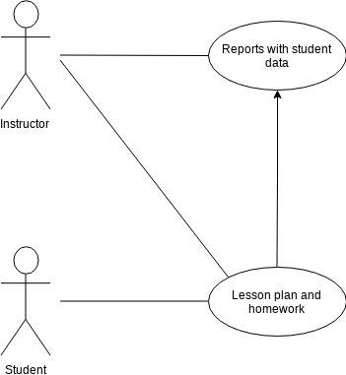

- activity diagrams

